**3GPP TSG-SA5 Meeting #141-eS5-221386**

**e-meeting, 17 - 26 January 2022**

**Source: Ericsson, Deutsche Telekom**

**Title: Discussion paper on cleaning up eCosla stage 2 description**

**Document for: Discussion**

**Agenda Item: 6.4.10**

# 1 Decision/action requested

***The group is asked to endorse the detailed proposal in section 4.***

# 2 References

[1] [3GPP TS 28.535](https://portal.3gpp.org/desktopmodules/Specifications/SpecificationDetails.aspx?specificationId=3693): "Management and orchestration; Management services for communication service assurance; Requirements"

[2] [3GPP TS 28.536](https://portal.3gpp.org/desktopmodules/Specifications/SpecificationDetails.aspx?specificationId=3701): "Management and orchestration; Management services for communication service assurance; Stage 2 and stage 3"

[3] [3GPP TS 28.533](https://portal.3gpp.org/desktopmodules/Specifications/SpecificationDetails.aspx?specificationId=3416): "Management and orchestration; Architecture framework"

[4] [SP-200196](https://www.3gpp.org/ftp/tsg_sa/TSG_SA/TSGS_87E_Electronic/Docs/SP-200196.zip): "New WID on Enhanced Closed loop SLS assurance"

[5] [SP 200465](https://www.3gpp.org/ftp/tsg_sa/TSG_SA/TSGS_88E_Electronic/Docs/SP-200465.zip): "Management data collection control and discovery"

[6] [SP_210136](https://www.3gpp.org/ftp/tsg_sa/TSG_SA/TSGs_91E_Electronic/Docs/SP-210136.zip): "Study on Enhancement of service-based management architecture"

[7] [SP 210132](https://www.3gpp.org/ftp/tsg_sa/TSG_SA/TSGs_91E_Electronic/Docs/SP-210132.zip) "Enhancements of Management Data Analytics Service"

# 3 Rationale

With the development of the stage 2 specification for Cosla Rel-17 many changes have been implemented and due to the many changes, the descriptions of classes, data types and attributes could be improved to make them more useable.

The most current agreements on stage 2 are documented in clause 4.1.2 of TS 28.536 [v17.1.0.](https://www.3gpp.org/ftp/Specs/archive/28_series/28.536/28536-h10.zip) in draftCR [S5-216596](https://www.3gpp.org/ftp/tsg_sa/WG5_TM/TSGS5_140e/Docs/S5-216596.zip). The table of content for clause 4.1.2 is as follows:

4.1.2 Model

4.1.2.1 Imported and associated information entities

4.1.2.1.1 Imported information entities and local labels

4.1.2.1.2 Associated information entities and local labels

4.1.2.2 Class diagram

4.1.2.2.1 Relationships

4.1.2.2.2 Inheritance

4.1.2.3 Class definitions

4.1.2.3.1 AssuranceClosedControlLoop

4.1.2.3.2 AssuranceGoal

4.1.2.3.3 Void

4.1.2.3.4 Void

4.1.2.3.5 AssuranceTarget <<dataType>>

4.1.2.3.5 AssuranceScope <<dataType>>

4.1.2.3.l AssuranceGoalStatus <<dataType>>

4.1.2.3.m AssuranceTargetStatus <<dataType>>

4.1.2.3.x AssuranceReport <<IOC>>

4.1.2.4 Attribute definitions

4.1.2.4.1 Attribute properties

4.1.2.4.2 Constraints

4.1.2.4.3 Notifications

4.1.2.5 Common notifications

4.1.2.5.1 Alarm notifications

4.1.2.5.2 Configuration notifications

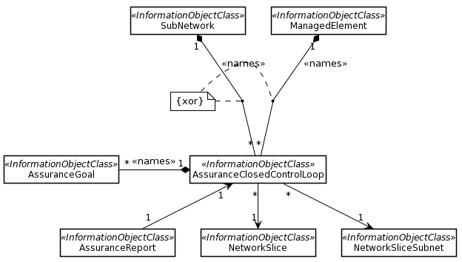

Figure 3.1 The eCOSLA NRM fragment as in draftCR S5-221596

The following updates to clause 4.1.2 have been identified:

**Update 1**

**Issue**: The AssuranceReport is an IOC but it has not been contained and can therefore not be addressed by an MnS consumer.There are two options for providing AssuranceReport (AR) per ACCL or per AG.Since the hierarchy for network slice is NSI/ServiceProfile/Attribute and that for network slice subnet is NSSI/SliceProfile/Attribute that of closed control loop is ACCL/Goal/Target and Service/SliceProfile relates to service intent (SLA) we think it is appropriate to report per Goal.

**Solution:** it is proposed to name contain the AssuranceReport under AssuranceGoal.

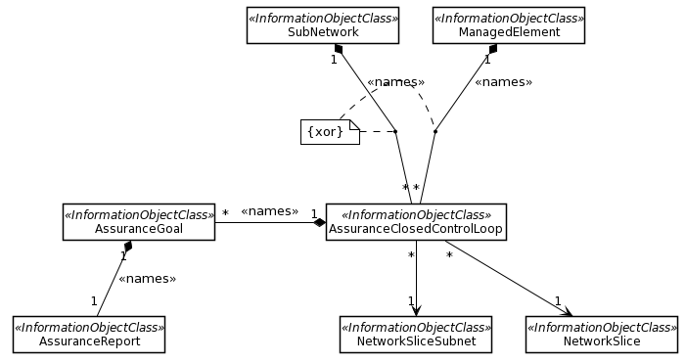

Figure 3.2 The proposed eCOSLA NRM fragment

**Update 2**

**Issue:** Description of Assurance report needs revision. If AssuranceReport is contained by AssuranceGoal the reference and description in attribute properties table is not needed.

**Solution: Remove reference to closed control loop**

**Update 3**

**Issue:** The introductory text in clause 4.1.2.2.1 is incomplete according to the methodology TS 32.160 [x]

**Solution:** updated to introductory text according to TS 32.160 [x]

**Update 4**

**Issue:** The formatting of clause 4.1.2.3.1/2/3/4/5 is Justified, it should be Align Right. Also, the word NetworkSLice should be NetworkSlice.

**Solution*:*** update formatting, and fix NetworkSlice to NetworkSlice

**Update 5**

**Issue:** Something funny with the formatting of heading 4.1.2.3.2 AssuranceGoal

**Solution*:*** Fix formatting

**Update 6**

**Issue:** Description of Assurance goal: “corresponding observed or predicted goal fulfilment” should be corresponding observed and/or predicted goal fulfilment. Last paragraph before the Note needs revision

**Solution*:*** Propose revision

**Update 7**

**Issue:** Description of Assurance goal status needs revision. Note also typo in “fuilfilment”.

**Solution*:*** Propose revision,

**Update 8**

**Issue:** The list of configuration notifications in clause 4.1.2.5.2 is incomplete, more notifications are specified in TS 28.532 that may be used.

**Solution:** Add missing notification “notifyMOIChanges” from TS 28.532 to table in clause 4.1.2.5.2

## 3.1 UML code for Figure 3.2

@startuml

skinparam backgroundColor white

skinparam classBackgroundColor white

skinparam classBorderColor black

skinparam Shadowing false

skinparam noteBackgroundColor white

skinparam noteBorderColor black

skinparam Note1BorderColor red

skinparam arrowColor black

hide circle

hide members

class SubNetwork <<InformationObjectClass>>

class ManagedElement <<InformationObjectClass>>

class AssuranceClosedControlLoop <<InformationObjectClass>>

class AssuranceGoal <<InformationObjectClass>>

class AssuranceReport <<InformationObjectClass>>

class NetworkSlice <<InformationObjectClass>>

class NetworkSliceSubnet <<InformationObjectClass>>

SubNetwork "1" *-- "*" AssuranceClosedControlLoop: <<names>>

ManagedElement "1" *-- "*" AssuranceClosedControlLoop: <<names>>

AssuranceClosedControlLoop "1" *-left- "*" AssuranceGoal: <<names>>

AssuranceGoal "1" *-- "*" AssuranceReport: <<names>>

AssuranceClosedControlLoop "1" <-- "1" AssuranceReport

AssuranceClosedControlLoop "*" --> "1" NetworkSlice

AssuranceClosedControlLoop "*" --> "1" NetworkSliceSubnet

note "{xor}" as Note1

Note1 .. (SubNetwork, AssuranceClosedControlLoop)

Note1 .. (ManagedElement, AssuranceClosedControlLoop)

@enduml

# 4 Detailed proposal

The group is asked to endorse the proposals described in the rational.