**3GPP TSG- Meeting # *rev1***

**, , -**

|  |  |  |  |  |  |  |  |  |
| --- | --- | --- | --- | --- | --- | --- | --- | --- |
| *CR-Form-v12.1* | | | | | | | | |
| **CHANGE REQUEST** | | | | | | | | |
|  | | | | | | | | |
|  |  | **CR** |  | **rev** |  | **Current version:** |  |  |
|  | | | | | | | | |
| *For* [***HE******LP***](http://www.3gpp.org/3G_Specs/CRs.htm#_blank)*on using this form: comprehensive instructions can be found at* [*http://www.3gpp.org/Change-Requests*](http://www.3gpp.org/Change-Requests)*.* | | | | | | | | |
|  | | | | | | | | |

|  |  |  |  |  |  |  |  |  |
| --- | --- | --- | --- | --- | --- | --- | --- | --- |
| ***Proposed change affects:*** | UICC apps |  | ME |  | Radio Access Network | **X** | Core Network | **X** |

|  |  |  |  |  |  |  |  |  |  |  |
| --- | --- | --- | --- | --- | --- | --- | --- | --- | --- | --- |
|  | | | | | | | | | | |
| ***Title:*** | Rel-17 Input to DraftCR 28.622 Add solution for retrieving stored data | | | | | | | | | |
|  |  | | | | | | | | | |
| ***Source to WG:*** | Nokia, Nokia Shanghai Bell | | | | | | | | | |
| ***Source to TSG:*** | SA5 | | | | | | | | | |
|  |  | | | | | | | | | |
| ***Work item code:*** | MADCOL | | | | |  | ***Date:*** | | |  |
|  |  | | | |  | |  | | |  |
| ***Category:*** |  |  | | | | | ***Release:*** | | |  |
|  | *Use one of the following categories:* ***F*** *(correction)* ***A*** *(mirror corresponding to a change in an earlier release)* ***B*** *(addition of feature),* ***C*** *(functional modification of feature)* ***D*** *(editorial modification)*  Detailed explanations of the above categories can be found in 3GPP [TR 21.900](http://www.3gpp.org/ftp/Specs/html-info/21900.htm). | | | | | | | | *Use one of the following releases: Rel-8 (Release 8) Rel-9 (Release 9) Rel-10 (Release 10) Rel-11 (Release 11) … Rel-15 (Release 15) Rel-16 (Release 16) Rel-17 (Release 17) Rel-18 (Release 18)* | |
|  |  | | | | | | | | | |
| ***Reason for change:*** | | Requirements for reporting and storing are agreed. This contribution proposes the corresponding data NRM fragment. | | | | | | | | |
|  | |  | | | | | | | | |
| ***Summary of change:*** | |  | | | | | | | | |
|  | |  | | | | | | | | |
| ***Consequences if not approved:*** | | The WI MADCOL cannot progress. | | | | | | | | |
|  | |  | | | | | | | | |
| ***Clauses affected:*** | |  | | | | | | | | |
|  | |  | | | | | | | | |
|  | | **Y** | **N** |  | | | |  | | |
| ***Other specs*** | |  | **X** | Other core specifications | | | | TS/TR ... CR ... | | |
| ***affected:*** | |  | **X** | Test specifications | | | | TS/TR ... CR ... | | |
| ***(show related CRs)*** | |  | **X** | O&M Specifications | | | | TS/TR ... CR ... | | |
|  | |  | | | | | | | | |
| ***Other comments:*** | | Baseline DraftCR for MADCOL: None. | | | | | | | | |
|  | |  | | | | | | | | |
| ***This CR's revision history:*** | |  | | | | | | | | |

|  |
| --- |
| **First modification** |

## 4.2 Class diagrams

### 4.2.1 Relationships

This clause depicts the set of classes (e.g. IOCs) that encapsulates the information relevant for this IRP. This clause provides the overview of the relationships of relevant classes in UML. Subsequent clauses provide more detailed specification of various aspects of these classes.

The following figure shows the containment/naming hierarchy and the associations of the classes defined in the present document. See Annex A of a class diagram that combines this figure with Figure 1 of [2], the class diagram of UIM.



NOTE 1: ManagedElement may be contained either

- in a SubNetwork (since *SubNetwork* inherits from *Domain*_ and *ManagedElement* inherits from *ManagedElement*_ and *Domain*_ name-contained *ManagedElement_* as observed in the figure of Annex A) or

- in a MeContext instance as observed by the above figure or in the figure of Annex A.

This either-or relation cannot be shown by using an {xor} constraint in the above figure.

ManagedElement may also have no parent instance at all.

NOTE 2: Void

NOTE 3: If the configuration contains several instances of SubNetwork, exactly one SubNetwork instance shall directly or indirectly contain all the other SubNetwork instances.

NOTE 4: The SubNetwork instance not contained in any other instance of SubNetwork is referred to as "the root SubNetwork instance".

NOTE 5: ManagementNode shall be contained in the root SubNetwork instance.

NOTE 6: If contained in a SubNetwork instance, MnsAgent shall be contained in the root SubNetwork instance.

NOTE 7: For a clarification on the choice of containment of the IRPAgent (since it has three possible parents), see the definition of MnsAgent.

NOTE 8: The MnsAgent shall be replaced by the IRPAgent in deployments using the IRP framework as defined in TS 32.102 [2].

Figure 4.2.1-1: NRM fragment

Each Managed Object is identified with a Distinguished Name (DN) according to 3GPP TS 32.300 [13] that expresses its containment hierarchy. As an example, the DN of a ManagedElement instance could have a format like:

SubNetwork=Sweden,MeContext=MEC-Gbg-1,ManagedElement=RNC-Gbg-1.



NOTE 8: Void

NOTE 9: Void

Figure 4.2.1-2: Vendor specific data container NRM fragment

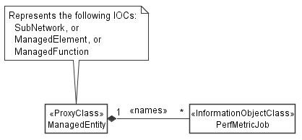

Figure 4.2.1-3: PM control NRM fragment

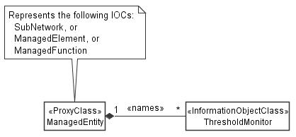

Figure 4.2.1-4: Threshold monitoring control NRM fragment

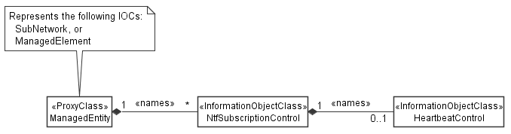

Figure 4.2.1-5: Notification subscription and heartbeat notification control NRM fragment

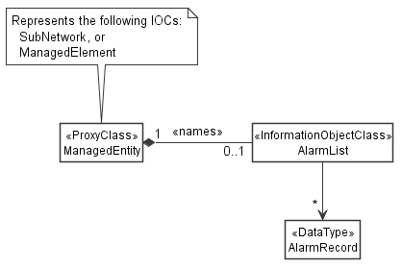

Figure 4.2.1-6: FM control NRM fragment

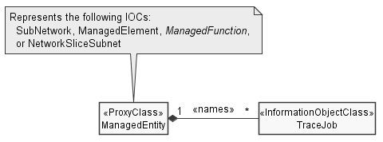

Figure 4.2.1-7: Trace control NRM fragment

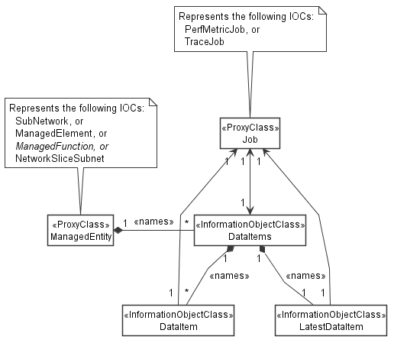

Figure 4.2.1-10: Data NRM fragment

### 4.2.2 Inheritance

This clause depicts the inheritance relationships.





Figure 4.2.2-1: NRM fragment

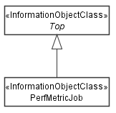

Figure 4.2.2-2: PM control NRM fragment

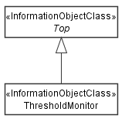

Figure 4.2.2-3: Threshold monitoring control NRM fragment

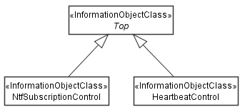

Figure 4.2.2-4: Notification subscription and heartbeat notification control NRM fragment

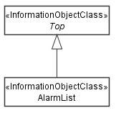

Figure 4.2.2-5: FM control NRM fragment

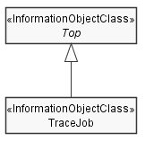

Figure 4.2.2-6: Trace control NRM fragment

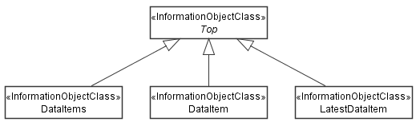

Figure 4.2.2-9: Data NRM fragment

|  |
| --- |
| **Next modification** |

### 4.3.X DataItems

#### 4.3.X.1 Definition

This IOC represents a collection of data items. It contains meta data about the management data stored in the collection, but not the actual data. The actual data is represented by the name-contained "DataItem" instances.

The data NRM fragment is provided for re-exposing collected data. For exampl a Management Function consumes data collected by jobs and re-exposes them to other data consumers such as SON or analytics applications.

"DataItems" can be name-contained by "ManagedElement", "ManagedFunction" or "SubNetwork". In addtion, it can be name-contained by "NetworkSliceSubnet" (3GPP TS 28.541 [c]). The name-containment links "DataItems" to the object that the data relates to. For example, data collected on or related to a network element of type XYZ shall be name-contained under the "XyzFunction" that represents the network element in the management system.

*Editor's note: It is ffs if the statement that "NetworkSliceSubnet" may contain "DataItems" should be put here or in 28.541, where "NetworkSliceSubnet" is defined.*

More specifically, the parent object for performance measurements is defined by item f) of the measurement specification template (3GPP TS 32.404 [y], clause 3.3) and by item d) of the KPI specification template (3GPP TS 28.554 [x], clause 5).

*Editor's note: The parent object for Trace/MDT is ffs.*

In the present 3GPP release "DataItems" and "DataItem" shall not be supported, when the root object of the information model exposed by a MnS producer is "ManagedElement".

*Editor's note: The sentence above is a way to say: Don't use this NRM fragment on a NF (box in the network) as an alternative for file or stream-based reporting of performance metrics and trace/MDT data. Use it only for* ***re-exposing*** *collected data by a Management Function. It is ffs if the technique to convey this message by specifying the class of the root object is appropriate, or if better ways exist.*

"DataItems" instances are created, updated and deleted by the MnS producer. They cannot be created nor updated nor deleted by MnS consumers.

The attributes of "DataItems" contain meta data about the collection. They specify the management data type ("dataType"), the total size of the data collection ("size"), the time window when the data was collected ("startTime", "endTime") and the time when the data will be deleted ("deletionTime"). The MnS producer shall update the meta data attributes when data items are added to or deleted from the collection, or when existing data items are changed, for example, when new data is added.

The attributes "jobId" and "jobRef" shall be supported when the data was originally collected by jobs that are represented by "PerfMetricJob" or "TraceJob" and this information is relevant when re-exposing the data.

*Editor's note: The need for "jobId" and "jobRef" is ffs.*

#### 4.3.X.2 Attributes

|  |  |  |  |  |  |
| --- | --- | --- | --- | --- | --- |
| Attribute name | S | isReadable | isWritable | isInvariant | isNotifyable |
| dataType | M | T | F | F | F |
| size | M | T | F | F | F |
| startTime | M | T | F | F | F |
| endTime | M | T | F | F | F |
| deletionTime | M | T | F | F | T |
| **Attributes related to roles** |  |  |  |  |  |
| jobId | CO | T | F | T | F |
| jobRef | CO | T | F | T | F |

#### 4.3.X.2a Attribute definitions

| Attribute Name | Documentation and Allowed Values | Properties |
| --- | --- | --- |
| dataType | Management data types stored in the collection.  allowedValues:  - PERFORMANCE_MANAGEMENT  - KPI  - TRACE  - MDT  - ANALYTICS  *Editor's note: ENUM needs to be aligned across all SA5 TS, could be an item for common definitions.* | Type: ENUM  multiplicity: 1  isOrdered: N/A  isUnique: N/A  defaultValue: None  isNullable: False |
| size | Size of all "DataItem" instances in the collection. Unit is bytes.  allowedValues: non-negative integers | Type: Integer  multiplicity: 1  isOrdered: N/A  isUnique: N/A  defaultValue: None  isNullable: False |
| startTime | Start time of the data, i.e. the time stamp of the first data element of the first "DataItem" in "DataItems". This attribute is set once only and is never updated.  allowedValues: N/A | Type: DateTime  multiplicity: 1  isOrdered: N/A  isUnique: N/A  defaultValue: None  isNullable: False |
| endTime | End time of the data, i.e. the time stamp of the last data element of the last "DataItem" in "DataItems". This attribute is updated always by the MnS producer when a new "DataItem" is added or an existing "DataItem" is modified.  allowedValues: N/A | Type: DateTime  multiplicity: 1  isOrdered: N/A  isUnique: N/A  defaultValue: None  isNullable: False |
| deletionTime | Time when the MnS producer will delete the data collection.  allowedValues: N/A | Type: DateTime  multiplicity: 1  isOrdered: N/A  isUnique: N/A  defaultValue: None  isNullable: False |

#### 4.3.B.3 Attribute constraints

|  |  |
| --- | --- |
| Name | Definition |
| jobId  Support Qualifier | Condition: This attribute shoukd be supported when "PerfMetricJob" or "TraceJob" are supported. |
| jobRef  Support Qualifier | Condition: This attribute should be supported when "PerfMetricJob" or "TraceJob" are supported. |

#### 4.3.B.4 Notifications

The common notifications defined in clause W4.5 are not valid for this IOC. The set of notifications defined in the following table is valid.

| Name | S | Notes |
| --- | --- | --- |
| notifyMOIObjectCreation | M |  |
| notifyMOIObjectDeletion | M |  |
| notifyMOIAttributeValueChanges | O |  |
| notifyMOIChanges | O |  |

### 4.3.Y DataItem

#### 4.3.Y.1 Definition

A "DataItem" represents collected management data. A "DataItems" instance name-contains one or more "DataItem" instances.

The purpose of "DataItem" is to provide a standardized representation of the data allowing MnS consumers to construct Read requests that specify in a standardized and interoperable manner which data pieces shall be returned in the Read response. There are no further semantics implied. More specifically, the present document does not make any statements on where and how the data is stored and how the received Read request may be translated into MnS producer internal queries for retrieving the data from the actual storage, such as a file server or a relational data base.

"DataItem" instances are created, updated and deleted by the MnS producer. They cannot be created nor updated nor deleted by a MnS consumer. The MnS producer shall advertise the deletion time of a "DataItem" instance by the "deletionTime" attribute.

Note that by always deleting the last item only the MnS producer can maintan a set of "DataItem" instances representing the data that was collected over a sliding time window. This allows to control the size of the stored data allowing for diverse deployment scenarios of the data NRM fragment. For example, in case of data store functions providing historical data the number of "DataItem" instances may become very large.

The MnS producer shall emit to subscribed MnS consumers an object creation notification as defined in 3GPP TS 28.532 ("notifyMOICreation") with the complete object representation. Data consumers wishing to receive collected data need to subscribe to this notification. Alternatively, data consumers can read the latest "DataItem" object contained in "DataItems".

The attributes "jobId" and "jobRef" shall be supported when the data was originally collected by jobs that are represented by "PerfMetricJob" or "TraceJob" and this information is relevant when re-exposing the data.

*Editor's note: The need for "jobId" and "jobRef" is ffs.*

#### 4.3.Y.2 Attributes

|  |  |  |  |  |  |
| --- | --- | --- | --- | --- | --- |
| Attribute name | S | isReadable | isWritable | isInvariant | isNotifyable |
| managementDataType | M | T | F | F | T |
| size | M | T | F | F | T |
| startTime | M | T | F | F | T |
| endTime | M | T | F | F | T |
| deletionTime | M | T | F | F | T |
| data | M | T | F | F | T |
| **Attributes related to roles** |  |  |  |  |  |
| jobId | CM | T | F | T | F |
| jobRef | CM | T | F | T | F |

#### 4.3.Y.2a Attribute definitions

| Attribute Name | Documentation and Allowed Values | Properties |
| --- | --- | --- |
| managementDataType | Management data types stored in the "DataItem".  allowedValues:  - PERFORMANCE_MANAGEMENT  - KPI  - TRACE  - MDT  - ANALYTICS | Type: ENUM  multiplicity: 1  isOrdered: N/A  isUnique: N/A  defaultValue: None  isNullable: False |
| size | Size of the "DataItem". Unit is byte.  allowedValues: non-negative integers | Type: Integer  multiplicity: 1  isOrdered: N/A  isUnique: N/A  defaultValue: None  isNullable: False |
| startTime | Start time of the data, i.e. the time stamp of the first data element in the "DataItem". This attribute is set once only and is never updated.  allowedValues: N/A | Type: DateTime  multiplicity: 1  isOrdered: N/A  isUnique: N/A  defaultValue: None  isNullable: False |
| endTime | End time of the data, i.e. the time stamp of the last data element in the "DataItem".  allowedValues: N/A | Type: DateTime  multiplicity: 1  isOrdered: N/A  isUnique: N/A  defaultValue: None  isNullable: False |
| deletionTime | Time when the MnS producer will delete the "DataItem".  allowedValues: N/A | Type: DateTime  multiplicity: 1  isOrdered: N/A  isUnique: N/A  defaultValue: None  isNullable: False |
| data | Data that is represented by the "DataItem".  *Editor's note: The data format is ffs.* | Type: tbc  multiplicity: 1  isOrdered: N/A  isUnique: N/A  defaultValue: None  isNullable: False |

#### 4.3.Y.3 Attribute constraints

|  |  |
| --- | --- |
| Name | Definition |
| jobRef  Support Qualifier | Condition: This attribute shall be supported when "PerfMetricJob" or "TraceJob" are supported. |
| jobId  Support Qualifier | Condition: This attribute shall be supported when "PerfMetricJob" or "TraceJob" are supported. |

#### 4.3.Y.4 Notifications

The common notifications defined in clause W4.5 are not valid for this IOC. The set of notifications defined in the following table is valid.

| Name | S | Notes |
| --- | --- | --- |
| notifyMOIObjectCreation | M |  |
| notifyMOIObjectDeletion | M |  |
| notifyMOIAttributeValueChanges | O |  |
| notifyMOIChanges | O |  |

### 4.3.Z LatestDataItem

#### 4.3.Z.1 Definition

The "LatestDataItem" represents the latest collected data. It is conceptually a copy of the latest "DataItem" in a collection. The "LatestDataItem" instance is name-contained under the same "DataItems" instance as the corresponding "DataItem" instance. Instances of "LatestDataItem" are created by the MnS producer.

The "id" of this object shall be set to "1".

The purpose of this object is to allow for easy retrieval of the latest data in a collection. The MnS consumer can always use the same Read request that returns the same object instance. No scoping or filtering is required.

This object does not support any notifications.

#### 4.3.Z.2 Attributes

Same as for "DataItem", except for that "isNotifyable" is false ("F") for all attributes.

#### 4.3.Z.2a Attribute definitions

Same as for "DataItem".

#### 4.3.Z.3 Attribute constraints

Same as for "DataItem".

#### 4.3.Z.4 Notifications

There is no notification defined.

|  |
| --- |
| **End of modifications** |