3GPP TSG-SA5 Meeting #141-e S5-221261rev2

e-meeting, 17 -26 January 2022

Source: AsiaInfo

Title: pCR TS 28.312 update clause 4.2.2 and clause 6.3.3

Document for: Approval

Agenda Item: 6.4.9

Decision/action requested
In this box give a very clear / short /concise statement of what is wanted.

2 References
[1] 3GPP draft TS 28.312: “Management and orchestration; Intent driven management services for mobile networks v0.7.0”.

3 Rationale
This contribution proposes to update the intent procedures:
- update clause 4.2.2 to align management capabilities with clause 6.3.
- add subsequence procedures in clause 6.3.3 after the intent MOI modified. The procedures include adding intent feasibility and conflict detection results in the response message, executing and monitoring the intent status, and notifying feedback to MnS Consumer.

4 Detailed proposal

First change

Second change

6.3.3 Modify an intent
The Figure 6.3.3-1 illustrates the procedure for modify an existing intent.

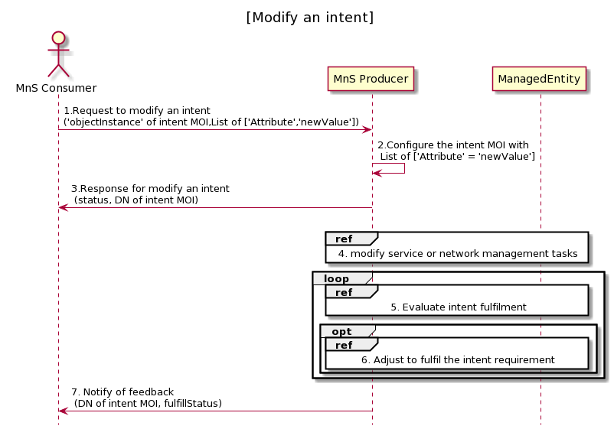
Figure 6.3.3-1 Procedure for modify an intent
- MnS Consumer sends a request to modify an intent intsnace to MnS Producer with ‘objectInstance’ of the intent MOI and List of [‘Attrribute’, ‘newValue’] to be modified. The detailed [Attribute,Value] see the concrete intent IOC defined in clause 6.2.
- Based on the request, MnS Producer configure the intent MOI with list of ‘Attribute’ = ’newValue’ which is required to be modified.
- MnS Producer sends a response to the MnS consumer with status (OperationSucceeded or OperationFailed), and ‘objectInstance’ of the modified intent MOI.. MnS Producer executes feasibility check and returns possible reasons for the unsuccessful executions (e.g., conflicting with other intents, the intent modify infeasible).
- MnS Producer derives one or more executable management tasks for these managed entities, then MnS producer deploys or configures corresponding managed entities to satisfy the intent.
- During the execution of intention, MnS producer continuously tracks intent fulfilment status.
- MnS producer analyses and adjusts the managed entities to ensure the intention is continuously satisfied.
- MnS Producer may notify MnS Consumer about the intent fulfilment information, including DN of intent MOI, and fulfillStatus.
NOTE： The intent fulfilment information can be sent via notification or intent reporting.

Third change

A.1.2 Modify an intent

@startuml
title "[Modify an intent]"
actor "MnS Consumer" as MnS_Consumer
participant "MnS Producer" as MnS_Producer
MnS_Consumer -> MnS_Producer: 1. Request to modify an intent\n(DN of intent MOI,List of ['Attribute','newValue'])
MnS_Producer -> MnS_Producer: 2. Configure the intent MOI with \n List of ['Attribute' = 'newValue']
MnS_Producer -> MnS_Consumer: 3. Response for modify an intent\n (status, DN of intent MOI, reason)

alt intent modification is feasible
Ref over MnS_Producer, ManagedEntity: 4. modify service or network management tasks
loop
Ref over MnS_Producer, ManagedEntity: 5. Evaluate intent fulfilment
opt
Ref over MnS_Producer, ManagedEntity: 6. Adjust to fulfil the intent requirement
end
end
MnS_Producer -> MnS_Consumer:7. Notify of feedback\n (DN of intent MOI, fulfillStatus)

hide footbox
@enduml

End of changes

