3GPP TSG-SA5 Meeting #141-e S5-221261rev1

e-meeting, 17 -26 January 2022

Source: AsiaInfo

Title: pCR TS 28.312 update clause 4.2.2 and clause 6.3.3

Document for: Approval

Agenda Item: 6.4.9

Decision/action requested
In this box give a very clear / short /concise statement of what is wanted.

2 References
[1] 3GPP draft TS 28.312: “Management and orchestration; Intent driven management services for mobile networks v0.7.0”.

3 Rationale
This contribution proposes to update the intent procedures:
- update clause 4.2.2 to align management capabilities with clause 6.3.
- add subsequence procedures in clause 6.3.3 after the intent MOI modified. The procedures include adding intent feasibility and conflict detection results in the response message, executing and monitoring the intent status, and notifying feedback to MnS Consumer.

4 Detailed proposal

First change

4.2.2 Intent driven MnS
Introduction of service-based architecture for 5G, in combination with functional model of business roles, exceeds the level of complexity for managing network in different scenarios (including scenarios for design/planning, deployment, maintenance and optimization) both in a single and multivendor network. New/simpler ways of managing are needed.
Actions of an intent driven MnS related to the fulfilment of intents may be categorized as intent deployment and intent assurance. Intent fulfilment refers to the steps taken to satisfy a newly received intent or an update to an existing intent. The goal of intent fulfilment is to bring the network or service’s state to satisfy the new or updated intent. The fulfilment of some intents may end at the intent deployment, the case, if the intent’s goal simply describes the availability or presence of a service. In other cases, the intent’s goal describes the assurance requirements for a network or service (e.g., quality of service, end user experience, SLS, etc.) in addition to the need of existence of a service. Those intents have their fulfilment tied to the operation of the referred service or network function and may require frequent recurring actions to keep those assurance requirements achieved. This part of the intent fulfilment is referred to as intent assurance.
An Intent driven MnS allows its consumer to express intents for managing the network and services and obtain the feedback of intent evaluation result. The Intent-driven MnS producer have the following capabilities:
- Validate the intent.
- Translate the received intent to executable actions as follows:
- Performing service or network management tasks
- Identifying, formulating and activating service or network management policies
- Evaluate the result/information about the intent fulfilment (e.g. the intent is initially satisfied or not) and intent assurance (e.g. the intent is continuously satisfied).
The following figure 4.2-1 shows the model of Intent-driven MnS.
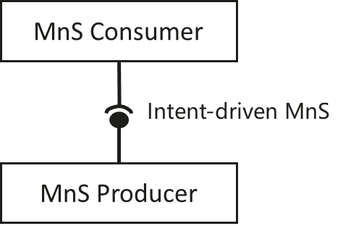
Figure 4.2-1: Intent-driven MnS
The intents may be fulfilled by utilizing multiple mechanisms including among others: Rule-based mechanisms, closed loop mechanisms and AI/ML based mechanisms. These mechanisms can be combined in solutions of various complexity, ranging from a simple approach rule-based mechanisms, to more elaborate solutions combining AI/ML, closed loop automation to ensure the fulfilment of intents.
When the intent is created on the MnS producer, the MnS producer may consume other management services (including non-intent driven MnS and intent driven MnS) to fulfil or satisfy the intent, e.g. creating new assurance closed control loop instance(s) or using assurance closed control loop instance ACCL instance(s) to satisfy the intent. The internal implementation of the intent fulfilment will however not be standardized.
An Intent driven MnS includes the following management capabilities to support intent lifecycle management:
- Create an intent, a MnS Consumer request to create a new intent on the MnS producer.

- Delete an intent, MnS Consumer request to remove an intent on the MnS producer.
- Modify an intent, MnS Consumer request to modify the content of the intent (e.g. optimization goal) on the MnS producer.
- Query an intent, MnS Consumer request to return the attribute and state (e.g. fulfillStatus and other status) of the intent on the MnS producer.

Second change

6.3.3 Modify an intent
The Figure 6.3.3-1 illustrates the procedure for modify an existing intent.

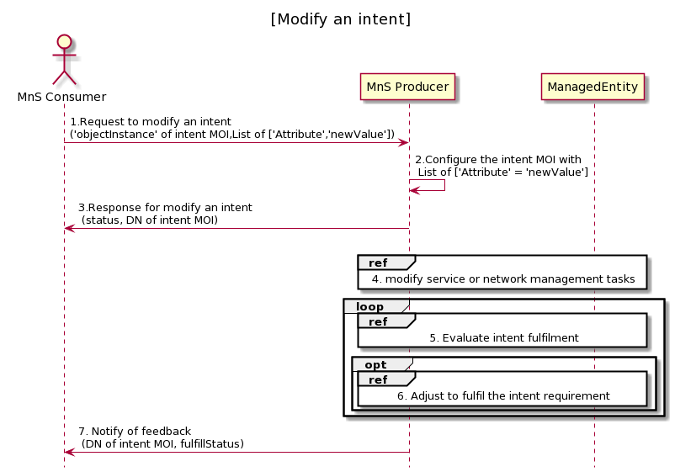
Figure 6.3.3-1 Procedure for modify an intent
- MnS Consumer sends a request to modify an intent intsnace to MnS Producer with ‘objectInstance’ of the intent MOI and List of [‘Attrribute’, ‘newValue’] to be modified. The detailed [Attribute,Value] see the concrete intent IOC defined in clause 6.2.
- Based on the request, MnS Producer configure the intent MOI with list of ‘Attribute’ = ’newValue’ which is required to be modified.
- MnS Producer sends a response to the MnS consumer with status (OperationSucceeded or OperationFailed), and ‘objectInstance’ of the modified intent MOI.. MnS Producer executes feasibility check and returns possible reasons for the unsuccessful executions (e.g., conflicting with other intents, the intent modify infeasible).
- MnS Producer derives one or more executable management tasks for these managed entities, then MnS producer deploys or configures corresponding managed entities to satisfy the intent.
- During the execution of intention, MnS producer continuously tracks intent fulfilment status.
- MnS producer analyses and adjusts the managed entities to ensure the intention is continuously satisfied.
- MnS Producer may notify MnS Consumer about the intent fulfilment information, including DN of intent MOI, and fulfillStatus.

Third change

A.1.2 Modify an intent

@startuml
title "[Modify an intent]"
actor "MnS Consumer" as MnS_Consumer
participant "MnS Producer" as MnS_Producer
MnS_Consumer -> MnS_Producer: 1. Request to modify an intent\n(DN of intent MOI,List of ['Attribute','newValue'])
MnS_Producer -> MnS_Producer: 2. Configure the intent MOI with \n List of ['Attribute' = 'newValue']
MnS_Producer -> MnS_Consumer: 3. Response for modify an intent\n (status, DN of intent MOI, reason)

alt intent modification is feasible
Ref over MnS_Producer, ManagedEntity: 4. modify service or network management tasks
loop
Ref over MnS_Producer, ManagedEntity: 5. Evaluate intent fulfilment
opt
Ref over MnS_Producer, ManagedEntity: 6. Adjust to fulfil the intent requirement
end
end
MnS_Producer -> MnS_Consumer:7. Notify of feedback\n (DN of intent MOI, fulfillStatus)

hide footbox
@enduml

End of changes

