3GPP TSG-SA5 Meeting #141-e S5-221258rev1

e-meeting, 17 -26 January 2022

Source: AsiaInfo, Alibaba Group

Title: Add new solution for MnS discovery service for exposure

Document for: Approval
Agenda Item: 6.5.2

Decision/action requested
In this box give a very clear / short /concise statement of what is wanted.

2 References
[1] 3GPP TR 28.824: " Study on network slice management capability exposure " V0.4.0

3 Rationale
This contribution proposes to add possible solutions for the use case – MnS discovery service for external customer.

4 Detailed proposal

First change

2 References
The following documents contain provisions which, through reference in this text, constitute provisions of the present document.
- References are either specific (identified by date of publication, edition number, version number, etc.) or non-specific.
- For a specific reference, subsequent revisions do not apply.
- For a non-specific reference, the latest version applies. In the case of a reference to a 3GPP document (including a GSM document), a non-specific reference implicitly refers to the latest version of that document in the same Release as the present document.
[1] 3GPP TR 21.905: "Vocabulary for 3GPP Specifications".
[2] TM Forum TMF622 Product Order API REST Specification
[3] TM Forum TMF641 Service Ordering API
[4] TM Forum TMF652 Resource Order Management API
[5] 3GPP TS 28.531: "Management and orchestration; Concepts, use cases and requirements"
[6] 3GPP TS 28.202: "Charging management; Network slice management charging in the 5G System (5GS); Stage 2"
[7] 3GPP TR23.700-99 “Study on Network Slice Capability Exposure for Application Layer Enablement (NSCALE)”

[8] 3GPP TS23.434 “Service Enabler Architecture Layer for Verticals (SEAL); Functional architecture and information flows.”
[9] 3GPP TS 28.541: "Management and orchestration; 5G Network Resource Model (NRM); Stage 2 and stage 3"
[10] 3GPP TS 28.537: "Management and orchestration; Management capabilities"
Second change

5.8.2.X Potential solution #2: MnS discovery service for exposure
An exposed MnS can be registered to a supported discovery system. The exposed MnS data can be accessed by different kinds of discovery service consumers based on different use causes.
In some use cases, the exposure usually goes through BSS. The BSS can obtain exposed MnS data from the MnS discovery service for external customer on behalf of the NSC.
There are different scenarios where the exposure without going through BSS. The NSC can access MnS discovery service providing discovery for the exposed MnS after authentication.
e
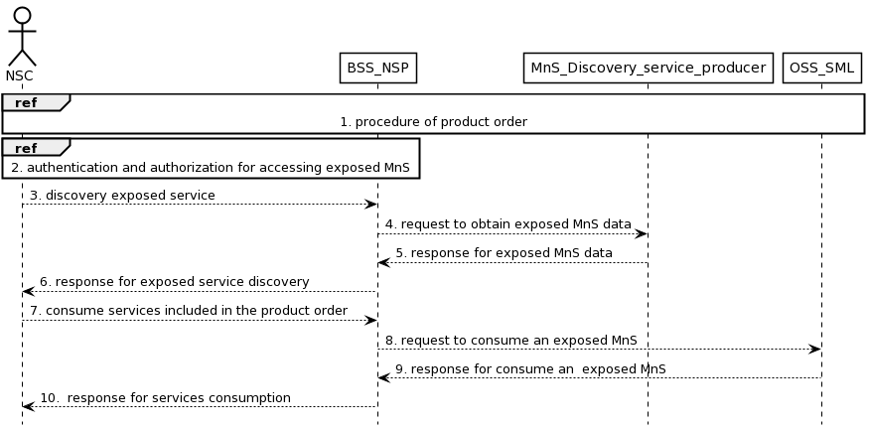
Figure 5.8.2.X.1 Procedure for MnS discovery for exposure via BSS
- The NSC completes the product order via the interaction with BSS_NSP.
- The NSC executes authentication and authorization to consume exposed MnS service.
- The NSC requests to discover the exposed MnS that has been ordered from BSS. The interface used towards the BSS is specified by TM Forum specifications [2].
- The BSS requests for exposed MnS data from the MnS discovery service for external customer on behalf of the NSC. The exposed MnS data may contain the address of the eMnS producer. The interface used towards the BSS is specified by TM Forum specifications [2].
NOTE: MnS discovery service producer providing discovery for the exposed MnS to external customer. The MnS discovery service producer for external customer can be internal or external of 3GPP management system.
- The MnS discovery service returns the exposed MnS data to BSS.
- The BSS returns the exposed MnS related discovery information to the NSC.
- The NSC starts using the services included in the product order.
- The BSS translates the product invocation into exposed MnS. A product invocation may contain multiple eMnSes. The BSS consumes the related exposed MnS to SML.
- SML returns the responses to BSS.
- The BSS notifies the responses to the NSC. The BSS may transtlate the responses into product description.

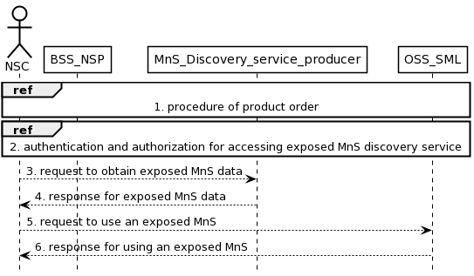
Figure 5.8.2.Y.1 Procedure for MnS service discovery for exposure without going through BSS
- The NSC completes the product order via the interaction with BSS_NSP. The NSC obtains the address of the MnS discovery service for external customer.
NOTE: MnS discovery service producer providing discovery for the exposed MnS to external. The MnS discovery service producer can be within the OSS or outside the OSS.
- The NSC executes authentication and authorization for accessing exposed MnS discovery service.
- The NSC requests for exposed MnS data from the MnS discovery service. The exposed MnS service data may contain the information of the eMnS instance and the address of the eMnS producer.
- The MnS discovery service returns the exposed MnS services data to the NSC.
- The NSC requests the services from the target exposed MnS producer.
- The target eMnS producer returns the responses, including the exposed MnS to the NSC.

5.8.3 Conclusion
The following issues are identified in the clause 5.8:
- The discovery of management services specified in TS 28.537 [10] should be updated to support the use case and requirement for MnS service exposure via BSS.
- The discovery of management services specified in TS 28.537 [10] should be updated to support the use case and requirement for MnS service exposure without going through BSS.

Third change

Annex A (informative):
Appendix with UML code of the sequence diagrams
A.X UML code for 5.8.2.X.1
@startuml
skinparam sequence {
ArrowColor Black
ActorBorderColor Black
ActorBackgroundColor White
ParticipantBorderColor Black
ParticipantBackgroundColor White
LifeLineBorderColor Black
BackGroundColor <<BSS_Prov>> Black
}
skinparam NoteBackgroundColor White
skinparam NoteBorderColor Black
skinparam shadowing false
hide footbox

actor NSC
participant BSS_NSP
participant MnS_Discovery_service_producer
participant OSS_SML

Ref over NSC, OSS_SML: 1. procedure of product order
Ref over NSC, BSS_NSP: 2. authentication and authorization for accessing exposed MnS
NSC --> BSS_NSP: 3. discovery exposed service
BSS_NSP --> MnS_Discovery_service_producer: 4. request to obtain exposed MnS data
MnS_Discovery_service_producer --> BSS_NSP: 5. response for exposed MnS data
BSS_NSP --> NSC: 6. response for exposed service discovery

NSC --> BSS_NSP: 7. consume services included in the product order
BSS_NSP ---> OSS_SML: 8. request to consume an exposed MnS
OSS_SML ---> BSS_NSP: 9. response for consume an exposed MnS
BSS_NSP --> NSC: 10. response for services consumption
@enduml

A.Y UML code for 5.8.2.Y.1
@startuml
skinparam sequence {
ArrowColor Black
ActorBorderColor Black
ActorBackgroundColor White
ParticipantBorderColor Black
ParticipantBackgroundColor White
LifeLineBorderColor Black
BackGroundColor <<BSS_Prov>> Black
}
skinparam NoteBackgroundColor White
skinparam NoteBorderColor Black
skinparam shadowing false
hide footbox

actor NSC
participant BSS_NSP
participant MnS_Discovery_service_producer
participant OSS_SML

Ref over NSC, OSS_SML: 1. procedure of product order
Ref over NSC, OSS_SML: 2. authentication and authorization for accessing exposed MnS discovery service

NSC --> MnS_Discovery_service_producer: 3. request to obtain exposed MnS data
MnS_Discovery_service_producer --> NSC: 4. response for exposed MnS data

NSC ---> OSS_SML: 5. request to use an exposed MnS
OSS_SML---> NSC: 6. response for using an exposed MnS
@enduml

End of changes

