3GPP TSG-SA5 Meeting #141-e S5-221246

Online, , 17th Jan 2022 - 26th Jan 2022
CR-Form-v12.1
CHANGE REQUEST
 | 28.531 | CR | 0100 | rev | - | Current version: | 17.2.0
For HELP on using this form: comprehensive instructions can be found at
http://www.3gpp.org/Change-Requests.

Proposed change affects: | UICC apps |  | ME |  | Radio Access Network | X | Core Network | X

Title: | TS 28.531 Add/Modify procedure of reservation of Network Slice/ Network Slice Subnet
Source to WG: | Nokia, Nokia Shanghai Bell
Source to TSG: | S5
Work item code: | eNETSLICE_PRO |  |  |  |  |  | Date: |  |  | 2022-01-07
Category: | B |  |  |  |  |  | Release: |  |  | Rel-17
 | Use one of the following categories:  F (correction)  A (mirror corresponding to a change in an earlier release)  B (addition of feature),  C (functional modification of feature)  D (editorial modification)  Detailed explanations of the above categories can  be found in 3GPP TR 21.900. |  |  |  |  |  |  |  | Use one of the following releases:  Rel-8 (Release 8)  Rel-9 (Release 9)  Rel-10 (Release 10)  Rel-11 (Release 11)  …  Rel-15 (Release 15)  Rel-16 (Release 16)  Rel-17 (Release 17)  Rel-18 (Release 18)
Reason for change: |  | The procedure for reservation of network slice / network slice subnet defined in clause 5.1.21 in TS 28.531 are not aligned with Network Slice Subnet feasibility check use case is described in clause 5.1.21 in TS 28.531. Also it is not clear for how to implement the network slice / network slice subnet reservation procedure.
Summary of change: |  | Update the procedure for reservation of network slice and network slice subnet resources.
Consequences if not approved: |  | Resource reservation procedure is not clear in the current 7.13 procedure and the procedure can not be implemented in a uniform way across the consumers/producers of different vendors.
Clauses affected: |  | 7.13
 |  | Y | N
Other specs |  |  | X | Other core specifications |  |  |  | TS/TR ... CR ...
affected: |  |  | X | Test specifications |  |  |  | TS/TR ... CR ...
(show related CRs) |  |  | X | O&M Specifications |  |  |  | TS/TR ... CR ...
Other comments:
This CR's revision history:

1st Change

7.13 Procedure of reservation and checking feasibility of NSI
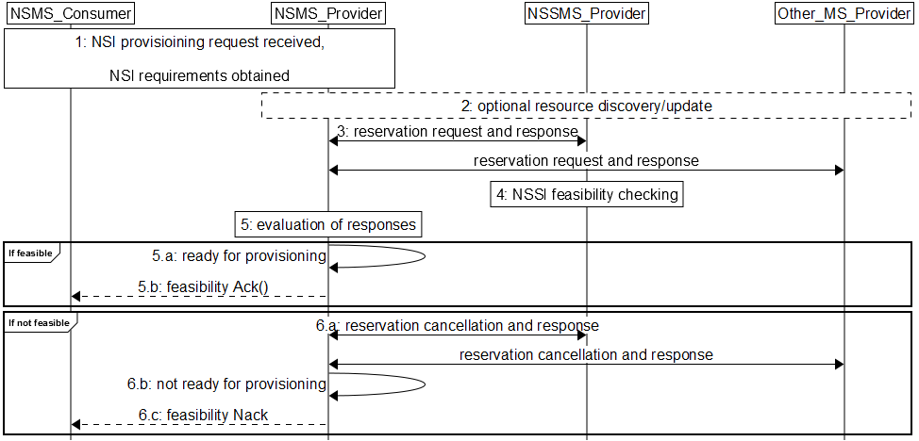
Figure 7.13-1 Network slice feasibility check procedure
- Network Slice Management Service Provider (NSMS_Provider) receives a provisioning NSI request (e.g., AllocateNsi request (see AllocateNsi operation defined in clause 6.5.1), ModifyNsi request (see modifyMOIAttributes operation defined in TS 28.532 [8])) from Network Slice Management Service Consumer (NSMS_Consumer) with network slice related requirements (e.g. Area information, User Number, traffic demand, QoS Quality, whether the requested network slice instance could be shared). Besides NSI requirements, it also contains the provisioningPriority attribute, which indicates to NSMS_Providers and NSSMS_Providers the priority of the provisioning request (cf. step 8).

2. The NSMS_Provider receiving the NSI provisioning request may optionally determine the estimated maximum duration of the complete NSI provisioning procedure
2) [Optional] NSMS_Provider may request information and updates from Network Slice Management Function _Provider and Other_MS_Provider regarding the resources.
3) NSMS_Provider sends reservation requests to Network Slice Subnet Management Service Provider (Network Slice Management Function _Provider) and (if needed) Other Management Service Providers (Other_MS_Provider), e.g., MANO, TN manager. NSMS_Provider receives responses with information regarding allocated resources, e.g., their availability, identification information of reserved resources and so on.This request may contain a timestamp indicating the requested earliest expiration of the reservation request (“requestedMinExpiration”), which is based on the estimation from step 2. The expectation or wish is that all constituent management services reserve the required resources at least until the requestedMinExpiration timestamp during the provisioning operation transaction, before it is committed by NSI activation procedure.

4) A reservation request to Network Slice Management Function _Provider can trigger NSSI feasibility checking. The MS_Providers may indicate in their response an expiration timestamp (“reservationExpiration”). This indicates the maximum time period, which the MS_Provider will reserve the resources before they must be committed (the provisioning process must be completed). In other words, the MS_Provider service will guarantee the reserved resources only until reservationExpiration and if the provisioning/allocation process is not completed by then, may free or allocate them for other use. If a request to complete the provisioning/allocation comes after reservationExpiration and the reserved resources have already been freed, the responding management service shall reject the request. In case the feasibility check and resource reservation process contain also nested constituent MS_Providers, the MS_Provider needs to consider also their potential reservationExpiration and choose the earliest expiration time for its response. In general, the MS_Provider should consider the requestedMinExpiration timestamp in the request but note that the response expiration timestamp reservationExpiration may differ from requestedMinExpiration i.e., it may be either before or after the timestamp given in the request.
The expiration timestamps reservationExpiration from the feasibility check and resource reservation responses are collected by the NSMS_Provider. It determines the earliest expiration timestamp from constituent MS_Providers and, Optionally, it may inform the MS_Providers for the constituent NSSIs about the earliest reservationExpiration so that they can adapt (i.e., shorten) their reservation.

5) NSMS_Provider evaluates the responses to determine if the network slice requirements can be satisfied.
6) If feasible,
6.a) If the NSMS_Provider is ready for provisioning, it sends a feasiblity Ack message to the NSMS_Consumer, including the reservationExpiration timestamp, indicating how long the resources reserved for the NSI to be provisioned are available, i.e., until the operation needs to be committed (completed).
6.b) [Optional] Acknowledgement regarding reservation check results can be sent to NSMS_Customer.
7) If not feasible,
7.a) NSMS_Provider cancels reservations, optionally may receive acknowledgement.
7.b) NSMS_Provider is not ready for provisioning. It sends a resource reservation cancellation message to constituent MS_Providers and they free the resources reserved for the NSI
7.c) NSMS_Provider may send negative acknowledgement regarding results of reservation check to NSMS_Customer.
8) If at any point during the actual provisioning/reservation checking, if one of the constituent MS_Providers wants to withdraw and free the resources reserved for the provisioning operation before the validity period defined by reservationExpiration ends, an additional constituent reservation cancellation that can be sent by a constituent MS_Provider. The cancellation may be either effective immediately or may indicate a new, updated reservationExpiration value. This could be, for example, used in a pre-emptive case, where an urgent higher priority provisioning request needs to be prioritized over the current one
Another case requiring cancellation might be unexpected failures in the constituent Network Slice Subnet resources reservation. In any case, the receiving NSMS_provider (or a parent NSSMS_Provider) shall evaluate the impact on the feasibility of the Network Slice (or Network Slice Subnet resources availability). If the Network Slice is not feasible anymore, the NSMS_Consumer will be notified with a feasibility Nack message and remaining reservations for constituent Network Slice Subnet(s) are cancelled.

