3GPP TSG-SA5 Meeting #141-e S5-221244rev1

Online, , 17th Jan 2022 - 26th Jan 2022
CR-Form-v12.1
CHANGE REQUEST
 | 28.622 | CR | Draft CR | rev | - | Current version: | 17.0.0
For HELP on using this form: comprehensive instructions can be found at
http://www.3gpp.org/Change-Requests.

Proposed change affects: | UICC apps |  | ME |  | Radio Access Network | X | Core Network | X

Title: | Rel-17 Input to DraftCR 28.622 Add file download NRM fragment
Source to WG: | Nokia, Nokia Shanghai Bell
Source to TSG: | SA5
Work item code: | FIMA |  |  |  |  |  | Date: |  |  | 2022-01-07
Category: | B |  |  |  |  |  | Release: |  |  | 17
 | Use one of the following categories:  F (correction)  A (mirror corresponding to a change in an earlier release)  B (addition of feature),  C (functional modification of feature)  D (editorial modification)  Detailed explanations of the above categories can  be found in 3GPP TR 21.900. |  |  |  |  |  |  |  | Use one of the following releases:  Rel-8 (Release 8)  Rel-9 (Release 9)  Rel-10 (Release 10)  Rel-11 (Release 11)  …  Rel-15 (Release 15)  Rel-16 (Release 16)  Rel-17 (Release 17)  Rel-18 (Release 18)
Reason for change: |  | Requirements for file download were agreed at SA5#138. This contribution proposes the corresponding file download control NRM fragment.
Summary of change:
Consequences if not approved: |  | The WI FIMA cannot progress.
Clauses affected:
 |  | Y | N
Other specs |  |  | X | Other core specifications |  |  |  | TS/TR ... CR ...
affected: |  |  | X | Test specifications |  |  |  | TS/TR ... CR ...
(show related CRs) |  |  | X | O&M Specifications |  |  |  | TS/TR ... CR ...
Other comments: |  | Baseline DraftCR for FIMA: S5-214758
This CR's revision history:

First modification

4.2 Class diagrams

4.2.1 Relationships
This clause depicts the set of classes (e.g. IOCs) that encapsulates the information relevant for this IRP. This clause provides the overview of the relationships of relevant classes in UML. Subsequent clauses provide more detailed specification of various aspects of these classes.
The following figure shows the containment/naming hierarchy and the associations of the classes defined in the present document. See Annex A of a class diagram that combines this figure with Figure 1 of [2], the class diagram of UIM.
NOTE 1: ManagedElement may be contained either
- in a SubNetwork (since SubNetwork inherits from Domain_ and ManagedElement inherits from ManagedElement_ and Domain_ name-contained ManagedElement_ as observed in the figure of Annex A) or
- in a MeContext instance as observed by the above figure or in the figure of Annex A.
This either-or relation cannot be shown by using an {xor} constraint in the above figure.
ManagedElement may also have no parent instance at all.
NOTE 2: Void
NOTE 3: If the configuration contains several instances of SubNetwork, exactly one SubNetwork instance shall directly or indirectly contain all the other SubNetwork instances.
NOTE 4: The SubNetwork instance not contained in any other instance of SubNetwork is referred to as "the root SubNetwork instance".
NOTE 5: ManagementNode shall be contained in the root SubNetwork instance.
NOTE 6: If contained in a SubNetwork instance, MnsAgent shall be contained in the root SubNetwork instance.
NOTE 7: For a clarification on the choice of containment of the IRPAgent (since it has three possible parents), see the definition of MnsAgent.
NOTE 8: The MnsAgent shall be replaced by the IRPAgent in deployments using the IRP framework as defined in TS 32.102 [2].

Figure 4.2.1-1: NRM fragment
Each Managed Object is identified with a Distinguished Name (DN) according to 3GPP TS 32.300 [13] that expresses its containment hierarchy. As an example, the DN of a ManagedElement instance could have a format like:
SubNetwork=Sweden,MeContext=MEC-Gbg-1,ManagedElement=RNC-Gbg-1.

NOTE 8: Void
NOTE 9: Void
Figure 4.2.1-2: Vendor specific data container NRM fragment

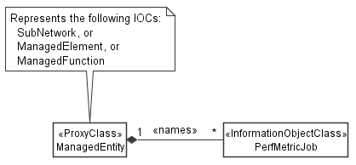

Figure 4.2.1-3: PM control NRM fragment

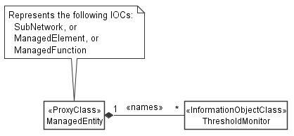
Figure 4.2.1-4: Threshold monitoring control NRM fragment

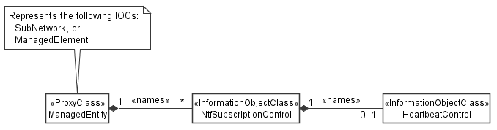
Figure 4.2.1-5: Notification subscription and heartbeat notification control NRM fragment

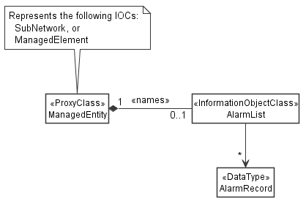
Figure 4.2.1-6: FM control NRM fragment

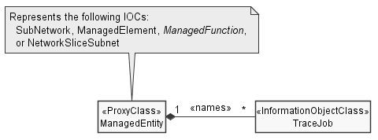
Figure 4.2.1-7: Trace control NRM fragment

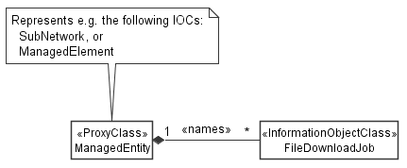
Figure 4.2.1-9: File download NRM fragment

4.2.2 Inheritance

This clause depicts the inheritance relationships.

Figure 4.2.2-1: NRM fragment

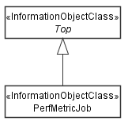

Figure 4.2.2-2: PM control NRM fragment

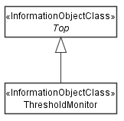

Figure 4.2.2-3: Threshold monitoring control NRM fragment

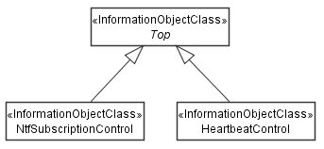

Figure 4.2.2-4: Notification subscription and heartbeat notification control NRM fragment

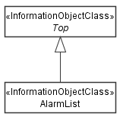
Figure 4.2.2-5: FM control NRM fragment

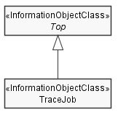
Figure 4.2.2-6: Trace control NRM fragment

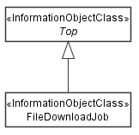
Figure 4.2.2-8: File download NRM fragment

Next modification

4.3.A FileDownloadJob

4.3.A.1 Definition
The "FileDownloadJob" represents a job on a MnS producer that downloads a file from a specified location to the MnS producer. It can be name-contained by "ManagedElement" or "SubNetwork".
A "FileDownloadJob" is created by a MnS consumer on a MnS producer. The creation requests the MnS producer to download a file from a specified location to the MnS producer.
The creation request contains the information required by the MnS producer to download the file, namely the attribute "fileLocation", and the file properties "fileCompression" and "fileSize".
The creation request may contain a "notificationRecipientAddress". If present, this attribute instructs the MnS producer to create, on behalf of the MnS consumer, a subscription for attribute value change notifications of the new "FileDownloadJob" (implicit notification subscription). In case the MnS producer supports the notification type "notifyMOIChanges", the created subscription shall be for this type, otherwise for "notifyMOIAttributeValueChanges". The MnS consumer needs to be prepared to receive either of them. The "notificationRecipientAddress" attribute of the created "NtfSubscriptionControl" object shall be set to the value of the "notificationRecipientAddress" in the "FileDownloadJob" creation request.
To cancel a file download, the MnS consumer shall set the "cancel" attribute to "TRUE". Cancellation is possible in the "NOT_STARTED" and "RUNNING" state. The MnS producer shall set the "status" attribute to "CANCELLING", and update it to "CANCELLED" once the job has been cancelled. It is also possible to specify the maximum duration of the file download in the job creation request with the "maxDuration" attribute. If specified, the MnS producer shall set the "cancel" attribute to "TRUE" when the time specified by "MaxDuration" elapses since the creation of the job.
Upon completion of the file download, i.e. when the staus is equal to "SUCCESS", "FAILURE" or "CANCELLED", the MnS consumer shall delete the "FileDownloadJob". When not deleted, the MnS producer may delete the "FileDownloadJob" as well after some time.
The attribute "progressMonitor" is provided for monitoring the progess of the file download job in a general manner independent from details of the file transfer protocol. It is not included in the "FileDownloadJob" creation request but added by the MnS producer to the "FileDownloadJob" instance upon its creation. The attribute is updated by the MnS producer as the file download progresses.

4.3.A.2 Attributes
Attribute name | S | isReadable | isWritable | isInvariant | isNotifyable
operationalState | M | T | F | F | T
administrativeState | M | T | T | F | T
fileLocation | M | T | T | T | F
fileCompression | M | T | T | T | F
fileSize | O | T | T | T | F
maxDuration | O | T | T | T | F
notificationRecipientAddress | O | T | T | T | F
cancel | M | T | T | F | T
progressMonitor | M | T | F | F | T

4.3.A.2a Attribute definitions
Attribute Name | Documentation and Allowed Values | Properties
fileLocation | Location of the file.  AllowedValues: N/A | Type: String  multiplicity: 1  isOrdered: N/A  isUnique: N/A  defaultValue: None  isNullable: False
fileCompression | Name of the algorithm used for compressing the file. An empty or absent "fileCompression" attribute indicates the file is not compressed.  AllowedValues: N/A | Type: String  multiplicity: 1  isOrdered: N/A  isUnique: N/A  defaultValue: None  isNullable: False
fileSize | Size of the file in bytes.  AllowedValues: Non-negative integer | Type: Integer  multiplicity: 1  isOrdered: N/A  isUnique: N/A  defaultValue: None  isNullable: False
maxDuration | Maximum duration of the file download job in minutes, i.e. the maximum time the "RUNNING" state can prevail until the MnS producer cancels the job automatically.  Unit is minutes.  AllowedValues: N/A | Type: Integer  multiplicity: 1  isOrdered: N/A  isUnique: N/A  defaultValue: None  isNullable: False
notificationRecipientAddress | Notification recipient address for implicit notification subscription.  AllowedValues: N/A | Type: String  multiplicity: 1  isOrdered: N/A  isUnique: N/A  defaultValue: None  isNullable: False
cancel | Setting this attribute to "TRUE" cancels a running file download job. Cancellation is possible in the "NOT_STARTED" and "RUNNING" state. Setting the attribute to "FALSE" has no observable result.  AllowedValues: TRUE, FALSE | Type: ENUM  multiplicity: 1  isOrdered: N/A  isUnique: N/A  defaultValue: FALSE  isNullable: False
progressMonitor | Provides monitoring of the progress for the file download job.  AllowedValues: N/A | Type: ProgressMonitor  multiplicity: 1  isOrdered: N/A  isUnique: N/A  defaultValue: None  isNullable: False

4.3.A.3 Attribute constraints
None.

4.3.A.4 Notifications
The common notifications defined in clause 4.5 are valid for this IOC, without exceptions or additions.

4.3.B ProgressMonitor <<dataType>>

4.3.B.1 Definition
This datatype provides attributes to monitor the progress of a job. The current state is described by the "status" and "progressPercentage" attributes. When the associated job is created, the "status" is set to "NOT_RUNNING" and the "progressPercentage" to "0". The MnS producer decides when to start exceting the job and transition into the "RUNNING" state. In case the job is cancelled, the "status" attribue is first set to "CANCELLING" and when the job is really cancelld to "CANCELLED".
If the "administrativeState" is set to "LOCKED" or the "operationalState" is set to "DISABLED" in the "NOT_STARTED" or "RUNNING" state, the "status" attribute changes to "SUSPENDED" and execution of the job stops until the "adminsitrativeState" is set back to "UNLOCKED or the "operationalState" is set back to "ENABLED". In the "SUCCESS", "FAILURE" or "CANCELLED" state, modifying the "administrativeState" or "operationalState" has no observable result.

4.3.B.2 Attributes
Attribute name | S | isReadable | isWritable | isInvariant | isNotifyable
status | M | T | F | F | T
progressPercentage | O | T | F | F | T
startTime | O | T | F | F | T
endTime | O | T | F | F | T
failureReason | M | T | F | F | T
timer | O | T | F | F | F
additionalText | O | T | F | F | T

4.3.B.2a Attribute definitions
Attribute Name | Documentation and Allowed Values | Properties
status | Status of the file download process.  allowedValues:  - NOT_STARTED  - RUNNING  - SUSPENDED  - CANCELLING  - SUCCESS  - FAILURE  - CANCELLED | Type: ENUM  multiplicity: 1  isOrdered: N/A  isUnique: N/A  defaultValue: None  isNullable: False
progressPercentage | Indicates how many percent of the file is already downloaded.  Allowed values:  integer between 0 and 100 with increments of 5 | Type: Integer  multiplicity: 1  isOrdered: N/A  isUnique: N/A  defaultValue: None  isNullable: False
startTime | Start time of the file download process, i.e. the time when the status changed from "NOT_STARTED" to "RUNNING".  allowedValues: N/A  Editor's note: It is tbd if this attribute should be nullable. | Type: DateTime  multiplicity: 1  isOrdered: N/A  isUnique: N/A  defaultValue: None  isNullable: False
endTime | End time of the file download process, i.e. the time when the status changed from "RUNNING" to "SUCCESS", "FAILURE" or "CANCELLED". If the time is in the future, it is the estimated time the job will end.  allowedValues: N/A  Editor's note: It is tbd if this attribute should be nullable. | Type: DateTime  multiplicity: 1  isOrdered: N/A  isUnique: N/A  defaultValue: None  isNullable: False
failureReason | Failure reason, present when the file download failed and "status"="FAILURE". Otherwise, the attribute shall be absent or carry the "NULL" value.  allowedValues:  - NULL  - UNKNOWN  - NO_STORAGE  - LOW_MEMROY  - NO_CONNECTION_TO_REMOTE_SERVER  - FILE_NOT_AVAILABLE  - DNS_CANNOT_BE_RESOLVED  - OTHER | Type: ENUM  multiplicity: 1  isOrdered: N/A  isUnique: N/A  defaultValue: None  isNullable: True
additionalText | Additional textual information about the progress of the file download job.  allowedValues: N/A | Type: String  multiplicity: 1  isOrdered: N/A  isUnique: N/A  defaultValue: None  isNullable: False
timer | Time until the associated job is automatically cancelled by the MnS producer. The system decreases the "timer" with time. When it reaches zero, the cancellation of the job is initiated. The start value of the "timer" is provided in the job creation request ("maxDuration") and set to this value upon creation of the job. If not provided in the job creation request, this attribute is absent and there is no time limit for the job.  Unit is minutes.  allowedValues: N/A | Type: Integer  multiplicity: 1  isOrdered: N/A  isUnique: N/A  defaultValue: None  isNullable: False

4.3.B.4 Notifications
The common notifications defined in clause W4.5 are not valid for this IOC. The set of notifications defined in the following table is valid.
Name | S | Notes
notifyMOICreation | M
notifyMOIDeletion | M
notifyMOIAttributeValueChanges | M
notifyMOIChanges | M

Editor's note: This contribution does not follow the agreed NRM template in 3GPP TS 32.156. It is based instead on an alternative for NRM fragments that is currently under discussion. Based on the outcome of this discussion this contribution needs to be updated.
End of modifications

