3GPP TSG-SA5 Meeting #141e S5-221213

e-meeting, 17 - 26 January 2022

Source: Huawei

Title: pCR 28.819 update CICD chain description

Document for: Approval

Agenda Item: 6.5.3

1 Decision/action requested
The group is asked to discuss and agree on the proposal.

2 References
[1] TR 28.819 v 0.4.0 Management and orchestration; Study on continuous integration continuous delivery support for 3GPP NFs

3 Rationale
Update the description in clause 5.2 to align with the figure related to CI-CD chain.

4 Detailed proposal
It is proposed to apply following changes in [1].

1st modified section

5.2 Single and Multiple NF Suppliers CI-CD

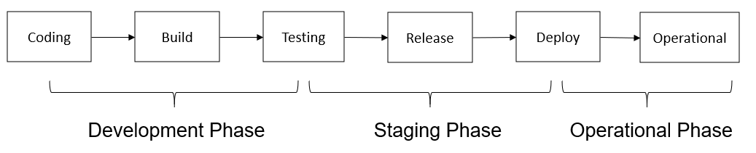
Figure 1 Typical CI-CD Chain
A typical CI-CD chain consists of several stages as shown in Figure 1: Development Phase, Staging Phase and Operational Phase. Starting from the Development Phase, the developers write the software of the NF, and the test code used to test the NF. When the software is finished and committed, the CI-CD tool will automatically trigger the building and testing. At the step of testing, the integrity of software artifacts is checked and the functional/non-functional acceptance testing are performed. At the staging phase, the software which passes all the tests will be release to the operational environment. At the Operational phase, the software is deployed in the production environment with the real traffic/user load. The software delivered in such typical CI-CD chain is usually provided by a single supplier.
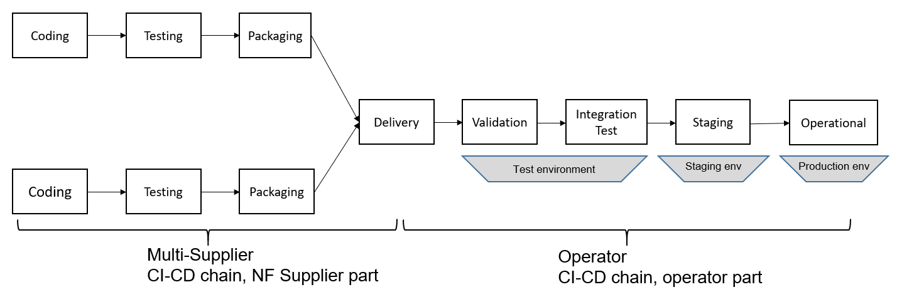
Figure 2 Multiple NF supplier to single operator
In telco environments (see Figure 2), the coding, initial testing and package part of the CI-CD chain is typically at the vendor premises, and the validation, integration testing and deployment part is at the operator part. The CI-CD tools used in the operator part is responsible for fetching delivered artifacts, triggering tests, collecting test results and data, deploying software to staging/production environment, collecting operational data and sending feedback to the vendor.

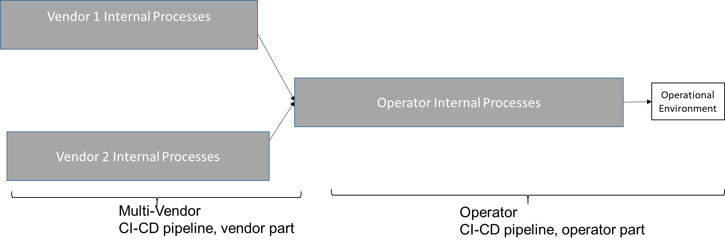
Figure 3: Vendor and Operator internal processes
As shown in Figure 3, the vendor internal CI-CD process can be vender specific, which may include coding, testing, packaging . Additionally, an operator receives software artifacts (for 3GPP NFs) from multiple vendors , and then follows its own internal CI-CD procedures (see Figure 3) as a part of the CI-CD chain before deploying the NF to an operational platform. The internal processes of the NF delivery process are not a subject of standardization and are therefore not considered in this study.

