3GPP TSG-SA5 Meeting #141-e S5-221199r01

e-meeting, 17 - 26 January 2022

Source: Alibaba

Title: Resolving the acquisition of operator’s MIB EN

Document for: Approval
Agenda Item: 6.5.2

1 Decision/action requested
The group is asked to agree the text in detailed proposal.

2 References
Not applicable

3 Rationale
This contribution proposes to address the EN for the acquisition of Operator’s MIB EN in clause 4.1.1.4.
Editor’s notes: Whether and how does the external customer obtain the copy of a part of the operator’s MIB is FFS.
The copy of a part of the Operator’s MIB can be obtained when the external customer negotiates contract with the NSP or CSP via BSS. S5-221196 proposes the solution for solving this EN. The Operator’s MIB can be carried by the service order completed and product order completed messages during the product ordering procedure. The customer can get the Operator’s MIB information via the reception of product order completed message.

4 Detailed proposal

First change

4.1.1.4 Exposure without going through BSS

4.1.1.4.1 General
Exposure of service data to companies that are external to the operator are regulated by contracts. The exposure usually goes through BSS, as explained in clause 4.1.1.2. However, based on specific contract, the customer may interact with the Operator without going through BSS. There are different scenarios for how a customer having such contract interacts with Operator for the network slice management capability exposure.

4.1.1.4.2 Exposure scenarios
Scenario 1: The NOP and NSP belong to the same Operator. The OSS/SML and OSS/NML are connected via internal interface. The external customer has an external interface with the NSP based on the contract between the external customer and NSP.
NOTE 1: External customer may have connection with NSP BSS for the product-level interaction. If not, the OSS/SML may have an embedded BSS functionalities for the product-level interaction.
NOTE 2: The Company-B BSS connects to the BSS part of external customer and the Company-B OSS/SML connect to the OSS/SML part of external customer.
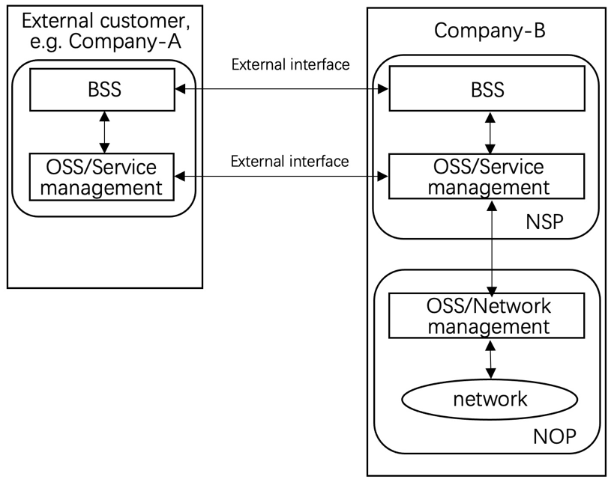
Figure 4.1.1.4.2-1 NSP OSS/SML to customer being an external interface

Scenario 2: The NOP may interface to an external NSP that has a contract with NOP for the exposure directly via OSS. The NOP’s OSS/SML have a direct machine to machine interface with the NSP’s OSS/SML. The external customer has an external interface with the NSP OSS/SML based on the contract between external customer and NSP.
NOTE 3: External customer may have connection with NSP BSS for the product-level interaction. If not, the NSP OSS/SML may have an embedded BSS functionalities for the product-level interaction.
NOTE 4: If the external customer can get access to the OSS directly, it must maintain a copy of a part of the operator’s MIB. if the customer wants to e.g. receive alarms or performance measurements or KPIs related to the network slice the customer has ordered to the NSP, these alarms / perf. meas / KPIs need to relate to some MOIs known at customer side. All these MOIs shall be part of a containment tree in the copy of the Operators’ MIB maintained by the customer.

NOTE 5: The Company-B BSS connects to the BSS part of external customer and the Company-B OSS/SML connect to the OSS/SML part of external customer.
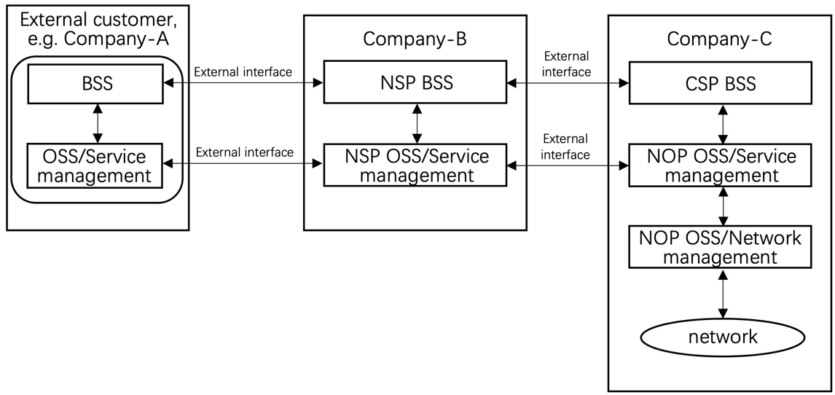
Figure 4.1.1.4.2-2 NOP OSS/SML to NSP OSS/SML interface being an external interface
Scenario 3: The NOP OSS/SML may interface to an external NSP OSS/SML based on the contract between the two parties. The "External NSP OSS/SML" has internal interface with NSP BSS. The NSP might have a machine to machine interface towards their customer (e.g. a vertical) via their BSS.
NOTE 6: External customer may have connection with BSS for the product-based interaction. If not, the NSP OSS/SML may have an embedded BSS functionalities for the product-based interaction.
NOTE 7: If the external customer can get access to the OSS directly, it must maintain a copy of a part of the operator’s MIB. if the customer wants to e.g. receive alarms or performance measurements or KPIs related to the network slice the customer has ordered to the NSP, these alarms / perf. meas / KPIs need to relate to some MOIs known at customer side. All these MOIs shall be part of a containment tree in the copy of the Operators’ MIB maintained by the customer.

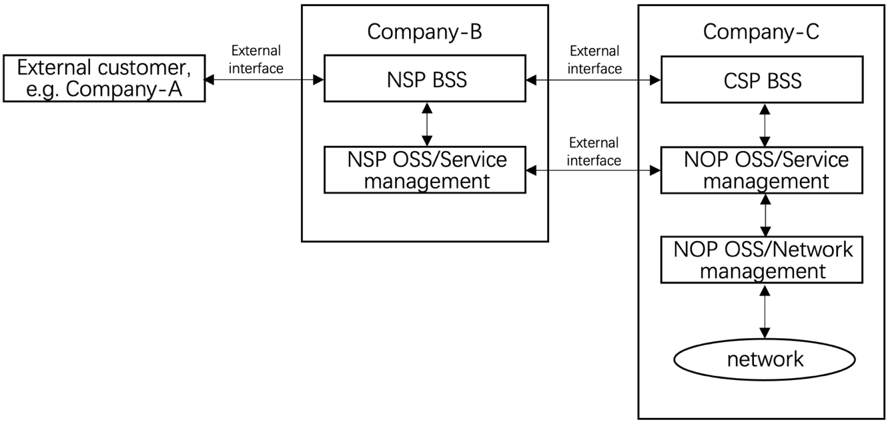
Figure 4.1.1.4.2-3 NOP OSS/SML to NSP OSS/SML being an external interface, NSP BSS to customer being an external interface
End of changes

