**3GPP TSG-SA5 Meeting #141-eS5-221196r02**

**e-meeting, 17 - 26 January 2022**

**Source: Alibaba**

**Title: Key issue and solution on exposure without going through BSS**

**Document for: Approval**

**Agenda Item: 6.5.2**

# 1 Decision/action requested

***The group is asked to agree the text in detailed proposal.***

# 2 References

Not applicable

# 3 Rationale

This contribution proposes key issue and solution on exposure without going through BSS.

# 4 Detailed proposal

|  |
| --- |
| **First change** |

## 5.11 Key Issue #11: Network slice management capability exposure without going through BSS

### 5.11.1 Description

Use cases regarding exposure without going through BSS has been introduced in Section 6. NSC can make contract with the NSP or CSP regarding expsoure via BSS. Upon the completion of the contact, the NSC can directly get access to the OSS within the NSP or CSP for access the exposed MnS. Several key issues exist for the use cases. For example, how does the NSC identifies the address of MnF within the OSS for accessing exposed MnS needs to be addressed. In addition, how does the NSC obtains the copy of a part of the Operator’s MIB also needs to be addressed.

### 5.11.2 Potential solutions

#### 5.11.2.1 Potential solution #1: Exposed MnS consumption without going through BSS

This clause introduces the solution for the use case where only NSP is involved and the use case where the NSP has BSS and need to leverage the CSP OSS to provide exposed MnS for the NSC.

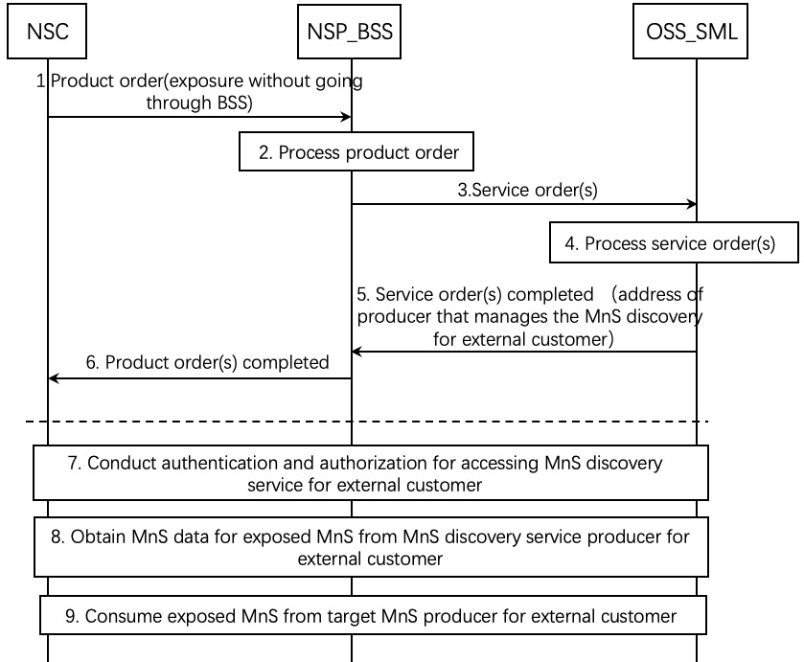

Figure 5.11.2.1-1 Exposed MnS consumption without going through BSS

1. The NSP receives a product order from the NSC through BSS. The interface used towards the BSS is specified by TM Forum specifications [2]. The product order may contain the agreement between NSC and NSP that exposed MnSs can exposed directly from OSS_SML.

2. The BSS processes the product order and when applicable converts it to appropriate service order(s) for the OSS Service Management Layer. This is internal to BSS and there are no interface requirements.

3. The OSS Service Management Layer receives a service order from the BSS. The interface used is specified by TM Forum specifications [3].

4. The MnS producer for external customer on the OSS Service Management Layer processes the service order and when applicable converts it to appropriate request(s) for the OSS Network Management Layer as requests for management and orchestration of resources. In addition, MnS producer on the OSS Service Management Layer identifies the product order is for exposure directly from OSS_SML and prepares the address of MnS discovery service producer for external customer that can be accessed by the NSC and related token information for accessing the MnS discovery service for external customer. The service order may trigger a procedure of resource order with OSS_NML.

5. The MnS producer for external customer on OSS Service Management Layer notifies the BSS that the service order has been completed. In addition, the notification may contain the address of producer that manages the MnS discovery service for external customer for the NSC to access and also a copy of a part of Operator’s MIB which is related to the exposed MnSs that the NSC requests. The interface used is specified by TM Forum specifications [3].

NOTE: The MnS discovery service producer for external customer can be within the OSS or outside the OSS.

6. The BSS notifies the NSC that the product order has been completed. In addition, the address of MnS discovery producer for external customer and the related token information for accessing the MnS discovery service for external customer are sent to the NSC by the product order completed messge. The interface used the interface towards the BSS is specified by TM Forum specifications [2].

7. If the notification in step 8 contains the address of MnS discovery service producer for external customer, the NSC conduct authentication and authorization for accessing exposed MnS discovery service.

8. After the authentication and authorization, the NSC obtains the exposed MnS data, which contains the information of the exposed MnS instance and the address of target MnS producer for external customer.

9. After obtaining the information of the exposed MnS data, the NSC identifies the target MnS producer for external customer (e.g. EGMF) and consumes the exposed MnS.

|  |
| --- |
| **End of changes** |