3GPP TSG-SA5 Meeting #141-e S5-221191rev2

E-meeting, 17-26 January 2022
CR-Form-v11.4
CHANGE REQUEST
 | 28.541 | CR | 0659 | rev | - | Current version: | 17.5.0
For HELP on using this form: comprehensive instructions can be found at
http://www.3gpp.org/Change-Requests.

Proposed change affects: | UICC apps |  | ME |  | Radio Access Network | X | Core Network

Title: | Rel-17 CR 28.541 Add C-SON CCO NRM model stage2
Source to WG: | Huawei
Source to TSG: | S5
Work item code: | eSON_5G |  |  |  |  |  | Date: |  |  | 2021-11-05
Category: | B |  |  |  |  |  | Release: |  |  | Rel-17
 | Use one of the following categories:  F (correction)  A (mirror corresponding to a change in an earlier release)  B (addition of feature),  C (functional modification of feature)  D (editorial modification)  Detailed explanations of the above categories can  be found in 3GPP TR 21.900. |  |  |  |  |  |  |  | Use one of the following releases:  Rel-8 (Release 8)  Rel-9 (Release 9)  Rel-10 (Release 10)  Rel-11 (Release 11)  Rel-12 (Release 12)  Rel-13 (Release 13)  Rel-14 (Release 14)  Rel-15 (Release 15)  Rel-16 (Release 16)
Reason for change: |  | To support CCO use case in TS 28.313 [57], this contribution proposes to add CCOFunction.
Summary of change: |  | Add NRM fragment for CCO Management and Inheritance Hierarchy.  Add CCOFunction and related data type including CCOPolicy, CCOPolicyAction, and ParameterInfo
Consequences if not approved: |  | Cannot support CCO use case in TS 28.313 [57].
Clauses affected: |  | 4.2.1.1, 4.2.1.2, 4.3.X (new), 4.3.Y (new), 4.4.1
 |  | Y | N
Other specs |  |  | X | Other core specifications |  |  |  | TS/TR ... CR ...
affected: |  |  | X | Test specifications |  |  |  | TS/TR ... CR ...
(show related CRs) |  | X |  | O&M Specifications |  |  |  | TS/TR 28.313 CR 0040
Other comments:

1st Change

4.2.1.1 Relationships
This clause depicts the set of classes (e.g. IOCs) that encapsulates the information relevant for this gNB and en-gNB. For the UML semantics, see 3GPP TS 32.156 [43]. Subsequent clauses provide more detailed specification of various aspects of these classes.
The model fragments are for management representation of gNB and en-gNB for all NG-RAN deployment scenario as listed below.
- Non-split NG-RAN deployment scenario, represents the gNB defined in TS 38.401[4]. In this scenario, a gNB is represented by a combination of a GNBCUCPFunction, one or more GNBCUUPFunctions and one or more GNBDUFunctions.
- 2-split NG-RAN deployment scenario, represents the gNB consist of gNB-CU and gNB-DU defined in TS 38.401[4] clause 6.1.1. In this scenario, a gNB-CU is represented by a combination of a GNBCUCPFunction and one or more GNBCUUPFunctions, whereas a gNB-DU is represented by a GNBDUFunction.
- 3-split NG-RAN deployment scenario, represents the gNB consist of gNB-CU-CP, gNB-CU-UP and gNB-DU defined in TS 38.401[4] clause 6.1.2. In this scenario, a gNB-CU-CP is represented by a GNBCUCPFunction, a gNB-CU-UP is represented by a GNBCUUPFunction, and a gNB-DU is represented by a GNBDUFunction.
……

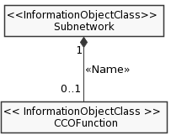
Figure 4.2.1.1-X: NRM fragment for CCO Management
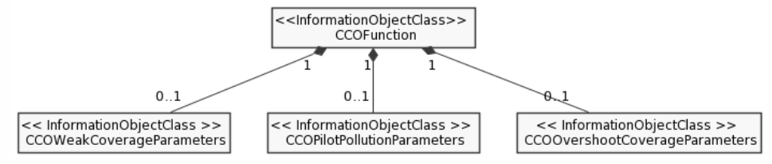
Figure 4.2.1.1-Y: NRM fragment for CCO parameters Management

2nd Change

4.2.1.2 Inheritance
……

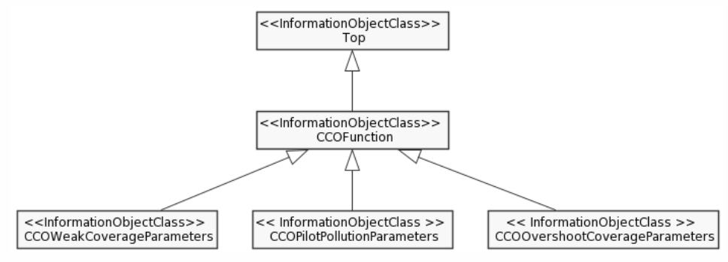
Figure 4.2.1.2-x: Inheritance Hierarchy

3rd Change

4.3.X CCOFunction

4.3.X.1 Definition
This IOC contains attributes to support the C-SON function of Capacity and Coverage optimization (See clause 7.2.3 in TS 28.313 [57]).
NOTE: in the case where multiple CCOFunction MOIs exist at different levels of the containment tree, the CCOFunction MOI at the lower level overrides the CCOFunction MOIs at higher level(s) of the same containment tree.

4.3.X.2 Attributes
The CCOFunction IOC includes attributes inherited from Top IOC (defined in TS 28.622[30]) and the following attributes:
Attribute Name | Support Qualifier | isReadable | isWritable | isInvariant | isNotifyable
cCOSwitch | M | T | T | F | T

4.3.X.3 Attribute constraints
None.

4.3.X.4 Notifications
The common notifications defined in sub clause 4.5 are valid for this IOC, without exceptions or additions.

4.3.X CCOWeakCoverageParameters

4.3.X.1 Definition
This IOC contains attributes to support the C-SON function of Capacity and Coverage optimization (See clause 7.2.3 in TS 28.313 [57]).
NOTE: in the case where multiple CCOFunction MOIs exist at different levels of the containment tree, the CCOFunction MOI at the lower level overrides the CCOFunction MOIs at higher level(s) of the same containment tree.

4.3.X.2 Attributes
The CCOFunction IOC includes attributes inherited from Top IOC (defined in TS 28.622[30]) and the following attributes:
Attribute Name | Support Qualifier | isReadable | isWritable | isInvariant | isNotifyable
cCOPolicy | M | T | T | F | T

4.3.X.3 Attribute constraints
None.

4.3.X.4 Notifications
The common notifications defined in sub clause 4.5 are valid for this IOC, without exceptions or additions.

4.3.X CCOPilotPollutionParameters

4.3.X.1 Definition
This IOC contains attributes to support the C-SON function of Capacity and Coverage optimization (See clause 7.2.3 in TS 28.313 [57]).
NOTE: in the case where multiple CCOFunction MOIs exist at different levels of the containment tree, the CCOFunction MOI at the lower level overrides the CCOFunction MOIs at higher level(s) of the same containment tree.

4.3.X.2 Attributes
The CCOFunction IOC includes attributes inherited from Top IOC (defined in TS 28.622[30]) and the following attributes:
Attribute Name | Support Qualifier | isReadable | isWritable | isInvariant | isNotifyable
cCOPolicy | M | T | T | F | T

4.3.X.3 Attribute constraints
None.

4.3.X.4 Notifications
The common notifications defined in sub clause 4.5 are valid for this IOC, without exceptions or additions.

4.3.X CCOOvershootCoverageParameters

4.3.X.1 Definition
This IOC contains attributes to support the C-SON function of Capacity and Coverage optimization (See clause 7.2.3 in TS 28.313 [57]).
NOTE: in the case where multiple CCOFunction MOIs exist at different levels of the containment tree, the CCOFunction MOI at the lower level overrides the CCOFunction MOIs at higher level(s) of the same containment tree.

4.3.X.2 Attributes
The CCOFunction IOC includes attributes inherited from Top IOC (defined in TS 28.622[30]) and the following attributes:
Attribute Name | Support Qualifier | isReadable | isWritable | isInvariant | isNotifyable
cCOPolicy | M | T | T | F | T

4.3.X.3 Attribute constraints
None.

4.3.X.4 Notifications
The common notifications defined in sub clause 4.5 are valid for this IOC, without exceptions or additions.

4.3.Y CCOPolicy <<dataType>>

4.3.Y.1 Definition
This data type represents the attributes of radio coverage policy content. It consists of condition and the corresponding actions applied for C-SON function of radio Capacity and Coverage optimization.

4.3.Y.2 Attributes
Attribute Name | Support Qualifier | isReadable | isWritable | isInvariant | isNotifyable
cCOPolicyCondition | M | T | T | F | T
downlinkTransmitPowerInfo | O | T | T | F | T
antennaTiltInfo | O | T | T | F | T
antennaAzimuthInfo | O | T | T | F | T
digitalTiltInfo | O | T | T | F | T
digitalAzimuthInfo | O | T | T | F | T
coverageShapeList | O | T | T | F | T

4.3.Y.3 Attribute constraints
None.

4.3.Y.4 Notifications
The subclause 4.5 of the <<IOC>> using this <<dataType>> as one of its attributes, shall be applicable.

4.3.A ParameterInfo <<dataType>>

4.3.A.1 Definition
This data type represents the adjustment range for parameters.

4.3.A.2 Attributes
The data type includes the following attributes:
Attribute Name | Support Qualifier | isReadable | isWritable | isInvariant | isNotifyable
maxValue | M | T | T | F | T
minValue | M | T | T | F | T
Editor’s NOTE: New attributes are FFS.

4.3.A.3 Attribute constraints
None.

4.3.A.4 Notifications
The subclause 4.5 of the <<IOC>> using this <<dataType>> as one of its attributes, shall be applicable.

4th Change

4.4 Attribute definitions

4.4.1 Attribute properties
Attribute Name | Documentation and Allowed Values | Properties
administrativeState | It indicates the administrative state of the NRCellDU. It describes the permission to use or prohibition against using the cell, imposed through the OAM services.  allowedValues: LOCKED, SHUTTING DOWN, UNLOCKED.  The meaning of these values is as defined in ITU-T Recommendation X.731 [18].  See Annex A for Relation between the "Pre-operation state of the gNB-DU Cell" and administrative state relevant in case of 2-split and 3-split deployment scenarios. | type: ENUM  multiplicity: 1  isOrdered: N/A  isUnique: N/A  defaultValue: LOCKED  isNullable: False
…… | …… | ……
isMLBAllowed | This indicates if mobility load balancing is allowed or prohibited from source cell to target cell.  If TRUE, load balancing is allowed from source cell to target cell. The source cell is identified by the name-containing NRCellCU of the NRCellRelation that contains the isMLBAllowed. The target cell is referenced by the NRCellRelation that contains this isLBAllowed. In case of isHOAllowed is FALSE, mobility load balancing is prohibited by handover from source cell to target cell.  If FALSE, load balancing shall be prohibited from source cell to target cell.  allowedValues: TRUE,FALSE | type: Boolean  multiplicity: 1  isOrdered: N/A  isUnique: N/A  defaultValue: None  isNullable: False
cCOPolicy | It indicates condition and the corresponding actions applied for the C-SON function of radio Capacity and Coverage optimization.  allowedValues: N/A | type: CCOPolicy  multiplicity: 1..*  isOrdered: N/A  isUnique: N/A  defaultValue: None  isNullable: False
cCOPolicyCondition | It indicates the condition which will trigger the actions to optimize radio coverage.  allowedValues: “weak coverage”, “pilot pollution”, “overshoot coverage”. | type: String  multiplicity: 1  isOrdered: N/A  isUnique: N/A  defaultValue: None  isNullable: False
downlinkTransmitPowerInfo | It indicates adjustment range (including maximum value, minimum value) of downlinkTransmitPower to optimize radio coverage.  allowedValues: [1..100] | type: ParameterInfo  multiplicity: 1  isOrdered: N/A  isUnique: N/A  defaultValue: None  isNullable: False
antennaTiltInfo | It indicates adjustment range (including maximum value, minimum value) of antennaTilt to optimize radio coverage.  allowedValues: [-900..900] 0.1 degree | type: ParameterInfo  multiplicity: 1  isOrdered: N/A  isUnique: N/A  defaultValue: None  isNullable: False
antennaAzimuthInfo | It indicates adjustment range (including maximum value, minimum value) of antennaAzimuth to optimize radio coverage.  allowedValues: [-1800..1800] 0.1 degree | type: ParameterInfo  multiplicity: 1  isOrdered: N/A  isUnique: N/A  defaultValue: None  isNullable: False
digitalTiltInfo | It indicates adjustment range (including maximum value, minimum value) of digitalTilt to optimize radio coverage.  allowedValues: [-900..900] 0.1 degree | type: ParameterInfo  multiplicity: 1  isOrdered: N/A  isUnique: N/A  defaultValue: None  isNullable: False
digitalAzimuthInfo | It indicates adjustment range (including maximum value, minimum value) of digitalAzimuth to optimize radio coverage.  allowedValues: [-1800..1800] 0.1 degree | type: ParameterInfo  multiplicity: 1  isOrdered: N/A  isUnique: N/A  defaultValue: None  isNullable: False
coverageShapeList | It indicates the coverage shape which can be selected to optimize radio coverage.  allowedValues: 0 : 65535 | type: Integer  multiplicity: 1..*  isOrdered: N/A  isUnique: True  defaultValue: None  isNullable: False
cCOSwitch | This attribute determines whether the centralized SON CCO Function is enabled or disabled.  allowedValues: TRUE,FALSE | type: Boolean  multiplicity: 1  isOrdered: N/A  isUnique: N/A  defaultValue: None  isNullable: False
maxValue | It indicates the maximum value of the parameter.  allowedValues: N/A | type: Integer  multiplicity: 1  isOrdered: N/A  isUnique: N/A  defaultValue: None  isNullable: False
minValue | It indicates the minimum value of the parameter.  allowedValues: N/A | type: Integer  multiplicity: 1  isOrdered: N/A  isUnique: N/A  defaultValue: None  isNullable: False
NOTE 1: Void
NOTE 2: The radio resource can be signaling resources (e.g. RRC connected users) or user plane resources (e.g. PRB, PRB UL, PRB DL, DRB). Different RRM Policy maybe applied for different types of radio resource. E.g. RRMPolicyRatio is used for PRB resource. When the resource type is PRB the policy applies for both uplink and downlink, and ‘PRB UL’ and ‘PRB DL’ are not used.
NOTE 3: Void
NOTE 4: A RRM Policy can make use of the defined policy (e.g. RRMPolicyRatio) or a vendor specific RRM Policy.
NOTE 5: For Global gNB Identifiers, the entries are formatted according to the pattern <mcc><mnc>-<gNBIdLength>-<gNBId>, where <mcc> is three digits, <mnc> two or three digits, <gNBIdLength> is a string containing a number n as digits, in the range 22 to 32, and <gNBId> is a string containing digits for the number 0 to 2^{n}-1. For Global eNB Identifiers, the entries are formatted according to the pattern <mcc><mnc>-<eNBIdLength>-<eNBId>, where <mcc> is three digits, <mnc> two or three digits, <gNBIdLength> is a string containing a number m as digits, m being one of 18, 20, 21 or 22, and <eNBId> is a string containing digits for the number 0 to 2^{m}-1.
NOTE 6: The maximum number of total RIM RS sequence within 10ms is 32 regardless single or two uplink-downlink period are configured in the 10ms..
NOTE 7:
1. The maximum number of consecutive uplink-downlink switching periods for repetition/near-far-functionality is 8 (the number can be either 2, 4, or 8) with near-far functionality and with repetition.
2. The maximum number of consecutive uplink-downlink switching periods for repetition is 4 (the number can be either 1, 2, or 4) without near-far functionality and with repetition only.
3. The maximum number of consecutive uplink-downlink switching periods is 2 with near-far functionality only and without repetition.
NOTE 8 (for information): “Not enough mitigation” means aggressor gNB needs to increase the interference mitigation level (i.e., further interference mitigation actions) (e.g., further reducing the DL transmission power on DL symbols at aggressor side), while “Enough mitigation” means aggressor gNB keeping the current interference mitigation level unchanged (i.e., no further interference mitigation actions) (e.g., remaining the DL transmission power on DL symbols unchanged at aggressor side).
NOTE 9: Value MS0P5 corresponds to 0.5 ms, MS0P625 corresponds to 0.625 ms, MS1 corresponds to 1 ms, MS1P25 corresponds to 1.25 ms, and so on.
NOTE 10: RIM RS-1, RIM-RS1，RIM RS1 is equivalent to RIM-RS type 1 (see 38.211 [32], clause 7.4.1.6)
RIM RS-2, RIM-RS2，RIM RS2 is equivalent to RIM-RS type 2 (see 38.211 [32], clause 7.4.1.6).

End of changes

