3GPP TSG-SA5 Meeting #141-e S5-221188rev2

e-meeting, 17 -26 January 2022

Source: Huawei, China Unicom

Title: pCR TS 28.104 add MDA analysis request and report generic workflow

Document for: Approval
Agenda Item: 6.4.15

1 Decision/action requested
In this box give a very clear / short /concise statement of what is wanted.

2 References
[1] 3GPP TS 28.104 “Management and orchestration; Management Data Analytics”

3 Rationale
This contribution propose to add generic MDA analysis request and reporting workflow in [1].

4 Detailed proposal
It is proposed to apply following changes in [1].
1st modified section

11 Workflows for MDA management

11.X MDA analysis request and reporting workflow
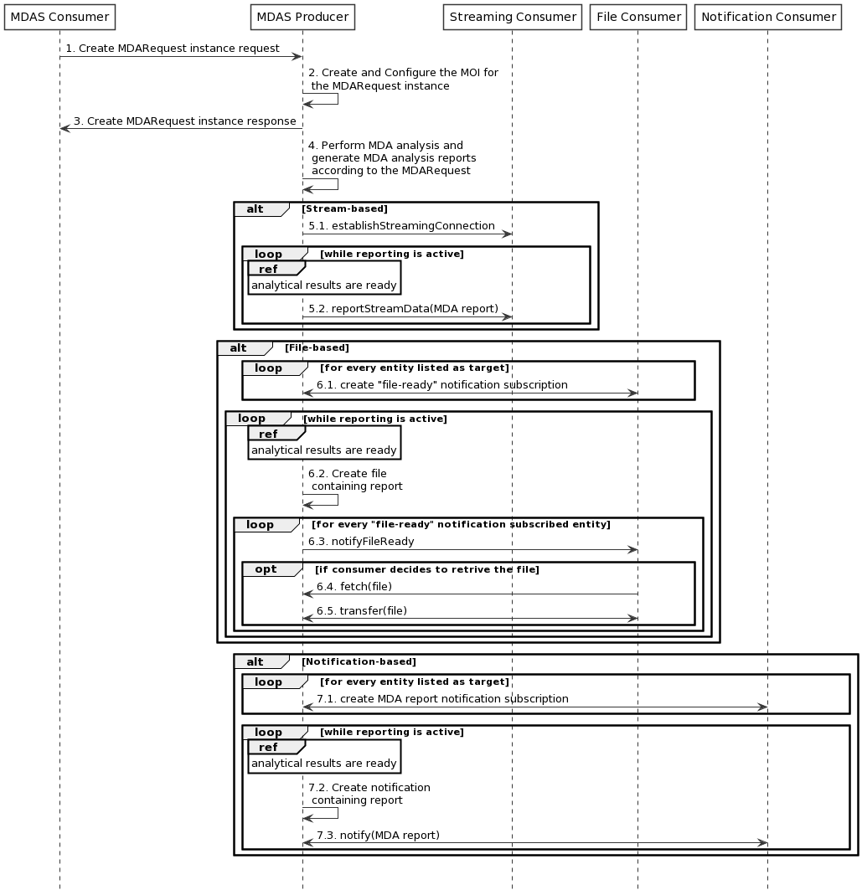
Figure 11.X-1: Generic MDA analysis request/reporting workflow
1 MDAS Producer receives a Create MDARequest MOI request (see createMOI operation defined in TS 28.532 [11]) from MDAS Consumer with MDA request related information.
Editor’s Note1: the reference of information model definition will be added, when they are available.
Editor’s Note2: the MDA request related information is can be refer in subclause 9.
2 The MDAS Producer creates the MOI for the MDARequest to be created.
3 The MDAS Producer sends the Create MDARequest MOI response (see createMOI operation defined in TS 28.532 [11]) to MDAS Consumer with identifier of MOI.
4 The MDAS Procedure perform MDA anlaysis and generate MDA report according to the MDA request.
Alt1: For stream-based MDA reporting
5.1 Establish the streaming connection containing the stream information, by invoking the establishStreamingConnection operation;
5.2 The MDAS producer sends the MDA report to the Streaming consumer via data streams, by invoking the reportStreamData operation.
Alt2: For file-based MDA reporting
6.1~6.2 The File consumer create a file-ready notification subscription by invoking the subscribe operation.
6.3~6.5 The MnS producer sends notifyFileReady notification to subscribed File consumers when a MDA report file becomes ready (available) on the MnS producer for upload by File consumers.
Alt3: For notification-based MDA reporting
7.1~7.2 The Notification consumer create a MDA report notification subscription by invoking the subscribe operation.
7.3 The MDAS producer creates a notification containing MDA report and sends the notification to subscribed Notification consumers.
Editor’s note: The definition of notification for MDA is FFS.
End of modified section

