**3GPP TSG-SA5 Meeting #141-e *S5-221165***

**e-meeting, 17 -26 January 2022**

|  |  |  |  |  |  |  |  |  |
| --- | --- | --- | --- | --- | --- | --- | --- | --- |
| *CR-Form-v12.1* | | | | | | | | |
| **CHANGE REQUEST** | | | | | | | | |
|  | | | | | | | | |
|  | **28.533** | **CR** | **0098** | **rev** | **1** | **Current version:** | **17.1.0** |  |
|  | | | | | | | | |
| *For* [***HE******LP***](http://www.3gpp.org/3G_Specs/CRs.htm#_blank)*on using this form: comprehensive instructions can be found at* [*http://www.3gpp.org/Change-Requests*](http://www.3gpp.org/Change-Requests)*.* | | | | | | | | |
|  | | | | | | | | |

|  |  |  |  |  |  |  |  |  |
| --- | --- | --- | --- | --- | --- | --- | --- | --- |
| ***Proposed change affects:*** | UICC apps |  | ME |  | Radio Access Network | **X** | Core Network | **X** |

|  |  |  |  |  |  |  |  |  |  |  |
| --- | --- | --- | --- | --- | --- | --- | --- | --- | --- | --- |
|  | | | | | | | | | | |
| ***Title:*** | CR Rel-17 TS 28.533 Add 5G specification information | | | | | | | | | |
|  |  | | | | | | | | | |
| ***Source to WG:*** | Huawei | | | | | | | | | |
| ***Source to TSG:*** | S5 | | | | | | | | | |
|  |  | | | | | | | | | |
| ***Work item code:*** | TEI17 | | | | |  | ***Date:*** | | | 2022-01-06 |
|  |  | | | |  | |  | | |  |
| ***Category:*** | **F** |  | | | | | ***Release:*** | | | Rel-17 |
|  | *Use one of the following categories:* ***F*** *(correction)* ***A*** *(mirror corresponding to a change in an earlier release)* ***B*** *(addition of feature),* ***C*** *(functional modification of feature)* ***D*** *(editorial modification)*  Detailed explanations of the above categories can be found in 3GPP [TR 21.900](http://www.3gpp.org/ftp/Specs/html-info/21900.htm). | | | | | | | | *Use one of the following releases: Rel-8 (Release 8) Rel-9 (Release 9) Rel-10 (Release 10) Rel-11 (Release 11) … Rel-15 (Release 15) Rel-16 (Release 16) Rel-17 (Release 17) Rel-18 (Release 18)* | |
|  |  | | | | | | | | | |
| ***Reason for change:*** | | It’s more appropriate to put 5G specification related information into annex of TS 28.533. | | | | | | | | |
|  | |  | | | | | | | | |
| ***Summary of change:*** | | Move the 5G specifications from TS 32.103 to annex of TS 28.533. | | | | | | | | |
|  | |  | | | | | | | | |
| ***Consequences if not approved:*** | | 5G specification related information is not captured in the right specification and it’s not uptodate. | | | | | | | | |
|  | |  | | | | | | | | |
| ***Clauses affected:*** | | 2, Annex B(new) | | | | | | | | |
|  | |  | | | | | | | | |
|  | | **Y** | **N** |  | | | |  | | |
| ***Other specs*** | |  | **X** | Other core specifications | | | | TS/TR ... CR ... | | |
| ***affected:*** | |  | **X** | Test specifications | | | | TS/TR ... CR ... | | |
| ***(show related CRs)*** | |  | **X** | O&M Specifications | | | | TS/TR ... CR ... | | |
|  | |  | | | | | | | | |
| ***Other comments:*** | |  | | | | | | | | |
|  | |  | | | | | | | | |
| ***This CR's revision history:*** | |  | | | | | | | | |

|  |
| --- |
| **1st Change** |

# 2 References

The following documents contain provisions which, through reference in this text, constitute provisions of the present document.

- References are either specific (identified by date of publication, edition number, version number, etc.) or non‑specific.

- For a specific reference, subsequent revisions do not apply.

- For a non-specific reference, the latest version applies. In the case of a reference to a 3GPP document (including a GSM document), a non-specific reference implicitly refers to the latest version of that document *in the same Release as the present document*.

[1] 3GPP TR 21.905: "Vocabulary for 3GPP Specifications".

[2] Void

[3] 3GPP TS 28.530: "Management and orchestration of networks and network slicing; Concepts, use cases and requirements".

[4] 3GPP TS 28.541: "Management and orchestration of 5G networks; Network Resource Model (NRM); Stage 2 and stage 3".

[5] 3GPP TS 28.552: "Management and orchestration of 5G networks; Performance measurements and assurance data".

[6] 3GPP TS 28.554: "Management and orchestration of 5G networks; 5G End to end Key Performance Indicators (KPI)".

[7] 3GPP TS 32.425: "Telecommunication management; Performance Management (PM); Performance measurements Evolved Universal Terrestrial Radio Access Network (E-UTRAN)".

[8] 3GPP TS 28.531: "Management and orchestration of 5G networks; Provisioning; Stage 1".

[9] 3GPP TS 28.532: "Management and orchestration; Management services".

[10] 3GPP TS 28.500: "Telecommunication management; Management concept, architecture and requirements for mobile networks that include virtualized network functions"

[11] 3GPP TS 28.510; "Telecommunication management; Configuration Management (CM) for mobile networks that include virtualized network functions; Requirements".

[12] 3GPP TS 28.511; "Telecommunication management; Configuration Management (CM) for mobile networks that include virtualized network functions; Procedures".

[13] 3GPP TS 28.512; "Telecommunication management; Configuration Management (CM) for mobile networks that include virtualized network functions; Stage 2".

[14] 3GPP TS 28.513: "Telecommunication management; Configuration Management (CM) for mobile networks that include virtualized network functions; Stage 3".

[15] 3GPP TS 28.515; "Telecommunication management; Fault Management (FM) for mobile networks that include virtualized network functions; Requirements".

[16] 3GPP TS 28.516: "Telecommunication management; Fault Management (FM) for mobile networks that include virtualized network functions; Procedures".

[17] 3GPP TS 28.517: "Telecommunication management; Fault Management (FM) for mobile networks that include virtualized network functions; Stage 2".

[18] 3GPP TS 28.518: "Telecommunication management; Fault Management (FM) for mobile networks that include virtualized network functions; Stage 3".

[19] 3GPP TS 28.520: "Telecommunication management; Performance Management (PM) for mobile networks that include virtualized network functions; Requirements".

[20] 3GPP TS 28.521: "Telecommunication management; Performance Management (PM) for mobile networks that include virtualized network functions; Procedures".

[21] 3GPP TS 28.522: "Telecommunication management; Performance Management (PM) for mobile networks that include virtualized network functions; Stage 2".

[22] 3GPP TS 28.523: "Telecommunication management; Performance Management (PM) for mobile networks that include virtualized network functions; Stage 3".

[23] 3GPP TS 28.525: "Telecommunication management; Life Cycle Management (LCM) for mobile networks that include virtualized network functions; Requirements".

[24] 3GPP TS 28.526: "Telecommunication management; Life Cycle Management (LCM) for mobile networks that include virtualized network functions; Procedures".

[25] 3GPP TS 28.527: "Telecommunication management; Life Cycle Management (LCM) for mobile networks that include virtualized network functions; Stage 2".

[26] 3GPP TS 28.528: "Telecommunication management; Life Cycle Management (LCM) for mobile networks that include virtualized network functions; Stage 3".

[27] ETSI GS NFV 003: "Network Functions Virtualisation (NFV); Terminology for Main Concepts in NFV V1.3.1 (2018-01)".

[28] 3GPP TS 28.545: "Management and orchestration; Fault Supervision (FS)".

[29] ETSI GS ZSM 002: "Zero-touch Network and Service Management (ZSM); Reference Architecture V.1.1 (2019-08)".

[30] 3GPP TS 23.288: "Architecture enhancements for 5G System (5GS) to support network data analytics services".

[31] 3GPP TS 23.501: "System Architecture for the 5G system".

[32] 3GPP TS 28.622: "Telecommunication management; Generic Network Resource Model (NRM) Integration Reference Point (IRP); Information Service (IS)".

[33] IETF RFC 8446: "The Transport Layer Security (TLS) Protocol Version 1.3".

[34] IETF RFC 4253: "The Secure Shell (SSH) Transport Layer Protocol".

[35] 3GPP TS 28.100: "Management and orchestration; Levels of autonomous network".

[36] 3GPP TS 28.533: "Management and orchestration; Architecture framework".

[37] 3GPP TS 28.535: "Management services for communication service assurance; Requirements ".

[38] 3GPP TS 28.536: "Management services for communication service assurance; Stage 2 and stage 3".

[39] 3GPP TS 28.537: "Management and orchestration; Management capabilities".

[40] 3GPP TS 28.538: "Management and orchestration; Edge Computing Management".

[41] 3GPP TS 28.540: "Management and orchestration; 5G Network Resource Model (NRM); Stage 1".

[42] 3GPP TS 28.550: "Management and orchestration; Performance assurance".

[43] 3GPP TS 32.421: "Telecommunication management; Subscriber and equipment trace; Trace concepts and requirements".

[44] 3GPP TS 32.422: "Telecommunication management; Subscriber and equipment trace; Trace control and configuration management ".

[45] 3GPP TS 32.423: "Telecommunication management; Subscriber and equipment trace;Trace data definition and management".

[46] 3GPP TS 28.312: "Management and orchestration; Intent driven management services for mobile networks".

[47] 3GPP TS 28.557: "Management and orchestration; Management of Non-Public Networks (NPN); Stage 1 and stage 2".

[48] 3GPP TS 28.404: "Telecommunication management; Quality of Experience (QoE) measurement collection; Concepts, use cases and requirements".

[49] 3GPP TS 28.405: "Telecommunication management; Quality of Experience (QoE) measurement collection; Control and configuration".

[50] 3GPP TS 28.406: "Telecommunication management; Quality of Experience (QoE) measurement collection; Information definition and transport".

[51] 3GPP TS 28.631: "Telecommunication management; Inventory Management (IM) Network Resource Model (NRM) Integration Reference Point (IRP); Requirements".

[52] 3GPP TS 28.632: "Telecommunication management; Inventory Management (IM) Network Resource Model (NRM) Integration Reference Point (IRP); Information Service (IS)".

[53] 3GPP TS 28.633: "Telecommunication management; Inventory Management (IM) Network Resource Model (NRM) Integration Reference Point (IRP); Solution Set (SS) definitions".

[54] 3GPP TS 28.623: "Telecommunication management; Generic Network Resource Model (NRM) Integration Reference Point (IRP); Solution Set (SS) definitions".

[55] 3GPP TS 32.130: "Telecommunication management; Network sharing; Concepts and requirements".

[56] 3GPP TS 28.310: "Management and orchestration; Energy efficiency of 5G".

[57] 3GPP TS 28.104: "Management and orchestration; Management Data Analytics".

[58] 3GPP TS 28.313: "Self-Organizing Networks (SON) for 5G networks".

[59] 3GPP TS 28.314: "Management and orchestration; Plug and Connect; Concepts and requirements".

[60] 3GPP TS 28.315: "Management and orchestration; Plug and Connect; Procedure flows".

[61] 3GPP TS 28.316: "Management and orchestration; Plug and Connect; Data formats".

[62] 3GPP TS 28.555: "Management and orchestration; Network policy management for 5G mobile networks; Stage 1".

[63] 3GPP TS 28.556: "Management and orchestration; Network policy management for 5G mobile networks; Stage 2 and stage 3".

|  |
| --- |
| **2nd Change** |

Annex B (informative):  
5G specifications overview

The following figure and table show the overview information of 5G specifications which capture corresponding management features:

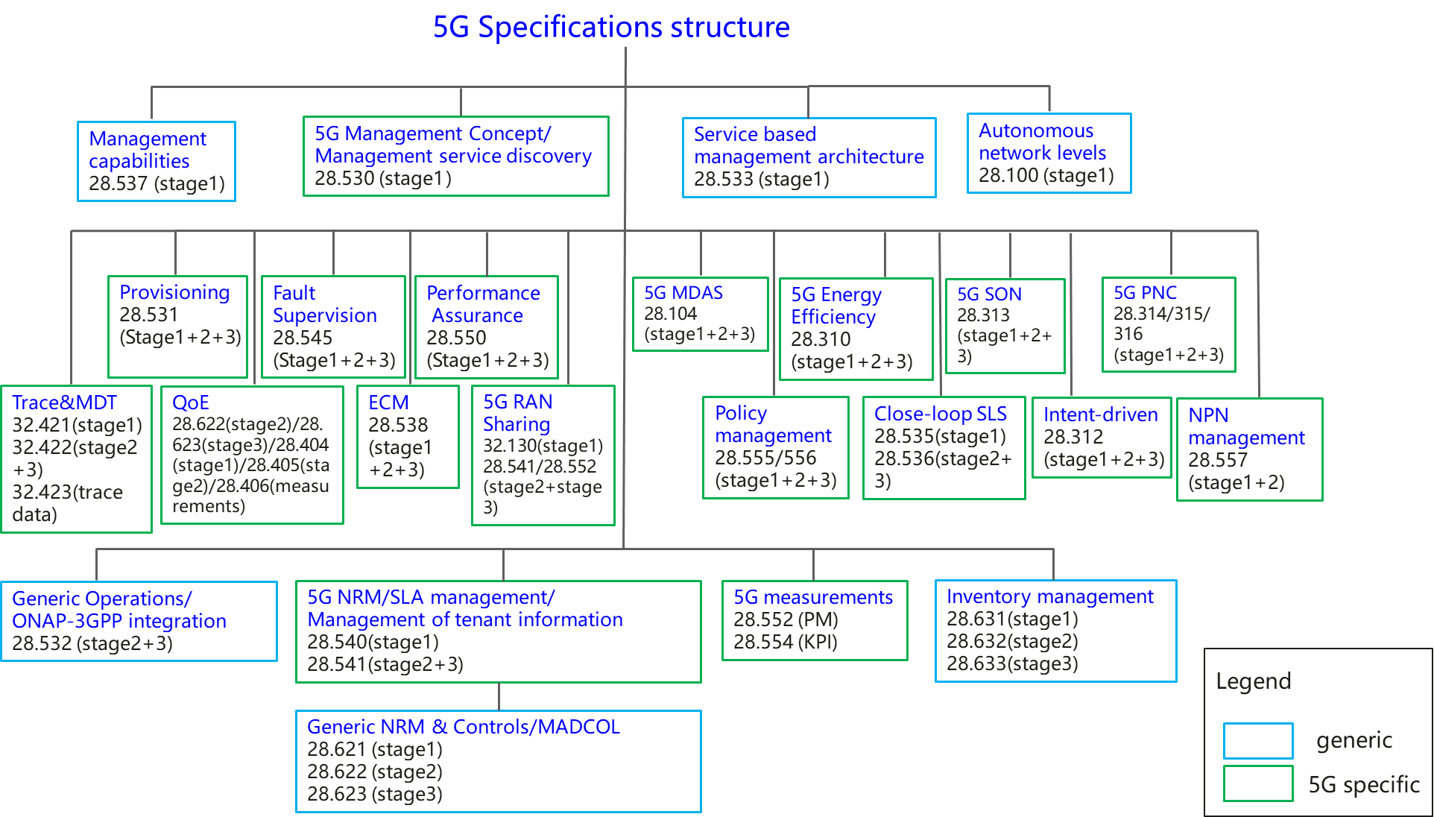

Figure B-1: Overview of 5G management specifications

In the figure, some features are generic management features which are applied to management of different network technologies, and some features are 5G specific management features which apply for management of 5G network only. The following table provides the overall 5G management features and the related specification information.

|  |  |  |
| --- | --- | --- |
|  | 5G related management features | Related specifications |
| 1 | 5G management capabilities (Heart beat) | TS 28.537[39],TS 28.532[9] |
| 2 | Network and service management concept | TS 28.530[3] |
| 3 | Network management service based management architecture | TS 28.533[36] |
| 4 | Management and orchestration; Levels of autonomous network | TS 28.100[35] |
| 5 | Network and Network slicing management related specifications |  |
| 5.1 | Network and Network slicing provisioning | TS 28.531[8],TS 28.532[9],TS 28.540[41],TS 28.541[4] |
| 5.2 | Network and Network slicing fault supervision | TS 28.545[28],TS 28.532[9] |
| 5.3 | Network and Network slicing performance assurance | TS 28.550[42],TS 28.532[9],TS 28.540[41],TS 28.541[4],TS 28.552[5], TS 28.554[6] |
| 5.4 | NRM | TS 28.540[41],TS 28.541[4] |
| 6 | ONAP-3GPP integration | TS 28.532[9] |
| 7 | Trace and MDT management | TS 32.421[43],TS 32.422[44], TS 32.423[45] |
| 8 | QOE Management | TS 28.622[32], TS 28.623[54],  TS 28.404[48], TS 28.405[49],TS 28.406[50] |
| 9 | Inventory management | TS 28.631[51], TS 28.632[52], TS 28.633[53] |
| 10 | Management data collection control and discovery (MADCOL) | TS28.533[36], 28.532[9],28.622[32],  28.623[54] |
| 11 | 5G RAN Sharing | TS 32.130[55], TS 28.541[4],TS 28.552[5] |
| 12 | Edge Computing Management | TS 28.538[40] |
| 13 | Energy efficiency related specifications | TS 28.310[56],TS 28.532[9],TS 28.552[5],TS 28.554[6] |
| 14 | Management Data Analytics | TS 28.104[57] |
| 15 | 5G SON management | TS 28.313[58],TS 28.541[4] |
| 16 | Plug and Connect | TS 28.314[59],TS 28.315[60], TS 28.316[61] |
| 17 | Policy management | TS 28.555[62], TS 28.556[63] |
| 18 | Close-loop SLS | TS 28.535[37], TS 28.536[38] |
| 19 | Intent-driven management | TS 28.312[46] |
| 20 | Management service discovery | TS 28.530[3],TS 28.533[36] |
| 21 | SLA management | TS 28.540[41],TS 28.541[4], TS 28.531[8], TS 28.550[42] |
| 22 | NPN management | TS 28.557[47] |
| 23 | Management of tenant information | TS 28.530[3], TS 28.531[8],TS 28.533[36],TS 28.550[42],TS 28.552[5],TS 28.541[4] |