3GPP TSG-SA5 Meeting #141-e S5-221136

e-meeting, 17 -26 January 2022
CR-Form-v12.1
CHANGE REQUEST
 | 28.541 | CR | 0652 | rev | - | Current version: | 17.5.0
For HELP on using this form: comprehensive instructions can be found at
http://www.3gpp.org/Change-Requests.

Proposed change affects: | UICC apps |  | ME |  | Radio Access Network | X | Core Network

Title: | Alignment on NR NRM for MOCN network sharing
Source to WG: | Huawei,Orange,China Mobile,China Unicom,China Telecom, Deutsche Telekom,Ericsson,Telefonica
Source to TSG: | S5
Work item code: | MANS |  |  |  |  |  | Date: |  |  | 2022-01-03
Category: | F |  |  |  |  |  | Release: |  |  | Rel-17
 | Use one of the following categories:  F (correction)  A (mirror correspo.nding to a change in an earlier release)  B (addition of feature),  C (functional modification of feature)  D (editorial modification)  Detailed explanations of the above categories can  be found in 3GPP TR 21.900. |  |  |  |  |  |  |  | Use one of the following releases:  Rel-8 (Release 8)  Rel-9 (Release 9)  Rel-10 (Release 10)  Rel-11 (Release 11)  …  Rel-15 (Release 15)  Rel-16 (Release 16)  Rel-17 (Release 17)  Rel-18 (Release 18)
Reason for change: |  | - The title for Figure 4.2.1.1-17 and Figure 4.2.1.1-18 is not aligned;  - The description for OperatorDU and NROperatorCellDU is not aligned;  - The inheritance diagram for OperatorDU and NROperatorCellDU is missing.
Summary of change: |  | - Update the title for Figure 4.2.1.1-17 to align with Figure 4.2.1.1-18  - Update the description for NROperatorCellDU to align with OperatorDU  - Add the inheritence daigram for OperatorDU and NROperatorCellDU
Consequences if not approved: |  | Some misalignment exist for NR NRM for MOCN network sharing scenario
Clauses affected: |  | 4.2.1.1, 4.2.1.2, 4.3.67.1, 4.3.67.2, 4.3.68.1, 4.3.68.2,
 |  | Y | N
Other specs |  |  | X | Other core specifications |  |  |  | TS/TR ... CR ...
affected: |  |  | X | Test specifications |  |  |  | TS/TR ... CR ...
(show related CRs) |  |  | X | O&M Specifications |  |  |  | TS/TR ... CR ...
Other comments:
This CR's revision history:

1st Change

4.2.1 Class diagram for gNB and en-gNB

4.2.1.1 Relationships
This clause depicts the set of classes (e.g. IOCs) that encapsulates the information relevant for this gNB and en-gNB. For the UML semantics, see 3GPP TS 32.156 [43]. Subsequent clauses provide more detailed specification of various aspects of these classes.
The model fragments are for management representation of gNB and en-gNB for all NG-RAN deployment scenario as listed below.
- Non-split NG-RAN deployment scenario, represents the gNB defined in TS 38.401[4]. In this scenario, a gNB is represented by a combination of a GNBCUCPFunction, one or more GNBCUUPFunctions and one or more GNBDUFunctions.
- 2-split NG-RAN deployment scenario, represents the gNB consist of gNB-CU and gNB-DU defined in TS 38.401[4] clause 6.1.1. In this scenario, a gNB-CU is represented by a combination of a GNBCUCPFunction and one or more GNBCUUPFunctions, whereas a gNB-DU is represented by a GNBDUFunction.
- 3-split NG-RAN deployment scenario, represents the gNB consist of gNB-CU-CP, gNB-CU-UP and gNB-DU defined in TS 38.401[4] clause 6.1.2. In this scenario, a gNB-CU-CP is represented by a GNBCUCPFunction, a gNB-CU-UP is represented by a GNBCUUPFunction, and a gNB-DU is represented by a GNBDUFunction.
Figure 4.2.1.1-1: NRM for all deployment scenarios
Figure 4.2.1.1-2: NRM for EPs for all deployment scenarios
Figure 4.2.1.1-3: NRM for <<IOC>>NRSectorCarrier and <<IOC>>BWP for all deployment scenarios
Figure 4.2.1.1-4: Cell Relation view for all deployment scenarios
NOTE 1: The above NRM fragment uses SubNetwork to hold both NR and LTE external entities and frequencies.
Figure 4.2.1.1-5: Cell Relation view for all deployment scenarios
NOTE 2: The above NRM fragment uses NRNetwork to hold NR external entities and frequency and using EUtraNetwork to hold LTE external entities and frequency. The NRNetwork and EUtraNetwork are subclasses of SubNetwork (defined in TS 28.622 [30]) with no additional attributes. The reason using NRNetwork and EUtraNetwork is for a clean separation of NR external entities and frequency and LTE external entities and frequency.
Figure 4.2.1.1-6: NRM fragment for RRM Policies
Figure 4.2.1.1-7: NRM fragment to support RIM
The Figure 4.2.1.1-8 shows the NRM fragment for pre-configured 5QIs in NG-RAN.
Figure 4.2.1.1-8: NRM fragment for pre-configured 5QIs in NG-RAN
Figure 4.2.1.1-9: NRM fragment for DANR Management
Figure 4.2.1.1-10: NRM fragment for DES Management
Figure 4.2.1.1-11: NRM fragment for DRACH Management
Figure 4.2.1.1-12: NRM fragment for DMRO Management
Figure 4.2.1.1-13: NRM fragment for DPCI Management
Figure 4.2.1.1-14: NRM fragment for CES Management
Figure 4.2.1.1-15: NRM fragment for CPCI Management
The Figure 4.2.1.1-16 shows the NRM fragment for dynamic 5QIs in NG-RAN.
Figure 4.2.1.1-16: NRM fragment for dynamically assigned 5QIs in NG-RAN

Figure 4.2.1.1-17: NRM for NG-RAN MOCN network sharing with multiple cell identity

Figure 4.2.1.1-18: NRM for F1 related EPs to support individual F1 interface for NG-RAN MOCN network sharing with multiple cell identity broadcast scenario

Figure 4.2.1.1-19: NRM fragment for DLBO Management

4.2.1.2 Inheritance

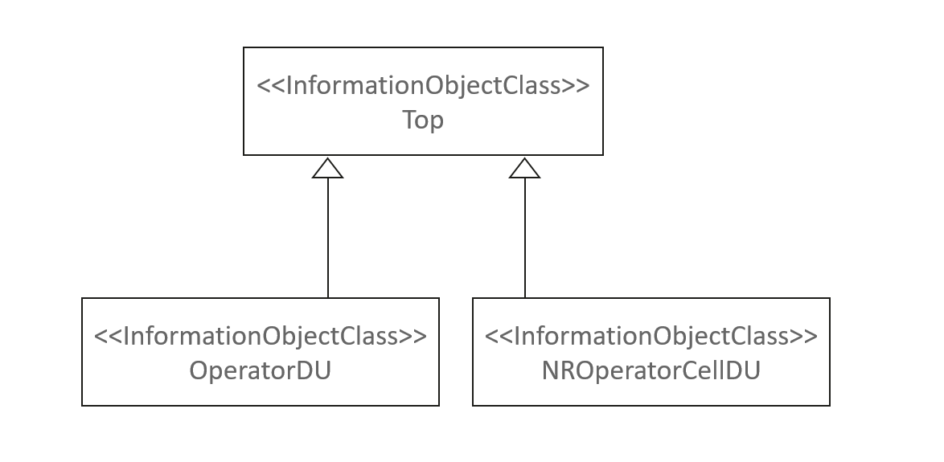
Figure 4.2.1.2-1: Inheritance Hierarchy

2nd Change

4.3.67 OperatorDU

4.3.67.1 Definition
This IOC contains attributes to support the NG-RAN Multi-Operator Core Network (NG-RAN MOCN) network sharing with multiple Cell Identity broadcast feature. An instance of OperatorDU <<IOC>> should be created and configured for each POP. When configured the attributes override those in parent GNBDUFunction instance.
The OperatorDU <<IOC>> is only used to support MOCN with multiple cell identity broadcast feature. If MOCN with multiple cell identity broadcast feature is not supported, this IOC is not used.
The following table identifies the necessary end points required for the representation of shared gNB and shared en-gNB, of all deployment scenarios.

Req  Role | End point requirement for 3-split deployment scenario | End point requirement for 2-split deployment scenario | End point requirement for Non-split deployment scenario
Shared gNB | <<IOC>>EP_F1C, <<IOC>>EP_F1U | <<IOC>>EP_F1C, <<IOC>>EP_F1U | None.
Shared en-gNB | <<IOC>>EP_F1C, <<IOC>>EP_F1U | <<IOC>>EP_F1C, <<IOC>>EP_F1U | None.

For scenarios with an F1 interface supporting multiple PLMN broadcast, the values of the EP_F1C and EP_F1U attributes contained by different OperatorDU of the same GNBDUFunction should be same.

4.3.67.2 Attributes
The OperatorDU IOC includes attributes inherited from Top IOC (defined in TS 28.622[30]) and the following attributes:
Attribute name | S | isReadable | isWritable | isInvariant | isNotifyable
gNBId | M | T | T | F | T
gNBIdLength | M | T | T | F | T

4.3.67.3 Attribute Constraints
None

4.3.67.4 Notifications
The common notifications defined in clause 5.5 are valid for this IOC, without exceptions or additions.

4.3.68 NROperatorCellDU

4.3.68.1 Definition
The NROperatorCellDU <<IOC>> contains attributes to support operator specific cell level information (including cellLocalId, pLMNInfoList, nRTAC) to support NG-RAN Multi-Operator Core Network (NG-RAN MOCN) network sharing with multiple Cell Identity broadcast feature. An instance of NROperatorCellDU <<IOC>> should be created and configured for each POP. When configured the attributes override those in the associated NRCellDU instance.
The NROperatorCellDU <<IOC>> is only used to support MOCN with multiple cell identity broadcast feature. If the MOCN with multiple cell identity broadcast feature is not supported, this IOC is not used.

4.3.68.2 Attributes
The NROperatorCellDU IOC includes attributes inherited from Top IOC (defined in TS 28.622[30]) and the following attributes:

Attribute name | S | isReadable | isWritable | isInvariant | isNotifyable
cellLocalId | M | T | T | F | T
pLMNInfoList | M | T | T | F | T
nRTAC | CM | T | T | F | T
Attribute related to role
nRCellDURef | M | T | T | F | T

4.3.68.3 Attribute Constraints
None

4.3.68.4 Notifications
The common notifications defined in clause 5.5 are valid for this IOC, without exceptions or additions.

End of Change

