3GPP TSG-SA5 Meeting #141-e S5-221135

e-meeting, 17 -26 January 2022

Source: Huawei, Deutsche Telekom

Title: Clean up on procedures

Document for: Approval
Agenda Item: 6.4.9

1 Decision/action requested
The group is asked to discuss and approval.

2 References
[1] 3GPP draft TS 28.312: “Management and orchestration; Intent driven management services for mobile networks v0.7.0”.

3 Rationale
This contribution proposes to address the following issues in related to operations and procedures described in clause 6.
Issue#1: Address the following Editor's Note.
Editor’s Note: The coordination/alignment work with TM Forum for the intent lifecycle management needs to be considered.
It proposes to remove this Editor's Note, because the intent lifecycle management is already described in Annex B Intent Life Cycle Management which is align with TM Forum.

Issue#2: Address the following Editor's Note.
Editor’s Note: The createMOI defined in TS 28.532[3] needs to add scenario of MnS producer allocate the DN for the intent.
It proposes to remove this Editor's Note, because whether createMOI should be supported the scenario of MnS producer allocate the DN for the object is a general issue, which is not specific for intent driven management, to suggest to have separate discussion for this.

Issue#3: Address the following Editor's Note.
Editor’s Note: Capability of version handling of Intent need further discussion.
It proposes to remove this Editor's Note, and suggest to discuss the capability of version handling of intent in R18 which needs further discussion.

Issue#4: Address the following Editor's Note
Editor’s Note: the subsequence after the intent MOI modified is FFS.
It proposed to remove this Editor's Note in the present document in R17.
Issue#5: Address the following Editor's Note.
Editor’s Note: the subsequence after the intent MOI deleted is FFS.
It proposed to remove this Editor's Note in the present document in R17.

Issue#6: Address the following Editor's Note.
Editor's note: Some content of this Annex can become a normative content after it is aligned with 3GPP terminology
It proposed to remove this Editor's Note in the present document at this moment, if some content identified as normative content later, it can be added later.

4 Detailed proposal
It proposes to make the following changes to TS 28.312[1].
1st Changes

6 Stage 2 definition for Intent Driven Management
Editor's note: this clause will specify the stage2 definition for Intent driven management which may include the management operations, management entities and management information
Editor’s Note: The coordination/alignment work with TM Forum for the intent lifecycle management needs to be considered.

6.1 Management operation for Intent (MnS component type A)
The operations (e.g. createMOI operations) and notifications (e.g. notifyMOIcreation) of generic provisioning MnS defined in TS 28.532[3] can be used for intent lifecycle management. The intent can be treated as object instance.

2nd Changes

6.3 Procedures for intent management

6.3.1 Introduction
This clause describes the procedures for intent management.

6.3.2 Create an intent
The Figure 6.3.2-1 illustrates the procedure for create a new intent.

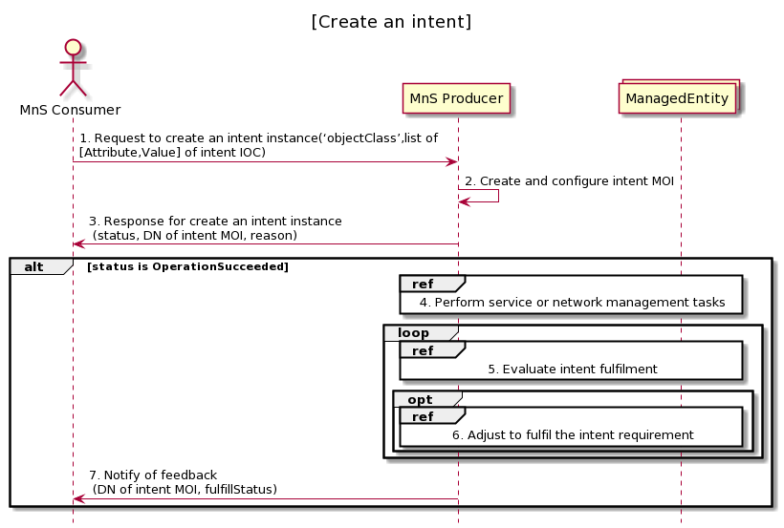

Figure 6.3.2-1 Procedure for create an intent
- MnS Consumer sends a request to create an intent instance to MnS Producer with ‘objectClass’ and list of [Attribute,Vlaue] for the new intent to be created. The detailed [Attribute,Value] see the concrete intent IOC defined in clause 6.2. ‘objectCalss’ is the name for the concrete intent IOC.
- Based on the request, the MnS Producer creates the concrete intent MOI (i.e. instance of intent IOC) with value for attribute ‘objectInstance’ allocated, and configure the new created intent MOI with the received list of [Attribute, Value]. ‘objectInstance’ is the identifier (DN) for the concrete intent MOI.
- MnS Producer sends a response to the MnS consumer with status (OperationSucceeded or OperationFailed) and ‘objectInstance’ of the created intent MOI. The response information may also include the possible reasons for the unsuccessful executions (e.g., conflicting with existing intents, the intent infeasible).
- Based on the intent, MnS Producer identifies the MOI for managed entities (e.g. ManagedElement, ManagedFunction) and derives one or more executable management tasks (including deployment and configuration requirements) for these managed entities, then MnS producer deploys or configures corresponding managed entities to satisfy the intent.
- During the execution of intention, MnS producer continuously monitors intent fulfilment status.
- MnS producer analyses and adjusts the managed entities to ensure the intention is continuously satisfied.
- MnS Producer may notify MnS Consumer about the intent fulfilment information, including DN of intent MOI, and fulfillStatus.

6.3.3 Modify an intent
The Figure 6.3.3-1 illustrates the procedure for modify an existing intent.

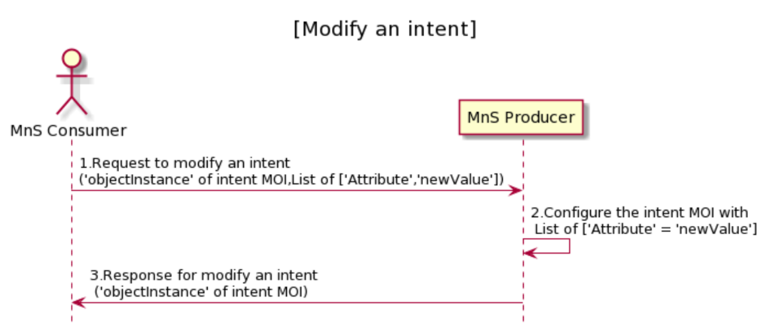

Figure 6.3.3-1 Procedure for modify an intent
- MnS Consumer sends a request to modify an intent intsnace to MnS Producer with ‘objectInstance’ of the intent MOI and List of [‘Attrribute’, ‘newValue’] to be modified. The detailed [Attribute,Value] see the concrete intent IOC defined in clause 6.2.
- Based on the request, MnS Producer configure the intent MOI with list of ‘Attribute’ = ’newValue’ which is required to be modified.
- MnS Producer sends a response to the MnS consumer with status (OperationSucceeded or OperationFailed), ‘objectInstance’ of the modified intent MOI and, and list of [‘Attrribute’, ‘newValue’] which is modified.

6.3.4 Delete an intent
The Figure 6.3.4-1 illustrates the procedure for modify an existing intent.
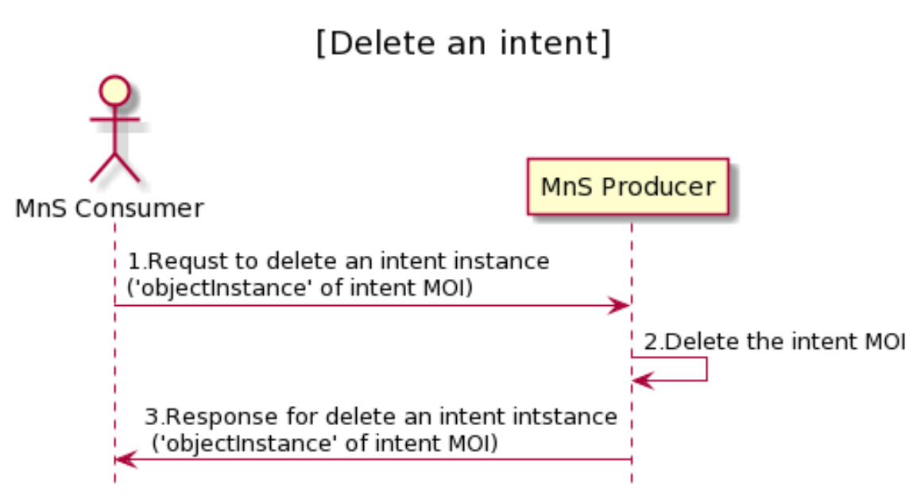
Figure 6.3.4-1 Procedure for delete an intent
- MnS Consumer sends a request to delete an intent to MnS Producer with ‘objectInstance’ of the intent MOI.
- Based on the request, MnS Producer delete the intent MOI.
- MnS Producer sends response to the MnS consumer with status (OperationSucceeded or OperationFailed), ‘objectInstance’ of the deleted intent MOI.

6.3.5 Query an intent
The Figure 6.3.5-1 illustrates the procedure for query an intent.
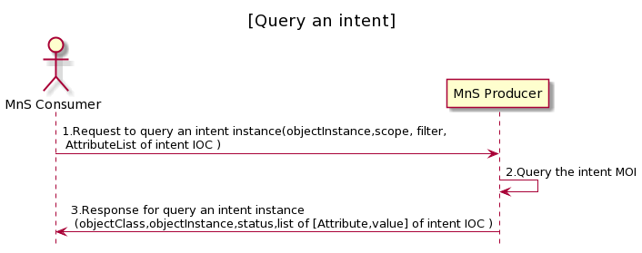
Figure 6.3.5-1 Procedure for query an intent
- MnS Consumer sends a request to query an intent instance to MnS Producer, with objectInstance of the existing intent MOI, scope, and list of attributes of intent IOC. The list of attributes identifies the attributes to be returned by this operation.
- Based on the request, the MnS Producer queries the concrete intent MOI.
- MnS Producer sends a response to the MnS consumer with objectClass, objectInstance, status (e.g. fulfillStatus and other status), and list of [Attribute,Value] which is defined in clause 6.2.
3rd Changes

Annex <B> (informative): Intent Life Cycle Management

B.1 Intent Life Cycle Management
As the MnS producer's (i.e. 3gpp system) capabilities (e.g. number and/or availability of the system resources) can change even after the Intent is accepted by the MnS producer, the Intent content (i.e. a list of Intent Expectations) might not be best aligned with the MnS producer' capabilities. For example, the resources in MnS producer are overbooked, and the intent content is failing to meet expectations of the MnS consumer or the resources of the MnS producer become underbooked which makes such a solution very expensive and therefore useless. Hence the creation/adjustment of an Intent content (i.e. a list of Intent Expectations) and keeping it aligned with the MnS producer's capabilities, can be automated.

This means that the life cycle of the Intent can begin before Intent content is retrieved by the MnS producer, e.g., the Intent content is being defined in a MnS consumer based on requirements towards a MnS producer (e.g., to deliver a service with certain characteristics), then be optimized based on the MnS producer's capabilities (e.g. availability of MnS Producer resources in certain area, time, etc.), then be refined if the initially captured requirement needs further detalization, etc.

The intent lifecycle consists of the following phases:
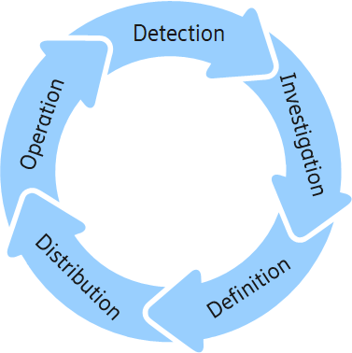
Figure B.1 -2: Intent Lifecycle Phases

Detection:
In the detection phase, the MnS Consumer as the system generating the intent content (a list of expectations), identifies if there is a need to define new or change/remove existing intent expectations to set requirements, goals, and constraints. The MnS Consumer has its own terminal expectations to fulfill. It would break its terminal expectations down into a suitable set of detailed instrumental expectations. Typically, these instrumental expectations need to be fulfilled by other management functions and domains and therefore they need to be not only defined but distributed to suitable MnS producer. In the detection phase, the MnS consumer can react to changes in its own terminal expectations or to changes in the fulfillment in its instrumental expectations. In this respect the MnS consumer deriving the expectations will need to collect information about the expectation' fulfillment. Intent reports coming from MnS producer, as a system to receive intent expectations are one source for this information. Through intent reports the MnS Consumer is able to react on intent handling outcomes in the MnS producer. In any case it is task of the MnS consumer to assure the fulfillment of its terminal expectations and the first step is to detect if any changes are needed in its instrumental expectations.
Investigation:
In the investigation phase, the MnS Consumer finds out what intent content (a list of expectations) are feasible. This has two aspects: first, it needs to find right MnS producer that have the right domain responsibilities and support the intent expectations the MnS consumer wants to define. MnS producer capability management and detection would be used for this process.
The other aspect of investigation would be finding out if the wanted intent expectations are realistic. This means, if the MnS producer would be able to successfully reach the wanted expectations. This depends on the current resource situation and capabilities of the system and can vary over time. Typically, the feasibility of intent expectations is done through a guided negotiation process between the MnS Producer and MnS Consumer. The MnS Consumer can explore what the handling result of wanted intent expectations would be, what would be the best result the MnS producer can achieve, or what would be the most challenging requirements, the aspiring MnS producer can offer to fulfill.
Definition:
At the end of the investigation phase the MnS consumer knows what is possible and what the MnS producer to be involved. By combining this information with the needs that were identified in detection, the MnS Consumer can now decide and plan all needed intent expectations. In the definition phase the MnS consumer formulates the intent expectations it needs to use.
Distribution:
In the distribution phase the MnS Consumer contacts a MnS producer in order to create a new intent object or modify or change an existing one to include the intent expectations derived in the Definition phase. This way the MnS consumer acts on the plan it has made in definition phase. In this phase a MnS producer starts handling the intent expectations by receiving them and included in the intent object. The MnS producer decides if it can accept the intent expectations. If not, it would send a report with the rejection reason back to the MnS consumer. While this finishes the lifecycle of this particular intent, the MnS consumer can start over with detection to create a new plan. If the MnS producer accepts the intent, it starts operating based on it.
Operation:
Each intent expectations yet another set of requirements, goals and constraints to be considered for decisions and actions by the MnS producers. The MnS producers operate their domains of responsibility according to the given intent expectations. They also report back to the MnS consumer about status and success while continuously reacting to intent fulfillment threats. Intent reports would be evaluated by the MnS consumer as part of its detection process, which leads to the next iteration of the intent life cycle.

End of Changes

