3GPP TSG-SA5 Meeting #141-e S5-221133
e-meeting, January 17 – 26 2022

Source: Huawei, China Mobile, China Unicom, Nokia, Deutsche Telekom, AsiaInfo,Orange

Title: Update intent information model in clause 6.2.1

Document for: Approval

Agenda Item: 6.4.9

1 Decision/action requested
The group is asked to discuss and approval.

2 References
[1] 3GPP draft TS 28.312: “Management and orchestration; Intent driven management services for mobile networks v0.7.0”.

3 Rationale
This contribution proposes to update the intent information model in clause 6.2.1 and address corresponding issues identified by Editor's Notes:
- Regarding the Editor's Note in the beginning of clause 6.2.1, it proposes to remove it in the present document at this moment, because Annex C already capture the mapping of 3GPP and TM Forum IntentExpectation Model, also further mapping or federated method will be investigated in R18 eIDMS_MN SID.
- Regarding the Figure 6.2.1.1.1-1, following updates are made:
  - Explicitily show the IntentContext, ExpectationContext, ObjectContext and TargetContext to make the diagram more clear, which are different type of context with same structure (e.g. Context<<dataType>>) .

  - Present the ExpectationObject<<dataType>> in the UML diagram to clearly illustrates IntentExpectation includes ExpectationObject and ExpectationTarget.
  - Remove the Editor's Notes under the Figure.
- Regarding the Clause 6.2.1.2.1 Intent <<IOC>>, it proposes to add attribute intentReport to align with the update in the UML diagram and move the attribute "intentFulfilStatus" as sub-attribute of IntentReport<<dataType>>.
- Regarding the Clause 6.2.1.2.2 IntentExpectation, it proposes to move to clause 6.2.1.3, because the IntentExpectation is a <<dataType>> instead of <<Class>>. Same update for IntentReport.
- Regarding the clause 6.2.1.3.1(new) IntentExpectation<<dataType>>, it proposes to introduce a new ExpectationObject<<dataType>> as attribute of IntentExpectation, which includes attributes "ObjectType", "ObjectInstance" and "ObjectContext". "ObjectInstance" is used in the scenario of MnS consumer's expectation is for a specific object instance and MnS consumer have the knowledge of the DN of this specific object instance, while "ObjectType" is used for MnS consumer's expectation is not for a specific object instance or MnS consumer have no knowledge of the DN of this specific object instance.
- Regarding the clause 6.2.1.4 Attribute definition, it proposed to update to align with above updates.

4 Detailed proposal
It proposes to make the following changes to TS 28.312[1].
1st Change

6.2 Information model definition for Intent (MnS component typeB)

6.2.1 Information model definition for Intent
Editor’s Note: The following information model needs to be revisited based on the further discussion, and the alignment/coordination work with other SDO needs to be considered, which may impact the following information model.

6.2.1.1 Class diagram

6.2.1.1.1 Relationship

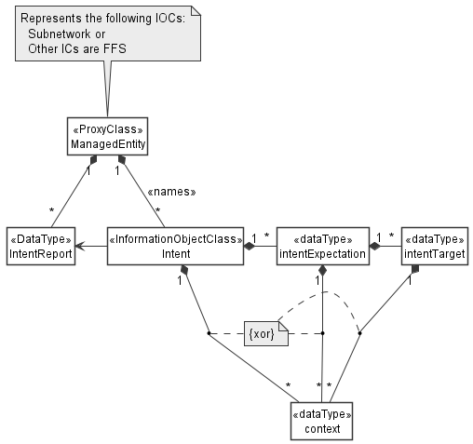
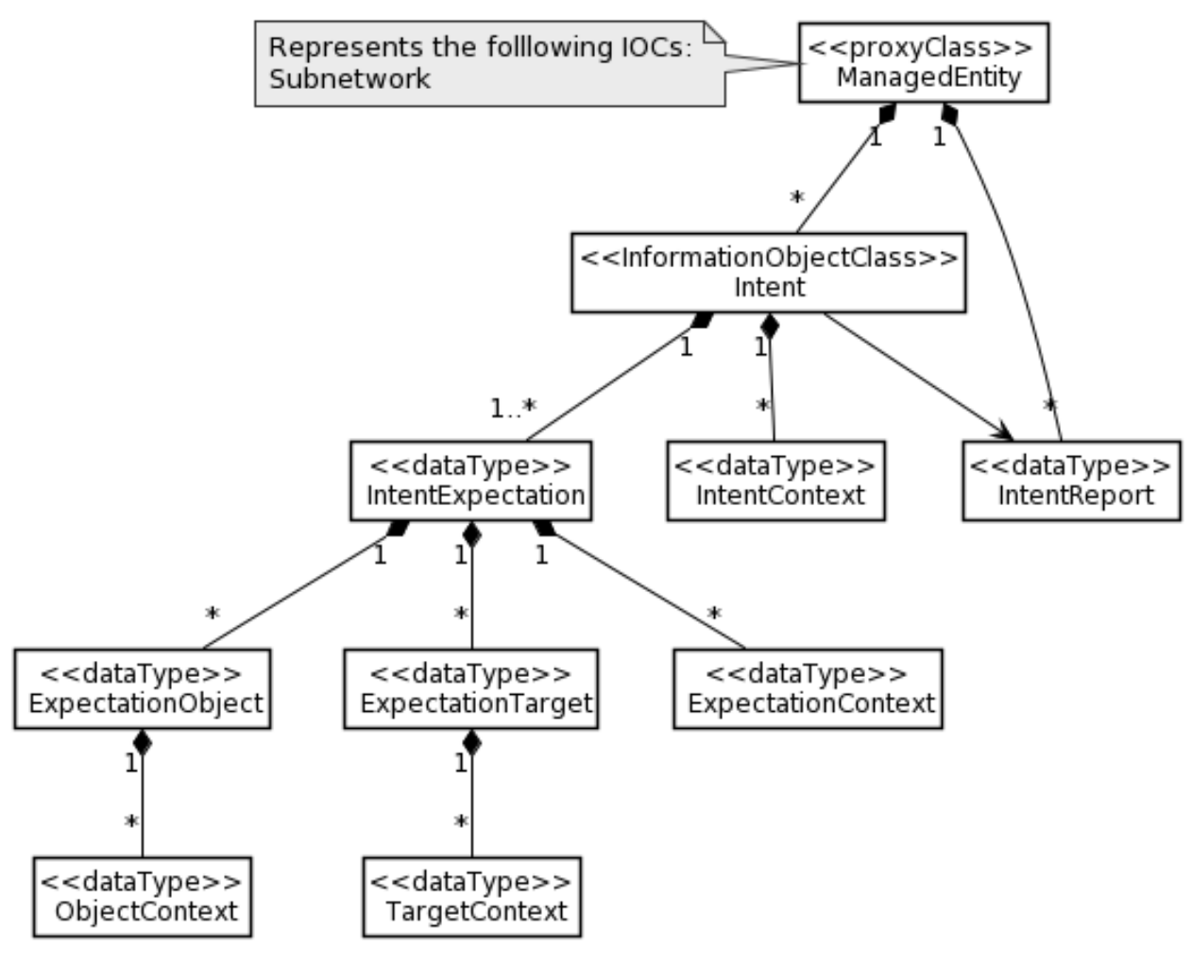
Figure 6.2.1.1.1-1 Relationship UML diagram for intent

Editor’s Note: The detailed model for Intent, IntentReport and IntentExpectation objects (e.g. is it <<IOC>>, <<DataType>>, or string) is FFS as their relationship needs to be decided later based on the content of these three objects

6.2.1.1.2 Inheritance

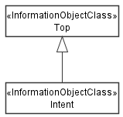
Figure 6.2.1.1.2-1 Inheritance UML diagram for intent

6.2.1.2 Class definition

6.2.1.2.1 Intent <<IOC>>

6.2.1.2.1.1 Definition
This IOC represents the properties of an Intent driven management information between MnS consumer and MnS producer.
The Intent IOC contains one or multiple IntentExpectation(s) which includes MnS consumer’s requirements, goals and contexts given to a 3GPP system.
The Intent IOC includes the attribute objectClass and objectInstance from the TOP IOC. The value of attribute objectClass is “Intent” and the value of attribute objectInstance is the DN of the instance of Intent IOC.

6.2.1.2.1.2 Attributes
The Intent IOC includes attributes inherited from TOP IOC (defined in TS 28.622) and the following attributes:
Attribute Name | Support Qualifier | isReadable | isWritable | isInvariant | isNotifyable
intentExpectations | M | T | T | F | F
userLabel | M | T | T | F | F
intentContexts | O | T | T | F | F
intentFulfilStatus | M | T | F | F | T

6.2.1.2.1.3 Attribute constraints
None

includes the following attributes:

2nd Change

6.2.1.3 DataType definition

6.2.1.3.1 IntentExpectation <<dataType>>

6.2.1.3.1.1 Definition
IntentExpectation <<dataType>>represents MnS consumer’s requirements, goals and contexts given to a 3GPP system. The information of IntentExpectation is generated by MnS consumer and delivered to MnS producer.

6.2.1.3.1.2 Attributes
The IntentExpectation includes the following attributes:
Attribute Name | Support Qualifier | isReadable | isWritable | isInvariant | isNotifyable
expectationId | M | T | T | T | F
expectationObject | O | T | T | F | F
expectationTargets | M | T | T | F | F
expectationContexts | O | T | T | F | F

Note: The scenario/requirements-specific IntentExpectations are defined utilizing the constructs of this generic IntentExpectation model.

6.2.1.3.1.3 Attribute constraints
TBD

6.2.1.3.3 ExpectationObject <<dataType>>

6.2.1.3.3.1 Definition
The ExpectationObject <<dataType>> represents the Object of the IntentExpectation that are required to be applied on.

6.2.1.3.3.2 Attributes
The expectationObject includes the following attributes:
Attribute Name | Support Qualifier | isReadable | isWritable | isInvariant | isNotifyable
ObjectType | CM | T | T | F | F
ObjectInstance | CM | T | T | F | F
ObjectContexts | O | T | T | F | F

6.2.1.3.3.3 Attribute constraints
Name | Definition
ObjectType  Support Qualifier | Condition: The intent expectation is not for a specific object instance or MnS consumer have no knowledge of the DN of this specific object instance.
ObjectInstance  Support Qualifier | Condition: The intent expectation is for a specific object instance and MnS consumer have the knowledge of the DN of this specific object instance

6.2.1.3.4 ExpectationTarget <<dataType>>

6.2.1.3.4.1 Definition
The ExpectationTarget <<dataType>> represents the targets of the IntentExpectation that are required to be achieved.

6.2.1.3.4.2 Attributes
The expectationTarget includes the following attributes:
Attribute Name | Support Qualifier | isReadable | isWritable | isInvariant | isNotifyable
targetName | M | T | T | F | F
targetCondition | M | T | T | F | F
targetValueRange | M | T | T | F | F
targetContexts | O | T | T | F | F

6.2.1.3.4.3 Attribute constraints
None

6.2.1.3.5 Context <<dataType>>

6.2.1.3.5.1 Definition
The Context <<dataType>> represents the properties of a context. A context describes the list of constraints and conditions that should evaluate to true when the targets are fulfilled but are themselves not to be enforced. The context may apply to the intent, the intent expectation, the intent targets or to the object.

6.2.1.3.5.2 Attributes
The Context includes the following attributes:
Attribute Name | Support Qualifier | isReadable | isWritable | isInvariant | isNotifyable
contextAttribute | M | T | T | F | F
contextCondition | M | T | T | F | F
contextValueRange | M | T | T | F | F

6.2.1.3.5.3 Attribute constraints
None
3rd Change

6.2.1.4 Attribute definition

Attribute Name | Documentation and Allowed Values | Properties
userLabel | A user-friendly (and user assignable) name of the intent.  allowedValues: Not Applicable | type: String  multiplicity: 1  isOrdered: F  isUnique: F  defaultValue: None  isNullable: False
intentExpectations | It describes the expectations including requirements, goals and contexts (including constraints and filter information) given to a 3GPP system. It states the list of specific outcomes desired to be realized for expectation object(s).  allowedValues: Not Applicable | type: IntentExpectation  multiplicity: 1..*  isOrdered: F  isUnique: F  defaultValue: None  isNullable: False
intentFulfilStatus | It describes the current status of the intent fulfilment result, which is configured by MnS producer and can be read by MnS consumer.  allowedValues: "FULFILLED", “NOT_FULFILLED | type: ENUM  multiplicity: 1  isOrdered: N/A  isUnique: N/A  defaultValue: None  isNullable: False
intentContexts | It describes the list of IntentContext(s) which represents the constraints and conditions that should apply for the entire intent even if there may be specific contexts defined for specific parts of the intent.  allowedValues: triple of (attribute, condition, value range) | type: Context  multiplicity: *  isOrdered: False  isUnique: False  defaultValue: None  isNullable: False
expectationId | A user-friendly (and user assignable) name of the intentExpectation.  allowedValues: Not Applicable | type: String  multiplicity: 1  isOrdered: False  isUnique: False  defaultValue: None  isNullable: False
expectationObject | It describes the expectation objects of the IntentExpectation that are required to be applied on.  allowedValues: Not Applicable | type: ExpectationObject  multiplicity: 1  isOrdered: False  isUnique: False  defaultValue: None  isNullable: False
objectType | It describes the type of expectation object of the IntentExpectation that are required to be applied on. It can be class name of the managed object.  allowedValues: see scenario specific Intent Expectation | type: Enum  multiplicity: 1  isOrdered: False  isUnique: False  defaultValue: None  isNullable: False
objectInstance | It describes an specific object instance (e.g. instance of managed object) to which the intentExpectation should apply.  allowedValues: Not Applicable | type: DN  multiplicity: 1  isOrdered: False  isUnique: False  defaultValue: None  isNullable: False
objectContexts | It describes the list of ObjectContext(s) which represents the constraints and conditions to be used as filter information to identify the object(s) to which a given intentExpectation should apply. Note there may be other constraints and conditions defined either for the entire intent, for the specific intentExpectation or for the expectationTarget of the considered intentExpectation.  allowedValues: depends on ExpectationObject in the IntentExpectation | type: Context  multiplicity: *  isOrdered: False  isUnique: False  defaultValue: None  isNullable: False
expectionTargets | It describes the list of ExpectationTarget(s) which represent specific outcomes on the metrics that characterize the performance of the object(s) or some abstract index that expresses the behavior of the object(s) that are desired to be realized for a given intentExpectation.  allowedValues: depends on Expectation Object in the IntentExpectation | type: ExpectationTarget  multiplicity: 1..*  isOrdered: False  isUnique: False  defaultValue: None  isNullable: False
expectationContexts | It describes the list of context(s) which represents the constraints and conditions that should apply for a specific intentExpectation.  Note there may be other constraints and conditions defined for the entire intent or for specific parts of the intentExpectation.  allowedValues: depends on Expectation Object in the IntentExpectation | type: Context  multiplicity: 1..*  isOrdered: False  isUnique: False  defaultValue: None  isNullable: False
targetName | It describes the name of the Expectation of the expectation target which represents specific outcomes on the metrics that characterize the performance of the object(s) or some abstract index that expresses the behavior of the object(s) that are desired to be realized for a given intentExpectation.  allowedValues: depends on ExpectationObject in the IntentExpectation | type: String  multiplicity: 1  isOrdered: False  isUnique: False  defaultValue: Null  isNullable: True
targetCondition | It expresses the limits within which the targetName is allowed/supposed to be  allowedValues: is equal to; is less than; is greater than:  "is within the range" ; "is outside the range" c | type: Enum  multiplicity: 1  isOrdered: False  isUnique: False  defaultValue: "is equal to"  isNullable: False
targetValueRange | It describes the range of values that applicable to the targetName and the TargetCondition.  allowedValues: depends on the targetName | type: Real  multiplicity: 1  isOrdered: False  isUnique: False  defaultValue: Null  isNullable: True
targetContexts | It describes the list of constraints and conditions that should apply for a specific expectationTarget. Note there may be other constraints and conditions defined for the entire intent or the intentExpectation.  allowedValues: Not Applicable | type: Context  multiplicity: 1..*  isOrdered: False  isUnique: False  defaultValue: None  isNullable: False
contextAttribute | It describes a specific attribute of or related to the object or to characteristics thereof (e.g. its control parameter, gauge, counter, KPI, weighted metric, etc) to which the expectation should apply or an attribute related to the operating conditions of the object (such as weather conditions, load conditions, etc). | type: String  multiplicity: 1  isOrdered: False  isUnique: False  defaultValue: Null  isNullable: True
contextCondition | It expresses the limits within which the ContextAttribute is allowed/supposed to be  allowedValues: is equal to; is less than; is greater than;  "is within the range" ;"is outside the range" . | type: Enum  multiplicity: upto 1  isOrdered: False  isUnique: False  defaultValue: "is equal to"  isNullable: False
contextValueRange | It describes the range of values that applicable to the ContextAttribute and the ContextCondition.  AllowedValue: depends on the contextAttribute | type: Real  multiplicity: 1  isOrdered: False  isUnique: False  defaultValue: Null  isNullable: True

3rd Change

A.2 Information model definition for Intent

A.2.1 Relationship UML diagram for intent (Figure 6.2.1.1.2-1)

@startuml
hide circle
hide methods
hide members

skinparam class {
AttributeIconSize 0
BackgroundColor white
BorderColor black
ArrowColor black
}
skinparam Shadowing false
skinparam Monochrome true
skinparam ClassBackgroundColor White

class “<<proxyClass>> \n ManagedEntity ” as ManagedEntity{}
class “<<InformationObjectClass>>\n Intent ” as Intent {}
class “<<dataType>>\n IntentExpectation” as IntentExpectation{}
class “<<dataType>>\n IntentContext” as IntentContext{}
class “<<dataType>>\n IntentReport” as IntentReport{}
class “<<dataType>>\n ExpectationObject” as ExpectationObject{}
class “<<dataType>>\n ObjectContext” as ObjectContext{}
class “<<dataType>>\n ExpectationTarget” as ExpectationTarget{}
class “<<dataType>>\n TargetContext” as TargetContext{}
class “<<dataType>>\n ExpectationContext” as ExpectationContext{}

ManagedEntity "1" *-- "*" Intent
ManagedEntity "1" *-- "*" IntentReport
Intent --> IntentReport
Intent "1" *-- "1..*" IntentExpectation
Intent "1" *-- "*" IntentContext

IntentExpectation "1" *-- "*" ExpectationTarget
IntentExpectation "1" *-- "*" ExpectationObject
IntentExpectation "1" *-- "*" ExpectationContext
ExpectationObject "1" *-- "*" ObjectContext
ExpectationTarget "1" *-- "*" TargetContext

note left of ManagedEntity
Represents the folllowing IOCs:
Subnetwork
end note

@enduml

4th Change

Annex C (informative): Mapping the 3GPP and the TM Forum intentExpectation Models
The TM forum defines the structure of an intent as a list of expectations with each expectation containing the requirements goals and constraints to be achieved. The expectation is defined to contain 2 attributes - the imm:target and the imm:params. On the hand, the intentExpectation defined in 3GPP (see clause 6.2.1.2.2) contain more attributes some of which (the expectionObject(including objectType,obejctInstance an dObjectContext) expectationTargets and expectationContexts)can be mapped to the TM Forum model.
Following the table to illustrate the attributes mapping between 3GPP Intent Expectation and TM Forum IntentExpectation
3GPP Intent Expectation | TM Forum Intent Expectation
Class Property | Attribute
expectionObject.ObjectInstance | imm:target
expectationObject.objectType | imm:params
expectionObject.ObjectContexts | imm:params
expectationTargets | imm:params
expectationContexts | imm:params

End of changes

