3GPP TSG-SA5 Meeting #141-e S5-221131

e-meeting, 17 -26 January 2022

Source: Huawei

Title: Rapporteur clean up

Document for: Approval
Agenda Item: 6.4.9

1 Decision/action requested
The group is asked to discuss and approval.

2 References
[1] 3GPP draft TS 28.312: “Management and orchestration; Intent driven management services for mobile networks v0.7.0”.

3 Rationale
This contribution proposes to do the following rapporteur clean up:
- Add missing Introduction
- Remove the Editor's Note in the beginning of each clause which capture the content description
- Add missing reference and current reference number for TS 28.530 in clause 4.1.2
- Correct the Figure number in clause 4.2.3

4 Detailed proposal
It proposes to make the following changes to TS 28.312[1].
1st Change

Introduction
The current 5G networks brings more operational complexities, and the telecom system need to be able to adapt their operation to the business objectives of the operator as well as expectations of customer, which is driving customer to shift the focus from "how" to "what". An intent driven system will be able to learn the behaviour of networks and services and allows a customer to provide the desired state, without detailed knowledge of how to get to the desired state. Thus, the intent driven management is introduced to reduce the complexity of management without getting into the intricate detail of the underlying network resources.

2nd Change

2 References
The following documents contain provisions which, through reference in this text, constitute provisions of the present document.
- References are either specific (identified by date of publication, edition number, version number, etc.) or non-specific.
- For a specific reference, subsequent revisions do not apply.
- For a non-specific reference, the latest version applies. In the case of a reference to a 3GPP document (including a GSM document), a non-specific reference implicitly refers to the latest version of that document in the same Release as the present document.
[1] 3GPP TR 21.905: "Vocabulary for 3GPP Specifications".
[2] 3GPP TS 28.531: "Management and orchestration; Provisioning".
[3] 3GPP TS 28.532: " Management and orchestration; Generic management services"
[4] 3GPP TS 28.530: " Management and orchestration; Concept, use cases and requirements"

3rd Change

4 Concepts and Background

4th Change

4.1.2 Intent categorizes based on user types
Based on roles related to 5G networks and network slicing management defined in clause 4.8 in TS 28.530[4], different kinds of intents are applicable for different kinds of standardized reference interfaces.
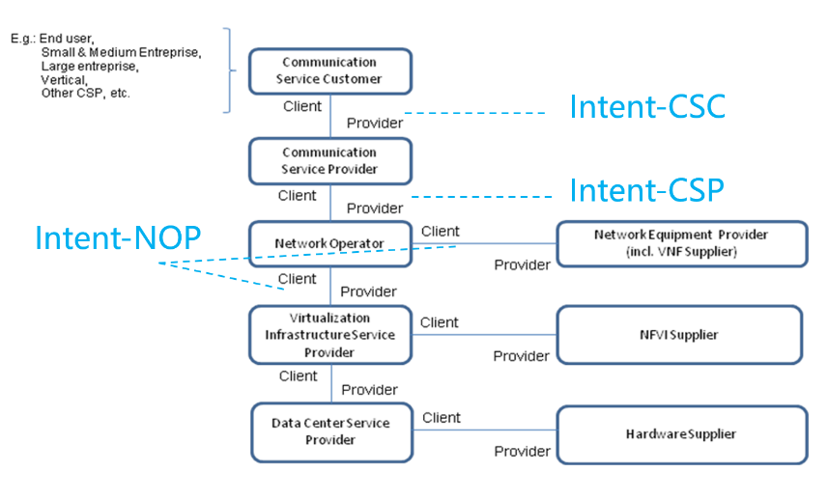
Figure 4.1.2-1: High-level model of different kind of intents expressed by different roles
- Intent from Communication Service Customer (Intent-CSC): Intent from Communication Service Customer enables Communication Service Customer (CSC) to express which properties of a communication service the CSC may request from CSP without knowing how to do the detailed management for communication service. For example, Intent-CSC can be 'Enable a V2X communication service for a group of vehicles in certain time'.
- Intent from Communication Service Provider (Intent-CSP): Intent from Communication Service Provider enables Communication Service Provider (CSP) to express an intent about what CSP would like to do for network without knowing how to do the detailed management for network. For example, Intent-CSP can be 'Provide a network service supporting V2X communications for highway-417 to support 500 vehicles simultaneously'.
- Intent from Network Operator(Intent-NOP): Intent from Network Operator enables Network Operator (NOP) to provide what NOP would like to do for group of network elements (i.e. subnetwork) management and control without knowing how to do the detailed management for the network elements. For example, Intent-NOP can be 'Provide a radio network service to satisfy the specified coverage requirements and UE throughput requirement in certain area'.

5th Change

4.2.3 Intent translation
The Intent driven MnS producer is the provider of Intent driven MnS and is responsible for deriving activities for networks and services or other intent(s).
The MnS consumer may consume Intent Driven MnS(s) provided by the Intent driven MnS producer(s) or may have the consumer role for non-intent MnS producers.
The conflict(s) including conflict between the intent and other intent(s) and/or Non-intent requirements needs to be detected and resolved during the intent translation. Figure 4.2.3-1 illustrate the potential way to satisfy intents originating from CSC:
- Intent-CSC MnS producer provides intent driven MnS for communication services. Intent-CSC MnS producers receive the expressed intent and translate it to Intent-CSP or network requirements, then may consume Intent-CSP MnS(s) or Non-Intent MnS(s) for network to fulfil the intent-CSC.
- Intent-CSP MnS producer provides intent driven MnS for network services. Intent-CSP MnS producers receive the intent and translate it to new Intents for NOP or network element requirements, then may consume Intent-NOP MnS(s) or Non-Intent MnS(s) for NE to fulfil the intent-CSP.
- Intent-NOP MnS producer provides intent driven MnS for network equipment. Intent-NOP MnS Producers receive the expressed intent, and translate it to detailed network element requirements, then takes some internal actions to fulfil the intent-NEP.
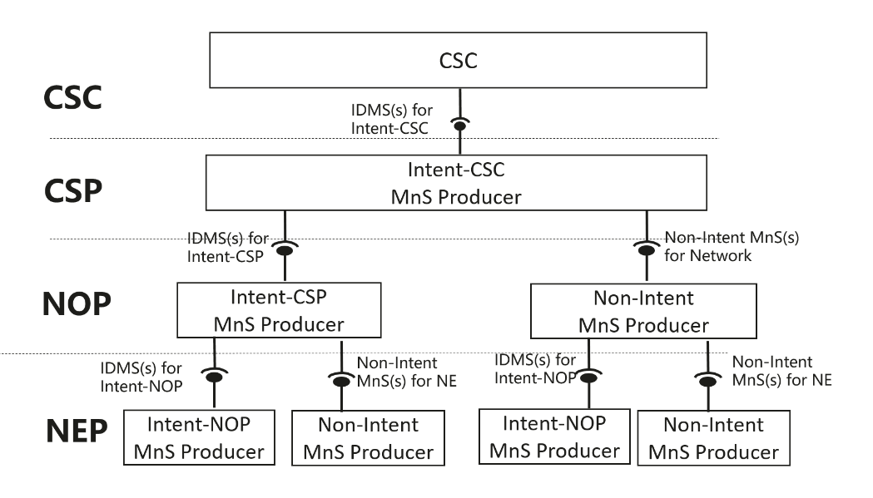
Figure 4.2.3-1: Potential way to satisfy intent-CSC originating from CSC

6th Change

5 Specification Level Requirements

7th Change

5.1 Use cases

8th Change

5.2 Generic requirements for intent driven MnS

9th Change

6 Stage 2 definition for Intent Driven Management

10th Change

6.3 Procedures for intent management

6.3.1 Introduction
This clauses describes the procedures for intent management.

11th Change

7 Stage 3 definition for Intent Driven Management

End of Changes

