**3GPP TSG-SA5 Meeting #141-e *S5-221091rev2***

**e-meeting, 17 -26 January 2022**

|  |  |  |  |  |  |  |  |  |
| --- | --- | --- | --- | --- | --- | --- | --- | --- |
| *CR-Form-v12.1* | | | | | | | | |
| **CHANGE REQUEST** | | | | | | | | |
|  | | | | | | | | |
|  | **28.533** | **CR** | **0096** | **rev** | **-** | **Current version:** | **17.1.0** |  |
|  | | | | | | | | |
| *For* [***HELP***](http://www.3gpp.org/3G_Specs/CRs.htm#_blank)*on using this form: comprehensive instructions can be found at* [*http://www.3gpp.org/Change-Requests*](http://www.3gpp.org/Change-Requests)*.* | | | | | | | | |
|  | | | | | | | | |

|  |  |  |  |  |  |  |  |  |
| --- | --- | --- | --- | --- | --- | --- | --- | --- |
| ***Proposed change affects:*** | UICC apps |  | ME |  | Radio Access Network | **X** | Core Network | **X** |

|  |  |  |  |  |  |  |  |  |  |  |
| --- | --- | --- | --- | --- | --- | --- | --- | --- | --- | --- |
|  | | | | | | | | | | |
| ***Title:*** | Update on management capability exposure governance | | | | | | | | | |
|  |  | | | | | | | | | |
| ***Source to WG:*** | Huawei | | | | | | | | | |
| ***Source to TSG:*** | S5 | | | | | | | | | |
|  |  | | | | | | | | | |
| ***Work item code:*** | 5GDMS | | | | |  | ***Date:*** | | | 2022-01-07 |
|  |  | | | |  | |  | | |  |
| ***Category:*** | C |  | | | | | ***Release:*** | | | Rel-17 |
|  | *Use one of the following categories:* ***F*** *(correction)* ***A*** *(mirror corresponding to a change in an earlier release)* ***B*** *(addition of feature),* ***C*** *(functional modification of feature)* ***D*** *(editorial modification)*  Detailed explanations of the above categories can be found in 3GPP [TR 21.900](http://www.3gpp.org/ftp/Specs/html-info/21900.htm). | | | | | | | | *Use one of the following releases: Rel-8 (Release 8) Rel-9 (Release 9) Rel-10 (Release 10) Rel-11 (Release 11) … Rel-15 (Release 15) Rel-16 (Release 16) Rel-17 (Release 17) Rel-18 (Release 18)* | |
|  |  | | | | | | | | | |
| ***Reason for change:*** | | The Exposure Governance Management Function (EGMF) was originally defined in TS 28.533 as an MnF providing management capability exposure governance. However, the details of EGMF management capability exposure governance is still FFS, see the NOTE in TS 28.533 clause A.3. To fix this NOTE and facilitate the ongoing management capability exposure discussion in SA5, it is proposed to add the detailed EGMF functionality. | | | | | | | | |
|  | |  | | | | | | | | |
| ***Summary of change:*** | | Add detailed EGMF functionality. | | | | | | | | |
|  | |  | | | | | | | | |
| ***Consequences if not approved:*** | |  | | | | | | | | |
|  | |  | | | | | | | | |
| ***Clauses affected:*** | | new 4.4.1, new 4.4.2, new 4.4.3, 4.7.1, A.3 | | | | | | | | |
|  | |  | | | | | | | | |
|  | | **Y** | **N** |  | | | |  | | |
| ***Other specs*** | |  | **x** | Other core specifications | | | | TS/TR ... CR ... | | |
| ***affected:*** | |  | **x** | Test specifications | | | | TS/TR ... CR ... | | |
| ***(show related CRs)*** | |  | **x** | O&M Specifications | | | | TS/TR ... CR ... | | |
|  | |  | | | | | | | | |
| ***Other comments:*** | |  | | | | | | | | |
|  | |  | | | | | | | | |
| ***This CR's revision history:*** | |  | | | | | | | | |

|  |
| --- |
| **1st modified section** |

## 4.4 Management capability exposure governance

### 4.4.1 General

As precondition for Management Service exposure governance offer, producer of management capability exposure governance should have access to:

An association between information about specified management service components and instances of management services.

NOTE: The detail creation of an association is left for implementation and out of scope of 3GPP standardization.

Management capability exposure governance provides exposure governance on basic elements of management function service based interface:

1) Management service component type A

2) Management service component type B

3) Management service component type C

As described in Figure 4.4.1 left hand part, when there is a Management Service A exposure without exposure governance, Management Service A Consumer (e.g. an authorized internal MnS consumer in the Network Operator (NOP) domain) can access all management capability offered by Management Service A Producer.

As described in Figure 4.4.1 right hand part, when Management Service A is exposed with applied exposure governance it becomes Management Service A'. Management Service A' Consumer, which may be 3rd party such as other operator, other management system, AF, other administrative domain, etc. can access Management Service A' after following steps:

- Management Service A, exposed by Management Service A Producer, is consumed by Management Service A Consumer;

- Management Service B, exposed by Management Service B Producer, is consumed by Management Service B Consumer (e.g. operator) who is authorized to access offered management capabilities exposure governance(s);

- Management Service B Consumer (e.g. operator) request a specified exposure governance on Management Service A;

- Management Service A' Producer produces Management Service A' based on applied exposure governance on consumed Management Service A.

NOTE: The Management Service A Consumer, the Management Service A' Producer and Management Service B Producer can be represented as a single Management Function e.g. a single MnF as EGMF providing management capability exposure governance).

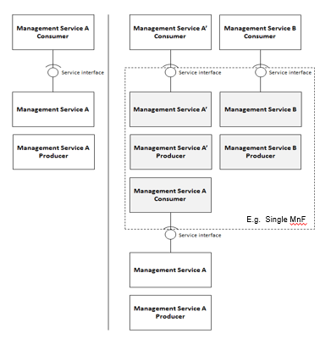

Figure 4.4.1: Management capability exposure governance applied on exposed Management Service A

### 4.4.2 EGMF functionality

The Exposure Governance Management Function (EGMF) supports the following independent functionality:

- Exposure of capabilities and events:

- Management capabilities and events may be securely exposed by EGMF for 3rd party e.g. other operator, other management system, Application Function.

- External exposure can be categorized as Fault Supervision capability, Performance Assurance capability and Provisioning capability.

1. The Fault Supervision capability is for allowing external fault supervision management services consumer to obtain fault supervision data report and have control on fault supervision data via Fault Supervision management services (see TS 28.545 [28]) exposed by EGMF.
2. The Performance Assurance capability is for collecting real-time performance data (see performance measurements and assurance data defined in TS 28.552 [5] and KPIs defined in TS 28.554 [6]) that can be consumed by applications with specific purposes for external exposure via the EGMF to detect the potential issues.
3. The Provisioning capability is for allowing external network management services consumer to obtain certain management capability to manage the network (e.g., network slice instance provisioning, see TS 28.541 [4] and 28.531 [8]) through the exposure interface via EGMF.

- Exposure of analytics: MDAF analytics may be securely exposed by EGMF for external 3rd party.

Editor's NOTE: how the exposure of management capabilities is made is FFS (this is the point where 3GPP needs to coordinate across WGs and where alignment with OPAG/CAMARA initiatives is needed).

### 4.4.3 EGMF services

When the operator decides to expose a management service (MnS), the operator selects the MnS(s) to be exposed, including which operations and which data. The operator may use the MnS discovery service to collect information. The operator exposes the MnS and registers it with the MnS discovery service, the MnS discovery service may be implemented using an EGMF.

|  |
| --- |
| **Next modified section** |

## 4.7 Management service discovery

### 4.7.1 Introduction

The MnS consumer in an operator’s management system or as external 3rd party customer needs to discover the availability of MnS instances provided by other MnS producer(s). In order to enable the MnS instances to be discovered by MnS consumer, the MnS needs to be discoverable to the operator’s management system when the MnS instance become operative.

|  |
| --- |
| **Next modified section** |

# A.3 Utilization of management services by Exposure Governance Management Function (EGMF)

Exposure Governance Management Function (EGMF) offers following management capability (Figure A.3.1):

- Exposure governance

In Figure A.3.1, EGMF produces exposure governance management capability that operators can apply on Management Function (MnF) 1 MnS for exposing different derivation of MnF 1 MnS to:

- MnF 2 (e.g. from another Operator) and

- 3rd party (e.g. from vertical industry).

NOTE: Exposure governance can be controlled by a policy for different type of MnF 1 MnS consumers (e.g. other operator, other management system, 3rd party, other administrative domain, etc.)

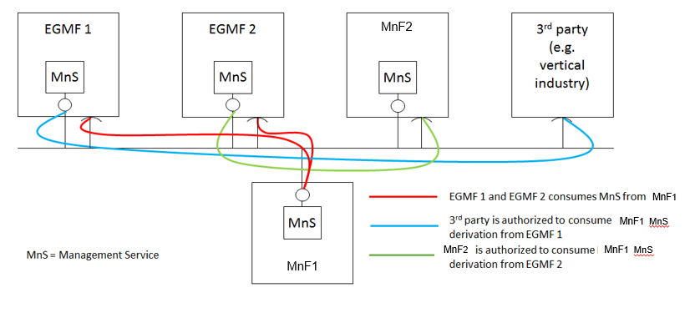

Figure A.3.1: MnF-1 Management Service (MnS) exposed through Exposure Governance Management Function 1 (EGMF 1) and through Exposure Governance Management Function 2 (EGMF 2)

|  |
| --- |
| **End of modified section** |