3GPP TSG-SA5 Meeting #141-e S5-221091rev1

e-meeting, 17 -26 January 2022
CR-Form-v12.1
CHANGE REQUEST
 | 28.533 | CR | 0096 | rev | - | Current version: | 17.1.0
For HELP on using this form: comprehensive instructions can be found at
http://www.3gpp.org/Change-Requests.

Proposed change affects: | UICC apps |  | ME |  | Radio Access Network | X | Core Network | X

Title: | Update on management capability exposure governance
Source to WG: | Huawei
Source to TSG: | S5
Work item code: | 5GDMS |  |  |  |  |  | Date: |  |  | 2022-01-07
Category: | C |  |  |  |  |  | Release: |  |  | Rel-17
 | Use one of the following categories:  F (correction)  A (mirror corresponding to a change in an earlier release)  B (addition of feature),  C (functional modification of feature)  D (editorial modification)  Detailed explanations of the above categories can  be found in 3GPP TR 21.900. |  |  |  |  |  |  |  | Use one of the following releases:  Rel-8 (Release 8)  Rel-9 (Release 9)  Rel-10 (Release 10)  Rel-11 (Release 11)  …  Rel-15 (Release 15)  Rel-16 (Release 16)  Rel-17 (Release 17)  Rel-18 (Release 18)
Reason for change: |  | The Exposure Governance Management Function (EGMF) was originally defined in TS 28.533 as an MnF providing management capability exposure governance. However, the details of EGMF management capability exposure governance is still FFS, see the NOTE in TS 28.533 clause A.3. To fix this NOTE and facilitate the ongoing management capability exposure discussion in SA5, it is proposed to add the detailed EGMF functionality.
Summary of change: |  | Add detailed EGMF functionality.
Consequences if not approved:
Clauses affected: |  | new 4.4.1, new 4.4.2, new 4.4.3, 4.7.1, A.3
 |  | Y | N
Other specs |  |  | x | Other core specifications |  |  |  | TS/TR ... CR ...
affected: |  |  | x | Test specifications |  |  |  | TS/TR ... CR ...
(show related CRs) |  |  | x | O&M Specifications |  |  |  | TS/TR ... CR ...
Other comments:
This CR's revision history:

1st modified section

4.4 Management capability exposure governance

4.4.1 General
As precondition for Management Service exposure governance offer, producer of management capability exposure governance should have access to:
An association between information about specified management service components and instances of management services.
NOTE: The detail creation of an association is left for implementation and out of scope of 3GPP standardization.
Management capability exposure governance provides exposure governance on basic elements of management function service based interface:
1) Management service component type A
2) Management service component type B
3) Management service component type C
As described in Figure 4.4.1 left hand part, when there is a Management Service A exposure without exposure governance, Management Service A Consumer (e.g. an authorized internal MnS consumer in the Network Operator (NOP) domain) can access all management capability offered by Management Service A Producer.
As described in Figure 4.4.1 right hand part, when Management Service A is exposed with applied exposure governance it becomes Management Service A'. Management Service A' Consumer, which may be 3rd party such as other operator, other management system, AF, other administrative domain, etc. can access Management Service A' after following steps:
- Management Service A, exposed by Management Service A Producer, is consumed by Management Service A Consumer;
- Management Service B, exposed by Management Service B Producer, is consumed by Management Service B Consumer (e.g. operator) who is authorized to access offered management capabilities exposure governance(s);
- Management Service B Consumer (e.g. operator) request a specified exposure governance on Management Service A;
- Management Service A' Producer produces Management Service A' based on applied exposure governance on consumed Management Service A.
NOTE: The Management Service A Consumer, the Management Service A' Producer and Management Service B Producer can be represented as a single Management Function e.g. a single MnF as EGMF providing management capability exposure governance).
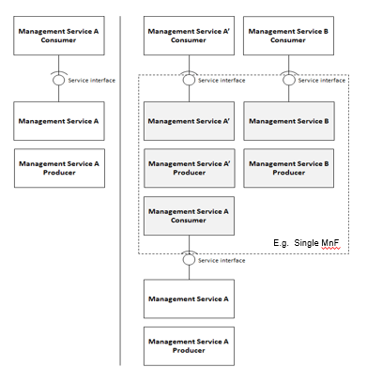
Figure 4.4.1: Management capability exposure governance applied on exposed Management Service A

4.4.2 EGMF functionality
The Exposure Governance Management Function (EGMF) supports the following independent functionality:
- Exposure of capabilities and events:
- Management capabilities and events may be securely exposed by EGMF for 3rd party e.g. other operator, other management system, Application Function.
- External exposure can be categorized as Fault Supervision capability, Performance Assurance capability and Provisioning capability.
- The Fault Supervision capability is for allowing external fault supervision management services consumer to obtain fault supervision data report and have control on fault supervision data via Fault Supervision management services (see TS 28.545 [28]) exposed by EGMF.
- The Performance Assurance capability is for collecting real-time performance data (see performance measurements and assurance data defined in TS 28.552 [5] and KPIs defined in TS 28.554 [6]) that can be consumed by applications with specific purposes for external exposure via the EGMF to detect the potential issues.
- The Provisioning capability is for allowing external network management services consumer to obtain certain management capability to manage the network (e.g., network slice instance provisioning, see TS 28.541 [4] and 28.531 [8]) through the exposure interface via EGMF.
- Exposure of analytics: MDAF analytics may be securely exposed by EGMF for external 3rd party.
- Translation of internal-external information:
It provides a means for the 3rd party to securely provide information to 3GPP network management system, e.g. Expected UE Behaviour, 5G UE group information and service specific information (e.g. Network Slice type with different flavours: Silver, Gold, Platinum). In that case the EGMF may authenticate and authorize and assist in throttling the 3rd party.
It translates between information exchanged with the 3rd party and information exchanged with the internal network management function. For example, it translates between service specific identifier and internal network management information such as S-NSSAI, PLMN Id.
In particular, EGMF handles masking of network management and user sensitive information to external 3rd party according to the network management policy.
- The EGMF receives information from other network management functions (based on exposed capabilities of other network management functions). EGMF stores the received information as structured data. The stored information can be accessed and "re-exposed" by the EGMF to 3rd party like other network management functions and Application Functions, and used for other purposes such as analytics.
A specific EGMF instance may support one or more of the functionalities described above and consequently an individual EGMF may support a subset of the APIs specified for capability exposure.

4.4.3 EGMF services
When the operator decides to expose a management service (eMnS), the operator selects the MnS(s) to be exposed, including which operations and which data. As part of the solution, the operator may use the MnS discovery service to collect information. The operator exposes the MnS and registers it with the eMnS discovery service, the eMnS discovery service may be implemented using an EGMF. The eMnS discovery service consumer sends a request using the eMnS discovery to obtain the eMnS data.

Next modified section

4.7 Management service discovery

4.7.1 Introduction
The MnS consumer in an operator’s management system or as external 3rd party customer needs to discover the availability of MnS instances provided by other MnS producer(s). In order to enable the MnS instances to be discovered by MnS consumer, the MnS needs to be discoverable to the operator’s management system when the MnS instance become operative.

Next modified section

A.3 Utilization of management services by Exposure Governance Management Function (EGMF)
Exposure Governance Management Function (EGMF) offers following management capability (Figure A.3.1):
- Exposure governance

In Figure A.3.1, EGMF produces exposure governance management capability that operators can apply on Management Function (MnF) 1 MnS for exposing different derivation of MnF 1 MnS to:
- MnF 2 (e.g. from another Operator) and
- 3rd party (e.g. from vertical industry).
NOTE: Exposure governance can be controlled by a policy for different type of MnF 1 MnS consumers (e.g. other operator, other management system, 3rd party, other administrative domain, etc.)

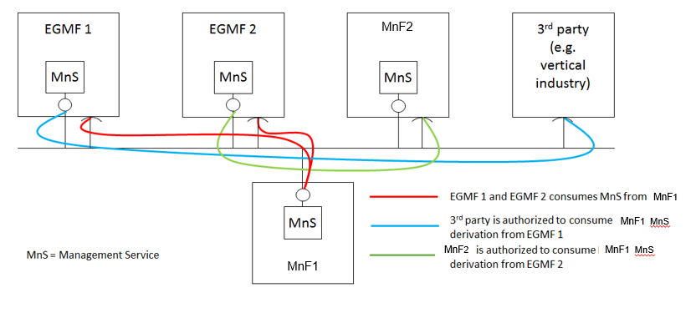
Figure A.3.1: MnF-1 Management Service (MnS) exposed through Exposure Governance Management Function 1 (EGMF 1) and through Exposure Governance Management Function 2 (EGMF 2)

End of modified section

