3GPP TSG-SA5 Meeting #141-e S5-221085rev2

e-meeting, 17 -26 January 2022

Source: Huawei

Title: Solution for collecting UE related data

Document for: Approval
Agenda Item: 6.4.1

1 Decision/action requested
Discuss and approve on the proposal.

2 References
[1] TS 28.557 Management of non-public networks; Stage 1 and stage 2 v1.2.0

3 Rationale
It is proposed to add solutions to support collecting UE related data in draft TS 28.557 [1].

4 Detailed proposal
This document proposes the following changes in TS 28.557 [1].

1st Change

2 References
The following documents contain provisions which, through reference in this text, constitute provisions of the present document.
- References are either specific (identified by date of publication, edition number, version number, etc.) or non-specific.
- For a specific reference, subsequent revisions do not apply.
- For a non-specific reference, the latest version applies. In the case of a reference to a 3GPP document (including a GSM document), a non-specific reference implicitly refers to the latest version of that document in the same Release as the present document.
[1] 3GPP TR 21.905: "Vocabulary for 3GPP Specifications".
[2] 3GPP TS 28.530: "Management and orchestration; Concepts, use cases and requirements".
[3] 3GPP TS 23.501: "System architecture for the 5G System (5GS)".
[4] 3GPP TS 22.261: "Service requirements for the 5G system".
[5] 5G-ACIA White paper: "5G Non-Public Networks for Industrial Scenarios", July 31, 2019.
[6] 3GPP TS 23.003: "Numbering, addressing and identification".
[7] 3GPP TS 28.541: "Management and orchestration; 5G Network Resource Model (NRM); Stage 2 and stage 3".
[8] 3GPP TS 28.531: "Management and orchestration; Provisioning".
[9] 3GPP TS 38.413: "NG-RAN; NG Application Protocol (NGAP)".
[10] 3GPP TS 38.473: "NG-RAN; F1 Application Protocol (F1AP)".
[11] 3GPP TS 38.331: "NR; Radio Resource Control (RRC); Protocol specification".
[12] 3GPP TS 28.552: "Management and orchestration; 5G performance measurements".
[13] 3GPP TS 28.554: "Management and orchestration; 5G end to end Key Performance Indicators (KPI)".
[1x] 3GPP TS 32.422: "Subscriber and equipment trace; Trace control and configuration management".
[1y] 3GPP TS 28.537: " Management and orchestration; Management capabilities ".

2nd Change

6.1 Generic solutions for management of NPN

6.1.x Solution for collecting UE related data
The NPN-SP/OP follows the mechanisms used for the control and configuration of the Trace and MDT as described in TS 32.422 [1x], including:
- the MDT/trace activation procedures in clause 4.1 of TS 32.422 [1x] for MDT/trace configuration, and,
- the MDT/trace reporting procedures in clause 4.6 and 4.7 of TS 32.422 [1x] for UE related data reporting.
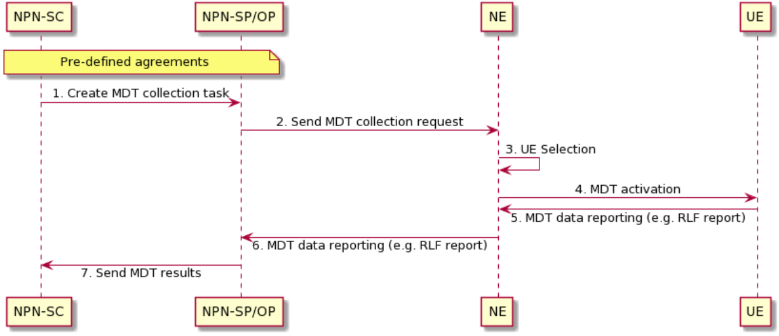
Figure 6.1.x-1 Procedures of UE related data collection
Figure 6.1.x-1 shows the procedure of UE related data collection.
It is assumed that the NPN-SP and NPN-OP roles are played by the same actor in figure 6.1.x-1. The work flow between NPN-SP and NPN-SC for the pre-defined agreements is out of scope of the present document.
1) Based on the pre-defined agreements, NPN-SC sends “Create MDT collection task” request to NPN-SP/OP.
2) The NPN-SP/OP sends a Trace Session activation request to the NE. This request includes the parameters for configuring MDT data collection such as area, job type and list of measurements.
3) After receiving the MDT collection request, NE performs the UE selection based on the input information derived from NPN-SP/OP, such as device capability information and area scope.
4) NE shall activate the MDT functionality and send configuration information to the selected UEs (see clause 4.1 of clause of TS 32.422 [1x]).
5) When UE receives the MDT activation, it shall start the MDT functionality based on the received configuration parameters. The MDT related measurements are then reported to NE.
6) Then NE reports the related data to NPN-SP/OP (see clause 4.6 and 4.7 of TS 32.422 [1x]).
7) According to pre-defined agreements among the NPN roles, some specific UE related data can be provided to authorized NPN customer (see clause 7.2 of TS 28.537 [1y]) such data may be processed or masked based on collected data such as MDT or trace. For example, GNSS information can be extracted from MDT to locate assets in NPN.
3rd Change

Annex A (informative):
PlantUML source code

A.1 Procedure for UE related data collection
@startuml

note over "NPN-SC", "NPN-SP/OP": Pre-defined agreements
"NPN-SC" -> "NPN-SP/OP": 1. Create MDT collection task
"NPN-SP/OP" -> "NE":2. Send MDT collection request
"NE" -> "NE":3. UE Selection

skinparam responseMessageBelowArrow true
"NE" -> "UE":4. MDT activation
"UE" -> "NE":5. MDT data reporting (e.g. RLF report)
"NE" -> "NPN-SP/OP":6. MDT data reporting (e.g. RLF report)
"NPN-SP/OP" -> "NPN-SC":7. Send MDT results

skinparam sequenceMessageAlign center

@enduml

End of change

