3GPP TSG-SA5 Meeting #141-e S5-221083rev1

e-meeting, 17 -26 January 2022

Source: Huawei

Title: Update solution for NPN provisioning by a network slice of a PLMN

Document for: Approval
Agenda Item: 6.4.1

1 Decision/action requested
Discuss and approve on the proposal.

2 References
[1] TS 28.557 Management of non-public networks; Stage 1 and stage 2 v1.2.0

3 Rationale
It is proposed to add procedure figure for NPN provisioning by a network slice of a PLMN in draft TS 28.557 [1] to enhance readability.

4 Detailed proposal
This document proposes the following changes in TS 28.557 [1].

1st Change

6.3.1 Solution for NPN provisioning by a network slice of a PLMN
A mobile network operator (playing the role of NPN-SP) decides to provision a PNI-NPN for private use by an enterprise (playing the role of NPN-SC) in the form of a network slice of a PLMN. NPN-SP and NPN-OP are assumed to be same in this case for simplicity in understanding.
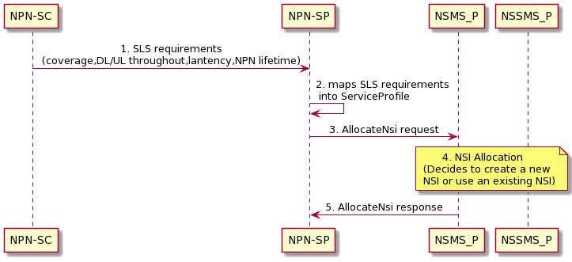
Figure 6.3.1-1: Procedure for NPN provisioning by a network slice of a PLMN
The main aspects of NPN provisioning by a network slice of a PLMN illustrated in Figure 6.3-1 include:
- The NPN-SC provides the NPN related SLA requirements to NPN-SP. These requirements specify NPN related SLS according to different vertical industry requirements (e.g. coverage requirement within a specific geographic area, downlink/uplink throughput requirements, latency requirement, etc.) together with other business related information (e.g. NPN lifetime, NPN slice charging / accounting, etc.). The work flow between NPN-SP and NPN-SC is out of scope of the present document.
- The NPN-SP maps these SLS requirements into ServiceProfile attributes (see TS 28.541 [7]).
- The NPN-SP sends ServiceProfile in “AllocateNSI” request to NSMS_P.
- Then the NSMS_P follows the NSI allocation procedure as described in clause 7.2 in TS 28.531 (This implicitly follows sub-steps like deriving slice profile requirements for subnets from service profile, checking possibility of reusing existing or creating new slice, allocation of NSSI etc. as per procedure defined in TS 28.531 [8]).
- The NG-RAN domain NSSMS_P determines to utilize the existing NG-RAN NE(s) or new NG-RAN NEs that are deployed in the PLMN network or deployed locally at the enterprise's premise or in the factory.
Based on the access policy from operator, from which the NSSMS_P can derive rules like days/time slots/occasions etc. for which an NPN UE can access a CAG cell, the NSSMF assigns the CAG ID identifying the CAG cells which enables the control of UE’s access to related PNI-NPN. The NRCellDU should be configured with the CAG ID to support access control for PNI-NPN UEs. The details of NRCellDU see TS 28.541 [7].
- The 5GC domain NSSMS_P determines to utilize new or existing 5GC NF(s) of the 5GC part that are deployed in the PLMN network.
- If any, the TN domain related requirements are provided to the management system of TN domain.
- The NSMS_P sends NSI allocation result in AllocateNsi response to the NPN-SP including the relevant network slice instance information.
2nd Change

Annex A (informative):
PlantUML source code

A.1 Procedure for NPN provisioning by a network slice of a PLMN
The following PlantUML source code is used to describe the procedure for NPN provisioning by a network slice of a PLMN, as depicted by Figure 6.3-1:
@startuml

"NPN-SC" -> "NPN-SP": 1. SLS requirements\n(coverage,DL/UL throughout,lantency,NPN lifetime)
"NPN-SP" -> "NPN-SP": 2. maps SLS requirements \n into ServiceProfile
"NPN-SP" -> "NSMS_P":3. AllocateNsi request

note over NSMS_P, NSSMS_P: 4. NSI Allocation \n (Decides to create a new NSI \n or use an existing NSI)
"NSMS_P" -> "NPN-SP":5. AllocateNsi response

skinparam sequenceMessageAlign center

@enduml

End of change

