3GPP TSG-SA5 Meeting #141-e S5-221082rev3

e-meeting, 17 -26 January 2022

Source: Huawei

Title: Solution for management of SNPN

Document for: Approval
Agenda Item: 6.4.1

1 Decision/action requested
Discuss and approve on the proposal.

2 References
[1] TS 28.557 Management of non-public networks; Stage 1 and stage 2 v1.2.0

3 Rationale
It is proposed to add solution to support management of SNPN in draft TS 28.557 [1].

4 Detailed proposal
This document proposes the following changes in TS 28.557 [1].

1st Change

2 References
The following documents contain provisions which, through reference in this text, constitute provisions of the present document.
- References are either specific (identified by date of publication, edition number, version number, etc.) or non-specific.
- For a specific reference, subsequent revisions do not apply.
- For a non-specific reference, the latest version applies. In the case of a reference to a 3GPP document (including a GSM document), a non-specific reference implicitly refers to the latest version of that document in the same Release as the present document.
[1] 3GPP TR 21.905: "Vocabulary for 3GPP Specifications".
[2] 3GPP TS 28.530: "Management and orchestration; Concepts, use cases and requirements".
[3] 3GPP TS 23.501: "System architecture for the 5G System (5GS)".
[4] 3GPP TS 22.261: "Service requirements for the 5G system".
[5] 5G-ACIA White paper: "5G Non-Public Networks for Industrial Scenarios", July 31, 2019.
[6] 3GPP TS 23.003: "Numbering, addressing and identification".
[7] 3GPP TS 28.541: "Management and orchestration; 5G Network Resource Model (NRM); Stage 2 and stage 3".
[8] 3GPP TS 28.531: "Management and orchestration; Provisioning".
[9] 3GPP TS 38.413: "NG-RAN; NG Application Protocol (NGAP)".
[10] 3GPP TS 38.473: "NG-RAN; F1 Application Protocol (F1AP)".
[11] 3GPP TS 38.331: "NR; Radio Resource Control (RRC); Protocol specification".
[12] 3GPP TS 28.552: "Management and orchestration; 5G performance measurements".
[13] 3GPP TS 28.554: "Management and orchestration; 5G end to end Key Performance Indicators (KPI)".
[1x] 3GPP TS 28.532: "Management and orchestration; Generic management services".
[1y] 3GPP TS 28.622: "Generic Network Resource Model (NRM); Integration Reference Point (IRP); Information Service (IS)".

2nd Change

6.2 Solutions for management of SNPN

6.2.x Solution for SNPN provisioning with 3GPP segments only
An SNPN, which includes 3GPP segment only, may need to be created for use of an NPN-SC. It is illustrated as provisioning a SNPN in figure 6.2.x-1 which can be used for create SNPN in the MNO Managed Mode and Vertical Managed Mode (see clause 4.3.2).

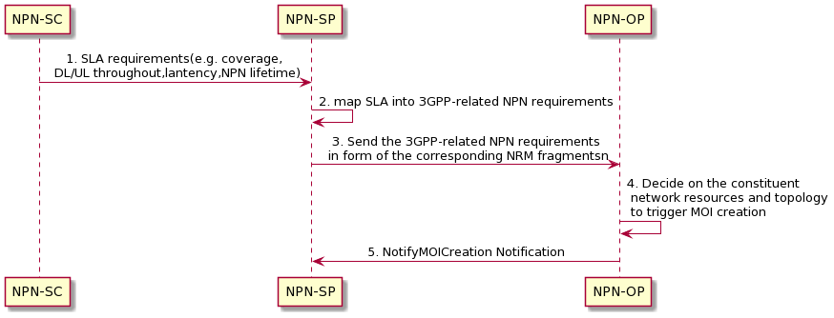
Figure 6.2.x-1 Procedure of SNPN provisioning with 3GPP segments only
- NPN-SP receives SLA requirements of the requested SNPN from NPN-SC. The SLA requirements specifies NPN related SLA according to different vertical industry requirements (e.g. coverage requirement within a specific geographic area, downlink/uplink throughput requirements, latency requirement, etc.) together with other business related information (e.g. NPN lifetime, etc.). The work flow between NPN-SP and NPN-SC is out of scope of present specification.
- Based on the requirements from NPN-SC, NPN-SP maps SLS into 3GPP-related NPN requirements including RAN/CN/TN part-related requirements.
- The NPN-SP sends the 3GPP-related NPN requirements in form of NRM fragments (e.g. serviceProfile <dataType>) to NPN-OP.
- The NPN-OP determines the constituent network resources and topology needed for the SNPN creation. The related Managed Object instance (reference to related information models for NR, 5GC in 3GPP TS 28.541[7] and generic NRM in TS 28.622 [1y], e.g., GNBCUCPFunction IOC, GNBDUFunction IOC, GNBCUUPFunction IOC, SubNetwork IOC, Top IOC and etc) would be created for the requested SNPN using the operations (e.g. createMOI operations) of generic provisioning MnS in TS 28.532 [1x].

The NPN-OP determines to reuse an existing 3GPP segment or create a new 3GPP segment for the requested NPN. If a 3GPP segment from an existing stand-alone NPN can be reused, the NPN-OP may reconfigure that SNPN:
a) In case of creating a new 3GPP segment for the SNPN:
- Based on RAN part-related requirements, the 3GPP network management system determines to utilize new RAN NE(s).
- Based on CN part-related requirements, the 3GPP network management system determines to utilize new CN NF(s) or CN NF service(s).
- Based on TN part-related requirements, the NPN operator configures the underlying transport network, considering the information on SNPN topology (e.g. external connection points of AN and CN) and performance (e.g. latency, bandwidth).
- The NPN-OP notifies the created 3GPP segment information (e.g. the DN of created MOI) to the NPN-SP which subscribes the provisioning notification by re-using the notifications (e.g. NotifyMOICreationnotifications) of generic provisioning MnS in TS 28.532 [1x].

3nd Change

A.x Procedure for SNPN provisioning with 3GPP segments only
The following PlantUML source code is used to describe the procedure for SNPN provisioning with 3GPP segments only, as depicted by Figure 6.2.x-1:
@startuml
"NPN-SC" -> "NPN-SP":1. SLA requirements(e.g. coverage, \n DL/UL throughout,lantency,NPN lifetime)
"NPN-SP" -> "NPN-SP": 2. map SLA into 3GPP-related NPN requirements
"NPN-SP" -> "NPN-OP": 3. Send the 3GPP-related NPN requirements\n in form of the corresponding NRM fragmentsn
"NPN-OP" -> "NPN-OP": 4. Decide on the constituent\n network resources and topology\n to trigger MOI creation
"NPN-OP"-> "NPN-SP": 5. NotifyMOICreation Notification
skinparam sequenceMessageAlign center
@enduml

End of change

