3GPP TSG-SA5 Meeting #141-e S5-221030rev1

Online, , 17th Jan 2022 - 26th Jan 2022
CR-Form-v12.1
CHANGE REQUEST
 | 28.541 | CR | 0642 | rev | - | Current version: | 17.5.0
For HELP on using this form: comprehensive instructions can be found at
http://www.3gpp.org/Change-Requests.

Proposed change affects: | UICC apps |  | ME |  | Radio Access Network | X | Core Network | X

Title: | Rel-17 CR 28.541 Update Figure L.2.1 and accompanying paragraph.
Source to WG: | TELEFONICA S.A.
Source to TSG: | S5
Work item code: | EMA5SLA |  |  |  |  |  | Date: |  |  | 2022-01-05
Category: | F |  |  |  |  |  | Release: |  |  | Rel-17
 | Use one of the following categories:  F (correction)  A (mirror corresponding to a change in an earlier release)  B (addition of feature),  C (functional modification of feature)  D (editorial modification)  Detailed explanations of the above categories can  be found in 3GPP TR 21.900. |  |  |  |  |  |  |  | Use one of the following releases:  Rel-8 (Release 8)  Rel-9 (Release 9)  Rel-10 (Release 10)  Rel-11 (Release 11)  …  Rel-15 (Release 15)  Rel-16 (Release 16)  Rel-17 (Release 17)  Rel-18 (Release 18)
Reason for change: |  | - Make terminology aligned with attribute datatypes defined in TS 28.541, replacing “Top SliceProfile”, “5GC SliceProfile and NG-RAN SliceProfile” with TopSliceSubnetProfile, CNSliceSubnetProfile and RANSliceSubnetProfile constructions.  - It is neeeded to clarify the scope of 3GPP on the relationship between GST and NetworkSlice NRM fragment.
Summary of change: |  | - Replace {Top SliceSubnet, 5GC SliceProfile, NG-RAN SliceProfile} with {TopSliceSubnetProfile, CNSliceSubnetProfile, RANSliceSubnetProfile} throughout the entire annex.  - Update Figure L.2.1 to clarify which SDO/fora is responsible to manage which information. Do not make use of GSMA logo.  - Update Figure L.2.1 to capture the two above changes.
Consequences if not approved: |  | May lead to wrong implementations, since workflow makes reference to concepts that are not defined in TS 28.541.
Clauses affected: |  | L.2
 |  | Y | N
Other specs |  |  | X | Other core specifications |  |  |  | TS/TR ... CR ...
affected: |  |  | X | Test specifications |  |  |  | TS/TR ... CR ...
(show related CRs) |  |  | X | O&M Specifications |  |  |  | TS/TR ... CR ...
Other comments: |  | This CR aims at removing GSMA logo from Figure L.2.1, which prevented the figure and accompanying paragraph (both agreed in S5-215649) from being approved at SA#94e.
This CR's revision history:

1st modified section

L.2 GSMA GST, ServiceProfile and sliceProfile
The GSMA GST is used as the SLA information for the communication between the NSC (e.g., vertical industry) and the NSP. The SLA requirements can be fulfilled from management aspect and control aspect in a coordinated way. The SLS includes ServiceProfile information model.
As shown in figure L.2.1, the GST parameters [50] are used as input to define the ServiceProfile. Indeed, some of the ServiceProfile attributes are based on GST parameters. The ServiceProfile, which defines the service requirements associated to the NSC, is translated into the SliceProfile. In particular, the attributes captured in the ServiceProfile are mapped to TopSliceSubnetProfile attributes. Based on the TopSliceSubnetProfile attributes, the corresponding requirements for the dedicated domain specific network slice subnets are defined. For example, the CNSliceSubnetProfile attributes are used to carry 5GC domain requirements, the RANSliceSubnetProfile attributes are used to carry NG-RAN domain requirements, and the TN requirements are derived and provide input to the TN domain.
As shown in Table L.2.1 some of the attributes in CNSliceSubnetProfile and RANSliceSubnetProfile parameters can be translated to configurable parameters related to network function behaviour to satisfy SLS of the service in the control plane. While other information (e.g., delay tolerance, deterministic communication support) in CNSliceSubnetProfile and RANSliceSubnetProfile are kept at OAM domain and is used to determine the overall behaviour of the network slice.
The following table show the translation of GST attributes.
Table L.2.1: GST translation
GST parameters | ServiceProfile attributes | SliceProfile Parameter |  |  | Configuration Parameters
 |  | TopSlice  SubnetProfile attributes | RANSlice  SubnetProfile attributes | CNSlice SubnetProfile attributes
Maximum number of UEs | maxNumberofUEs | maxNumberofUE | maxNumberofUEs | maxNumberofUEs | attributes in NSACF
Maximum number of PDU sessions | maxNumberofConns | maxNumberofPDUSessions | N/A | maxNumberofPDUSessions | TBD
Downlink maximum throughput per UE | dLThptPerUE | dLThptPerUE | dLThptPerUE | dLThptPerUE | TBD
Uplink maximum throughput per UE | uLThptPerUE | uLThptPerUE | uLThptPerUE | uLThptPerUE | TBD

Editor's note: The list of exact configurable parameters is to be revisited depending on the requirements from SA2 and RAN WGs.
NOTE: Void.
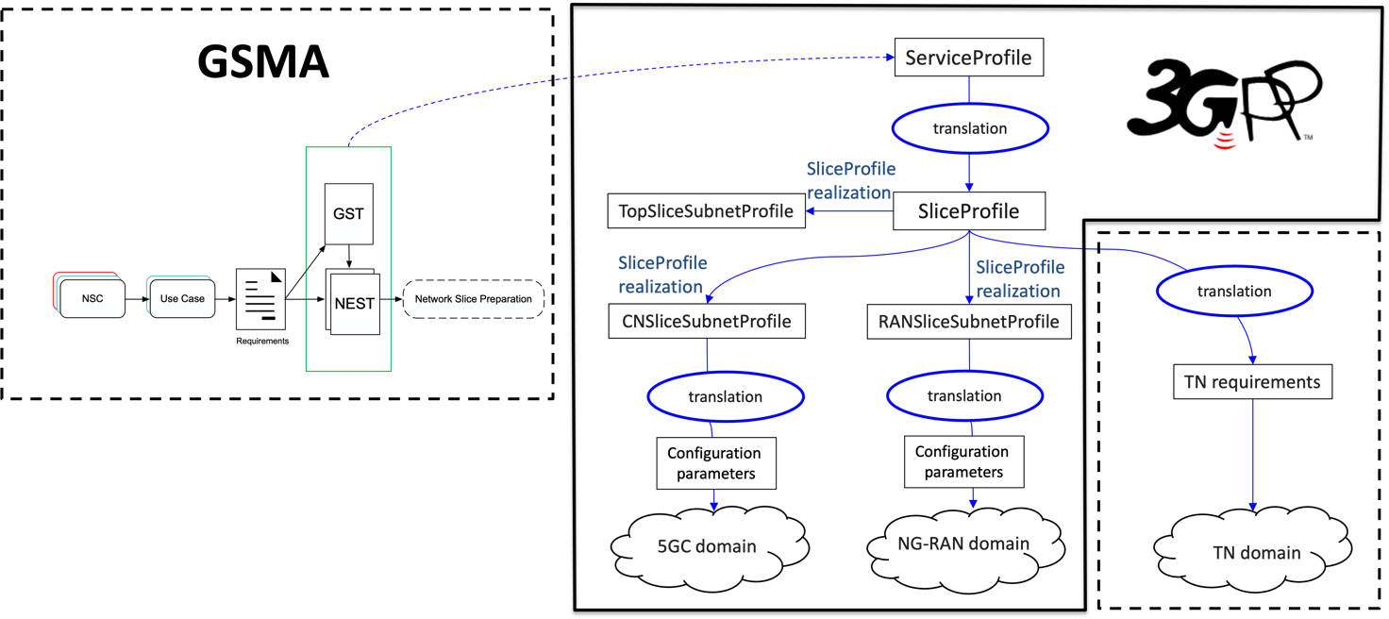
Figure L.2.1 Relation between GSMA GST, ServiceProfile and SliceProfile

End of modified section

