3GPP TS 32.277 V17.0.0 (2021-12)
Technical Specification
3rd Generation Partnership Project;
Technical Specification Group Services and System Aspects; Telecommunication management;
Charging management;
Proximity-based Services (ProSe) charging
(Release 17)


The present document has been developed within the 3rd Generation Partnership Project (3GPP TM) and may be further elaborated for the purposes of 3GPP..
The present document has not been subject to any approval process by the 3GPP Organizational Partners and shall not be implemented.
This Specification is provided for future development work within 3GPP only. The Organizational Partners accept no liability for any use of this Specification.
Specifications and Reports for implementation of the 3GPP TM system should be obtained via the 3GPP Organizational Partners' Publications Offices.

Keywords
GSM, UMTS, LTE, charging, management, ProSe
3GPP
Postal address

3GPP support office address
650 Route des Lucioles - Sophia Antipolis
Valbonne - FRANCE
Tel.: +33 4 92 94 42 00 Fax: +33 4 93 65 47 16
Internet
http://www.3gpp.org
Copyright Notification
No part may be reproduced except as authorized by written permission.
The copyright and the foregoing restriction extend to reproduction in all media.

© 2021, 3GPP Organizational Partners (ARIB, ATIS, CCSA, ETSI, TSDSI, TTA, TTC).
All rights reserved.

UMTS™ is a Trade Mark of ETSI registered for the benefit of its members
3GPP™ is a Trade Mark of ETSI registered for the benefit of its Members and of the 3GPP Organizational Partners
LTE™ is a Trade Mark of ETSI registered for the benefit of its Members and of the 3GPP Organizational Partners
GSM® and the GSM logo are registered and owned by the GSM Association
Contents
Foreword 6
1 Scope 7
2 References 7
3 Definitions, symbols and abbreviations 9
3.1 Definitions 9
3.2 Symbols 11
3.3 Abbreviations 12
4 Architecture considerations 14
4.1 High level ProSe architecture 14
4.1a High level 5G ProSe architecture 16
4.2 ProSe offline charging architecture 16
4.3 ProSe online charging architecture 19
4.4 ProSe converged charging architecture 19
5 ProSe charging principles and scenarios 21
5.1 ProSe charging principles 21
5.1.1 Requirements 21
5.1.2 Charging information 22
5.1.2.1 Charging information for ProSe Direct Discovery 22
5.1.2.2 Charging information for ProSe EPC-level Discovery 23
5.1.2.3 Charging information for ProSe one-to-many Direction Communication for Public Safety Use 23
5.2 ProSe offline charging scenarios 25
5.2.1 Basic principles 25
5.2.1.1 General 25
5.2.1.2 ProSe Direct Discovery charging 25
5.2.1.3 ProSe EPC-level Discovery charging 26
5.2.1.4 ProSe Direct Communication charging 27
5.2.2 Rf message flows 27
5.2.2.1 Offline charging message flow for ProSe Direct Discovery 27
5.2.2.1.1 Triggers for charging events from ProSe Function for ProSe Direct Discovery 27
5.2.2.1.2 Message flow for ProSe Direct Discovery Announce Request 28
5.2.2.1.3 Message flow for ProSe Direct Discovery Monitor Request 30
5.2.2.1.4 Message flow for ProSe Direct Discovery Match Report 33
5.2.2.1.5 Message flow for Discovery Request - Model B procedures 37
5.2.2.1.6 Message flow for Discovery reporting - Model B procedures 42
5.2.2.1.7 Message flow for ProSe Direct Discovery for Public Safety use when the UE is under coverage 44
5.2.2.1.8 Message flow for ProSe Direct Discovery for Public Safety use when the UE is out of coverage 45
5.2.2.2 Offline charging message flow for ProSe EPC-level Discovery 46
5.2.2.2.1 Triggers for charging events 46
5.2.2.2.2 Message flow for ProSe EPC-level Discovery Proximity Request 46
5.2.2.2.3 Message flow for ProSe EPC-level Discovery Proximity Request Cancellation 47
5.2.2.3 Offline charging message flow for ProSe Direct Communication 48
5.2.2.3.1 Triggers for charging events at ProSe Function 48
5.2.2.3.1.1 Triggers for charging events at ProSe Function for event based charging 48
5.2.2.3.1.2 Triggers for charging events at ProSe Function for session based charging 49
5.2.2.3.2 Message flow for ProSe one-to-many Direct Communication when the UE is under coverage of E-UTRAN (event based) 49
5.2.2.3.3 Message flow for ProSe one-to-many Direct Communication when the UE is out of coverage of E-UTRAN (event based) 50
5.2.2.3.4 Message flow for ProSe one-to-many Direct Communication when the UE is under coverage of E-UTRAN (session based) 52
5.2.2.3.5 Message flow for ProSe one-to-many Direct Communication when the UE is out of coverage of E-UTRAN (session based) 54
5.2.2.3.6 Message flow for Direct communication via ProSe UE-to-Network Relay(event based) 56
5.2.2.3.7 Message flow for ProSe one-to-one direct communication when the UE is under coverage (event based) 58
5.2.2.3.8 Message flow for ProSe one-to-one direct communication when the UE is out of coverage (event based) 59
5.2.2.3.9 (Void) 61
5.2.2.3.10 Message flow for ProSe one-to-one Direct Communication when the UE is under coverage (session based) 61
5.2.2.3.11 Message flow for ProSe one-to-one Direct Communication when the UE is out of coverage (session based) 63
5.2.2.3.12 Void 64
5.2.2.3.13 Void 64
5.2.3 CDR generation 64
5.2.3.1 Triggers for PF-DC-CDR creation and closure 64
5.2.3.1.1 General 64
5.2.3.1.2 Triggers for PF-DC-CDR charging information addition 64
5.2.3.1.3 Triggers for PF-DC-CDR closureThe PF-DC-CDR shall be closed on encountering any of the following trigger conditions: 65
5.2.4 Ga record transfer flows 65
5.2.5 Bx CDR file transfer 65
5.3 ProSe online charging scenarios 65
5.3.1 Basic principles 65
5.3.1.1 General 65
5.3.1.2 ProSe Direct Discovery charging 66
5.3.1.3 ProSe EPC-Level Discovery charging 66
5.3.2 Ro message flows 67
5.3.2.1 Introduction 67
5.3.2.2 ProSe Direct Discovery 67
5.3.2.2.1 Triggers for online charging from ProSe Function for ProSe Direct Discovery 67
5.3.2.2.2 Message flows for ProSe Direct Discovery Announce Request 67
5.3.2.2.3 Message flows for ProSe Direct Discovery Monitor Request 71
5.3.2.2.4 Message flows for ProSe Direct Discovery Match Report Request 75
5.3.2.2.5 Message flow for Discovery Request - Model B procedures 85
5.3.2.2.6 Message flow for Discovery reporting - Model B procedures 92
5.3.2.3 ProSe EPC-level Discovery 95
5.3.2.3.1 Triggers for ProSe EPC-level Discovery online charging 95
5.3.2.3.2 Message flow for ProSe EPC-level Discovery Proximity Request 96
5.3.2.3.3 Message flow for ProSe EPC-level Discovery Proximity Request Cancellation 98
6 Definition of charging information 99
6.1 Data description for ProSe offline charging 99
6.1.1 Rf message contents 99
6.1.1.1 General 99
6.1.1.2 Charging Data Request message 99
6.1.1.3 Charging Data Response message 100
6.1.2 Ga message contents 100
6.1.3 CDR description on the Bx interface 100
6.1.3.1 General 100
6.1.3.2 Direct Discovery charging data in ProSe Function (PF-DD-CDR) 100
6.1.3.3 ProSe EPC-level Discovery charging data in ProSe Function (PF-ED-CDR) 101
6.1.3.4 Direct communication charging data in ProSe Function (PF-DC-CDR) 103
6.2 Data description for ProSe online charging 105
6.2.1 Ro message contents 105
6.2.1.1 General 105
6.2.1.2 Debit / Reserve Units Request message 106
6.2.1.3 Debit / Reserve Units Response message 106
6.3 ProSe charging specific parameters 107
6.3.1 Definition of ProSe charging information 107
6.3.1.1 ProSe charging information assignment for Service Information 107
6.3.1.2 Definition of the ProSe Information 108
6.3.1.3 Supported features 111
6.3.2 Formal ProSe charging parameter description 111
6.3.2.1 ProSe CDR parameters 111
6.3.2.2 ProSe AVPs 111
6.3.3 Detailed message format for offline charging 111
6.3.4 Detailed Message Format for online charging 114
6.4 Bindings for ProSe offline charging 116
Annex A (normative): Charging Characteristics 119
A.1 General 119
Annex B (informative): Change history 120

Foreword
This Technical Specification has been produced by the 3rd Generation Partnership Project (3GPP).
The contents of the present document are subject to continuing work within the TSG and may change following formal TSG approval. Should the TSG modify the contents of the present document, it will be re-released by the TSG with an identifying change of release date and an increase in version number as follows:
Version x.y.z
where:
x the first digit:
1 presented to TSG for information;
2 presented to TSG for approval;
3 or greater indicates TSG approved document under change control.
y the second digit is incremented for all changes of substance, i.e. technical enhancements, corrections, updates, etc.
z the third digit is incremented when editorial only changes have been incorporated in the document.

1 Scope
The present document is part of a series of documents that specify charging functionality and charging management in 3GPP networks. The 3GPP core network charging architecture and principles are specified in TS 32.240 [1], which provides an umbrella for other charging management specifications that specify:
- the content of the CDRs per domain / subsystem / service (offline and convergedcharging);
- the content of real-time charging messages per domain / subsystem / service (online and converged charging);
- the functionality of online and offline charging for those domains / subsystems / services;
- the interfaces that are used in the charging framework to transfer the charging information (i.e. CDRs or charging events).
The complete document structure for these specifications is defined in TS 32.240 [1].
The present document specifies the offline, online and converged charging description for the Proximity-based Services (ProSe), based on the stage 2 description of ProSe in TS 23.303 [238] and TS 23.304 [241]. This charging description includes the offline, online and converged charging architecture and scenarios specific to the ProSe, as well as the mapping of the common 3GPP charging architecture specified in TS 32.240 [1] onto the ProSe. It further specifies the structure and content of the CDRs for offline charging, and the charging events for online charging. The present document is related to other 3GPP charging TSs as follows:
- The common 3GPP charging architecture is specified in TS 32.240 [1].
- The parameters, abstract syntax and encoding rules for the CDRs are specified in TS 32.298 [51].
- A transaction based mechanism for the transfer of CDRs within the network is specified in TS 32.295 [54].
- The file based mechanism used to transfer the CDRs from the network to the operator's billing domain (e.g. the billing system or a mediation device) is specified in TS 32.297 [52].
- The 3GPP Diameter application that is used for ProSe offline and online charging is specified in TS 32.299 [50].
- The services, operations and procedures of charging, using Service Based Interface are specified in TS 32.290 [55].
- The charging service of 5G system is specified in TS 32.291 [56].
All references, abbreviations, definitions, descriptions, principles and requirements, used in the present document, that are common across 3GPP TSs, are defined in TR 21.905 [100]. Those that are common across charging management in GSM/UMTS domains, services or subsystems are provided in the umbrella TS 32.240 [1] and are copied into clause 3 of the present document for ease of reading. Finally, those items that are specific to the present document are defined exclusively in the present document.

2 References
The following documents contain provisions which, through reference in this text, constitute provisions of the present document.
- References are either specific (identified by date of publication, edition number, version number, etc.) or non-specific.
- For a specific reference, subsequent revisions do not apply.
- For a non-specific reference, the latest version applies. In the case of a reference to a 3GPP document (including a GSM document), a non-specific reference implicitly refers to the latest version of that document in the same Release as the present document.
[1] 3GPP TS 32.240: "Telecommunication management; Charging management; Charging Architecture and Principles".
[2] - [9] Void.
[10] 3GPP TS 32.250: "Telecommunication management; Charging management; Circuit Switched (CS) domain charging".
[11] 3GPP TS 32.251: "Telecommunication management; Charging management; Packet Switched (PS) domain charging".
[12] - [19] Void.
[20] 3GPP TS 32.260: "Telecommunication management; Charging management; IP Multimedia Subsystem (IMS) charging".
[21] - [29] Void.
[30] 3GPP TS 32.270: "Telecommunication management; Charging management; Multimedia Messaging Service (MMS) charging".
[31] - [49] Void.
[50] 3GPP TS 32.299: "Telecommunication management; Charging management; Diameter charging applications".
[51] 3GPP TS 32.298: "Telecommunication management; Charging management; Charging Data Record (CDR) parameter description".
[52] 3GPP TS 32.297: "Telecommunication management; Charging management; Charging Data Record (CDR) file format and transfer".
[53] Void.
[54] 3GPP TS 32.295: "Telecommunication management; Charging management; Charging Data Record (CDR) transfer".
[55] 3GPP TS 32.290: "Telecommunication management; Charging management; 5G system; Services, operations and procedures of charging using Service Based Interface (SBI)".
[56] 3GPP TS 32.291: " Telecommunication management; Charging management 5G system; Charging service, stage 3".
[57] - [99] Void.
[100] 3GPP TR 21.905: "Vocabulary for 3GPP Specifications".
[101] 3GPP TS 22.115: "Service aspects; Charging and billing".
[102] - [199] Void.
[200] - [236] Void.
[237] 3GPP TS 24.002: "GSM - UMTS Public Land Mobile Network (PLMN) Access Reference Configuration".
[238] 3GPP TS 23.303: "Proximity-based services (ProSe); Stage 2".
[239] Void.
[240] 3GPP TS 33.303: "Proximity-based Services (ProSe); Security aspects".
[241] 3GPP TS 23.304: "Proximity based Services (ProSe) in the 5G System (5GS)".
[242] - [499] Void.

3 Definitions, symbols and abbreviations

3.1 Definitions
For the purposes of the present document, the terms and definitions given in TR 21.905 [100] and the following apply. A term defined in the present document takes precedence over the definition of the same term, if any, in TR 21.905 [100].
2G- / 3G-: prefixes 2G- and 3G- refer to functionality that supports only GSM or UMTS, respectively, e.g. 2G-SGSN refers only to the GSM functionality of an SGSN. When the term/prefix is omitted, reference is made independently from the GSM or UMTS functionality.
accounting: process of apportioning charges between the Home Environment, Serving Network and Subscriber.
billing: function whereby CDRs generated by the charging function(s) are transformed into bills requiring payment.
Billing Domain: part of the operator network, which is outside the telecommunication network that receives and processes CDR files from the core network charging functions. It includes functions that can provide billing mediation and billing or other (e.g. statistical) end applications. It is only applicable to offline charging (see "Online Charging System" for equivalent functionality in online charging).
chargeable event: activity utilizing telecommunication network resources and related services for:
- user to user communication (e.g. a single call, a data communication session or a short message); or
- user to network communication (e.g. service profile administration); or
- inter-network communication (e.g. transferring calls, signalling, or short messages); or
- mobility (e.g. roaming or inter-system handover); and
- that the network operator may want to charge for.
As a minimum, a chargeable event characterises the resource / service usage and indicates the identity of the involved end user(s).
charged party: user involved in a chargeable event who has to pay parts or the whole charges of the chargeable event, or a third party paying the charges caused by one or all users involved in the chargeable event, or a network operator.
charging: function within the telecommunications network and the associated OCS/BD components whereby information related to a chargeable event is collected, formatted, transferred and evaluated in order to make it possible to determine usage for which the charged party may be billed (offline charging) or the subscriber's account balance may be debited (online charging).
Charging Data Record (CDR): formatted collection of information about one or more chargeable event(s) (e.g. time of call set-up, duration of the call, amount of data transferred, etc) for use in billing and accounting. For each party to be charged for parts of or all charges of the chargeable event(s) a separate CDR should be generated, i.e. more than one CDR may be generated for a single chargeable event, e.g. because of its long duration, or because more than one charged party is to be charged.
charging event: set of charging information forwarded by the CTF towards the CDF (offline charging) or towards the OCS (online charging). Each charging event matches exactly one chargeable event.
charging function: entity inside the core network domain, subsystem or service that is involved in charging for that domain, subsystem or service.
Credit Control: mechanism which directly interacts in real-time with an account and controls or monitors the charges, related to the service usage. Credit control is a process of: checking if credit is available, credit reservation, deduction of credit from the end user account when service is completed and refunding of reserved credit not used.
domain: part of a communication network that provides network resources using a certain bearer technology.
EPC-level ProSe Discovery: A ProSe Discovery procedure by which the EPC determines the proximity of two ProSe-enabled UEs and informs them of their proximity.
Fully Qualified Partial CDR (FQPC): partial CDR that contains a complete set of the fields specified in the present document. This includes all the mandatory and conditional fields as well as those fields that the PLMN operator has provisioned to be included in the CDR. The first Partial CDR should be a Fully qualified Partial CDR.
GTP': GPRS protocol used for CDR transport. It is derived from GTP with enhancements to improve transport reliability necessary for CDRs.
NOTE: This protocol is not used for tunnelling.
GSM only: qualifier indicating that this clause or paragraph applies only to a GSM system. For multi-system cases this is determined by the current serving radio access network.
in GSM,...: qualifier indicating that this paragraph applies only to GSM System.
in UMTS,...: qualifier indicating that this paragraph applies only to UMTS System.
inter-system change: change of radio access between different radio access technologies such as GSM and UMTS.
Local PLMN: A PLMN which is not the serving PLMN, and in whose radio resources the monitoring UE is authorized by the HPLMN to engage in ProSe Direct Discovery.
middle tier TS: term used for the 3GPP charging TSs that specify the domain / subsystem / service specific, online and offline, charging functionality. These are all the TSs in the numbering range from 3GPP TS 32.250 to 3GPP TS 32.279, e.g. 3GPP TS 32.250 [10] for the CS domain, or 3GPP TS 32.270 [30] for the MMS service. Currently, there is only one "tier 1" TS in 3GPP, which is 3GPP TS 32.240 [1] that specifies the charging architecture and principles. Finally, there are a number of top tier TSs in the 32.29x numbering range ([50] ff) that specify common charging aspects such as parameter definitions, encoding rules, the common billing domain interface or common charging applications.
Model A: involves one UE announcing "I am here"
Model B: involves one UE asking "who is there" and/or "are you there"
offline charging: charging mechanism where charging information does not affect, in real-time, the service rendered.
online charging: charging mechanism where charging information can affect, in real-time, the service rendered and therefore a direct interaction of the charging mechanism with bearer/session/service control is required.
Online Charging System (OCS): the entity that performs real-time credit control. Its functionality includes transaction handling, rating, online correlation and management of subscriber account balances.
partial CDR: CDR that provides charging information on part of a subscriber session. A long session may be covered by several partial CDRs. Two formats are considered for Partial CDRs. One that contains all of the provisioned fields (FQPC); the second has a reduced format (RPC).
ProSe Direct Discovery: A procedure employed by a ProSe-enabled UE to discover other ProSe-enabled UEs in its vicinity by using only the capabilities of the two UEs with E-UTRA or NR technology.
ProSe Discovery: A process that identifies that a UE that is ProSe-enabled is in proximity of another, using E-UTRA (with or without E-UTRAN) or EPC.
ProSe-enabled Public Safety UE: A UE that the HPLMN has configured to be authorized for Public Safety use, and which is ProSe-enabled and supports ProSe procedures and capabilities specific to Public Safety.
ProSe Function: The ProSe Function is the logical function that is used for network related actions required for ProSe. The ProSe Function plays different roles for each of the features of ProSe. In this version of the specification it is assumed that there is only one logical ProSe Function in each PLMN that supports Proximity Services.
The ProSe Function contains three main sub-functions: Direct Provisioning Function (DPF), Direct Discovery Name Management Function, and EPC-level Discovery Function. The ProSe Function provides the necessary charging functionality for usage of ProSe.
ProSe identifier: An identifier used to indicate the ProSe Application associated with the ProSe operation in ProSe Direct Discovery and ProSe Direct Communication. A ProSe identifier can be associated with one or more ProSe applications, and a ProSe application can be associated with one or more ProSe identifier(s). For ProSe Direct Discovery, ProSe identifier is equivalent to "Application ID" defined in 23.303 [240].
Editor's note: For ProSe Direct Communication, ProSe identifier is to be determined.
real-time: real-time charging and billing information is to be generated, processed, and transported to a desired conclusion in less than 1 second.
Reduced Partial CDR (RPC): partial CDRs that only provide mandatory fields and information regarding changes in the session parameters relative to the previous CDR.
EXAMPLE: Location information is not repeated in these CDRs if the subscriber did not change its location.
settlement: payment of amounts resulting from the accounting process.
subscriber: entity (associated with one or more users) that is engaged in a subscription with a service provider. The subscriber is allowed to subscribe and unsubscribe services, to register a user or a list of users authorized to enjoy these services, and also to set the limits relative to the use that associated users make of these services.
user: entity, not part of the 3GPP System, that uses network resources by means of a subscription. The user may or may not be identical to the subscriber holding that subscription.
User Equipment (UE): device allowing a user access to network services. For the purpose of 3GPP specifications the interface between the UE and the network is the radio interface. A User Equipment can be subdivided into a number of domains, the domains being separated by reference points. Currently defined domains are the USIM and ME Domains. The ME Domain can further be subdivided into several components showing the connectivity between multiple functional groups. These groups can be implemented in one or more hardware devices. An example of such a connectivity is the TE – MT interface. Further, an occurrence of a User Equipment is an MS for GSM as defined in TS 24.002 [237].
5G ProSe-enabled UE: A UE that supports 5G ProSe requirements and associated procedures.
5G ProSe Direct Discovery: A procedure employed by a 5G ProSe-enabled UE to discover other 5G ProSe-enabled UEs in its vicinity based on direct radio transmissions between the two UEs with NR technology.
5G ProSe Direct Communication: A communication between two or more UEs in proximity that are 5G ProSe-enabled, by means of user plane transmission using NR technology via a path not traversing any network node.
5G ProSe UE-to-Network Relay: A 5G ProSe-enabled UE that provides functionality to support connectivity to the network for 5G ProSe Remote UE(s).
5G ProSe Remote UE: A 5G ProSe-enabled UE that communicates with a DN via a 5G ProSe UE-to-Network Relay.

3.2 Symbols
For the purposes of the present document, the following symbols apply:
Bpr Reference point for CDR file transfer between ProSe CGF and the BD.
Bx Reference point for CDR file transfer between any (generic) UMTS domain, subsystem or service CGF and the BD.
Ga Reference point for CDR transfer between a CDF and the CGF.
Nchf Service based interface exhibited by CHF.
PC3 Reference point between UE and the ProSe Function.
PC3ch Subset of PC3 specific to usage information collection for charging purposes.
PC5: The reference point between ProSe-enabled UEs used for control and user plane for 5G ProSe Direct Discovery, ProSe Direct Communication and ProSe UE-to-Network Relay.
Npc2: The reference point between the ProSe Application Server and the 5G DDNMF. It is used to define the interaction between ProSe Application Server and 5G DDNMF for 5G ProSe Direct Discovery.
Npc4: The reference point between the UDM and 5G DDNMF. It is used to provide subscription information in order to authorise 5G ProSe Direct Discovery request.
Npc6: The reference point between the 5G DDNMF in the HPLMN and the 5G DDNMF in a Local PLMN (5G ProSe Direct Discovery). This reference point is used for HPLMN control of ProSe service authorization.
Npc7: The reference point between the 5G DDNMF in the HPLMN and the 5G DDNMF in the VPLMN. It is used for HPLMN control of ProSe service authorization.
Npc8: The reference point between the PCF and the 5G DDNMF. It is used to define the interactions between the 5G DDNMF and the PCF to e.g. get a PDUID from the PCF.
Rf Offline charging reference point between a ProSe Function and the CDF.
Ro Online charging reference point between a ProSe Function and the OCS.

3.3 Abbreviations
For the purposes of the present document, the abbreviations given in TR 21.905 [100] and the following apply. An abbreviation defined in the present document takes precedence over the definition of the same abbreviation, if any, in TR 21.905 [100].
3G 3rd Generation
3GPP 3rd Generation Partnership Project
5G DDNMF 5G Direct Discovery Name Management Function
APN Access Point Name
AVP Attribute Value Pair
BD Billing Domain
CDF Charging Data Function
CDR Charging Data Record
CGF Charging Gateway Function
CHF Charging Function
CTF Charging Trigger Function
CTF (AMC) Charging Trigger Function (Accounting Metrics Collection)
CTF (ADF) Charging Trigger Function (Accounting Data Forwarding)

ECUR Event Charging with Unit Reservation
E-UTRA Evolved Universal Terrestrial Radio Access
E-UTRAN Evolved Universal Terrestrial Radio Access Network
FQPC Fully Qualified Partial CDR
GTP GPRS Tunnelling Protocol
GTP The GPRS protocol used for CDR transport. It is derived from GTP with enhancements to improve transport reliability necessary for CDRs.
HPLMN Home PLMN
HSS Home Subscriber Server
IE Information Element
IEC Immediate Event Charging
IMS IP Multimedia Subsystem
IMSI International Mobile Subscriber Identity
IP Internet Protocol
IPv4 Internet Protocol version 4
IPv6 Internet Protocol version 6
ISDN Integrated Services Digital Network
MCC Mobile Country Code (part of IMSI)
ME Mobile Equipment
MNC Mobile Network Code (part of IMSI)
MSISDN Mobile Station ISDN number
NE Network Element
OCS Online Charging System
PLMN Public Land Mobile Network
ProSe Proximity-based Services
PS Packet-Switched
PFI PC5 QoS Flow Identifier
PQI PC5 5QI
QoS Quality of Service
RAN Radio Access Network
SCUR Session Charging with Unit Reservation
SIM Subscriber Identity Module
TR Technical Report
TS Technical Specification
UE User Equipment
UMTS Universal Mobile Telecommunications System
USIM User Service Identity Module
VPLMN Visited PLMN
WLAN Wireless LAN

4 Architecture considerations

4.1 High level ProSe architecture
Figure 4.1.1 shows the high level view of the non-roaming architecture for ProSe that is defined in TS 23.303 [238].
In this figure, UE A and UE B have subscriptions from the same PLMN.
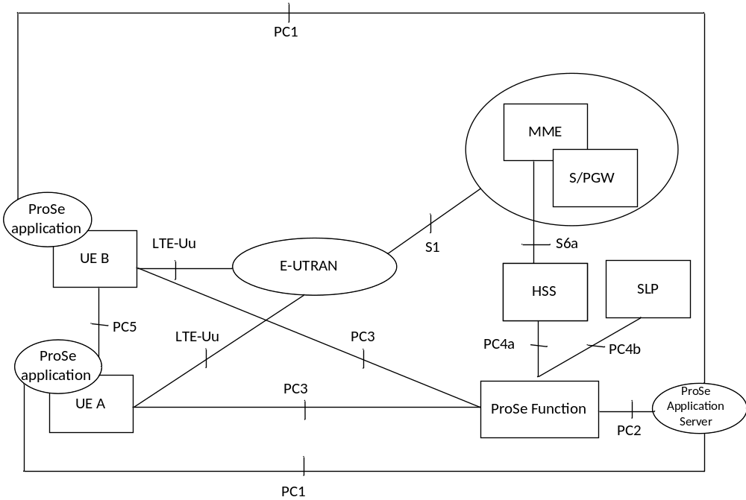
Figure 4.1.1: Non-roaming reference architecture
Figure 4.1.2 shows the high level view of non-roaming inter-PLMN architecture for ProSe defined in TS 23.303 [238]. In this figure, PLMN A is the HPLMN of UE A, and PLMN B is the HPLMN of UE B.
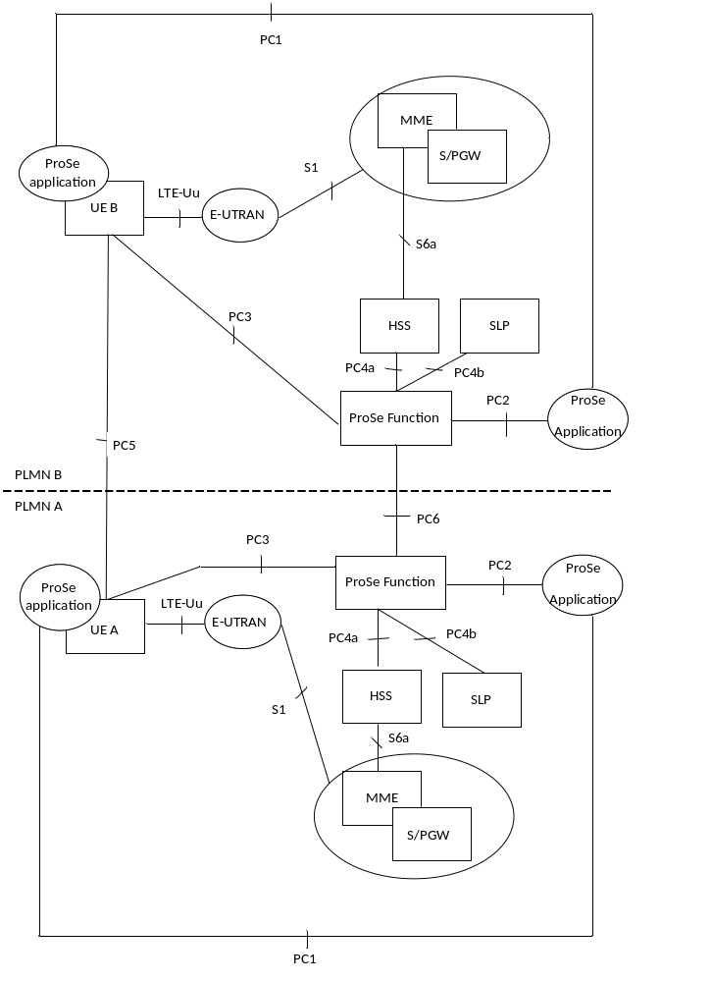
Figure 4.1.2: Inter-PLMN reference architecture
Figure 4.1.3 shows the high level view of the roaming architecture for ProSe as defined in TS 23.303 [238]. In this figure, UE A uses a subscription of PLMN A and UE B uses a subscription of PLMN B; UE A is roaming in PLMN C while UE B is not roaming.
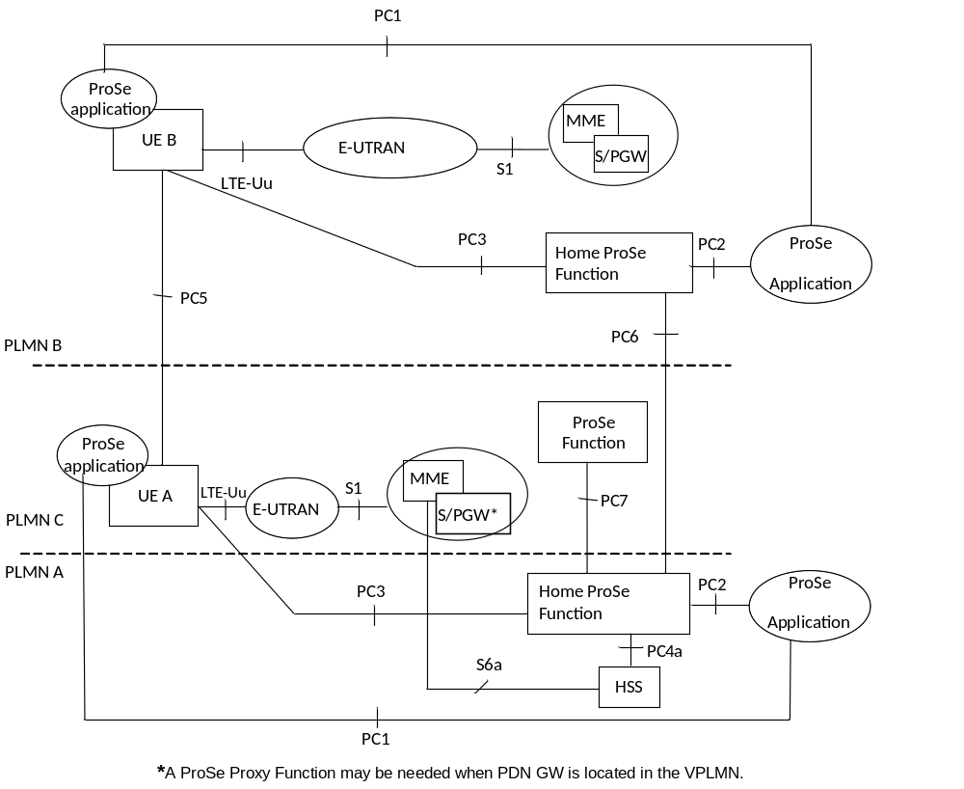
Figure 4.1.3: Roaming reference architecture
NOTE: For EPC-level ProSe discovery the roaming architecture is not specified in the present document.

4.1aa High level 5G ProSe architecture
The high level 5G ProSe architecture is as defined in TS 23.304 [241] clause 4.2.
NOTE: As defined in TS 23.303 [238], the ProSe Function consists of Direct Provisioning Function (DPF), Direct Discovery Name Management Function (DDNMF) and EPC-level Discovery Function. In 5GS, the 5G DDNMF takes the role of "ProSe Function", DPF is replaced by PCF, and EPC-level Discovery Function is not supported.

4.2 ProSe offline charging architecture
For ProSe Direct Discovery and EPC-level Discovery services, as described in TS 32.240 [1], the CTF (an integrated component in each charging relevant ProSe Function) generates charging events and forwards them to the CDF. The CDF, in turn, generates CDRs which are then transferred to the CGF. Finally, the CGF creates CDR files and forwards them to the Billing Domain.
If the ProSe Function generating the charging information has an integrated CDF, then the ProSe Function can produce CDRs. The CGF may also be integrated in the ProSe Function, or it may exist as a physically separate entity. If the CGF is external to the ProSe Function, then the CDF forwards the CDRs to the CGF across the Ga interface.
In this case, the relationship between ProSe Function/CDF and CGF is m:1. If the CGF is integrated in the ProSe Function, then there is only an internal interface between the CDF and the CGF. In this case, the relationship between ProSe Function/CDF and CGF is 1:1.
If the CDF is external to the ProSe Function, the charging events are transferred from the ProSe Function to the CDF via the Rf interface specified in TS 32.299 [50]. In this case, the relationship between ProSe Function and CDF is m:1.
When an external CGF is used, this CGF may also be used by other, i.e. non-ProSe, network elements, according to network design and operator decision. It should be noted that the CGF may also be an integrated component of the BD – in this case, the Bx interface does not exist and is replaced by a proprietary solution internal to the BD.
Figure 4.2.1 depicts the architectural options described above.
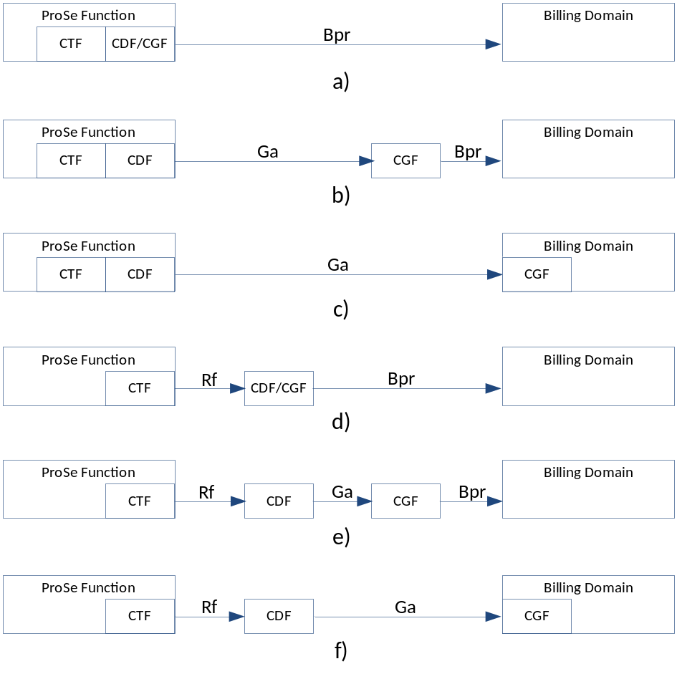
Figure 4.2.1: ProSe offline charging architecture
For the ProSe Direction Communication Service, the CTF is divided into two functional blocks as described in Annex D of TS 32.240 [1]. The Accounting Metrics Collection (AMC) function block is in the UE. The AMC sends usage information collected to the Accounting Data Forwarding (ADF) function block of the CTF in the ProSe Function over the PC3 reference point defined in TS 23.303 [238]. The subset of PC3 specific to usage information collection for charging purposes is denoted as PC3ch in figure 4.2.2.
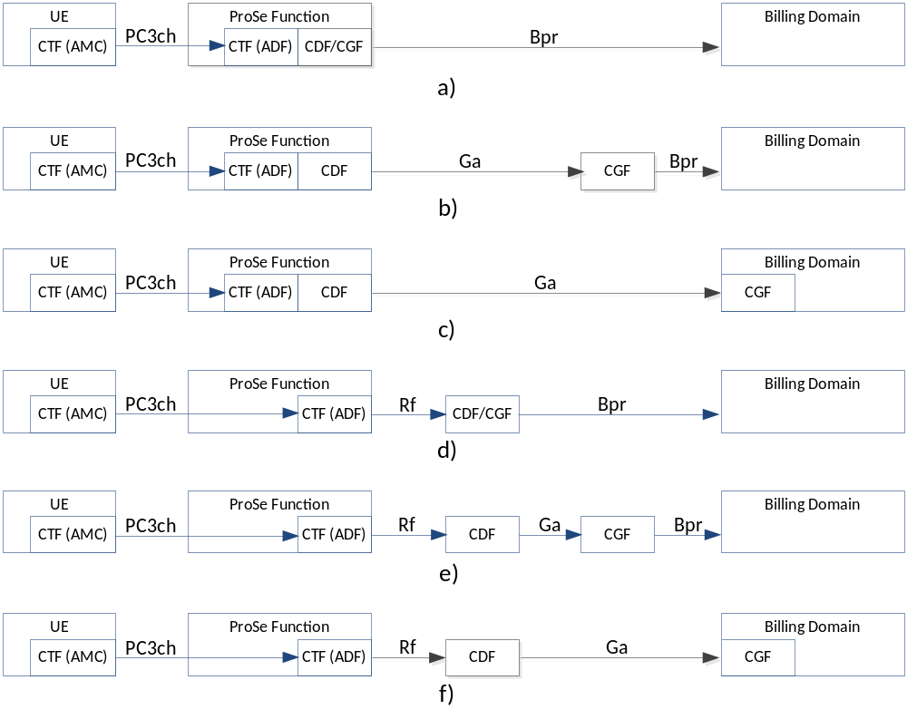
Figure 4.2.2: ProSe Direct Communication offline charging architecture
The PC3 protocol shall allow the following deployment options for the ProSe Function CTF (ADF) for ProSe Direct Communication depicted in figure 4.2.2:
- The ProSe Function CTF (ADF) for ProSe Direct Communication may be deployed in the same system as any combination of the ProSe Function components defined in clause 4.4.1 of TS 23.303 [238] (i.e. Direct Provisioning Function, Direct Discovery Name Management Function, EPC-level Discovery Function).
- The ProSe Function CTF (ADF) for ProSe Direct Communication may be deployed in a logically or physically separate system from the ProSe Function components defined in clause 4.4.1 of TS 23.303 [238]. To support this deployment scenario, the PC3ch subset of the protocol for usage information report delivery shall not require interaction with any other ProSe Function component for successful and complete processing.
The network ensures that the UE can have IP access to its HPLMN ProSe Function, in non-roaming and roaming case, as defined in TS 23.303 [238].
When the UE is out of coverage, PC3 reference point is not available. UE will store the logged information and upload to the ProSe Function once the PC3 becomes available and the reporting criteria are met. UE's reporting of usage information is only visible to the ProSe Function.
It is mandatory to support at least one of the options Rf, Ga or Bx interfaces from the ProSe Function as described in the specification.

4.3 ProSe online charging architecture
ProSe online charging is based on ProSe function utilizing Ro interface and application towards the OCS as specified in TS 32.299 [50]. The Ro reference point covers all online charging functionality required for ProSe.
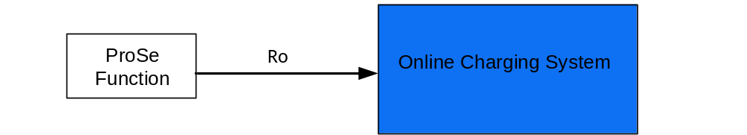
Figure 4.3.1: ProSe online charging architecture

4.4 ProSe converged charging architecture
The ProSe converged charging architecture can be achieved under the alternatives:
- Charging Trigger Function (CTF) based, including distributed CTF, as depicted in figure 4.4-1 and 4.4.2.
- Charging Enablement Function (CEF) based, depicted in figure 4.4-3.
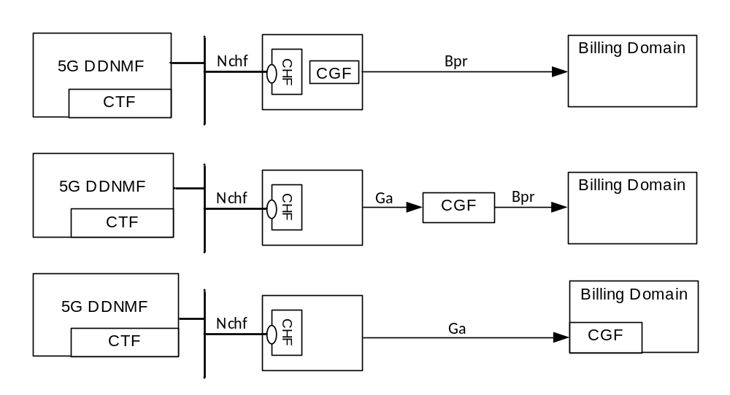
Figure 4.4.-1: ProSe converged charging architecture (CTF)

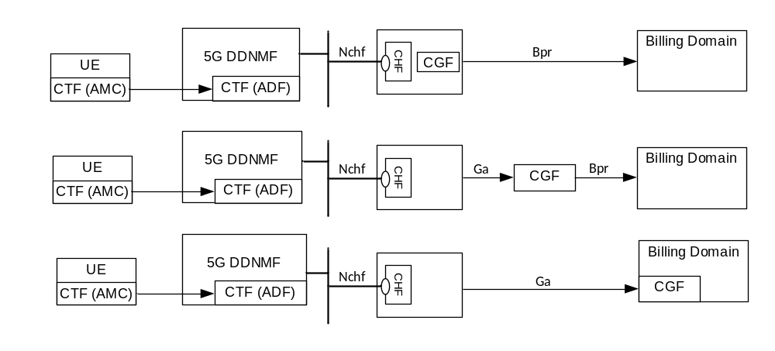
Figure 4.4-2: ProSe converged charging architecture over PC5 (Distributed CTF)

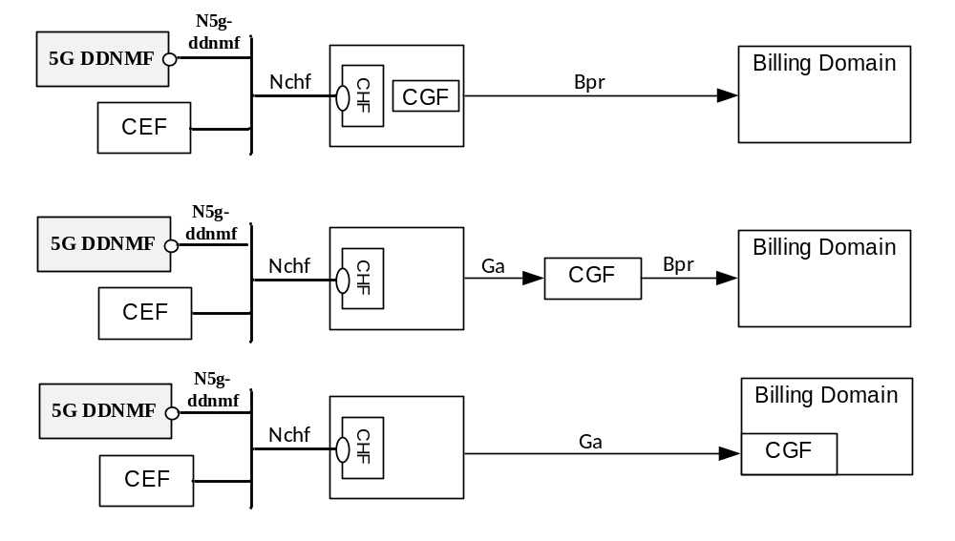
Figure 4.4.3: ProSe converged charging architecture (CEF)
Editor's Note: The architecture figure should follow up the decision of the common CEF issues.
Editor's Note: The details for charging information transfer in CEF-based charging architecture over PC5 are ffs.

5 ProSe charging principles and scenarios

5.1 ProSe charging principles

5.1.1 Requirements
There are three types of ProSe services defined in TS 23.303 [238]:
- ProSe Direct Discovery, including ProSe open Direct Discovery and restricted Direct Discovery, and
- ProSe EPC-level Discovery, and
- ProSe one-to-many Direct Communication for Public Safety Use, and
- ProSe one-to-one Direct Communication, including UE-to-Network Relay for Public Safety Use.
The following are high-level charging requirements for ProSe services, derived from the requirements in TS 22.115 [101], and TS 23.303 [238].
ProSe Function shall be able to collect charging information for UEs in HPLMN, in online and offline charging for:
- ProSe open Direct Discovery Model A;
- ProSe restricted Direct Discovery Model A and Model B;
- ProSe EPC-level Discovery.
ProSe Function shall be able to collect charging information for UEs in VPLMN in offline charging for:
- ProSe open Direct Discovery for Announce;
- ProSe restricted Direct Discovery for Announce.
ProSe Function shall be able to collect charging information for UEs in VPLMN and Local PLMNs where applicable in offline charging for:
- ProSe open Direct Discovery for Monitor and Match;
- ProSe restricted Direct Discovery for Monitor and Match.
NOTE: the notion of "Local PLMN" does not apply to WLAN-based ProSe Direct Discovery, so the requirements related to charging for Local PLMN do not apply to WLAN-based ProSe Direct Discovery.
ProSe Function shall be able to indicate the PC5 radio technology (e.g., E-UTRA, WLAN) used for ProSe Direct Discovery in the charging information.
ProSe Function shall be able to collect charging information from UEs in HPLMN and VPLMN in offline charging for:
- ProSe one-to-many Direct Communication for Public Safety Use;
- ProSe one-to-one Direct Communication for Public Safety Use, including UE-to-Network Relay;
For ProSe one-to-many Direct Communication for Public Safety Use, the following requirements apply to the UE delivery of usage information to the ProSe Function:
- When the UE is in E-UTRAN coverage, if the usage information recorded for the current collection period is not empty, it shall report the usage information as configured when the earlier one of the following criteria are met:
- a configured collection period has elapsed; the end of an associated configured reporting window has not been reached; and the UE temporarily switches to RRC CONNECTED mode; or
- a configured collection period has elapsed and the end of an associated configured reporting window has been reached.
- When the UE is out of E-UTRAN coverage, the UE shall generate reports from the recorded usage information every collection period and store the non-empty reports in a non-volatile memory, and send the reports once the UE returns to coverage.
- The storage of the usage information and the execution of the reporting procedure shall be in a secure environment in the UE that is trusted by the operator.
NOTE 1: The secured storage and execution of the reporting procedure do not guarantee that the recording of the usage information is trusted.
NOTE 2: When the UE operates out of coverage for a long time, the stored reports may reach the limit of the memory. The handling of such situation is determined by UE implementation.
- The UE shall upload the usage information to a location configured by the ProSe Function securely over PC3ch using the mechanism defined in TS 33.303 [240].
- If a replacement of USIM occurs when UE is out of coverage, the usage information for a given IMSI shall remain stored on the UICC or ME as long as the UE does not use the USIM associated with that IMSI.
- The results of the collection and delivery of usage information reports should not affect the UE's use of the ProSe Direct Communication service.
NOTE 3: For Public Safety use the UE is able to use ProSe Direct Communication service even if there are errors in usage information collection or reporting.
ProSe Function shall be capable of handling the Charging Characteristics. Charging Characteristics can be specific for a subscription or for subscribed services. ProSe Function shall use the Charging Characteristics profile to decide if online or offline charging is used for a user. The Charging Characteristics is provided by the HSS to the ProSe Function as part of the subscription information. Requirements of the use of Charging Characteristics are provided in annex A.

5.1.2 Charging information

5.1.2.1 Charging information for ProSe Direct Discovery
For ProSe Direct Discovery, the ProSe Function shall collect the following charging information:
- identity of the mobile subscriber using the ProSe functionality, e.g. IMSI;
- identity of the PLMN where the ProSe functionality is used;
- specific ProSe functionality used, e.g. Announcing, Monitoring, or Match Report;
- role of the UE in the ProSe, e.g. Announcing UE, Monitoring UE, Discoveree UE, Discoverer UE;
- modelof the Direct Discovery used by the UE, e.g. Model A, or Model B;
- the validity period associated with ProSe Application Code allocated to an Announcing UE;
- the PLMN ID extracted from the set of Filters provided for a Monitoring UE in a Monitor Request and the maximum validity period associated with the set of Filters;
- the PLMN ID extracted from the ProSe Application Code and the monitored PLMN ID with the timestamp reported by a Monitoring UE in the Match Report message, which is triggered by the Monitoring UE when the ProSe Application Code that matches the Discovery Filters does not have ProSe Application ID already locally stored that correspond to this ProSe Application Code;
- ProSe Application ID used in the ProSe Direct Discovery;
- Application ID related to the ProSe Direct Discovery.
- PC5 radio technology (e.g., E-UTRA or WLAN) used for ProSe Direct Discovery. When this information is not present, it means the PC5 radio technology is E-UTRA.
The charging information shall be collected when a UE performs ProSe Direct Discovery, including Announcing Request, Monitoring Request, and Match Report.

5.1.2.2 Charging information for ProSe EPC-level Discovery
For ProSe EPC-level Discovery, the ProSe Function shall collect the following charging information:
- identity of the mobile subscriber using the EPC-level Discovery, e.g. IMSI;
- timestamp of Proximity Request received from UE;
- duration of the EPC-level Discovery services authorized for the UE;
- discovery Range authorized for the UE, e.g. geographic limit;
- timestamp when a Proximity Alert is triggered, and the associated location information;
- WLAN direct communication Assistance Information and associated timestamps, when applicable.

5.1.2.3 Charging information for ProSe one-to-many Direction Communication for Public Safety Use
For the ProSe one-to-many Direct Communication for Public Safety Use, the UE shall collect the following information, and be included in the usage information report to the ProSe Function for charging purposes, if configured by the network:
- UE identity, e.g. IMSI;
- For every collection period:
- Sequence number of the report;
- List of the locations of the UE when in coverage, e.g. ECGIs, and the corresponding timestamps;
- Configured Radio Parameters used for the ProSe Direct Communication, as defined in TS 24.333 [241];
- List of timestamps of when the UE goes in/out of E-UTRAN coverage;
- For every ProSe Direct Communication Group (identified by ProSe L2 Group ID):
- Group Parameters used for the ProSe Direct Communication, as defined in TS 24.333 [241], e.g. ProSe L2 Group ID, IP Multicast Address, Source IP address, etc.;
- Timestamp of the first one-to-many communication transmission/reception;
- Identities of the transmitters in the one-to-many communication session, e.g. Source L2 ID and IP address;
- List of non-zero amount of data transmitted by UE;
- List of amount of data transmitted by UE when in E-UTRAN coverage at each location, with ECGI and the corresponding timestamps, and indicator of which radio resources used (i.e., operator-provided in coverage or configured) and the radio frequency used;
- List of amount of data transmitted by UE for each out of E-UTRAN coverage period and the corresponding timestamps and the radio frequency used ;
- List of non-zero amount of data received by UE;
- List of amount of data received by UE when in E-UTRAN coverage at each location, with ECGI and the corresponding timestamps, and indicator of which radio resources used (i.e., operator-provided in coverage or configured) and the radio frequency used;
- List of amount of data received by UE for each out of E-UTRAN coverage period and the corresponding timestamps and the radio frequency used;
- Application specific data, e.g. application specific session floor control information, Application layer User ID of group members in the communication.
The network shall be able to configure the UE with information to be included in the usage information report as per following:
- Whether the Group Parameters need to be reported;
- Whether timestamps of the first transmission/reception need to be reported;
- Whether the amount of data transmitted by UE needs to be reported, and whether with location information;
- Whether the amount of data received by UE needs to be reported, and whether with location information;
- Whether the list of locations of the UE when in E-UTRAN coverage needs to be reported;
- Whether the list of timestamps of when UE goes in/out of E-UTRAN coverage need to be recorded.
- Whether the indicator of radio resources used and radio frequency are to be reported with the amount of data transmitted and received.
5.1.2.4 Charging information for ProSe one-to-one Direction Communication for Public Safety Use
For the ProSe one-to-one Direct Communication for Public Safety Use, the UE shall collect the following information, and be included in the usage information report to the ProSe Function for charging purposes, if configured by the network:
- UE identity, e.g. IMSI;
- For every collection period:
- Sequence number of the report;
- List of the locations of the UE when in coverage, e.g. ECGIs, and the corresponding timestamps;
- Configured Radio Parameters used for the ProSe Direct Communication, as defined in TS 24.333 [241];
- List of timestamps of when the UE goes in/out of E-UTRAN coverage;
- For every ProSe Direct Communication (identified by ProSe L2 ID):
- Timestamp of the first one-to-one communication transmission/reception;
- Identities of the transmitters in the non-relay one-to-one communication session, e.g. Source L2 ID and IP address and Target L2 ID and IP address;
- Identities of the transmitters in the direct communication via ProSe UE-to-Network relay, e.g. Source L2 ID and IP address, ProSe UE-to-Network Relay UE L2 ID and IP address.
- List of non-zero amount of data transmitted by UE;
- List of amount of data transmitted by UE when in E-UTRAN coverage at each location, with ECGI and the corresponding timestamps, and indicator of which radio resources used (i.e., operator-provided in coverage or configured) and the radio frequency used;
- List of amount of data transmitted by UE for each out of E-UTRAN coverage period and the corresponding timestamps and the radio frequency used;
- List of non-zero amount of data received by UE;
- List of amount of data received by UE when in E-UTRAN coverage at each location, with ECGI and the corresponding timestamps, and indicator of which radio resources used (i.e., operator-provided in coverage or configured) and the radio frequency used;
- List of amount of data received by UE for each out of E-UTRAN coverage period and the corresponding timestamps and the radio frequency used;
- List of non-zero amount of data relayed by UE, only for ProSe direct communication via ProSe UE-to-Network Relay,
- List of amount of data relayed by a ProSe UE-to-Network Relay at each location, with ECGI and the corresponding timestamps, and indicator of radio resources used and the radio frequency used;
- Application specific data, e.g. application specific session floor control information, Application layer User ID in the one-to-one communication.
The network shall be able to configure the UE with information to be included in the usage information report as per following:
- Whether UE need to be reported;
- Whether timestamps of the first transmission/reception need to be reported;
- Whether the amount of data transmitted by UE needs to be reported, and whether with location information;
- Whether the amount of data received by UE needs to be reported, and whether with location information;
- Whether the list of locations of the UE when in E-UTRAN coverage needs to be reported;
- Whether the list of timestamps of when UE goes in/out of E-UTRAN coverage need to be recorded.
- Whether the indicator of radio resources used and radio frequency are to be reported with the amount of data transmitted and received.

5.2 ProSe offline charging scenarios

5.2.1 Basic principles

5.2.1.1 General
The ProSe Functions in HPLMN, VPLMN, and Local PLMNs shall be able to report charging events for CDRs generation by CDF.
In ProSe EPC-level Discovery scenario, the ProSe EPC-level Discovery CDRs (PF-ED-CDR) shall be opened, updated, and closed based on the following:
- Charging data related to ProSe EPC-level Discovery Proximity Request;
- Charging data related to ProSe EPC-level Discovery Proximity Alert;
- Charging data related to ProSe EPC-level Discovery Proximity Request Cancellation.
The contents and purpose of each charging event that triggers CDR creation, information addition, or closure are described in the following clauses.
When the CDF is implemented as a separate entity (than the ProSe Function), the Charging Events triggering and contents for CDRs handling by the CDF are described in clause 5.2.2.
NOTE: the notion of "Local PLMN" does not apply to WLAN-based ProSe Direct Discovery, so the collection of charging information by ProSe Functions in local PLMN does not apply to WLAN-based ProSe Direct Discovery.

5.2.1.2 ProSe Direct Discovery charging
The charging information on the use of ProSe Direct Discovery is collected by the ProSe Functions in HPLMN, VPLMN, and local PLMNs. Inter-operator charging is supported.
When a charging event is reported to the CDF, it includes relevant information as listed in clause 5.1.2.
The following chargeable events are defined for ProSe Direct Discovery charging:
- Monitor Request received by the ProSe Function in the HPLMN of the Monitoring UE. Upon this event, a PF-DD-CDR is generated.
- Monitor Request received by the ProSe Function of the PLMN providing the Discovery Filter. Upon this event, a PF-DD-CDR is generated.
- Announce Request received by the HPLMN ProSe Function of the Announcing UE. Upon this event, a PF-DD-CDR is generated.
- Announce Request received by the ProSe Function in the VPLMN of the Announcing UE when roaming. Upon this event, PF-DD-CDR is generated.
- Announce Request received by the ProSe Function in the other PLMN of the Announcing UE when inter-PLMN transmission. Upon this event, PF-DD-CDR is generated.
- Discovery query received by the ProSe Function in the HPLMN of the Discoverer UE. Upon this event, a PF-DD-CDR is generated.
- Discovery query received by the ProSe Function in the VPLMN of the Discoverer UE when roaming. Upon this event, PF-DD-CDR is generated.
- Discovery query received by the ProSe Function in the other PLMN of the Discoverer UE when inter-PLMN transmission. Upon this event, PF-DD-CDR is generated.
- Discovery response received by the ProSe Function in the HPLMN of the Discoveree UE. Upon this event, a PF-DD-CDR is generated.
- Discovery response received by the ProSe Function in the VPLMN of the Discoveree UE when roaming. Upon this event, a PF-DD-CDR is generated.
- Discovery response received by the ProSe Function in other PLMN of the Discoveree UE when inter-PLMN transmission. Upon this event, a PF-DD-CDR is generated.
- Match Report Request received by the ProSe Function in the HPLMN of the Monitoring UE. Upon this event, a PF-DD-CDR is generated.
- Match Report Request received by the ProSe Function in the HPLMN of the Discoverer UE. Upon this event, a PF-DD-CDR is generated.
- Match Report Request received by the ProSe Function in the HPLMN of the Announcing UE. Upon this event, a PF-DD-CDR is generated.
- Match Report Info received by the ProSe Function in the VPLMN of the Announcing UE when roaming. Upon this event, a PF-DD-CDR is generated.

5.2.1.3 ProSe EPC-level Discovery charging
When a charging event is reported to the CDF, it includes relevant information as listed in clause 5.1.2.
The following chargeable events are defined for ProSe EPC-level Discovery charging:
- Proximity Request. Upon this event, a new PF-ED-CDR is opened, and the corresponding EPUID, ALUIDs, Application ID, window, Range, and location of the UE are captured.
- Proximity Request Renewal. Upon this event, an already open PF-ED-CDR for corresponding initial request is updated with new location of the UE, time window and range class.
- Proximity Request Reject. Upon this event, the corresponding PF-ED-CDR is closed, and an indication of the cause for reject is captured.
- Proximity Request Cancellation. Upon this event, the corresponding PF-ED-CDR is closed, and an indication of whether Proximity Alert was sent is captured.
When the CDF is implemented as a separate entity, all these ProSe EPC-level Discovery related chargeable events triggers the CDRs to be constructed, enriched, or closed by CDF, according to description in clause 5.2.2.

5.2.1.4 ProSe Direct Communication charging
Based on the usage information reported by the UE, the ProSe Functions in HPLMN produces CDRs or reports charging events for CDRs generation by CDF. The CDRs or charging events are generated for the ProSe one-to-many Direct Communication for Public Safety use (PF-DC-CDR).
When the CDF is implemented as a separate entity (than the ProSe Function), the charging events triggering and handling are described in clause 5.2.2.3.
For ProSe one-to-many Direct Communication charging, ProSe one-to-one Direct Communication and Direct Communication via ProSe UE-to-Network Relay, either event based charging or session based charging can be used, depending on configuration of the ProSe Function and CDF.
NOTE: The charging session does not correspond to any ProSe one-to-many Direct Communication session, as there is no session concept defined for the group communication in TS 23.303 [238].
When a charging event is reported to the CDF, it includes relevant information as listed in clause 5.1.2.
The following chargeable events are defined for ProSe one-to-many Direct Communication charging:
- Received Direct Communication Usage Report (for a group).
If event based charging is used, upon this event, a Charging Data Request[Event] for a specific group is generated.
If session based charging is used, either a Charging Data Request[Start], Charging Data Request[Interim], or Charging Data Request[Stop] for a specific group is generated.
The following chargeable events are defined for ProSe one-to-one Direct Communication (none of the UEs is a relay) charging:
- Received Direct Communication Usage Report (for the both UEs in the one-to-one communication).
If event based charging is used, upon this event, a Charging Data Request[Event] for each UE in the one-to-one communication is generated.
If session based charging is used, either a Charging Data Request[Start], Charging Data Request[Interim], or Charging Data Request[Stop] for each UE in the one-to-one communication is generated.
The following chargeable events are defined for Direct Communication via ProSe UE-to-Network Relay charging:
- Received Direct Communication Usage Report (for the remote UE).
If event based charging is used, upon this event, a Charging Data Request[Event] for a remote UE is generated.
If session based charging is used, either a Charging Data Request[Start], Charging Data Request[Interim], or Charging Data Request[Stop] for a remote UE is generated.
The triggering conditions for the corresponding charging events are defined in clause 5.2.2.3.1.

5.2.2 Rf message flows

5.2.2.1 Offline charging message flow for ProSe Direct Discovery
The following ProSe operation flows are based on the procedures defined in TS 23.303 [238]

5.2.2.1.1 Triggers for charging events from ProSe Function for ProSe Direct Discovery
When a charging event is reported to the CDF, it includes details such as subscriber identifier (e.g. IMSI), PLMN ID, Specific ProSe Direct Discovery Model (e.g. Model A, Model B), Specific ProSe UE's role used (e.g. Announcing UE, Monitoring UE, Discoverer UE, Discoveree UE), Specific ProSe functionality used (e.g. Announcing, Monitoring, Match, restricted Announcing, restricted Discovery Request), Allocation of a ProSe App Code to an Announcing UE and the associated period , Allocation of a set of Filters for a Monitoring UE and the associated period, Match of the ProSe App Code at a Monitoring UE and the timestamp and ProSe App ID for ProSe Direct Discovery Announce Request and Monitoring.
As stated above, the trigger conditions described in Table 5.2.2.1.1.1 are applicable for charging information collection.
Charging Data Request[Event] is sent at successful response to different Discovery Request and Discovery Report.
Table 5.2.2.1.1.1: Charging Data Request messages triggered by messages
for ProSe Function in ProSe Direct Discovery
message | Triggering conditions
Charging Data Request[Event] | Discovery Response to Direct Discovery Request with command (Announce, Monitor restricted Announcing, restricted Monitoring, restricted Discovery Request)  Announce Auth Ack to Announce Authorization messageMonitor response to Monitor Request message  Match Report Ack to Match Report message  Match report information for Match report of Open discovery  Announce Auth Ack to restricted Discovery Request message Model B  Match Report Ack to Model B Discovery reporting

5.2.2.1.2 Message flow for ProSe Direct Discovery Announce Request
ProSe Direct Discovery Announce Request allows a ProSe-enabled UE to request a set of ProSe App Code from the HPLMN ProSe Function, with associated validity timer and security materials, to announce over the air. Charging Data Request[Event] is triggered for Announcing UE after ProSe Function responds to the Discovery Request or to the Announce Authorization message.
When the ProSe Application ID has a scope different from PLMN specific scope (i.e. country-wide or global), the message flows are the same as those for the case of PLMN specific ProSe Application ID provided by the HPLMN.
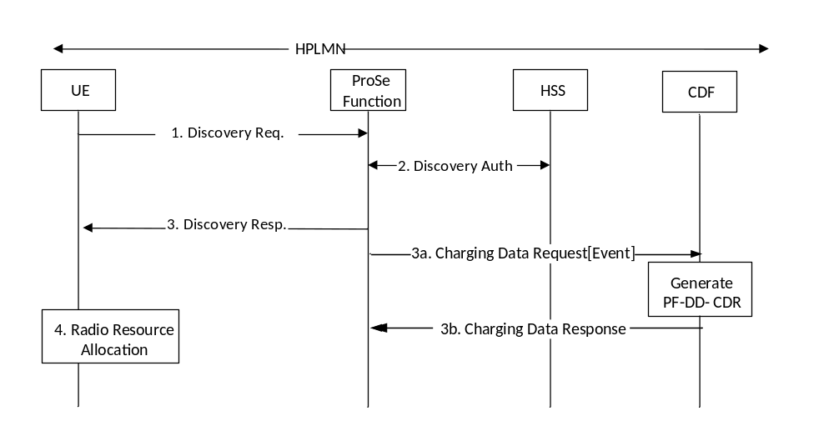
Figure 5.2.2.1.2.1: Message flow for ProSe Direct Discovery Announce Request (non-roaming)
The detailed description for the message flow is defined in TS 23.303 [238].
1-2. These steps are the same as the ProSe Direct Discovery are defined in TS 23.303[238].
3. The ProSe Function responds with a Discovery Response with:
- (ProSe Application Code, validity timer, PC5_tech) for open discovery.
- (ProSe Application Code, ProSe Restricted Code/ ProSe Restricted Code Prefix[ProSe Restricted Code Suffix pool], validity timer, Discovery Entry ID, Announcing Enabled indicator, PC5_tech) for restricted discovery.
3a. The ProSe Function triggers Charging Data Request[Event] to CDF in HPLMN where event represents Announce. The PF-DD-CDR is generated by CDF for Announcing UE.
3b. The CDF returns Charging Data Response corresponding to the received Charging Data Request[Event].
4. The UE may start announcing the provided ProSe Application Code in HPLMN for open discovery and ProSe Restricted Code in serving PLMN for restricted discovery, using the radio resources authorized and configured by E-UTRAN to be used for ProSe as defined in RAN specifications, or using WLAN, or both.
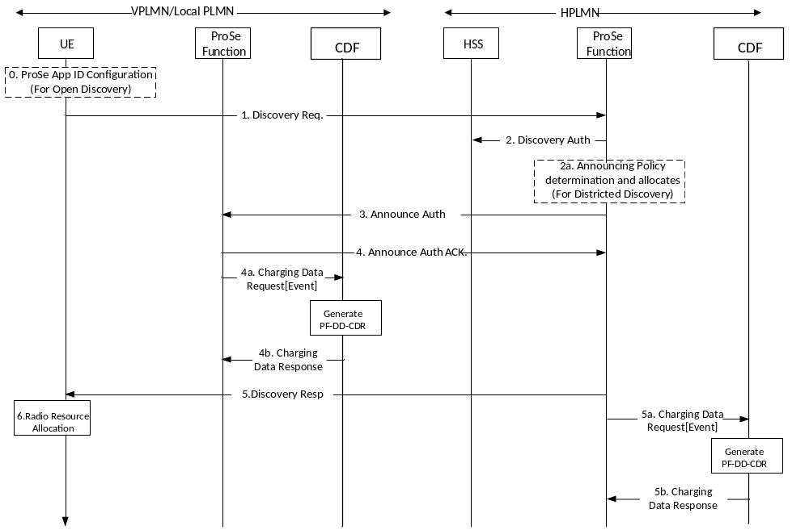
Figure 5.2.2.1.2.2: Message flow for ProSe Direct Discovery Announce Request (roaming/ inter-PLMN transmission)
The UE is only allowed to announce in the bands signalled from VPLMN. The detailed description for the message flow of open discovery and restricted discovery are defined in TS 23.303 [238] clause 5.3.3.

0-4. If the UE is authorized to announce in VPLMN and is triggered to announce, it shall establish a secure connection with the ProSe Function in HPLMN and it shall then send a Discovery Request and then the ProSe Function in VPLMN authorizes the UE to perform ProSe Direct Discovery Announce.
4a. After the ProSe Function in VPLMN responds to the Announce Authorisation message, the ProSe Function in VPLMN sends Charging Data Request[Event] to CDF in VPLMN. The PF-DD-CDR for Announcing UE is generated by the CDF in VPLMN where event represents Announce.
4b. The CDF in VPLMN returns Charging Data Response corresponding to the received Charging Data Request[Event].
5. The ProSe Function in HPLMN shall respond to the UE with a Discovery Response with:
- (ProSe Application Code, validity timer, Discovery Entry ID, PC5_tech) for open discovery.
- (ProSe Restricted Code/ProSe Restricted Code Prefix[ProSe Restricted Code Suffix pool], validity timer, Discovery Entry ID, ProSe Enabled Indicator, PC5_tech) for districted discovery.
5a. After the ProSe Function in HPLMN responds to the UE with a Discovery Response, the ProSe Function sends Charging Data Request[Event] to CDF in HPLMN. The PF-DD-CDR for Announcing UE is generated by the CDF in HPLMN where event represents Announce.
5b. The CDF in HPLMN returns Charging Data Response corresponding to the received Charging Data Request[Event].
6. The UE may start announcing the provided ProSe Application Code for open discovery and ProSe Restricted Code for restricted discovery in the VPLMN or Local PLMN, using the radio resources authorized and configured by E-UTRAN to be used for ProSe as defined in RAN specifications, or using WLAN, or both.

5.2.2.1.3 Message flow for ProSe Direct Discovery Monitor Request
ProSe Direct Discovery Monitor Request allows a ProSe-enabled UE to obtain a set of filters from the HPLMN ProSe Function, which enables the UE to discover Announcing UE of its interest. Charging Data Request[Event] is triggered for Monitoring UE after ProSe Function responds to the Discovery Request or to the Monitor Request message.
When the ProSe Application ID has a scope different from PLMN specific scope (i.e. country-wide or global), the message flows are the same as those for the case of PLMN specific ProSe Application ID provided by the HPLMN.

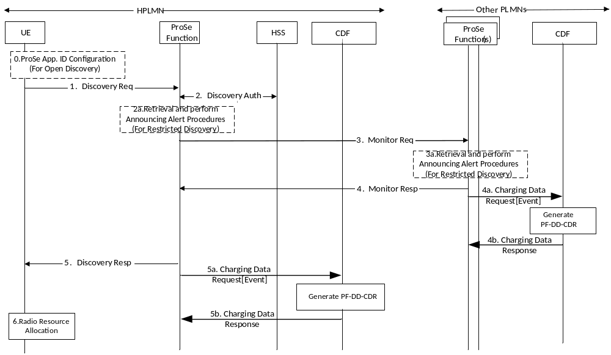
Figure 5.2.2.1.3.1: Message flow for ProSe Direct Discovery Monitor Request (non-roaming)
More details and completed message flow for ProSe Direct Discovery Monitor Request for open discovery and restricted discovery are defined in TS 23.303[238] clause 5.3.3.4 and 5.3.3.4.A.
0-2. Monitoring UE sends out Discovery Req message and if there is no associated UE context, the ProSe Function shall check with HSS the authorization for discovery and create a new context for this UE that contains the subscription parameters for this UE for the duration the Discovery Filters will be valid.
For open discovery, if the Discovery Request is authorized, and the ProSe Application ID sent by the UE in step 1 indicates another Local PLMN and for restricted discovery, if the PLMN ID in the Target ProSe Disc UE ID indicates a PLMN different from the HPLMN then steps 3-6 are executed, otherwise (i.e. the ProSe Application ID indicates HPLMN) only steps 5-6 are executed:
3. For open discovery, the ProSe Function in HPLMN shall contact other Local PLMNs in order to resolve the ProSe Application ID Name(s) to mask(s) that corresponds to this ProSe Application ID Name. The request shall also include the UE identity information e.g. IMSI or MSISDN, and PC5_tech in order to allow the ProSe Function in Local PLMN to perform charging.
For restricted discovery, the ProSe Function in the HPLMN contacts the ProSe Function in that PLMN to retrieve the corresponding ProSe Restricted Code with a Monitor Request (RPAUID, UE Identity, Target PDUID, Application ID, Target RPAUID, Discovery Entry ID, and PC5_tech) message.
4. For open discovery, if the ProSe Function of the Local PLMN stores valid ProSe Application Code(s) corresponding to the requested ProSe Application ID Name(s) and the requested PC5 radio technology, then the ProSe Function of the Local PLMN returns the related mask(s) and the corresponding TTL for each.
For restricted discovery, the ProSe Function in the other PLMN returns to the ProSe Function in the HPLMN the ProSe Restricted Code and the corresponding residual validity timer with a Monitor Response (ProSe Restricted Code, validity timer, PC5_tech) message. The Prose Function in the other PLMN also stores, in the context of the announcing UE, the PDUID of the monitoring UE and the allocated validity timer.
4a. After the ProSe Function of the Local PLMN responds to Monitor Request from the ProSe Function of HPLMN, the ProSe Function of the Local PLMN sends Charging Data Request[Event] to CDF in Local PLMN. The PF-DD-CDR is generated for Monitoring UE where Event represents Monitor.
4b. The CDF in Local PLMN returns Charging Data Response corresponding to the received Charging Data Request[Event].
NOTE 1: If the ProSe Function of the Local PLMN does not return any mask, than the ProSe Function in the HPLMN notifies the UE that the Discovery Request has been rejected.
5. The ProSe Function in the HPLMN shall respond with a Discovery Response message:
- Discovery Filter(s), Discovery Entry ID, and PC5_tech for open discovery;
- Discovery Filter(s), Metadata Indicator, Discovery Entry ID, Application Level Container, and PC5_tech for restricted discovery.
5a. After the ProSe Function in the HPLMN responds with a Discovery Response, the ProSe Function sends Charging Data Request[Event] to CDF in HPLMN. The PF-DD-CDR is generated for Monitoring UE where Event represents Monitor.
5b. The CDF in HPLMN returns Charging Data Response corresponding to the received Charging Data Request[Event].
6. The UE may start monitoring using the Discovery Filter(s) in the radio resources that are authorized and configured by the PLMN(s) to be used for ProSe as defined in RAN specification, or using WLAN, or both s.
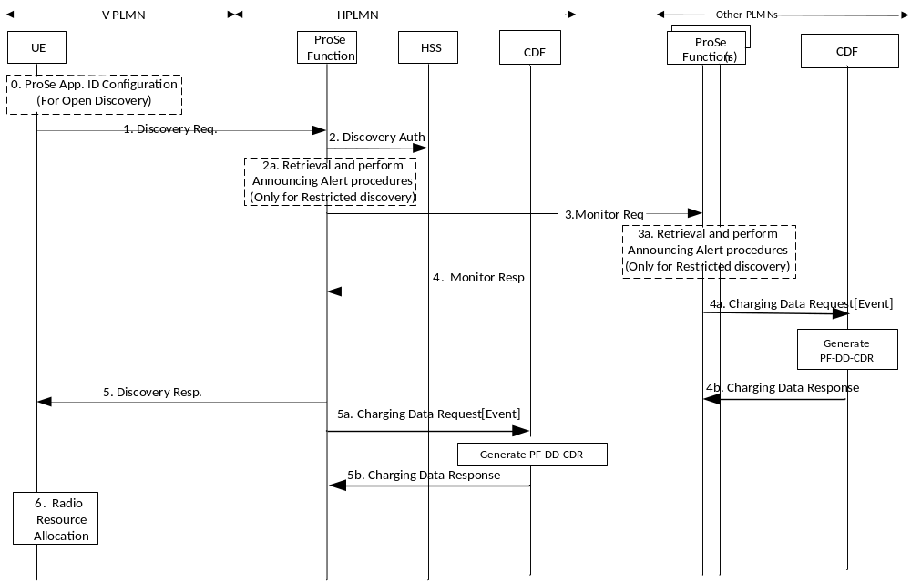
Figure 5.2.2.1.3.2: Message flow for ProSe Direct Discovery Monitor Request (roaming/ inter-PLMN transmission)
More details and completed message flow for ProSe Direct Discovery Monitor Request for open discovery and restricted discovery are defined in TS 23.303[238] clause 5.3.3.5 and clause 5.3.3.5.A.
0-4. These steps are defined in TS 23.303 [238] clause 5.3.3.5 for open discovery and clause 5.3.3.5.A for restricted discovery.
4a. After the ProSe Function of the other PLMN responds to Monitor Request from the ProSe Function of HPLMN, the ProSe Function of the other PLMN sends Charging Data Request[Event] to CDF in other PLMN. The PF-DD-CDR is generated for Monitoring UE where Event represents Monitor.
4b. The CDF in other PLMN returns Charging Data Response corresponding to the received Charging Data Request[Event].
NOTE 2: If the ProSe Function of the other PLMN does not return any mask, than the ProSe Function in the HPLMN notifies the UE that the Discovery Request has been rejected.
5. The ProSe Function in the HPLMN responds with a Discovery Response message.
- Discovery Filter(s), Discovery Entry ID, PC5_tech) for open discovery. The Discovery Filter(s) consists of the ProSe Application mask(s). The Discovery Filter(s) include the TTL. The TTL(s) in the Discovery Filter(s) indicate for how long the Discovery Filter(s) are going to be valid.
- Discovery Filter(s), Metadata Indicator, Discovery Entry ID, Application Level Container, and PC5_tech for restricted discovery. The Discovery Filter includes the ProSe Restricted Code to be monitored and the TTL that indicates for how long the related ProSe Restricted Code in the Discovery Filter is valid after it is received. If configured by the operator, the Target RPAUID(s) and metadata corresponding to the ProSe Restricted Code(s) may be included in the Discovery Response message.
5a. After the ProSe Function in the HPLMN responds with a Discovery Response, the ProSe Function sends Charging Data Request[Event] to CDF in HPLMN. The PF-DD-CDR is generated for Monitoring UE where Event represents Monitor.
5b. The CDF in HPLMN returns Charging Data Response corresponding to the received Charging Data Request[Event].
6. The UE may start monitoring using the Discovery Filter(s) in the radio resources that are authorized and configured by the PLMN(s) to be used for ProSe as defined in RAN specifications, or using WLAN, or both.

5.2.2.1.4 Message flow for ProSe Direct Discovery Match Report
ProSe Direct Discovery Match Report allows a ProSe-enabled UE to report a match of the ProSe Application Code to the HPLMN ProSe Function, and obtain the corresponding ProSe Application ID and metadata. Charging Data Request[Event] is triggered for Monitoring UE after ProSe Function responds to the Match Report message.
When the ProSe Application ID has a scope different from PLMN specific scope (i.e. country-wide or global), the message flows are the same as those for the case of PLMN specific ProSe Application ID.
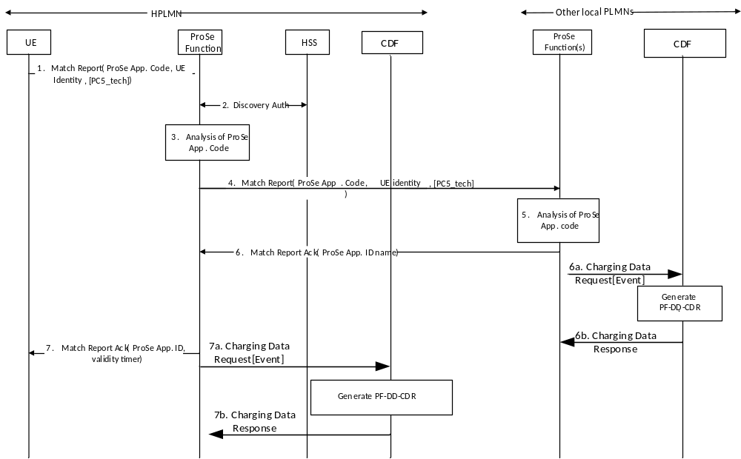
Figure 5.2.2.1.4.1: Message flow for Match Report of Open Discovery (non-roaming)
More details and completed message flow for ProSe Direct Discovery Match Report for Open discovery(non-roaming) are defined in TS 23.303[238] clause 5.3.4.1.
1. If the UE finds ProSe Application Code(s) that matches the Discovery Filters and does not have ProSe Application ID(s) already locally stored that correspond to this ProSe Application Code(s), it shall (re)establish a secure connection with the ProSe Function in HPLMN to which it shall then send a Match Report (ProSe Application Code(s), UE Identity, Monitored PLMN ID, and PC5_tech) message.
2. The ProSe Function shall check the context for this UE that contains its subscription parameters. The authorization information also contains the PLMN that this UE is allowed to perform discovery.
3. The ProSe Function analyses the ProSe Application Code received from the UE.
If the PLMN ID that assigned the given ProSe Application Code is another Local PLMN then steps 4-7 are executed, otherwise (i.e. the ProSe Application Code was assigned by HPLMN) only step 7 is executed:
4. The ProSe Function in HPLMN sends a Match Report (ProSe Application Code(s), UE identity, PC5_tech) to the ProSe Function of the PLMN that assigned the ProSe Application Code. The UE identity information e.g. IMSI or MSISDN can be used by the ProSe Function in Local PLMN to perform charging.
5. The ProSe Function analyses the ProSe Application Code(s) received from the UE.
6. If the ProSe Application Code is confirmed then the ProSe Function in Local PLMN shall send Match Report Acknowledgement (ProSe Application ID Name(s), validity timer(s) , PC5_tech). This message may also contain certain metadata corresponding to the ProSe Application ID Name e.g. postal address, phone number, URL etc.
6a. After the ProSe Function in Local PLMN sends Match Report Acknowledgement, the ProSe Function in Local PLMN sends Charging Data Request[Event] to the CDF in Local PLMN. The PF-DD-CDR is generated for Monitoring UE where Event represents Match.
6b. The CDF in Local PLMN returns Charging Data Response corresponding to the received Charging Data Request[Event].
7. The ProSe Function in HPLMN shall respond to the UE with Match Report Acknowledgment (ProSe Application ID(s), validity timer(s)). This message may also contain certain metadata corresponding to the ProSe Application ID Name e.g. postal address, phone number, URL etc. The validity timer(s) indicate for how long the ProSe Application ID(s) provided are going to be valid. The UE may store the mapping of ProSe Application Code(s) and corresponding ProSe Application ID(s) for the duration of their validity timer.
7a. After the ProSe Function in HPLMN responds to the UE with Match Report Acknowledgment, the ProSe Function in HPLMN sends Charging Data Request[Event] to CDF in HPLMN. The PF-DD-CDR is generated for Monitoring UE where Event represents Match, with indication of the PC5 radio technology used for the ProSe Direct Discovery.
7b. The CDF in Local PLMN returns Charging Data Response corresponding to the received Charging Data Request[Event].
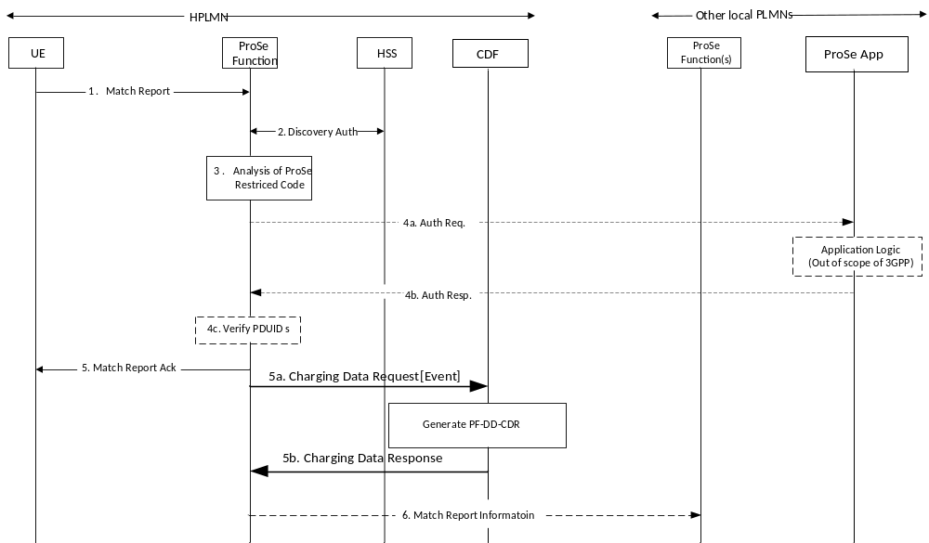
Figure 5.2.2.1.4.1A: Message flow for Match Report of Restricted Discovery (non-roaming)
More details and completed message flow for ProSe Direct Discovery Match Report for Restricted discovery(non-roaming) are defined in TS 23.303[238] clause 5.3.4.1.A.
1. When the monitoring UE has received a ProSe Restricted Code over the air that matches the Discovery Filter it obtained from monitoring Request procedure, and if the UE does not have a corresponding RPAUID associated with it with a valid TTL, the UE sends a Match Report (RPAUID, UE Identity, Discovery Type, Application ID, ProSe Restricted Code, Metadata Requested, PC5_tech) message to the ProSe Function in the HPLMN to get the Target RPAUID.
2. The HPLMN ProSe Function checks the authorization for the monitoring UE to perform restricted discovery.
3-4c. The HPLMN ProSe Function analyses the ProSe Restricted Code and identifies in the UE context of the monitoring UE the corresponding Target RPAUID.
5. The ProSe Function in HPLMN returns a Match Report Ack (Application ID, Target RPAUID, validity timer, metadata) to the UE.
5a. After the ProSe Function of the HPLMN responds to Match Report Request from the UE.The ProSe Function in HPLMN sends Charging Data Request[Event] to CDF in HPLMN. The PF-DD-CDR for UE is generated by the CDF in the HPLMN where event represents Match, with indication of the PC5 radio technology used for the ProSe Direct Discovery.
5b. The CDF in HPLMN returns Charging Data Response corresponding to the received Charging Data Request[Event].
6. The ProSe Function in HPLMN may optionally send a Match Report Info (RPAUID, Target RPAUID, UE Identity, ProSe Restricted Code, Discovery Type and PC5_tech) to the ProSe Function of the announcing UE.
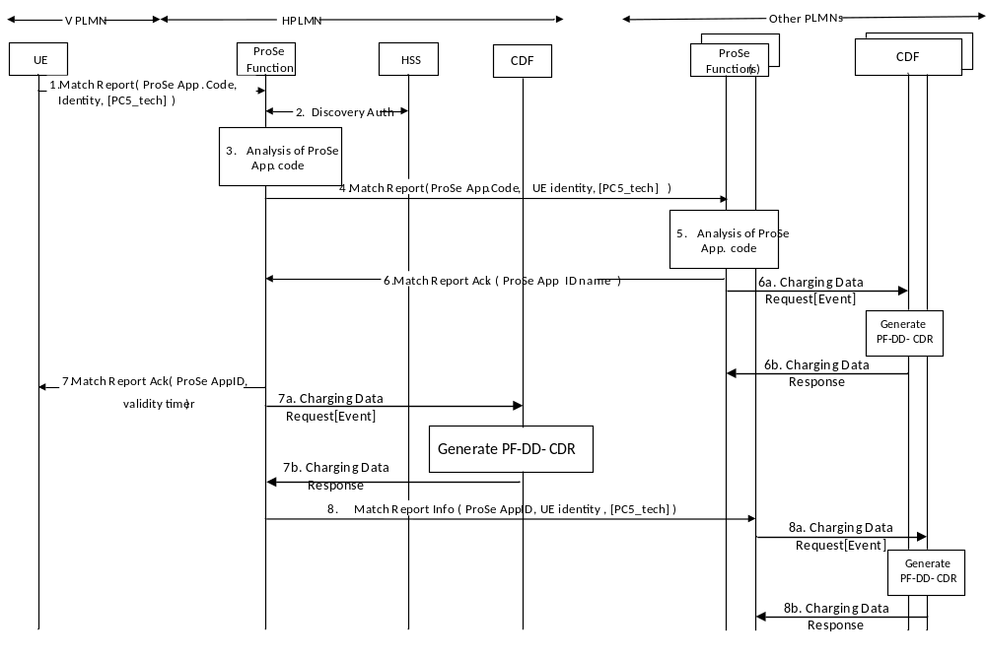
Figure 5.2.2.1.4.2: Message flow for Match Report of Open Discovery (roaming/inter-PLMN transmission)
More details and completed message flow for ProSe Match Report of open discovery(roaming/inter-PLMN transmission) are defined in TS 23.303[238] clause 5.3.4.2.
1. If the UE finds ProSe Application Code(s) that matches the Discovery Filters and does not have ProSe Application ID(s) already locally stored that correspond to this ProSe Application Code(s), it (re)establishes a secure connection with the ProSe Function in HPLMN and sends a Match Report (ProSe Application Code(s), UE Identity, VPLMN ID, Monitored PLMN ID, PC5_tech) message.
2. The ProSe Function shall check the context for this UE that contains its subscription parameters for this UE. The authorization information also contains the PLMN that this UE is allowed to perform discovery. The UE context also contains the VPLMN ID where the UE is registered.
3. The ProSe Function analyses the ProSe Application Code(s) received from the UE.
If the PLMN ID that assigned the given ProSe Application Code is not the HPLMN, then steps 4-8 are executed, otherwise (i.e. the HPLMN assigned the ProSe Application Code) only steps are executed:
4. The ProSe Function in HPLMN sends a Match Report (ProSe Application Code(s), UE identity, monitored PLMN ID, PC5_tech) to the ProSe Function of the PLMN that assigned the ProSe Application Code (i.e. the ProSe Function of the HPLMN of the Announcing UE).
5. The ProSe Function ensures that the received ProSe Application Code is authorized to be transmitted on the monitored PLMN. The ProSe Function analyses the ProSe Application Code(s) received from the UE, and confirms the ProSe Application Code(s).
6. The ProSe Function shall send Match Report Acknowledgement (ProSe Application ID Name(s), validity timer(s)). This message may also contain certain metadata corresponding to the ProSe Application ID Name e.g. postal address, phone number, URL, etc.
6a. After the ProSe Function in other PLMNs sends Match Report Acknowledgement message, the ProSe Function in other PLMNs sends Charging Data Request[Event] to the CDF in other PLMNs. The PF-DD-CDR is generated for the Monitoring UE where Event represents Match, with indication of the PC5 radio technology used for the ProSe Direct Discovery.
6b. The CDF in other PLMNs returns Charging Data Response corresponding to the received Charging Data Request[Event].
7. The ProSe Function in HPLMN shall respond to the UE with Match Report Acknowledgment (ProSe Application ID(s), validity timer(s)). This message may also contain certain metadata corresponding to the ProSe Application ID Name e.g. postal address, phone number, URL, etc. The validity timer(s) indicate for how long the ProSe Application ID(s) provided are going to be valid. The UE may store the mapping of ProSe Application Code(s) and corresponding ProSe Application ID(s) for the duration of their validity timer.
7a. After the ProSe Function in HPLMN respond to the UE with Match Report Acknowledgment message, the ProSe Function in HPLMN sends Charging Data Request[Event] to the CDF in HPLMN. The PF-DD-CDR is generated for Monitoring UE where Event represents Match, with indication of the PC5 radio technology used for the ProSe Direct Discovery.
7b. The CDF in HPLMNs returns Charging Data Response corresponding to the received Charging Data Request[Event].
8. If in step 4 it was indicated that the Announcing UE is roaming, the ProSe Function in HPLMN may optionally send a Match Report Info (ProSe Application ID(s), UE Identity, PC5_tech) to the ProSe Function of the serving PLMN (i.e. VPLMN) of the Announcing UE.
8a. When receiving a Match Report Info message, the ProSe Function in VPLMN of the Announcing UE sends Charging Data Request[Event] to the CDF in VPLMN of the Announcing UE. The PF-DD-CDR is generated for Announcing UE where Event represents Match.
8b. The CDF in VPLMN of the Announcing UE returns Charging Data Response corresponding to the received Charging Data Request[Event].
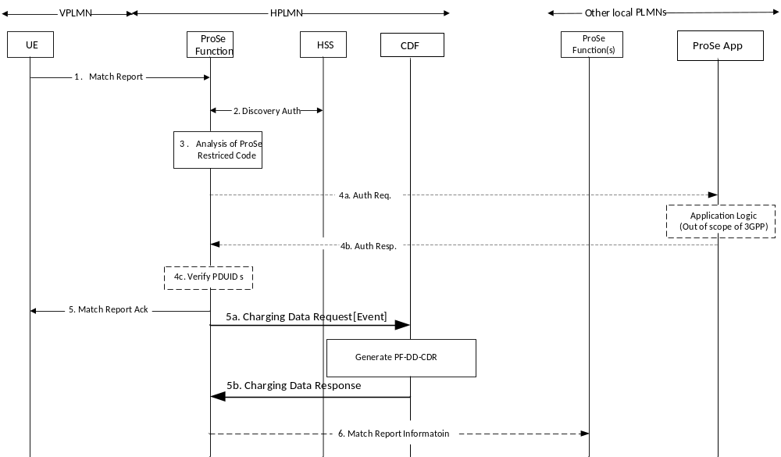
Figure 5.2.2.1.4.3: Message flow for Match Report of Restricted Discovery (roaming//inter-PLMN transmission)
More details and completed message flow for ProSe Match Report of restricted discovery(roaming//inter-PLMN transmission) are defined in TS 23.303[238] clause 5.3.4.2.A.
1-5. These steps are the similar with the figure 5.2.2.1.4.1A Message flow for Match Report of restricted discovery (non-roaming).
5a. After the ProSe Function of the HPLMN responds to Match Report Request from the UE.The ProSe Function in HPLMN sends Charging Data Request[Event] to CDF in HPLMN. The PF-DD-CDR for UE is generated by the CDF in the HPLMN where event represents Match, with indication of the PC5 radio technology used for the ProSe Direct Discovery.
5b. The CDF in HPLMN returns Charging Data Response corresponding to the received Charging Data Request[Event].
6. The ProSe Function in HPLMN may optionally send a Match Report Info (RPAUID, Target RPAUID, UE Identity, ProSe Restricted Code, Discovery Type, PC5_tech) to the ProSe Function in the HPLMN of the announcing UE.

5.2.2.1.5 Message flow for Discovery Request - Model B procedures
The Discovery Request is sent by the Discoveree UE or the Discoverer UE in order to be authorised to access the discovery resources and perform restricted ProSe Direct Discovery, Model B.
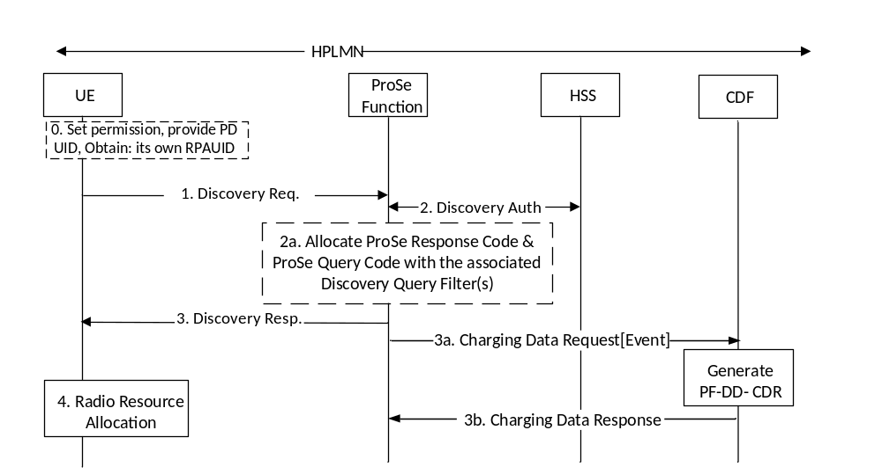
Figure 5.2.2.1.5.1: Discoveree UE procedures for Model B restricted discovery (non-roaming)
More details and complete message flow of Discoveree UE procedures for Model B restricted discovery (non-roaming) are defined in TS 23.303 [238] clause 5.3.3A.2.
The user sets the permission for the restricted discovery using application layer mechanisms.
1-3. If the Discoveree UE is authorised to use Model B discovery in the serving PLMN, or if UE intends to use Model B discovery using WLAN-based PC5 and is triggered by the application client to perform a Discoveree Request procedure, the UE shall establish a secure connection to the ProSe Function in the HPLMN and send a Discovery Request (RPAUID, UE Identity, command, Discovery Type, Discovery Model, Application ID, Discovery Entry ID, PC5_tech) message.
After ProSe Function check the authorization, the ProSe Function in HPLMN shall allocate and respond with a Discovery Response (Discovery Model, ProSe Response Code, Discovery Query Filter(s), validity timer, Discovery Entry ID, PC5_tech) message.
3a. After the ProSe Function in HPLMN responds to the Discoveree UE with a Discovery Response (Discovery Model, ProSe Response Code, Discovery Query Filter(s), validity timer, Discovery Entry ID, PC5_tech) message.The ProSe Function in HPLMN sends Charging Data Request[Event] to CDF in HPLMN. The PF-DD-CDR for Discoveree UE is generated by the CDF in HPLMN where event represents Model B restricted discovery.
3b. The CDF in HPLMN returns Charging Data Response corresponding to the received Charging Data Request[Event].4. The UE may then obtain the radio resources as authorised and configured by E-UTRAN for ProSe as defined in RAN specifications, or use WLAN or both, to monitor using the Discovery Query Filter(s).
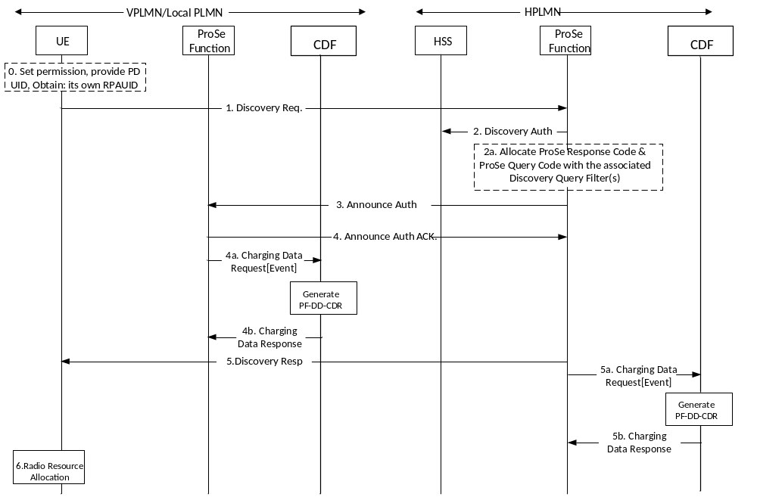
Figure 5.2.2.1.5.2: Discoveree UE procedures for Model B restricted discovery (roaming/Inter-PLMN transmission)
More details and complete message flow of Discoveree UE procedures for Model B restricted discovery (roaming/inter-PLMN transmission) are defined in TS 23.303 [238] clause 5.3.3A.3.
0-4. These steps are defined in TS 23.303[238].
4a. After the ProSe Function of the VPLMN or Local PLMN responds to Discovery Request from the ProSe Function of HPLMN, the ProSe Function of the VPLMN or Local PLMN sends Charging Data Request[Event] to CDF in VPLMN or Local PLMN. The PF-DD-CDR is generated for Discoveree UE where Event represents Model B restricted discovery.
4b. The CDF in VPLMN or Local PLMN returns Charging Data Response corresponding to the received Charging Data Request[Event].
5. The ProSe Function in HPLMN shall respond with a Discovery Response (Discovery Model, ProSe Response Code, Discovery Query Filter(s), validity timer, Discovery Entry ID, PC5_tech) message.
5a. After the ProSe Function in the HPLMN responds with a Discovery Response (Discovery Model, ProSe Response Code, Discovery Query Filter(s), validity timer, Discovery Entry ID, PC5_tech) message, the ProSe Function sends Charging Data Request[Event] to CDF in HPLMN. The PF-DD-CDR is generated for Discoveree UE where Event represents Model B restricted discovery.
5b. The CDF in HPLMN returns Charging Data Response corresponding to the received Charging Data Request[Event].
6. The UE may then obtain the radio resources as authorised and configured by E-UTRAN for ProSe as defined in RAN specifications, or use WLAN or both, to monitor using the Discovery Query Filter.
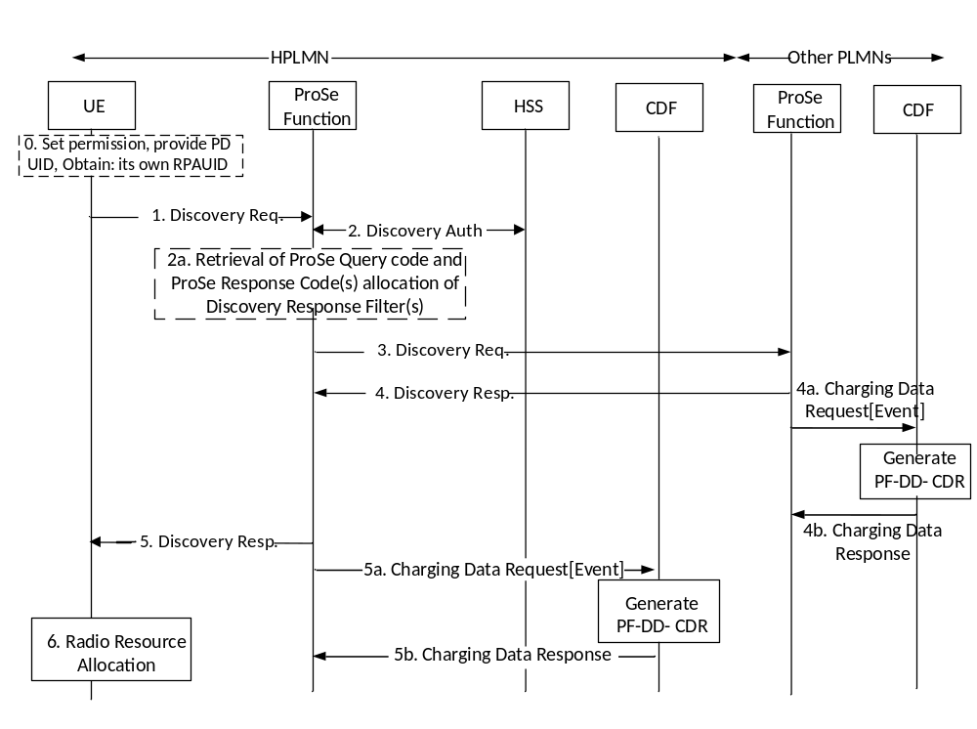
Figure 5.2.2.1.5.3: Discoverer UE procedures for Model B restricted discovery (non-roaming)
More details and complete message flow of Discoverer UE procedures for Model B restricted discovery (non-roaming) are defined in TS 23.303 [238] clause 5.3.3A.4.
0. In this step, the application client in the UE retrieves its own PDUID and provides it to the ProSe Application Server.
1-4. If the Discoverer UE is authorised to use Model B discovery in the serving PLMN and is triggered by the application client to perform a Discoverer Request procedure, the UE shall establish a secure connection to the ProSe Function in the HPLMN and send a Discovery Request (RPAUID, UE Identity, command, Discovery Type, Discovery Model, Application ID, Application Transparent Container, Discovery Entry ID, PC5_tech) message. Based on the Target ProSe Discovery UE ID, Application ID, and Target Restricted ProSe App User ID, the ProSe Function locates the Discoveree UE(s) context, and responds with a Discovery Response (ProSe Query Code(s), ProSe Response Code, validity timer).
4a. After the ProSe Function of the other PLMN responds to Discovery Request (Restricted ProSe App User ID, UE Identity, Target ProSe Discovery UE ID, Application ID, Target Restricted ProSe App User ID, Discovery Entry ID, PC5_tech) from the ProSe Function of HPLMN.The ProSe Function in other PLMN sends Charging Data Request[Event] to CDF in other PLMN. The PF-DD-CDR for Discoverer UE is generated by the CDF in other PLMN where event represents Model B restricted discovery.
4b. The CDF in other PLMN returns Charging Data Response corresponding to the received Charging Data Request[Event].
5. The ProSe Function in the HPLMN shall respond with a Discovery Response (Discovery Model, ProSe Query Code(s), Discovery Response Filter(s) validity timer, PC5_tech) message.
5a. After the ProSe Function in HPLMN responds to the Discoverer UE with a Discovery Response (Discovery Model, ProSe Query Code(s), Discovery Response Filter(s) validity timer, PC5_tech) message.The ProSe Function in HPLMN sends Charging Data Request[Event] to CDF in HPLMN. The PF-DD-CDR for Discoverer UE is generated by the CDF in HPLMN where event represents Model B ristricted discovery.
5b. The CDF in HPLMN returns Charging Data Response corresponding to the received Charging Data Request[Event].
6. The UE may then obtain the radio resources as authorised and configured by E-UTRAN for ProSe as defined in RAN specifications, or use WLAN or both, to announce the ProSe Query Code.
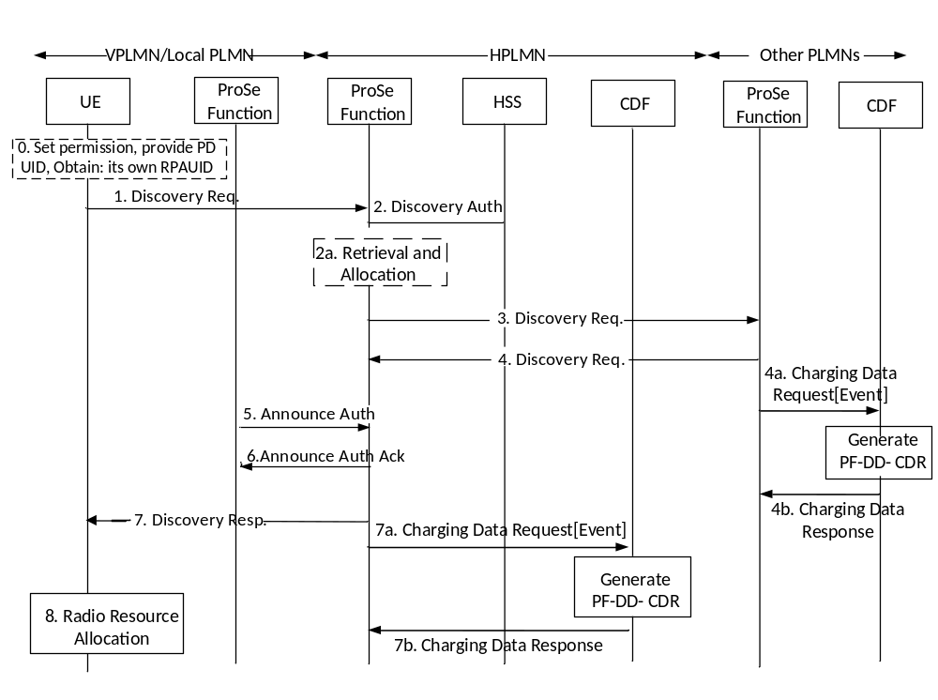
Figure 5.2.2.1.5.4: Discoverer UE procedures for Model B restricted discovery (roaming/inter-PLMN transmission)
More details and complete message flow of Discoverer UE procedures for Model B restricted discovery (roaming/inter-PLMN transmission) are defined in TS 23.303 [238] clause 5.3.3A.5.
0-4. These Steps are defined in TS 23.203 [238].
4a. After the ProSe Function of the other PLMN responds to Discovery Request from the ProSe Function of HPLMN.The ProSe Function in other PLMN sends Charging Data Request[Event] to CDF in other PLMN. The PF-DD-CDR for Discoverer UE is generated by the CDF in the other PLMN where event represents Model B restricted discovery.
4b. The CDF in other PLMN returns Charging Data Response corresponding to the received Charging Data Request[Event].
5-6. The ProSe Function in the HPLMN shall inform the ProSe Function in VPLMN or Local PLMN if Announcing PLMN ID is included in step 1 with the Announce Authorisation (Restricted ProSe Application User ID, Application ID, ProSe Query Code(s), validity timer, UE Identity, Discovery Entry ID, PC5_tech) message. The ProSe Function in VPLMN or Local PLMN authorizes the UE to perform ProSe Direct Discovery announcing.
7. The ProSe Function in the HPLMN shall respond with a Discovery Response (Discovery Model, ProSe Query Code(s), Discovery Response Filter(s) validity timer, PC5_tech) message.
7a. After the ProSe Function of HPLMN responds to Discovery Request from UE.The ProSe Function in HPLMN sends Charging Data Request[Event] to CDF in HPLMN. The PF-DD-CDR for Discoverer UE is generated by the CDF in the HPLMN where event represents Model B restricted discovery.
7b. The CDF in other PLMN returns Charging Data Response corresponding to the received Charging Data Request[Event].
8. The UE may then obtain the radio resources as authorised and configured by E-UTRAN for ProSe as defined in RAN specifications, or use WLAN or both, to announce the ProSe Query Code.

5.2.2.1.6 Message flow for Discovery reporting - Model B procedures
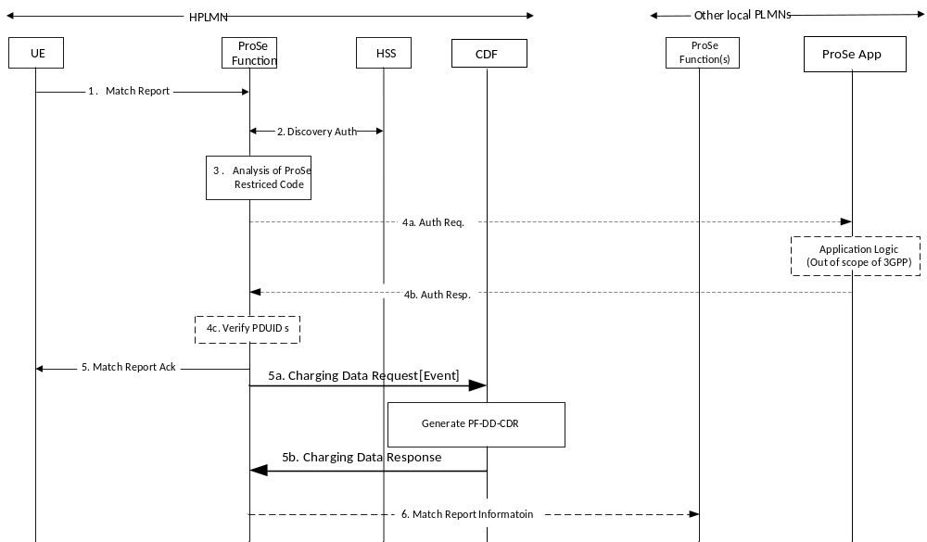
Figure 5.2.2.1.6.1: Match Report procedure for Model B restricted discovery (non-roaming)
More details and complete message flow of Discoverer UE Match Report procedures for Model B restricted discovery (non-roaming) are defined in TS 23.303 [238] clause 5.3.4A.1.
1-5. When the Discoverer UE has received a ProSe Response Code over the air that matches the Discovery Response Filter it obtained from Discoverer Request procedure, and if the UE does not have a corresponding RPAUID associated with it with a valid TTL, the UE sends a Match Report (RPAUID, UE Identity, Discovery Type, Application ID, ProSe Response Code, Metadata Requested, PC5_tech) message to the ProSe Function in the HPLMN to get the Target RPAUID. The ProSe Function in HPLMN returns a Match Report Acknowledgement (Application ID, Target RPAUID, validity timer, metadata (optional)) message to the UE.
5a. After the ProSe Function of the HPLMN responds to Match Report Request from the UE.The ProSe Function in HPLMN sends Charging Data Request[Event] to CDF in HPLMN. The PF-DD-CDR for Discoverer UE is generated by the CDF in other PLMN where event represents Model B restricted discovery reporting.
5b. The CDF in HPLMN returns Charging Data Response corresponding to the received Charging Data Request[Event].
6. The ProSe Function in HPLMN may optionally send a Match Report Info (RPAUID, Target RPAUID, UE Identity, ProSe Response Code, Discovery Type, PC5_tech) to the ProSe Function of the Discoveree UE.

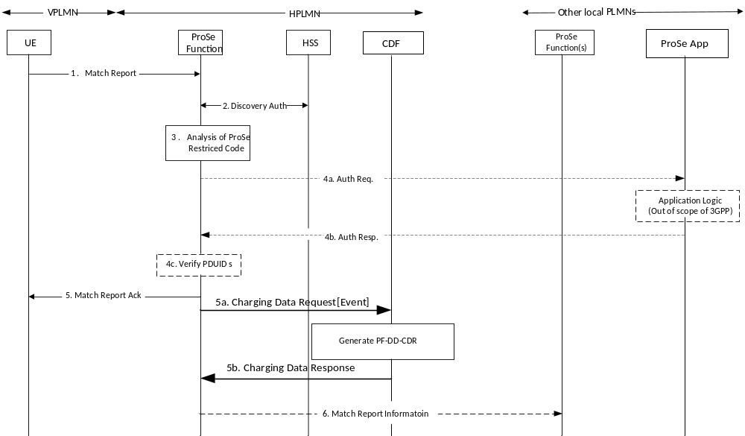
Figure 5.2.2.1.6.2: Match Report procedure for Model B restricted discovery (roaming/Inter-PLMN transmission)
More details and complete message flow of Discoverer UE Match Report procedures for Model B restricted discovery (roaming/inter-PLMN transmission) are defined in TS 23.303 [238] clause 5.3.4A.2.
1-5. These Steps are defined in TS 23.203 [238].
5a. After the ProSe Function of the HPLMN responds to Match Report Request from the UE.The ProSe Function in HPLMN sends Charging Data Request[Event] to CDF in HPLMN. The PF-DD-CDR for Discoverer UE is generated by the CDF in HPLMN where event represents Model B restricted discovery reporting.
5b. The CDF in HPLMN returns Charging Data Response corresponding to the received Charging Data Request[Event].
6. The ProSe Function in HPLMN may optionally send a Match Report Info (RPAUID, Target RPAUID, UE Identity, ProSe Response Code, Discovery Type, PC5_tech) to the ProSe Function of the Discoveree UE.

5.2.2.1.7 Message flow for ProSe Direct Discovery for Public Safety use when the UE is under coverage
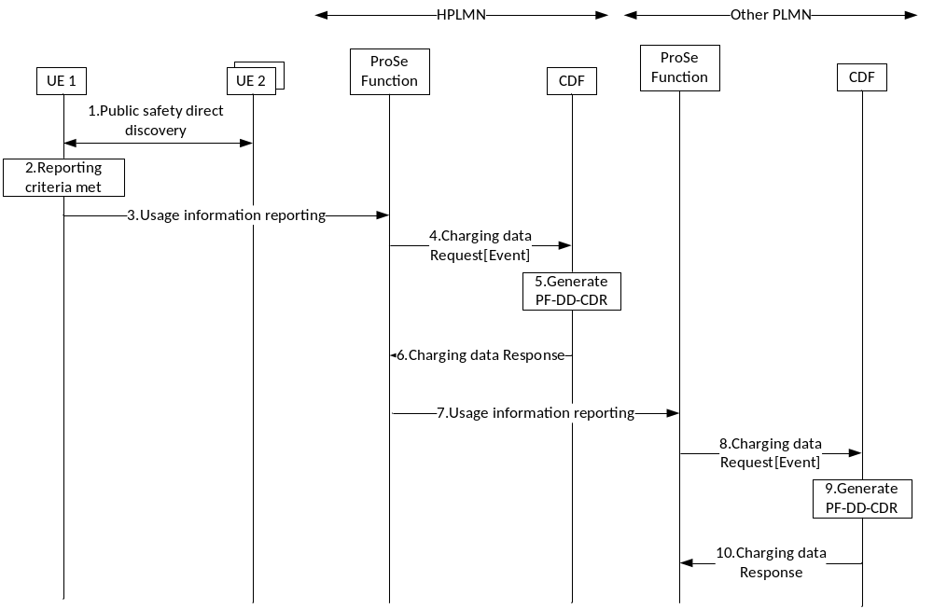
Figure 5.2.2.1.7: Offline Charging for ProSe Direct Discovery for Public Safety use (under coverage)
Figure 5.2.2.1.x depicts the message flow for event based charging for ProSe Direct Discovery for Public Safety use. More details and the completed message flow for ProSe Direct Discovery for Public Safety use are defined in TS 23.303[238] clause 5.3.7. Both UE-1 and UE-2 can decide that reporting criteria are met and trigger the usage reporting procedure.
1. UE-1 sends announcement message with model A or solicitation message with model B. In the latter case, UE 2 sends a response message.
2. When the UE-1 decides that reporting criteria are met, according to the pre-configuration, the UE creates the corresponding usage information report.
3. UE-1 triggers the usage reporting procedure by sending the usage information report to the ProSe Function.
4. Upon reception of ProSe Direct Discovery for Public Safety use usage information report, the ProSe Function triggers the Charging Data Request[Event]. The ProSe Function sends the Charging Data Request[Event] to the corresponding CDF.
5. The CDR (PF-DD-CDR) for ProSe Direct Discovery for Public Safety use is generated by CDF for the UE-1.6. The CDF returns Charging Data Response corresponding to the received Charging Data Request.
7. If the announcing radio resource info included in the usage information indicates the PLMN of the radio resource UE-1 used to announce is not the HPLMN, HPLMN ProSe Function shall send the usage information report to the ProSe Function of the PLMN providing the radio resource.
8. Upon reception of ProSe Direct Discovery for Public Safety use usage information report, the ProSe Function triggers the Charging Data Request[Event] . The ProSe Function sends the Charging Data Request[Event] to the corresponding CDF.
9. The CDR (PF-DD-CDR) for ProSe Direct Discovery for Public Safety use is generated by CDF for the UE-1.
10. The CDF returns Charging Data Response corresponding to the received Charging Data Request.

5.2.2.1.8 Message flow for ProSe Direct Discovery for Public Safety use when the UE is out of coverage
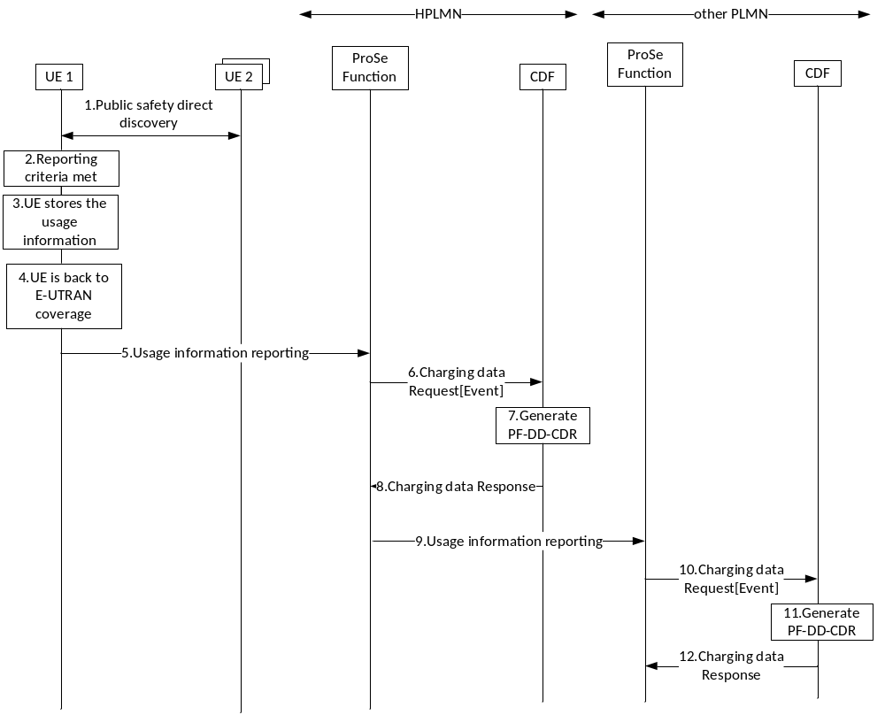
Figure 5.2.2.8.y: Offline Charging for ProSe Direct Discovery for Public Safety use (out of coverage)
Both UE-1 and UE-2 can decide that reporting criteria are met and trigger the usage reporting procedure.
1. UE-1 sends announcement message with model A or solicitation message with model B. In the latter case, UE 2 sends a response message.
2. When the UE-1 decides that reporting criteria are met, according to the pre-configuration, the UE creates the corresponding usage information report.
3. The UE-1 stores the usage information, when the UE-1 is out of E-UTRAN coverage and has no connection to the HPLMN ProSe Function.
NOTE : The usage information is stored in a secure environment in the UE-1.
4. When the UE-1 comes back to E-UTRAN coverage, it will trigger the reporting of the usage information.
5. UE-1 triggers the usage reporting procedure by sending the usage information report to the ProSe Function.
6. Upon reception of ProSe Direct Discovery for Public Safety use usage information report, the ProSe Function triggers the Charging Data Request[Event] . The ProSe Function sends the Charging Data Request[Event] to the corresponding CDF.
7. The CDR (PF-DD-CDR) for ProSe Direct Discovery for Public Safety use is generated by CDF for the UE-1.8. The CDF returns Charging Data Response corresponding to the received Charging Data Request.
9. If the announcing radio resource info included in the usage information indicates the PLMN of the radio resource UE-1 used to announce is not the HPLMN, HPLMN ProSe Function shall send the usage information report to the ProSe Function of the PLMN providing the radio resource.
10. Upon reception of ProSe Direct Discovery for Public Safety use usage information report, the ProSe Function triggers the Charging Data Request[Event] . The ProSe Function sends the Charging Data Request[Event] to the corresponding CDF.
11. The CDR (PF-DD-CDR) for ProSe Direct Discovery for Public Safety use is generated by CDF for the UE-1.
12. The CDF returns Charging Data Response corresponding to the received Charging Data Request.

5.2.2.2 Offline charging message flow for ProSe EPC-level Discovery

5.2.2.2.1 Triggers for charging events
When a charging event is reported to the CDF, it includes details related to the services provided, e.g. the EPUID, ALUID, Application ID, window, Range, location of the UE, and the reasons for triggering the event, e.g. due to Proximity Alert, or timeout of window, user request, etc.
The Proximity Request event is triggered when a ProSe Function responds to the first Proximity Request from a UE or another ProSe Function, with the Proximity Request Ack message. The Proximity Request event for a UE triggers a Charging Data Request[Start] message towards the CDF, and the subsequent Proximity Request for the same ALUID , i.e. Proximity Request Renewal event, triggers a Charging Data Request[Interim] message to the CDF. A Proximity Request Reject event, which is triggered by the ProSe Function responding a Proximity Request Reject to a Proximity Request, shall trigger a Charging Data Request[Stop] message to the CDF.
The Proximity Request Cancellation event is triggered when a ProSe Function responds to a Cancel Proximity Request from a UE or another ProSe Function, with the Proximity Request Cancellation or Cancel Proximity Request Ack message, or a Proximity Request expires. Proximity Request Cancellation event triggers a Charging Data Request[Stop] message to the CDF. It shall indicate if a Proximity Alert has been triggered for the UE.
Table 5.2.2.2.1.1 presents a summary of the messages from the ProSe Function and the triggering conditions.
Table 5.2.2.2.1.1: Triggers for charging events in ProSe EPC-level Discovery
Message | Triggering conditions
Charging Data Request [Start] | ProSe Function responded with Proximity Request Ack to the first Proximity Request for a UE.
Charging Data Request [Interim] | ProSe Function responded with Proximity Request Ack to the renewal Proximity Requests for a UE.
Charging Data Request [Stop] | ProSe Function responded with Proximity Request Reject to the Proximity Request for a UE; or  ProSe Function responded with Proximity Request Cancellation or Cancel Proximity Request Ack to the Cancel Proximity Request for a UE, or a Proximity Request expires.

5.2.2.2.2 Message flow for ProSe EPC-level Discovery Proximity Request
ProSe EPC-level Discovery Proximity Request allows a ProSe-enabled UE A to request the network to assist it detecting if UE B is in proximity using architecture specified in Figure 4.1.2, where UE A and UE B are using subscription from different networks. Upon this procedure, Charging Data Request is triggered for UE A and UE B, after the respective ProSe Function responded to the Proximity Request message.
Figure 5.2.2.2.2.1 depicts the message flow for ProSe EPC-level Discovery Proximity Request.
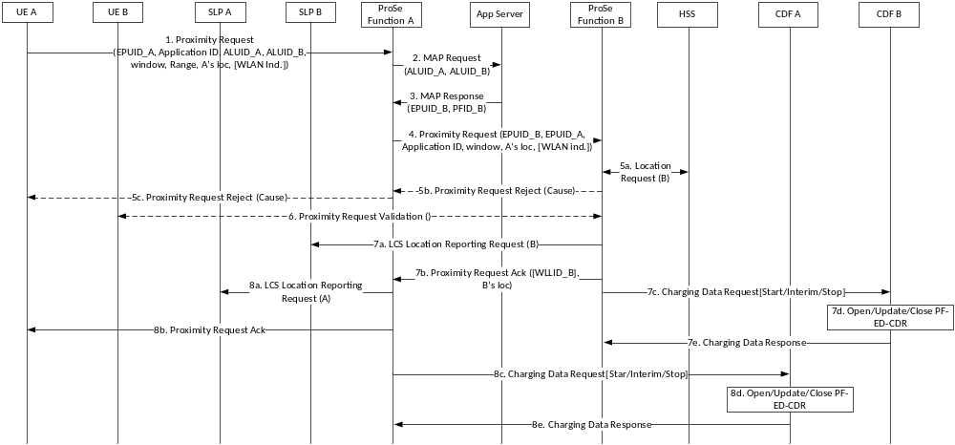
Figure 5.2.2.2.2.1: Message flow for ProSe EPC-level Discovery Proximity Request
1 - 7b. These steps are defined in TS 23.303 [238] clause 5.5.5.
7c. After the ProSe Function B responded to ProSe Function A, the ProSe Function B triggers Charging Data Request[Start/Interim/Stop] according to the conditions specified in clause 5.2.2.2.1 to the corresponding CDF B, where the charging event represents Proximity Request.
7d. The ProSe EPC-level Discovery CDR (PF-ED-CDR) is opened/updated/closed for UE B, according to the Charging Data Request.
7e. The CDF B returns Charging Data Response corresponding to the received Charging Data Request.
8a - 8b. These steps are defined in TS 23.303 [238] clause 5.5.5.
8c. After the ProSe Function A responded to UE A, the ProSe Function A triggers Charging Data Request[Start/Interim/Stop] according to the conditions specified in 5.2.2.2.1 to the corresponding CDF A, where the charging event represents Proximity Request.
8d. The ProSe EPC-level Discovery CDR (PF-ED-CDR) is opened/updated/closed for UE A.
8e. The CDF A returns Charging Data Response corresponding to the received Charging Data Request.

5.2.2.2.3 Message flow for ProSe EPC-level Discovery Proximity Request Cancellation
ProSe EPC-level Discovery Proximity Request cancellation is triggered by either the UE or network. It is cancels the proximity detection for a particular pair of UEs, e.g. UE A and UE B. Therefore, upon this procedure, Charging Data Request[Stop] is triggered for UE A and UE B, after the respective ProSe Function responded to the Cancel Proximity Request message.
Figure 5.2.2.2.3.1 depicts the message flow for ProSe EPC-level Discovery Proximity Request Cancellation.
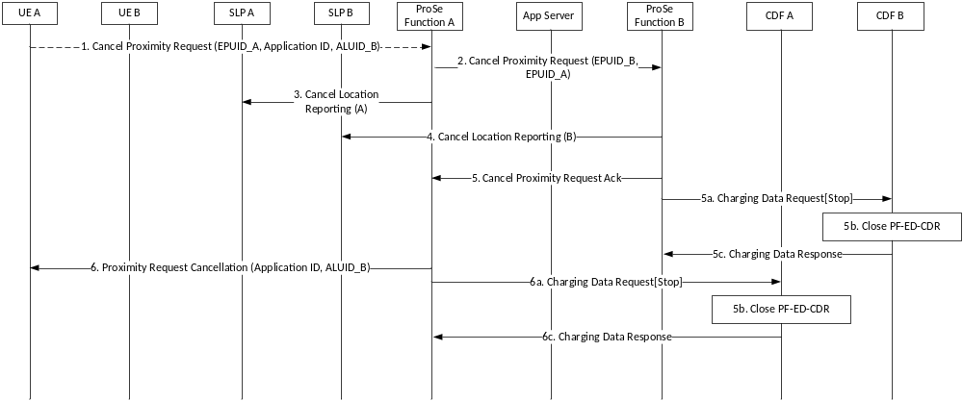
Figure 5.2.2.2.3.1: Message flow for ProSe EPC-level Discovery Proximity Request Cancellation
1 - 5. These steps are defined in TS 23.303 [238] clause 5.5.9.
5a. After the ProSe Function B sends a Cancel Proximity Request Ack to the ProSe Function A, the ProSe Function B triggers Charging Data Request[Stop] to the corresponding CDF B, where the event represents Proximity Request Cancellation. This shall also indicate if a Proximity Alert has been sent to UE B.
5b. The corresponding ProSe EPC-level Discovery CDR (PF-ED-CDR) is closed for UE B.
5c. The CDF B returns Charging Data Response corresponding to the received Charging Data Request.
6. This step is defined in TS 23.303 [238] clause 5.5.9.
6a. After the ProSe Function A sends a Proximity Request Cancellation to the UE A, the ProSe Function A triggers Charging Data Request[Stop] to the corresponding CDF A, where the charging event represents Proximity Request Cancellation. This shall also indicate if a Proximity Alert has been sent to UE A.
6b. The corresponding ProSe EPC-level Discovery CDR (PF-ED-CDR) is closed for UE A.
6c. The CDF A returns Charging Data Response corresponding to the received Charging Data Request.

5.2.2.3 Offline charging message flow for ProSe Direct Communication

5.2.2.3.1 Triggers for charging events at ProSe Function

5.2.2.3.1.1 Triggers for charging events at ProSe Function for event based charging
This reporting is achieved by sending Charging Data Request[event] from the ProSe Function to the CDF.
The Received Direct Communication Usage Report event for a group is triggered by the ProSe Function receiving a usage information report from the UE for the group over PC3. The ProSe Function goes through the reported usage information, and if it contains valid ProSe Direct Communication usage data for a specific group, the ProSe Function sends the events to the CDF, which triggers the generation of the PF-DC-CDR for a specific group. It is possible that a single UE usage information report triggers multiple Received Direct Communication Usage Report events, each for a particular group.
The Received Direct Communication Usage Report event for the one-to-one communication is triggered by the ProSe Function receiving a usage information report from the UE for the one-to-one communiction over PC3 and from the ProSe UE-to-Network relay UE for the one-to-one communication via UE-Network relay. The Prose Function goes through the reported usage information, and if it contains valid ProSe Direct Communication usage data for the one-to-one communication, the ProSe Function sends the events to the CDF, which triggers the generation of the PF-DC-CDR for the one-to-one communication.
The ProSe charging operation flows in the following subclauses are based on the above triggers and the procedures defined in TS 23.303 [238].

5.2.2.3.1.2 Triggers for charging events at ProSe Function for session based charging
The ProSe Function may be configured to use session based charging in order to reduce the number of CDRs generated.
The Charging Data Request[Start] is sent when the ProSe Function receives a Received Direct Communication Usage Report event, and there is no open charging session for the group communication and one-to-one communication including the UE-Network-relay
The Charging Data Request[Interim] is sent when the ProSe Function receives a Received Direct Communication Usage Report event, and there is an open charging session for the group communication and one-to-one communication including the UE-Network-relay.
The Charging Data Request[Stop] is sent when the ProSe Function decides one of the following conditions is met:
- operator configured maximum number of reports, or
- operator configured maximum time limit.

5.2.2.3.2 Message flow for ProSe one-to-many Direct Communication when the UE is under coverage of E-UTRAN (event based)
Figure 5.2.2.3.2.1 depicts the message flow for ProSe one-to-many Direct Communication for non-roaming and roaming case, when UE is under coverage of E-UTRAN.
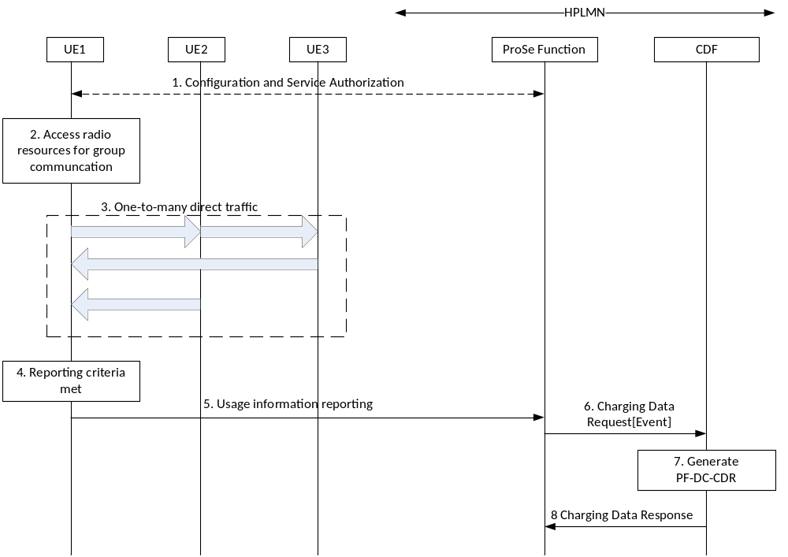
Figure 5.2.2.3.2.1: Offline Charging for ProSe one-to-many Direct Communication
1. The ProSe Function in HPLMN configures the UE on the usage information collection and reporting using the Service authorization and provisioning mechanism defined in TS 23.303 [238]. The configuration parameters are delivered as defined in TS 24.333 [241].
This step is optional, as the UE can be pre-configured with the corresponding information.
2-3. UE performs one-to-many Direct Communication as defined in TS 23.303 [238].
4. When the UE decides that reporting criteria are met, according to the configuration in step 1, and the connection to the ProSe Function is available, the UE triggers the usage reporting procedure.
NOTE 1: The UE has a connection to the HPLMN ProSe Function when any PDN Connection is available, as specified in TS 23.303 [238].
5. UE sends the usage information report to the ProSe Function, according to the configuration in step 1.
When the usage information report in step 5 includes information for multiple groups, step 6 to 8 are repeated for each of the group.
6. Upon reception of direct communication usage information report, the ProSe Function triggers the Charging Data Request[Event] . The ProSe Function sends the Charging Data Request[Event] to the corresponding CDF.
7. The ProSe one-to-many Direct Communication for Public Safety use CDR (PF-DC-CDR) for the group is generated by CDF for the UE.
8. The CDF returns Charging Data Response corresponding to the received Charging Data Request.
NOTE 2: The delivery of the charging data to the VPLMN in roaming case is handled outside of 3GPP.
NOTE 3: The procedure applies to UE1 to UE3 independently, i.e. each of the UE sends the respective usage information reports about the group communication to the network using either the under coverage procedure or out of coverage procedure.

5.2.2.3.3 Message flow for ProSe one-to-many Direct Communication when the UE is out of coverage of E-UTRAN (event based)
Figure 5.2.2.3.3.1 depicts the message flow for ProSe one-to-many Direct Communication for non-roaming and roaming case, when UE is out of coverage of E-UTRAN.
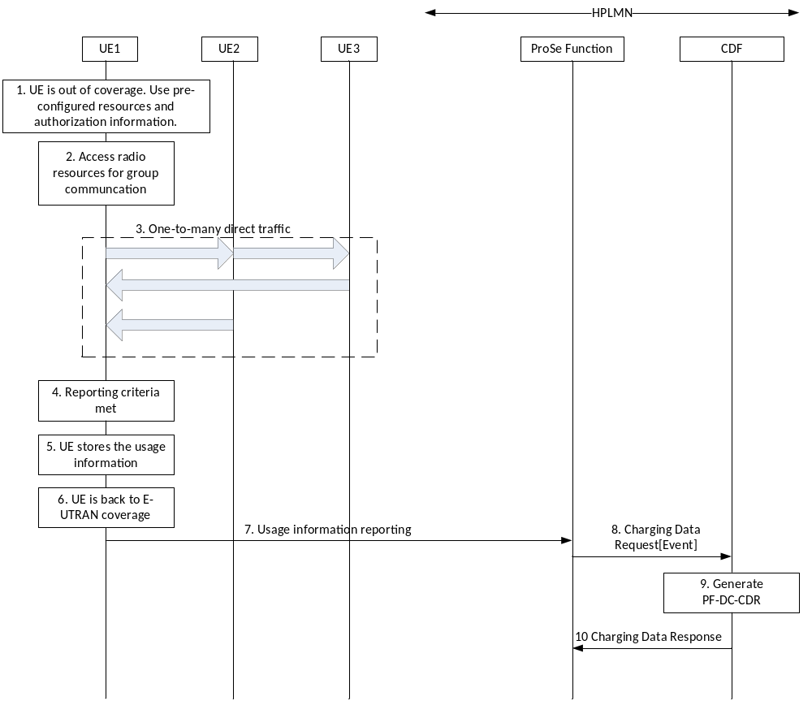
Figure 5.2.2.3.3.1: Offline Charging for ProSe one-to-many Direct Communication (out of coverage)
1. When the UE is out of coverage of the E-UTRAN, it makes use of the pre-configured resources in USIM or ME for the ProSe one-to-many Direct Communication for public safety use. The mechanism to decide on the resources to use is defined in TS 23.303 [238].
2-3. UE performs one-to-many Direct Communication as defined in TS 23.303 [238].
4. When the UE decides that reporting criteria are met, according to the pre-configuration, the UE create the corresponding usage information report.
5. The UE stores the usage information, when the UE is out of E-UTRAN coverage and has no connection to the HPLMN ProSe Function.
NOTE 1: The usage information is stored in a secure environment in the UE.
6. When the UE comes back to E-UTRAN coverage, it will trigger the reporting of the usage information.
7. UE sends the usage information report to the ProSe Function, according to the pre-configuration or new configuration from the HPLMN ProSe Function.
When the usage information report in step 7 includes information for multiple groups, step 8 to 10 are repeated for each of the group. When the usage information report in step 7 includes multiple reports for a group, e.g. the UE has been out of coverage for a long time, step 8 to 10 are repeated for each of the report.
8. Upon reception of direct communication usage information report, the ProSe Function triggers the Charging Data Request[Event] for each of the group in the report. The ProSe Function sends the Charging Data Request[Event] to the corresponding CDF.
9. The ProSe one-to-many Direct Communication for Public Safety use CDR (PF-DC-CDR) for the group is generated by CDF for the UE.
10. The CDF returns Charging Data Response corresponding to the received Charging Data Request.
NOTE 2: The procedure applies to UE1 to UE3 independently, i.e. each of the UE sends the respective usage information reports about the group communication to the network using either the under coverage procedure or out of coverage procedure.

5.2.2.3.4 Message flow for ProSe one-to-many Direct Communication when the UE is under coverage of E-UTRAN (session based)
Figure 5.2.2.3.4.1 depicts the message flow for session based charging for ProSe one-to-many Direct Communication for non-roaming and roaming case, when UE is under coverage of E-UTRAN.
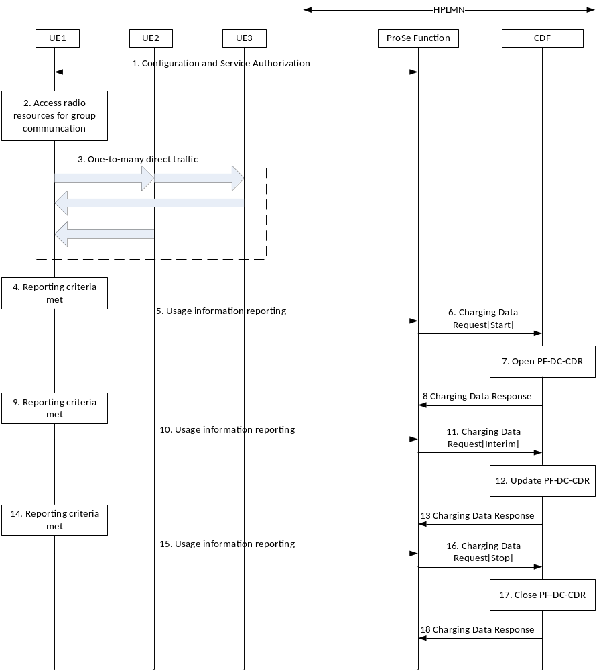
Figure 5.2.2.3.4.1: Offline Charging for ProSe one-to-many Direct Communication
(under coverage, session based charging)
1. The ProSe Function in HPLMN configures the UE on the usage information collection and reporting using the Service authorization and provisioning mechanism defined in TS 23.303 [238]. The configuration parameters are delivered as defined in TS 24.333 [241].
This step is optional, as the UE can be pre-configured with the corresponding information.
2-3. UE performs one-to-many Direct Communication as defined in TS 23.303 [238].
4. When the UE decides that reporting criteria are met, according to the configuration in step 1, and the connection to the ProSe Function is available, the UE triggers the usage reporting procedure.
NOTE 1: The UE is provided a connection to the HPLMN ProSe Function as specified in TS 23.303 [238].
5. UE sends the usage information report to the ProSe Function, according to the configuration in step 1.
When the usage information report in step 5 includes information for multiple groups, step 6 to 8 are repeated for each of the group.
6. If the ProSe Function is configured to use session based charging, upon reception of direct communication usage information report for a group, the ProSe Function triggers the Charging Data Request[Start] when there is no open charging session for the group, according to 5.2.2.3.1.2. The ProSe Function sends the Charging Data Request[Start] to the corresponding CDF, and starts a charging session for the group.
7. The ProSe one-to-many Direct Communication for Public Safety use CDR (PF-DC-CDR) for the group is opened by CDF for the UE.
8. The CDF returns Charging Data Response corresponding to the received Charging Data Request.
9. UE triggers the usage reporting procedure when the reporting criteria are met.
10. UE sends the usage information report to the ProSe Function.
When the usage information report in step 10 includes information for multiple groups, step 11 to 13 are repeated for each of the group.
11. If there is a charging session for the group, upon reception of direct communication usage information report for the group, the ProSe Function triggers the Charging Data Request[Interim], according to clause 5.2.2.3.1.2. The ProSe Function sends the Charging Data Request[Interim] to the corresponding CDF.
12. The ProSe one-to-many Direct Communication for Public Safety use CDR (PF-DC-CDR) for the group is updated by CDF for the UE.
13. The CDF returns Charging Data Response corresponding to the received Charging Data Request.
NOTE 2: Step 9 to 13 may happen multiple times before step 14.
14. UE triggers the usage reporting procedure when the reporting criteria are met.
15. UE sends the usage information report to the ProSe Function.
When the usage information report in step 15 includes information for multiple groups, step 16 to 18 are repeated for each of the group.
16. The ProSe Function decides that the charging session should be closed, according to clause 5.2.2.3.1.2, and triggers the Charging Data Request[Stop]. The ProSe Function sends the Charging Data Request[Stop] to the corresponding CDF.
17. The ProSe one-to-many Direct Communication for Public Safety use CDR (PF-DC-CDR) for the group is closed by CDF for the UE.
18. The CDF returns Charging Data Response corresponding to the received Charging Data Request.
NOTE 3: The procedure applies to UE1 to UE3 independently, i.e. each of the UE sends the respective usage information reports about the group communication to the network using either the under coverage procedure or out of coverage procedure.

5.2.2.3.5 Message flow for ProSe one-to-many Direct Communication when the UE is out of coverage of E-UTRAN (session based)
Figure 5.2.2.3.5.1 depicts the message flow for session based charging for ProSe one-to-many Direct Communication for non-roaming and roaming case, when UE is out of coverage of E-UTRAN.
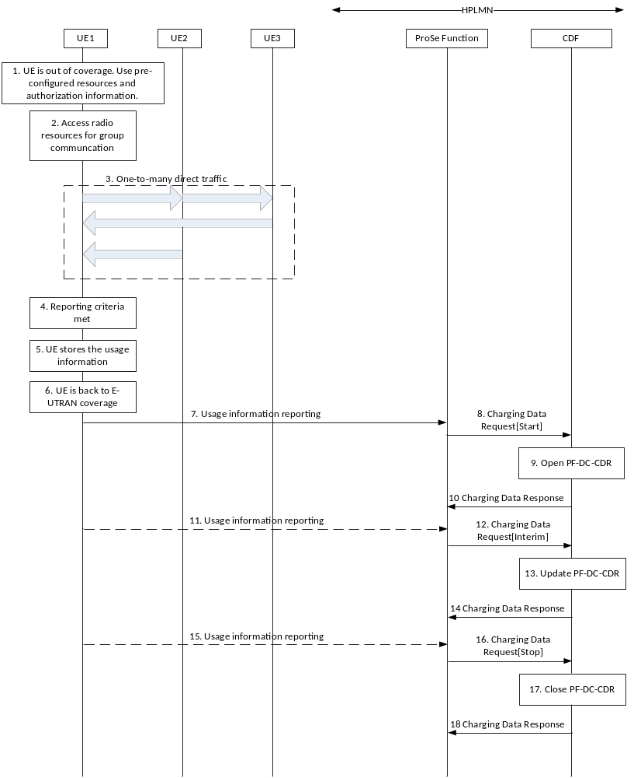
Figure 5.2.2.3.5.1: Offline Charging for ProSe one-to-many Direct Communication
(out of coverage, session based)
1. When the UE is out of coverage of the E-UTRAN, it makes use of the pre-configured resources in USIM or ME for the ProSe one-to-many Direct Communication for public safety use. The mechanism to decide on the resources to use is defined in TS 23.303 [238].
2-3. UE performs one-to-many Direct Communication as defined in TS 23.303 [238].
4. When the UE decides that reporting criteria are met, according to the pre-configuration, the UE create the corresponding usage information report.
5. The UE stores the usage information, when the UE is out of E-UTRAN coverage and has no connection to the HPLMN ProSe Function.
NOTE 1: The usage information is stored in a secure environment in the UE.
6. When the UE comes back to E-UTRAN coverage, it will trigger the reporting of the usage information.
7. UE sends the usage information report to the ProSe Function, according to the pre-configuration or new configuration from the HPLMN ProSe Function.
When the usage information report in step 7 includes information for multiple groups, step 8 to 10 are repeated for each of the group.
8. If the ProSe Function is configured to use session based charging, upon reception of direct communication usage information report for a group, the ProSe Function triggers the Charging Data Request[Start] when there is no open charging session for the group, according to clause 5.2.2.3.1.2. The ProSe Function sends the Charging Data Request[Start] to the corresponding CDF, and starts a charging session for the group.
9. The ProSe one-to-many Direct Communication for Public Safety use CDR (PF-DC-CDR) for the group is opened by CDF for the UE.
10. The CDF returns Charging Data Response corresponding to the received Charging Data Request.
When the usage information report in step 7 includes multiple reports for a group, e.g. the UE has been out of coverage for a long time, step 12 to 14 and 16 to 18 may be triggered without step 11 or 15.
11. UE sends the usage information report to the ProSe Function when the reporting criteria are met.
When the usage information report in step 11 includes information for multiple groups, step 12 to 14 are repeated for each of the group.
12. If there is a charging session for the group, upon reception of direct communication usage information report for the group, the ProSe Function triggers the Charging Data Request[Interim], according to clause 5.2.2.3.1.2. The ProSe Function sends the Charging Data Request[Interim] to the corresponding CDF.
13. The ProSe one-to-many Direct Communication for Public Safety use CDR (PF-DC-CDR) for the group is updated by CDF for the UE.
14. The CDF returns Charging Data Response corresponding to the received Charging Data Request.
15. UE sends the usage information report to the ProSe Function when the reporting criteria are met.
When the usage information report in step 15 includes information for multiple groups, step 16 to 18 are repeated for each of the group.
16. The ProSe Function decides that the charging session should be closed, according to clause 5.2.2.3.1.2, and triggers the Charging Data Request[Stop]. The ProSe Function sends the Charging Data Request[Stop] to the corresponding CDF.
17. The ProSe one-to-many Direct Communication for Public Safety use CDR (PF-DC-CDR) for the group is closed by CDF for the UE.
18. The CDF returns Charging Data Response corresponding to the received Charging Data Request.
NOTE 2: The procedure applies to UE1 to UE3 independently, i.e. each of the UE sends the respective usage information reports about the group communication to the network using either the under coverage procedure or out of coverage procedure.

5.2.2.3.6 Message flow for Direct communication via ProSe UE-to-Network Relay(event based)
A ProSe UE-to-Network Relay capable UE may attach to the network (if it is not already connected) and connect to a PDN connection enabling the necessary relay traffic, or it may need to connect to additional PDN connection(s) in order to provide relay traffic towards Remote UE(s). PDN connection(s) supporting UE-to-Network Relay shall only be used for Remote ProSe UE(s) relay traffic.
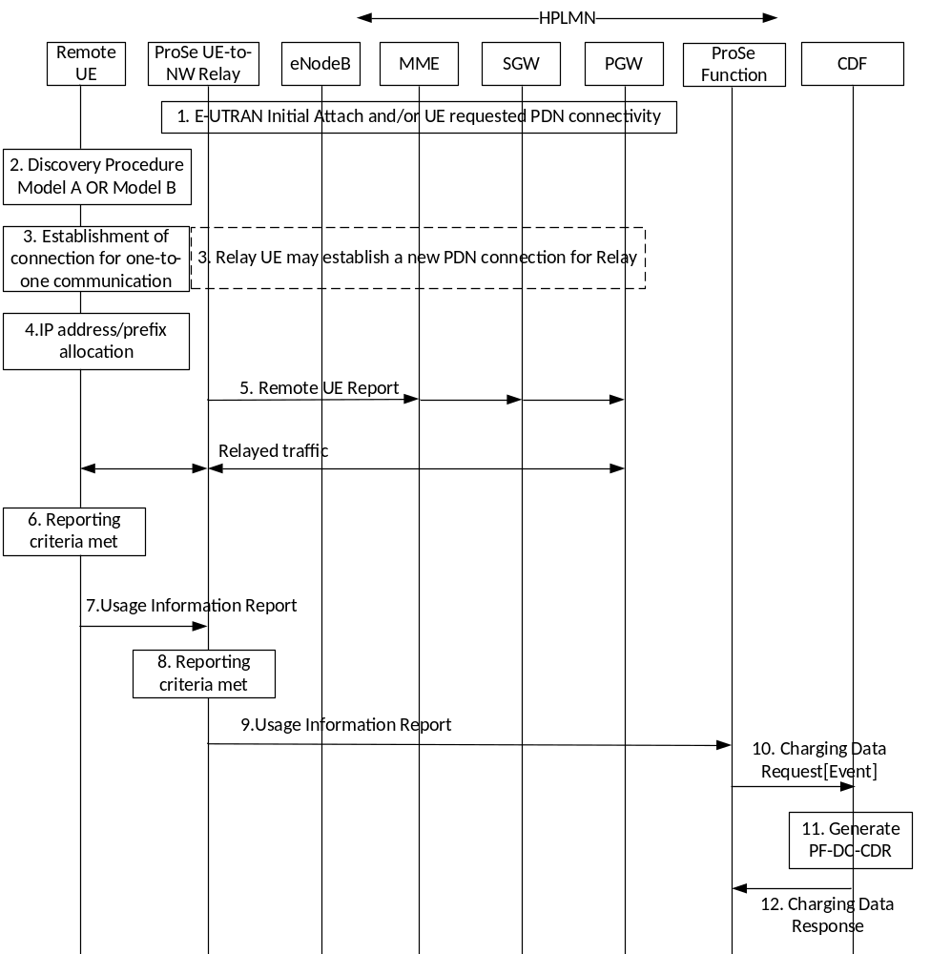
Figure 5.2.2.3.6. 1: Offline Charging for Direct Communication via ProSe UE-to-Network Relay
More details and complete message flow of ProSe UE-to-Network Relay procedures are defined in TS 23.303 [238] clause 5.4.4.
1-4. These steps are the same as message flow for ProSe UE-to-Network Direct Communication in figure 5.4.4.1-1 of TS 23.303[238].
5. The ProSe UE-to-Network Relay sends a Remote UE Report (Remote User ID, IP info) message to the MME for the PDN connection associated with the relay. The MME forwards the Remote UE Report message to the S-GW and S-GW forwards the message to the P-GW of the UE-to-Network Relay UE.
6. When remote UE decides that reporting criteria are met according to the configuration, the Remote UE triggers the usage reporting procedure and creates the corresponding usage information report.
7. The Remote UE sends the usage reporting to ProSe UE-to-Network Relay UE.
8. When the ProSe UE-to-Network Relay decides that reporting criteria are met according to the configuration, and the connection to the ProSe Function is available, the ProSe UE-to-Network Relay triggers the usage reporting procedure and creates the corresponding usage information report.
9. ProSe UE-to-Network Relay sends the usage reporting to ProSe Function.
NOTE 1: Step 8 and Step 9 can occur before Step 6 and Step 7.
10. The ProSe Function triggers the Charging Data Request[Event]. The ProSe Function sends the Charging Data Request[Event] to the corresponding CDF.
11. The ProSe Direct communication via UE-to-Network Relay use CDR (PF-DC-CDR) is generated by CDF for the Remote UE.
12. The CDF returns Charging Data Response corresponding to the received Charging Data Request.

5.2.2.3.7 Message flow for ProSe one-to-one direct communication when the UE is under coverage (event based)
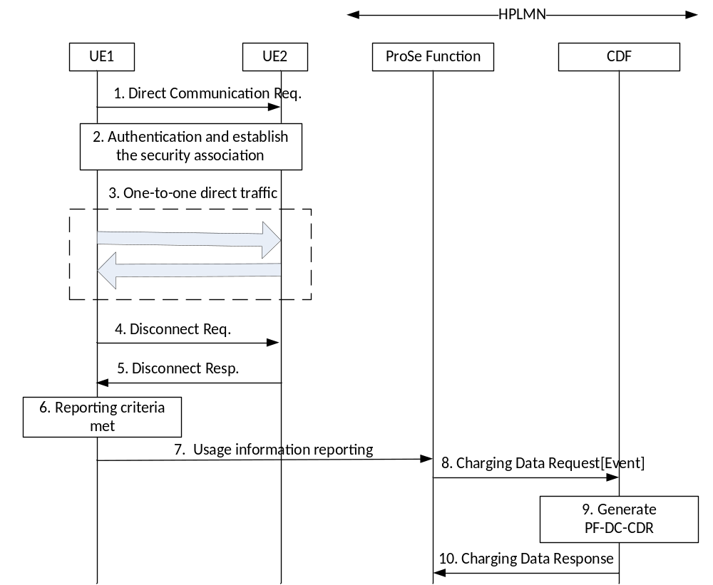
Figure 5.2.2.3.7.1: Offline Charging for ProSe one-to-one Direct Communication (under coverage)
Figure 5.2.2.3.7.1 depicts the message flow for event based charging for ProSe one-to-one Direct Communication. More details and the completed message flow for ProSe one-to-one Direct Commnication are defined in TS 23.303[238] clause 5.4.5.
1.UE-1 sends a Direct Communication Request message to UE-2 in order to trigger mutual authentication.
2-3. UE-2 initiates the procedure for mutual authentication. The successful completion of the authentication procedure completes the establishment of the secure layer-2 link over PC5 and then UE performs one-to-one Direct Communication.
4. UE-1 sends a Disconnect Request message to UE-2 in order to release the layer-2 link and deletes all context data associated with.
5. Upon reception of the Disconnect Request message UE-2 responds with a Disconnect Response message and deletes all context data associated with the layer-2 link.
6. When the UE-1 decides that reporting criteria are met, according to the pre-configuration, the UE creates the corresponding usage information report.
NOTE 1: Both UE-1 and UE-2 can decide that reporting criteria are met and trigger the usage reporting procedure.
7. Upon reception of the Disconnect Response from UE-2, the UE-1 triggers the usage reporting procedure.UE-1 sends the usage information report to the ProSe Function.
8. Upon reception of Direct Communication usage information report, the ProSe Function triggers the Charging Data Request[Event] . The ProSe Function sends the Charging Data Request[Event] to the corresponding CDF.
NOTE 2: The step 6 can occur before step 4 and 5.
9. The ProSe one-to-one Direct Communication for Public Safety use CDR (PF-DC-CDR) is generated by CDF for the UE-1 and UE-2.
10. The CDF returns Charging Data Response corresponding to the received Charging Data Request.

5.2.2.3.8 Message flow for ProSe one-to-one direct communication when the UE is out of coverage (event based)
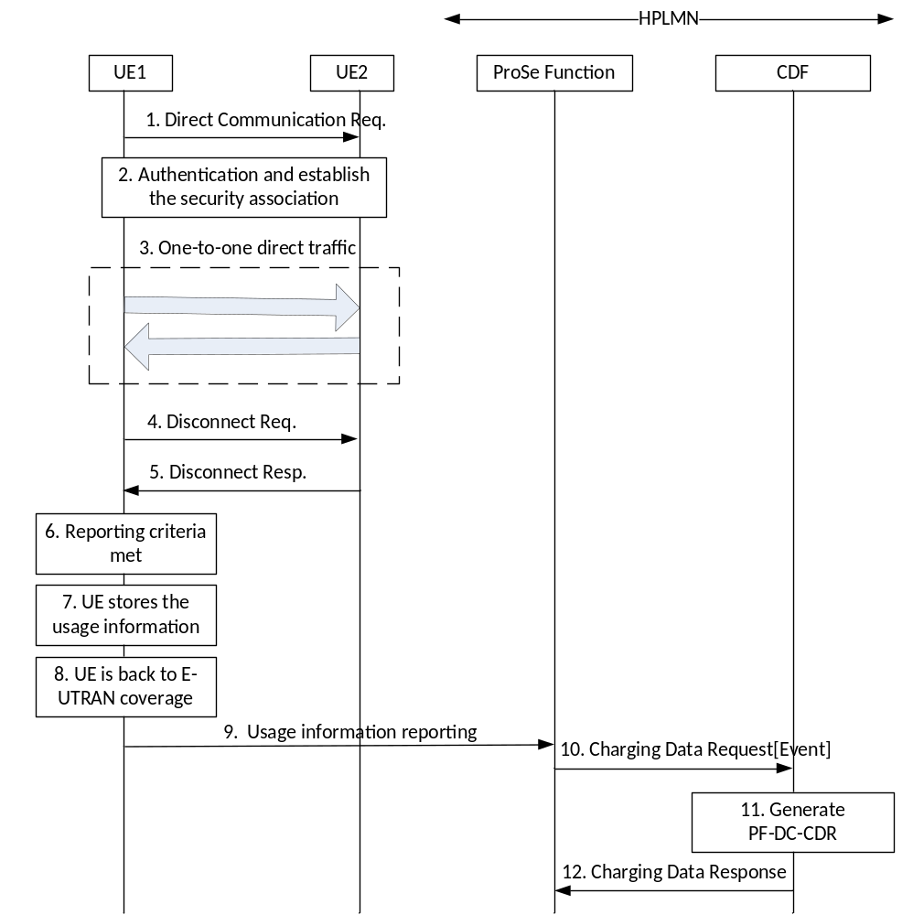
Figure 5.2.2.3.8.1: Offline Charging for ProSe one-to-one Direct Communication (out of coverage)
1-5. These steps are the same as offline charging for ProSe one-to-one Direct Communication in figure 5.2.2.3.8.1.
6. When the UE-1 decides that reporting criteria are met, according to the pre-configuration, the UE-1 creates the corresponding usage information report.
7. The UE-1 stores the usage information, when the UE-1 is out of E-UTRAN coverage and has no connection to the HPLMN ProSe Function.
NOTE 1: The usage information is stored in a secure environment in the UE-1.
8.When the UE-1 comes back to E-UTRAN coverage, it will trigger the reporting of the usage information.
NOTE 2: Both UE-1 and UE-2 can decide that reporting criteria, store the usage information and trigger the reporting when out of coverage.
9-12. These steps are the same as the step 7-10 offline charging for ProSe one-to-one Direct Communication in figure 5.2.2.3.8.1.

5.2.2.3.9 (Void)

5.2.2.3.10 Message flow for ProSe one-to-one Direct Communication when the UE is under coverage (session based)
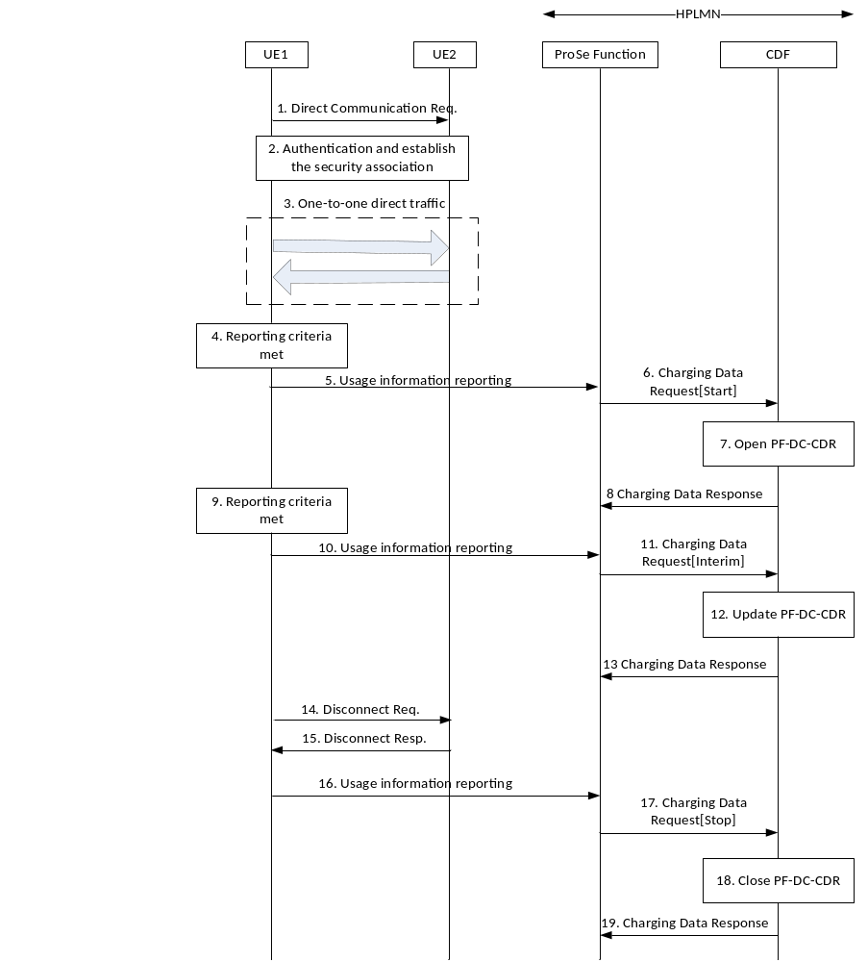
Figure 5.2.2.3.10-1: Offline Charging for ProSe one-to-one Direct Communication (under coverage)
Figure 5.2.2.3.10-1 depictes the message flow for session based charging for ProSe one-to-one Direct Communication. More details and the completed message flow for ProSe one-to-one Direct Commnication are defined in TS 23.303[238] clause 5.4.5. Both UE-1 and UE-2 can decide that reporting criteria are met and trigger the usage reporting procedure.
1-3. These steps are the same as offline charging for ProSe one-to-one Direct Communication in figure 5.2.2.3.7.1.
4. When the UE decides that reporting criteria are met, according to the configuration, and the connection to the ProSe Function is available, the UE triggers the usage reporting procedure.
5. UE sends the usage information report to the ProSe Function, according to the configuration.
6. If the ProSe Function is configured to use session based charging, upon reception of one-to-one direct communication usage information report, the ProSe Function triggers the Charging Data Request[Start] when there is no open charging session for the session of one-to-one direct communication. The ProSe Function sends the Charging Data Request[Start] to the corresponding CDF, and starts a charging session.
7. The CDR for the ProSe one-to-one Direct Communication for Public Safety use is generated and opened by CDF for the UE.
8. The CDF returns Charging Data Response corresponding to the received Charging Data Request.
9. UE triggers the usage reporting procedure when the reporting criteria are met.
10. UE sends the usage information report to the ProSe Function.
11. If there is a charging session for the session of one-to-one direct communication, upon reception of direct communication usage information report for the session, the ProSe Function triggers the Charging Data Request[Interim]. The ProSe Function sends the Charging Data Request[Interim] to the corresponding CDF.
12. The CDR for the ProSe one-to-one Direct Communication for Public Safety use is updated by CDF for the UE.
13. The CDF returns Charging Data Response corresponding to the received Charging Data Request.
NOTE 1: The Step 11 to 13 may occur multiple times for update.
14. Upon reception of the Disconnect Request message UE2 responds with a Disconnect Response message and deletes all context data associated with the layer-2 link.
15. Upon reception of the Disconnect Response from UE-2, the UE-1 triggers the usage reporting procedure.UE1 sends the usage information report to the ProSe Function,
16. UE sends the usage information report to the ProSe Function.
NOTE 2: The Step 16 may occur before step 14 and step 15.
17. The ProSe Function decides that the charging session should be closed, and triggers the Charging Data Request[Stop]. The ProSe Function sends the Charging Data Request[Stop] to the corresponding CDF.
18. The CDR for the ProSe one-to-one Direct Communication for Public Safety use is closed by CDF for the UE.
19. The CDF returns Charging Data Response corresponding to the received Charging Data Request.

5.2.2.3.11 Message flow for ProSe one-to-one Direct Communication when the UE is out of coverage (session based)
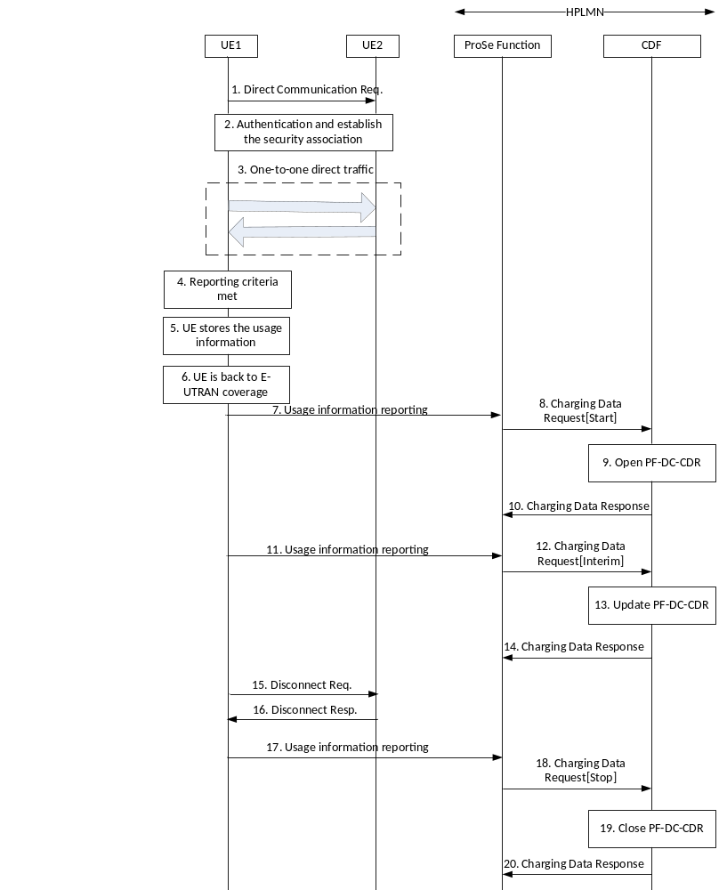
Figure 5.2.2.3.11-1: Offline Charging for ProSe one-to-one Direct Communication (out of coverage)
Both UE-1 and UE-2 can decide that reporting criteria, stores the usage information and trigger the reporting when out of coverage.
1-3. These steps are the same as the steps 1-3 in offline charging for ProSe one-to-one Direct Communication in figure 5.2.2.3.7.1.
4.-6. These steps are the same as the steps 6-8 in offline charging for ProSe one-to-one Direct Communication in figure 5.2.2.3.8.1.
7-20. These steps are the same with the steps 5-8(Charging Data Request[Start] and Response), steps 10-13(Charging Data Request[Interim] and Response), steps 14-15(Disconnect procedure), step 16-19(Charging Data Request[Stop] and Response) in offline charging for ProSe one-to-one Direct Communication in figure 5.2.2.3.10-1.
NOTE: The Step 17 may occur before step 15 and step 16.

5.2.2.3.12 Void

5.2.2.3.13 Void

5.2.3 CDR generation

5.2.3.1 Triggers for PF-DC-CDR creation and closure

5.2.3.1.1 General
A PF-DC-CDR is used to collect charging information related to the ProSe Direct Communication for a specific group. Multiple containers can be included in the PF-DC-CDR.
When a direct communication usage information report for a group is received from the UE, a PF-DC-CDR shall be opened if no open PF-DC-CDR for this group exists.
When event based charging is used, the corresponding containers are added, and the PF-DC-CDR is closed upon receiving the direct communication usage report.
When session based charging is used, the PF-DC-CDR is closed as described in clause 5.2.2.3.1.2.

5.2.3.1.2 Triggers for PF-DC-CDR charging information addition
The "List of Transmission/Reception Data" attributes of the PF-DC-CDR consists of a set of containers, which are added when specific trigger conditions are met and if UE is configured to include this charging information in the usage information report. Details of the container are defined in clause 6.1.3.4. Table 5.2.3.1.2.1 identifies which conditions are supported to trigger PF-DC-CDR charging information addition for "List of Transmission/Reception Data" attributes.
Table 5.2.3.1.2.1: Triggers for PF-DC-CDR charging information addition "List of Transmission/Reception Data"
Trigger Conditions | Description/Behaviour
Receipt of usage information report | On receipt of usage information report, "List of Transmission/Reception Data" containers shall be added to the PF-DC-CDR for the groups with usage to report.

The "List of Coverage Info" attribute of the PF-DC-CDR consists of a set of containers including coverage status, time stamps and optionally list of location changes (i.e., ECGI change) and timestamps when in coverage. These containers are added when specific trigger conditions are met and if UE is configured to include this charging information in the usage information report. Table 5.2.3.1.2.2 identifies which conditions are supported to trigger PF-DC-CDR charging information addition for " List of Coverage Info" attribute.
Table 5.2.3.1.2.2: Triggers for PF-DC-CDR charging information addition "List of Coverage Info"
Trigger Conditions | Description/Behaviour
Receipt of usage information report | On receipt of usage information report, "List of Coverage Info" containers shall be added to all open group PF-DC-CDRs.

The "List of Radio Parameter Set Info" attribute of the PF-DC-CDR consists of a list of radio parameter sets configured in the UE for direct communication use and activation timestamps. A new set of radio parameters is added to the list for all open group PF-DC-CDRs, when it becomes active on the UE and then received by the ProSe Function in a usage information report.
The "List of Application Specific Data" attribute of the PF-DC-CDR is a list of data blocks provided by the application in the UE. A new data block can be added to the list for all open group PF-DC-CDRs, when the UE sends usage information report(s) to the ProSe Function.
The "List of Transmitters" attribute of the PF-DC-CDR is a list of transmitters detected for a group. A new transmitter is added to the list in the PF-DC-CDR for the group with usage to report, when it is detected by the UE and then received by the ProS e Function in a usage information report.

5.2.3.1.3 Triggers for PF-DC-CDR closureThe PF-DC-CDR shall be closed on encountering any of the following trigger conditions:
- When event based charging is used, and the usage information report for the group is received from UE.
- When session based charging is used, and the charging session is closed as described in clause 5.2.2.3.1.2. In this case, a further PF-DC-CDR is opened when another usage information report for the group is received from the UE.

5.2.4 Ga record transfer flows
Details of the Ga protocol application are specified in TS 32.295 [54].

5.2.5 Bx CDR file transfer
Details of the Bx protocol application are specified in TS 32.297 [52].

5.3 ProSe online charging scenarios

5.3.1 Basic principles

5.3.1.1 General
ProSe online charging uses the Debit / Reserve Units operation as specified in TS 32.299 [50].
The charging functions specified for ProSe relate to:
- ProSe Direct Discovery, with distinction of the used PC5 radio technology:
- Announce Discovery Request;
- Monitor Discovery Request;
- Match report Discovery Reporting;
- Model B Restricted Discovery Request;
- Model B Restricted Discovery Reporting.
- ProSe EPC-level Discovery:
- Proximity Request.
ProSe charging may use the Immediate Event Charging (IEC) principle, the Event Charging with Unit Reservation (ECUR) principle or the Session Charging with Unit Reservation (SCUR) principle as specified in TS 32.299 [50].
The notion of "Local PLMN" does not apply to WLAN-based ProSe Direct Discovery, , so the collection of charging information by ProSe Functions in local PLMN does not apply to WLAN-based ProSe Direct Discovery.

5.3.1.2 ProSe Direct Discovery charging
The ProSe Functions in HPLMN is responsible for sending Debit/Reserve operation messages to OCS. ProSe charging may use the Immediate Event Charging (IEC) principle or the Event Charging with Unit Reservation (ECUR) principle as specified in TS 32.299 [50].
In IEC principle:
- The Debit operation is performed after discovery authorization of receiving Direct Discovery Request, Match Report Message, Model B Restricted Discovery Request or Model B Restricted Discovery Reporting;
- The optional refund operation shall be considered:
- if Announce, Monitor and Match operation fails in model A;
- if the discovery request and discovery reporting operation fails in model B.
In ECUR principle:
- The Reserve operation is performed after discovery authorization of receiving Direct Discovery Request, Match Report Message, Model B Restricted Discovery Request or Model B Restricted Discovery Reporting;
- The Debit operation is performed only when:
- Announce, Monitor and Match operation succeeds in model A;
- discovery request and discovery reporting operation succeeds in model B.

5.3.1.3 ProSe EPC-Level Discovery charging
Session Charging with Unit Reservation (SCUR) principle is applied to ProSe EPC-Level Discovery online charging.
The following chargeable events are defined for ProSe EPC-level Discovery online charging:
- Proximity Request. Upon this event, a Debit/Reserve Units Request[Initial] message is sent to OCS, and the corresponding EPUID, ALUIDs, Application ID, window, Range, and location of the UE are captured.
- Proximity Request Renewal. Upon this event, a Debit/Reserve Units Request[Update] message is sent to OCS with new location of the UE and window.
- Proximity Request Reject. Upon this event, a Debit/Reserve Units Request[Terminate] message is sent to OCS, and an indication of the cause for reject is captured.
- Proximity Request Cancellation. Upon this event, a Debit/Reserve Units Request[Terminate] message is sent to OCS, and an indication of whether Proximity Alert was sent is captured.

5.3.2 Ro message flows

5.3.2.1 Introduction
The flows described in the present document specify the exchange between the ProSe Function and the OCS for ProSe Services for different charging scenarios.
Debit Units Request message and Reserve Units Request message as defined in TS 32.299 [50] are used by the ProSe Function to transfer the collected charging information towards the OCS depending on which mode is used: Immediate Event Charging (IEC) mode or Event Charging with Unit Reservation (ECUR) respectively.

5.3.2.2 ProSe Direct Discovery

5.3.2.2.1 Triggers for online charging from ProSe Function for ProSe Direct Discovery
Table 5.3.2.2.1.1: Debit Units Request messages triggered for ProSe Function
in ProSe Direct Discovery
message | Triggering conditions
Debit Units Request[Event] | After discovery authorization of receiving Direct Discovery Request  with command (Announce, Monitor)  After discovery authorization of receiving Match Report message  After discovery authorization of Model B Restricted Discovery Request  After discovery authorization of Model B Restricted Discovery Reporting

5.3.2.2.2 Message flows for ProSe Direct Discovery Announce Request
Figures 5.3.2.2.2.1 to 5.3.2.2.2.3 define the transactions between ProSe Function and OCS for the successful scenario where an Announcing UE sends a Discovery request in IEC mode for non-roaming case and in IEC and ECUR modes for roaming case.
When the ProSe Application ID has a scope different from PLMN specific scope (i.e. country-wide or global), the message flows are the same as those for the case of PLMN specific ProSe Application ID provided by the HPLMN.

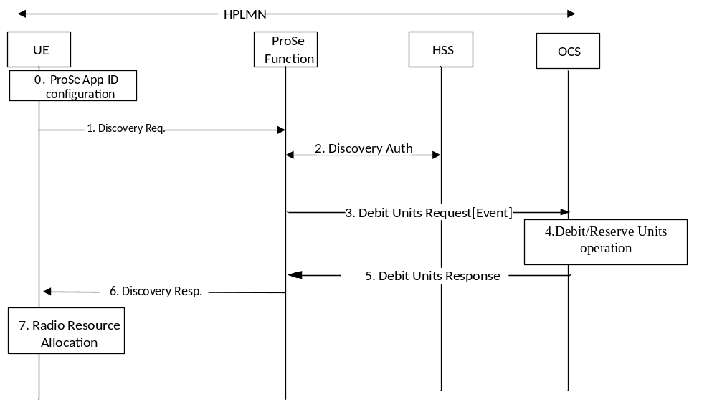

Figure 5.3.2.2.2.1: Message flow for ProSe Direct Discovery Announce Request (IEC for non-roaming)
0. The UE is configured with the data structure of the ProSe Application IDs corresponding to HPLMN. This step is performed using mechanisms that are out of scope of 3GPP.
1. If the UE is authorized to announce in HPLMN and is triggered to announce, it shall establish a secure connection with the ProSe Function and it shall send a Discovery Request message for announcing.
2. If there is no associated UE context, the ProSe Function shall check with HSS the authorization for discovery and create a new context for this UE that contains the subscription parameters for this UE for the duration of the validity timer.
3. ProSe function sends Debit Units Request[Event] indicating Announce to the OCS.
4. The OCS performs Debit Units Request operation for Announcing UE.
5. The OCS returns the Debit Units Response to ProSe Function.
6. If the Discovery Request is authorized, then the ProSe Function shall respond with a Discovery Response with:
- (ProSe Application Code, validity timer, PC5_tech) for open discovery.
- (ProSe Application Code, ProSe Restricted Code/ ProSe Restricted Code Prefix[ProSe Restricted Code Suffix pool], validity timer, Discovery Entry ID, Announcing Enabled indicator, PC5_tech) for restricted discovery.
7. The UE may start announcing the provided ProSe Application Code in HPLMN for open discovery and ProSe Restricted Code in serving PLMN for restricted discovery using the radio resources authorized and configured by E-UTRAN to be used for ProSe as defined in RAN specifications, or using WLAN, or both.
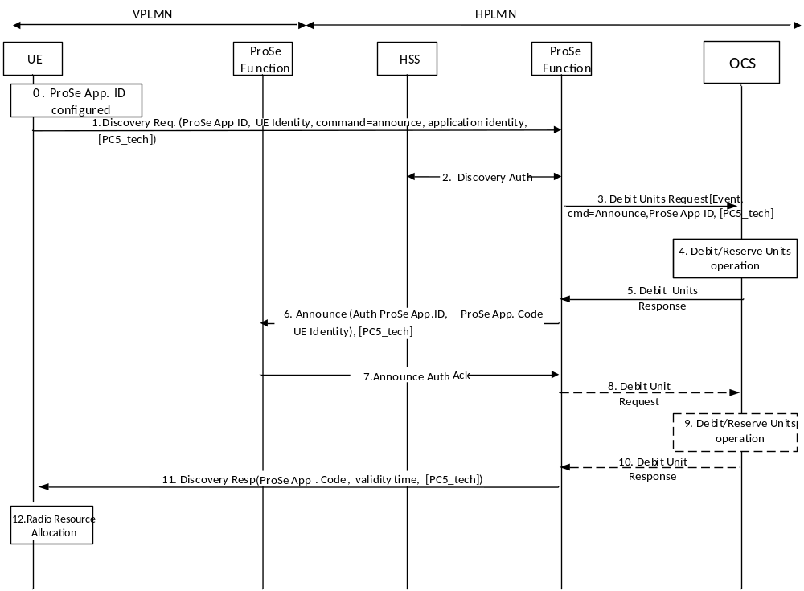
Figure 5.3.2.2.2.2: Message flow for ProSe Direct Discovery Announce Request (IEC for roaming/inter-PLMN transmission)
0. The UE is configured with the data structure of the ProSe Application IDs corresponding to HPLMN. This step is performed using mechanisms that are out of scope of 3GPP.
1. The UE establishes a secure connection with the ProSe Function in HPLMN and then sends a Discovery Request message for announcing.
2. If there is no associated UE context, the ProSe Function shall check with HSS the authorization for discovery and, if necessary, create a new context for this UE that contains the subscription parameters for this UE for the duration of the validity timer.
3. ProSe Function sends Debit Units Request[Event] indicating Announce to the OCS.
4. The OCS performs Debit Units Request operation for Announcing UE.
5. The OCS returns the Debit Units Response to ProSe Function.
6. If the Discovery Request is authorized then the HPLMN ProSe Function shall request authorisation from the ProSe Function in VPLMN with the Announce Authorisation (ProSe Application ID, ProSe Application Code, UE Identity, PC5_tech) message.
7. The ProSe Function in VPLMN authorizes the UE to perform ProSe Direct Discovery announcing.
If the Discovery Request is not authorized, the optional refund steps 8 to 10 are required:
8. ProSe function sends Debit Units Request[Event] to the OCS for refund purpose.
9. The OCS performs Debit Units Request operation for refund.
10. The OCS returns the Debit Units Response to ProSe Function.
11. The ProSe Function in HPLMN shall respond to the UE with a Discovery Response when step 7 is successful.
- (ProSe Application Code, validity timer, Discovery Entry ID, PC5_tech) for open discovery.
- (ProSe Restricted Code/ProSe Restricted Code Prefix[ProSe Restricted Code Suffix pool], validity timer, Discovery Entry ID, ProSe Enabled Indicator, PC5_tech) for districted discovery.
12. The UE may start announcing the provided ProSe Application Code in the VPLMN for open discovery and ProSe Restricted Code for restricted discovery in the VPLMN or Local PLMN, using the radio resources authorized and configured by E-UTRAN to be used for ProSe as defined in RAN specifications, or using WLAN or both.
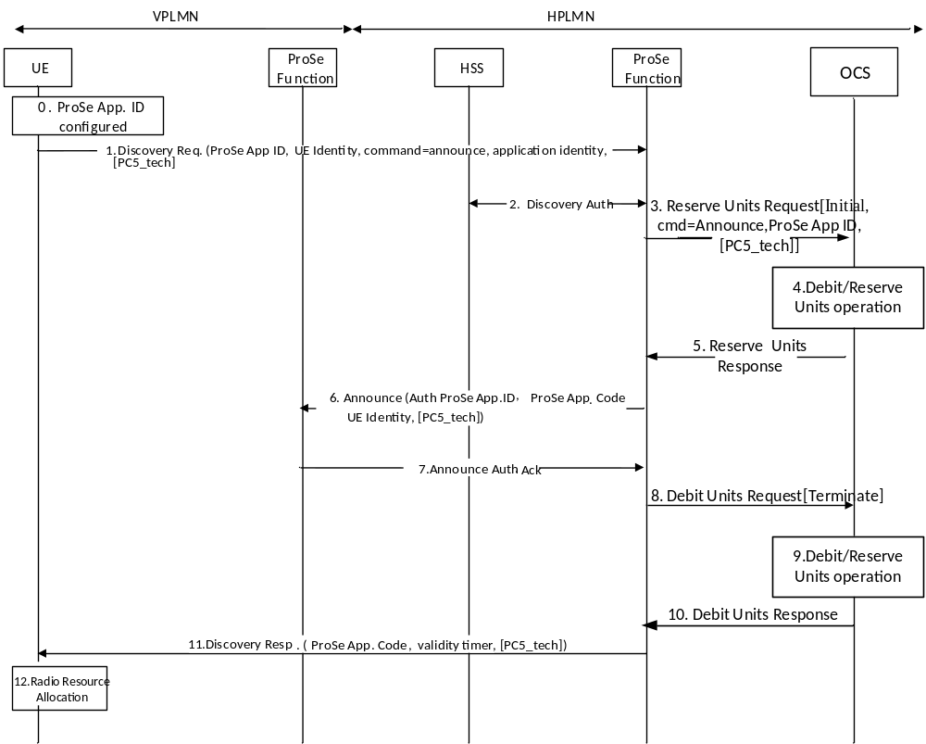
Figure 5.3.2.2.2.3: Message flow for ProSe Direct Discovery Announce Request (ECUR for roaming/inter-PLMN transmission)
0-2. same as figure 5.3.2.2.3.2 step 0-2
3. ProSe Function sends Reserve Units Request[Initial, ProSe App ID, cmd = Announce, PC5_tech] to the OCS for requesting units.
4. The OCS performs Reserve Units Request operation for Announcing UE.
5. The OCS grants service units in the Reserve Units Response to ProSe Function.
6-7. same as figure 5.3.2.2.3.2 step 6-7
8. ProSe Function sends Debit Units Request[Terminate] to the OCS indicating granted units are used. On unsuccessful Announce authorization, granted units are returned.
9. The OCS performs Debit Units operation.
10. The OCS returns the Debit Units Response to ProSe Function.
11-12. same as figure 5.3.2.2.3.2 step 11-12.

5.3.2.2.3 Message flows for ProSe Direct Discovery Monitor Request
Figures 5.3.2.2.3.1 to 5.3.2.2.3.4 describe the transactions between ProSe Function and OCS for the successful scenario where a "monitoring UE" sends a Discovery request and gets authorization to access the discovery resources.
When the ProSe Application ID has a scope different from PLMN specific scope (i.e. country-wide or global), the message flows are the same as those for the case of PLMN specific ProSe Application ID provided by the HPLMN.
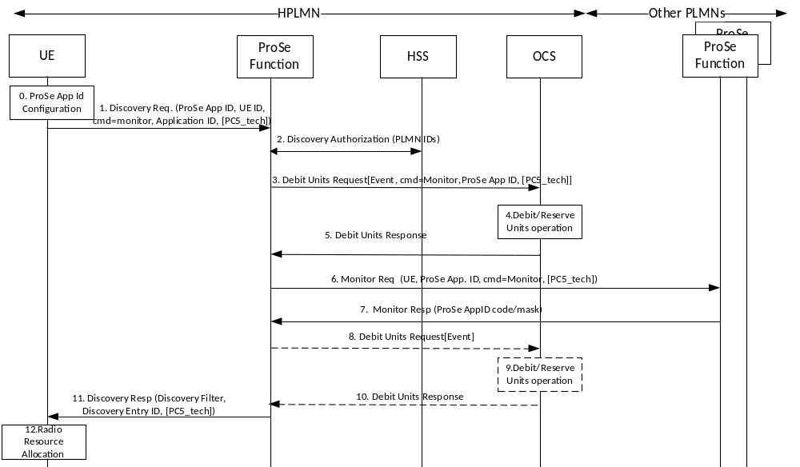
Figure 5.3.2.2.3.1: ProSe Direct Discovery Monitor Request – IEC (non-roaming)
0. The UE is configured with the data structure of the ProSe Application IDs corresponding to PLMNs the UE is authorized to monitor.
1. If the UE is authorized to monitor in at least one PLMN and is interested to monitor certain ProSe Application ID(s), the UE sends a Discovery Request (ProSe Application ID(s), UE Identity, monitor command, application identity, PC5_tech) message for monitoring to the ProSe Function.
2. Interaction between ProSe Function and HSS for authorization process for discovery: check if UE is authorized for ProSe discovery service and for this Application ID, retrieval of PLMNs allowed for discovery. A new context for this UE is created if no associated UE context exists.
3. ProSe Function sends Debit Units Request[Event, ProSe App ID, cmd = Monitor, PC5_tech] to the OCS.
4. The OCS performs the Debit Units operation for Discovery Monitor Request.
5. The OCS returns the Debit Units Response to ProSe Function.
6. For open discovery, the ProSe Function in HPLMN shall contact other Local PLMNs in order to resolve the ProSe Application ID Name(s) to mask(s) that corresponds to this ProSe Application ID Name. The request shall also include the UE identity information e.g. IMSI or MSISDN, and PC5_tech in order to allow the ProSe Function in Local PLMN to perform charging.
For restricted discovery, the ProSe Function in the HPLMN contacts the ProSe Function in that PLMN to retrieve the corresponding ProSe Restricted Code with a Monitor Request (RPAUID, UE Identity, Target PDUID, Application ID, Target RPAUID and Discovery Entry ID, PC5_tech) message.
7. For open discovery, if the ProSe Function of the Local PLMN stores valid ProSe Application Code(s) corresponding to the requested ProSe Application ID Name(s) and the requested PC5 radio technology, then the ProSe Function of the Local PLMN returns the related mask(s) and the corresponding TTL for each.
For restricted discovery, the ProSe Function in the other PLMN returns to the ProSe Function in the HPLMN the ProSe Restricted Code and the corresponding residual validity timer with a Monitor Response (ProSe Restricted Code, validity timer, PC5_tech) message. The Prose Function in the other PLMN also stores, in the context of the announcing UE, the PDUID of the monitoring UE and the allocated validity timer.
In case of unsuccessful scenario, the optional refund steps 8 to 10 are required:
8. ProSe function sends Debit Units Request[Event] to the OCS for refund purpose.
9. The OCS performs Debit Units Request operation for refund.
10. The OCS returns the Debit Units Response to ProSe Function.
11. The ProSe Function responds with a Discovery Response [Discovery Filter, Discovery Entry ID, PC5_tech] message, when step 7 is successful.. The ProSe Function may use the service units granted in step 5 to determine the Time To Live value(s) of the Discovery Filter.
12. The UE may start monitoring using the Discovery Filter in the authorized radio resources, or using WLAN or both.
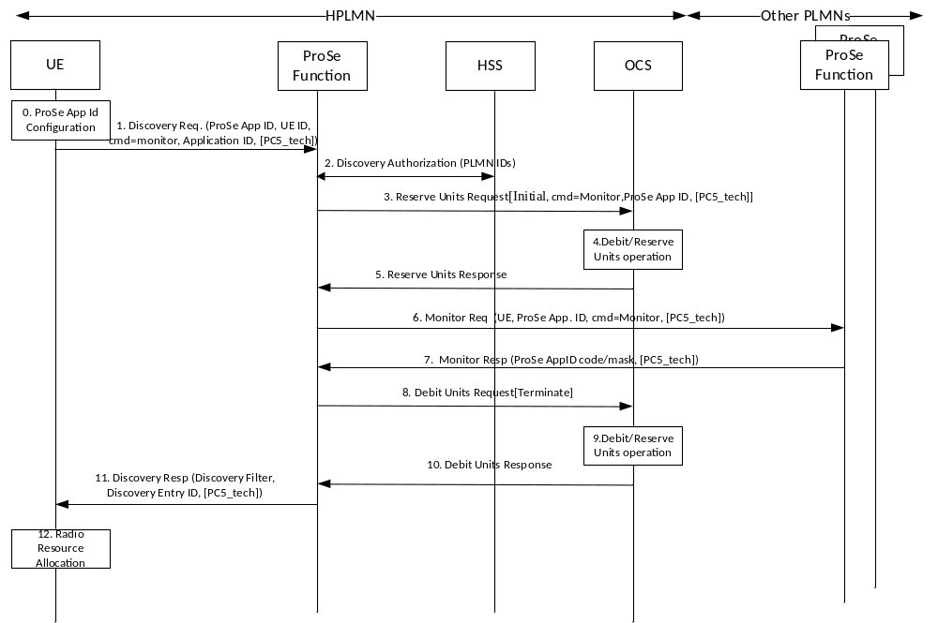
Figure 5.3.2.2.3.2: ProSe Direct Discovery Monitor Request – ECUR (non-roaming)
0-2. same as figure 5.3.2.2.3.1 step 0-2.
3. ProSe Function sends Reserve Units Request[Initial, ProSe App ID, cmd = Monitor] to the OCS for requesting units.
4. The OCS performs Reserve Units Request operation for Discovery Monitor Request.
5. The OCS grants service units in the Reserve Units Response to ProSe Function.
6-7. same as figure 5.3.2.2.3.1 step 6-7.
8. ProSe Function sends Debit Units Request[Terminate] to the OCS indicating granted units are used. On unsuccessful Monitor Response, granted units are returned.
9. The OCS performs the Debit Units operation.
10. The OCS returns the Debit Units Response to ProSe Function.
11-12. same as figure 5.3.2.2.3.1 step 11-12.
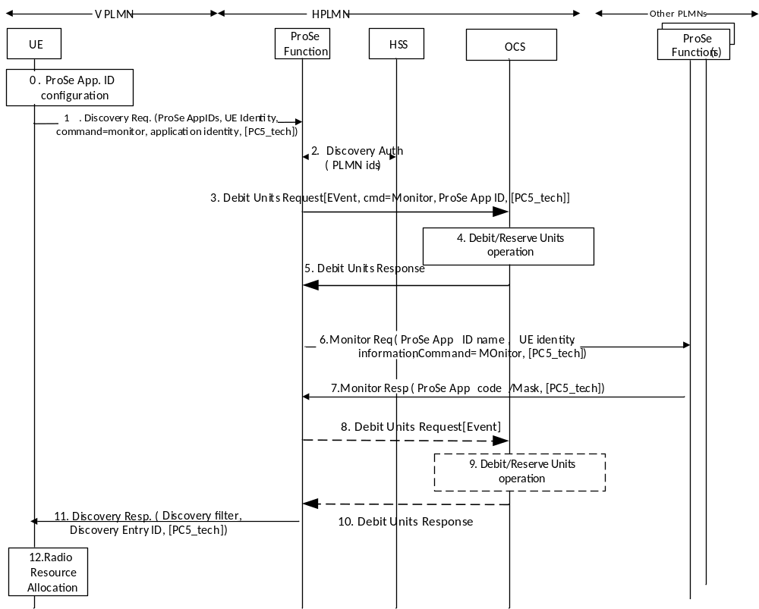
Figure 5.3.2.2.3.3: ProSe Direct Discovery Monitor Request – IEC (roaming/inter-PLMN transmission)
0. The UE is configured with the data structure of the ProSe Application IDs corresponding to PLMNs the UE is authorized to monitor. This step is performed using mechanisms out of scope of 3GPP.
1. If the UE is authorized to monitor in at least one PLMN and is interested to monitor certain ProSe Application ID(s), it shall establish a secure connection with the ProSe Function in HPLMN and it shall send a Discovery Request (ProSe Application ID(s), UE Identity, Monitor command, application identity, PC5_tech) message for monitoring.
2. If there is no associated UE context, the ProSe Function shall check with HSS the authorization for discovery and, if necessary, create a new context for this UE that contains the subscription parameters for this UE for the duration the Discovery Filters will be valid.
3. ProSe Function sends Debit Units Request[Event,ProSe App ID, cmd = Monitor, PC5_tech] to the OCS.
4. The OCS performs the Debit Units operation for Discovery Monitor Request.
5. The OCS returns the Debit Units Response to ProSe Function.
6. The ProSe Function in HPLMN shall contact other PLMNs that are indicated by the ProSe Application ID(s) sent by the UE, in order to resolve the corresponding ProSe Application ID Name(s) to mask(s).
7. If the ProSe Function of the other PLMN stores valid ProSe Application Code(s) corresponding to the requested ProSe Application ID Name(s) and the requested PC5 radio technolog, then the ProSe Function of the Local PLMN returns the related ProSe Application mask(s) and the corresponding TTL for each.
In case of unsuccessful scenario, the optional refund steps 8 to 10 are required:
8. ProSe function sends Debit Units Request[Event] to the OCS for refund purpose.
9. The OCS performs Debit Units Request operation for refund.
10. The OCS returns the Debit Units Response to ProSe Function.
11. The ProSe Function in the HPLMN responds with a Discovery Response message, in case step 7 is successful.
- Discovery Filter(s), Discovery Entry ID, PC5_tech message for open discovery. The Discovery Filter(s) consists of the ProSe Application mask(s). The Discovery Filter(s) include the TTL. The TTL(s) in the Discovery Filter(s) indicate for how long the Discovery Filter(s) are going to be valid.
- Discovery Filter(s), Metadata Indicator, Discovery Entry ID, Application Level Container and PC5_tech for restricted discovery. The Discovery Filter includes the ProSe Restricted Code to be monitored and the TTL that indicates for how long the related ProSe Restricted Code in the Discovery Filter is valid after it is received. If configured by the operator, the Target RPAUID(s) and metadata corresponding to the ProSe Restricted Code(s) may be included in the Discovery Response message.
12. The UE may start monitoring using the Discovery Filter(s) in the radio resources that are authorized and configured by the PLMN(s) to be used for ProSe as defined in RAN specifications, or using WLAN or both.
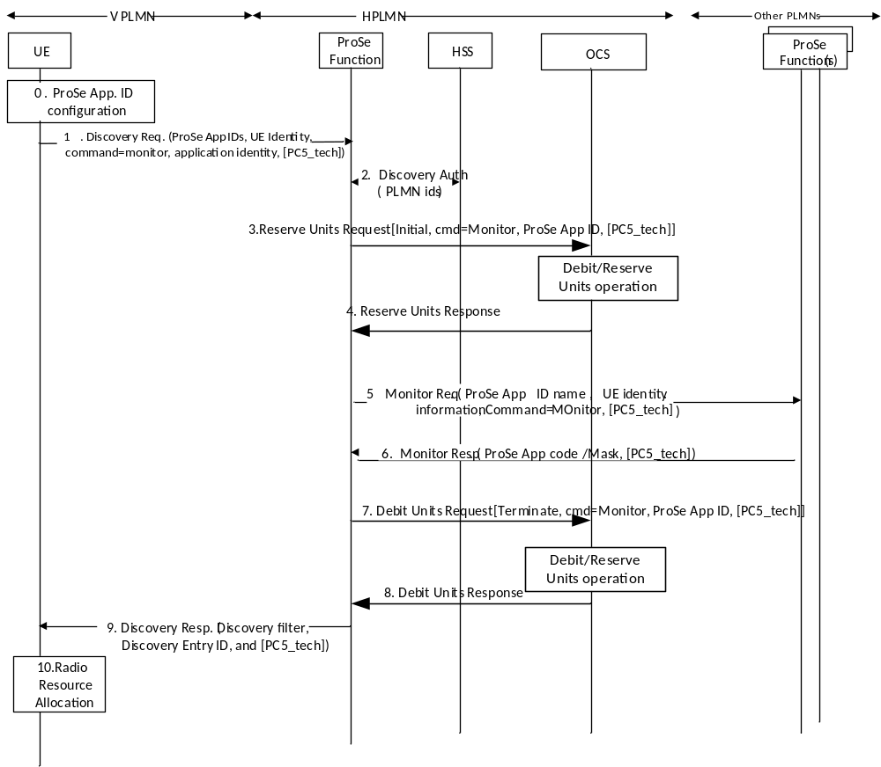
Figure 5.3.2.2.3.4: ProSe Direct Discovery Monitor Request – ECUR (roaming/ inter-PLMN transmission)
0-2. same as figure 5.3.2.2.3.3 step 0-2.
3. ProSe Function sends Reserve Units Request[Initial, ProSe App ID, cmd = Monitor] to the OCS for requesting units.
4. The OCS grants service units in the Reserve Units Response to ProSe Function.
5-6. same as figure 5.3.2.2.3.3 step 5-6.
7. ProSe Function sends Debit Units Request[Terminate] to the OCS indicating granted units are used. On unsuccessful Monitor Response, granted units are returned.
8. The OCS returns the Debit Units Response to ProSe Function.
9-10. same as Figure 5.3.2.2.3.3 step 11-12.

5.3.2.2.4 Message flows for ProSe Direct Discovery Match Report Request
Figures 5.3.2.2.4.1 to 5.3.2.2.4.4 define the transactions between ProSe Function and OCS for the successful scenario where a "Monitoring UE" sends a Match report in non-roaming case and roaming case for IEC and ECUR modes.
When the ProSe Application ID has a scope different from PLMN specific scope (i.e. country-wide or global), the message flows are the same as those for the case of PLMN specific ProSe Application ID.
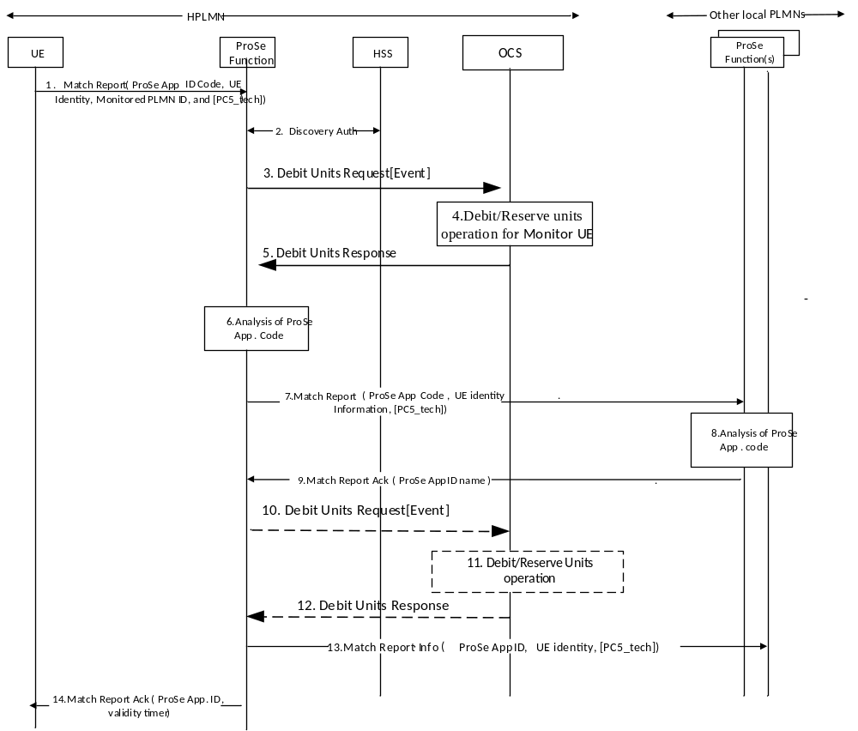
Figure 5.3.2.2.4.1: Message flow for ProSe Direct Open Discovery Match Report Request (IEC for non-roaming)
1. If the UE finds ProSe Application Code(s) that matches the Discovery Filters and does not have ProSe Application ID(s) already locally stored that correspond to this ProSe Application Code(s), it shall (re)establish a secure connection with the ProSe Function in HPLMN to which it shall then send a Match Report (ProSe Application Code(s), UE Identity, Monitored PLMN ID, and PC5_tech) message to the ProSe Function in HPLMN.
2. The ProSe Function shall check the context for this UE that contains its subscription parameters.
The authorization information also contains the PLMN that this UE is allowed to perform discovery.
3. ProSe Function sends Debit Units Request[Event] indicating "Match" to the OCS.
4. The OCS performs the Debit Units operation for "Match".
5. The OCS returns the Debit Units Response to ProSe Function.
6. The ProSe Function analyses the ProSe Application Code received from the UE.
If the PLMN ID that assigned the given ProSe Application Code is another Local PLMN then steps 7-14 are executed, otherwise (i.e. the ProSe Application Code was assigned by HPLMN) only step 14 is executed:
7. The ProSe Function in HPLMN sends a Match Report (ProSe Application Code(s), UE identity, PC5_tech) to the ProSe Function of the PLMN that assigned the ProSe Application Code.
8. The ProSe Function analyses the ProSe Application Code(s) received from the UE.
9. If the ProSe Application Code is confirmed then the ProSe Function in Local PLMN shall send Match Report Acknowledgement (ProSe Application ID Name(s), validity timer(s) , PC5_tech).
In case of unsuccessful scenario, the optional refund steps 10 to 12 are required:
10. ProSe function sends Debit Units Request[Event] to the OCS for refund purpose.
11. The OCS performs Debit Units Request operation for refund.
12. The OCS returns the Debit Units Response to ProSe Function.
13. If it was indicated that the announcing UE is roaming during the Monitor Request process, the ProSe Function in HPLMN shall send a Match Report Info (ProSe Application ID(s), UE Identity, PC5_tech) to the ProSe Function of the serving PLMN of the Announcing UE.
14. The ProSe Function in HPLMN shall respond to the UE with Match Report Acknowledgment (ProSe Application ID(s), validity timer(s)).
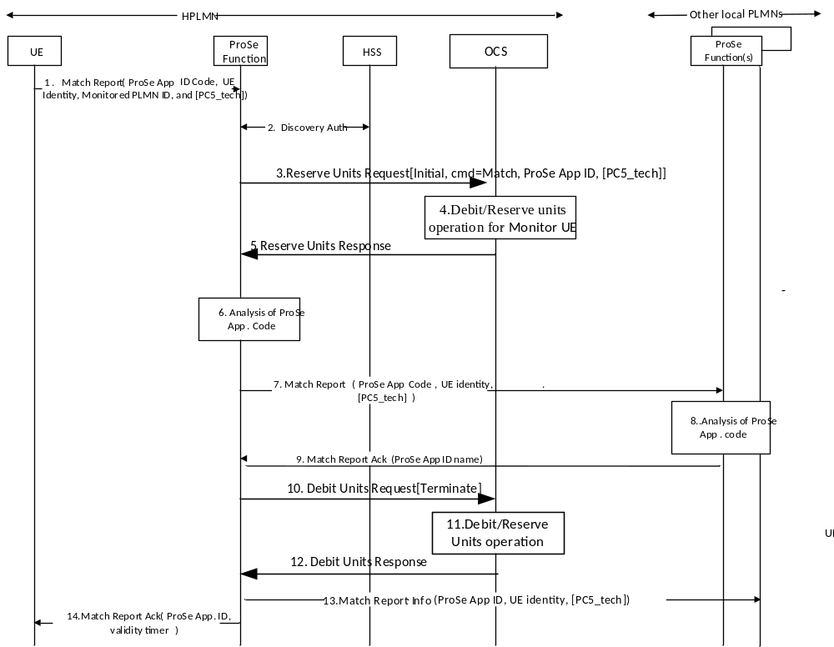
Figure 5.3.2.2.4.2: Message flow for ProSe Direct Open Discovery Match Report Request
(ECUR for non-roaming)
1-2. same as figure 5.3.2.2.4.1 step 1-2.
3. ProSe Function sends Reserve Units Request[Initial, ProSe App ID, cmd = Match, PC5_tech] to the OCS for requesting units.
4. The OCS performs the Debit Units operation for "Match".
5. The OCS grants service units in the Reserve Units Response to ProSe Function.
6-9. same as figure 5.3.2.2.4.1 step 6-9.
10. ProSe Function sends Debit Units Request[Terminate] to the OCS with granted units used. On unsuccessful Match Report, granted units are returned.
11. The OCS performs the Debit Units operation for "Match".
12. The OCS returns the Debit Units Response to ProSe Function.
13-14. same as figure 5.3.2.2.4.1 step 13-14.
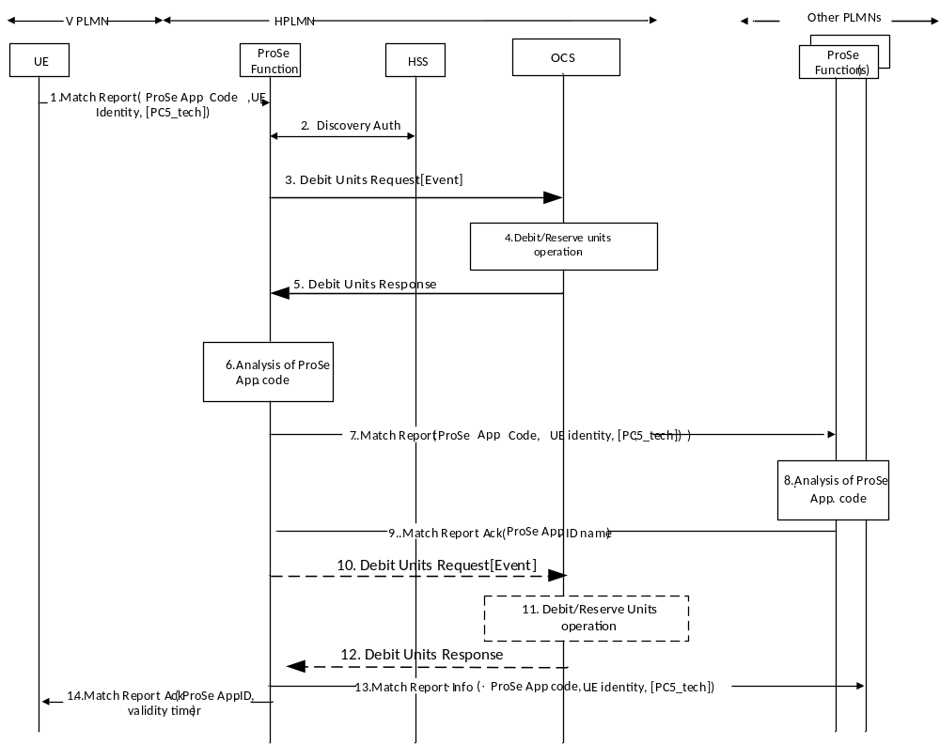
Figure 5.3.2.2.4.3: Message flow for ProSe Direct Open Discovery Match Report Request (IEC for roaming/inter-PLMN transmission)
1. If the UE finds ProSe Application Code(s) that matches the Discovery Filters and does not have ProSe Application ID(s) already locally stored that correspond to this ProSe Application Code(s), it (re)establishes a secure connection with the ProSe Function in HPLMN and sends a Match Report (ProSe Application Code(s), Discovery Filter ID(s), UE Identity, VPLMN ID, Monitored PLMN ID, PC5_tech) message to the ProSe Function in HPLMN.
2. The ProSe Function shall check the context for this UE that contains its subscription parameters for this UE. The authorization information also contains the PLMN that this UE is allowed to perform discovery.
3. ProSe Function sends Debit Units Request[Event] indicating "Match" to the OCS.
4. The OCS performs the Debit Units operation for "Match".
5. The OCS returns the Debit Units Response to ProSe Function.
6. The ProSe Function analyses the ProSe Application Code(s) received from the UE.
If the PLMN ID that assigned the given ProSe Application Code is not the HPLMN, then steps 7-14 are executed, otherwise (i.e. the HPLMN assigned the ProSe Application Code) only steps 14 is executed:
7. The ProSe Function in HPLMN sends a Match Report (ProSe Application Code(s), UE identity, monitored PLMN ID, PC5_tech) to the ProSe Function of the PLMN that assigned the ProSe Application Code (i.e. the ProSe Function of the HPLMN of the "announcing UE").
8. The ProSe Function ensures that the received ProSe Application Code is authorized to be transmitted on the monitored PLMN. The ProSe Function analyses the ProSe Application Code(s) received from the UE, and confirms the ProSe Application Code(s).
9. The ProSe Function shall send Match Report Acknowledgement (ProSe Application ID Name(s), validity timer(s)).
In case of unsuccessful scenario, the optional refund steps 10 to 12 are required:
10. ProSe function sends Debit Units Request[Event] to the OCS for refund purpose.
11. The OCS performs Debit Units Request operation for refund.
12. The OCS returns the Debit Units Response to ProSe Function.
13. If it was indicated that the Announcing UE is roaming during the Monitor Request process, the ProSe Function in HPLMN shall send a Match Report Info (ProSe Application ID(s), UE Identity, PC5_tech) to the ProSe Function of the serving PLMN of the Announcing UE.
14. The ProSe Function in HPLMN shall respond to the UE with Match Report Acknowledgment (ProSe Application ID(s), validity timer(s)).
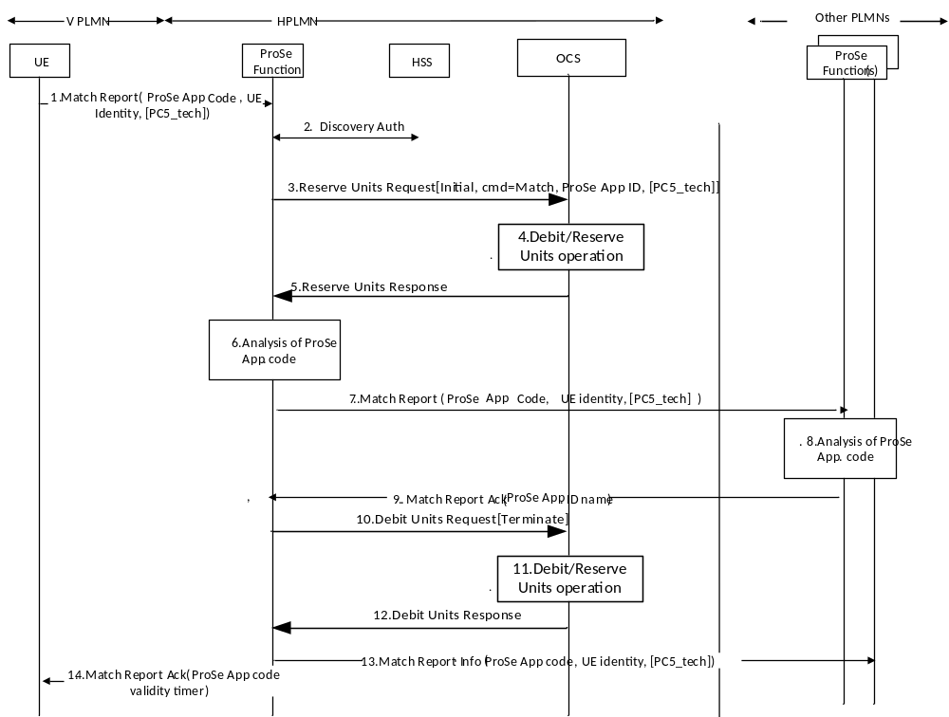
Figure 5.3.2.2.4.4: Message flow for ProSe Direct Open Discovery Match Report Request (ECUR for roaming/ inter-PLMN transmission)
1-2. same as figure 5.3.2.2.4.3 step 1-2.
3. ProSe Function sends Reserve Units Request[Initial, ProSe App ID, cmd = Match, PC5_tech] to the OCS for requesting units.
4. The OCS performs the Debit Units operation for "Match" Report Request.
5. The OCS grants service units in the Reserve Units Response to ProSe Function.
6-9. same as figure 5.3.2.2.4.3 step 6-9.
10. ProSe Function sends Debit Units Request[Terminate] to the OCS with granted units used. On unsuccessful Match Report, granted units are returned.
11. The OCS performs the Debit Units operation for "Match".
12. The OCS returns the Debit Units Response to ProSe Function.
13-14. same as figure 5.3.2.2.4.3 step 13-14.
Figures 5.3.2.2.4.a to 5.3.2.2.4.d define the transactions between ProSe Function and OCS for the successful scenario where a "Monitoring UE" using ProSe direct restricted discovery model A sends a Match report in non-roaming case and roaming case for IEC and ECUR modes.
When the ProSe Application ID has a scope different from PLMN specific scope (i.e. country-wide or global), the message flows are the same as those for the case of PLMN specific ProSe Application ID.
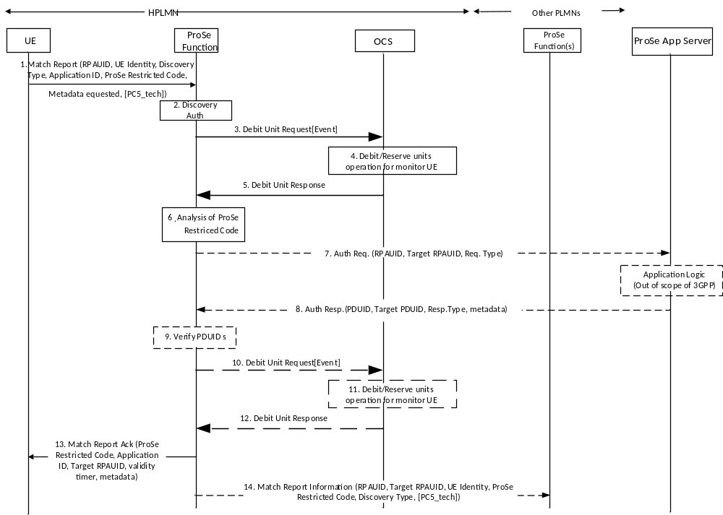
Figure 5.3.2.2.4.a: Message flow for Match Report of Restricted Discovery-model A(IEC for non-roaming)
1. When the monitoring UE has received a ProSe Restricted Code over the air that matches the Discovery Filter it obtained from monitoring Request procedure, and if the UE does not have a corresponding RPAUID associated with it with a valid TTL, the UE sends a Match Report (RPAUID, UE Identity, Discovery Type, Application ID, ProSe Restricted Code, Metadata Requested, PC5_tech) message to the ProSe Function in the HPLMN to get the Target RPAUID.
2. The HPLMN ProSe Function checks the authorization for the monitoring UE to perform restricted discovery.
3. ProSe Function sends Debit Units Request[Event] indicating "Restricted Match" to the OCS.
4. The OCS performs the Debit Units operation for "Restricted Match".
5. The OCS returns the Debit Units Response to ProSe Function.
6. The HPLMN ProSe Function analyses the ProSe Restricted Code and identifies in the UE context of the monitoring UE the corresponding Target RPAUID.
7. Optionally, the ProSe Function sends a Auth Request (RPAUID, Target RPAUID, Request Type) to the ProSe Application Server. The ProSe Function locates the ProSe Application Server based on the Application ID. The Request Type is set to "restricted discovery/match". If the Metadata Requested is included in the Match Report in step 1, the ProSe Function shall send the Auth Request message.
8. If, based on the permission setting, the RPAUID is allowed to discover the Target RPAUID, the ProSe Application Server returns a Auth Response (PDUID, Target PDUID, Response Type, metadata) message. The PDUID corresponds to RPAUID, the Target PDUID corresponds to the Target RPAUID stored in the ProSe Application Server. The Response Type is set to "restricted discovery/match ack". This message may also contain certain metadata corresponding to the Target PDUID, e.g. welcome message, etc.
9. The ProSe Function verifies that the returned PDUID belongs to the requesting UE, and the Target PDUID is the same as the stored Target PDUID.
In case of unsuccessful scenario, the optional refund steps 10 to 12 are required:
10. ProSe function sends Debit Units Request[Event] to the OCS for refund purpose.
11. The OCS performs Debit Units Request operation for refund.
12. The OCS returns the Debit Units Response to ProSe Function.
13. The ProSe Function in HPLMN returns a Match Report Ack (Application ID, Target RPAUID, validity timer, metadata) to the UE. The UE stores the mapping between the RPAUID, the ProSe Restricted Code and the Application ID for the duration of the validity timer.
14. The ProSe Function in HPLMN may optionally send a Match Report Info (RPAUID, Target RPAUID, UE Identity, ProSe Restricted Code, Discovery Type, PC5_tech) to the ProSe Function of the announcing UE. Discovery Type is set to "restricted discovery".
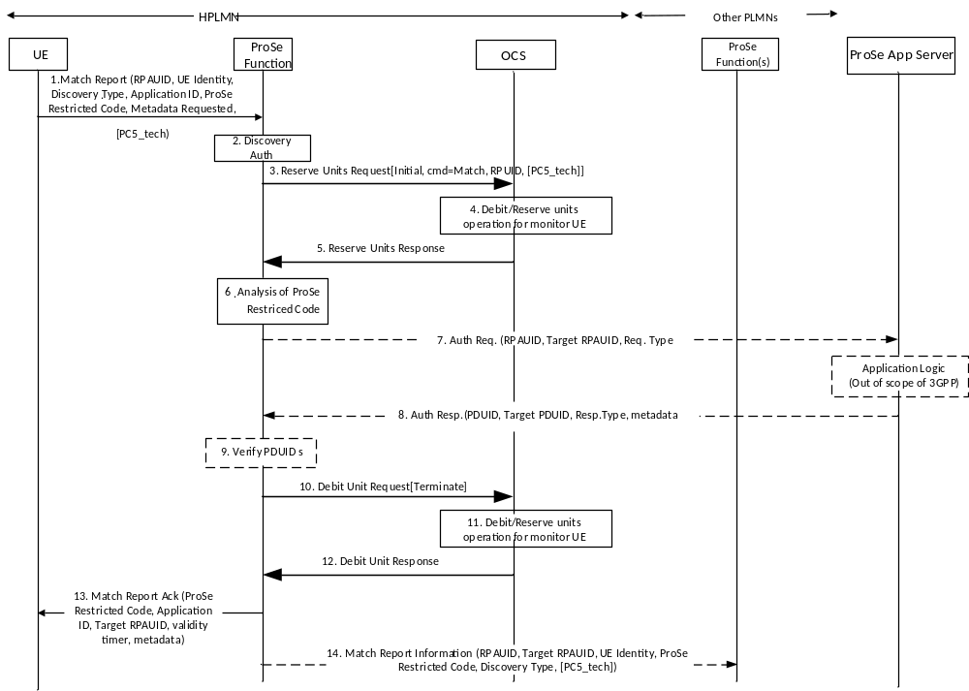
Figure 5.3.2.2.4.b: Message flow for Match Report of Restricted Discovery-model A (ECUR for non-roaming)
1-2. same as figure 5.3.2.2.4.a step 1-2
3. ProSe Function sends Reserve Units Request [Initial, RPUID, cmd = Restricted Match, PC5_tech] to the OCS for requesting units.
4. The OCS performs the Debit Units operation for "Restricted Match".
5. The OCS grants service units in the Reserve Units Response to ProSe Function.
6-9. same as figure 5.3.2.2.4.1 step 6-9.
10. ProSe Function sends Debit Units Request[Terminate] to the OCS with granted units used. On unsuccessful Match Report, granted units are returned.
11. The OCS performs the Debit Units operation for "Restricted Match".
12. The OCS returns the Debit Units Response to ProSe Function.
13-14. same as figure 5.3.2.2.4.a step 13-14.
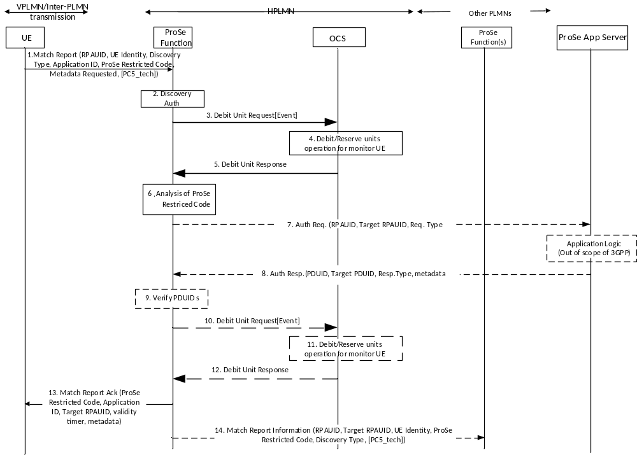
Figure 5.3.2.2.4.c: Message flow for Match Report of Restricted Discovery-model A (ICE for roaming//inter-PLMN transmission)
1. When the monitoring UE has received a ProSe Restricted Code over the air that matches the Discovery Filter it obtained from monitoring Request procedure, and if the UE does not have a corresponding RPAUID associated with it with a valid TTL, the UE sends a Match Report (RPAUID, UE Identity, Discovery Type, Application ID, ProSe Restricted Code, Metadata Requested, Monitored PLMN ID, PC5_tech) message to the ProSe Function in the HPLMN to get the Target RPAUID.
2. The HPLMN ProSe Function checks the authorization for the monitoring UE to perform restricted discovery.
3. ProSe Function sends Debit Units Request[Event] indicating "Restricted Match" to the OCS.
4. The OCS performs the Debit Units operation for "Restricted Match".
5. The OCS returns the Debit Units Response to ProSe Function.
6. The HPLMN ProSe Function analyses the ProSe Restricted Code and identifies in the UE context of the monitoring UE the corresponding Target RPAUID.
7. Optionally, the ProSe Function sends a Auth Request (RPAUID, Target RPAUID, Request Type) to the ProSe Application Server. The ProSe Function locates the ProSe Application Server based on the Application ID. The Request Type is set to "restricted discovery/match". If the Metadata Requested is included in the Match Report in step 1, the ProSe Function shall send the Auth Request message.
8. If, based on the permission setting, the RPAUID is allowed to discover the Target RPAUID, the ProSe Application Server returns a Auth Response (PDUID, Target PDUID, Response Type, metadata) message. The PDUID corresponds to RPAUID, the Target PDUID corresponds to the Target RPAUID stored in the ProSe Application Server. The Response Type is set to "restricted discovery/match ack". This message may also contain certain metadata corresponding to the Target PDUID, e.g. welcome message, etc.
9. The ProSe Function verifies that the returned PDUID belongs to the requesting UE, and the Target PDUID is the same as the stored Target PDUID.
In case of unsuccessful scenario, the optional refund steps 10 to 12 are required:
10. ProSe function sends Debit Units Request[Event] to the OCS for refund purpose.
11. The OCS performs Debit Units Request operation for refund.
12. The OCS returns the Debit Units Response to ProSe Function.
13. The ProSe Function in HPLMN returns a Match Report Ack (Application ID, Target RPAUID, validity timer, metadata (opt.)) to the UE. The UE stores the mapping between the RPAUID, the ProSe Restricted Code and the Application ID for the duration of the validity timer.
14. The ProSe Function in HPLMN may optionally send a Match Report Info (RPAUID, Target RPAUID, UE Identity, ProSe Restricted Code, Discovery Type, PC5_tech) to the ProSe Function in the HPLMN of the announcing UE. Discovery Type is set to "restricted discovery". If the Monitored PLMN ID is different from that of the Target PDUID, i.e. the "announcing UE" is roaming or performs inter-PLMN discovery transmission, the ProSe Function in HPLMN of the Monitoring UE may send another Match Report Info (RPAUID, Target RPAUID, UE Identity, ProSe Restricted Code, Discovery Type) to the ProSe Function of the PLMN indicated by the Monitored PLMN ID. 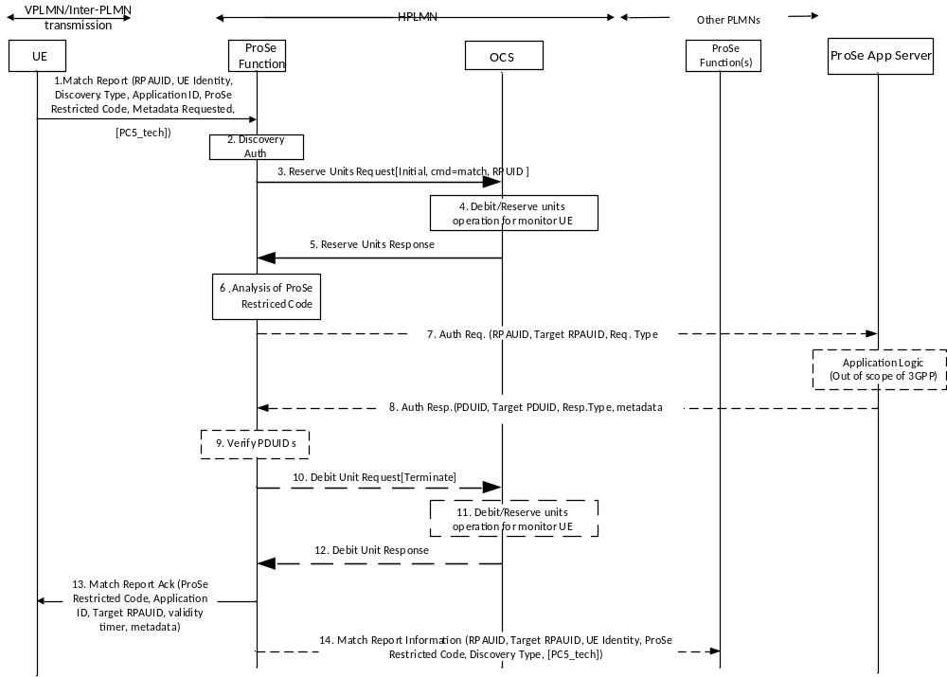
Figure 5.3.2.2.4.d: Message flow for Match Report of Restricted Discovery-model A (ECUR for roaming//inter-PLMN transmission)
1. When the monitoring UE has received a ProSe Restricted Code over the air that matches the Discovery Filter it obtained from monitoring Request procedure, and if the UE does not have a corresponding RPAUID associated with it with a valid TTL, the UE sends a Match Report (RPAUID, UE Identity, Discovery Type, Application ID, ProSe Restricted Code, Metadata Requested, Monitored PLMN ID, PC5_tech) message to the ProSe Function in the HPLMN to get the Target RPAUID.
2. The HPLMN ProSe Function checks the authorization for the monitoring UE to perform restricted discovery.
3. ProSe Function sends Reserve Units Request [Initial, RPUID, cmd = Restricted Match] to the OCS for requesting units.
4. The OCS performs the Debit Units operation for "Restricted Match".
5. The OCS grants service units in the Reserve Units Response to ProSe Function.
6. The HPLMN ProSe Function analyses the ProSe Restricted Code and identifies in the UE context of the monitoring UE the corresponding Target RPAUID.
7. Optionally, the ProSe Function sends a Auth Request (RPAUID, Target RPAUID, Request Type) to the ProSe Application Server. The ProSe Function locates the ProSe Application Server based on the Application ID. The Request Type is set to "restricted discovery/match". If the Metadata Requested is included in the Match Report in step 1, the ProSe Function shall send the Auth Request message.
8. If, based on the permission setting, the RPAUID is allowed to discover the Target RPAUID, the ProSe Application Server returns a Auth Response (PDUID, Target PDUID, Response Type, metadata) message. The PDUID corresponds to RPAUID, the Target PDUID corresponds to the Target RPAUID stored in the ProSe Application Server. The Response Type is set to "restricted discovery/match ack". This message may also contain certain metadata corresponding to the Target PDUID, e.g. welcome message, etc.
9. The ProSe Function verifies that the returned PDUID belongs to the requesting UE, and the Target PDUID is the same as the stored Target PDUID.
In case of unsuccessful scenario, the optional refund steps 10 to 12 are required:
10. ProSe Function sends Debit Units Request[Terminate] to the OCS with granted units used. On unsuccessful Match Report, granted units are returned.
11. The OCS performs the Debit Units operation for "Match".
12. The OCS returns the Debit Units Response to ProSe Function.
13. The ProSe Function in HPLMN returns a Match Report Ack (Application ID, Target RPAUID, validity timer, metadata (opt.)) to the UE. The UE stores the mapping between the RPAUID, the ProSe Restricted Code and the Application ID for the duration of the validity timer.
14. The ProSe Function in HPLMN may optionally send a Match Report Info (RPAUID, Target RPAUID, UE Identity, ProSe Restricted Code, Discovery Type, PC5_tech) to the ProSe Function in the HPLMN of the announcing UE. Discovery Type is set to "restricted discovery". If the Monitored PLMN ID is different from that of the Target PDUID, i.e. the "announcing UE" is roaming or performs inter-PLMN discovery transmission, the ProSe Function in HPLMN of the Monitoring UE may send another Match Report Info (RPAUID, Target RPAUID, UE Identity, ProSe Restricted Code, Discovery Type) to the ProSe Function of the PLMN indicated by the Monitored PLMN ID.

5.3.2.2.5 Message flow for Discovery Request - Model B procedures
The Discovery Request is sent by the Discoveree UE or the Discoverer UE in order to be authorised to access the discovery resources and perform restricted ProSe Direct Discovery, Model B.

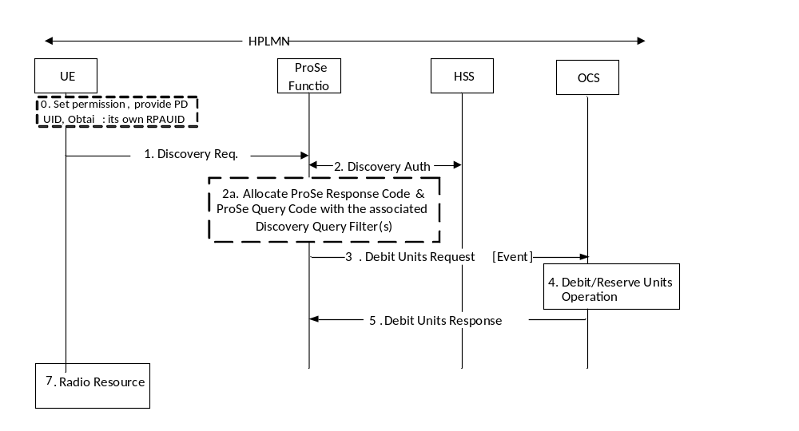
Figure 5.3.2.2.5.1: Discoveree UE procedures for Model B restricted discovery (IEC for non-roaming)
More details and complete message flow of Discoveree UE procedures for Model B restricted discovery (non-roaming) are defined in TS 23.303 [238] clause 5.3.3A.2.
The user sets the permission for the restricted discovery using application layer mechanisms.
0-2a. If the Discoveree UE is authorised to use Model B discovery in the serving PLMN and is triggered by the application client to perform a Discoveree Request procedure, the UE shall establish a secure connection to the ProSe Function in the HPLMN and send a Discovery Request (RPAUID, UE Identity, command, Discovery Type, Discovery Model, Application ID, Discovery Entry ID, PC5_tech) message. ProSe Function in the HPLMN check the authorization with the HSS.
3. ProSe Function sends Debit Units Request [Event] indicating "Restricted Announce" to the OCS.
4. The OCS performs the Debit Units operation for Discoveree UE.
5. The OCS returns the Debit Units Response to ProSe Function.
6. The ProSe Function in HPLMN shall allocate and respond with a Discovery Response (Discovery Model, ProSe Response Code, Discovery Query Filter(s), validity timer, Discovery Entry ID, PC5_tech) message.
7. The UE may then obtain the radio resources as authorised and configured by E-UTRAN for ProSe as defined in RAN specifications, or use WLAN or both, to monitor using the Discovery Query Filter(s).
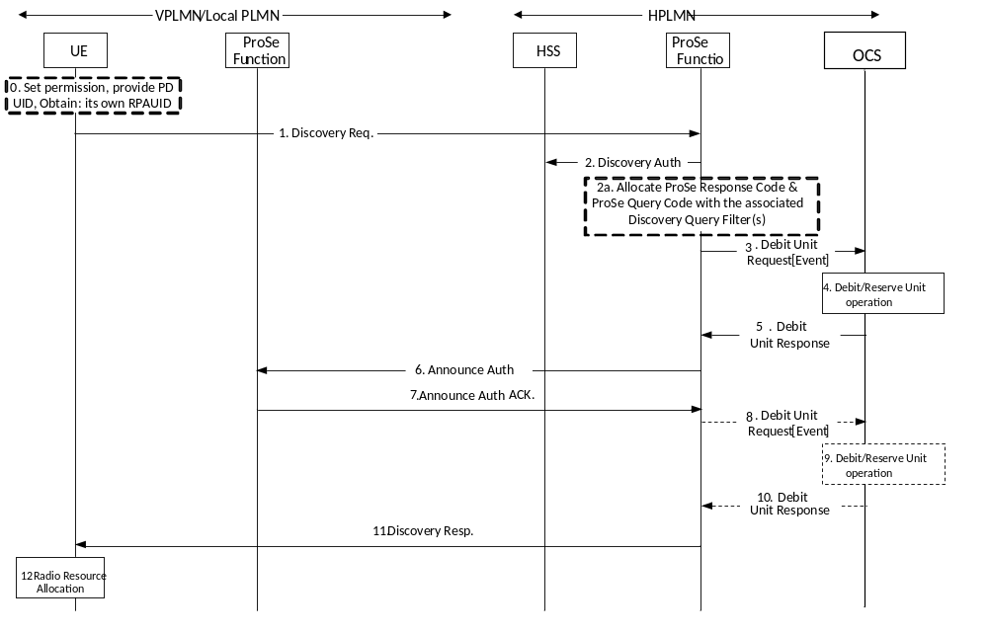
Figure 5.3.2.2.5.2: Discoveree UE procedures for Model B restricted discovery (IEC for roaming/Inter-PLMN transmission)
More details and complete message flow of Discoveree UE procedures for Model B restricted discovery (roaming/inter-PLMN transmission) are defined in TS 23.303 [238] clause 5.3.3A.3.
0-2a. These steps are defined in TS 23.303[238].
3. ProSe Function sends Reserve Units Request [Initial, RPUID, cmd = Restricted Announce, PC5_tech] to the OCS for requesting units.
4. The OCS performs Reserve Units Request operation for Discoveree UE.
5. The OCS grants service units in the Reserve Units Response to ProSe Function.
6-7. These steps are defined in TS 23.303[238].
If the Discovery Request is not authorized, the optional refund steps 8 to 10 are required:
8. ProSe function sends Debit Units Request[Event] to the OCS for refund purpose.
9. The OCS performs Debit Units Request operation for refund.
10. The OCS returns the Debit Units Response to ProSe Function.
11. The ProSe Function in HPLMN shall respond with a Discovery Response (Discovery Model, ProSe Response Code, Discovery Query Filter(s), validity timer, Discovery Entry ID, PC5_tech) message. After the ProSe Function in the HPLMN responds with a Discovery Response,
12. The UE may then obtain the radio resources as authorised and configured by E-UTRAN for ProSe as defined in RAN specifications, or use WLAN or both to monitor using the Discovery Query Filter.

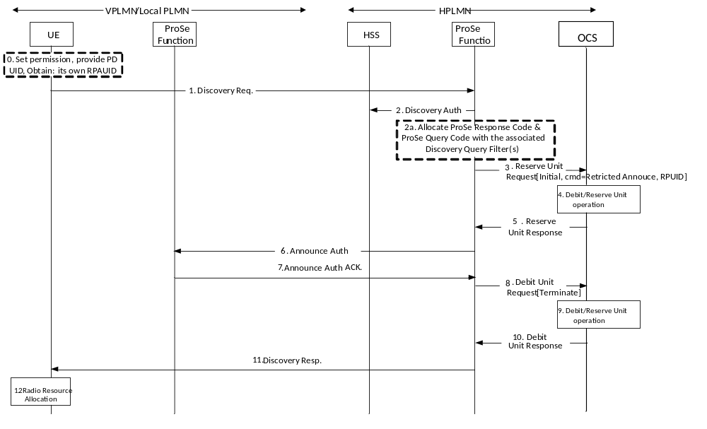
Figure 5.3.2.2.5.3: Discoveree UE procedures for Model B restricted discovery (ECUR for roaming/Inter-PLMN transmission)
More details and complete message flow of Discoveree UE procedures for Model B restricted discovery (roaming/inter-PLMN transmission) are defined in TS 23.303 [238] clause 5.3.3A.3.
0-2a. These steps are defined in TS 23.303[238].
3. ProSe Function sends Reserve Units Request [Initial, RPUID, cmd = Restricted Announce, PC5_tech] to the OCS for requesting units.
4. The OCS performs Reserve Units Request operation for Discoveree UE.
5. The OCS grants service units in the Reserve Units Response to ProSe Function.
6-7. These steps are defined in TS 23.303[238].
8. ProSe Function sends Debit Units Request[Terminate] to the OCS indicating granted units are used. On unsuccessful Announce authorization, granted units are returned.
9. The OCS performs Debit Units operation.
10. The OCS returns the Debit Units Response to ProSe Function.
11. The ProSe Function in HPLMN shall respond with a Discovery Response (Discovery Model, ProSe Response Code, Discovery Query Filter(s), validity timer, Discovery Entry ID, PC5_tech) message. After the ProSe Function in the HPLMN responds with a Discovery Response,
12. The UE may then obtain the radio resources as authorised and configured by E-UTRAN for ProSe as defined in RAN specifications, or use WLAN or both to monitor using the Discovery Query Filter.
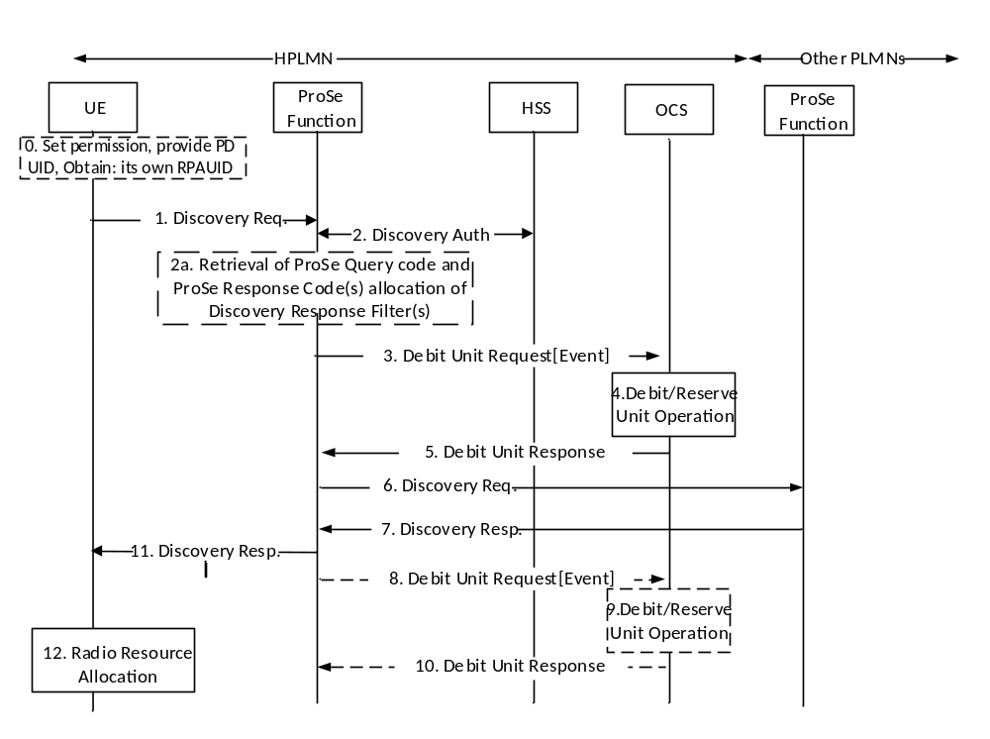
Figure 5.3.2.2.5.4: Discoverer UE procedures for Model B restricted discovery (IEC for non-roaming)
More details and complete message flow of Discoverer UE procedures for Model B restricted discovery (non-roaming) are defined in TS 23.303 [238] clause 5.3.3A.4.
0-2a. If the Discoverer UE is authorised to use Model B discovery in the serving PLMN and is triggered by the application client to perform a Discoverer Request procedure, the UE shall establish a secure connection to the ProSe Function in the HPLMN and send a Discovery Request (RPAUID, UE Identity, command, Discovery Type, Discovery Model, Application ID, Application Transparent Container, Discovery Entry ID, PC5_tech) message. ProSe Function in the HPLMN check the authorization with the HSS. Based on the Target ProSe Discovery UE ID, Application ID, and Target Restricted ProSe App User ID, the ProSe Function locates the Discoveree UE(s) context.
3. ProSe Function sends Debit Units Request [Event] indicating "Restricted Monitor" with the requested PC5 radio technology to the OCS.
4. The OCS performs the Debit Units operation for Discoverer UE.
5. The OCS returns the Debit Units Response to ProSe Function.
6-7. These steps are defined in TS 23.303[238].
If the Discovery Request is not authorized, the optional refund steps 8 to 10 are required:
8. ProSe function sends Debit Units Request[Event] to the OCS for refund purpose.
9. The OCS performs Debit Units Request operation for refund.
10. The OCS returns the Debit Units Response to ProSe Function.
11. The ProSe Function in HPLMN shall responds with a Discovery Response (ProSe Query Code(s), ProSe Response Code, validity timer, PC5_tech).
12. The UE may then obtain the radio resources to monitor using the Discovery Query Filter, as authorised and configured by E-UTRAN for ProSe as defined in RAN specifications.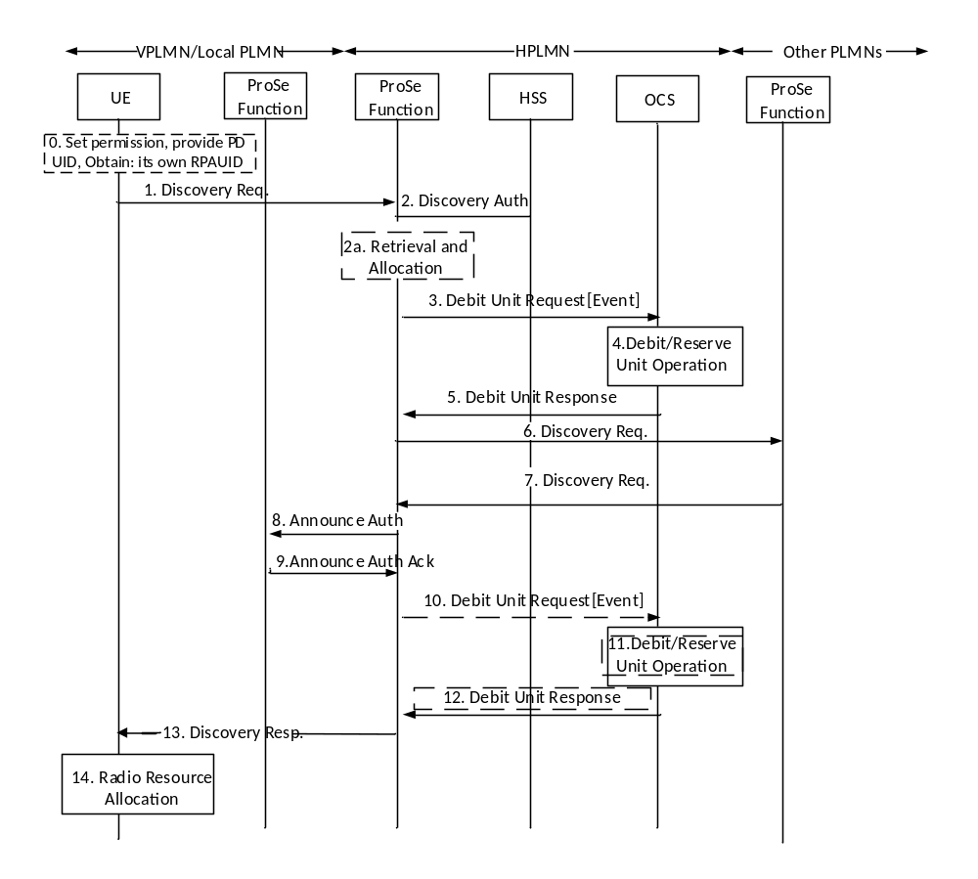
Figure 5.3.2.2.5.5: Discoverer UE procedures for Model B restricted discovery (IEC for roaming/inter-PLMN transmission)
More details and complete message flow of Discoverer UE procedures for Model B restricted discovery (roaming/inter-PLMN transmission) are defined in TS 23.303 [238] clause 5.3.3A.5.
0-2a. If the Discoverer UE is authorised to use Model B discovery in the serving PLMN and is triggered by the application client to perform a Discoverer Request procedure, the UE shall establish a secure connection to the ProSe Function in the HPLMN and send a Discovery Request (RPAUID, UE Identity, command, Discovery Type, Discovery Model, Application ID, Application Transparent Container, Discovery Entry ID, PC5_tech) message. ProSe Function in the HPLMN check the authorization with the HSS. Based on the Target ProSe Discovery UE ID, Application ID, and Target Restricted ProSe App User ID, the ProSe Function locates the Discoveree UE(s) context.
3. ProSe Function sends Debit Units Request [Event] indicating "Restricted Monitor" with the requested PC5 radio technology to the OCS.
4. The OCS performs the Debit Units operation for Discoverer UE.
5. The OCS returns the Debit Units Response to ProSe Function.
6-9. These steps are defined in TS 23.303[238].
If the Discovery Request is not authorized, the optional refund steps 8 to 10 are required:
10. ProSe function sends Debit Units Request[Event] to the OCS for refund purpose.
11. The OCS performs Debit Units Request operation for refund.
12. The OCS returns the Debit Units Response to ProSe Function.
13. The ProSe Function in HPLMN shall responds with a Discovery Response (ProSe Query Code(s), ProSe Response Code, validity timer, PC5_tech).
14. The UE may then obtain the radio resources as authorised and configured by E-UTRAN for ProSe as defined in RAN specifications, or use WLAN or both, to monitor using the Discovery Query Filter.
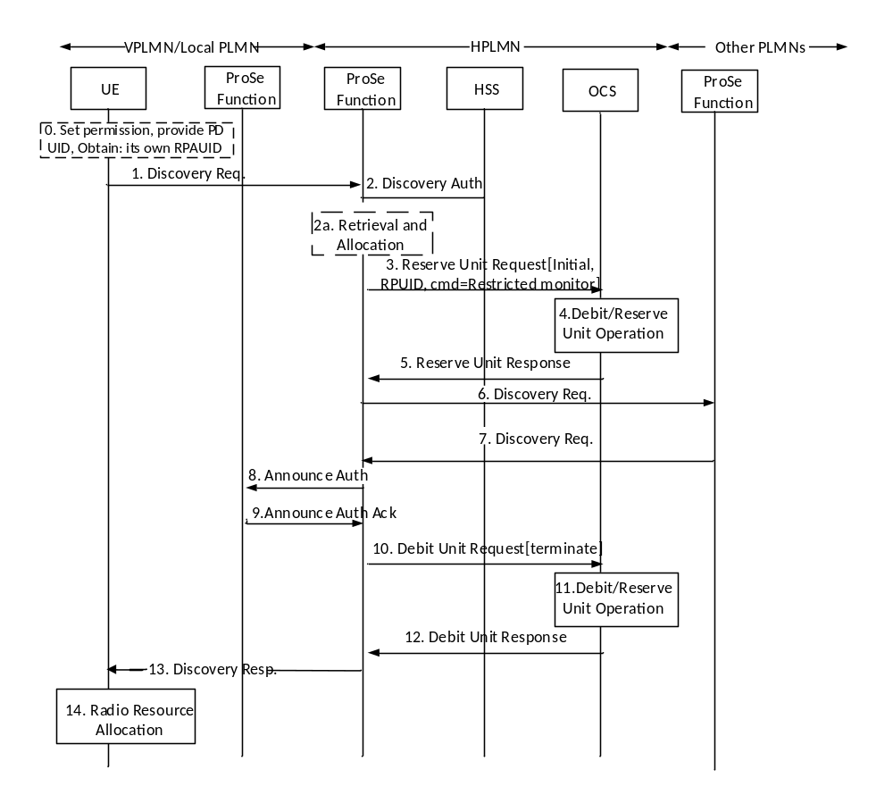
Figure 5.3.2.2.5.6: Discoverer UE procedures for Model B restricted discovery (ECUR for roaming/inter-PLMN transmission)
More details and complete message flow of Discoverer UE procedures for Model B restricted discovery (roaming/inter-PLMN transmission) are defined in TS 23.303 [238] clause 5.3.3A.5.
0-2a. If the Discoverer UE is authorised to use Model B discovery in the serving PLMN and is triggered by the application client to perform a Discoverer Request procedure, the UE shall establish a secure connection to the ProSe Function in the HPLMN and send a Discovery Request (RPAUID, UE Identity, command, Discovery Type, Discovery Model, Application ID, Application Transparent Container, Discovery Entry ID, PC5_tech) message. ProSe Function in the HPLMN check the authorization with the HSS. Based on the Target ProSe Discovery UE ID, Application ID, and Target Restricted ProSe App User ID, the ProSe Function locates the Discoveree UE(s) context.
3. ProSe Function sends Reserve Units Request [Initial, RPUID, cmd = Restricted Monitor, PC5_tech] to the OCS for requesting units.
4. The OCS performs Reserve Units Request operation for Discoverer UE.
5. The OCS grants service units in the Reserve Units Response to ProSe Function.
6-9. These steps are defined in TS 23.303[238].
10. ProSe Function sends Debit Units Request[Terminate] to the OCS indicating granted units are used. On unsuccessful Monitor authorization, granted units are returned.
11. The OCS performs Debit Units operation.
12. The OCS returns the Debit Units Response to ProSe Function.
13. The ProSe Function in HPLMN shall responds with a Discovery Response (ProSe Query Code(s), ProSe Response Code, validity timer, PC5_tech).
14. The UE may then obtain the radio resources as authorised and configured by E-UTRAN for ProSe as defined in RAN specifications, or use WLAN or both, to monitor using the Discovery Query Filter.

5.3.2.2.6 Message flow for Discovery reporting - Model B procedures
Figures 5.3.2.2.6.1 to 5.3.2.2.6.4 define the transactions between ProSe Function and OCS for the successful scenario where a "Discoverer UE" sends a Match report for Model B restricted discovery in non-roaming case and roaming case for IEC and ECUR modes.
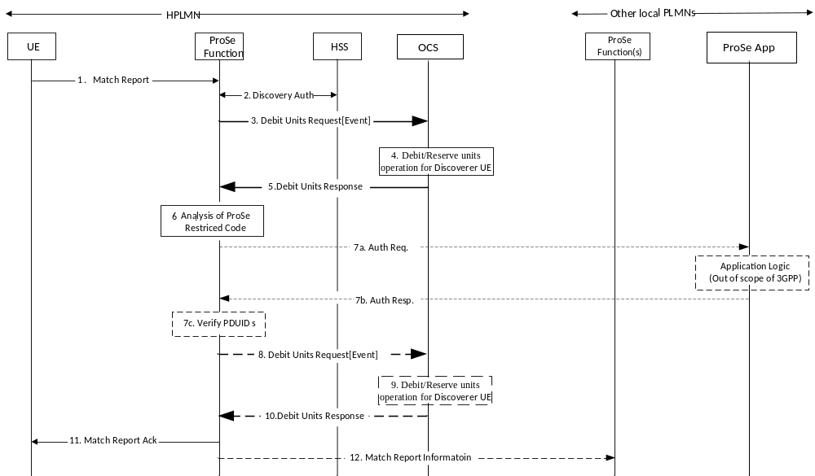
Figure 5.3.2.2.6.1: Match Report procedure for Model B restricted discovery (IEC for non-roaming)
More details and complete message flow of Discoverer UE Match Report procedures for Model B restricted discovery (non-roaming) are defined in TS 23.303 [238] clause 5.3.4A.1.
1-2. These Steps are defined in TS 23.203 [238].
3. ProSe Function sends Debit Units Request[Event] indicating "Match" to the OCS.
4. The OCS performs the Debit Units operation for "Match ".
5. The OCS returns the Debit Units Response to ProSe Function.
6-7. The HPLMN ProSe Function analyses and optionally sends an Auth Request to the ProSe Application Server. The ProSe Function verifies that the returned PDUID.
In case of unsuccessful scenario, the optional refund steps 8 to 10 are required:
8. ProSe function sends Debit Units Request[Event] to the OCS for refund purpose.
9. The OCS performs Debit Units Request operation for refund.
10. The OCS returns the Debit Units Response to ProSe Function.
11-12. The ProSe Function in VPLMN returns a Match Report and may optionally send a Match Report Information.
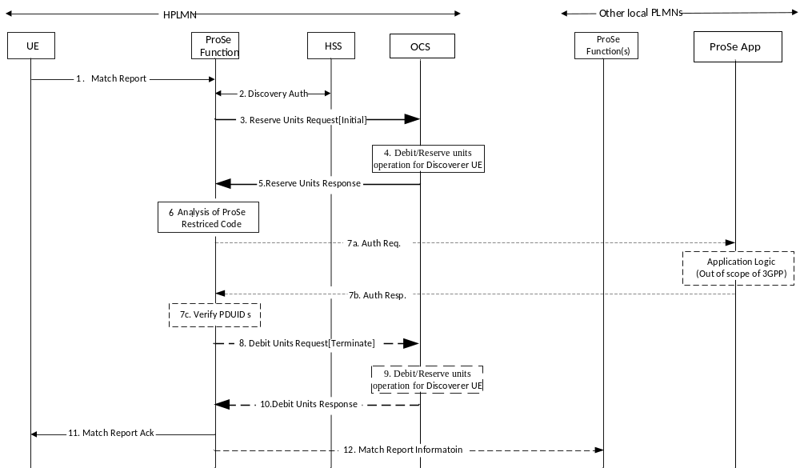
Figure 5.3.2.2.6.2: Match Report procedure for Model B restricted discovery (ECUR for non-roaming)
More details and complete message flow of Discoverer UE Match Report procedures for Model B restricted discovery (non-roaming) are defined in TS 23.303 [238] clause 5.3.4A.1.
1-2. These Steps are defined in TS 23.203 [238].
3. ProSe Function sends Reserve Units Request[Initial] to the OCS for requesting units.
4. The OCS performs the Debit Units operation for "Match".
5. The OCS grants service units in the Reserve Units Response to ProSe Function.
6-7. The HPLMN ProSe Function analyses and optionally sends an Auth Request to the ProSe Application Server. The ProSe Function verifies that the returned PDUID.
8. ProSe Function sends Debit Units Request[Terminate] to the OCS with granted units used. On unsuccessful Match Report, granted units are returned.
9. The OCS performs the Debit Units operation for "Match".
10. The OCS returns the Debit Units Response to ProSe Function.
11-12. The ProSe Function in VPLMN returns a Match Report and may optionally send a Match Report Information.

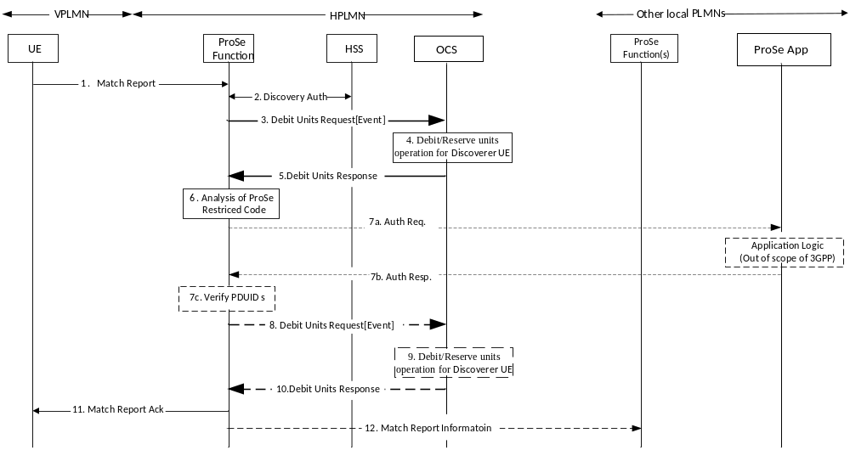
Figure 5.3.2.2.6.3: Match Report procedure for Model B restricted discovery (IEC for roaming/Inter-PLMN transmission)
More details and complete message flow of Discoverer UE Match Report procedures for Model B restricted discovery (roaming/inter-PLMN transmission) are defined in TS 23.303 [238] clause 5.3.4A.2.
1-2. These Steps are defined in TS 23.203 [238].
3. ProSe Function sends Debit Units Request[Event] indicating "Match" to the OCS.
4. The OCS performs the Debit Units operation for "Match ".
5. The OCS returns the Debit Units Response to ProSe Function.
6-7. The HPLMN ProSe Function analyses and optionally sends an Auth Request to the ProSe Application Server. The ProSe Function verifies that the returned PDUID.
In case of unsuccessful scenario, the optional refund steps 8 to 10 are required:
8. ProSe function sends Debit Units Request[Event] to the OCS for refund purpose.
9. The OCS performs Debit Units Request operation for refund.
10. The OCS returns the Debit Units Response to ProSe Function.
11-12. The ProSe Function in VPLMN returns a Match Report and may optionally send a Match Report Information.
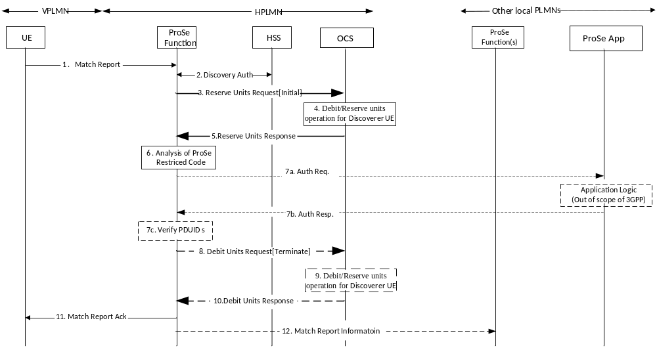
Figure 5.3.2.2.6.4: Match Report procedure for Model B restricted discovery (ECUR for roaming/Inter-PLMN transmission)
More details and complete message flow of Discoverer UE Match Report procedures for Model B restricted discovery (roaming/inter-PLMN transmission) are defined in TS 23.303 [238] clause 5.3.4A.2.1-2. These Steps are defined in TS 23.203 [238].
3. ProSe Function sends Reserve Units Request[Initial] to the OCS for requesting units.
4. The OCS performs the Debit Units operation for "Match".
5. The OCS grants service units in the Reserve Units Response to ProSe Function.
6-7. The HPLMN ProSe Function analyses and optionally sends an Auth Request to the ProSe Application Server. The ProSe Function verifies that the returned PDUID.
8. ProSe Function sends Debit Units Request[Terminate] to the OCS with granted units used. On unsuccessful Match Report, granted units are returned.
9. The OCS performs the Debit Units operation for "Match".
10. The OCS returns the Debit Units Response to ProSe Function.
11-12. The ProSe Function in VPLMN returns a Match Report and may optionally send a Match Report Information.

5.3.2.3 ProSe EPC-level Discovery

5.3.2.3.1 Triggers for ProSe EPC-level Discovery online charging
ProSe EPC-level Discovery Proximity Request allows a ProSe-enabled UE A to request the network to assist it detecting if UE B is in proximity.
Debit/Reserve Unit Request[Initial/Update] is triggered for UE A, when a Proximity Request is received and the App Server provides the valid mapping information. Debit/Reserve Unit Request[Initial] is triggered when there is no active discovery session for the same pair of UE A and UE B identified by EPC ProSe User ID A (EPUID_A) and EPC ProSe User ID B (EPUID_B). Debit/Reserve Unit Request[Update] is triggered when there is an existing discovery session for the same pair of UE A and UE B.
Debit/Reserve Unit Request[Terminate] is triggered for UE A, when a Proximity Request Reject or Proximity Request Cancellation is sent.
Debit/Reserve Unit Request[Initial/Update] is triggered for UE B, when a Proximity Request is received. Debit/Reserve Unit Request[Initial] is triggered when there is no active discovery session for the same pair of UE A and UE B identified by EPC ProSe User ID A (EPUID_A) and EPC ProSe User ID B (EPUID_B). Debit/Reserve Unit Request[Update] is triggered when there is an existing discovery session for the same pair of UE A and UE B.
Debit/Reserve Unit Request[Terminate] is triggered for UE B, when a Proximity Request Reject or Proximity Request Cancellation is sent.

5.3.2.3.2 Message flow for ProSe EPC-level Discovery Proximity Request
Figure 5.3.2.3.2.1 depicts the message flow for ProSe EPC-level Discovery Proximity Request for UE A.
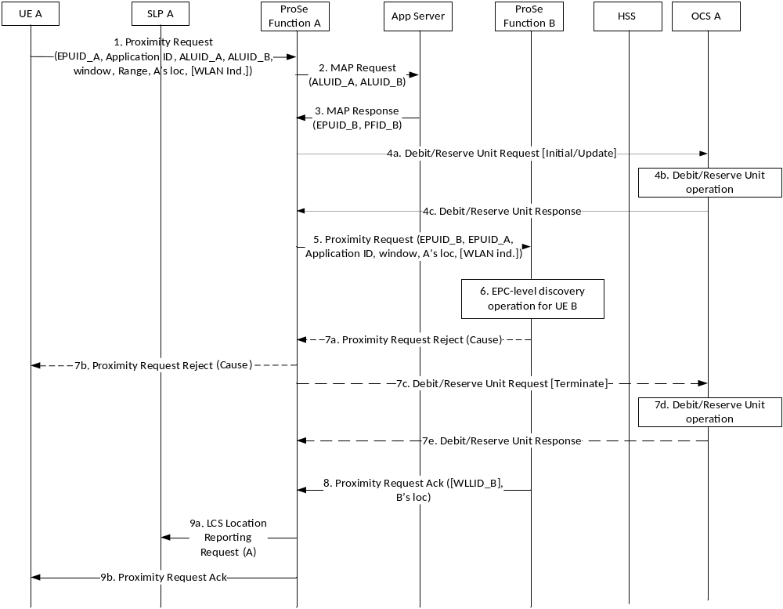
Figure 5.3.2.3.2.1: Message flow for ProSe EPC-level Discovery Proximity Request (UE A)
1 - 3. These steps are defined in TS 23.303 [238] clause 5.5.5.
4a. ProSe Function A sends Debit/Reserve Units Request[Initial/Update] according to the conditions specified in 5.3.2.3.1 to the corresponding OCS A.
4b. The OCS A performs Debit/Reserve Units operation for the UE.
4c. The OCS A returns the Debit Units Response to ProSe Function A.
5. ProSe Functions A sends the Proximity Request to ProSe Function B if step 4c indicates success.
6. ProSe Function B triggers the corresponding EPC-level discovery procedure for UE B, as depicted in figure 5.3.2.3.2.2.
7a ProSe Function B rejects the Proximity Request with the Proximity Request Reject (Cause) message.
If ProSe Function received Proximity Request Reject in step 7a, the following step 7b to 7e will executed. Otherwise, step 8 to 9b will be executed.
7b. ProSe Function A sends the Proximty Request Reject (Cause) to UE A.
7c ProSe Function A sends Debit/Reserve Units Request[Terminate] the corresponding OCS A.
7d. The OCS A performs Debit/Reserve Units operation for the UE.
7e. The OCS A returns the Debit Units Response to ProSe Function A.
8. ProSe Function B sends Proxmity Request Ack message to ProSe Function A.
9a. ProSe Function A sends LCS Locaiton Reporting Request for UE A to SLP A.
9b. ProSe Function A sends Proximity Request Ack to UE A.

Figure 5.3.2.3.2.2 depicts the message flow for ProSe EPC-level Discovery Proximity Request for UE B.

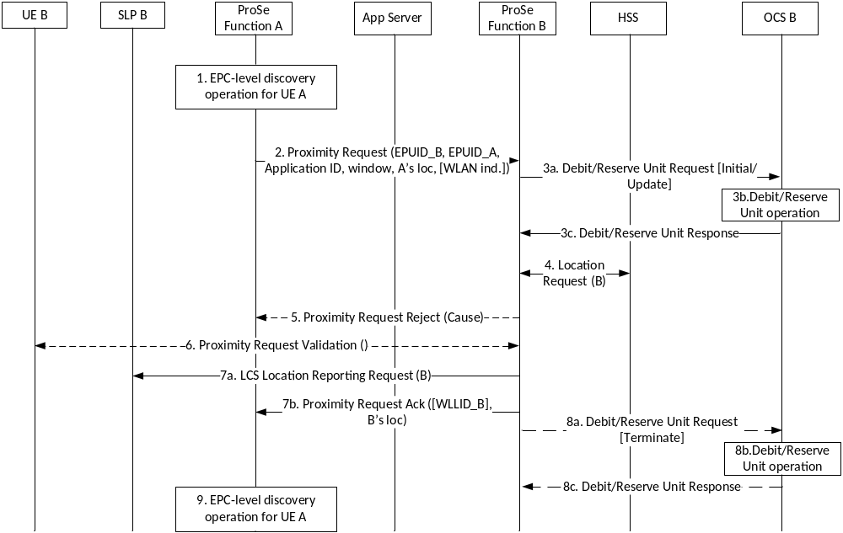
Figure 5.3.2.3.2.2: Message flow for ProSe EPC-level Discovery Proximity Request (UE B)
1. EPC-level discovery operation for UE A is executed, as depicted in step 1 to 4c in figure 5.3.2.3.2.2.
2. ProSe Functions A sends the Proximity Request to ProSe Function B.
3a. ProSe Function B sends Debit/Reserve Units Request[Initial/Update] according to the conditions specified in 5.3.2.3.1 to the corresponding OCS B.
3b. The OCS B performs Debit/Reserve Units operation for the UE.
3c. The OCS B returns the Debit Units Response to ProSe Function B.
4. If step 3c indicates success, the ProSe Function B obtains from HSS the last known location of UE B.
5. ProSe Function B may reject the request based on the information obtained in step 4, and send a Proximity Request Reject (Cause) message to ProSe Function A.
6. ProSe Function B validates the Proximity Request with UE B if it decides to accept the Proximity Request.
7a. ProSe Function B sends LCS Location Reporting Request to SLP B for UE B.
7b. ProSe Function B sends Proximity Request Ack message to the ProSe Function A.
The following step 8a to 8c are executed only when 5 is executed or step 6 validation fails.
8a. ProSe Function B sends Debit/Reserve Units Request[Terminate] the corresponding OCS B.
8b. The OCS B performs Debit/Reserve Units operation for the UE.
8c. The OCS B returns the Debit Units Response to ProSe Function B.
9. EPC-level discovery operation for UE A is executed, as depicted in step 7a to 9b in figure 5.3.2.3.2.2.

5.3.2.3.3 Message flow for ProSe EPC-level Discovery Proximity Request Cancellation
ProSe EPC-level Discovery Proximity Request cancellation is triggered by either the UE or network. It is cancels the proximity detection for a particular pair of UEs, e.g. UE A and UE B. Therefore, upon this procedure, Debit/Reserve Unit Request[Termiante] is triggered for UE A and UE B, after the respective ProSe Function responded to the Cancel Proximity Request message.
Figure 5.3.2.3.3.1 depicts the message flow for ProSe EPC-level Discovery Proximity Request Cancellation.
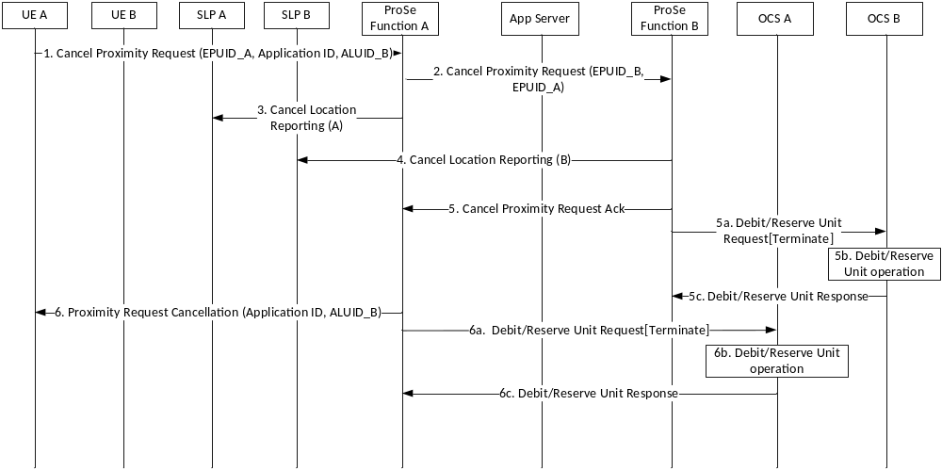
Figure 5.3.2.3.3.1: Message flow for ProSe EPC-level Discovery Proximity Request Cancellation
1 - 5. These steps are defined in TS 23.303 [238] clause 5.5.9.
5a. After the ProSe Function B sends a Cancel Proximity Request Ack to the ProSe Function A, the ProSe Function B triggers Debit/Reserve Units Request[Termiante] to the corresponding OCS B. This shall also indicate if a Proximity Alert has been sent to UE B.
5b. OCS B perform the Debit/Reserve Unit operation for UE B.
5c. The OCS B returns Debit/Reserve Units Response.
6. This step is defined in TS 23.303 [238] clause 5.5.9.
6a. After the ProSe Function A sends a Proximity Request Cancellation to the UE A, the ProSe Function A triggers Debit/Reserve Units Request[Termiante] to the corresponding OCS A. This shall also indicate if a Proximity Alert has been sent to UE A.
6b. OCS A perform the Debit/Reserve Unit operation for UE A.
6c. The OCS A returns Debit/Reserve Units Response.

6 Definition of charging information

6.1 Data description for ProSe offline charging

6.1.1 Rf message contents

6.1.1.1 General
The ProSe Offline Charging uses the Charging Data Transfer messages Charging Data Request and Charging Data Response defined in TS 32.299 [50].
The Charging Data Request can be of type event and includes all charging information. The Charging Data Response is an acknowledgement of the Charging Data Request.
Table 6.1.1.1.1 describes the use of these messages for offline charging.
Table 6.1.1.1.1: Offline charging messages reference table
Message | Source | Destination
Charging Data Request | ProSe Function | CDF
Charging Data Response | CDF | ProSe Function

This clause describes the different fields used in the Charging Data messages and the category in the tables are used according to the charging data configuration defined in clause 5.4 of TS 32.240 [1].

6.1.1.2 Charging Data Request message
Table 6.1.1.2.1 illustrates the basic structure of a Charging Data Request message from the ProSe Function as used for ProSe offline charging.
Table 6.1.1.2.1: Charging Data Request message contents
Information Element | Category | Description
Session Identifier | M | Described in TS 32.299 [50]
Originator Host | M | Described in TS 32.299 [50]
Originator Domain | M | Described in TS 32.299 [50]
Destination Domain | M | Described in TS 32.299 [50]
Operation Type | M | Described in TS 32.299 [50]
Operation Number | M | Described in TS 32.299 [50]
Operation Identifier | O_{C} | Described in TS 32.299 [50]
User Name | O_{C} | Described in TS 32.299 [50]
Destination Host | O_{C} | Described in TS 32.299 [50]
Operation Interval | O_{C} | Described in TS 32.299 [50]
Origination State | O_{C} | Described in TS 32.299 [50]
Origination Timestamp | O_{C} | Described in TS 32.299 [50]
Proxy Information | O_{C} | Described in TS 32.299 [50]
Route Information | O_{C} | Described in TS 32.299 [50]
Operation Token | O_{M} | This field identifies the Proximity-based Services.
Service Information | O_{M} | This field holds the ProSe specific information described in clause 6.3.

NOTE: Detailed descriptions of the information elements are provided in TS 32.299 [50].

6.1.1.3 Charging Data Response message
Table 6.1.1.3.1 illustrates the basic structure of a Charging Data Response message as used for the ProSe function.
Table 6.1.1.3.1: Charging Data Response message contents
Information Element | Category | Description
Session Identifier | M | Described in TS 32.299 [50]
Operation Result | M | Described in TS 32.299 [50]
Originator Host | M | Described in TS 32.299 [50]
Originator Domain | M | Described in TS 32.299 [50]
Operation Type | M | Described in TS 32.299 [50]
Operation Number | O_{C} | Described in TS 32.299 [50]
Operation Identifier | O_{C} | Described in TS 32.299 [50]
Operation Interval | O_{C} | Described in TS 32.299 [50]
Error Reporting Host | O_{C} | Described in TS 32.299 [50]
Origination State | O_{C} | Described in TS 32.299 [50]
Origination Timestamp | O_{C} | Described in TS 32.299 [50]
Proxy Information | O_{C} | Described in TS 32.299 [50]

NOTE: Detailed descriptions of the information elements are provided in TS 32.299 [50].

6.1.2 Ga message contents
Refer to clause 5.2.4 for further information.

6.1.3 CDR description on the Bx interface

6.1.3.1 General
The following standard CDR content and format are considered:
- PF-DD-CDR generated based on ProSe Direct Discovery information from the ProSe function;
- PF-ED-CDR generated based on ProSe EPC-level Discovery from the ProSe function.
- PF-DC-CDR generated based on ProSe Direct Communication from the ProSe function.
For each of the CDR types, a parameter table, which gives a short description of the parameters, is provided. The category in the tables are used according to the charging data configuration defined in clause 5.4 of TS 32.240 [1].

6.1.3.2 Direct Discovery charging data in ProSe Function (PF-DD-CDR)
If the collection of CDR data is enabled then the charging data specified in table 6.1.3.2.1 shall be available for direct discovery request.
Table 6.1.3.2.1: ProSe Function Direct Discovery data (PF-DD-CDR)
Field | Category | Description
Record Type | M | ProSe Direct Discovery record.
Retransmission | Oc | This parameter, when present, indicates that information from retransmitted Accounting Requests has been used in this CDR.
Served IMSI | C | IMSI of the served party.
Announcing PLMN ID | OC | PLMN identity of the serving PLMN which signalled the carrier frequency, when this serving PLMN is not the HPLMN nor the VPLMN, if available.
Announcing UE HPLMN Identifier | OM | PLMN identity of Announcing UE HPLMN.
Announcing UE VPLMN Identifier | OC | PLMN identity of Announcing UE VPLMN.
Monitoring UE HPLMN Identifier | OC | PLMN identity of monitoring UE HPLMN.
Monitoring UE VPLMN Identifier | OC | PLMN identity of monitoring UE VPLMN.
Discoverer UE HPLMN Identifier | OM | PLMN identity of Discoverer UE HPLMN.
Discoverer UE VPLMN Identifier | OC | PLMN identity of Discoverer UE VPLMN.
Discoveree UE HPLMN Identifier | OC | PLMN identity of Discoveree UE HPLMN.
Discoveree UE VPLMN Identifier | OC | PLMN identity of Discoveree UE VPLMN.
Monitored PLMN Identifier | OC | Monitored PLMN ID in Match_Report request, as defined in TS23.303 [238] clause 5.3.4. It corresponds to the Announcing UE VPLMN Identifier when roaming and Announcing UE HPLMN Identifier when non-roaming.
Role of ProSe Function | OM | This field indicates the CDR resource ProSe Function resides in which PLMN, i.e. in HPLMN, VPLMN or local PLMN.
ProSe Application ID | Oc | The identities used for ProSe Direct Discovery, identifying application related information for the ProSe-enabled UE.  (see note)
Application ID | Oc | A globally unique identifier identifying a specific 3rd party application.
ProSe Event Type | Oc | This IE holds the event which triggers the charging message delivery, e.g. open Announcing, open Monitoringopen Match Report or, restricted Announcing.
Direct Discovery Model | Oc | model of the Direct Discovery used by the UE, e.g. Model A, or Model B.
Node ID | Oc | The identifier of the ProSe Function.
ProSe Function IP Address | Oc | The IP address of the ProSe Function.
ProSe Function ID | Oc | The FQDN that identifies the ProSe Function.
Validity Period | Oc | Time interval during which user is authorized for using ProSe Direct Discovery functionality (e.g. announcing, monitoring, match reporting).
Role of UE | Oc | Role of the UE using ProSe, e.g. Announcing UE, Monitoring UE, Discoveree UE, Discoverer UE.
ProSe Request Timestamp | Oc | The time when ProSe Request is received from UE.
PC3 Control Protocol Cause | Oc | This field holds the particular reason why a DISCOVERY_REQUEST or Match_Report messages from the UE have been rejected by the ProSe Function.
Monitoring UE Identifier | Oc | Identifier of the party who initiate monitor/match report, i.e. IMSI, which corresponds to UE Identifier parameter in monitor/match report request, as defined in TS 23.303 [238].
Charging characteristics | M | The Charging Characteristics applied to the ProSe direct discovery.
Charging Characteristics Selection Mode | OM | Holds information about how Charging Characteristics were selected.
Record Extensions | Oc | A set of network operator/manufacturer specific extensions to the record. Conditioned upon the existence of an extension.
PC5 Radio Technology | OM | The PC5 radio technology used by UE for ProSe Direct Discovery.
Note: For the CDR generated for announcing UE in match report event, it holds the ProSe application id name.

6.1.3.3 ProSe EPC-level Discovery charging data in ProSe Function (PF-ED-CDR)
If enabled, a ProSe EPC-level Discovery record shall be produced for each EPC-level discovery request for a specific user received from a ProSe enabled UE. Renewal requests for a specific user are captured in the same CDR as the initial request. The fields in the record are specified in table 6.1.3.3.1.

Table 6.1.3.3.1: ProSe Function EPC-level Discovery data (PF-ED-CDR)
Field | Category | Description
Record Type | M | ProSe Function EPC-level Discovery record.
Retransmission | Oc | This parameter, when present, indicates that information from retransmitted Accounting Requests has been used in this CDR.
Served IMSI | C | IMSI of the served party.
ProSe Function PLMN Identifier | OC | PLMN identity of ProSe function.
Application ID | Oc | A globally unique identifier identifying a specific 3rd party application.
ProSe Function ID | Oc | The FQDN that identifies a ProSe Function.
ProSe Function IP Address | Oc | The IP address of the ProSe Function.
Role of UE | Oc | role of the UE using ProSe, e.g. requestor UE, requested UE
ProSe Request Timestamp | Oc | The time when ProSe Request is received from UE.
PC3 EPC Control Protocol Cause | Oc | This field holds the particular reason why a Proximity request messages from the UE have been rejected by the ProSe Function.
Requestor Application Layer User ID | Oc | The user identifier designated in 3rd party application for the user who initiate EPC-level ProSe discovery request.
WLAN Link Layer ID | Oc | This field holds WLAN Link Layer ID.
Requestor EPC ProSe User ID | Oc | The identifier generated in ProSe Function for UE who initiate EPC-level ProSe discovery request.
Requested Application Layer User ID | Oc | The user identifier designated in 3rd party application for the user who is targeted in proximity request.
Requested PLMN Identifier | Oc | The PLMN identifier of the user who is targeted in proximity request.
Time Window | Oc | The time interval in minutes during which the first proximity request is valid.
Range Class | Oc | A range class for the first proximity request.
UE Location | Oc | The UE location with the best known accuracy (e.g. Cell ID or geo-location coordinates) at the time fo the first proximity request..
Proximity Request Renewal Info Block List | Oc | This is a list of information blocks that are added by each of the Proximity renewal Request messages captured in the CDR. The information block contains information of the renewal request, e.g. timestamp, time window, range class, and UE location. The definition of the information block is in table 6.1.3.3.2.
Proximity Alert Indication | Oc | Indication of whether proximity alert has been sent before proximity request cancellation.
Proximity Alert Timestamp | Oc | The time stamp when proximity alert is sent, to indicate two UEs are in proximity.
Proximity Cancellation Timestamp | Oc | The time stamp when proximity request cancellation is requested.
Reason for Cancellation | Oc | The reason for cancellation of an EPC-level discovery request i.e. proximity alerted, time expired with no renewal, requestor cancellation.
Charging characteristics | M | The Charging Characteristics applied to the ProSe EPC-Level discovery.
Charging Characteristics Selection Mode | OM | Holds information about how Charging Characteristics were selected.
Cause for Record Closing | M | The reason for the release of record from this ProSe Function.
Record Extensions | Oc | A set of network operator/manufacturer specific extensions to the record. Conditioned upon the existence of an extension.

Table 6.1.3.3.2: ProSe Function EPC-level Discovery Proximity Request Renewal Info Block
Field | Category | Description
ProSe Request Timestamp | Oc | The time when the proximity renewal request is received from UE.
Time Window | Oc | The time interval in minutes during which the proximity renewal request is valid.
Range Class | Oc | A range class for the proximity renewal request.
UE Location | Oc | The UE location with the best known accuracy (e.g. Cell ID or geo-location coordinates) at the time fo the proximity renewal request.

6.1.3.4 Direct communication charging data in ProSe Function (PF-DC-CDR)
If the collection of CDR data is enabled then the charging data specified in table 6.1.3.4.1 shall be available for Direct Communication request.
Table 6.1.3.4.1: ProSe Function Direct Communication data (PF-DC-CDR)
Field | Category | Description
Record Type | M | ProSe Direct Communication record.
Retransmission | Oc | This parameter, when present, indicates that information from retransmitted Charging Data Request has been used in this CDR.
Served IMSI | C | IMSI of the served party.
ProSe Function PLMN Identifier | OM | PLMN identity of HPLMN ProSe function.
Node ID | Oc | The identifier of the ProSe Function.
ProSe Function IP Address | Oc | The IP address of the ProSe Function.
ProSe Function ID | Oc | The FQDN that identifies the ProSe Function.
Charging characteristics | M | The Charging Characteristics applied to the ProSe group communication.
Charging Characteristics Selection Mode | OM | Holds information about how Charging Characteristics were selected.
Record Opening Time | M | Time stamp when the CDR is open.
Cause for Record Closing | M | The reason for the closing of record from this ProSe Function.
List of Coverage Info | Oc | A list of coverage status changes with time stamps. When in coverage, additionally includes list of location changes (i.e., ECGI change) and time stamps.
List of Radio Parameter Set Info | Oc | A list of radio parameter sets configured in the UE for direct communication use. Each set has an associated time stamp of when it became active.
ProSe UE ID | Oc | A link layer identifier assigned by the EPS that uniquely represents the UE in the context of ProSe Direct Communication.
Source IP address | Oc | The IP address UE used as source address for performing ProSe Direct Communication , including ProSe one-to-many, ProSe one-to-one Communication and via ProSe UE-to-Network Relay.
Target IP address | Oc | The IP unicast address target UE used for non-relay ProSe Direct one-to-one Communication.
Relay IP address | Oc | The IP address UE used as ProSe UE-to-Network Relay UE address for performing ProSe Direct Communication via UE-to-Network Relay.
ProSe UE-to-Network Relay UE ID | Oc | A link layer identifier that uniquely represents the ProSe UE-to-Network Relay UE in the context of ProSe Direct Communication via UE-to-Network Relay.
ProSe Layer-2 Group ID | Oc | The identifier of a ProSe communication group, uniquely represents a specific one-to-many ProSe Direct Communication and is included in CDRs for each participantes in the specific group.
ProSe Target Layer-2 ID | Oc | The identifier of target UE, uniquely represents a specific one-to-one ProSe Direct Communication.
ProSe Group IP multicast address | Oc | The IP multicast address to be used for performing ProSe Direct Communication.
Time of First Transmission | Oc | Time when collection of transmission data is started for the group in this CDR, i.e., the first one-to-many direct communication transmission started.
Time of First Reception | Oc | Time when collection of reception data is started for the group in this CDR, i.e., the first one-to-many direct communication reception started.
List of Transmitters | Oc | A list of transmitters detected for the group. The information stored consists of the source IP address and the ProSe UE ID for each transmitter.
List of Transmission Data | OM | A list of changes in trigger conditions (e.g. change of cell, go out of coverage, come back to coverage, etc.) for a specific ProSe group communication. Each change is time stamped. Trigger condition is used to categorize transmitted data volumes, such as per coverage status duration.
List of Reception Data | Oc | A list of changes in trigger conditions (e.g. change of cell, go out of coverage, come back to coverage, etc.) for a specific ProSe group communication. Each change is time stamped. Trigger condition is used to categorize received data volumes, such as per coverage status duration.
List of Application Specific Data | Oc | A list of data blocks provided by the application in the UE. The content of each block is application-specific. The Application Specific Data is not related to any specific group. When received from the UE, it shall be added to all open group CDRs. The content of the Application Specific Data for a particular application should clearly identify to which group(s) the information applies and uniquely identify chargeable events in order for the billing domain to properly charge this information and avoid duplicate charging.
Record Extensions | Oc | A set of network operator/manufacturer specific extensions to the record. Conditioned upon the existence of an extension.

The components of the Direct Communication Transmission and Reception Data Containers are defined in following table.
Table 6.1.3.4.2: Structure of the Direct Communication Transmission and Reception Data Containers
Field | Category | Description
Local Sequence Number | Oc | The sequence number of the Direct Communication data container, which is increased by 1 for each container closed
Change Time | Oc | The time when the container is closed and reported due to ProSe charging condition change.
Coverage status | Oc | Whether UE is served by E-UTRAN or not, i.e. in coverage, out of coverage.
UE Location | Oc | The location of the UE, e.g. ECGI
Data Volume Transmitted | Oc | Amount of data transmitted by UE, only applicable in the Transmission Data Container.
Data Volume Received | Oc | Amount of data received by UE, only applicable in the Reception Data Container.
Change Condition | Oc | ProSe specific reason for closing the container, e.g. change of Cell, go out of coverage, come back to coverage.
VPLMN Identifier | Oc | Indentifier of PLMN which UE visits.
Usage information report sequence number | Oc | The sequence number of usage information report, which is used to generate the container.
Radio Resources Indicator | Oc | Identifies whether the operator-provided radio resources or the configured radio resources were used for ProSe direct communication.
Radio Frequency | Oc | Identifies the radio frequency used for ProSe direct communication.

6.2 Data description for ProSe online charging

6.2.1 Ro message contents

6.2.1.1 General
The ProSe Online Charging uses the Debit / Reserve Units Request and Debit / Reserve Units Response messages defined in TS 32.299 [50].
Table 6.2.1.1.1 describes the use of these messages for online charging.
Table 6.2.1.1.1: Online charging messages reference table
Message | Source | Destination
Debit / Reserve Units Request | ProSe Function | OCS
Debit / Reserve Units Response | OCS | ProSe Function

The structure of the Debit / Reserve Units Request and Debit / Reserve Units Reponse messages defined in the following clauses. The category in the tables are used according to the charging data configuration defined in clause 5.4 of TS 32.240 [1].

6.2.1.2 Debit / Reserve Units Request message
Table 6.2.1.2.1 illustrates the basic structure of a Debit / Reserve Units Request message from the ProSe Function as used for ProSe online charging.
Table 6.2.1.2.1: Debit / Reserve Units Request message contents
Information Element | Category | Description
Session Identifier | M | Described in TS 32.299 [50]
Originator Host | M | Described in TS 32.299 [50]
Originator Domain | M | Described in TS 32.299 [50]
Destination Domain | M | Described in TS 32.299 [50]
Operation Identifier | M | Described in TS 32.299 [50]
Operation Token | M | Described in TS 32.299 [50]
Operation Type | M | Described in TS 32.299 [50]
Operation Number | M | Described in TS 32.299 [50]
Destination Host | O_{C} | Described in TS 32.299 [50]
User Name | O_{C} | Described in TS 32.299 [50]
Origination State | O_{C} | Described in TS 32.299 [50]
Origination Timestamp | O_{C} | Described in TS 32.299 [50]
Subscriber Identifier | O_{M} | Described in TS 32.299 [50].  The IMSI and MSISDN shall be included, if available.
Termination Cause | O_{C} | Described in TS 32.299 [50]
Requested Action | O_{C} | Described in TS 32.299 [50]
Multiple Operation | O_{M} | Described in TS 32.299 [50]
Multiple Unit Operation | O_{C} | Described in TS 32.299 [50]
Operation Correlation Identifier | O_{C} | Described in TS 32.299 [50]
Subscriber Equipment Number | O_{C} | Described in TS 32.299 [50]
Proxy Information | O_{C} | Described in TS 32.299 [50]
Route Information | O_{C} | Described in TS 32.299 [50]
Service Information | O_{M} | This field holds the ProSe specific information described in clause 6.3

NOTE: Detailed descriptions of the information elements are provided in TS 32.299 [50].

6.2.1.3 Debit / Reserve Units Response message
Table 6.2.1.3.1 illustrates the basic structure of a Debit / Reserve Units Response message as used for the ProSe function.
Table 6.2.1.3.1: Debit / Reserve Units Response message contents
Information Element |  | Category | Description
Session Identifier |  | M | Described in TS 32.299 [50]
Operation Result |  | M | Described in TS 32.299 [50]
Originator Host |  | M | Described in TS 32.299 [50]
Originator Domain |  | M | Described in TS 32.299 [50]
Operation Identifier |  | M | Described in TS 32.299 [50]
Operation Type |  | M | Described in TS 32.299 [50]
Operation Number |  | M | Described in TS 32.299 [50]
Operation Failover |  | O_{C} | Described in TS 32.299 [50]
Multiple Unit Operation | O_{M} |  | Described in TS 32.299 [50]
Cost Information | O_{C} |  | Described in TS 32.299 [50]
Low Balance Indication | O_{C} |  | Described in TS 32.299 [50]
Remaining Balance | O_{C} |  | Described in TS 32.299 [50]
Operation Failure Action |  | O_{C} | Described in TS 32.299 [50]
Operation Event Failure Action |  | O_{C} | Described in TS 32.299 [50]
Redirection Host |  | O_{C} | Described in TS 32.299 [50]
Redirection Host Usage |  | O_{C} | Described in TS 32.299 [50]
Redirection Cache Time |  | O_{C} | Described in TS 32.299 [50]
Proxy Information |  | O_{C} | Described in TS 32.299 [50]
Route Information |  | O_{C} | Described in TS 32.299 [50]
Failed Parameter |  | O_{C} | Described in TS 32.299 [50]
Service Information |  | O_{C} | Described in TS 32.299 [50]

NOTE: Detailed descriptions of the information elements are provided in TS 32.299 [50].

6.3 ProSe charging specific parameters

6.3.1 Definition of ProSe charging information

6.3.1.1 ProSe charging information assignment for Service Information
The components in the Service Information that are used for ProSe charging can be found in table 6.3.1.1.1.
Table 6.3.1.1.1: Service Information used for ProSe charging
Information Element | Category | Description
Service Information | O_{M} | This is a structured IE and holds the 3GPP specific parameter as defined in TS 32.299 [50].
Subscriber Identifier | O_{C} | This IE contains the identification of the user (e.g. IMSI), for offline charging only.
PS Information | Oc | This is a structured IE and hold PS specification parameters.  The complete structure is defined in TS 32.251 [11].
Node Id | Oc | This IE holds the name of the Node.
User Location Info | Oc | This IE indicates details of where the UE is currently located (e.g. SAI, TAI, RAI, CGI, ECGI or access-specific user location information).
Change Condition | Oc | This field holds the reason for sending Charging Data Request from the ProSe Function.
Charging Characteristics | Oc | The Charging Characteristics applied to the ProSe service.
Charging Characteristics Selection Mode | Oc | Holds information about how Charging Characteristics were selected.
ProSe Information | O_{M} | This is a structured IE and holds the ProSe specific parameters.  The details are defined in clause 6.3.1.2.

6.3.1.2 Definition of the ProSe Information
ProSe specific charging information is provided within the ProSe Information. The fields of the ProSe Information are indicated with the node (ProSe Function) from which the information is sent.
The detailed structure of the ProSe Information can be found in table 6.3.1.2.1.
Table 6.3.1.2.1: Structure of the ProSe Information
Information Element | Category | Description
Supported Features | OC | This field holds the list of features supported by the ProSe Function, CDF or OCF as defined in clause 6.3.1.x.
Announcing PLMN ID | OC | PLMN identity of the serving PLMN which signalled the carrier frequency, when this serving PLMN is not the HPLMN nor the VPLMN, if available
Announcing UE HPLMN Identifier | OM | PLMN identity of HPLMN for announcing UE. This field holdes PLMN identity of HPLMN for UE requested to be monitored in monitor/match report procedure.
Announcing UE VPLMN Identifier | OC | PLMN identity of VPLMN for announcing UE. This field correspondes to Monitored PLMN ID in match report request, as defined in TS23.303 [238] clause 5.3.4. In this case it’s the same with announcing UE HPLMN Identifier when non-roaming
Monitoring UE HPLMN Identifier | OC | PLMN identity of HPLMN for monitoring UE.
Monitoring UE VPLMN Identifier | OC | PLMN identity of VPLMN for monitoring UE.
Discoverer UE HPLMN Identifier | OM | PLMN identity of Discoverer UE HPLMN.
Discoverer UE VPLMN Identifier | OC | PLMN identity of Discoverer UE VPLMN.
Discoveree UE HPLMN Identifier | OC | PLMN identity of Discoveree UE HPLMN.
Discoveree UE VPLMN Identifier | OC | PLMN identity of Discoveree UE VPLMN.
Monitored PLMN Identifier | OC | Monitored PLMN ID in Match_Report request, as defined in TS23.303 [238] clause 5.3.4. It corresponds to the Announcing UE VPLMN Identifier when roaming and Announcing UE HPLMN Identifier when non-roaming.
Role of ProSe Function | OM | This IE indicates the CDR resource ProSe Function resides in which PLMN, i.e. in HPLMN, VPLMN or local PLMN.
ProSe Application ID | Oc | The identities used for ProSe Direct Discovery, identifying application related information for the ProSe-enabled UE.  Note: For the CDR generated for announcing UE in match report event, it holds the ProSe application id name.
Application ID | Oc | A globally unique identifier identifying a specific 3rd party application.
Application Specific Data | Oc | This IE contains a data block provided by the application in the UE. The content of each block is application-specific.
ProSe functionality | Oc | This IE holds the ProSe functionality UE is requesting, e.g. direct discovery, EPC-level discovery, group communication.
ProSe Event Type | Oc | This IE holds the event which triggers the charging message delivery, e.g. open Announcing, open Monitoring, open Match Report, or restricted Match Report.
Direct Discovery Model | Oc | model of the Direct Discovery used by the UE, e.g. Model A, or Model B.
ProSe Function IP Address | Oc | The IP address of the ProSe Function.
ProSe Function ID | Oc | The FQDN that identifies a ProSe Function.
Validity Period | Oc | Time interval during which user is authorized for using ProSe Direct Discovery functionality (e.g. announcing, monitoring, match reporting).
Role of UE | Oc | Role of the UE using ProSe served by the ProSe Function, e.g. Announcing UE, Monitoring UE, requestor UE, requested UE, Disvoerer UE, Discoveree UE.
ProSe Request Timestamp | Oc | The time when ProSe Request is received from UE.
PC3 Protocol Cause | Oc | This IE holds the particular reason why a DISCOVERY_REQUEST or Match_Report messages from the UE have been rejected by the ProSe Function in PC3 interface.
Monitoring UE Identifier | Oc | Identifier of the party who initiate monitor/match report, i.e. IMSI, which corresponds to UE Identifier parameter in monitor/match report request, as defined in TS 23.303 [238].
ProSe Function PLMN Identifier | OC | PLMN identity of ProSe function.
Requestor PLMN Identifier | OC | The PLMN identifier of the user who initiate proximity request.
Requestor Application Layer User ID | Oc | The user identifier designated in 3rd party application for the user who initiate EPC-level ProSe discovery request.
WLAN Link Layer ID | Oc | This IE holds WLAN Link Layer ID.
Requestor EPC ProSe User ID | Oc | The identifier generated in ProSe Function for UE who initiate EPC-level ProSe discovery request.
Requested Application Layer User ID | Oc | The user identifier designated in 3rd party application for the user who is targeted in proximity request.
Requested PLMN Identifier | Oc | The PLMN identifier of the user who is targeted in proximity request.
Time Window | Oc | The time interval in minutes during which a proximity request is valid.
Range Class | Oc | A range class for a specific proximity request.
Proximity Alert Indication | Oc | Indication of whether proximity alert has been sent before proximity request cancellation.
Proximity Alert Timestamp | Oc | The time stamp when proximity alert is sent, to indicate two UEs are in proximity.
Proximity Cancellation Timestamp | Oc | The time stamp when proximity request cancellation is requested.
Reason for Cancellation | Oc | The reason for cancellation of an EPC-level discovery request i.e. proximity alerted, time expired with no renewal, requestor cancellation.
PC3 EPC Control Protocol Cause | Oc | This field holds the particular reason why a Proximity request messages from the UE have been rejected by the ProSe Function.
ProSe UE ID | Oc | A link layer identifier assigned by the EPS that uniquely represents the UE in the context of ProSe Direct Communication.
Source IP address | Oc | The IP address UE used as source address for performing ProSe direct communication.
Target IP address | Oc | The IP unicast address target UE used for non-relay ProSe direct one-to-one communication.
Relay IP address | Oc | The IP address UE used as ProSe UE-to-Network Relay UE address for performing ProSe direct communication via UE-to-Network Relay.
ProSe UE-to-Network Relay UE ID | Oc | A link layer identifier that uniquely represents the ProSe UE-to-Network Relay UE in the context of ProSe Direct Communication.
ProSe Layer-2 Group ID | Oc | The identifier of a ProSe communication group, uniquely represents a specific one-to-many ProSe Direct Communication and is included in CDRs for each participantes in the specific group.
ProSe Target Layer-2 ID | Oc | The identifier of target UE, uniquely represents a specific one-to-one ProSe Direct Communication.
ProSe Group IP multicast address | Oc | The IP multicast address to be used for performing ProSe direct communication.
Coverage Info | Oc | This IE provides information on the coverage status (i.e., whether the UE is served by E-UTRAN or not) and the time when the coverage status changed to its current state. When in E-UTRAN coverage, additionally includes a list of location changes (i.e., ECGI change) and associated time for each change.
Radio Parameter Set Info | Oc | This IE provides information on a radio parameter set configured in the UE for direct communication use. Each set has an associated time stamp of when it became active.
Transmitter Info | Oc | This IE provides information on a transmitter detected for direct communication. Each transmitter is identified by a source IP address and ProSe UE ID.
Time of First Transmission | Oc | This IE holds the time in UTC format for the first IP packet transmitted.
Time of First Reception | Oc | This IE holds the time in UTC format for the first IP packet received.
Transmission Data Container | OC | This field holds the container associated to a trigger conditions (e.g. change of Cell, go out of coverage, come back to coverage, etc.) on a specific ProSe transmission of group communication.
Local Sequence Number | Oc | The sequence number of the Direct Communication data container, which is increased by 1 for each container closed
Change Time | Oc | The time when the container is closed and reported due to ProSe charging condition change.
Coverage status | Oc | Whether UE is served by E-UTRAN or not, i.e. in coverage, out of coverage.
User Location Information | Oc | The location of the UE, e.g. ECGI
Data Volume Transmitted | Oc | Amount of data transmitted by UE.
Change Condition | Oc | ProSe specific reason for closing the container, e.g. change of Cell, go out of coverage, come back to coverage.
VPLMN Identifier | Oc | Indentifier of PLMN which UE visits.
Usage information report sequence number | Oc | The sequence number of usage information report, which is used to generate the container.
Radio Resources indicator | Oc | This IE identifies whether the operator-provided radio resources or the configured radio resources were used for ProSe direct communication.
Radio Frequency | Oc | This IE identifies the radio frequency used for ProSe direct communication.
Reception Data Container | Oc | This field holds the container associated to a trigger conditions (e.g. change of Cell, go out of coverage, come back to coverage, etc.) on a specific ProSe reception of group communication.
Local Sequence Number | Oc | The sequence number of the Direct Communication data container, which is increased by 1 for each container closed
Change Time | Oc | The time when the container is closed and reported due to ProSe charging condition change.
Coverage status | Oc | Whether UE is served by E-UTRAN or not, i.e. in coverage, out of coverage.
User Location Information | Oc | The location of the UE, e.g. ECGI
Data Volume Received | Oc | Amount of data received by UE.
Change Condition | Oc | ProSe specific reason for closing the container, e.g. change of Cell, go out of coverage, come back to coverage.
VPLMN Identifier | Oc | Indentifier of PLMN which UE visits.
Usage information report sequence number | Oc | The sequence number of usage information report, which is used to generate the container.
Radio Resources indicator | Oc | This IE identifies whether the operator-provided radio resources or the configured radio resources were used for ProSe direct communication.
Radio Frequency | Oc | This IE identifies the radio frequency used for ProSe direct communication.
PC5 Radio Technology | OM | The PC5 radio technology used by UE for ProSe Direct Discovery.

6.3.1.3 Supported features
The Supported features information that is used for ProSe charging is based on the information defined for the supported features mechanism specified in clause 6.5.10 TS 32.299 [50].
The following table defines the features applicable for the feature lists with a Feature-List-ID of 1.

Table 6.3.1.3: Features of Feature-List-ID 1 used in ProSe charging
Feature bit | Feature | Description | Online/Offline
0 | ProSe_WLAN_DD-CH | This feature indicates the support of PC5 radio technology for WLAN-based Direct Discovery charging | Both
Feature bit: The order number of the bit within the Feature-List AVP where the least significant bit is assigned number "0".
Feature: A short name that can be used to refer to the bit and to the feature, e.g. "EPS".
Feature in this table is always mandatory since it relates to the charging functionality of a network feature.
Description: A clear textual description of the feature.

6.3.2 Formal ProSe charging parameter description

6.3.2.1 ProSe CDR parameters
The detailed definitions, abstract syntax and encoding of the ProSe CDR parameters are specified in TS 32.298 [51].

6.3.2.2 ProSe AVPs
The detailed definitions of ProSe AVPs are specified in TS 32.299 [50].

6.3.3 Detailed message format for offline charging
The following clause specifies per Operation Type the charging data that are sent by ProSe Function for different functionality, i.e. Direct Discovery, EPC_Level Discovery and Direct Communication.
The Operation Types are listed in the following order: S (Start)/I (Interim)/S (Stop)/E (Event). Therefore, when all Operation Types are possible it is marked as SISE. If only some Operation Types are allowed for a node, only the appropriate letters are used (i.e. SIS or E) as indicated in the table heading. The omission of an Operation Type for a particular field is marked with "-" (i.e. SI-E). Also, when an entire field is not allowed in a node the entire cell is marked as "-".
Table 6.3.3.1 illustrates the basic structure of the supported fields in the Charging Data Request message for ProSe offline charging.
Table 6.3.3.1: Supported fields in Charging Data Request message
Information Element | Service Type | Direct Discovery | EPC_Level  Discovery | Direct  Communication
Information Element | Supported Operation Types | S/I/S/E | S/I/S/E | S/I/S/E
Session Identifier |  | ---E | SIS- | SISE
Originator Host |  | ---E | SIS- | SISE
Originator Domain |  | ---E | SIS- | SISE
Destination Domain |  | ---E | SIS- | SISE
Operation Type |  | ---E | SIS- | SISE
Operation Number |  | ---E | SIS- | SISE
Operation Identifier |  | ---E | SIS- | SISE
User Name |  | ---E | SIS- | SISE
Destination Host |  | ---E | SIS- | SISE
Operation Interval |  | ---E | SIS- | SISE
Origination State |  | ---E | SIS- | SISE
Origination Timestamp |  | ---E | SIS- | SISE
Proxy Information |  | ---E | SIS- | SISE
Route Information |  | ---E | SIS- | SISE
Operation Token |  | ---E | SIS- | SISE
Service Information with PS and ProSe Information
Subscriber Identifier |  | ---E | SIS- | SISE
Node Id |  | ---E | SIS- | SISE
Announcing PLMN ID |  | ---E | - | -
Announcing UE HPLMN Identifier |  | ---E | - | -
Announcing UE VPLMN Identifier |  | ---E | - | -
Monitoring UE HPLMN Identifier |  | ---E | - | -
Monitoring UE VPLMN Identifier |  | ---E | - | -
Discoverer UE HPLMN Identifier |  | ---E | - | -
Discoverer UE VPLMN Identifier |  | ---E | - | -
Discoveree UE HPLMN Identifier |  | ---E | - | -
Discoveree UE VPLMN Identifier |  | ---E | - | -
Role of ProSe Function |  | ---E | - | -
ProSe Application ID |  | ---E | - | -
Application ID |  | ---E | SIS- | -
Application Specific Data |  | - | - | SISE
ProSe functionality |  | ---E | SIS - | SISE
ProSe Event Type |  | ---E | - | -
Direct Discovery Model |  | ---E | - | -
ProSe Function IP Address |  | ---E | SIS- | SISE
ProSe Function ID |  | ---E | SIS- | SISE
ProSe Function PLMN Identifier |  | ---E | SIS- | SISE
Validity Period |  | ---E | - | -
Role of UE |  | ---E | SIS- | -
ProSe Request Timestamp |  | ---E | SIS- | -
PC3 Control Protocol Cause |  | ---E | - | -
Monitoring UE Identifier |  | ---E | - | -
Monitored PLMN Identifier |  | ---E | - | -
Requestor PLMN Identifier |  | - | SIS- | -
Requestor Application Layer User ID |  | ---E | SIS- | -
WLAN Link Layer ID |  | ---E | SIS- | -
Requestor EPC ProSe User ID |  | ---E | SIS- | -
Requested Application Layer User ID |  | ---E | SIS- | -
Requested PLMN Identifier |  | ---E | SIS- | -
Time Window |  | ---E | SI-- | -
Range Class |  | ---E | SI-- | -
User Location Info |  | ---E | SI-- | -
Proximity Alert Indication |  | ---E | --S- | -
Proximity Alert Timestamp |  | ---E | --S- | -
Proximity Cancellation Timestamp |  | ---E | SIS- | -
Reason for Cancellation |  | ---E | SIS- | -
PC3 EPC Control Protocol Cause |  | - | --S- | -
Charging Characteristics |  | ---E | SIS- | SISE
Charging Characteristics Selection Mode |  | ---E | SIS- | SISE
Change Condition |  | - | SIS- | --SE
ProSe UE ID |  | - | - | SISE
Source IP address |  | - | - | SISE
Target IP address |  | - | - | SISE
Relay IP address |  | - | - | SISE
ProSe UE-to-Network Relay UE ID |  | - | - | SISE
ProSe Layer-2 Group ID |  | - | - | SISE
ProSe Target Layer-2 ID |  | - | - | SISE
ProSe Group IP multicast address |  | - | - | SISE
Coverage Info |  | - | - | SISE
Radio Parameter Set Info |  | - | - | SISE
Reception Data Container |  | - | - | SISE
Time of First Reception |  | - | - | SISE
Time of First Transmission |  | - | - | SISE
Transmission Data Container |  | - | - | SISE
Transmitter Info |  | - | - | SISE
PC5 Radio Technology |  | ---E | - | -

Table 6.3.3.2 illustrates the basic structure of the supported fields in the Charging Data Responsemessage for ProSe offline charging.
Table 6.3.3.2: Supported fields in Charging Data Response message
Information Element | Service Type | Direct  Discovery | EPC_Level  Discovery | Direct  Communication
Information Element | Supported Operation Types | S/I/S/E | S/I/S/E | S/I/S/E
Session Identifier |  | ---E | SIS- | SISE
Operation Result |  | ---E | SIS- | SISE
Originator Host |  | ---E | SIS- | SISE
Originator Domain |  | ---E | SIS- | SISE
Operation Type |  | ---E | SIS- | SISE
Operation Number |  | ---E | SIS- | SISE
Operation Identifier |  | ---E | SIS- | SISE
Operation Interval |  | ---E | SIS- | SISE
Error Reporting Host |  | ---E | SIS- | SISE
Origination State |  | ---E | SIS- | SISE
Origination Timestamp |  | ---E | SIS- | SISE
Proxy Information |  | ---E | SIS- | SISE
Route Information |  | ---E | SIS- | SISE

6.3.4 Detailed Message Format for online charging
The following table specifies per Operation type the charging data that are sent ProSe Function network element for:
The Operation types are listed in the following order: I [initial]/U [update]/T [terminate]/E [event]. Therefore, when all Operation types are possible it is marked as IUTE. If only some Operation types are allowed for a node, only the appropriate letters are used (i.e. IUT or E) as indicated in the table heading. The omission of an Operation type for a particular field is marked with "-" (i.e. IU-E). Also, when an entire filed is not allowed in a node the entire cell is marked as "-".
Note that not for all structured fields the individual field members are listed in the table. Detailed descriptions of the fields are provided in TS 32.299 [50].
Table 6.3.4.1 illustrates the basic structure of the supported fields in the Debit / Reserve Units Request for ProSe online charging.
Table 6.3.4.1: Supported fields in Debit / Reserve Units Request message
Information Element | Sevice Type | Direct  Discovery | EPC_Level  Discovery
Information Element | Supported Operation Types | I/U/T/E | I/U/T/E
Session Identifier |  | IUTE | IUT-
Originator Host |  | IUTE | IUT-
Originator Domain |  | IUTE | IUT-
Destination Domain |  | IUTE | IUT-
Operation Identifier |  | IUTE | IUT-
Operation Token |  | IUTE | IUT-
Operation Type |  | IUTE | IUT-
Operation Number |  | IUTE | IUT-
Destination Host |  | IUTE | IUT-
User Name |  | IUTE | IUT-
Origination State |  | IUTE | IUT-
Origination Timestamp |  | IUTE | IUT-
Subscriber Identifier |  | IUTE | IUT-
Termination Cause |  | --TE | --T-
Requested Action |  | IUTE | IUT-
Multiple Operation |  | IU-E | IU--
Multiple Unit Operation |  | IUTE | IUT-
Operation Correlation Identifier |  | IUTE | IUT-
Subscriber Equipment Number |  | IUTE | IUT-
Proxy Information |  | IUTE | IUT-
Route Information |  | IUTE | IUT-
Service Information |  | IUTE | IUT-
Service Information with PS and ProSe Information
Supported Features |  | IUTE | -
Subscriber Identifier |  | - | -
Node Id |  | IUTE | IUT-
Announcing UE HPLMN Identifier |  | IUTE | -
Announcing UE VPLMN Identifier |  | IUTE | -
Monitoring UE HPLMN Identifier |  | IUTE | -
Monitoring UE VPLMN Identifier |  | IUTE | -
Discoverer UE HPLMN Identifier |  | IUTE | -
Discoverer UE VPLMN Identifier |  | IUTE | -
Discoveree UE HPLMN Identifier |  | IUTE | -
Discoveree UE VPLMN Identifier |  | IUTE | -
Role of ProSe Function |  | IUTE | -
ProSe Application ID |  | IUTE
Application ID |  | IUTE | IUT-
ProSe functionality |  | IUTE | -
ProSe Event Type |  | IUTE | -
Direct Discovery Model |  | IUTE | -
ProSe Function IP Address |  | IUTE | IUT-
ProSe Function ID |  | IUTE | IUT-
Validity Period |  | IUTE | -
Role of UE |  |  | IUT-
ProSe Request Timestamp |  | IUTE | IUT-
PC3 Control Protocol Cause |  | --TE | -
Monitoring UE Identifier |  | IUTE | IUT-
Monitored PLMN Identifier |  | IUTE | -
Requestor PLMN Identifier |  | - | IUT-
Requestor Application Layer User ID |  | - | IUT-
WLAN Link Layer ID |  | - | IUT-
Requestor EPC ProSe User ID |  | - | IUT-
Requested Application Layer User ID |  | - | IUT-
Requested PLMN Identifier |  | - | IUT-
Time Window |  | - | IU--
Range Class |  | - | IU--
User Location Info |  | - | IU--
Proximity Alert Indication |  | - | --T-
Proximity Alert Timestamp |  | - | --T-
Proximity Cancellation Timestamp |  | - | --T-
Reason for Cancellation |  | - | --T-
PC3 EPC Control Protocol Cause |  | - | --T-
Charging characteristics |  | IUTE | IUT-
Charging Characteristics Selection Mode |  | IUTE | IUT-
Change Condition |  | - | -
ProSe UE ID |  | - | -
Source IP address |  | - | -
ProSe Layer-2 Group ID |  | - | -
ProSe Group IP multicast address |  | - | -
Application Specific Data |  | - | -
Coverage Info |  | - | -
ProSe Function PLMN Identifier |  | - | -
Radio Parameter Set Info |  | - | -
Reception Data Container |  | - | -
Time of First Reception |  | - | -
Time of First Transmission |  | - | -
Transmission Data Container |  | - | -
Transmitter Info |  | - | -
PC5 Radio Technology |  | IUTE | -

Table 6.3.4.2 illustrates the basic structure of the supported fields in the Debit / Reserve Units Response for ProSe online charging.
Table 6.3.4.2: Supported fields in Debit / Reserve Units Response Message
Information Element | Sevice Type | Direct  Discovery | EPC_Level  Discovery
Information Element | Supported Operation Types | I/U/T/E | I/U/T/E
Session Identifier |  | IUTE | IUT-
Operation Result |  | IUTE | IUT-
Originator Host |  | IUTE | IUT-
Originator Domain |  | IUTE | IUT-
Operation Identifier |  | IUTE | IUT-
Operation Type |  | IUTE | IUT-
Operation Number |  | IUTE | IUT-
Operation Failover |  | IUTE | IUT-
Multiple Unit Operation |  | IUTE | IUT-
Cost Information |  | IUTE | IUT-
Low Balance Indication |  | IUTE | IUT-
Remaining Balance |  | IUTE | IUT-
Operation Failure Action |  | IUTE | IUT-
Operation Event Failure Action |  | IUTE | IUT-
Redirection Host |  | IUTE | IUT-
Redirection Host Usage |  | IUTE | IUT-
Redirection Cache Time |  | IUTE | IUT-
Proxy Information |  | IUTE | IUT-
Route Information |  | IUTE | IUT-
Failed parameter |  | IUTE | IUT-
Service Information |  | IUTE | IUT-
Service Information with ProSe Information
Supported Features |  | IUTE | -

6.4 Bindings for ProSe offline charging
This clause aims to describe the mapping between the Diameter Accounting AVPs, IEs and CDR parameters for ProSe offline charging.
Table 6.4.1 describes the mapping of the Diameter Accounting AVPs, IEs, and CDR parameters of PF-DD-CDR, PF-ED-CDR and PF-DC-CDR in ProSe offline charging.
Table 6.4.1: Bindings of CDR Parameters, Information Elements and AVPs
CDR Parameter | Information Element | AVP
 | Service Information | Service-Information
Served IMSI | Subscriber Identifier | Subscription-Id
 | ProSe Information | ProSe-Information
- | Supported Features | Supported-Features
Announcing PLMN ID | Announcing PLMN ID | Announcing-PLMN-ID
Announcing UE HPLMN Identifier | Announcing UE HPLMN Identifier | Announcing-UE-HPLMN-Identifier
Announcing UE VPLMN Identifier | Announcing UE VPLMN Identifier | Announcing-UE-VPLMN-Identifier
Application ID | Application ID | ProSe-3rd-Party-Application-ID
Application Specific Data | Application Specific Data | Application-Specific-Data
Coverage Info | Coverage Info | Coverage-Info
Direct Discovery Model | Direct Discovery Model | ProSe-Direct-Discovery-Model
Discoveree UE HPLMN Identifier | Discoveree UE HPLMN Identifier | Discoveree-UE-HPLMN-Identifier
Discoveree UE VPLMN Identifier | Discoveree UE VPLMN Identifier | Discoveree-UE-VPLMN-Identifier
Discoverer UE HPLMN Identifier | Discoverer UE HPLMN Identifier | Discoverer-UE-HPLMN-Identifier
Discoverer UE VPLMN Identifier | Discoverer UE VPLMN Identifier | Discoverer-UE-VPLMN-Identifier
Monitoring UE Identifier | Monitoring UE Identifier | Monitoring-UE-Identifier
Monitoring UE HPLMN Identifier | Monitoring UE HPLMN Identifier | Monitoring-UE-HPLMN-Identifier
Monitoring UE VPLMN Identifier | Monitoring UE VPLMN Identifier | Monitoring-UE-VPLMN-Identifier
Monitored PLMN Identifier | Monitored PLMN Identifier | Monitored-PLMN-Identifier
PC3 Control Protocol Cause | PC3 Control Protocol Cause | PC3-Control-Protocol-Cause
PC3 EPC Control Protocol Cause | PC3 EPC Control Protocol Cause | PC3-EPC-Control-Protocol-Cause
ProSe Application ID | ProSe Application ID | ProSe-App-Id
ProSe Event Type | ProSe Event Type | ProSe-Event-Type
ProSe Function ID | ProSe Function ID | ProSe-Function-ID
ProSe Function IP Address | ProSe Function IP Address | ProSe-Function-IP-Address
ProSe Function PLMN Identifier | ProSe Function PLMN Identifier | ProSe-Function-PLMN-Identifier
Record Type | ProSe Functionality | Prose-Functionality
ProSe Group IP multicast address | ProSe Group IP multicast address | ProSe-Group-IP-multicast-address
ProSe Layer-2 Group ID | ProSe Layer-2 Group ID | Layer-2-Group-ID
ProSe Request Timestamp | ProSe Request Timestamp | ProSe-Request-Timestamp
ProSe Target Layer-2 ID | ProSe Target Layer-2 ID | ProSe-Target-Layer-2-ID
ProSe UE ID | ProSe UE ID | ProSe-UE-ID
Proximity Alert Indication | Proximity Alert Indication | Proximity-Alert-Indication
Proximity Alert Timestamp | Proximity Alert Timestamp | Proximity-Alert-Timestamp
Proximity Cancellation Timestamp | Proximity Cancellation Timestamp | Proximity-Cancellation-Timestamp
Proximity Request Renewal Info Block List | Proximity Request Renewal Info Block List | -
ProSe Request Timestamp | ProSe Request Timestamp | ProSe-Request-Timestamp
Range Class | Range Class | ProSe-Range-Class
Time Window | Time Window | Time-Window
UE Location | User Location Info | 3GPP-User-Location-Info
Radio Parameter Set Info | Radio Parameter Set Info | Radio-Parameter-Set-Info
Range Class | Range Class | ProSe-Range-Class
Reason for Cancellation | Reason for Cancellation | ProSe-Reason-for-Cancellation
Reception Data Container | Reception Data Container | ProSe-Direct-Communication-Reception-Data-Container
Change Time | Change Time | Change-Time
Coverage status | Coverage status | Coverage-status
Data Volume Received | Data Volume Transmitted | Accounting-Input-Octets
Local Sequence Number | Local Sequence Number | Local-Sequence-Number
Change Condition | Change Condition | Change-Condition
Usage information report sequence number | Usage information report sequence number | Usage-information-report-sequence- number
UE Location | User Location Info | 3GPP-User-Location-Info
VPLMN Identifier | VPLMN Identifier | Visited-PLMN-Id
Radio Resources Indicator | Radio Resources Indicator | Radio-Resources-Indicator
Radio Frequency | Radio Frequency | Radio-Frequency
Relay IP address | Relay IP address | ProSe-Relay-IP-Address
ProSe UE-to-Network Relay UE ID | ProSe UE-to-Network Relay UE ID | ProSe-UE-to-Network-Relay-UE-ID
Requested Application Layer User ID | Requested Application Layer User ID | Target-App-Layer-User-Id
Requested PLMN Identifier | Requested PLMN Identifier | Requested-PLMN-Identifier
Requestor Application Layer User ID | Requestor Application Layer User ID | Origin-App-Layer-User-Id
Requestor EPC ProSe User ID | Requestor EPC ProSe User ID | Requesting-EPUID
Requestor PLMN Identifier | Requestor PLMN Identifier | Requestor-PLMN-Identifier
Role of ProSe Function | Role of ProSe Function | Role-Of-ProSe-Function
Role of UE | Role of UE | ProSe-Role-Of-UE
Source IP address | Source IP address | ProSe-Source-IP-Address
Target IP address | Target IP address | ProSe-Target -IP-Address
Time of First Transmission | Time of First Transmission | Time-First-Transmission
Time of First Reception | Time of First Reception | Time-First-Reception
Time Window | Time Window | Time-Window
Transmission Data Container | Transmission Data Container | ProSe-Direct-Communication-Transmission-Data-Container
Change Time | Change Time | Change-Time
Coverage status | Coverage status | Coverage-status
Data Volume Transmitted | Data Volume Transmitted | Accounting-Output-Octets
Local Sequence Number | Local Sequence Number | Local-Sequence-Number
Change Condition | Change Condition | Change-Condition
Usage information report sequence number | Usage information report sequence number | Usage-information-report-sequence- number
UE Location | User Location Info | 3GPP-User-Location-Info
VPLMN Identifier | VPLMN Identifier | Visited-PLMN-Id
Radio Resources Indicator | Radio Resources Indicator | Radio-Resources-Indicator
Radio Frequency | Radio Frequency | Radio-Frequency
Transmitter Info | Transmitter Info | ProSe-Direct-Communication-Transmitter-Info
Validity Period | Validity Period | ProSe-Validity-Timer
WLAN Link Layer ID | WLAN Link Layer ID | WLAN-Link-Layer-Id
PC5 Radio Technology | PC5 Radio Technology | PC5-Radio-Technology
 | PS Information | PS-Information
Cause for Record Closing | Change Condition | Change-Condition
Charging characteristics | Charging characteristics | 3GPP-Charging-Characteristics
Charging Characteristics Selection Mode | Charging Characteristics Selection Mode | Charging-Characteristics-Selection-Mode
Node Id | Node Id | Node-ID
UE Location | User Location Info | 3GPP-User-Location-Info

Annex A (normative):
Charging Characteristics

A.1 General
Charging Characteristics can be supplied by the HSS to the HPLMN ProSe Function of a UE as part of the subscription information. The VPLMN ProSe Function or Local PLMN ProSe Function does not need the Charging Characteristics, as they only support offline charging for the UE.
Refer to TS 32.251 [11] Annex A for charging characteristic examples.
The ProSe Function applies a pre-configured default if no Charging Characteristics are supplied by the HSS. The ProSe Function shall support the following Charging Characteristics default configurations:
- the home default behaviour for subscribers of the ProSe Function's PLMN, and uses ProSe in the HPLMN;
- the roaming default behaviour for subscribers of the ProSe Function's PLMN, but uses ProSe in a different PLMN.
It is possible that different parameters are configured for different ProSe services.

Annex B (informative):
Change history
Change history
Date | TSG # | TSG Doc. | CR | Rev | Subject/Comment | Old | New
2015-03 | SA#67 | SP-150069 | 01 | - | Corrections to UE requirements for ProSe Direct Communication Charging | 12.0.0 | 12.1.0
2015-03 | SA#67 | SP-150069 | 02 | 1 | Consistency correction to charging information for ProSe Direct Discovery | 12.0.0 | 12.1.0
2015-03 | SA#67 | SP-150069 | 03 | 1 | Adding additional ProSe Information element | 12.0.0 | 12.1.0
2015-03 | SA#67 | SP-150069 | 04 | 1 | Adding bindings for ProSe offline charging | 12.0.0 | 12.1.0
2015-03 | SA#67 | SP-150069 | 05 | 1 | Correction of triggers for ProSe PF-DC-CDR charging information addition | 12.0.0 | 12.1.0
2015-03 | SA#67 | SP-150069 | 06 | 1 | Remove editor's note for PF-ED-CDR | 12.0.0 | 12.1.0
2015-06 | SA#68 | SP-150332 | 07 | 1 | Alignment of Direct Communications CDR with PC3ch protocol | 12.1.0 | 12.2.0
2015-06 | SA#68 | SP-150332 | 08 | 1 | Correction to UE secure transmission requirement for ProSe Direct Communication Charging | 12.1.0 | 12.2.0
2015-06 | SA#68 | SP-150332 | 09 | - | Clarification of EPC_level discovery renewal charging | 12.1.0 | 12.2.0
2015-09 | SA#69 | SP-150458 | 010 | - | Correction of ProSe usage of Diameter Credit Control Application - align with TS 32.299 | 12.2.0 | 12.3.0
2015-09 | SA#69 | SP-150458 | 011 | 1 | Correction of monitored PLMN Identifier field usage in Prose offline and online charging | 12.2.0 | 12.3.0
2016-01 |  |  |  |  | Update to Rel-13 (MCC) | 12.3.0 | 13.0.0

Change history
Date | Meeting | TDoc | CR | Rev | Cat | Subject/Comment | New version
2016-09 | SA#73 | SP-160624 | 0014 | 1 | B | Message flow for Announce Request of Prose Restricted Discovery | 14.0.0
2016-09 | SA#73 | SP-160624 | 0015 | 1 | B | Addition of Message flow for Direct Communication via UE-to-Network Relay | 14.0.0
2016-09 | SA#73 | SP-160624 | 0016 | 1 | B | Addition of Message flow for Model B of ProSe Direct Discovery | 14.0.0
2016-09 | SA#73 | SP-160624 | 0017 | 1 | B | Addition of Message flow for ProSe one-to-one Direct Communication | 14.0.0
2016-09 | SA#73 | SP-160624 | 0018 | 1 | B | Addition of Message flow for Restricted Discovery | 14.0.0
2016-09 | SA#73 | SP-160624 | 0019 | 1 | B | Addition of the ProSe Discovery and Communication | 14.0.0
2016-10 |  |  |  |  |  | Editorial corrections (MCC) | 14.0.1
2016-12 | SA#74 | SP-160848 | 0020 | 1 | B | Correction on the ProSe offline Charging | 14.1.0
2016-12 | SA#74 | SP-160848 | 0021 | 1 | B | Addition of session based charging for ProSe one-to-one communication | 14.1.0
2016-12 | SA#74 | SP-160848 | 0022 | 1 | B | Addition of the triggers for ProSe charging | 14.1.0
2016-12 | SA#74 | SP-160848 | 0023 | 1 | B | Addition of Message flow for ProSe Direct Discovery for Public Safety use | 14.1.0
2017-03 | SA#75 | SP-170133 | 0024 | 1 | B | Addition of the fields for ProSe charging | 14.2.0
2017-03 | SA#75 | SP-170133 | 0025 | 1 | B | Addition of message flows for ProSe Online Charging | 14.2.0
2017-06 | SA#76 | SP-170497 | 0026 | 1 | B | Addition of the triggers and description for ProSe Charging | 14.3.0
2017-06 | SA#76 | SP-170497 | 0027 | 1 | B | Addition of the fields for ProSe one-to-one communication charging | 14.3.0
2017-06 | SA#76 | SP-170497 | 0028 | - | B | Charging information for ProSe Direct Communication charging | 14.3.0
2017-06 | SA#76 | SP-170497 | 0029 | 1 | B | Addition of the fields for ProSe Direct Discovery for Public Safety use | 14.3.0
2017-06 | SA#76 | SP-170497 | 0030 | 1 | B | Correction on the ProSe Direct Discovery for Public Safety | 14.3.0
2018-01 | SA#78 | SP-171011 | 0031 | 3 | B | Add charging description for WLAN-based ProSe direct discovery | 15.0.0
2018-061 | SA#80 | SP-180428 | 0032 | 1 | B | Introduce Supported Features mechanism | 15.1.0
2020-07 | - | - | - | - | - | Update to Rel-16 version (MCC) | 16.0.0
2021-12 | SA#94e | SP-211479 | 0033 | 1 | B | Introduction of 5G ProSe charging and high-level architecture | 17.0.0
2021-12 | SA#94e | SP-211479 | 0034 | 1 | B | Add converged charging architecture for ProSe | 17.0.0

