3GPP TSG-SA5 Meeting #140-e S5-216411

e-meeting, 15 - 24 November 2021
CR-Form-v12.1
CHANGE REQUEST
 | 32.240 | CR | 0433 | rev | 1 | Current version: | 17.3.0
For HELP on using this form: comprehensive instructions can be found at
http://www.3gpp.org/Change-Requests.

Proposed change affects: | UICC apps |  | ME |  | Radio Access Network |  | Core Network | X

Title: | Correction on charging architecture for management domain
Source to WG: | MATRIXX Software, Nokia
Source to TSG: | S5
Work item code: | TEI16 |  |  |  |  |  | Date: |  |  | 2021-11-06
Category: | A |  |  |  |  |  | Release: |  |  | Rel-17
 | Use one of the following categories:  F (correction)  A (mirror corresponding to a change in an earlier release)  B (addition of feature),  C (functional modification of feature)  D (editorial modification)  Detailed explanations of the above categories can  be found in 3GPP TR 21.900. |  |  |  |  |  |  |  | Use one of the following releases:  Rel-8 (Release 8)  Rel-9 (Release 9)  Rel-10 (Release 10)  Rel-11 (Release 11)  …  Rel-15 (Release 15)  Rel-16 (Release 16)  Rel-17 (Release 17)  Rel-18 (Release 18)
Reason for change: |  | The embedded CEF does not reflect the correct the usage in the charging architecture for management domain.
Summary of change: |  | The Management Data Analytics Function are presenting all Management services interfacing the CEF.
Consequences if not approved: |  | 5GC Charging does not reflect the correct use of management services
Clauses affected: |  | 3.3, 4.2.4
 |  | Y | N
Other specs |  |  | X | Other core specifications |  |  |  | TS/TR ... CR ...
affected: |  |  | X | Test specifications |  |  |  | TS/TR ... CR ...
(show related CRs) |  |  | X | O&M Specifications |  |  |  | TS/TR ... CR ...
Other comments:
This CR's revision history:

First change

3.3 Abbreviations
For the purposes of the present document, the following abbreviations apply:
3G 3rd Generation
3GPP 3rd Generation Partnership Project
5GC 5G Core Network
5GS 5G System
ABMF Account Balance Management Function
AF Application Function
AMF Access and Mobility Management Function
AoC Advice of Charge
API Application Program Interfaces
APN Access Point Name
AS Application Server
BD Billing Domain
BGCF Breakout Gateway Control Function
BS Bearer Services
BSC Base Station Controller
BSS Base Station Subsystem
BTS Base Transceiver Station
CAMEL Customized Applications for Mobile network Enhanced Logic
CAP CAMEL Application Part
CCS Converged Charging System
CDF Charging Data Function
CDR Charging Data Record
CG Charging Gateway
CGF Charging Gateway Function
CHF Charging Function
CN Core Network
CP Control Plane
CS Circuit Switched
CSCF Call Session Control Function (I-Interrogating; E-Emergency; P-Proxy; and S-Serving)
CTF Charging Trigger Function
EATF Emergency Access Transfer Function
EBCF Event Based Charging Function
ECUR Event Charging with Unit Reservation
EIR Equipment Identity Register
EPC Evolved Packet Core
ePDG Evolved Packet Data Gateway
EPS Evolved Packet System
E-UTRAN Evolved Universal Terrestrial Radio Access Network
FQPC Fully Qualified Partial CDR
GGSN Gateway GPRS Support Node
GMLC Gateway MLC
GMSC Gateway MSC
GPRS General Packet Radio Service
GSM Global System for Mobile communication
gsmSCF GSM Service Control Function
gsmSSF GSM Service Switching Function
GSN GPRS Support Node (either SGSN or GGSN)
HLR Home Location Register
HPLMN Home PLMN
HSCSD High Speed Circuit Switched Data
IBCF Interconnect Border Control Function
ICS IMS Centralized Services
IE Information Element
IEC Immediate Event Charging
IETF Internet Engineering Task Force
IMEI International Mobile Equipment Identity
IMS GWF IMS GateWay Function
IMS IP Multimedia Subsystem
IMSI International Mobile Subscriber Identity
IP Internet Protocol
ISC IMS Service Control
ISDN Integrated Services Digital Network
ITU-T International Telecommunication Union - Telecommunications standardization sector
LAC Location Area Code
LAN Local Area Network
LCS Location Services
LRF Location Retrieval Function
LTE Long Term Evolution
MAP Mobile Application Part
MBMS Multimedia Broadcast and Multicast Service
MDAS Management Data Analytics Service
ME Mobile Equipment
MGCF Media Gateway Control Function
MGW Media GateWay
MLC Mobile Location Center
MME Mobility Management Entity
MMI Man-Machine Interface
MMS Multimedia Messaging Service
MMSE Multimedia Messaging Service Environment
MMTel MultiMedia Telephony
MnS Management Service
MO Mobile Originated
MOC MO Call
MRF Media Resource Function
MRFC MRF Controller
MS Mobile Station
MSC Mobile Services Switching Centre
MSISDN Mobile Station ISDN number
MT Mobile Terminated
MTC MT Call
NE Network Element
NF Network Function
NWDAF Network Data Analytics Function
OCF Online Charging Function
OCS Online Charging System
OFCS Offline Charging System
OMR Optimal Media Routing
PCEF Policy and Charging Enforcement Function
PCF Policy Control Function
PCRF Policy and Charging Rules Function
PDG Packet Data Gateway
PDN Packet Data Network
PDP Packet Data Protocol, e.g. IP
PLMN Public Land Mobile Network
PoC Push-to-talk over Cellular
ProSe Proximity-based Services
PS Packet-Switched
PSPDN Packet-Switched Public Data Network
QoS Quality of Service
RF Rating Function
RNC Radio Network Controller
RNS Radio Network Subsystem
RPC Reduced Partial CDR
SBCF Session Based Charging Function
SCCP Signalling Connection Control Part
SCEF Service Capability Exposure Function
SCF Service Control FunctionSCS Services Capability Server
SCUR Session Charging with Unit Reservation
SGSN Serving GPRS Support Node
SIM Subscriber Identity Module
SMS Short Message Service
SMF Session Management Function
SSF Service Switching Function
TAP Transferred Account Procedure
TDF Traffic Detection Function
TR Technical Report
TRF Transit and Roaming Function
TS Technical Specification
TWAG Trusted WLAN Access Gateway
UE User Equipment
UMTS Universal Mobile Telecommunications System
UPF User Plane Function
USIM Universal SIM
VAS Value Added Service
VLR Visitor Location Register
VMSC Visited MSC
VPLMN Visited PLMN
WLAN Wireless LAN

Second change

4.2.4 Common architecture - management domain
Figure 4.2.4.1 provides an overview of the logical ubiquitous charging architecture for the management domain.
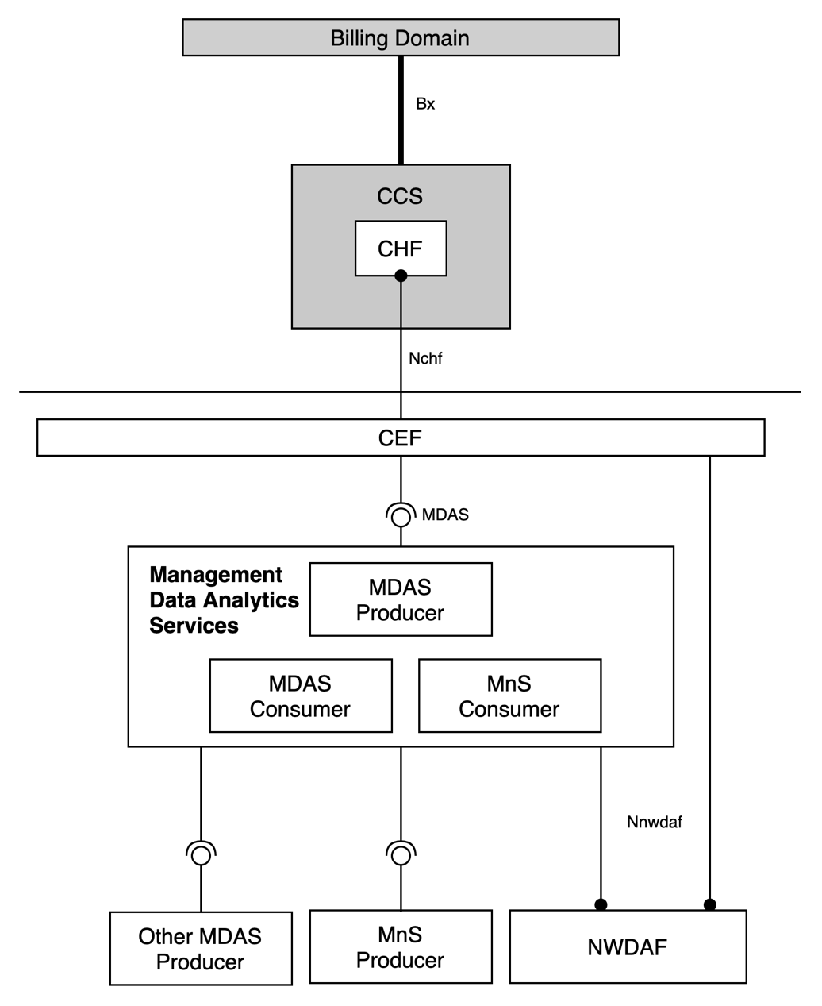
Figure 4.2.4.1: Logical ubiquitous charging architecture for management domain
This common charging architecture provides only a common logical view and the actual domain / service / subsystem specific charging architecture is specified in the respective middle tier TS.
The Network Data Analytics Function (NWDAF) is specified in TS 23.501 [215].
The MnS producer, MnS consumer, MDA and MDAS are defined in TS 28.533 [216].
The Charging Enablement Function (CEF) is defined in clause 4.3.3.3
The Charging Enablement Function (CEF) is a consumer of Nchf charging services, and for the purpose of charging information collection may consume management services, services exposed by other network functions or both.

End of changes

