3GPP TSG-SA5 Meeting #140-e S5-216276

e-meeting, 15 - 24 November 2021
CR-Form-v12.1
CHANGE REQUEST
 | 28.530 | CR | 0051 | rev | - | Current version: | 17.1.0
For HELP on using this form: comprehensive instructions can be found at
http://www.3gpp.org/Change-Requests.

Proposed change affects: | UICC apps |  | ME |  | Radio Access Network | X | Core Network | X

Title: | Add description for SBMA supporting manangement of 5G SA and NSA scenarios
Source to WG: | Huawei
Source to TSG: | S5
Work item code: | NSA_SBMA |  |  |  |  |  | Date: |  |  | 2021-11-04
Category: | B |  |  |  |  |  | Release: |  |  | Rel-17
 | Use one of the following categories:  F (correction)  A (mirror corresponding to a change in an earlier release)  B (addition of feature),  C (functional modification of feature)  D (editorial modification)  Detailed explanations of the above categories can  be found in 3GPP TR 21.900. |  |  |  |  |  |  |  | Use one of the following releases:  Rel-8 (Release 8)  Rel-9 (Release 9)  Rel-10 (Release 10)  Rel-11 (Release 11)  …  Rel-15 (Release 15)  Rel-16 (Release 16)  Rel-17 (Release 17)  Rel-18 (Release 18)
Reason for change: |  | Solutions to support manangement of 5G SA and NSA scenarios are concluded in TR 28.925. This document proposes to add related description for SBMA supporting manangement of 5G SA and NSA scenarios.
Summary of change: |  | Description for SBMA supporting manangement of 5G SA and NSA scenarios is added.
Consequences if not approved:
Clauses affected: |  | 2, 6.x(new), Annex <Y>(new)
 |  | Y | N
Other specs |  |  | x | Other core specifications |  |  |  | TS/TR ... CR ...
affected: |  |  | x | Test specifications |  |  |  | TS/TR ... CR ...
(show related CRs) |  |  | x | O&M Specifications |  |  |  | TS/TR ... CR ...
Other comments:
This CR's revision history:

1st Change

2 References
The following documents contain provisions which, through reference in this text, constitute provisions of the present document.
- References are either specific (identified by date of publication, edition number, version number, etc.) or non-specific.
- For a specific reference, subsequent revisions do not apply.
- For a non-specific reference, the latest version applies. In the case of a reference to a 3GPP document (including a GSM document), a non-specific reference implicitly refers to the latest version of that document in the same Release as the present document.
[1] 3GPP TR 21.905: "Vocabulary for 3GPP Specifications".
[2] 3GPP TS 22.261 "Service requirements for next generation new services and markets".
[3] 3GPP TS 23.501: " System Architecture for the 5G system".
[4] 3GPP TS 38.401 "NG-RAN; Architecture description".
[5] 3GPP TS 28.531: "Management and orchestration; Provisioning".
[6] 3GPP TS 28.541: "Management and orchestration ; 5G Network Resource Model (NRM); Stage 2 and stage3".
[x] 3GPP TS 28.533: "Management and orchestration; Architecture framework".
[y] 3GPP TS 32.101: "Telecommunication management; Principles and high level requirements".
[z] 3GPP TS 38.300: "NR; NR and NG-RAN Overall Description; Stage 2".
[w] 3GPP TS 37.340: "Evolved Universal Terrestrial Radio Access (E-UTRA) and NR; Multi-connectivity; Stage 2".

2nd Change

6.x SBMA supporting manangement of 5G SA and NSA scenarios
The management of 5G SA and NSA could be classified to the following two management options.
Option#A (interface IRP and NRM IRP are used for management of legacy nodes)

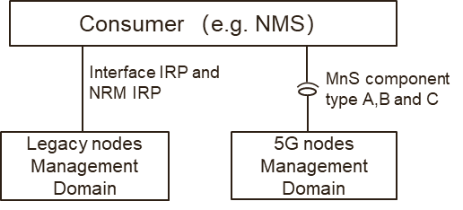
Figure 6.x-1: Management Option A for 5G SA and NSA management
NOTE: The consumer behaves as IRPManager in IPR management mechanism of LTE and MnS consumer in service-based management mechanism of 5G.

In option A,
- The legacy nodes (e.g. eNB, ng-eNB and EPC) management domain provides IRP (including interface IRP and NRM IRP) for the management of legacy nodes.
- The 5G nodes (e.g. gNB, en-gNB and 5GC) provides MnS (including MnS component type A, B and C) for the management of 5G nodes.
Option#B (MnS is used for management of legacy nodes)

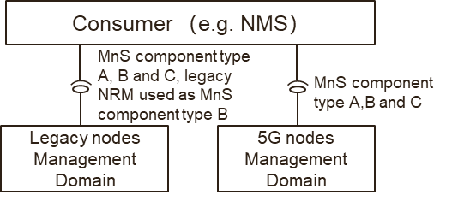
Figure 6.x-2: Management Option B for 5G SA and NSA management
NOTE: The consumer behaves as IRPManager in IPR management mechanism of LTE and MnS consumer in service-based management mechanism of 5G.
In option B,
- The legacy nodes (e.g. eNB, ng-eNB and EPC) management domain provides MnS (including MnS component type A, B and C) for the management of legacy node. In this case, legacy node NRM used as MnS component type B, which means the YAML/YANG solution set for legacy node NRM needs to be provided.

- The 5G nodes (e.g. gNB, en-gNB and 5GC) provides MnS (including MnS component type A, B and C) for the management of 5G nodes.

3rd Change

Annex <Y> (informative) : SBMA supporting manangement of 5G SA and NSA scenarios

Y.1 Analysis of the existing specification capabilities
Service based management architecture (SBMA) and corresponding MnS are introduced in 5G management architecture in TS 28.533[x], and a different management reference model (i.e. IRP) had been used to manage the network before 5G era in 3GPP TS 32.101[y].
The analysis is based on the following understanding of the existing specification capabilities:
- The management mechanism of LTE supports interface IRP and NRM IRP models.
- The management mechanism of 5G supports MnS which includes MnS component A (Operation/Notification), MnS component B (NRM models) and MnS component C (Alarm/Performance information).
- LTE NRM (with enhancement of YAML or YANG solution set) can be used as MnS component type B and work together with MnS component type A.

Y.2 Management support for NG-RAN Overall Architecture
As description in 3GPP TS 38.300 [z], an NG-RAN node is either a gNB or an ng-eNB which are interconnected with each other by means of the Xn interface and connected with 5GC by means of the NG interface, more specifically to the AMF by means of the NG-C interface and to the UPF by means of the NG-U interface. The NG-RAN architecture is introduced in 3GPP TS 38.300 [z], as follows.
Figure Y.2-1: NG-RAN Overall Architecture
NOTE: The ng-eNB node provides E-UTRA user plane and control plane protocol terminations towards the UE, and connects via the NG interface to the 5GC.
In order to provide management support for NG-RAN, the 3GPP management system needs to support the management for gNB, ng-eNB and 5GC. There are potential 2 management options to support, as follows.
NG-RAN management Option#1
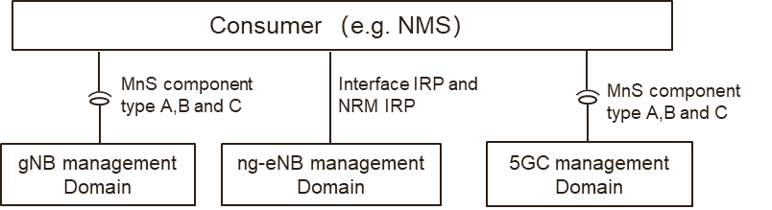
Figure Y.2-2: NG-RAN management Option#1
NOTE: The consumer behaves as IRPManager in IPR management mechanism of LTE and MnS consumer in service-based management mechanism of 5G.
In the NG-RAN management Option#1:
- The gNB management domain provides MnS (including MnS component type A, B and C) for the management of gNB.
- The ng-eNB management domain provides IRP (including interface IRP and NRM IRP) for the management of ng-eNB.
- The 5GC management domain provides MnS (including MnS component type A, B and C) for the management of 5GC.

NG-RAN management Option#2
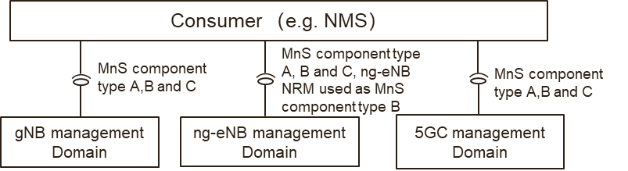
Figure Y.2-3: NG-RAN management Option#2
NOTE: The consumer behaves as IRPManager in IPR management mechanism of LTE and MnS consumer in service-based management mechanism of 5G.
In the NG-RAN management Option#2:
- The gNB management domain provides MnS(including MnS component type A, B and C) for the management of gNB
- The ng-eNB management domain provides MnS ((including MnS component type A, B and C) for the management of ng-eNB. In this case, ng-eNB NRM used as MnS component type B, which means the YAML/YANG solution set for ng-eNB needs to be provided.
- The 5GC management domain provides MnS (including MnS component type A, B and C) for the management of 5GC.

Y.3 Management support for EN-DC Overall Architecture
NG-RAN supports Multi-Radio Dual Connectivity (MR-DC) operation whereby a UE in RRC_CONNECTED is connected to two different nodes, one providing NR access and the other one providing either E-UTRA or NR access. One node acts as the MN and the other as the SN. The MN and SN are connected via a network interface and at least the MN is connected to the core network (e.g. EPC).
The following figure illustrates the MR-DC with EPC (i.e. EN-DC) architecture in TS 37.340 [w].
Figure Y.3-1: EN-DC Overall Architecture
NOTE: the en-gNB node provides NR user plane and control plane protocol terminations towards the UE, and acts as Secondary Node in EN-DC.
In order to provide management support for EN-DC, 3GPP management system needs to provide the management for en-gNB, eNB and EPC. There are also potential 2 management options to support, as follows.
EN-DC management Option#1
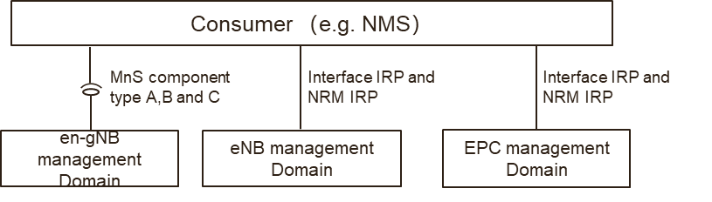
Figure Y.3-2: EN-DC management option#1
NOTE: The consumer behaves as IRPManager in IPR management mechanism of LTE and MnS consumer in service-based management mechanism of 5G.
In EN-DC management option#1,
- The en-gNB management domain provides MnS (including component type A, B and C) for management of en-gNB.
- The eNB management domain provides IRP (including interface IRP and NRM IRP) for the management of eNB.
- The EPC management domain provides IRP (including interface IRP and NRM IRP) for the management of EPC.
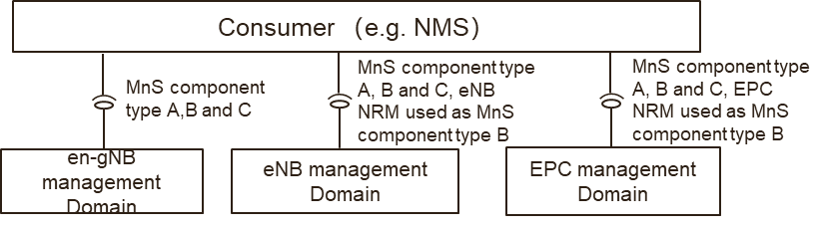
Figure Y.3-3: EN-DC management Option#2
NOTE: The consumer behaves as IRPManager in IPR management mechanism of LTE and MnS consumer in service-based management mechanism of 5G.

EN-DC management Option#2
In EN-DC management option#2,
- The en-gNB management domain provides MnS (including component type A, B and C) for management of en-gNB.
- The eNB management domain provides MnS (including component type A, B and C) for management of eNB. In this case, eNB NRM used as MnS component type B, which means the YAML/YANG solution set for eNB NRM needs to be provided.
- The EPC management domain provides MnS (including component type A, B and C) for management of EPC. In this case, EPC NRM used as MnS component type B, which means the YAML/YANG solution set for EPC NRM needs to be provided

End of Changes

