3GPP TSG-SA5 Meeting #140-e S5-216213

e-meeting, 15 - 24 November 2021
CR-Form-v12.1
CHANGE REQUEST
 | 28.662 | CR | 0012 | rev | 1 | Current version: | 15.3.0
For HELP on using this form: comprehensive instructions can be found at
http://www.3gpp.org/Change-Requests.

Proposed change affects: | UICC apps |  | ME |  | Radio Access Network | X | Core Network

Title: | Rel-15 CR TS 28.658 Update Generic RAN NRM to be applicable for SBMA
Source to WG: | Huawei
Source to TSG: | S5
Work item code: | NETSLICE-5GNRM |  |  |  |  |  | Date: |  |  | 2021-11-4
Category: | F |  |  |  |  |  | Release: |  |  | Rel-15
 | Use one of the following categories:  F (correction)  A (mirror corresponding to a change in an earlier release)  B (addition of feature),  C (functional modification of feature)  D (editorial modification)  Detailed explanations of the above categories can  be found in 3GPP TR 21.900. |  |  |  |  |  |  |  | Use one of the following releases:  Rel-8 (Release 8)  Rel-9 (Release 9)  Rel-10 (Release 10)  Rel-11 (Release 11)  …  Rel-15 (Release 15)  Rel-16 (Release 16)  Rel-17 (Release 17)  Rel-18 (Release 18)
Reason for change: |  | The current description in scope and several contents limit the Generic RAN NRM,making it only applicable for the deployments using IRP framework. However, the Generic RAN NRM should also be applicable for deployments using SBMA.
Summary of change: |  | Update the Scope and several content to be applicable for deployments using SBMA.
Consequences if not approved: |  | The specification is not applicable for deployments using SBMA
Clauses affected: |  | 1, 2 ,4.2.1,4.5.1,4.5.2
 |  | Y | N
Other specs |  |  | X | Other core specifications |  |  |  | TS/TR ... CR ...
affected: |  |  | X | Test specifications |  |  |  | TS/TR ... CR ...
(show related CRs) |  |  | X | O&M Specifications |  |  |  | TS/TR ... CR ...
Other comments:
This CR's revision history:

1st Change

1 Scope
The present document specifies the Generic Radio Access Network (RAN) network resource model (NRM) that can be communicated between an IRPAgent and an IRPManager in the deployment scenarios using IRP framework as defined in TS 32.102 [3], or between an MnS consumer and MnS producer in deployment scenarios using the Service Based Management Architecture (SBMA) as defined in TS 28.533 [X], for telecommunication network management purposes, including management of converged networks.
This document specifies the semantics and behaviour of information object class attributes and relations visible across the reference point in a protocol and technology neutral way. It does not define their syntax and encoding.
In order to access the information defined by this NRM, an Interface IRP such as the "Basic CM IRP"(3GPP TS 32.602 [5] and TS 32.606 [Z]) or an MnS such as "Generic Provisioning MnS" (3GPP TS 28.532 [Y]) is needed. However, which Interface IRP is applicable is outside the scope of the present document.
2nd Change

2 References
The following documents contain provisions which, through reference in this text, constitute provisions of the present document.
- References are either specific (identified by date of publication, edition number, version number, etc.) or non-specific.
- For a specific reference, subsequent revisions do not apply.
- For a non-specific reference, the latest version applies. In the case of a reference to a 3GPP document (including a GSM document), a non-specific reference implicitly refers to the latest version of that document in the same Release as the present document.
[1] 3GPP TR 21.905: "Vocabulary for 3GPP Specifications".
[2] 3GPP TS 32.101: "Telecommunication management; Principles and high level requirements".
[3] 3GPP TS 32.102: "Telecommunication management; Architecture".
[4] 3GPP TS 32.150: "Telecommunication management; Integration Reference Point (IRP) Concept and definitions".
[5] 3GPP TS 32.602: "Telecommunication management; Configuration Management (CM); Basic CM Integration Reference Point (IRP) ; Information Service (IS)".
[6] Void.
[7] 3GPP TS 36.104: "Evolved Universal Terrestrial Radio Access (E_UTRA); Base Station (BS) radio transmission and reception".
[8] Void.
[9] Void.
[10] 3GPP TS 28.661: "Telecommunication management; Generic Radio Access Network (RAN) Network Resource Model (NRM) Integration Reference Point (IRP); Requirements".
[11] 3GPP TS 32.111-2: "Telecommunication management; Fault Management; Part 2: Alarm Integration Reference Point (IRP): Information Service (IS)".
[12] 3GPP TS 28.652: "Telecommunication management; Universal Terrestrial Radio Access Network (UTRAN) Network Resource Model (NRM) Integration Reference Point (IRP); Information Service (IS) ".
[13] 3GPP TS 28.658: "Telecommunication management; Evolved Universal Terrestrial Radio Access Network (E-UTRAN) Network Resource Model (NRM) Integration Reference Point (IRP); Information Service (IS)".
[14] 3GPP TS 28.655:"Telecommunication management; GSM/EDGE Radio Access Network (GERAN) Network Resource Model (NRM) Integration Reference Point (IRP); Information Service (IS)".
[15] 3GPP TS 28.622: "Telecommunication management; Generic Network Resource Model (NRM) Integration Reference Point (IRP); Information Service (IS)".
[16] 3GPP TS 32.302: "Telecommunication management; Configuration Management (CM); Notification Integration Reference Point (IRP): Information Service (IS)".
[17] 3GPP TS 32.662: "Telecommunication management; Configuration Management (CM); Kernel CM Information Service (IS)".
[18] 3GPP TS 25.106: "Technical Specification Group Radio Access Network; UTRA repeater radio transmission and reception".
[19] 3GPP TS 45.005: "Radio transmission and reception".
[20] 3GPP TS 45.010: "Radio subsystem synchronization".
[21] 3GPP TS 25.104: "Base Station (BS) radio transmission and reception (FDD)".
[22] 3GPP TS 25.105: "Base Station (BS) radio transmission and reception (TDD)".
[23] 3GPP TS 38.104: "NR; Base Station (BS) radio transmission and reception".
[24] 3GPP TS 28.541: "NR and NG-RAN Network Resource Model (NRM) stage 2 and stage 3".
[25] 3GPP TS 28.652: "UTRAN Network Resource Model (NRM) Integration Reference Point (IRP): Information Service (IS)".
[26] 3GPP TS 37.466: "Iuant Interface: Application Part".
[X] 3GPP TS 28.533: "Management and orchestration; Architecture framework".
[Y] 3GPP TS 28.532: "Management and orchestration; Generic management services".
[Z] 3GPP TS 32.606: "Telecommunication management; Configuration Management (CM); Basic CM Integration Reference Point (IRP); Solution Set (SS) definitions".

3rd Change

4.2.1 Relationships
This subclause depicts the set of classes (e.g. IOCs) that encapsulates the information relevant for this IRP or MnS. This subclause provides the overview of the relationships of relevant classes in UML. Subsequent subclauses provide more detailed specification of various aspects of these classes.
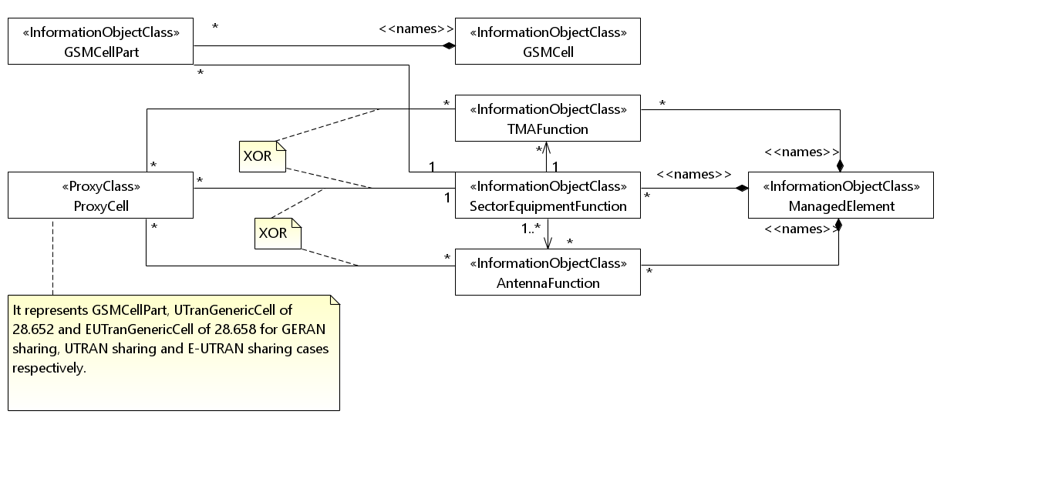
Figure 4.2.1.1: UTRAN/E-UTRAN/NR/GERAN sharing (1/2)
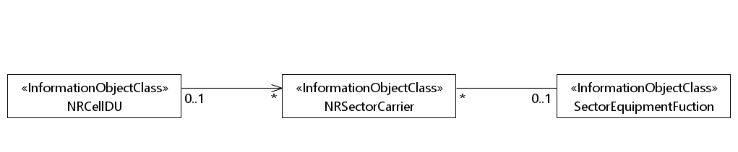

Figure 4.2.1.2: UTRAN/E-UTRAN/NR/GERAN sharing (2/2)
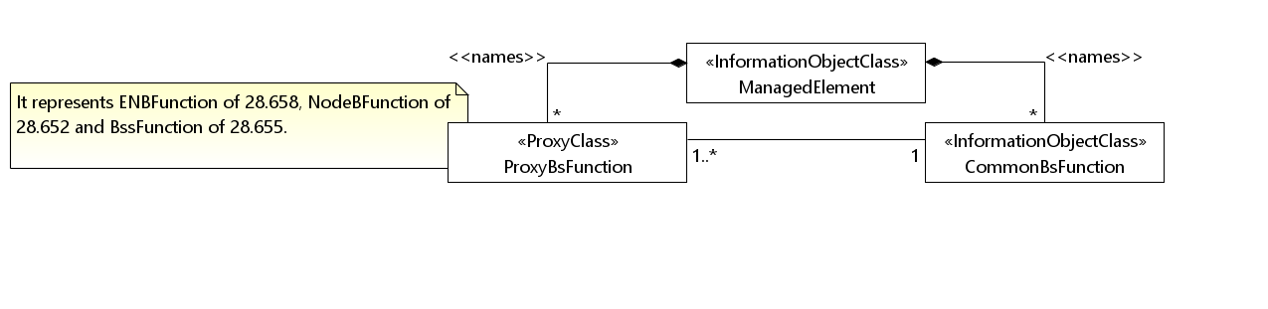
Figure 4.2.1.3: CommonBsFunction NRM fragment

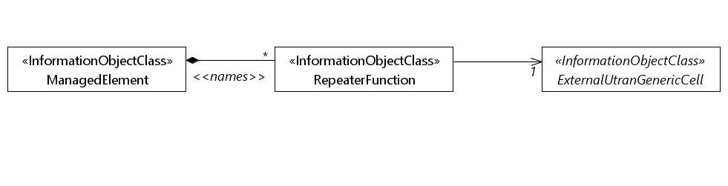
Figure 4.2.1.4: RepeaterFunction NRM fragment
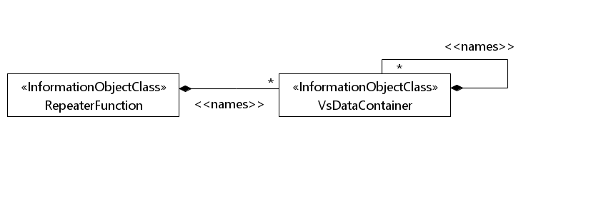
Figure 4.2.1.5: RepeaterFunction related VsDataContainer Containment/Naming and Association diagram

4th Change

4.5 Common Notifications

4.5.1 Alarm notifications

4.5.1.1 Alarm notifications used in deployments using IRP framework
This subclause presents a list of notifications, defined in 3GPP TS 32.111-2 [11], that IRPManager can receive. The notification header attribute objectClass/objectInstance, defined in 3GPP TS 32.302 [16], would capture the DN of an instance of an IOC defined in this IRP specification.
Name | Qualifier | Notes
notifyAckStateChanged | See Alarm IRP (3GPP TS 32.111-2 [11])
notifyChangedAlarm | See Alarm IRP (3GPP TS 32.111-2 [11])
notifyClearedAlarm | See Alarm IRP (3GPP TS 32.111-2 [11])
notifyNewAlarm | See Alarm IRP (3GPP TS 32.111-2 [11])
notifyComments | See Alarm IRP (3GPP TS 32.111-2 [11])
notifyAlarmListRebuilt | See Alarm IRP (3GPP TS 32.111-2 [11])
notifyPotentialFaultyAlarmList | See Alarm IRP (3GPP TS 32.111-2 [11])

4.5.1.2 Alarm notifications used in deployments using SBMA
This clause presents a list of notifications, defined in TS 28.532 [Y], that an MnS consumer may receive. The notification header attribute objectClass/objectInstance shall capture the DN of an instance of a class defined in the present document.
Name | Qualifier | Notes
notifyNewAlarm | M | --
notifyClearedAlarm | M | --
notifyAckStateChanged | M | --
notifyAlarmListRebuilt | M | --
notifyChangedAlarm | O | --
notifyCorrelatedNotificationChanged | O | --
notifyChangedAlarmGeneral | O | --
notifyComments | O | --
notifyPotentialFaultyAlarmList | O | --

4.5.2 Configuration notifications

4.5.2.1 Configuration notifications used in deployments using IRP framework
This subclause presents a list of notifications, defined in 3GPP TS 32.662 [17], that IRPManager can receive. The notification header attribute objectClass/objectInstance, defined in 3GPP TS 32.302[16], would capture the DN of an instance of an IOC defined in this IRP specification.
Name | Qualifier | Notes
notifyAttributeValueChange | O
notifyObjectCreation | O
notifyObjectDeletion | O

4.5.2.2 Configuration notifications used in deployments using SBMA
This clause presents a list of notifications, defined in TS 28.532 [Y], that an MnS consumer may receive. The notification header attribute objectClass/objectInstance shall capture the DN of an instance of a class defined in the present document.

Name | Qualifier | Notes
notifyMOICreation | O | --
notifyMOIDeletion | O | --
notifyMOIAttributeValueChanges | O | --
notifyEvent | O | --

End of Change

