3GPP TSG-SA5 Meeting #140-e S5-216169rev1

e-meeting, 15 - 24 November 2021
CR-Form-v12.1
CHANGE REQUEST
 | 28.531 | CR | 0097 | rev | - | Current version: | 17.1.0
For HELP on using this form: comprehensive instructions can be found at
http://www.3gpp.org/Change-Requests.

Proposed change affects: | UICC apps |  | ME |  | Radio Access Network | x | Core Network | x

Title: | Update NSI and NSSi allocation procedures
Source to WG: | Huawei
Source to TSG: | S5
Work item code: | eMEMTANE |  |  |  |  |  | Date: |  |  | 2021-11-05
Category: | B |  |  |  |  |  | Release: |  |  | Rel-17
 | Use one of the following categories:  F (correction)  A (mirror corresponding to a change in an earlier release)  B (addition of feature),  C (functional modification of feature)  D (editorial modification)  Detailed explanations of the above categories can  be found in 3GPP TR 21.900. |  |  |  |  |  |  |  | Use one of the following releases:  Rel-8 (Release 8)  Rel-9 (Release 9)  Rel-10 (Release 10)  Rel-11 (Release 11)  …  Rel-15 (Release 15)  Rel-16 (Release 16)  Rel-17 (Release 17)  Rel-18 (Release 18)
Reason for change: |  | The discussion (S5-215264) is endorsed, that provides a problem statement during NSI and NSSI allocation.  The proposals in S5-215264 conclude to update NSI and NSSI allocation procedure, to address the problem raised.
Summary of change: |  | - Creating a network slice  The NS MnS provider creates a NSI with non-shared resource, based on the attributes included in service profile, e.g., sliceProfile.resourceSharingLevel, tenantProfile.  - Allocate a network slice to existing NSI  The NS MnS provider is capable to allocate a new network slice to an existing NSI that satisfies the requirements described in service profile, e.g., serviceProfile.resourceSharingLevel, tenantProfile.
Consequences if not approved: |  | The problem exists, “that In this case, the sharing level for network slice is not efficient to describe the tenant requirements to allocate network slice to a non-shared virtual resource to other tenants, especially when network slice management function is to allocate a network slice based on the serviceprofile attributes and network slice profile attributes”, as described in S5-215264.
Clauses affected: |  | 7.2, 7.3
 |  | Y | N
Other specs |  |  |  | Other core specifications |  |  |  | TS/TR ... CR ...
affected: |  |  |  | Test specifications |  |  |  | TS/TR ... CR ...
(show related CRs) |  |  |  | O&M Specifications |  |  |  | TS/TR ... CR ...
Other comments:
This CR's revision history:

1st modified section

7.2 Procedure of Network Slice Instance Allocation
The Figure 7.2-1 illustrates the procedure of creating a new NSI or using an existing NSI to satisfy the required network slice related requirements.
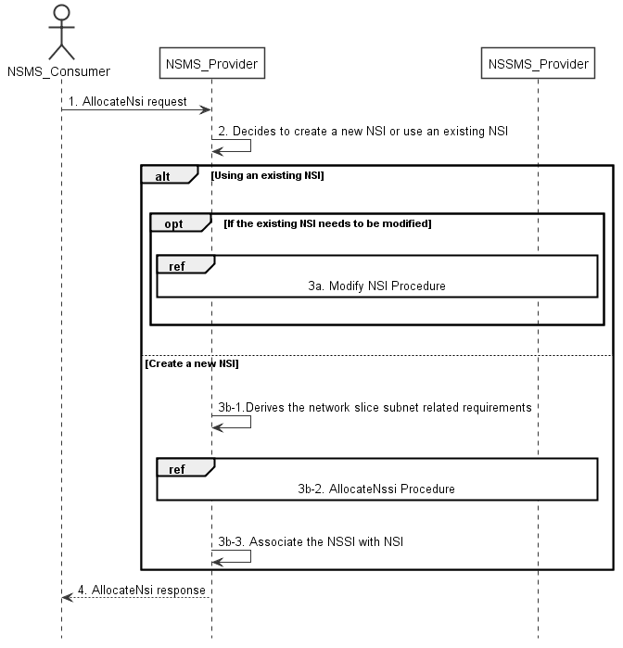
Figure 7.2-1: Network Slice Instance Allocation Request procedure
1) Network Slice Management Service Provider (NSMS_Provider) receives an AllocateNsi request (see AllocateNsi operation defined in clause 6.5.1) from Network Slice Management Service Consumer (NSMS_Consumer) with network slice related requirements (the network slice related requirements are defined as the attributes in the ServiceProfile see clause 6.3.3 in TS 28.541 [6]).
2) Based on the network slice related requiremen and the knowledge of the capabilities of existing deployed network slices, the NSMS_Provider compare/match the provided requirements against all the candidate NetworkSlice instances, and then decides whether to use an existing NSI or create a new NSI. If the network slice related requirements allow the requested NSI to be shared and if an existing suitable NSI can be reused, the NSMS_Provider may decide to use the existing NSI. In addition to requirments for sharing or non-sharing level for NSI, the sharing or non-sharing level resource requirements described for a tenant may be also used for NSMS_Provider to decide to use the existing NSI or create a new NSI.
3a) If using an existing NSI and the existing NSI needs to be modified to satisfy the network slice related requirements, the NSMS_Provider invokes the procedure to modify the existing NSI as described in clause 7.6.
3b-1) If creating a new NSI, the NSMS_Provider derives the network slice subnet related requirements from the received network slice related requirements. Before NSMS_Provider derives the network slice subnet related requirements, NSMS_Provider may invoke corresponding network slice subnet capability information querying procedure as described in clause 7.8.
3b-2) The NSMS_Provider invokes the NSSI allocation procedure as described in clause 7.3.
3b-3) The NSMS_Provider creates the MOI for NSI and configures the MOI with the DN of MOI for the NSSI, other configuration information may be configured for the created MOI.
Note: The detailed configuration information is described in network slice NRM (see NetworkSlice IOC defined in clause 6.3.1 in TS 28.541 [6]).
4) The NSMS_Provider sends NSI allocation result (see AllocateNsi operation defined in clause 6.5.1) to the NSMS_Consumer. If an existing NSI is modified or a new NSI is created successfully to satisfy the network slice related requirements, the result includes the relevant network slice instance information (see NetworkSlice IOC defined in clause 6.3.1 in TS 28.541 [6]):
- DN of the MOI for NSI.
Otherwise the result may include the reason of failure, for example, the required latency or user number cannot be satisfied, or the physical resource is not enough.

7.3 Procedure of Network Slice Subnet Instance Allocation
The Figure 7.3-1 illustrates the procedure of creating a new network slice subnet instance or using an existing network slice subnet instance to satisfy the required network slice subnet related requirements.
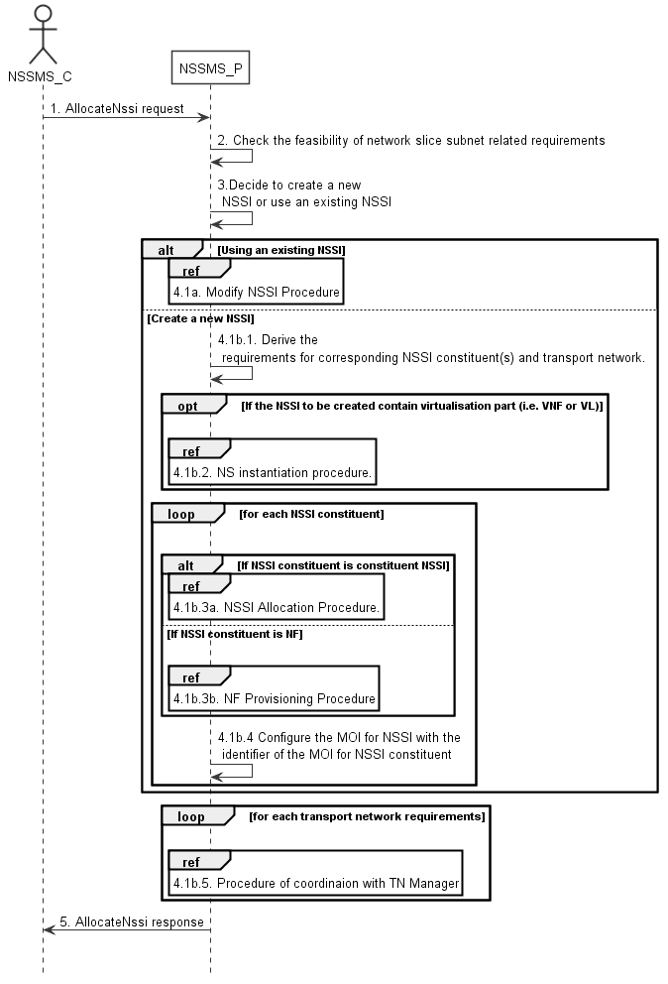
Figure 7.3-1: Network Slice Subnet Instance Allocation Request procedure
1) Network Slice Subnet Management Service Provider (NSSMS_P) receives an AllocateNssi request (see AllocateNssi operation defined in clause 6.5.2) from Network Slice Subnet Management Service Consumer (NSSMS_C) with network slice subnet related requirements (network slice subnet related requirements defined in SliceProfile see clause 6.3.4 in TS 28.541 [6]).
2) NSSMS_P check the feasibility of network slice subnet related requirements. If the network slice subnet related requirements can be satisfied, the following step 3) are needed, else go to step 5).
3) Based on the network slice subnet related requirements and the existing NSSI capabilities, NSSMS_P decides whether to use an existing NSSI or create a new NSSI. If the network slice subnet related requirements allow the requested NSSI to be shared and if an existing suitable NSSI can be reused, the NSSMS_P decides to use the existing NSSI. In addition to requirments for sharing or non-sharing level for NSSI, the sharing or non-sharing level resource requirements described for a tenant may be also used for NSSMS_Provider to decide to use the existing NSSI or create a new NSSI.
4.1a) If using an existing NSSI and the existing NSSI needs to be modified to satisfy the network slice subnet related requirements, the NSSMS_P invokes the procedure to modify the existing NSSI as described in clause 7.7.
4.1b.1) If creating a new NSSI, the NSSMS_P creates the MOI for the NSSI to be created. NSSMS_P derives the corresponding network slice subnet constituent (i.e. NF, constituent NSS) related requirements and transport network related requirements (e.g. 3GPP endpoint information, latency requirements, bandwidth requirements and isolation requirements) from the received network slice subnet related requirements. Part of these requirements may be referenced by attribute "epTransportRef" as defined in clause 6.3.2.2 in TS 28.541[6]. Before NSSMS_Provider derives the constituent network slice subnet related requirements, NSMS_Provider may invoke corresponding network slice subnet capability information querying procedure as described in clause 7.8.2.
4.1b.2) If the NSSI to be created contains virtualisation part (i.e. VNF or VL), NSSMS_P derives the NS instance instantiation information (the NS instance instantiation information is described in clause 7.3.2.2 and clause 7.3.3.2 [3]) based on network slice subnet related requirements. NSSMS_P determines VNF instance(s) that need to be deployed according to the necessary network function(s) and then derives the profile of virtual link(s) according to the connection requirements between the network functions. NSSMS_P chooses a proper NSD deployment flavour and creates data concerning the SAPs of the NS instance. NSSMS_P invokes the NS instantiation procedures to create a NS instance. NSSMS_P configures the NSS MOI with the NS instance identifier.
Note: NS instantiation procedure is described in TS 28.526 [7].
4.1b.3) For each required NSSI constituent, the following step 4.1b.3a) and 4.1b.3b) are needed:
4.1b.3a) If the required NSSI constituent is constituent NSSI, NSSMS_P invokes NSSI Allocation Procedure.
4.1b.3b) If the required NSSI constituent is NF instance, NSSMS_P invokes NF Creation Procedure as described in clause 7.10 or NF Modification Procedure as described in clause 7.11.
4.1b.4) NSSMS_P configures the MOI for NSSI with the DN of the MOI for NSSI constituent (i.e. NF, constituent NSSI).
4.1b.5) For each required transport network related requirements, NSSMS_P invokes corresponding procedure of coordination with relevant TN Manager to handle the TN part as described in clause 7.9.
5) The NSSMS_P sends the NSSI allocation result (see AllocateNssi operation defined in clause 6.5.2) to the NSSMS_C. If the NSSI is created successfully, the result includes the relevant constituent network slice subnet instance information (see NetworkSliceSubnet IOC defined in clause 6.3.2 in TS 28.541 [6]):
- DN of the MOI for NSSI.
- NS instance Info (e.g. NSinstanceId)
Otherwise the result may include the reason of failure, for example, the required latency or user Number cannot be satisfied, or the physical resource is not enough.

End of change

