3GPP TSG-SA5 Meeting #140-e S5-216055rev1

e-meeting, 15 - 24 November 2021
CR-Form-v12.1
CHANGE REQUEST
 | 28.310 | CR | 0020 | rev | - | Current version: | 17.2.0
For HELP on using this form: comprehensive instructions can be found at
http://www.3gpp.org/Change-Requests.

Proposed change affects: | UICC apps |  | ME |  | Radio Access Network | X | Core Network

Title: | Update energy saving solution
Source to WG: | Huawei
Source to TSG: | S5
Work item code: | EE_5G |  |  |  |  |  | Date: |  |  | 2021-11-05
Category: | A |  |  |  |  |  | Release: |  |  | Rel-17
 | Use one of the following categories:  F (correction)  A (mirror corresponding to a change in an earlier release)  B (addition of feature),  C (functional modification of feature)  D (editorial modification)  Detailed explanations of the above categories can  be found in 3GPP TR 21.900. |  |  |  |  |  |  |  | Use one of the following releases:  Rel-8 (Release 8)  Rel-9 (Release 9)  Rel-10 (Release 10)  Rel-11 (Release 11)  …  Rel-15 (Release 15)  Rel-16 (Release 16)  Rel-17 (Release 17)  Rel-18 (Release 18)
Reason for change: |  | In existing Energy Saving solution in clause 6.2.2 of TS 28.310, the Centralized energy saving solution which describes how MnS producer of Centralized ES management makes the NR capacity booster cell enter the energySaving state, which means the Centralized ES solution scope is for NR only, therefore a clarification with the term “Domain-Centralized SON Energy Saving (ES)” which defined in TS 28.313 is needed. In the meantime, the existing Distributed energy saving solution in clause 6.2.3 of TS 28.310 which wrongly includes "Domain-Centralized ES solution" should be fixed.
Summary of change: |  | Remove "Domain-Centralized SON Energy Saving solution" from clause 6.2.3 into clause 6.2.2 of TS 28.310.
Consequences if not approved: |  | Incorrect spec may lead to wrong implementation.
Clauses affected: |  | 6.2.2.1.1, 6.2.2.1.2, new 6.2.2, 6.2.3.0, 6.2.3.1.2.2, 6.2.3.1.3.2
 |  | Y | N
Other specs |  |  | x | Other core specifications |  |  |  | TS/TR ... CR ...
affected: |  |  | x | Test specifications |  |  |  | TS/TR ... CR ...
(show related CRs) |  |  | x | O&M Specifications |  |  |  | TS/TR ... CR ...
Other comments:
This CR's revision history:

1st modified section

6.2.2 Centralized energy saving solution

6.2.2.1 Procedures

6.2.2.1.1 Energy saving activation
NOTE: The centralized energy saving solution in clause 6.2.2 is Domain-Centralized ES solution because the scope of the centralized ES solution is for NR only.
Figure 6.2.2.1.1-1 depicts a procedure that describes how MnS producer of Domain-Centralized SON ES management makes the NR capacity booster cell enter the energySaving state.
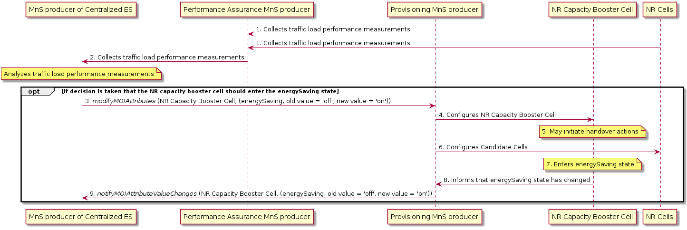
Figure 6.2.2.1.1-1: Centralized energy saving activation
It is assumed that all relevant MOIs have been created.
Energy saving activation:
The MnS producer for Domain-centralized ES collects the traffic load performance measurements from the NR capacity booster cell and candidate cells.
The MnS producer for Domain-centralized ES analyzes the traffic load performance measurements and decides that the NR capacity booster cell should enter the energySaving state.
The MnS producer for Domain-centralized ES consumes the management service for NF provisioning with modifyMOIAttributes operation to request the NR capacity booster cell to enter the energySaving state.
The NR capacity booster cell may initiate handover actions to off-load the traffic to the neighbour cells (see clause 15.4.2 in TS 38.300 [13]), prior to entering into the energySaving state, and then change to the energySaving state, leading to a notifyMOIAttributeValueChanges being sent to the MnS producer for Domain-centralized ES that the NR capacity booster cell has entered the energySaving state.

6.2.2.1.2 Energy saving deactivation
Figure 6.2.2.1.2-1 depicts a procedure that describes how MnS producer of Domain-Centralized ES management makes the NR capacity booster cell leave the energySaving state.
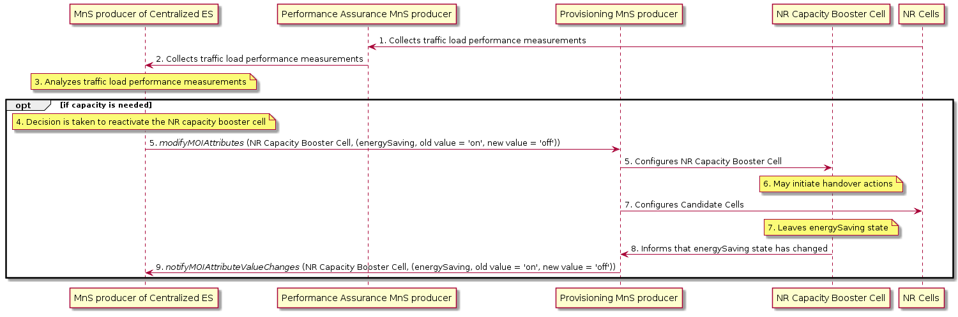
Figure 6.2.2.1.2-1: Centralized energy saving deactivation

Energy saving deactivation:
The MnS producer for Domain-centralized ES collects the traffic load performance measurements from the candidate cells.
The MnS producer for Domain-centralized ES decides to re-activate the NR capacity booster cell if it detects that the capacity is needed (see clause 15.4.2 in TS 38.300 [13]).
The MnS producer for Domain-centralized ES consumes the management service for NF provisioning with modifyMOIAttributes operation to re-activate the NR capacity booster cell, and changes to the notEnergySaving state, leading to a notifyMOIAttributeValueChanges being sent to the consumer to indicate that the NR capacity booster cell has been re-activated.

6.2.2.2 Management services

6.2.2.2.1 MnS component type A

MnS Component Type A | Note
Operations defined in clause 11.1.1 of TS 28.532 [16]:  - createMOI  - getMOIAttributes  - modifyMOIAttributes  - deleteMOI | Supported by the Provisioning MnS for NF, as defined in TS 28.531 [6].
Notifications defined in clause 11.1.1 of TS 28.532 [16]:  - notifyMOICreation  - notifyMOIAttributeValueChanges  - notifyMOIDeletion  - notifyMOIChanges | Supported by the Provisioning MnS for NF, as defined in TS 28.531 [6].

6.2.2.2.2 MnS Component Type B

6.2.2.2.2.1 Objective and targets
The objective of ES is to automatically set parameters so as to maximize NG-RAN data energy efficiency - see Table 6.2.2.1.2.1-1.
Table 6.2.2.1.2.1-1. Energy Saving targets
Targets | Definition | Legal Values
NG-RAN data Energy Efficiency | Data Volume (DV) divided by Energy Consumption (EC) of the considered network elements. | In bit/J.

6.2.2.2.2.2 Control information
The parameters in CESManagementFunction IOC, which is defined in TS 28.541 [11], are used to control the Domain-SON ES functionality.

6.2.2.2.3 MnS Component Type C

6.2.2.2.3.1 Parameters to be optimized
This is out of the scope of the present document.

6.2.2.2.3.2 Performance measurements
Performance measurements related to Domain-centralized SON ES are captured in Table 6.2.2.2.3.2-1:
Table 6.2.2.2.3.2-1. Energy saving management related performance measurements
Performance measurements | Description | Related targets
DRB.PdcpSduVolumeDL_Filter | Data Volume (amount of PDCP SDU bits) in the downlink delivered to PDCP layer – see clause 5.1.2.1.1.1 of TS 28.552 [15], per configured PLMN ID and per QoS level (mapped 5QI) and per S-NSSAI.  In case of non-split gNBs. | NG-RAN data Energy Efficiency
DRB.PdcpSduVolumeUL_Filter | Data Volume (amount of PDCP SDU bits) in the uplink delivered from PDCP layer to higher layers – see clause 5.1.2.1.2.1 of TS 28.552 [15], per configured PLMN ID and per QoS level (mapped 5QI) and per S-NSSAI.  In case of non-split gNBs. | NG-RAN data Energy Efficiency
DL Cell PDCP SDU Data Volume on X2 Interface | Data Volume (amount of PDCP SDU bits) in the downlink delivered on X2 interface in DC-scenarios – see clause 5.1.2.1.1.2 of TS 28.552 [15], per PLMN ID and per QoS level (mapped 5QI or QCI in NR option 3).  In case of non-split gNBs. | NG-RAN data Energy Efficiency
DL Cell PDCP SDU Data Volume on Xn Interface | Data Volume (amount of PDCP SDU bits) in the downlink delivered on Xn interface in DC-scenarios scenarios – see clause 5.1.2.1.1.3 of TS 28.552 [15], per PLMN ID and per QoS level (mapped 5QI) and per S-NSSAI.  In case of non-split gNBs. | NG-RAN data Energy Efficiency
UL Cell PDCP SDU Data Volume on X2 Interface | Data Volume (amount of PDCP SDU bits) in the uplink delivered on X2 interface in NSA scenarios – see clause 5.1.2.1.2.2 of TS 28.552 [15], per PLMN ID and per QoS level (mapped 5QI or QCI in NR option 3).  In case of non-split gNBs. | NG-RAN data Energy Efficiency
UL Cell PDCP SDU Data Volume on Xn Interface | Data Volume (amount of PDCP SDU bits) in the uplink delivered on Xn interface in SA scenarios – see clause 5.1.2.1.2.3 of TS 28.552 [15], per PLMN ID and per QoS level (mapped 5QI) and per S-NSSAI.  In case of non-split gNBs. | NG-RAN data Energy Efficiency
DRB.F1uPdcpSduVolumeDL_Filter | Data Volume (amount of PDCP SDU bits) in the downlink delivered from GNB-CU-UP to GNB-DU (F1-U interface) – see clause 5.1.3.6.2.3 of TS 28.552 [15], per PLMN ID and per QoS level (mapped 5QI) and per S-NSSAI. In case of split gNBs | NG-RAN data Energy Efficiency
DRB.XnuPdcpSduVolumeDL_Filter | Data Volume (amount of PDCP SDU bits) in the downlink delivered from GNB-CU-UP to external gNB-CU-UP (Xn-U interface) – see clause 5.1.3.6.2.3 of TS 28.552 [15], per PLMN ID and per QoS level (mapped 5QI) and per S-NSSAI. In case of split gNBs | NG-RAN data Energy Efficiency
DRB.X2uPdcpSduVolumeDL_Filter | Data Volume (amount of PDCP SDU bits) in the downlink delivered from GNB-CU-UP to external eNB (X2-U interface) – see clause 5.1.3.6.2.3 of TS 28.552 [15], per PLMN ID and per QoS level (mapped 5QI). In case of split gNBs. | NG-RAN data Energy Efficiency
DRB.F1uPdcpSduVolumeUL_Filter | Data Volume (amount of PDCP SDU bits) in the uplink delivered to GNB-CU-UP from GNB-DU (F1-U interface) – see clause 5.1.3.6.2.4 of TS 28.552 [15], per PLMN ID and per QoS level (mapped 5QI) and per S-NSSAI. In case of split gNBs | NG-RAN data Energy Efficiency
DRB.XnuPdcpSduVolumeUL_Filter | Data Volume (amount of PDCP SDU bits) in the uplink delivered to GNB-CU-UP from external gNB-CU-UP (Xn-U interface) – see clause 5.1.3.6.2.4 of TS 28.552 [15], per PLMN ID and per QoS level (mapped 5QI) and per S-NSSAI. In case of split gNBs | NG-RAN data Energy Efficiency
DRB.X2uPdcpSduVolumeUL_Filter | Data Volume (amount of PDCP SDU bits) in the uplink delivered to GNB-CU-UP from external eNB (X2-U interface) – see clause 5.1.3.6.2.4 of TS 28.552 [15], per PLMN ID and per QoS level (mapped 5QI). In case of split gNBs. | NG-RAN data Energy Efficiency
PNF Energy consumption | Energy consumed – see clause 5.1.1.19.3 of TS 28.552 [15] | NG-RAN data Energy Efficiency

6.2.3 Distributed energy saving solution

6.2.3.0 Management service components used for Distributed SON ES solution
The MnS components used for Distributed SON ES solution are listed in the following clauses 6.2.3.1.1, 6.2.3.1.2 and 6.2.3.1.3.

6.2.3.1 Management services

6.2.3.1.1 MnS component type A

MnS Component Type A | Note
Operations defined in clause 11.1.1 of TS 28.532 [16]:  - createMOI  - getMOIAttributes  - modifyMOIAttributes  - deleteMOI | Supported by the Provisioning MnS for NF, as defined in TS 28.531 [6].
Notifications defined in clause 11.1.1 of TS 28.532 [16]:  - notifyMOICreation  - notifyMOIAttributeValueChanges  - notifyMOIDeletion  - notifyMOIChanges | Supported by the Provisioning MnS for NF, as defined in TS 28.531 [6].

6.2.3.1.2 MnS Component Type B

6.2.3.1.2.1 Objective and targets
The objective of ES is to automatically set parameters so as to maximize NG-RAN data energy efficiency - see Table 6.2.3.1.2.1-1.
Table 6.2.3.1.2.1-1. Energy Saving targets
Targets | Definition | Legal Values
NG-RAN data Energy Efficiency | Data Volume (DV) divided by Energy Consumption (EC) of the considered network elements. | In bit/J.

6.2.3.1.2.2 Control information
The parameters in DESManagementFunction IOC, which is defined in TS 28.541 [11], are used to control the Distributed SON ES functionality.

6.2.3.1.3 MnS Component Type C

6.2.3.1.3.1 Parameters to be optimized
This is out of the scope of the present document.

6.2.3.1.3.2 Performance measurements
Performance measurements related to Distributed SON ES are captured in Table 6.2.3.1.3.2-1:
Table 6.2.3.1.3.2-1. Energy saving management related performance measurements
Performance measurements | Description | Related targets
DRB.PdcpSduVolumeDL_Filter | Data Volume (amount of PDCP SDU bits) in the downlink delivered to PDCP layer – see clause 5.1.2.1.1.1 of TS 28.552 [15], per configured PLMN ID and per QoS level (mapped 5QI) and per S-NSSAI.  In case of non-split gNBs. | NG-RAN data Energy Efficiency
DRB.PdcpSduVolumeUL_Filter | Data Volume (amount of PDCP SDU bits) in the uplink delivered from PDCP layer to higher layers – see clause 5.1.2.1.2.1 of TS 28.552 [15], per configured PLMN ID and per QoS level (mapped 5QI) and per S-NSSAI.  In case of non-split gNBs. | NG-RAN data Energy Efficiency
DL Cell PDCP SDU Data Volume on X2 Interface | Data Volume (amount of PDCP SDU bits) in the downlink delivered on X2 interface in DC-scenarios – see clause 5.1.2.1.1.2 of TS 28.552 [15], per PLMN ID and per QoS level (mapped 5QI or QCI in NR option 3).  In case of non-split gNBs. | NG-RAN data Energy Efficiency
DL Cell PDCP SDU Data Volume on Xn Interface | Data Volume (amount of PDCP SDU bits) in the downlink delivered on Xn interface in DC-scenarios scenarios – see clause 5.1.2.1.1.3 of TS 28.552 [15], per PLMN ID and per QoS level (mapped 5QI) and per S-NSSAI.  In case of non-split gNBs. | NG-RAN data Energy Efficiency
UL Cell PDCP SDU Data Volume on X2 Interface | Data Volume (amount of PDCP SDU bits) in the uplink delivered on X2 interface in NSA scenarios – see clause 5.1.2.1.2.2 of TS 28.552 [15], per PLMN ID and per QoS level (mapped 5QI or QCI in NR option 3).  In case of non-split gNBs. | NG-RAN data Energy Efficiency
UL Cell PDCP SDU Data Volume on Xn Interface | Data Volume (amount of PDCP SDU bits) in the uplink delivered on Xn interface in SA scenarios – see clause 5.1.2.1.2.3 of TS 28.552 [15], per PLMN ID and per QoS level (mapped 5QI) and per S-NSSAI.  In case of non-split gNBs. | NG-RAN data Energy Efficiency
DRB.F1uPdcpSduVolumeDL_Filter | Data Volume (amount of PDCP SDU bits) in the downlink delivered from GNB-CU-UP to GNB-DU (F1-U interface) – see clause 5.1.3.6.2.3 of TS 28.552 [15], per PLMN ID and per QoS level (mapped 5QI) and per S-NSSAI. In case of split gNBs | NG-RAN data Energy Efficiency
DRB.XnuPdcpSduVolumeDL_Filter | Data Volume (amount of PDCP SDU bits) in the downlink delivered from GNB-CU-UP to external gNB-CU-UP (Xn-U interface) – see clause 5.1.3.6.2.3 of TS 28.552 [15], per PLMN ID and per QoS level (mapped 5QI) and per S-NSSAI. In case of split gNBs | NG-RAN data Energy Efficiency
DRB.X2uPdcpSduVolumeDL_Filter | Data Volume (amount of PDCP SDU bits) in the downlink delivered from GNB-CU-UP to external eNB (X2-U interface) – see clause 5.1.3.6.2.3 of TS 28.552 [15], per PLMN ID and per QoS level (mapped 5QI). In case of split gNBs. | NG-RAN data Energy Efficiency
DRB.F1uPdcpSduVolumeUL_Filter | Data Volume (amount of PDCP SDU bits) in the uplink delivered to GNB-CU-UP from GNB-DU (F1-U interface) – see clause 5.1.3.6.2.4 of TS 28.552 [15], per PLMN ID and per QoS level (mapped 5QI) and per S-NSSAI. In case of split gNBs | NG-RAN data Energy Efficiency
DRB.XnuPdcpSduVolumeUL_Filter | Data Volume (amount of PDCP SDU bits) in the uplink delivered to GNB-CU-UP from external gNB-CU-UP (Xn-U interface) – see clause 5.1.3.6.2.4 of TS 28.552 [15], per PLMN ID and per QoS level (mapped 5QI) and per S-NSSAI. In case of split gNBs | NG-RAN data Energy Efficiency
DRB.X2uPdcpSduVolumeUL_Filter | Data Volume (amount of PDCP SDU bits) in the uplink delivered to GNB-CU-UP from external eNB (X2-U interface) – see clause 5.1.3.6.2.4 of TS 28.552 [15], per PLMN ID and per QoS level (mapped 5QI). In case of split gNBs. | NG-RAN data Energy Efficiency
PNF Energy consumption | Energy consumed – see clause 5.1.1.19.3 of TS 28.552 [15] | NG-RAN data Energy Efficiency

End of modified section

