3GPP TS 32.255 V17.3.0 (2021-09)
Technical Specification
3rd Generation Partnership Project;
Technical Specification Group Services and System Aspects;
Telecommunication management;
Charging management;
5G data connectivity domain charging;
stage 2
(Release 17)


The present document has been developed within the 3rd Generation Partnership Project (3GPP TM) and may be further elaborated for the purposes of 3GPP..
The present document has not been subject to any approval process by the 3GPP Organizational Partners and shall not be implemented.
This Specification is provided for future development work within 3GPP only. The Organizational Partners accept no liability for any use of this Specification.
Specifications and Reports for implementation of the 3GPP TM system should be obtained via the 3GPP Organizational Partners' Publications Offices.

Keywords
charging, accounting, management, 5G data

3GPP
Postal address

3GPP support office address
650 Route des Lucioles - Sophia Antipolis
Valbonne - FRANCE
Tel.: +33 4 92 94 42 00 Fax: +33 4 93 65 47 16
Internet
http://www.3gpp.org
Copyright Notification
No part may be reproduced except as authorized by written permission.
The copyright and the foregoing restriction extend to reproduction in all media.

© 2021, 3GPP Organizational Partners (ARIB, ATIS, CCSA, ETSI, TSDSI, TTA, TTC).
All rights reserved.

UMTS™ is a Trade Mark of ETSI registered for the benefit of its members
3GPP™ is a Trade Mark of ETSI registered for the benefit of its Members and of the 3GPP Organizational Partners
LTE™ is a Trade Mark of ETSI registered for the benefit of its Members and of the 3GPP Organizational Partners
GSM® and the GSM logo are registered and owned by the GSM Association
Contents
Foreword 7
1 Scope. 8
2 References 8
3 Definitions, symbols and abbreviations 9
3.1 Definitions 9
3.2 Symbols 9
3.3 Abbreviations 10
4 Architecture considerations 11
4.1 High-level 5G System architecture 11
4.1.1 Non-roaming reference architecture 11
4.1.2 Roaming Home Routed reference architecture 11
4.1.3 Interworking with EPC architecture 11
4.1.4 Architecture reference for Non-3GPP Accesses 12
4.1.5 Architecture for deployments topologies with specific SMF Service Areas 13
4.1.5.1 Non-roaming architecture with an I-SMF insertion without ULCL/BP 13
4.1.5.2 Non-roaming architecture with an I-SMF insertion with ULCL/BP 13
4.1.6 Architecture reference for ATSSS support 14
4.1.7 Architecture reference for Wireline Access network 14
4.2 5G data connectivity domain converged charging architecture 15
5 5G data connectivity charging principles and scenarios 17
5.1 5G data connectivity charging principles 17
5.1.1 General 17
5.1.2 Requirements 18
5.1.3 Charging information 19
5.1.4 Charging Identifier 19
5.1.5 PCC rules and charging 20
5.1.5.1 PCC rules and chargeable events 20
5.1.5.2 Specific PCC rules scenarios 20
5.1.5.3 PCC rules - MA PDU session 20
5.1.6 Session and Service Continuity modes 20
5.1.7 UE Presence in Presence Reporting Area (PRA) 21
5.1.8 CHF selection 21
5.1.9 Roaming 21
5.1.9.1 General 21
5.1.9.2 CHF selection 22
5.1.10 Data Volume Reporting for Secondary RAT usage 22
5.1.11 Charging method and Charging service selection 23
5.1.12 Emergency PDU session handling 23
5.1.13 Support of deployments topologies with specific SMF Service Areas 23
5.1.14 Ultra Reliable Low Latency Communication 24
5.1.14.1 General 24
5.1.14.2 Support redundant transmission for high reliability communication 24
5.1.14.3 QoS Monitoring to Assist URLLC Service 24
5.1.14.4 Void 24
5.2 5G data connectivity converged online and offline charging scenarios 24
5.2.1 Basic principles 24
5.2.1.1 General 24
5.2.1.2 Applicable Triggers in the SMF 25
5.2.1.2.1 General 25
5.2.1.2.2 Flow Based Charging (FBC) triggers 26
5.2.1.2.2 QoS flow Based Charging (QBC) triggers 26
5.2.1.3 PDU session charging 26
5.2.1.4 Flow Based Charging (FBC) 26
5.2.1.5 SSC Mode and Triggers 33
5.2.1.6 QoS flow Based Charging 35
5.2.1.7 Roaming QoS flow Based charging (QBC) 39
5.2.1.8 Termination action 40
5.2.1.9 Sponsored data connectivity charging 40
5.2.1.10 Branching point or UL CL controlled by I-SMF 40
5.2.1.11 CHF-Controlled Quota Management 41
5.2.1.12 URLLC Charging 41
5.2.2 Message flows 41
5.2.2.1 General 41
5.2.2.2 PDU session charging from SMF 42
5.2.2.2.1 General 42
5.2.2.2.2 PDU session establishment 42
5.2.2.2.3 PDU Session Modification 44
5.2.2.2.4 PDU Session Release 45
5.2.2.3 PDU session charging SSC Mode 1 from SMF 46
5.2.2.3.1 General 46
5.2.2.3.2 PDU session charging SSC Mode 1 46
5.2.2.4 PDU session Charging SSC Mode 2 from SMF 47
5.2.2.4.1 General 47
5.2.2.4.2 PDU session Charging SSC Mode 2 47
5.2.2.5 PDU session Charging SSC Mode 3 from SMF 49
5.2.2.5.1 General 49
5.2.2.5.2 PDU session Charging SSC Mode 3 49
5.2.2.6 PDU session Charging SSC Mode 3 IPv6 Multi Homed from SMF 50
5.2.2.6.1 General 50
5.2.2.6.2 PDU session Charging SSC Mode 3 IPv6 Multi Homed 50
5.2.2.7 Addition of additional PDU Session Anchor and Branching Point or UL CL 52
5.2.2.8 Removal of additional PDU Session Anchor and Branching Point or UL CL 53
5.2.2.9 Change of additional PDU Session Anchor for IPv6 multi-homing or UL CL 54
5.2.2.10 Simultaneous change of Branching Point or UL CL and additional PSA for a PDU Session 55
5.2.2.11 PDU session charging for interworking with EPC 57
5.2.2.11.1 General 57
5.2.2.11.2 5GS to EPS handover using N26 interface 58
5.2.2.11.3 EPS to 5GS handover using N26 interface 59
5.2.2.11.4 Handover Cancel 60
5.2.2.11.5 EPS to 5GS mobility without N26 interface 61
5.2.2.11.6 5GS to EPS mobility without N26 interface 62
5.2.2.11.7 EPS to 5GS handover for roaming in Home routed scenario 63
5.2.2.11.8 Handover from EPC/ePDG to 5GS 64
5.2.2.11.9 Handover from 5GS to EPC/ePDG 65
5.2.2.12 PDU session charging for roaming in Home routed scenario 66
5.2.2.12.1 General 66
5.2.2.12.2 PDU session establishment 66
5.2.2.12.3 PDU session modification 68
5.2.2.12.4 PDU session release 69
5.2.2.13 PDU session charging - non-3GPP access 70
5.2.2.13.1 General 70
5.2.2.13.2 PDU session establishment 71
5.2.2.13.3 PDU session modification 72
5.2.2.13.4 PDU session release 73
5.2.2.14 PDU session served by I-SMF and SMF 74
5.2.2.14.1 General 74
5.2.2.14.2 PDU session establishment with I-SMF insertion 74
5.2.2.14.3 PDU Session modification procedure with I-SMF involved 76
5.2.2.14.4 PDU Session release procedure with I-SMF involved 78
5.2.2.14.5 PDU Session procedures with I-SMF insertion/change/removal 79
5.2.2.14.6 5GS to EPS handover using N26 interface with I-SMF removal 81
5.2.2.14.7 EPS to 5GS handover using N26 interface with I-SMF insertion 82
5.2.2.14.8 Addition/removal/change of PSA and UL CL or BP controlled by I-SMF 82
5.2.2.14.9 Roaming Home routed PDU session - inter-PLMN V-SMF change 84
5.2.2.14.10 Roaming Home routed PDU session - intra-PLMN V-SMF change 85
5.2.2.15 PDU session charging from SMF - ATSSS 86
5.2.2.15.1 General 86
5.2.2.15.2 UE requested MA PDU session establishment 86
5.2.2.15.3 UE requested PDU session establishment with Network Modification to MA PDU Session 88
5.2.2.15.4 UE Requested PDU Session Establishment with Network Modification to MA PDU Session - roaming in Home routed scenario 89
5.2.2.15.4.1 UE registered to the same VPLMN over 3GPP access and non-3GPP access 89
5.2.2.15.5 UE requested MA PDU session establishment - roaming in Home routed scenario 89
5.2.2.15.5.1 General 89
5.2.2.15.5.2 UE registered to the same VPLMN over 3GPP access and non-3GPP access 89
5.2.2.15.6 EPS interworking 91
5.2.2.15.6.1 5GS to EPS handover using N26 interface 91
5.2.2.15.6.2 5GS to EPS mobility without N26 interface 91
5.2.2.15.7 Hybrid Access with Multi-Access PDU Session connectivity over NG-RAN and W-5GAN 92
5.2.2.15.8 Hybrid Access with multi-access connectivity over E-UTRAN/EPC and W-5GAN 92
5.2.2.16 PDU session charging – wireline access 94
5.2.2.16.1 General 94
5.2.2.16.2 5G-RG Requested PDU Session Establishment via W-5GAN 95
5.2.2.16.3 FN-RG related PDU Session Establishment via W-5GAN 95
5.2.2.16.4 Handover procedure 96
5.2.2.16.4.1 5G RG handover of a PDU Session procedure from W-5GAN access to 3GPP access 96
5.2.2.16.4.2 5G RG handover of a PDU Session procedure from 3GPP to W-5GAN access 97
5.2.2.17 Ultra Reliable Low Latency Communication (URLLC) 98
5.2.2.17.1 General 98
5.2.2.17.2 Void 98
5.2.2.17.3 Redundant transmission for high reliability communication 98
5.2.2.17.3.1 PDU Session establishment 98
5.2.2.17.3.2 PDU Session Modification 99
5.2.2.17.3.3 PDU Session Release 99
5.2.3 CDR generation 100
5.2.3.1 Introduction 100
5.2.3.2 Triggers for CHF CDR 100
5.2.3.2.1 General 100
5.2.3.2.2 Triggers for CHF CDR charging information addition 100
5.2.3.2.3 Triggers for CHF CDR partial record closure 101
5.2.3.2.4 Triggers for CHF CDR closure 102
5.2.3.3 Triggers for CHF CDR for roaming QBC 102
5.2.3.3.1 General 102
5.2.3.3.2 Triggers for CHF CDR charging information addition for roaming QBC 102
5.2.3.3.3 Triggers for CHF CDR partial record closure for roaming QBC 103
5.2.3.3.4 Triggers for roaming QBC CHF CDR closure 103
5.2.4 Ga record transfer flows 103
5.2.5 Bd CDR file transfer 103
6. Definition of charging information 104
6.1 Data description for 5G data connectivity charging 104
6.1.1 Message contents 104
6.1.1.1 General 104
6.1.1.2 Charging Data Request message 105
6.1.1.3 Charging data response message 106
6.1.2 Ga message contents 106
6.1.3 CDR description on the B_{d} interface 106
6.1.3.1 General 106
6.1.3.2 PDU session charging CHF CDR data 106
6.1.3.3 Roaming QBC CHF CDR data 109
6.2 5G data connectivity charging specific parameters 109
6.2.1 Definition of 5G data connectivity charging information 109
6.2.1.1 General 109
6.2.1.2 Definition of PDU session charging information 110
6.2.1.3 Definition of PDU Container information 112
6.2.1.4 Definition of roaming QBC information 113
6.2.1.5 Definition of QFI Container information 113
6.2.2 Detailed message format for converged charging 114
6.2.3 Formal 5G data connectivity charging parameter description 118
6.2.3.1 5G data connectivity CHF CDR parameters 118
6.2.3.2 5G data connectivity resources attributes 118
Annex A (normative): Charging Characteristics 118
A.1 General 118
Annex B (normative): Interworking 120
B.1 General 120
B.2 Definition of charging information for interworking 120
B.2.1 Data description for interworking with EPC 120
B.2.1.1 Message contents 120
B.2.1.2 Ga message contents 120
B.2.1.3 CDR description on the Bd interface 120
B.2.2 Interworking charging specific parameters 120
B.2.2.1 Definition of Interworking charging information 120
B.2.2.1.1 Message content 120
B.2.2.1.2 Roaming QBC information 121
B.2.2.1.3 QFI Container Information 121
B.2.2.2 Detailed message format for Interworking charging 121
B.2.2.3 Formal Interworking charging parameter description 122
Annex C (normative): Support of GERAN/UTRAN access 123
C.1 General 123
C.2 5G data connectivity charging principles and scenarios 123
C.2.1 5G data connectivity charging principles 123
C.2.2 5G data connectivity converged online and offline charging scenarios 123
C.2.3 CDR generation and transfer 123
C.3 Data description for 5G data connectivity charging 124
C.3.1 Data description for support of GERAN/UTRAN access 124
C.3.1.1 Message contents 124
C.3.1.2 Ga message contents 124
C.3.1.3 CDR description on the B_{d} interface 124
C.3.2 5G data connectivity charging specific parameters 124
C.3.2.1 Definition of 5G data connectivity charging information 124
C.3.2.2 Detailed message format for converged charging 126
C.3.2.3 Formal 5G data connectivity charging parameter description 126
Annex D (informative): Change history 127

Foreword
This Technical Specification has been produced by the 3rd Generation Partnership Project (3GPP).
The contents of the present document are subject to continuing work within the TSG and may change following formal TSG approval. Should the TSG modify the contents of the present document, it will be re-released by the TSG with an identifying change of release date and an increase in version number as follows:
Version x.y.z
where:
x the first digit:
1 presented to TSG for information;
2 presented to TSG for approval;
3 or greater indicates TSG approved document under change control.
y the second digit is incremented for all changes of substance, i.e. technical enhancements, corrections, updates, etc.
z the third digit is incremented when editorial only changes have been incorporated in the document.

1 Scope.
The present document is part of a series of documents that specify charging functionality and charging management in 3GPP networks. The 3GPP core network charging architecture and principles are specified in TS 32.240 [1], which provides an umbrella for other charging management TSs that specify:
- the content of the CDRs per domain / subsystem / service (offline charging);
- the content of real-time charging messages per domain / subsystem / service (online charging);
- the functionality of online and offline charging for those domains / subsystems / services;
- the interfaces that are used in the charging framework to transfer the charging information (i.e. CDRs or charging events).
The complete document structure for these TSs is defined in TS 32.240 [1].
The present document specifies the converged offline and online charging description for the 5G Data Connectivity domain based on the functional stage 2 description in TS 23.501 [200], TS 23.502 [201] and TS 23.503 [202].
This charging description includes the converged offline and online charging architecture and scenarios specific to the 5G Data Connectivity domain, as well as the mapping of the common 3GPP charging architecture specified in TS 32.240 [1] onto the 5G Data Connectivity domain.
It further specifies the structure and content of the CDRs for offline charging, and the charging events for converged online and offline charging. The present document is related to other 3GPP charging TSs as follows:
- The common 3GPP charging architecture is specified in TS 32.240 [1].
- The parameters, abstract syntax and encoding rules for the CDRs are specified in TS 32.298 [51].
- A transaction based mechanism for the transfer of CDRs within the network is specified in TS 32.295 [54].
- The file based mechanism used to transfer the CDRs from the network to the operator's billing domain (e.g. the billing system or a mediation device) is specified in TS 32.297 [52].
- The services, operations and procedures of charging, using Service Based Interface are specified in TS 32.290 [57].
- The charging service of 5G system is specified in TS 32.291 [58].
All references, abbreviations, definitions, descriptions, principles and requirements, used in the present document, that are common across 3GPP TSs, are defined in TR 21.905 [100]. Those that are common across charging management in 3GPP networks/domains, services or subsystems are provided in the umbrella TS 32.240 [1] and are copied into clause 3 of the present document for ease of reading. Finally, those items that are specific to the present document are defined exclusively in the present document.

2 References
The following documents contain provisions which, through reference in this text, constitute provisions of the present document.
- References are either specific (identified by date of publication, edition number, version number, etc.) or non-specific.
- For a specific reference, subsequent revisions do not apply.
- For a non-specific reference, the latest version applies. In the case of a reference to a 3GPP document (including a GSM document), a non-specific reference implicitly refers to the latest version of that document in the same Release as the present document.
[1] 3GPP TS 32.240: "Telecommunication management; Charging management; Charging architecture and principles".
[2] - [50] Void.
[51] 3GPP TS 32.298: "Telecommunication management; Charging management; Charging Data Record (CDR) parameter description".
[52] 3GPP TS 32.297: "Telecommunication management; Charging management; Charging Data Record (CDR) file format and transfer".
[53] Void.
[54] 3GPP TS 32.295: "Telecommunication management; Charging management; Charging Data Record (CDR) transfer".
[55-56] Void.
[57] 3GPP TS 32.290: "Telecommunication management; Charging management; 5G system; Services, operations and procedures of charging using Service Based Interface (SBI)".
[58] 3GPP TS 32.291: " Telecommunication management; Charging management; 5G system; Charging service, stage 3".
[59] - [99] Void.
[100] 3GPP TR 21.905: "Vocabulary for 3GPP Specifications".
[101] 3GPP TS 22.115: "Service aspects; Charging and billing".
[102] 3GPP TS 22.261: "Service requirements for next generation new services and markets".
[103] - [199] Void
[200] 3GPP TS 23.501:"System Architecture for the 5G System".
[201] 3GPP TS 23.502:"Procedures for the 5G System".
[202] 3GPP TS 23.503:"Policy and Charging Control Framework for the 5G System; Stage 2".
[203] 3GPP TS 23.316: "Wireless and wireline convergence access support for the 5G System (5GS)".
[204] - [299] Void
[300] - [399] Void.
[400] - [499] Void.
[500] - [599] Void.

3 Definitions, symbols and abbreviations

3.1 Definitions
For the purposes of the present document, the terms and definitions given in 3GPP TR 21.905 [100] and the following apply. A term defined in the present document takes precedence over the definition of the same term, if any, in 3GPP TR 21.905 [100].

3.2 Symbols
For the purposes of the present document, the following symbols apply:
Bd Reference point for the CDR file transfer from the 5G Data connectivity CGF to the BD.
Ga Reference point for CDR transfer between a CDF and the CGF.
Nchf Service based interface exhibited by CHF.
N40 Reference point between SMF and the CHF.

3.3 Abbreviations
For the purposes of the present document, the abbreviations given in 3GPP TR 21.905 [100] and the following apply. An abbreviation defined in the present document takes precedence over the definition of the same abbreviation, if any, in 3GPP TR 21.905 [100].
5GC 5G Core Network
5GS 5G System
ABMF Account Balance Management Function
AF Application Function
AMF Access and Mobility Management Function
ATSSS Access Traffic Steering, Switching, Splitting
AUSF Authentication Server Function
BD Billing Domain
CCS Converged Charging System
CDF Charging Data Function
CGF Charging Gateway Function
CHF Charging Function
CP Control Plane
CTF Charging Trigger Function
DNN Data Network Name
FBC Flow Based Charging
GPSI Generic Public Subscription Identifier
GUAMI Globally Unique AMF Identifier
MA Multi-Access
MPTCP Multi-Path TCP Protocol
N3IWF Non-3GPP InterWorking Function
NE Network Element
NEF Network Exposure Function
NF Network Function
NRF Network Repository Function
NSSF Network Slice Selection Function
OCF Online Charging Function
OCS Online Charging System
PCC Policy and Charging Control
PCF Policy Control Function
PEI Permanent Equipment Identifier
QBC QoS flow Based Charging
QFI QoS Flow Identifier
SCP Service Communication Proxy
SDF Service Data Flow
SMF Session Management Function
SSC Session and Service Continuity
SUPI Subscription Permanent Identifier
TNAN Trusted Non-3GPP Access Network
TNAP Trusted Non-3GPP Access Point
UDM Unified Data Management
UDR Unified Data Repository
UPF User Plane Function

4 Architecture considerations

4.1 High-level 5G System architecture

4.1.1 Non-roaming reference architecture
Figure 4.1.1.1 shows the 5G System high level architecture as defined in TS 23.501 [200] for 5G data connectivity, in the service-based representation for Control Plane (CP) Network Functions.
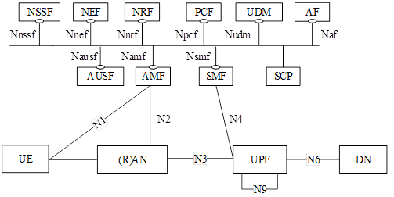
Figure 4.1.1.1: 5G System architecture

4.1.2 Roaming Home Routed reference architecture
Figure 4.1.2.1 shows the 5G System high level Roaming Home Routed architecture as defined in TS 23.501 [200] for 5G data connectivity, in the service-based representation for Control Plane (CP) Network Functions.
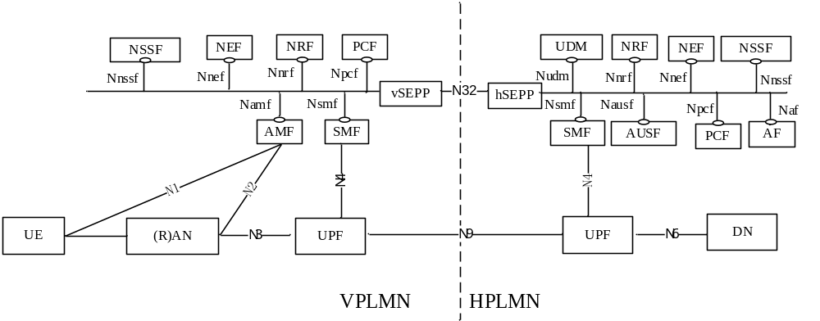
Figure 4.1.2.1: Roaming 5G System architecture - home routed scenario in service-based interface representation

4.1.3 Interworking with EPC architecture
Figure 4.1.3.1 shows the non-roaming architecture for interworking between 5GS and EPC/E-UTRAN as defined in TS 23.501 [200] for 5G data connectivity.
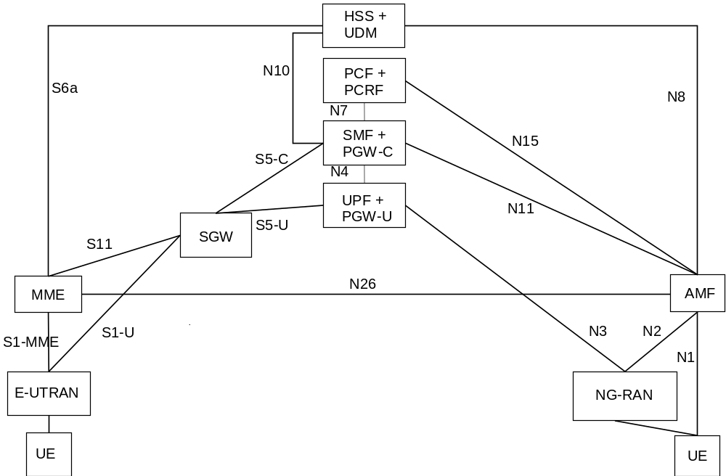
Figure 4.1.3.1: Non-roaming architecture for interworking between 5GS and EPC/E-UTRAN
NOTE: N26 interface is an inter-CN interface between the MME and 5GS AMF in order to enable interworking between EPC and the NG core. Support of N26 interface in the network is optional for interworking.

4.1.4 Architecture reference for Non-3GPP Accesses
Figure 4.1.4.1 shows the non-roaming architecture for Non-3GPP Accesses as defined in TS 23.501 [200] for 5G data connectivity.
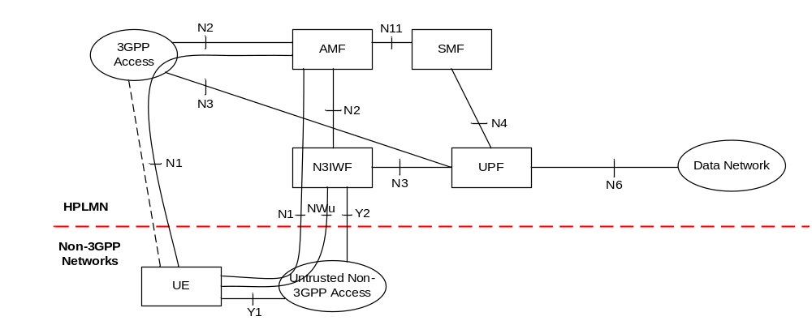Figure 4.1.4.1: Non-roaming architecture for Untrusted Non-3GPP Accesses
This reference architecture supports service based interfaces for AMF, SMF and other NFs not represented in the figure.
Figure 4.1.4.2 shows the non-roaming architecture for 5G Core Network with trusted non-3GPP access as defined in TS 23.501 [200] for 5G data connectivity.
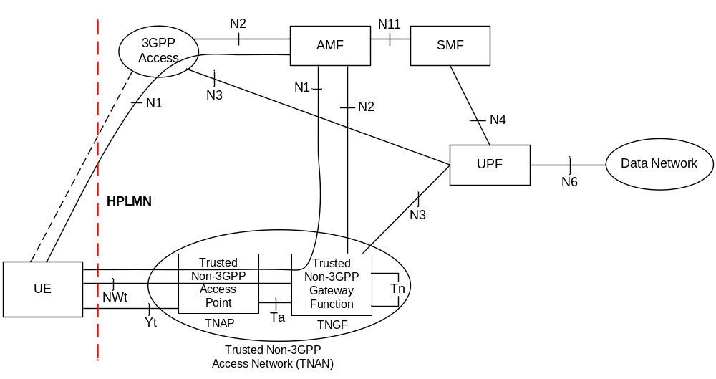

Figure 4.1.4.2: Non-roaming architecture for 5G Core Network with trusted non-3GPP access
The UE is connected to the 5G Core Network over non-3GPP access. This reference architecture supports service based interfaces for AMF, SMF and other NFs not represented in the figure.

4.1.5 Architecture for deployments topologies with specific SMF Service Areas

4.1.5.1 Non-roaming architecture with an I-SMF insertion without ULCL/BP
Figure 4.1.5.1 shows the 5G System high level non-roaming architecture, as defined in TS 23.501 [200], with an I-SMF insertion to the PDU Session without UL-CL/BP, using reference point representation.
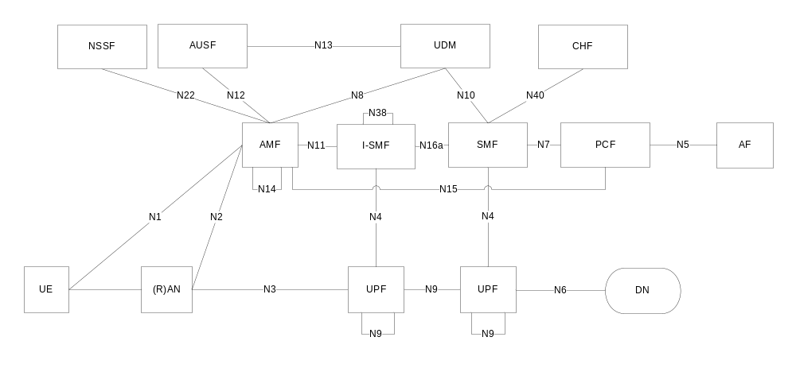
Figure 4.1.5.1: Non-roaming architecture with I-SMF insertion to the PDU Session in reference point representation, with no UL-CL/BP

4.1.5.2 Non-roaming architecture with an I-SMF insertion with ULCL/BP
Figure 4.1.5.2 shows the 5G System high level non-roaming architecture, as defined in TS 23.501 [200], for an I-SMF insertion to the PDU Session with UL-CL/BP, using reference point representation.
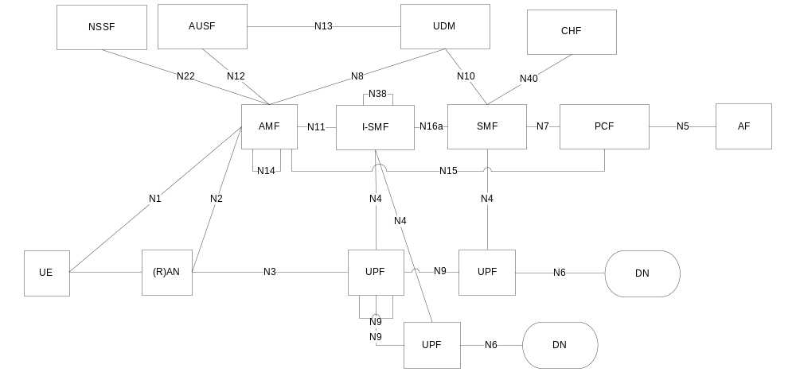
Figure 4.1.5.2: Non-roaming architecture with I-SMF insertion to the PDU Session in reference point representation, with UL-CL/BP

4.1.6 Architecture reference for ATSSS support
The 5G System Architecture references for the support of ATSSS in 5G data connectivity charging are specified in TS 23.501 [200]:
- Non-roaming: Figure 4.2.10-1.
- Roaming with Home-routed architecture - UE registered to the same VPLMN: Figure 4.2.10-2.
- Roaming with Home-routed architecture - UE registered to different PLMNs: Figure 4.2.10-3.
The Hybrid Access architecture of 5G-RG for the support of ATSSS in 5G data connectivity charging is defined in clause 4.1.7.

4.1.7 Architecture reference for Wireline Access network
Figure 4.1.7.1 shows the non- roaming architecture for 5G Core Network for 5G-RG with Wireline 5G Access network and NG RAN as defined in TS 23.501 [200] for 5G data connectivity.
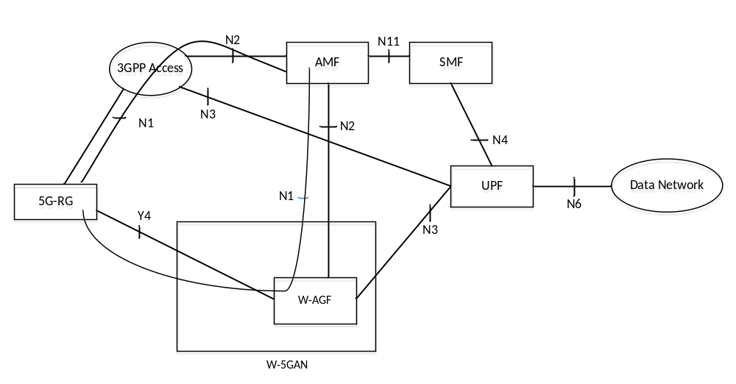
Figure 4.1.7.1: Non- roaming architecture for 5G Core Network for 5G-RG with Wireline 5G Access network and NG RAN
The 5G-RG can be connected to 5GC via W-5GAN, NG RAN or via both accesses. The reference architecture in Figure 4.1.7.1 shows service based interfaces for AMF, SMF and other NFs are not represented in this figure.
Non- roaming architecture for 5G Core Network for FN-RG with Wireline 5G Access network is specified in TS 23.501 [200].

4.2 5G data connectivity domain converged charging architecture
The SMF embedding the CTF, generates charging events towards the CHF for PDU connectivity converged charging or offline only charging.
As described in TS 32.240 [1], the CTF generates charging events towards to the CHF for converged online and offline charging processing. The CDRs generation is performed by the CHF acting as a CDF, which transfers them to the CGF.
Finally, the CGF creates CDR files and forwards them to the BD.
If the CGF is external, the CHF acting as a CDF, forwards the CDRs to the CGF across the Ga interface.
If the CGF is integrated, there is only one internal interface between the CHF and the CGF. In this case, the relationship between CHF and CGF is 1:1. An integrated CGF may support the Ga interface from other CDFs.
When an external CGF is used, this CGF may also be used by other, i.e. non-5GCS, network elements, according to network design and operator decision. It should be noted that the CGF may also be an integrated component of the BD – in this case, the Bd interface does not exist and is replaced by a proprietary solution internal to the BD.
Figure 4.2.1 depicts the architectural options for converged charging in service-based representation for CHF.
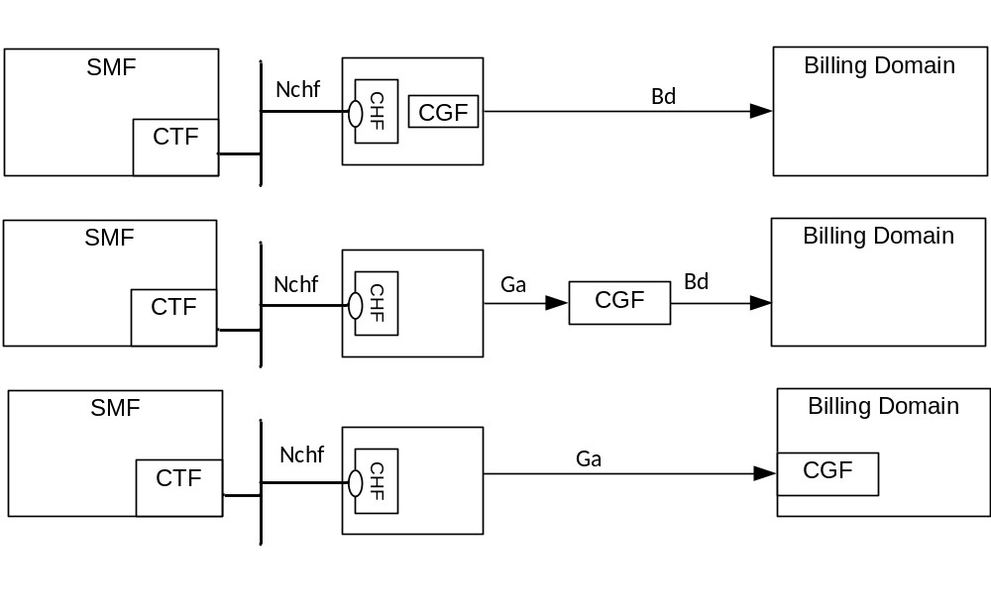
Figure 4.2.1: 5G data connectivity converged charging architecture
Architectural options of figure 4.2.1 apply to any 5G data connectivity converged charging architectures in this clause.
Ga is described in clause 5.2.4 and Bd in clause 5.2.5. of the present document and Nchf is described in TS 32.290 [57]..
Figure 4.2.2 depicts the 5G data connectivity converged charging architecture in reference point representation for non-roaming:
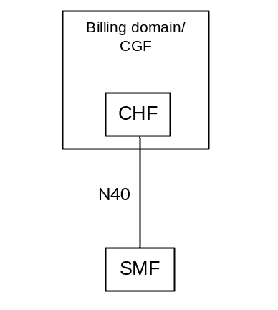
Figure 4.2.2: 5G data connectivity converged charging architecture non-roaming reference point representation
Figure 4.2.3 depicts the 5G data connectivity converged charging architecture service-based representation for roaming Home Routed:
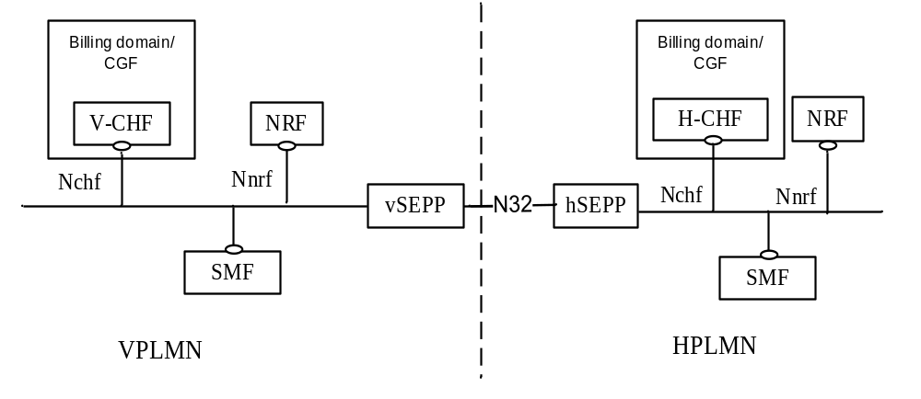
Figure 4.2.3: 5G data connectivity converged charging architecture roaming Home Routed service based representation
Figure 4.2.4 depicts the 5G data connectivity converged charging architecture for roaming Home Routed in reference point representation:
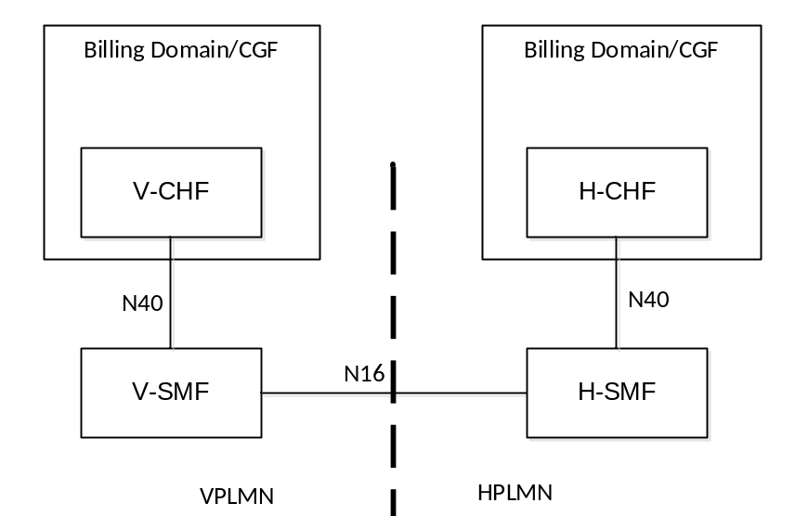
Figure 4.2.4: 5G connection and mobility converged charging architecture in roaming Home routed reference point representation
The N40 reference point is defined for the interactions between H-SMF and H-CHF and between V-SMF and V-CHF in the reference point representation.

5 5G data connectivity charging principles and scenarios

5.1 5G data connectivity charging principles

5.1.1 General
The charging functions specified for the 5G data connectivity charging:
- PDU session in SMF, refer to TS 23.501 [200];
- service data flows, within PDU session, refer to TS 23.503 [202].
- QoS flows within PDU session refer to TS 23.501 [200] and TS 23.503 [202].

5.1.2 Requirements
The following are high-level charging requirements specific to the packet domain, derived from the requirements in TS 22.115 [101], TS 22.261 [102], TS 23.501 [200], TS 23.502 [201] and TS 23.503 [202].
- The SMF shall support converged online and offline charging.
- The SMF may support offline only charging.
- The SMF shall support PDU session charging using service based interface.
- The SMF shall support network slice instance charging.
- The SMF shall collect charging information per PDU session for UEs served under 3GPP access and non-3GPP access (untrusted non-3GPP access, trusted non-3GPP access and wireline).
- Every PDU session shall be assigned a unique identity number for billing purposes per PLMN. (i.e. the Charging Id).
- Data volumes on both the uplink and downlink directions shall be counted separately. The data volumes shall reflect the data as delivered to and forwarded from the user.
- The charging mechanisms shall provide the date and time information when the PDU session starts.
- The SMF shall be capable of handling the Charging Characteristics. Charging Characteristics can be specific to a subscription or subscribed DNN.
- The SMF may be capable of identifying data volumes, elapsed time or events for individual service data flows (flow based charging). One PCC rule identifies one service data flow.
- SMF shall allow reporting of the service or the detected application usage per rating group or per combination of the rating group and service id. This reporting level can be activated per PCC rule.
- The quota management shall be per rating group per PDU session.
- If there are multiple UPFs for one PDU session, the quota management may be one for all UPFs or separate per UPF and the usage and charging information reporting per UPF.
- The SMF shall support charging for PDU Session types of IP, Ethernet and Unstructured.
- In Home Routed scenario, the SMF shall collect charging information per PDU session and, based on Home Operator policy and agreement between Home and Visit Operators, shall be able to collect charging information per Qos Flow for in-bound and out-bound roamers in Home Routed scenario.
- For interworking between 5GS and EPC, the dedicated PGW-C + SMF shall collect charging information using the same mechanisms as the SMF.
- The SMF shall support PDU session charging when the PDU session is served by both I-SMF and SMF.
- The SMF shall support charging for MA PDU Connectivity Service over 3GPP access and non-3GPP access.
- The SMF in VPLMN and in HPLMN shall support charging for MA PDU Connectivity Service in roaming Home Routed scenario with UE registered to the same VPLMN for 3GPP access and non-3GPP access.
- The SMF in HPLMN shall support charging for MA PDU Connectivity Service in roaming Home Routed scenario with UE registered in different PLMNs.
- The SMF shall support the charging of redundant transmission for high reliability communication.

5.1.3 Charging information
Charging information in the 5GC domain network is collected for each UE by the SMFs. PDU session charging allows the SMF to collect and categorize per UE per UPF per PDU session, charging information related to data volumes.
The SMF shall collect the following charging information for converged online and offline charging:
- usage of the access and core network resources: the charging information shall describe the amount of data delivered to and forwarded from the UE;
- usage duration: duration of PDU session is counted as the time interval from PDU session establishment to PDU session release;
- user: the charging information shall provide the actual UE addresses used by the user for the PDU session;
- data network: the charging information shall describe the data network addresses with a level of accuracy as determined by the DNN;
- usage of the external data networks: the charging information shall describe the amount of data sent and received to and from the external data network. External networks can be identified by the DNN;
- start time: identifying the time when the PDU session was started;
- user location: HPLMN, VPLMN, inside/outside presence reporting area, plus optional higher-accuracy location information.
The service data flows categorization is achieved by rating group or combination of the rating group and service id: i.e. based on the level of reporting defined per PCC rule, counting per rating group or combination of the rating group and service id. According to TS 23.503 [202], flow based charging shall support different charging models per PCC rule. These charging models may be based on volume, time and/or on number of events matching a specific service data flow template in PCC rule.
For service data flows defined for FBC, the SMF shall collect the following charging information:
- the information described above for PDU session;
- the amount of data transmitted in uplink and downlink directions categorized by rating group or combination of the rating group and service id when volume based charging applies;
- the duration of service data flows is counted and categorized by rating group or combination of the rating group and service id when time based charging applies;
- the number of events and corresponding time stamps categorized by rating group or combination of the rating group and service id when event based charging applies.
Within the PDU session the SMF shall collect the charging information for service data flows per UPF, categorized by rating group or combination of the rating group and service id.
Within the PDU session for local traffic offload scenarios with I-SMF insertion, the SMF shall collect the charging information for service data flows per I-SMF and categorized by rating group or combination of the rating group and service id.
Editor's note: To have I-UPF as well as PSA2 UPF for the I-SMF controlled UPF is FFS.
The user can be identified by a Generic Public Subscription Identifier (GPSI) and/or a 5G Subscription Permanent Identifier (SUPI). For wireline access, SUPI may be used to identify subscriber via wireline network as specified in clause 5.9.2 of TS 23.501 [200].

5.1.4 Charging Identifier
Charging identifier is created to allow correlation of charging information.
For the SMF the charging identifier is assigned per PDU session including the case of I-SMF insertion. At each PDU session establishment, i.e. assignment of a new PDU session id, a new PDU session specific SMF Charging Identifier is generated at the first SMF that processes the PDU session initiating request. The SMF Charging Identifier shall be unique within the SMF which assigned it and is then used in all subsequent messages for that PDU session. The Charging Identifier shall be used throughout the PDU session’s lifetime once assigned. In case of inter-system changes or handovers of PDU session, the Charging Identifier is preserved as long as the PDU session Identifier is preserved.
For EPS handover 5GS in Home routed scenario, the Charging Identifier for the PDU session will be generated by PGW-C+SMF in HPLMN and transferred to the SMF in VPLMN, if the V-SMF has already generated the Charging Identifier, the value shall be replaced by Home Provided Charging Id generated by H-SMF.
For 5GS interworking with EPS, an "EPS bearer Charging Id" is assigned by the PGW-C+SMF to each dedicated EPS bearer QoS Flow(s). For the default bearer QoS Flow(s), the "EPS bearer Charging Id" is the "Charging Id" assigned to the PDU session.

5.1.5 PCC rules and charging

5.1.5.1 PCC rules and chargeable events
PCC rules can be activated, deactivated and modified at any time during the PDU session lifetime. The following attribute can be modified by the PCF in a dynamic PCC rule active in the SMF: Charging key, Service identifier, Sponsor Identifier, Application Service Provider Identifier, Measurement method and reporting level. The QoS Flow binding mechanism employed by the SMF upon operations on PCC rules, may result in QoS Flows establishment, modification, or release. This is specified in TS 23.503 [202].
Activities on PCC rules are not chargeable events. However, change of charging rule in PCC rules will lead to chargeable events "start of service data flow" and when this is the last service data flow for the original PCC rule, "termination of service data flow".
The charging key (i.e. Rating group) is a piece of information used to request online charging quotas as defined in TS 23.503 [202].

5.1.5.2 Specific PCC rules scenarios
The capability of SMF to support Application Based Charging is achieved with appropriate PCC rules activation in the SMF. Such PCC Rule shall be defined with service data flow template including an Application Identifier for the application which needs to be detected, enforced and charged. Application detection mechanism in SMF is defined in TS 23.503 [202].

5.1.5.3 PCC rules - MA PDU session
As specified with PCC Rule definition in clause 6.3.1 TS 23.503 [202], during MA PDU session handling by the SMF, PCC Rules can be activated with a MA PDU session control information attribute including an optional rating group for Non-3GPP access, in addition to the rating group included in the PCC rule description.
When the MA PDU session control information in a PCC Rule includes a separate rating group for Non-3GPP access, it shall be used by the SMF for the SDF traffic carried via non-3GPP access. The PCC Rule rating group shall be used for the SDF traffic carried via 3GPP access, and all other charging related attributes in the PCC rule shall be the used for both accesses.
When the MA PDU session control information in a PCC Rule does not include any rating group for Non-3GPP access, the PCC Rule rating group shall be used by the SMF for the SDF traffic carried via both accesses (i.e. 3GPP access and non-3GPP access).

5.1.6 Session and Service Continuity modes
For any scenario of SSC modes specified in TS 23.501 [200], one charging Id shall correspond to a single PDU session ID.
As a result from such SSC mode, a new charging Id is generated by the SMF for the new PDU session Id, and the charging session associated to the old PDU session Id is released.
This behaviour applies to the following scenario:
- PDU session anchor UPF relocation, in SSC mode 2;
- PDU session anchor UPF relocation in SSC mode 3 with multiple PDU Sessions.

5.1.7 UE Presence in Presence Reporting Area (PRA)
During charging session lifetime, the CHF may provide the Presence Reporting Area identifier to be activated for Core Network pre-configured Presence Reporting Area(s) and additionally all of PRA Identifier(s) and list(s) of its elements for UE-dedicated Presence Reporting Area(s) and provision the "Change of UE presence in Presence Reporting Area(s)" trigger to the SMF to request the reporting of Change of UE presence in Presence Reporting Area. After such trigger is enabled, SMF shall close the current count, open a new count with the initial status of UE presence in the PRA(s). In case of quota management is required, a Charging Data Response [Update] including the initial status is sent. UE presence status in the PRA(s) describes whether the UE is entering or leaving Presence Reporting Area (s) and if the corresponding Presence Reporting Area(s) is set to inactive by the serving node.
The CHF may modify the list of PRA Identifier(s) by providing the new Presence Reporting Area(s) or by removing existing Presence Reporting Area(s) or modify the list(s) of Presence Reporting Area elements by providing the updated Presence Reporting Area.
The CHF may remove the trigger of change of UE presence in Presence Reporting Area as defined in subclause 5.2.1.2, if previously activated.

5.1.8 CHF selection
The CHF selection by the SMF is done at the PDU session establishment, this selection shall be based on the following and with this priority order (highest to lowest):
- CHF address(es) with possible associated CHF instance ID(s) and/or CHF set ID(s) provided by the PCF for the PDU session.
- UDM provided charging characteristics.
- NRF based discovery.
- SMF locally provisioned charging characteristics.
This means that if there are PCF provided CHF address(es) with possible associated CHF instance ID(s) and/or CHF set ID(s) these shall be used, otherwise if the UDM provides charging characteristics these shall be used. If neither of these results in CHF address(es) the NRF can be used to discover CHF instance(s) possibly within a CHF set, and as a last resource the SMF locally provisioned charging characteristics shall be used.
When NRF is used for the CHF selection, and the PDU session charging method indicates "offline only" for the PDU session, CHF instance(s) supporting CHF "offline only" service instances may be selected.

5.1.9 Roaming

5.1.9.1 General
Based on roaming agreements between the V-PLMN and the H-PLMN, in Home Routed scenario, for each UE roaming in VPLMN:
- The SMF in VPLMN (V-SMF) shall be able to collect charging information per QoS Flow within a PDU session when UE is determined as an in-bound roamer, for CDR generation in VPLMN.
- The SMF in HPLMN (H-SMF) shall be able to collect charging information per QoS Flow within a PDU session when UE is determined as an out-bound roamer, for CDR generation in HPLMN.
This charging information collection mechanism is achieved under Roaming QoS flow Based Charging (QBC) performed by each PLMN, based on a set of charging parameters exchanged between the V-SMF and the H-SMF on a per PDU session basis.
The main parameters exchanged at PDU session establishment are:
- The Charging Id which may include the VPLMN PLMN ID, assigned by the V-SMF and transferred to the H-SMF in the HPLMN.
- Optionally, the "Roaming Charging Profile" negotiated between the VPLMN and the HPLMN.
The parameters exchanged during the PDU session handover from EPS to 5GS in Home routed roaming scenario:
- The Home Provided Charging Id which includes the Charging Id assigned by the H-SMF to the original PDU session over EPS and transferred by the H-SMF to the V-SMF. This Home Provided Charging Id shall be used by the V-SMF to replace the existing Charging Id previously generated by V-SMF.
- Optionally, the "Roaming Charging Profile" negotiated between the VPLMN and the HPLMN on 5GS side.
In roaming Home routed PDU session, upon V-SMF change:
- intra-PLMN V-SMF change: Charging Id, "Roaming Charging Profile" and CHF address are transferred from the old V-SMF to the new V-SMF.
- inter-PLMN V-SMF change: The Charging Id is transferred from the old V-SMF to the new V-SMF.
- The "Roaming Charging Profile" is optionally exchanged between the new V-SMF and the H-SMF as for a PDU session establishment.

5.1.9.2 CHF selection
In roaming Home routed scenario, at PDU session establishment, the CHF selection mechanism specified in clause 5.1.8 applies to:
- The V-SMF for CHF selection in VPLMN, with the following differences:
- CHF address(es) selection mechanisms based on PCF and UDM are not applicable.
- when charging characteristics is used it will be based on local configuration;
- when NRF is used, the V-CHF can be selected based on UE identified as in-bound roamer and the PLMN Id of the H-PLMN;
- The H-SMF for CHF selection in HPLMN, with the following difference: when NRF is used, the H-CHF can be selected based on UE identified as out-bound roamer and the PLMN Id of the V-PLMN.
In roaming Home routed PDU session, upon V-SMF change:
- intra-PLMN V-SMF change: CHF address supplied by the old V-SMF shall be used.
- inter-PLMN V-SMF change: CHF selection mechanism as per V-SMF CHF selection in VPLMN at PDU session establishment.

5.1.10 Data Volume Reporting for Secondary RAT usage
Volume reporting for Secondary RAT usage is an optional capability in the SMF that provides usage reporting functionality when a Secondary RAT is used by NG-RAN. Use of Secondary RAT refers to options supported by NG-RAN with dual radio accesses, per NG-RAN definition in TS 23.501 [200]. This is valid for both HPLMN and VPLMN.
The following principles are used:
- The reporting of Secondary RAT Data Volume is controlled by the NG-RAN.
- The uplink and downlink data volumes for the Secondary RAT are reported (from NG-RAN to 5G Core) on a per QoS Flow basis and per time interval (controlled by NG-RAN). The report contains Secondary RAT (e.g. E-UTRA) resources used for transport of user data and indicated separately for uplink and downlink per QoS Flow and per time interval. The time interval used for the measurements reported (from NG-RAN) may be partitioned to indicate usage that occurred before respectively after an absolute time (that occurs while measurement for secondary RAT usage report is ongoing).
- The reporting (performed by NG-RAN) in association with UE-related control signaling and via standalone reporting is internally triggered by NG-RAN.
NOTE: Volumes for the secondary RAT are reported to the CHF in addition to, and uncorrelated from volumes of reported usage, which are undifferentiated between primary and secondary RAT. Considering both volumes would imply the same traffic to be counted twice.

5.1.11 Charging method and Charging service selection
A PDU session charging method indicating "offline only", can be assigned to a PDU session, to indicate a charging method applicable at PDU session level.
When there is no PDU session charging method indicating "offline only" associated to a PDU session, for each PCC Rule:
- if indicated for this PCC Rule, the required charging method applies;
- otherwise (i.e. no required charging method is indicated for this PCC Rule), the default charging method applies.
In this case, the converged charging service will be invoked by the SMF at the PDU session establishment.
When a PDU session charging method indicates "offline only" for a PDU session, offline charging method applies to all the PCC Rules activated during the PDU session. In this case, at the PDU session establishment, the SMF can select between the converged charging service or the offline only charging service based on Operator policy.
This PDU session charging method can be received from PCF by the SMF or configured in the SMF charging characteristics.

5.1.12 Emergency PDU session handling
Volume reporting for Emergency PDU Sessions is a capability in the SMF that provides usage reporting functionality when a session is setup to provide emergency services.
The following principles are used:
- The reporting of Emergency PDU sessions is controlled by the SMF.
- The uplink and downlink data volumes for Emergency PDU Session are reported.
- It includes either or both of an unauthenticated SUPI and a PEI (especially applicable in the case where there is a UE without a UICC).

5.1.13 Support of deployments topologies with specific SMF Service Areas
Depending on scenario, a PDU Session in non-roaming case is either served by a single SMF or served by an SMF and an I-SMF, specified in the clause 5.34 of TS 23.501 [200].When a PDU Session is served by both an SMF and an I-SMF, the SMF is the NF Consumer that has the interfaces towards CHF for I-SMF for the case of an I-SMF insertion, relocation or removal.
For the following case with the I-SMF involved, the SMF shall collect the charging information and report to CHF:
- PDU session establishment, modification and release;
- PDU Session message flows for N2 based handover procedure, with I-SMF insertion/change/removal;
- PDU Session message flows for Xn based handover procedure, with I-SMF insertion/change/removal;
- PDU Session message flows for Service Request, with I-SMF insertion/change/removal
- branching point or UL CL controlled by I-SMF.

5.1.14 Ultra Reliable Low Latency Communication

5.1.14.1 General
The enhancement of the 5GS to support Ultra Reliable Low Latency Communication (URLLC) is specified in the clause 5.33 of TS 23.501 [200]. For the redundant transmission for high reliability communication, the SMF shall collect the charging information for redundant transmission and report to CHF for the following cases.
- Dual Connectivity based end to end Redundant User Plane Paths;
- Redundant transmission on N3/N9 interfaces;
- Redundant transmission at transport layer.

5.1.14.2 Support redundant transmission for high reliability communication
The SMF reports the redundant transmission type to the CHF to indicate which redundant transmission type is used for the PDU session or service data flow.
For dual connectivity based end to end Redundant User Plane Paths, the charging information is collected independently per each redundant PDU session. The quota is granted for each redundant PDU session independently. The SMF reports the usage per redundant PDU session.

5.1.14.3 QoS Monitoring to Assist URLLC Service
For the QoS Monitoring to Assist URLLC Service, the SMF may report the packet delay measurement per QoS Flow per UE to CHF.

5.1.14.4 Void

5.2 5G data connectivity converged online and offline charging scenarios

5.2.1 Basic principles

5.2.1.1 General
Converged charging may be performed by the SMF interacting with CHF using Nchf specified in TS 32.290 [57] and TS 32.291 [58]. In order to provide the data required for the management activities outlined in TS 32.240 [1] (Credit-Control, accounting, billing, statistics etc.), the SMF shall be able to perform converged charging for each of the following:
- Charging data related to PDU session;
- Charging data related to service data flows within the PDU session.
Converged charging includes quota management and usage reporting.
The SMF shall be able to report charging events to CDF for CDR generation.
The SMF shall be able to perform convergent charging by interacting with CHF, for charging data related to PDU sessions. The Charging Data Request and Charging Data Response are exchanged between the SMF and the CHF, based on SCUR scenarios specified in TS 32.290 [57]. The Charging Data Request is issued by the SMF towards the CHF when certain conditions (chargeable events) are met.
The quota management is always per rating group, reporting level can be either per rating group or per combination of the rating group and service id, which is defined per PCC rule.
Converged charging uses centralized or decentralized unit determination and centralized rating scenarios for session based convergent charging specified in TS 32.290 [57].
The charging information collected per PDU session includes the network slice instance the PDU session belongs to.
The contents and purpose of each charging event that triggers interaction with CHF, as well as the chargeable events that trigger them, are described in the following sub-clauses.
The SMF initiates a charging session with Charging Data Request/Response [Initial], updates the charging session with Charging Data Request/Response [Update], and terminates the charging session with Charging Data Request/Response [Termination].
A detailed formal description of the converged charging parameters defined in the present document is to be found in TS 32.291 [58].
A detailed formal description of the CDR parameters defined in the present document is to be found in TS 32.298 [51].
In order to avoid a charging session remaining inactive for a long period of time, upon expiry of the Unit Count Inactivity Timer, the charging session may be terminated by the SMF sending Charging Data Request [Termination], indicating the PDU session shall continue and the CHF can expect a later Charging Data Request [Initial] request for the same PDU session with the original Charging ID and new session identifier. The SMF may send its locally configured value of the Unit Count Inactivity Timer to the CHF. The CHF may respond with a new Unit Count Inactivity Timer for use in the SMF.

5.2.1.2 Applicable Triggers in the SMF

5.2.1.2.1 General
When a charging event is issued towards the CHF, it includes details such as Subscriber identifier (e.g. SUPI), Charging-id, etc. and also containers identifying the volume count (separated for uplink and downlink traffic), with charging condition change information.
Each trigger condition (i.e. chargeable event) defined for the 5G data connectivity converged charging functionality, is specified with the associated behaviour when they are met.
Two categories of chargeable events are identified:
- immediate report: chargeable events for which, when occurring, the current counts are closed and sent together with the charging data generated by the SMF towards the CHF in a Charging Data Request. New counts are started by the SMF.
- deferred report: chargeable events for which, when occurring, the current counts are closed and stored together with the charging data generated by the SMF. The stored counts will be sent to the CHF in next a Charging Data Request. New counts are started by the SMF
When a PDU session starts, and the converged charging is activated, the SMF invokes a Charging Data Request [Initial] towards the CHF to get authorization to start based on the default triggers. The SMF is optionally provided in a Charging Data Response [Initial] to override the default triggers, with a set of chargeable event triggers to be enabled, and the associated category (i.e. immediate or deferred report).
The triggers remain active until they are updated or disabled by subsequent Charging Data Response [Update] from the CHF or the PDU session is terminated.
A set of chargeable events are based on trigger thresholds and default ones can be configured in Charging Characteristics which are described in Annex A.
The SMF is optionally provided in the Charging Data Response [Initial], with trigger thresholds which override the default ones configured in the Charging Characteristics selected by the SMF for the PDU session. They remain active until they are updated by subsequent Charging Data Response [Update] from the CHF or the PDU session is terminated.
When a trigger is enabled, the SMF needs to ensure that monitoring and subscriptions in UPF and RAN are setup so that SMF can report the charging information to the CHF if the trigger event occurs.

5.2.1.2.2 Flow Based Charging (FBC) triggers
The set of chargeable events and associated category, which shall be supported by the SMF as the default, is specified in the sub-clause 5.2.1.4 for Flow Based Charging.
Two level of triggers can be supplied by the CHF:
- Triggers associated to the PDU session.
- Triggers associated to a rating group within the PDU session.
The set of triggers along with their category (i.e. immediate or deferred report) and level (i.e. per PDU session or per rating group), which can be supplied by the CHF to the SMF for 5G data connectivity converged charging or offline only charging are detailed in the sub-clause 5.2.1.4 for Flow Based Charging.

5.2.1.2.2 QoS flow Based Charging (QBC) triggers
The set of chargeable events and associated category, which shall be supported by the SMF as the default for QoS flow Based Charging, when applicable, is specified in the sub-clause 5.2.1.6.
Two level of triggers can be supplied by the CHF:
- Triggers associated to the PDU session.
- Triggers associated to a QoS Flow within the PDU session.
The set of triggers along with their category (i.e. immediate or deferred report) and level (i.e. per PDU session or per QoS Flow), which can be supplied by the CHF to the SMF for 5G data connectivity converged charging are detailed in the sub-clause 5.2.1.6 for QBC.
When QBC is used in the context of roaming, the set of triggers, their associated category, and trigger thresholds, compose the "Roaming Charging Profile", which governs the SMF charging data generation, synchronously between the V-SMF and the H-SMF when shared.

5.2.1.3 PDU session charging
Converged charging allows the SMF to collect charging information related to data volumes sent to and received by the UE/MS per user per PDU session. The user can be identified by SUPI.
If PDU session specific converged charging is supported, this is achieved by FBC charging, with specific rating group/service identifier, see clause 5.2.1.4.

5.2.1.4 Flow Based Charging (FBC)
For FBC charging, the SMF categorizes the service data flows within PDU session data traffic by rating group and / or combination of the rating group and service id. The level of the reporting and charging method is defined per PCC rule. Details of this functionality are specified in TS 23.503 [202] and TS 32.240 [1].
The SMF can include the QoS Information per rating group or per combination of rating group/service id. If the QoS Information cannot be unambiguously determined per rating group or per combination of rating group/service id, it should be omitted.
NOTE: The SMF can only include one QoS Information occurrence per combination of rating group/service id. This implies if an operator wishes to be able to separate usage according to 5QI and ARP for the same charging method, they will need to ensure that service data flows having different 5QI and ARP do not have the same:
- rating group in cases where rating reporting is used;
- rating group/service id where rating group/service id reporting is used.
When a service data flow is governed by a PCC Rule indicated with "Online" charging method, quota management is required for the service data flow. It may also indicate if authorization for the service data flow is needed or not before service delivery, i.e. blocking or non-blocking mode.
When a service data flow is governed by a PCC Rule indicated with "Offline" charging method, quota management is not required for this service data flow. Usage reporting is required for this service data flow without affecting the delivery.
According to TS 23.503 [202], FBC shall support different charging models per PCC rule. These charging models may be based on volume and/or time and on number of events matching a specific service data flow template in PCC rule. When a chargeable event occurs for which quota needs to be requested by the SMF to the CHF, the type of requested quota may depend on measurement method configured for the PCC rule.
In general, the charging of a service data flow shall be linked to the PDU session under which the service data flow has been activated.
The amount of data counted shall be the user plane payload at the UPF separated between UL and DL.
For PDU session specific charging, time metering shall start when PDU session is activated.
Table 5.2.1.4.1 summarizes the set of default trigger conditions and their category which shall be supported by the SMF. For "immediate report" category, the table also provides the corresponding Charging Data Request [Initial, Update, Termination] message sent from SMF towards the CHF.
Table 5.2.1.4.1: Default Trigger conditions in SMF
Trigger Conditions | Trigger level | Converged Charging default category | Offline only charging default category | CHF allowed to change category | CHF allowed to enable and disable | Message when "immediate reporting" category
Start of PDU Session. | PDU session | Immediate | Immediate | Not Applicable | Not Applicable | Charging Data Request [Initial]
Start of the Service data flow and no charging session exists. | RG | Immediate | Immediate | No | No | Charging Data Request [Initial]
Change of Charging conditions |  |  |  |  |  | Charging Data Request [Update]
QoS change | PDU session/ RG | Deferred | Deferred | Yes | Yes | Charging Data Request [Update]
GFBR guaranteed status change | RG | Deferred | Deferred | Yes | Yes | Charging Data Request [Update]
User Location change | PDU session/ RG | Deferred | Deferred | Yes | Yes | Charging Data Request [Update]
Serving Node change | PDU session/ RG | Deferred | Deferred | Yes | Yes | Charging Data Request [Update]
Change of UE presence in Presence Reporting Area(s) | PDU session/ RG | Deferred | Deferred | Yes | Yes | Charging Data Request [Update]
Change of 3GPP PS Data off Status | PDU session/ RG | Deferred | Deferred | Yes | Yes | Charging Data Request [Update]
Tariff time change | PDU session/ RG | Deferred | Deferred | No | No | Charging Data Request [Update]
UE time zone change | PDU session/ RG | Immediate | Deferred | Yes | Yes | Charging Data Request [Update]
PLMN change | PDU session/ RG | Immediate | Deferred | Yes | Yes | Charging Data Request [Update]
RAT type change | PDU session/ RG | Immediate | Deferred | Yes | Yes | Charging Data Request [Update]
Session-AMBR change | PDU session | Immediate | Deferred | Yes | Yes | Charging Data Request [Update]
Addition of UPF | PDU Session/RG | Immediate | Deferred | Yes | Yes | Charging Data Request [Update]
Removal of UPF | PDU session/RG | Immediate | Deferred | Yes | Yes | Charging Data Request [Update]
Insertion of I-SMF | PDU Session | Deferred | Deferred | Yes | Yes | Charging Data Request [Update]
Change of I-SMF | PDU Session | Deferred | Deferred | Yes | Yes | Charging Data Request [Update]
Removal of I-SMF | PDU Session | Deferred | Deferred | Yes | Yes | Charging Data Request [Update]
Handover cancel | PDU session | Immediate | Deferred | Yes | Yes | Charging Data Request [Update]
Handover start | PDU session | Immediate | Deferred | Yes | Yes | Charging Data Request [Update]
Handover complete | PDU session | Immediate | Deferred | Yes | Yes | Charging Data Request [Update]
Addition of access | PDU session/ RG | Immediate | Deferred | Yes | Yes | Charging Data Request [Update]
Removal of access | PDU session/ RG | Immediate | Deferred | Yes | Yes | Charging Data Request [Update]
Redundant transmission change | RG | Immediate | Deferred | Yes | Yes | Charging Data Request [Update]
Limit per PDU session |  |  |  |  |  | Charging Data Request [Update]
Expiry of data time limit per PDU session | PDU session | Immediate | Immediate | No | Yes | Charging Data Request [Update]
Expiry of data volume limit per PDU session | PDU session | Immediate | Immediate | No | Yes | Charging Data Request [Update]
Expiry of data event limit per PDU session | PDU session | Immediate | Immediate | No | Yes | Charging Data Request [Update]
Expiry of limit of number of charging condition changes | PDU session | Immediate | Immediate | No | Yes | Charging Data Request [Update]
Limit per Rating group |  |  |  |  |  | Charging Data Request [Update]
Expiry of data time limit per rating group | RG | Deferred | Deferred | Yes | Yes | Charging Data Request [Update]
Expiry of data volume limit per rating group | RG | Deferred | Deferred | Yes | Yes | Charging Data Request [Update]
Expiry of data event limit per rating group | RG | Deferred | Deferred | Yes | Yes | Charging Data Request [Update]
Quota management |  |  |  |  |  | Charging Data Request [Update]
Time threshold reached | RG | Immediate | Not applicable | No | Yes | Charging Data Request [Update]
Volume threshold reached | RG | Immediate | Not applicable | No | Yes | Charging Data Request [Update]
Unit threshold reached | RG | Immediate | Not applicable | No | Yes | Charging Data Request [Update]
Time quota exhausted | RG | Immediate | Not applicable | No | Yes | Charging Data Request [Update]
Volume quota exhausted | RG | Immediate | Not applicable | No | Yes | Charging Data Request [Update]
Unit quota exhausted | RG | Immediate | Not applicable | No | Yes | Charging Data Request [Update]
Expiry of quota validity time | RG | Immediate | Not applicable | No | Yes | Charging Data Request [Update]
Expiry of quota holding time | RG | Immediate | Not applicable | No | Yes | Charging Data Request [Update]
Re-authorization request by CHF | RG | Immediate | Not applicable | No | No | Charging Data Request [Update]
Start of service data flow, in case no valid quota for this rating group | RG | Immediate | Not applicable | No | No | Charging Data Request [Update]
Start of SDF additional access, in case no valid quota for this access rating group | RG | Immediate | Not applicable | No | No | Charging Data Request [Update]
Others |  |  |  |  |  | Charging Data Request [Update]
Termination of service data flow - last service data flow under a given Rating Group. | RG | Immediate | Immediate | No | No | Charging Data Request [Update]
Management intervention | PDU session | Immediate | Immediate | No | No | Charging Data Request [Update]
Expiry of Unit Count Inactivity Timer | PDU session | Immediate | Not applicable | No | Yes | Charging Data Request [Termination]
End of PDU session | PDU session | Immediate | Immediate | No | No | Charging Data Request [Termination]
CHF response with session termination | PDU session | Immediate | Not applicable | No | No | Charging Data Request [Termination]
Abort request is received from the CHF | PDU session | Immediate | Immediate | No | No | Charging Data Request [Termination]
NOTE 1: If GFBR guaranteed status change is enabled, SMF needs to ensure the request for the notification from the access network (i.e. 3GPP RAN) when the GFBR can no longer (or can again) be guaranteed for a QoS Flow during the lifetime of the QoS Flow.

The default "Limit" trigger conditions are trigger thresholds configured in the Charging Characteristics applied to the PDU session. It shall be possible for the CHF to override these default triggers when providing Charging Data Response [Initial], either to disable the triggers, or to enable triggers new thresholds value.
When the traffic is counted in more than one UPF, the CHF overrides these default triggers of volume limit for the all UPFs.
For converged charging, the following details of chargeable events and corresponding actions in the SMF are defined in Table 5.2.1.4.2:
Table 5.2.1.4.2: Chargeable events and their related actions in SMF
Chargeable event | Conditions | SMF action
Start of PDU session |  | Charging Data Request [Initial] with a possible request quota for later use.
Start of service data flow | If quota management is required, and valid quota for this rating group does not exist | Charging Data Request [Update] to request quota with a possible amount of quota.
Start of service data flow | If service identifier level reporting is required by the PCC rule | Start new counts with time stamps for the combination of the rating group and service id
Start of service data flow | If rating group level reporting is required by the PCC rule | Start new counts with time stamps for the rating group
Start of service data flow | If sponsored connectivity level reporting is required by the PCC rule | Start new counts with time stamps for the combination of the rating group, sponsor identity and application service provider identity
Start of service data flow | If charging resource, i.e. charging session, for the PDU session does not exist | Charging Data Request [Initial] with a possible request quota
Start of SDF additional access | If ATSSS is supported with access differentiated rating groups, quota management is required, and valid quota for this access rating group does not exist. | Charging Data Request [Update] to request quota with a possible amount of quota.
Start of SDF additional access | If ATSSS is supported with access differentiated rating groups, service identifier level reporting is required by the PCC rule | Start new counts with time stamps for the combination of the access rating group and service id
Start of SDF additional access | If ATSSS is supported with access differentiated rating groups, rating group level reporting is required by the PCC rule | Start new counts with time stamps for the access rating group
Start of SDF additional access | If ATSSS is supported with access differentiated rating groups, sponsored connectivity level reporting is required by the PCC rule | Start new counts with time stamps for the combination of the access rating group, sponsor identity and application service provider identity
Termination of service data flow | If service identifier level reporting is required by the PCC rule and this is the last service data flow for this combination of the rating group and service id | Close the counts with time stamps
Termination of service data flow | If rating group level reporting is required by the PCC rule and this is the last service data flow utilizing that specific rating group | Close the counts with time stamps
Termination of service data flow | If sponsored connectivity level reporting is required by the PCC rule and this was the last active service data flow for this combination of rating group, sponsor identity and application service provider identity | Close the counts with time stamps
Expiry of the Unit Count Inactivity Timer for the PDU session | If the corresponding trigger is enabled | Charging Data Request [Termination], indicating that charging session is terminated, and the PDU session is still active  May include the configured Unit Count Inactivity Timer value
End of PDU session in the SMF |  | Charging Data Request [Termination]  Close the counts with time stamps
Quota specific chargeable events (e.g. threshold reached, QHT expires, quota exhaustion, validity time reached, forced re-authorization, expiry of quota holding time) | If the corresponding trigger is enabled | Charging Data Request [Update] with a possible request quota  Close the counts and start new counts with time stamps
Change of charging condition in the SMF (e.g. QoS change, Session-AMBR change, user location change, Radio access type change, PLMN change, Serving Node change, UE Time Zone change, change of UE presence in Presence Reporting Area(s), change of 3GPP PS Data Off status, handover cancel, GFBR guaranteed status change) | If the corresponding trigger is enabled | Close the counts and start new counts with time stamps for all active service data flows
 | If the corresponding trigger is enabled and the category is set to "immediate reporting" | Charging Data Request [Update] with a possible request quota.
Handover start | If the corresponding trigger is enabled | Close the counts with time stamps and start new counts with time stamps for active service data flows.
Handover start | If the corresponding trigger is enabled and the category is set to "immediate reporting" | Charging Data Request [Update] with a possible request quota.
Handover cancel | If the corresponding trigger is enabled | Close the counts with time stamps and start new counts with time stamps for active service data flows.
Handover cancel | If the corresponding trigger is enabled and the category is set to "immediate reporting" | Charging Data Request [Update] with a possible request quota.
Handover complete | If the corresponding trigger is enabled | Close the counts with time stamps and start new counts with time stamps for active service data flows.
Handover complete | If the corresponding trigger is enabled and the category is set to "immediate reporting" | Charging Data Request [Update]
Addition of UPF | If the corresponding trigger is enabled | Start new counts with time stamps for the added UPF.
Addition of UPF | If the corresponding trigger is enabled and the category is set to "immediate reporting" with the quota management is being performed and quota is granted per each UPF | Charging Data Request [Update] to request quota with a possible amount of quota.
Tariff time change |  | Close the counts and start new counts with time stamps
CHF response with session termination (e.g. Not Applicable), abort request |  | Charging Data Request [Termination]  Close the counts with time stamps
Removal of a UPF | If the corresponding trigger is enabled | Close the counts with time stamps for the removed UPF
Removal of a UPF | If the corresponding trigger is enabled and the category is set to "immediate reporting" with quota management is being performed and quota is granted per each UPF | Charging Data Request [Update].
Insertion of I-SMF | If the corresponding trigger is enabled | Close the counts with time stamps for all active service data flows in SMF, open new accounts for all active service data flows with I-SMF information.
Insertion of I-SMF | If the corresponding trigger is enabled and the category is set to "immediate reporting" with quota management is being performed and quota is granted per each UPF | Charging Data Request [Update] to request quota with a possible amount of quota.
Removal of I-SMF | If the corresponding trigger is enabled | Close the counts with time stamps for the removed I-SMF
Removal of I-SMF | If the corresponding trigger is enabled and the category is set to "immediate reporting" with quota management being performed and quota is granted per each UPF | Charging Data Request [Update].
Change of I-SMF | If the corresponding trigger is enabled | Close the counts with time stamps for the removed I-SMF, open active traffic flows’ counts for the new I-SMF
Change of I-SMF | If the corresponding trigger is enabled and the category is set to "immediate reporting" with quota management being performed and quota is granted per each UPF | Charging Data Request [Update].
Addition of access | If the corresponding trigger is enabled | Close the counts with time stamps for all active service data flows usage report in SMF, open new counts for all active service data flows.
Addition of access | If the corresponding trigger is enabled and the category is set to "immediate reporting" | Charging Data Request [Update] with a possible request quota.
Removal of access | If the corresponding trigger is enabled | Close the counts with time stamps for all active service data flows usage report in SMF, open new counts for all active service data flows.
Removal of access | If the corresponding trigger is enabled and the category is set to "immediate reporting" | Charging Data Request [Update].
Redundant transmission change | If the corresponding trigger is enabled and the category is set to "immediate reporting" | Charging Data Request [Update].  Close the counts and start new counts with time stamps.
Expiry of time limit per rating group | If the corresponding trigger is enabled | Close the counts with time stamps
Expiry of time limit per rating group | If the category is set to "immediate reporting" | Charging Data Request [Update]
Expiry of time limit per rating group | If any matching service data flow is still active | Start new counts with time stamps
Expiry of data volume limit per rating group | If the corresponding trigger is enabled | Close the counts with time stamps
Expiry of data volume limit per rating group | If the category is set to "immediate reporting" | Charging Data Request [Update]
Expiry of data volume limit per rating group | If any matching service data flow is still active | Open a new service data container
Expiry of data event limit per rating group | If the corresponding trigger is enabled | Close the counts with time stamps
Expiry of data event limit per rating group | If the category is set to "immediate reporting" | Charging Data Request [Update]
Expiry of data event limit per rating group | If any matching service data flow is still active | Open a new service data container
Expiry of data event limit per PDU session | If the corresponding trigger is enabled | Charging Data Request [Update]  Close the counts with time stamps
Expiry of data event limit per PDU session | If the PDU session is still active | Start new counts with time stamps
Expiry of time limit per PDU session | If the corresponding trigger is enabled | Charging Data Request [Update]  Close the counts with time stamps
Expiry of time limit per PDU session | If the PDU session is still active | Start new counts with time stamps
Expiry of data volume limit per PDU session |  | Charging Data Request [Update]  Close the counts with time stamps
Expiry of data volume limit per PDU session | If the PDU session is still active | Start new counts with time stamps
Expiry of a limit of number of charging condition changes per PDU session |  | Charging Data Request [Update]  Close the counts with time stamps
 | If the PDU session is still active | Start new counts with time stamps
Management intervention |  | Charging Data Request [Update]  Close the counts with time stamps
Management intervention | If the PDU session is still active | Start new counts with time stamps
When event based charging applies, the first occurrence of an event matching a service data flow template in PCC rule shall be considered as the start of a service.
How the termination of service data flows is detected, is specified in TS 23.503 [202]. Termination of the service data flow itself does not trigger Charging Data Request [Update].
The CDR generation mechanism processed by the CHF upon receiving Charging Data Request [Initial, Update, Termination] issued by the SMF for these chargeable events, is specified in clause 5.2.3.

5.2.1.5 SSC Mode and Triggers
In case of SSC Mode1, the chargeable events are Change of charging condition in the SMF.
In case of SSC Mode2 and SSC Mode3 PDU session Anchor with multiple PDU session, the chargeable events are Start of PDU session and End of PDU session.
There are two cases related to quota management when the granted quota is volume for multiple UPFs and per Operator's policy, the traffic is counted in more than one UPF:
- Quota shared by UPFs means that SMF manages the shared quota consumption per RG for multiple UPFs and reports the total quota consumed to CHF;
- Quota granted for each UPF means that the CHF manages the quota granted for each UPF and SMF manages and reports the quota consumption per UPF.
For configurations involving multiple UPFs and Operator's policy is to count the traffic in a single UPF (e.g. BP), the quota is granted to the SMF for this single UPF per RG for the whole traffic.
The following scenarios describe configurations in which the traffic is counted in more than one UPF:
In case of SSC mode 3 PDU Session Anchor with IPv6 Multi-homed PDU Session,
- The addition of UPF2 and BP (Change the part of traffic from UPF1 to UPF2):
- if quota granted for each UPF, SMF triggers the chargeable event of Start of SDF for UPF2 to request the quota;
- if quota shared by UPFs, SMF requests UPF1 report usage of quota, caches the usage from UPF1 and re-allocates the remaining quota to UPF2 and UPF1(if needed). When the granted quota from CHF is used up, the SMF reports total usage of quota to CHF.
- The removal of UPF1and BP:
- In case the quota management and quota granted for each UPF, UPF1 reports final counts to SMF, SMF triggers the chargeable event of Remove the UPF to report final counts from UPF1;
- In case the quota management and quota shared by UPFs, UPF1 report final counts to SMF, SMF caches the final count from UPF1. SMF sends counts from UPF1 and UPF2 to the CHF together in next Charging Data Request.
- In case without the quota management or offline only charging, UPF1 report final count to SMF, SMF caches the final count from UPF1 and sends counts from UPF1 and UPF2 to the CHF together in next a Charging Data Request. In case of Addition of additional PDU Session Anchor and Branching Point or UL CL:
- The addition of UPF2 and BP (Change the part of traffic from UPF1 to UPF2):
- if quota granted for each UPF, SMF triggers the chargeable event of Start of SDF for UPF2 to request the quota for Rating group;
- if quota shared by UPFs, SMF indicates UPF1 report usage of quota, caches the usage from UPF1 and re-allocates the remain quota to UPF2 and UPF1(if needed). When the granted quota from CHF is used up, the SMF reports total usage of quota to CHF.
In case of Removal of additional PDU Session Anchor and Branching Point or UL CL:
- The removal of UPF1 and BP (Change traffic from UPF1 to UPF2):
- In case the quota management and quota granted for each UPF, UPF1 report final counts to SMF, SMF triggers chargeable event of Remove the UPF to report final counts from UPF1;
- In case the quota management and quota shared by UPFs, UPF1 report final counts to SMF, SMF caches the final count from UPF1 and re-allocates the remain quota to UPF2. SMF sends counts from UPF1 and UPF2 to the CHF together in next a Charging Data Request.
- In case without the quota management or offline only charging,, UPF1 report final count to SMF, SMF caches the final count from UPF1 and sends counts from UPF1 and UPF2 to the CHF together in next a Charging Data Request.In case of Change of additional PDU Session Anchor for IPv6 multi-homing or UL CL and Simultaneous change of Branching Point or UL CL and additional PSA for a PDU Session.
- The additional of UPF2 (Change the part of traffic from UPF1 to UPF2):
- if quota granted for each UPF, SMF triggers the chargeable event of Start of SDF for UPF2 to request the quota for Rating group;
- if quota shared by UPFs, SMF indicates UPF1 report usage of quota, caches the usage from UPF1 and re-allocates the remain quota to UPF2 and UPF1(if needed). When the granted quota from CHF is used up, the SMF reports total usage of quota to CHF.
- The removal of UPF1:
- In case the quota management and quota granted for each UPF, UPF1 report final counts to SMF, SMF triggers chargeable event of Remove the UPF to report final counts from UPF1.
- In case the quota management and quota shared by UPFs, UPF1 report final counts to SMF, SMF caches the final count from UPF1 and re-allocates the remain quota to UPF2. SMF sends counts from UPF1 and UPF2 to the CHF together in next Charging Data Request.
- In case without the quota management or offline only charging, UPF1 report final count to SMF, SMF caches the final count from UPF1 and sends counts from UPF1 and UPF2 to the CHF together in next a Charging Data Request.

5.2.1.6 QoS flow Based Charging
QoS flow Based Charging allows the SMF to collect charging information related to data volumes per PDU session, categorized per QoS Flow.
The user can be identified by SUPI.
For a given PDU session, QBC shall be performed by the SMF within the same charging session used for Flow Based Charging. For the case where QBC is performed from SMF in VPLMN, Flow Based Charging is not applicable and there is no possibility to have quota management for the PDU Session.
The SMF categorizes the volume within PDU session by QoS Flow identified by QoS Flow Identifier (QFI).
The amount of data counted for the QoS Flow shall be the user plane payload at the UPF.
Table 5.2.1.6.1 summarizes the set of default trigger conditions and their category which shall be supported by the SMF in QBC. For "immediate report" category, the table also provides the corresponding Charging Data Request [Initial, Update, Termination] message sent from SMF towards the CHF.
Table 5.2.1.6.1: Default Chargeable events in SMF for QBC
Chargeable event | Trigger level | Default category | CHF allowed to change category | CHF allowed to enable and disable | Message when "immediate reporting" category
Start of PDU session | PDU session | Immediate | Not Applicable | Not Applicable | Charging Data Request [Initial]
Start of a QoS Flow | QoS Flow | Deferred | Not Applicable | Not Applicable | Charging Data Request [Update]
Change of Charging conditions |  |  |  |  | Charging Data Request [Update]
QoS change | QoS Flow | Deferred | Yes | Yes | Charging Data Request [Update]
GFBR guaranteed status change | QoS Flow | Deferred | Yes | Yes | Charging Data Request [Update]
User Location change | PDU session | Deferred | Yes | Yes | Charging Data Request [Update]
Serving Node change | PDU session | Deferred | Yes | Yes | Charging Data Request [Update]
Change of UE presence in Presence Reporting Area(s) | PDU session | Deferred | Yes | Yes | Charging Data Request [Update]
Change of 3GPP PS Data off Status | PDU session | Deferred | Yes | Yes | Charging Data Request [Update]
Tariff time change | PDU session | Deferred | No | No | Charging Data Request [Update]
UE time zone change | PDU session | Immediate | Yes | Yes | Charging Data Request [Update]
PLMN change | PDU session | Immediate | Yes | Yes | Charging Data Request [Update]
RAT type change | PDU session | Immediate | Yes | Yes | Charging Data Request [Update]
Session-AMBR change | PDU session | Immediate | Yes | Yes | Charging Data Request [Update]
Addition of UPF | PDU session | Immediate | Yes | Yes | Charging Data Request [Update]
Removal of UPF | PDU session | Immediate | Yes | Yes | Charging Data Request [Update]
Handover cancel | PDU session | Immediate | Yes | Yes | Charging Data Request [Update]
Handover start | PDU session | Immediate | Yes | Yes | Charging Data Request [Update]
Handover complete | PDU session | Immediate | Yes | Yes | Charging Data Request [Update]
Redundant transmission change | QoS Flow | Immediate | Yes | Yes | Charging Data Request [Update]
Limit per PDU session |  |  |  |  | Charging Data Request [Update]
Expiry of data time limit per PDU session | PDU session | Immediate | Yes | Yes | Charging Data Request [Update]
Expiry of data volume limit per PDU session | PDU session | Immediate | Yes | Yes | Charging Data Request [Update]
Expiry of data event limit per PDU session | PDU session | Immediate | Yes | Yes | Charging Data Request [Update]
Expiry of limit of number of charging condition changes | PDU session | Immediate | Yes | Yes | Charging Data Request [Update]
Limit per QoS Flow |  |  |  |  | Charging Data Request [Update]
Expiry of data time limit per QoS Flow | QoS Flow | Deferred | Yes | Yes | Charging Data Request [Update]
Expiry of data volume limit per QoS Flow | QoS Flow | Deferred | Yes | Yes | Charging Data Request [Update]
Others |  |  |  |  | Charging Data Request [Update]
End of QoS Flow | QoS Flow | Deferred | Yes | Yes | Charging Data Request [Update]
Management intervention | PDU session | Immediate | No | No | Charging Data Request [Update]
End of PDU session | PDU session | Immediate | No | No | Charging Data Request [Termination]
Abort request is received from the CHF | PDU session | Immediate | No | No | Charging Data Request [Termination]
NOTE 1: If GFBR guaranteed status change is enabled, SMF needs to ensure the request for the notification from the access network (i.e. 3GPP RAN) when the GFBR can no longer (or can again) be guaranteed for a QoS Flow during the lifetime of the QoS Flow.

The default "Limit" trigger conditions, are trigger thresholds configured in the Charging Characteristics applied to the PDU session for QBC. It shall be possible for the CHF to override these default triggers when providing Charging Data Response [Initial], either to disable the triggers, or to enable triggers new thresholds value.
For QBC the following details of chargeable events and corresponding actions in the SMF are defined in Table 5.2.1.6.2:
Table 5.2.1.6.2: Chargeable events and their related actions in SMF for QBC
Chargeable event | Conditions | SMF action
Start of PDU session |  | Charging Data Request [Initial] with a possible request quota for later use.
Start of a QoS Flow | Start of the QoS Flow associated with the default QoS rule | Charging Data Request [Update].
Start of a QoS Flow | Start of a QoS Flow | Start new counts with time stamps.
End of a QoS Flow |  | Close the counts with time stamps for the QoS flows
End of PDU session |  | Charging Data Request [Termination]  Close the counts with time stamps
Change of charging condition in the SMF (e.g. QoS change, Session-AMBR change, user location change, Radio access type change, PLMN change, Serving Node change, UE Time Zone change, change of UE presence in Presence Reporting Area(s), change of 3GPP PS Data Off status, handover cancel, GFBR guaranteed status change) | If the corresponding trigger is enabled | Close the counts and start new counts with time stamps for all active QoS flows.
 | If the corresponding trigger is enabled and the category is set to "immediate reporting" | Charging Data Request [Update]
Handover start | If the corresponding trigger is enabled | Close the counts with time stamps and start new counts with time stamps.
Handover start | If the corresponding trigger is enabled and the category is set to "immediate reporting" | Charging Data Request [Update] with a possible request quota.
Handover cancel | If the corresponding trigger is enabled | Close the counts with time stamps and start new counts with time stamps for active QoS flows.
Handover cancel | If the corresponding trigger is enabled and the category is set to "immediate reporting" | Charging Data Request [Update] with a possible request quota.
Handover complete | If the corresponding trigger is enabled | Close the counts and start new counts with time stamps for active QoS flows.
Handover complete | If the corresponding trigger is enabled and the category is set to "immediate reporting" | Charging Data Request [Update]
Redundant transmission change | If the corresponding trigger is enabled and the category is set to "immediate reporting" | Charging Data Request [Update].  Close the counts and start new counts with time stamps.
Addition of UPF | If the corresponding trigger is enabled | Start new counts with time stamps for the added UPF.
Addition of UPF | If the corresponding trigger is enabled and the category is set to "immediate reporting" with the quota management is being performed and quota is granted per each UPF | Charging Data Request [Update] to request quota with a possible amount of quota.
Removal of UPF | If the corresponding trigger is enabled | Close the counts with time stamps for the removed UPF
Removal of UPF | If the corresponding trigger is enabled and the category is set to "immediate reporting" with quota management is being performed and quota is granted per each UPF | Charging Data Request [Update].
Expiry of time limit per QoS Flow | If the corresponding trigger is enabled | Close the counts with time stamps.
Expiry of time limit per QoS Flow | If the category is set to "immediate reporting" | Charging Data Request [Update]
Expiry of time limit per QoS Flow | If the QoS Flow is still active | Start new counts with time stamps
Expiry of data volume limit per QoS Flow | If the corresponding trigger is enabled | Close the counts with time stamps
Expiry of data volume limit per QoS Flow | If the category is set to "immediate reporting" | Charging Data Request [Update]
Expiry of data volume limit per QoS Flow | If the QoS Flow is still active | Start new counts with time stamps
Expiry of time limit per PDU session | If the corresponding trigger is enabled | Close the counts with time stamps for all QoS flows.
Expiry of time limit per PDU session | If the category is set to "immediate reporting" | Charging Data Request [Update]
Expiry of time limit per PDU session | If the PDU session is still active | Start new counts with time stamps for all active QoS flows
Expiry of data volume limit per PDU session | If the corresponding trigger is enabled | Close the counts with time stamps for all QoS flows.
Expiry of data volume limit per PDU session | If the category is set to "immediate reporting" | Charging Data Request [Update]
Expiry of data volume limit per PDU session | If the PDU session is still active | Start new counts with time stamps for all active QoS flows
Expiry of a limit of number of charging condition changes per PDU session | If the corresponding trigger is enabled | Close the counts with time stamps for all QoS flows.
 | If the category is set to "immediate reporting" | Charging Data Request [Update]
 | If the PDU session is still active | Start new counts with time stamps for all active QoS flows
Management intervention |  | Charging Data Request [Update]  Close the counts with time stamps for all QoS Flows
Management intervention | If the PDU session is still active | Start new counts with time stamps
Abort |  | Charging Data Request [Termination]  Close the counts with time stamps

The CDR generation mechanism processed by the CHF upon receiving Charging Data Request [Initial, Update, Termination] issued by the SMF for these chargeable events in QBC, is specified in clause 5.2.3.

5.2.1.7 Roaming QoS flow Based charging (QBC)
When QoS flow Based Charging specified in 5.2.1.6 is used in a context of roaming, a "Roaming Charging Profile" is defined to allow, when shared, QBC synchronized between both PLMNs and includes:
- The set of chargeable events as per Table 5.2.1.6.1 and associated category.
- The set of thresholds for chargeable events based on trigger thresholds.
- An indication on whether the "Default partial record" or the "Individual partial record" mechanism per clause 5.2.3, is used by CHF.
A default "Roaming Charging Profile" is specified for the SMF and comprises:
- The set of chargeable events and associated category specified as the default per Table 5.2.1.6.1.
- The default set of thresholds configured in the Charging Characteristics for QBC.
- The "Default partial record" mechanism indicated as the one used by CHF.
In the VPLMN, at PDU session establishment or PDU session transfer from a different VPLMN, the default "Roaming Charging Profile" in the new V-SMF may optionally be overridden by a new "Roaming Charging Profile" supplied by the CHF in the Charging Data Response [Initial] with:
- updated set of chargeable events and associated category.
- updated thresholds for chargeable events based on trigger thresholds.
- the selected partial record mechanism ("Default partial record" or "Individual partial record").
This updated "Roaming Charging Profile" is transferred from the new V-SMF to the H-SMF and may be acknowledged or replaced by the HPLMN selected "Roaming Charging Profile" to be used by the new V-SMF.
In the HPLMN, at PDU session establishment or V-SMF change for a PDU session, the "Roaming Charging Profile", when received by the H-SMF from the new V-SMF, may be updated by the CHF in the HPLMN in the Charging Data Response [Initial] to H-SMF. This HPLMN CHF selected "Roaming Charging Profile" is used by the H-SMF and transferred towards the VPLMN.
The "Roaming Charging Profile" resulting from the exchange between the VPLMN and HPLMN at PDU session establishment shall remain unchanged during the PDU session lifetime, unless there is a V-SMF change.
At each V-SMF change in Home routed scenario, the "Roaming Charging Profile" may be renegotiated between the VPLMN and HPLMN and shall remain unchanged during the PDU session lifetime with the actual V-SMF.
The capability specified in clause 5.2.1.2.1 for the CHF to be able to update the triggers after the PDU session is established for a given VPLMN shall not be applicable for Roaming QBC.

5.2.1.8 Termination action
The termination action applies only in case of online charging, i.e. quota management is active. It indicates the action, which the UPF should perform when no quota is granted. A packet for a specific rating group is subject to a termination action in the following cases:
- Zero units have been granted;
- The final granted units have been used;
- Quota limit reached;
- End user service rejected;
- End user service denied;
- Rating failed.
The defined termination actions include:
- Allowing the packets to pass through;
- Dropping the packets;
- The SMF Default Termination Action;
- The re-direction of packets to an application server (e.g. defined in the termination action).
NOTE Such a re-direction may trigger a new charging session to be initiated.
A Default Termination Action for all rating groups, for which no quota is granted and there is no specific termination action, shall be pre-configured in the SMF according to operator's policy. For instance, the default behaviour may consist of allowing packets of any terminated service to pass through the UPF.
When final units are granted for a given rating group, the CHF shall provide a termination action using finalUnitAction for this rating group. For the rating group, the CHF provided termination action shall be used instead of SMF pre-configured termination action for “The final granted units have been used” case.

5.2.1.9 Sponsored data connectivity charging
The Sponsor Identifier and Application Service Provider Identifier are provided for sponsored data connectivity to the PCF from the AF, according to TS 23.503 [215].
The Sponsor Identifier and Application Service Provider Identity may be included in PCC rules with "offline" charging method from the PCF to the SMF. In this case, charging information collected by the SMF includes the Sponsor Identity and the Application Service Provider Identity. Correlation of charging information from multiple users per sponsor and/or application service provider can then be based on Sponsor Identity and Application Service Provider Identity.

5.2.1.10 Branching point or UL CL controlled by I-SMF
The interaction between I-SMF and SMF for the support of traffic offload by UPF controlled by the I-SMF is specified in the clause 5.34.6 TS 23.501[200].
There are two cases related to quota management when the granted quota is volume for multiple UPFs and per Operator's policy for the scenarios, i.e.Addition, Removal and Change of PDU Session Anchor (PSA2), Branching Point or UL CL controlled by I-SMF, the traffic is counted in more than one UPF:
- Quota shared by UPFs (PSA)
- Quota granted for each UPF (PSA)
In the scenario UL CL/BP controlled by I-SMF, the I-SMF forwards traffic usage information of UPF (PSA2) to the SMF as specified clause 5.34.4 and clause 5.34.5 in TS 23.501 [200].

5.2.1.11 CHF-Controlled Quota Management
Quota management process is initiated by NF consumer, e.g. SMF, for service data flows handled with the online charging method for a given Rating Group. For the provision of the service to the end user, NF consumer requests quota from CHF via Charging Data Request messages [Initial / Update]. CHF-Controlled Quota Management in this context allows CHF to suspend/resume the quota management process for that Rating Group within a PDU session.
When an NF consumer issues a Charging Data Request [Initial / Update] CHF may decide to authorize the service and suspend the quota management for that Rating Group. This means that: the service is authorized without granted units and that all quota management triggers for that Rating Group within a PDU session are ignored by the NF consumer.
Usage will continue to be reported via the remaining default active triggers. It is the sole responsibility of CHF to activate other applicable triggers if additional reporting is needed.
When an NF consumer issues a Charging Data Request [Update] in which a given Rating Group has quota management previously suspended, CHF may decide to resume quota management for that Rating Group. This means that all previously set quota management triggers for that Rating Group are considered by the NF consumer and granted units are reconfigured by the CHF.
CHF may want to resume quota management at any time, for this Re-authorization mechanisms can be used to trigger NF consumer to subsequently issue a Charging Data Request [Update].Procedures enabling CHF-Controlled Quota Management to suspend/resume the quota management are described in TS 32.290 [57].

5.2.1.12 URLLC Charging
The CHF can be aware of redundant transmission type (i.e.dual connectivity, redundant transmission on N3/N9 and redundant transmission at transport layer) and provide the quota allocation based on the redundant transmission type:
- For dual connectivity based end to end redundant user plane paths, the granted quotas is allocated for each PDU session.
- For the redundant transmission on N3/N9 interfaces, the CHF grants the quota regardless if packets were duplicated or not.
- For the redundant transmission at transport layer, the CHF grants the quota regardless if packets were duplicated or not.
For dual connectivity based end to end Redundant User Plane Paths, SMF shall collect and report the usage for each redundant PDU session.
For redundant transmission at N3/N9 interface, the SMF shall collect and report the usage not counting redundant packets.
During the PDU session life, the SMF may decide to active or deactive the redundant transmission and reports the usage based on the redundant transmission change trigger.
For redundant Transmission at transport layer, the SMF shall collect and report the usage not counting redundant packets.

5.2.2 Message flows

5.2.2.1 General
The flows in the present document specify the interaction between the SMF and the CHF for 5G data connectivity converged charging functionality, in different scenarios, based on TS 23.501 [200] and TS 23.502 [201] procedures and flows.
This interaction is based on Charging Data Request /Response specified in TS 32.290 [57], exchanged between the SMF embedding the CTF and the CHF.
As a general principle, the steps in the figures for the message flows below correspond to the steps of figures in TS 23.502 [201], which is the reference. This document specifies the charging specific extension part.

5.2.2.2 PDU session charging from SMF

5.2.2.2.1 General
The subclause below describes PDU session charging in non-roaming scenarios.

5.2.2.2.2 PDU session establishment
The following figure 5.2.2.2.2-1 describes a PDU session establishment charging, based on figure 4.3.2.2.1.1 TS 23.502 [202] description:

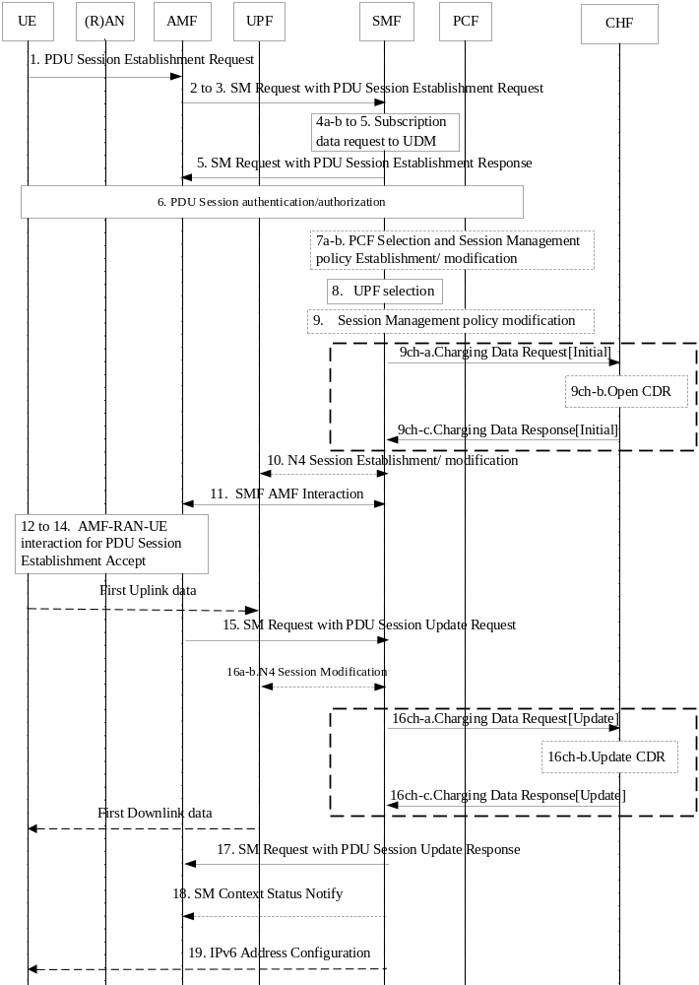
Figure 5.2.2.2.2-1: PDU session establishment
8. The SMF selects an SSC mode for the PDU Session and also selects one or more UPFs.
9. The SMF may perform a Session Management Policy Modification procedure to report some event to the PCF that has previously subscribed.
9ch-a.The SMF creates a Charging Id for the PDU session, and sends Charging Data Request[initial] to CHF for authorization for the subscriber to start the PDU session which is triggered by start of PDU session charging event.
9ch-b. The CHF opens CDR for this PDU session.
9ch-c. The CHF acknowledges by sending Charging Data Response[Initial] to the SMF.
15. AMF to SMF: SM Request (N2 SM information).
[16a-b]. N4 session Modification.
16ch-a. This step may occur in case "start of service data flow" needs quota from CHF, for the SMF to request quota.
16ch-b. The CHF updates CDR for this PDU session.
16ch-c. The CHF acknowledges by sending Charging Data Response[Update] to the SMF.
NOTE 1: The steps from 16ch-a to 16ch-c for quota request from CHF are not applicable for offline only charging.
17. SM Request with PDU session Update Response to AMF.
18. SMF sends SM Context Status Notify to AMF.
19. In case of PDU Type IPv6, IPv6 Address Configuration.

5.2.2.2.3 PDU Session Modification
The following figure 5.2.2.2.3-1 describes the PDU session modification charging, based on figure 4.3.3.2-1 TS 23.502 [202] description:
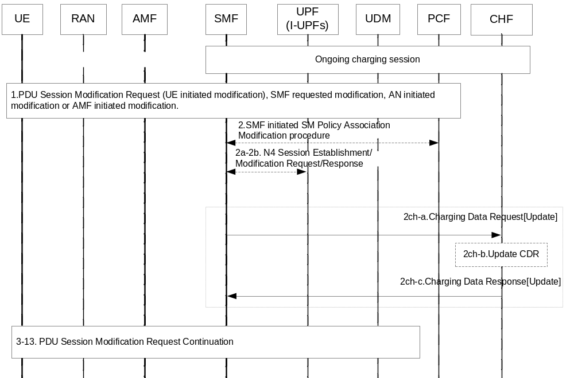
Figure 5.2.2.2.3-1: PDU Session Modification
2ch-a. The SMF sends Charging Data Request [Update] to the CHF for reporting the charging information when the corresponding trigger is armed.
2ch-b. The CHF update the CDR for the PDU session.
2ch-c. The CHF acknowledges by sending Charging Data Response [Update] to the SMF.

5.2.2.2.4 PDU Session Release
The following figure 5.2.2.2.4-1 describes the PDU session release charging, based on figure 4.3.4.2-1 TS 23.502 [202] description:
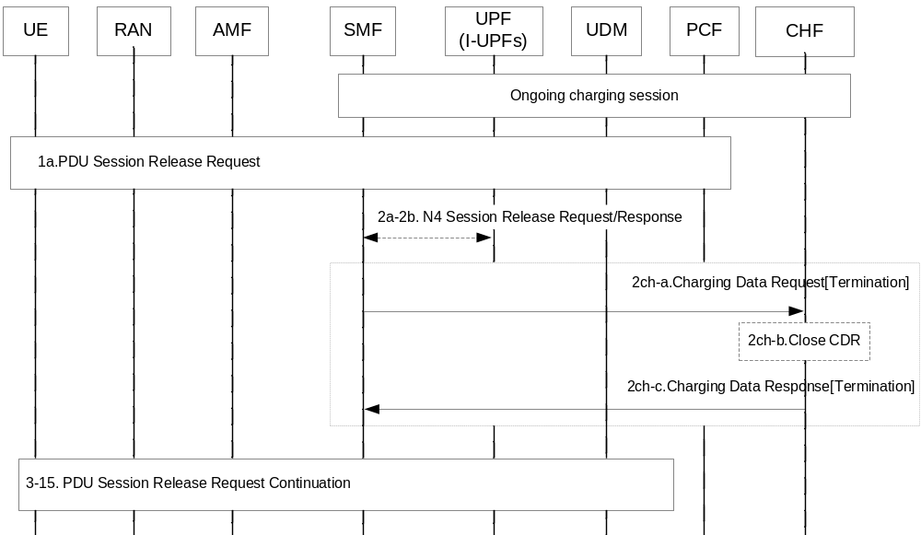
Figure 5.2.2.2.4-1: PDU Session Release
2ch-a. The SMF sends Charging Data Request [Termination] to the CHF for terminating the charging associated with PDU sessions, with the trigger "End of PDU session".
2ch-b. The CHF closes the CDR for the PDU session.
2ch-c. The CHF acknowledges by sending Charging Data Response [Termination] to the SMF.

5.2.2.3 PDU session charging SSC Mode 1 from SMF

5.2.2.3.1 General
The subclause below describes PDU session SSC mode 1 charging in non-roaming scenarios.

5.2.2.3.2 PDU session charging SSC Mode 1
The following figure 5.2.2.3.2.1 describes a PDU session SSC mode 1 charging, based on clause 5.6.9.2.1 TS 23.501 [201] description:

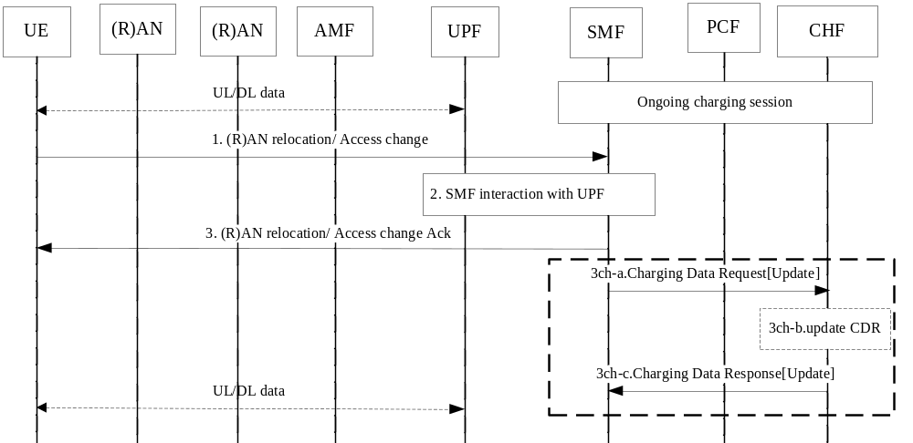
Figure 5.2.2.3.2.1: PDU session anchor relocation in SSC mode 1
Ongoing charging interaction associated with the established PDU session (UPF).
1. A (R)AN relocation is performed.
2. The SMF determines that the serving UPF needs to be maintained and interacts with the UPF for the path switch to the new (R)AN access.
3. the SMF acknowledges the path switch to the new (R)AN.
3ch-a. The SMF sends Charging Data Request[Update] to the CHF for reporting the charging information User location information/ Access Technology Type Information.
3ch-b. The CHF updates the CDR.
3ch-c. The CHF acknowledges by sending Charging Data Response[Update] to the SMF.

5.2.2.4 PDU session Charging SSC Mode 2 from SMF

5.2.2.4.1 General
The subclause below describes PDU session charging for change the PDU Session Anchor serving a PDU Session of SSC mode 2

5.2.2.4.2 PDU session Charging SSC Mode 2
The following figure 5.2.2.4.2.1 describes a PDU session anchor relocation in SSC mode 2 charging, based on figure 4.3.5.1.1 TS 23.502 [201] description:

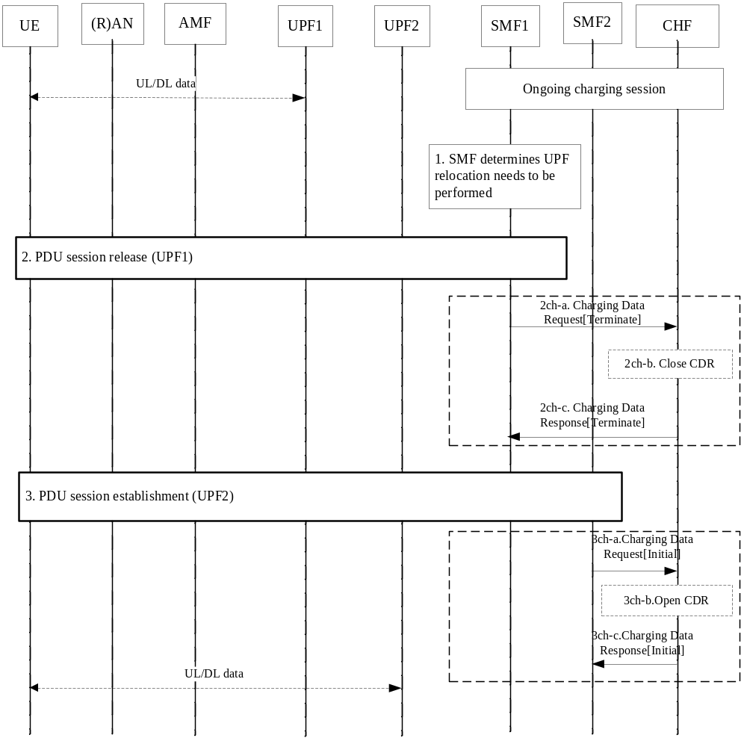
Figure 5.2.2.4.2.1: PDU session anchor relocation in SSC mode 2 with single PDU session anchor
Ongoing charging session associated with the established PDU session (UPF1)
2. PDU session release procedure (UPF1).
2ch-a. The SMF1 sends Charging Data Request[Termination] to the CHF for terminating the charging associated with old PDU session in UPF1.
2ch-b. The CHF closes the CDR for old PDU session in UPF1.
2ch-c. The CHF acknowledges by sending Charging Data Response[Termination] to the SMF1.
3. PDU session establishment procedure (UPF2).
3ch-a. The SMF2 creates a Charging Id for new PDU session ID in UPF2 and sends Charging Data Request[initial] to CHF for authorization for the subscriber to start the new PDU session which is triggered by start of PDU session charging event.
3ch-b. The CHF opens CDR for new PDU session in UPF2.
3ch-c. The CHF acknowledges by sending Charging Data Response[initial] to the SMF2.
NOTE: If the same SMF1 is re-selected is step 3, the same steps 3ch-a to b apply to SMF1

5.2.2.5 PDU session Charging SSC Mode 3 from SMF

5.2.2.5.1 General
The subclause below describes PDU session charging for change the PDU Session Anchor serving a PDU Session of SSC mode 3.

5.2.2.5.2 PDU session Charging SSC Mode 3
The following figure 5.2.2.5.2.1 describes a PDU session anchor relocation in SSC with mode 3 multiple PDU sessions and SMF reallocation, based on figure 4.3.5.2.1 TS 23.502 [201] description:

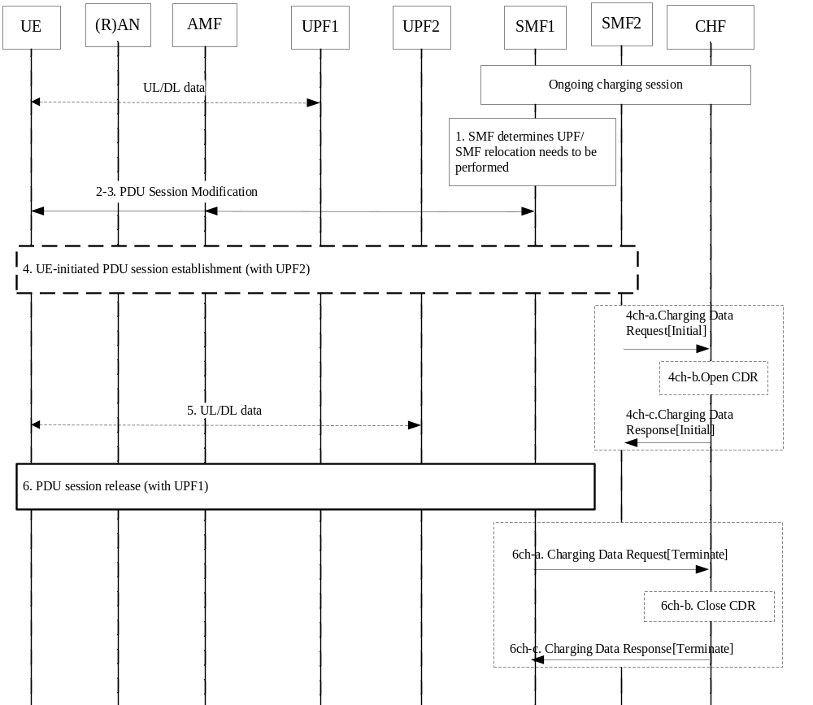
Figure 5.2.2.5.2.1: PDU session anchor relocation in SSC mode 3 with multiple PDU sessions – SMF reallocation
Ongoing charging interaction associated with the established PDU session (with UPF1).
4. UE initiates PDU session establishment procedure with UPF2..
4ch-a. The SMF2 creates a Charging Id for new PDU session ID with UPF2 and sends Charging Data Request[initial] to CHF for authorization for the subscriber to start the new PDU session (with UPF2) which is triggered by start of PDU session charging event.
4ch-b. The CHF opens CDR for new PDU session in UPF2.
4ch-c. The CHF acknowledges by sending Charging Data Response[initial] to the SMF2.
6. Old PDU session for UPF1 release.
6ch-a. The SMF1 sends Charging Data Request[Termination] to the CHF for terminating the charging associated with old PDU session in UPF1.
6ch-b. The CHF closes the CDR for old PDU session in UPF1.
6ch-c. The CHF acknowledges by sending Charging Data Response[Termination] to the SMF1.

5.2.2.6 PDU session Charging SSC Mode 3 IPv6 Multi Homed from SMF

5.2.2.6.1 General
The subclause below describes PDU session charging for service continuity with SSC mode 3 using the multi-homed PDU Session.

5.2.2.6.2 PDU session Charging SSC Mode 3 IPv6 Multi Homed
The following figure 5.2.2.6.2.1 describes a PDU session anchor relocation in SSC mode 3 with IPv6 Multi homed PDU Session charging, based on figure 4.3.5.3.1 TS 23.502 [201] description:

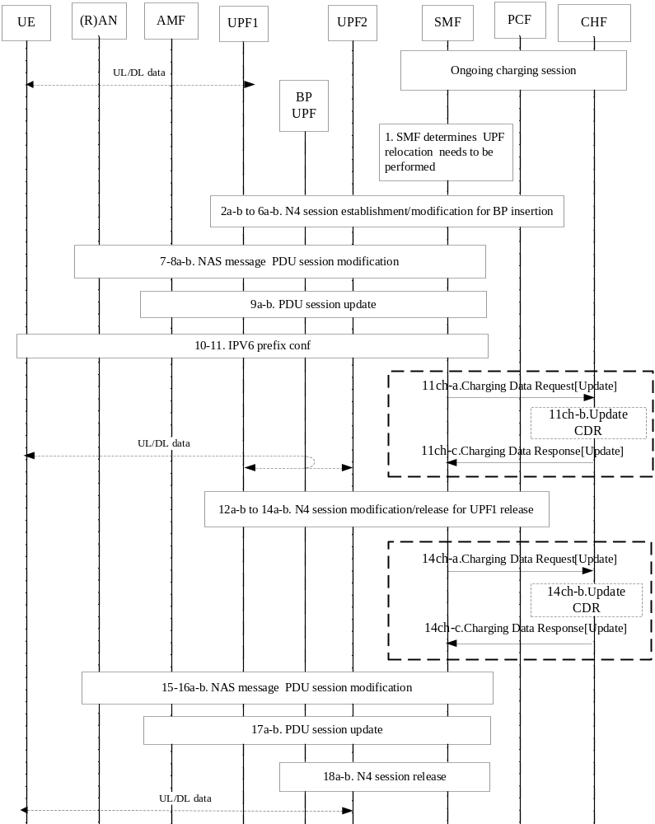
Figure 5.2.2.6.2.1: PDU session anchor relocation in SSC mode 3 with IPv6 Multi homed PDU Session
Ongoing charging interaction associated with the established PDU session (UPF1).
Traffic starts at UPF2.
11ch-a. The SMF sends Charging Data Request[Update] to the CHF for request quota for UPF2 which is triggered by start of service data flow charging event, if quota management per UPF.
11ch-b. The CHF updates CDR for this PDU session
11ch-c. The CHF acknowledges by sending Charging Data Response[Update] to the SMF.
[12a-b to 13a-b] The SMF releases the UE's old IPv6 prefix (IP@1), and releases the path between BP UPF and UPF1.
13ch-a. The SMF sends Charging Data Request[Update] to the CHF for usage reporting for UPF1 which is triggered by termination of service data flow charging event, if quota management per UPF.
13ch-b. The CHF updates CDR for this PDU session.
13ch-c. The CHF acknowledges by sending Charging Data Response[Update] to the SMF.

In this scenario, the PDU session Id is maintained during the whole procedure.

5.2.2.7 Addition of additional PDU Session Anchor and Branching Point or UL CL
The following figure 5.2.2.7.1 describes the charging procedure to add a PDU Session Anchor and a Branching Point or UL CL for an established PDU Session, based on figure 4.3.5.4.1 TS 23.502[201].
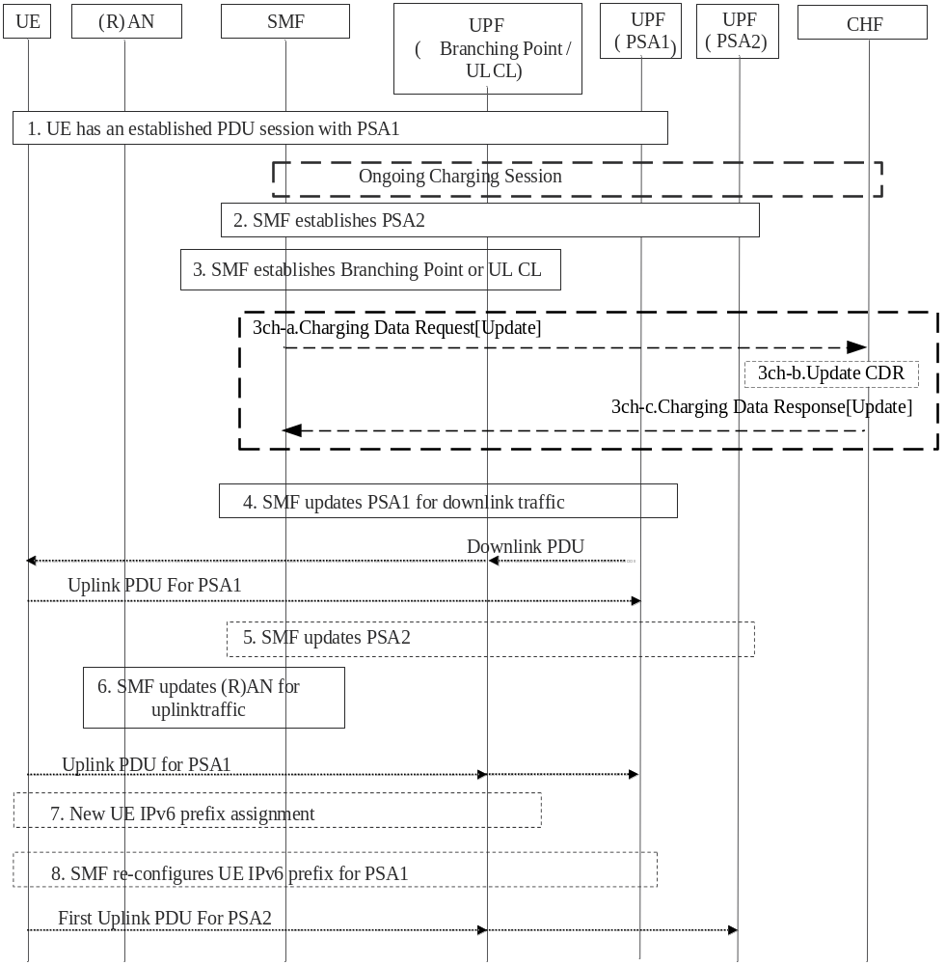
Figure 5.2.2.7.1: Addition of additional PDU Session Anchor and Branching Point or UL CL

Ongoing charging interaction associated with the established PDU session (UPF).
3. The SMF establishes the Branching Point (in case of IPv6 multi-homing) or a UL CL for the PDU Session.
3ch-a. The SMF sends Charging Data Request[Update] to the CHF for the additional of UPF (PSA 2) if quota management is granted per UPF by trigger "Addition of UPF".
3ch-b. The CHF updates the CDR for the charging information of UPF (PSA 2).
3ch-c. The CHF acknowledges by sending Charging Data Response[Update] to the SMF.

5.2.2.8 Removal of additional PDU Session Anchor and Branching Point or UL CL
The following figure 5.2.2.8.1 describes charging procedure to remove a PDU Session Anchor and (optionally) remove Branching Point or UL CL for an established PDU Session, based on figure 4.3.5.5.1 TS 23.502[201].
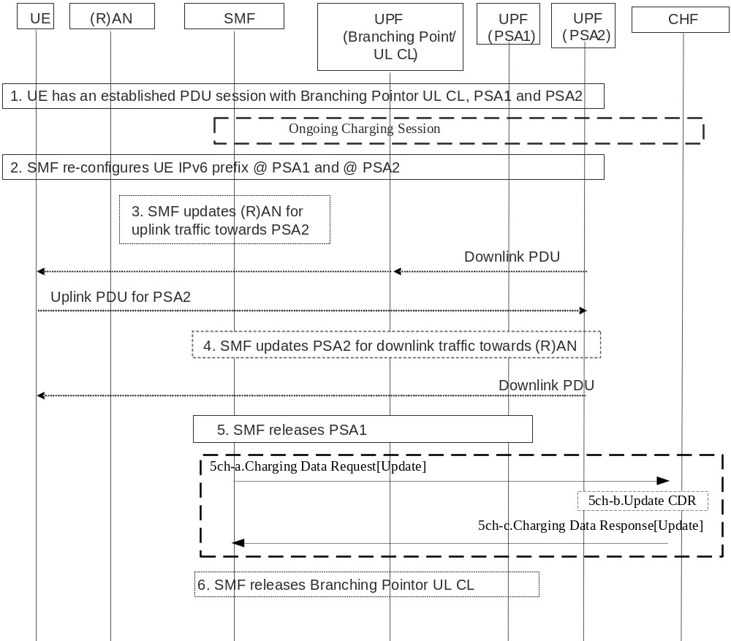
Figure 5.2.2.8.1: Removal of additional PDU Session Anchor and Branching Point or UL CL
Ongoing charging interaction associated with the established PDU session (UPF).
5. The SMF releases via N4 the PSA1.
5ch-a. The SMF sends Charging Data Request[Update] to the CHF for the removal of UPF (PSA 1) if quota management is granted per UPF by trigger "Removal of UPF".
5ch-b. The CHF updates the CDR for the charging information of UPF (PSA 1).
5ch-c. The CHF acknowledges by sending Charging Data Response[Update] to the SMF.
6. If steps 4 and 5 were executed, the SMF releases the Branching Point / UL CL.

5.2.2.9 Change of additional PDU Session Anchor for IPv6 multi-homing or UL CL
The following figure 5.2.2.9.1 charging procedure to establish a new additional PDU Session Anchor (i.e., PSA2) and conditionally releases the existing additional PDU Session Anchor (i.e. PSA1), while modifying IPv6 multi-homing or UL CL rule in the same Branching Point or UL CL under controlled by the same SMF abased on figure 4.3.5.6.1 TS 23.502[201].
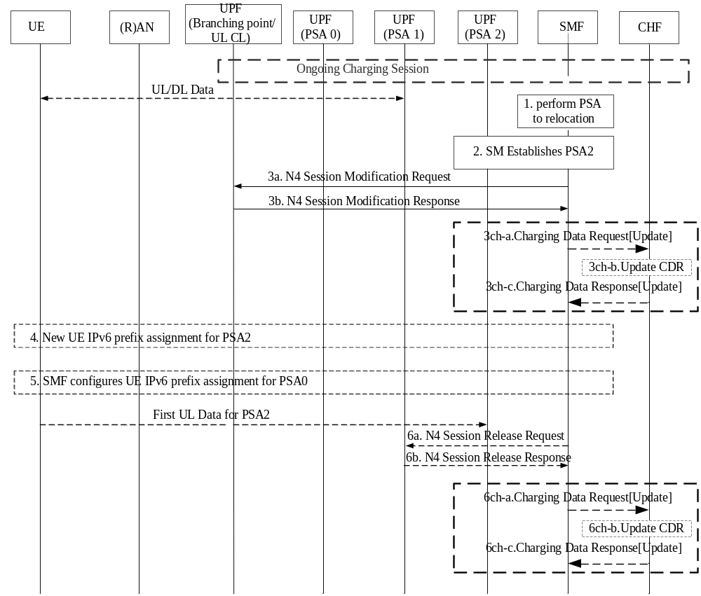
Figure 5.2.2.9.1: Change of additional PSA for a PDU Session in IPv6 multi-homing or UL CL case
Ongoing charging interaction associated with the established PDU session (UPF).
3a-b. The SMF exchange the N4 message toBranching Point or UL CL .
3ch-a. The SMF sends Charging Data Request[Update] to the CHF for the additional of UPF (PSA 2) if quota management is granted per UPF by trigger "Addition of UPF".
3ch-b. The CHF updates the CDR for the charging information of UPF (PSA 2).
3ch-c. The CHF acknowledges by sending Charging Data Response[Update] to the SMF.

6a-b. Step 6 occurs only if the Branching Point or UL CL does not have any traffic filter on the PDU Session which forwards a traffic flow to PSA1.
6ch-a. The SMF sends Charging Data Request[Update] to the CHF for the removal of UPF (PSA 1) if quota management is granted per UPF by trigger "Removal of UPF".
6ch-b. The CHF updates the CDR for the charging information of UPF (PSA 1).
6ch-c. The CHF acknowledges by sending Charging Data Response[Update] to the SMF.

5.2.2.10 Simultaneous change of Branching Point or UL CL and additional PSA for a PDU Session
The following figure 5.2.2.10.1 describe the charging procedure to change the Branching Point or the UL CL and additional PSA serving a PDU Session for a UE triggered by SMF ((just an example call flow triggered by Xn based handover) based on figure 4.3.5.7.1 TS 23.502[201].
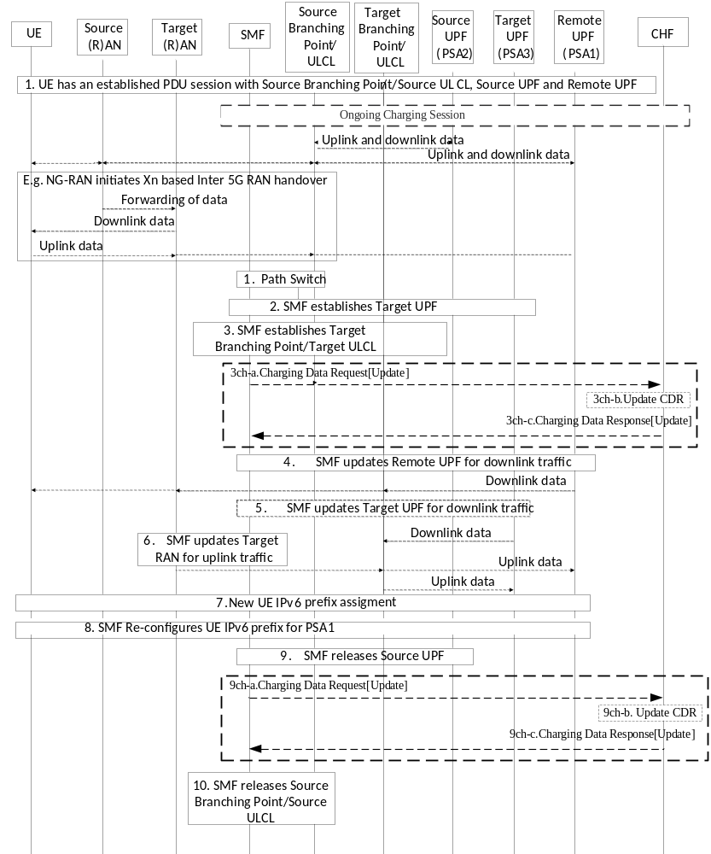
Figure 5.2.2.10.1: Simultaneous change of Branching Point or UL CL and additional PSA for a PDU Session

Ongoing charging interaction associated with the established PDU session (UPF).

3ch-a. The SMF sends Charging Data Request[Update] to the CHF for the additional of Target UPF if quota management is granted per UPF by trigger "Addition of UPF".
3ch-b. The CHF updates the CDR for the charging information of Target UPF.
3ch-c. The CHF acknowledges by sending Charging Data Response[Update] to the SMF.
9. The SMF releases PSA2.
9ch-a. The SMF sends Charging Data Request[Update] to the CHF for the removal of Source UPF if quota management is granted per UPF by trigger "Removal of UPF".
9ch-b. The CHF updates the CDR for the charging information of Source UPF.
9ch-c. The CHF acknowledges by sending Charging Data Response[Update] to the SMF.

5.2.2.11 PDU session charging for interworking with EPC

5.2.2.11.1 General
In order to interwork with EPC, the N26 interface is introduced as an inter-CN interface between the MME in EPC and 5GS AMF in order to enable provide seamless session continuity for single registration mode UE for inter-system change in the clause 5.17.2.2 TS 23.501[201].
PCF + PCRF, PGW-C + SMF and UPF + PGW-U are dedicated for interworking between 5GS and EPC, which are optional and are based on UE MM Core Network Capability and UE subscription in the clause 4.3 TS 23.501 [201]. The procedures for interworking with EPS based on N26 interface are specified in clause 4.11.1 TS 23.502 [201].
When 5GS and EPC interworking, interaction between the PGW-C + SMF and CHF is using the same interface as for interaction between SMF and CHF.
When a UE establishes a PDU session with PGW-C+SMF in EPS or 5GS, a charging session is established for the PDU session to support 5GS and EPS interworking as follows:
- When a UE is served by EPC, a charging session is established between the PGW-C+SMF and CHF via Nchf interface for EPC online charging and offline charging if 5GS interworking indication from SGW indicates that the UE supports 5G and the PDU session is not restricted to interworking with 5GS by user subscription.
- When a UE is served by 5GS, a charging session is established between the PGW-C+SMF and CHF via Nchf interface for 5GS converged online and offline charging.
- When a UE is served by EPC, the PGW-C+SMF acts as the PGW and a charging session is established via Gy interface for EPC online charging and Gz interface for offline charging if 5GS interworking is not supported.
The chargable events for 5GS and EPC interworking are handover cancel, handover start and handover complete.
The triggers for 5GS and EPC interworking may be enabled or disabled, the PGW-C+SMF will interact with charging system as the following:
- If the trigger for interworking is enabled and the category is set to "immediate reporting", the PGW-C+SMF will report usage in source network and/or request quota for target network.
- If the trigger for interworking is enabled and the category is set to "defered reporting", the PGW-C+SMF will close the count in source network and start a new count in target network, and continue to consume the quota in target network. The source access specific triggers will no more be applicable in the PGW-C+SMF, the target access specific triggers will apply instead.
- If the trigger for interworking is disabled, the PGW-C+SMF will record usage for both source and target network accesses into common count, and consumes the same quota in source and target network. The source access specific triggers will no more be applicable in the PGW-C+SMF, the target access specific triggers will apply instead.

5.2.2.11.2 5GS to EPS handover using N26 interface
The following figure 5.2.2.11.2.1 describes a PDU session charging handover from 5GS to EPS when N26 is supported, based on figure 4.11.1.2.1.1 TS 23.502 [201] description:

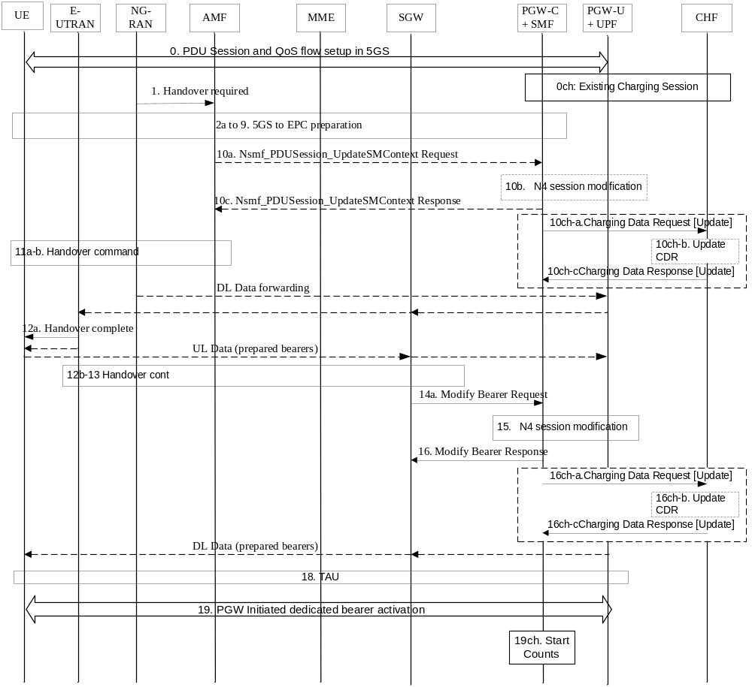Figure 5.2.2.11.2.1: PDU session charging: 5GS to EPS handover using N26
0. A PDU session is established in 5GS with multiple QoS Flows. A "Charging Id" was assigned to the PDU session.
0ch. A charging session between the PGW-C+SMF and CHF exists for this PDU session.
10c. PDU session update response to AMF.
10ch-a. This step occurs if steps 10a-c occurred. All counts are closed and a Charging Data Request [Update] is sent to CHF, if required by "Handover start" trigger. New counts and time stamps for all active service data flows are started in the PGW-C+SMF.
10ch-b. The CHF updates CDR for this PDU session.
10ch-c. The CHF acknowledges by sending Charging Data Response [Update] to the PGW-C+SMF.
16. User Plane path switch for the default bearer and the dedicated GBR bearers between the UE and PGW-U+UPF via SGW. The "Charging Id" assigned to the PDU session is supplied as the "Charging Id" for the default bearer QoS Flow(s). The "EPS bearer Charging Id" assigned to the dedicated EPS bearer QoS Flow(s), is supplied as the "Charging Id" for that dedicated EPS bearer
16ch-a. All counts are closed and a Charging Data Request [Update] is sent to CHF, if required by "RAT type change" trigger. New counts and time stamps for all active service data flows are started in the PGW-C+SMF.
16ch-b. The CHF updates CDR for this PDU session.
16ch-c. The CHF acknowledges by sending Charging Data Response [Update] to the PGW-C+SMF.
19. Dedicated bearer activation procedure for non-GBR QoS flows initiated by PGW-C+SMF.
19ch. Needed counts are started on start of service data flows of corresponding non-GBR Qos Flows.

5.2.2.11.3 EPS to 5GS handover using N26 interface
The following figures 5.2.2.11.3.1 and 5.2.2.11.3.2 describe a PDU session charging handover from EPS to 5GS when N26 is supported, based on figures 4.11.1.2.2.2.1 and 4.11.1.2.2.3.1 TS 23.502 [201] description:
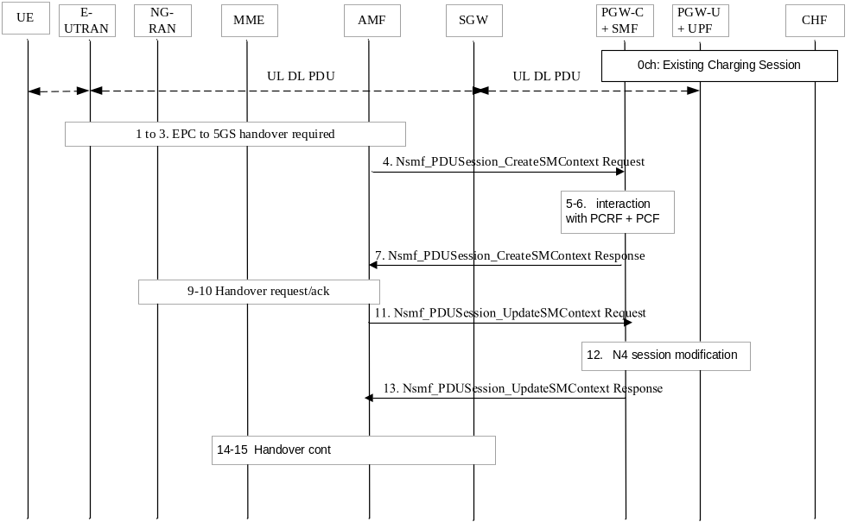
Figure 5.2.2.11.3.1: PDU session charging: EPS to 5GS handover using N26 - preparation
0. If the UE supports 5G and the PDU session is not restricted to interworking with 5GS by user subscription, the PGW-C+SMF is aware that 5GS interworking is supported. A PDU session is established in EPC with default bearer and dedicated bearers. Association between the EPS bearer and the corresponding 5G QoS Rules is stored by the PGW-C+SMF.
0ch. A charging session between the PGW-C+SMF and CHF exists for this PDU session with multiple QoS Flows associated to the default bearer and dedicated bearers. The set of QoS Flow(s) associated to the default bearer are assigned with the "Charging Id" of the PDU session. The set of QoS Flow(s) associated to a dedicated bearer are assigned with the "EPS bearer Charging Id" of that dedicated bearer.

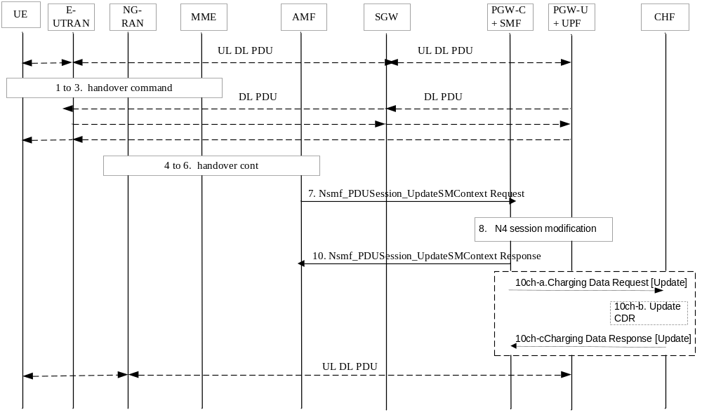
Figure 5.2.2.11.3.2: PDU session charging: EPS to 5GS handover using N26 - execution
10ch-a. All counts are closed and a Charging Data Request [Update] is sent to CHF, if required by "RAT type change" trigger. New counts and time stamps for all active service data flows are started in the PGW-C+SMF.
10ch-b. The CHF updates CDR for this PDU session.
10ch-c. The CHF acknowledges by sending Charging Data Response[Update] to the PGW-C+SMF.

5.2.2.11.4 Handover Cancel
The following figures 5.2.2.11.4.1 describe a PDU session charging handover cancel, based on clause 4.11.1.2.3 TS 23.502 [201] description:
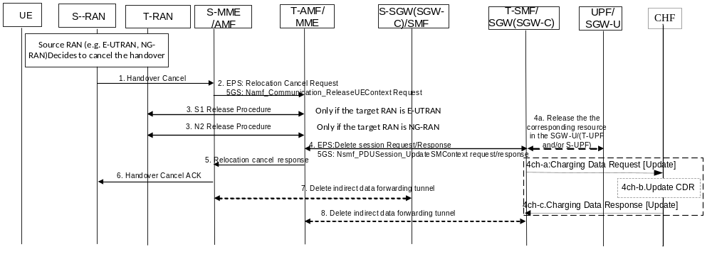
Figure 5.2.2.11.4.1: PDU session charging: Handover Cancel
4. Based on the Relocation Cancel Indication, the target CN node (MME or AMF) deletes the session resources established during handover preparation phase in SGW(SGW-C and SGW-U)/(SMF and UPF).
4ch-a. All counts are closed and a Charging Data Request [Update] is sent to CHF which triggered by “Handover cancel”, New counts and time stamps for all active service data flows are started in the PGW-C+SMF.
4ch-b. The CHF updates CDR for this PDU session.
4ch-c. The CHF acknowledges by sending Charging Data Response [Update] to the PGW-C+SMF.7. If indirect forwarding tunnel is setup during handover preparation phase then cancellation of handover triggers the source CN node to release the temporary resources used for indirect forwarding.
8. If indirect forwarding tunnel is setup during handover preparation phase then cancellation of handover triggers the target CN node to release the temporary resources used for indirect forwarding.

5.2.2.11.5 EPS to 5GS mobility without N26 interface
The following figures 5.2.2.11.5.1 describe a PDU session charging handover from EPS to 5GS without N26 support, based on clause 4.11.2.3 TS 23.502 [201] description:
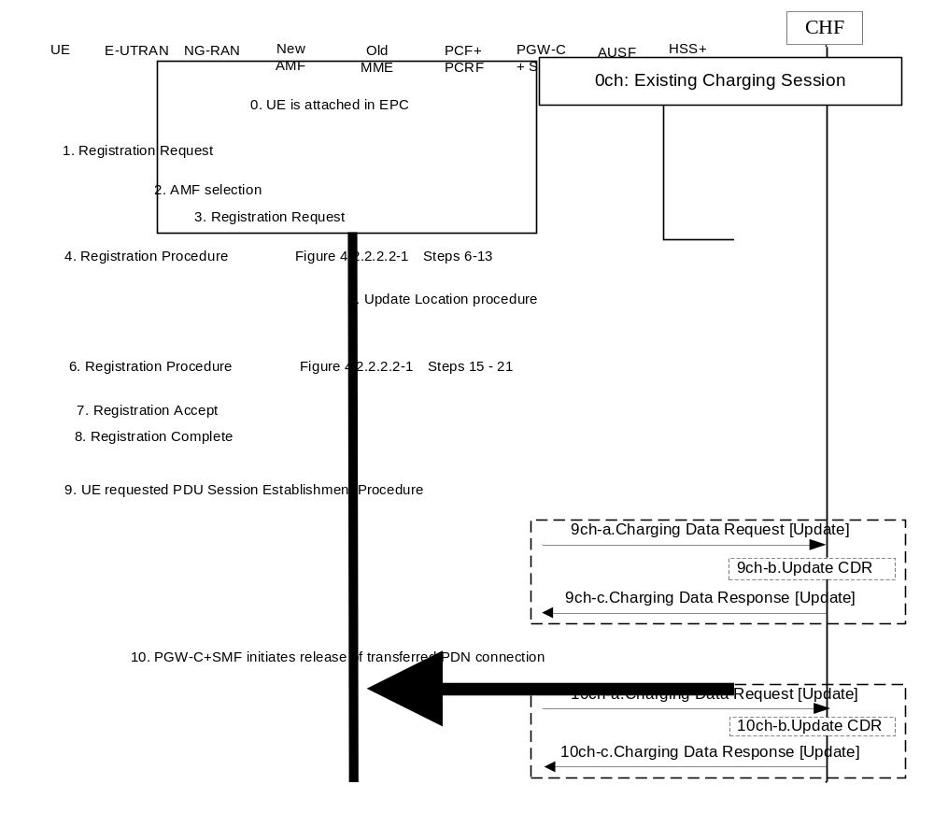
Figure 5.2.2.11.5.1: PDU session charging: EPS to 5GS mobility without N26
0. The UE is attached in EPC.
1-8. UE initiate registration procedure to the 5GS and indicates that it is moving from EPC.
9. UE requested PDU Session Establishment.
9ch-a. a Charging Data Request [Update] is sent to CHF which is trigged by Handover start charging event, New counts and time stamps for all active service data flows are started in the PGW-C+SMF.
9ch-b. The CHF updates CDR for this PDU session.
9ch-c. The CHF acknowledges by sending Charging Data Response [Update] to the PGW-C+SMF.
10. The PGW-C+SMF performs release of the resources in EPC for the PDN connections(s) transferred to 5GS by performing the PDN GW initiated bearer deactivation procedure.
10ch-a. All counts are closed and a Charging Data Request [Update] is sent to CHF which is trigged by Handover complete charging event.
10ch-b. The CHF updates CDR for this PDU session.
10ch-c. The CHF acknowledges by sending Charging Data Response [Update] to the PGW-C+SMF.

5.2.2.11.6 5GS to EPS mobility without N26 interface
The following figures 5.2.2.11.6.1 describe a PDU session charging handover from 5GS to EPS without N26 support, based on clause 4.11.2.2 TS 23.502 [201] description:

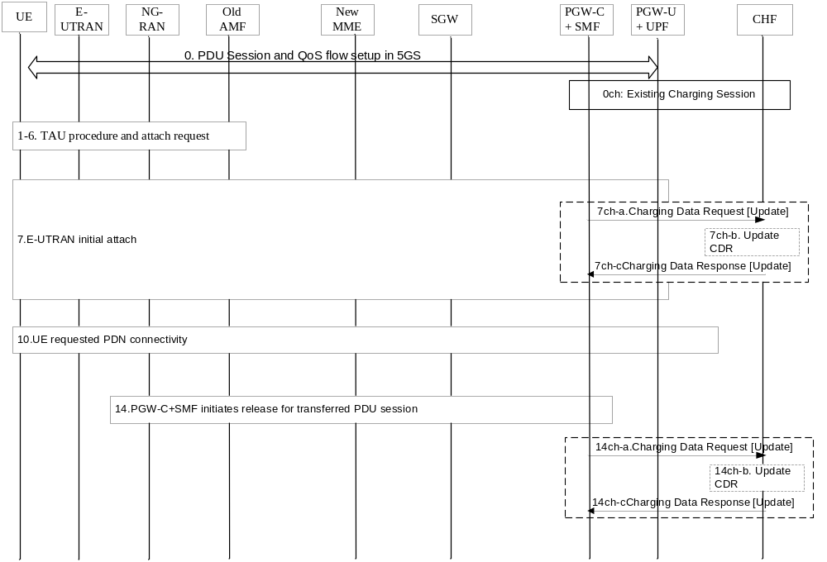
Figure 5.2.2.11.6.1: PDU session charging: 5GS to EPS mobility without N26
- UE is registered in 5GS.
1-6. TAU procedure is triggered to start for E-UTRAN initial attach.
7. UE initiate E-UTRAN Initial Attach procedure to the EPS and indicates that it is moving from 5GS.
7ch-a. a Charging Data Request [Update] is sent to CHF which is triggered by Handover start charging event. New counts and time stamps for all active service data flows are started in the PGW-C+SMF.
7ch-b. The CHF updates CDR for this PDU session.
7ch-c.The CHF acknowledges by sending Charging Data Response [Update] to the PGW-C+SMF.
10. If the UE has remaining PDU Sessions in 5GS which it wants to transfer to EPS and maintain the same IP address/prefix, the UE performs the UE requested PDN Connectivity Procedure.
14. The PGW-C+SMF initiates release of the PDU Session(s) in 5GS transferred to EPS.
14ch-a. All counts are closed and a Charging Data Request [Update] is sent to CHF which is triggered by Handover complete charging event.
14ch-b. The CHF updates CDR for this PDU session.
14ch-c. The CHF acknowledges by sending Charging Data Response [Update] to the PGW-C+SMF.

5.2.2.11.7 EPS to 5GS handover for roaming in Home routed scenario
The following figure 5.2.2.11.7.1 describes a PDU session charging handover from EPS to 5GS for roaming in Home routed scenario, focusing on the charging id generation mechanism.
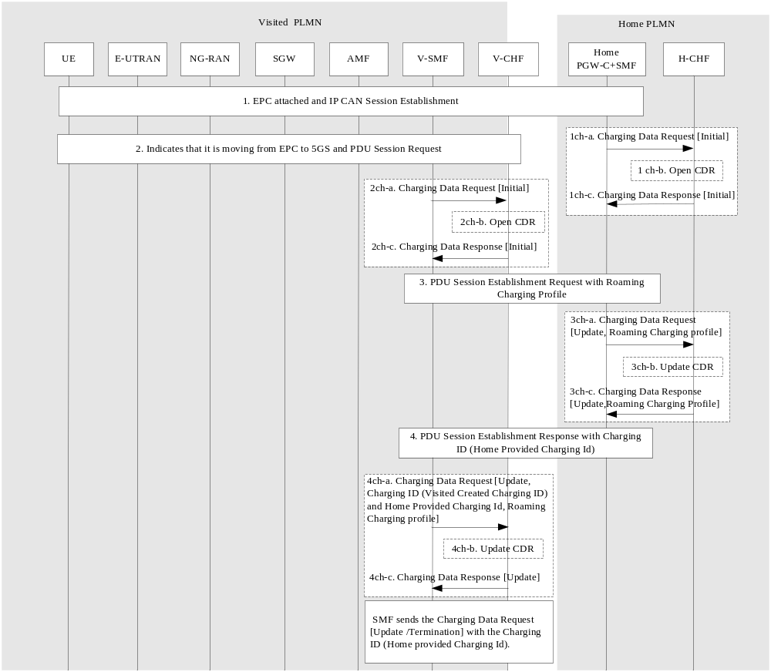
Figure 5.2.2.11.7.1: EPS to 5GS mobility without N26 in Home-Routed Roaming
1. The UE is attached in EPC and initiates a new IP-CAN session.
1ch-a. A Charging Data Request [Initial] is sent to CHF via PGW-C+SMF in HPLMN. The charging ID included is generated by PGW-C +SMF in HPLMN.
1ch-b. The H-CHF opens a CDR 1ch-c. The H-CHF acknowledges by sending Charging Data Response [Initial] to the PGW-C+SMF.
2. UE initiates registration procedure to the 5GS and indicates that it is moving from EPC. UE requests PDU Session Establishment.
2ch-a. SMF in VPLMN creates a charging ID (Visited created Charging Id) for the PDU session and sends the Charging Data Request [Initial] to CHF in VPLMN
2ch-b. The CHF in VPLMN opens a CDR.
2ch-c. The CHF in VPLMN acknowledges by sending Charging Data Response [Initial] to the SMF and optionally supplies a “Roaming Charging Profile” to the V-SMF which override the default one.
3. UPF selection and V-SMF sends the PDU session establishement request to H-SMF.
3ch-a. A Charging Data Request [Update] is sent to CHF in HPLMN, indicating the "Roaming Charging Profile" received from the VPLMN. The same charging ID in step 1ch-a will be the only one charging ID used for any subsequent charging data request sent from H-SMF to CHF i.e. the charging id generated in PGW-C +SMF in HPLMN.
3ch-b. The CHF in HPLMN updates the CDR.
3ch-c. The CHF in HPLMN acknowledges by sending Charging Data Response [Update] to the PGW-C+SMF and supplies the HPLMN selected "Roaming Charging Profile" to the PGW-C+SMF.
4. H-SMF sends the PDU session establishment response with charging Id (Home provided Charging ID).
4ch-a. A Charging Data Request [Update] is sent to CHF in VPLMN, with the "Roaming Charging Profile", charging ID (Visited created Charging Id) and Home provided Charging ID.
4ch-b. The CHF updates the CDR.
4ch-c. The CHF acknowledges by sending Charging Data Response [Update].
NOTE: Void
In subsequent charging data request sent from V-SMF to V-CHF, the charging ID Information element has the value of Home provided charging ID, and the Home provided charging ID Information element is not provided

5.2.2.11.8 Handover from EPC/ePDG to 5GS
The following figure 5.2.2.11.11.1 describes a PDU session charging handover from EPC/ePDG to 5GS for non-roaming scenario based on clause 4.11.4.1 Handover from EPC/ePDG to 5GS of TS 23.502 [201].
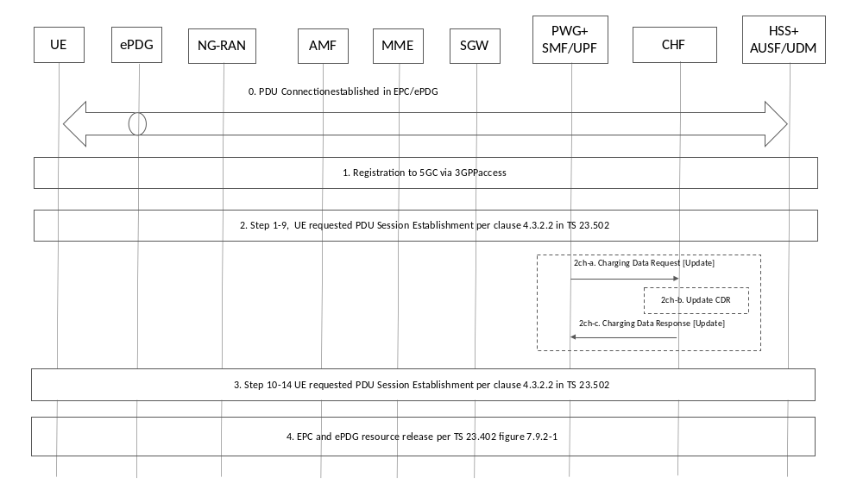
Figure 5.2.2.11.11.1: PDU session charging handover from EPC/ePDG to 5GS
0. One or more PDN Connections have been established.
1. UE register to 5GC via NG RAN.
2. The UE initiates a UE requested PDU Session Establishment via 3GPP Access and includes the "Existing PDU Session" indication or "Existing Emergency PDU Session" and the PDU Session ID.
2ch-a. PGW-C+SMF sends Charging Data Request [Update] to CHF if required by "RAT type change" trigger.
2ch-b. The CHF updates for this PDU session
2ch-c. The CHF acknowledges by sending Charging Data Response [Update] to the PGW-C+SMF.
3. Step 10-14, in procedure of UE requested PDU Session Establishment.
4. The combined PGW+SMF/UPF initiates a PDN GW initiated Resource Allocation Deactivation to release the EPC and ePDG resources.

5.2.2.11.9 Handover from 5GS to EPC/ePDG
The following figure 5.2.2.11.9.1 describes a PDU session charging handover from 5GS to EPC/ePDG based on clause 4.11.4.2 Handover from 5GS to EPC/ePDG in TS 23.502 [201].
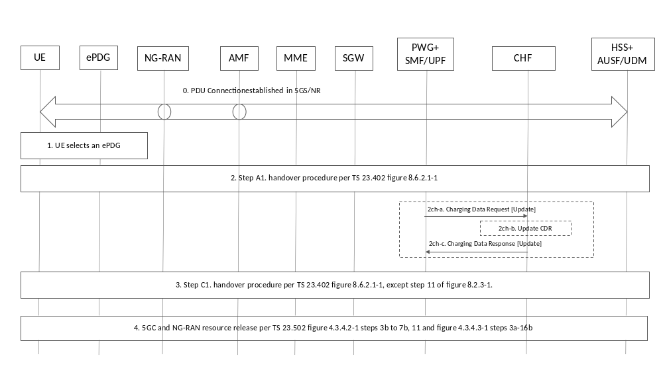
Figure 5.2.2.11.9.1: PDU session charging handover from 5GS to EPC/ePDG
0) One or more PDU Sessions have been established between the UE and the SMF/UPF via NG-RAN.
1) UE selects an ePDG.
2) Step A1 in procedure of the UE initiates a Handover Attach procedure.
2ch-a. PGW-C+SMF sends Charging Data Request [Update] to CHF if required by "RAT type change" trigger.
2ch-b. The CHF updates for this PDU session.
2ch-c. The CHF acknowledges by sending Charging Data Response [Update] to the PGW-C+SMF.
3) Step C1, in procedure of the UE initiates a Handover Attach procedure to the release of resources.
4) The combined PGW+SMF/UPF initiates a network requested PDU Session Release via 3GPP access.

5.2.2.12 PDU session charging for roaming in Home routed scenario

5.2.2.12.1 General
The subclauses below describe PDU session charging for roaming in Home routed scenario focusing on roaming QBC procedures between SMF and a CHF in respective PLMNs.
In H-PLMN, PDU session charging for FBC between H-SMF and a H-CHF occurring within the same charging session is not reflected.

5.2.2.12.2 PDU session establishment
The following figure 5.2.2.12.2.1 describes a PDU session charging establishment in roaming Home routed scenario based on figure 4.3.2.2.2.1 TS 23.502 [201] description:
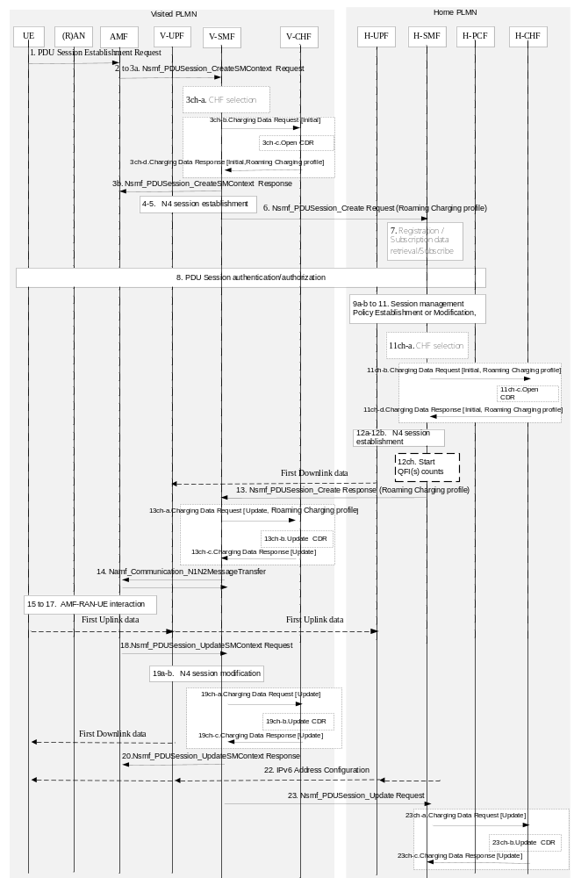Figure 5.2.2.12.2.1: PDU session charging: establishment roaming Home Routed
1-3a. UE initiates a new PDU session. V-SMF and H-SMF selection by the AMF.
3ch-a. The UE is identified as a roamer (PLMN ID of the received SUPI is different from VPLMN PLMN ID), the CHF is selected accordingly.
3ch-b. A Charging Data Request [Initial] is sent to CHF, indicating "in-bound roamer".
3ch-c. The CHF opens a CDR (indicating "in-bound roamer")
3ch-d. The CHF acknowledges by sending Charging Data Response[Initial] to the SMF and optionally supplies a "Roaming Charging Profile" to the V-SMF which overrides the default one.
10. UPF selection.
11. If dynamic PCC is deployed, SM policy association modification.
11ch-a. Based on UE is identified as roaming in a different PLMN, the CHF is selected accordingly.
11ch-b. A Charging Data Request [Initial] is sent to CHF, indicating "out-bound roamer", with the "Roaming Charging Profile" received from the VPLMN.
11ch-c. The CHF opens a CDR (indicating "out-bound roamer").
11ch-d. The CHF acknowledges by sending Charging Data Response[Initial] to the H-SMF and supplies the HPLMN selected "Roaming Charging Profile" (either the same as the one received from VPLMN, either its own selected) to the H-SMF.
[12a-b]. The SMF initiates an N4 Session Establishment procedure with the selected UPF.
12ch. Counts per QFI are started.
13. Nsmf_PDUSession_Create Response from H-SMF to V-SMF
13ch-a. Based on "received PDU session conditions" trigger, a Charging Data Request [Update] is sent to CHF with charging information received from H-SMF, which includes the HPLMN selected "Roaming Charging Profile" and counts per QFI are started.
13ch-b. The CHF updates the CDR.
13ch-c. The CHF acknowledges by sending Charging Data Response[Update] to the V-SMF.

19a-b. N4 session modification.
19ch-a. Counts per rejected QFI(s) are closed. A Charging Data Request [Update] is sent to CHF to report if needed.
19ch-b. The CHF updates the CDR.
19ch-c. The CHF acknowledges by sending Charging Data Response[Update] to the V-SMF.
23. Nsmf_PDUSession_UpdateRequest from V-SMF to H-SMF. The rejected QFI(s) are notified to H-SMF.
23ch-a. Counts per rejected QFI(s) are closed. A Charging Data Request [Update] is sent to CHF to report if needed.
23ch-b. The CHF updates the CDR.
23ch-c. The CHF acknowledges by sending Charging Data Response[Update] to the H-SMF.

5.2.2.12.3 PDU session modification
The following figure 5.2.2.12.3.1 describes a PDU Session Modification procedure, home-routed roaming scenario based on figure 4.3.3.3.1 TS 23.502 [201] description:
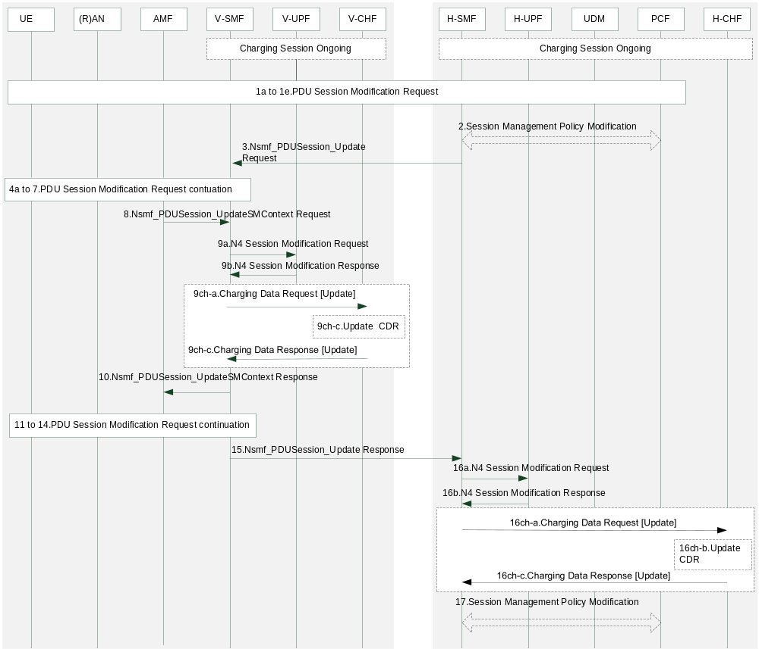
Figure 5.2.2.12.3.1: UE or network requested PDU Session Modification (for home-routed roaming scenario)

9ch-a. A Charging Data Request [Update] is sent to V-CHF with charging information received from V-SMF, if needed and new counts per QFI are started.
9ch-b. The CHF updates the CDR.
9ch-c. The CHF acknowledges by sending Charging Data Response[Update] to the V-SMF.
16ch-a. A Charging Data Request [Update] is sent to H-CHF with charging information received from H-SMF, if needed, and new counts per QFI are started.
16ch-b. The CHF updates the CDR.
16ch-c. The CHF acknowledges by sending Charging Data Response[Update] to the H-SMF.

5.2.2.12.4 PDU session release
The following figure 5.2.2.8.4.1 describes a PDU session charging release in roaming Home routed scenario based on figure 4.3.4.3.1 TS 23.502 [201] description:
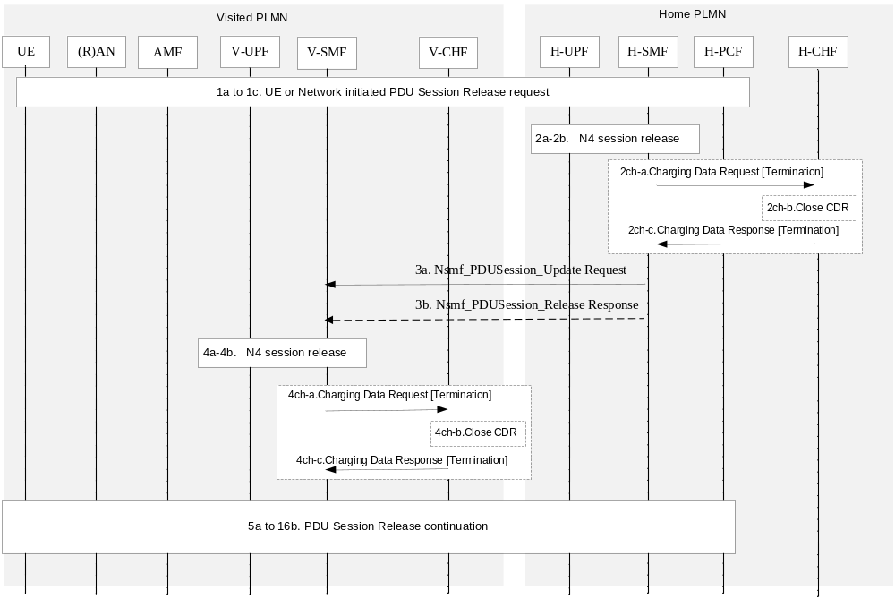
Figure 5.2.2.12.4.1: PDU session charging: release roaming Home Routed

2a-2b. N4 session release between H-SMF and H-UPF.
2ch_a. A Charging Data Request [Termination] is sent to CHF with the set of QFI(s) counts.
2ch-b. The CHF closes the CDR
2ch-c. The CHF acknowledges by sending Charging Data Response[Termination] to the H-SMF.

4a-4b. N4 session release between V-SMF and V-UPF.
4ch-a. A Charging Data Request [Termination] is sent to CHF with the set of QFI(s) counts.
4ch-b. The CHF closes the CDR
4ch-c. The CHF acknowledges by sending Charging Data Response[Termination] to the V-SMF.

5.2.2.13 PDU session charging - non-3GPP access

5.2.2.13.1 General
After UE registration to 5GC via an non-3GPP access network, a PDU session can be established via this non-3GPP access. For following scenarios, the PDU session establishment via untrusted non-3GPP access network is specified in clause 4.12 of TS 23.502 [201] and the PDU session establishment via trusted non-3GPP access network is specified in clause 4.12a of TS 23.502 [201]:
- UE initiated PDU session establishment;
- Handover of a PDU Session from 3GPP access to untrusted non-3GPP access;
- Service Request procedures via Untrusted non-3GPP Access specified in clause 4.12.4.5 of TS 23.502 [201];
- Service Request procedures via Trusted non-3GPP Access specified in clause 4.12.4a.5 of TS 23.502 [201].
Handover procedure of a PDU Session between 3GPP access and non-3GPP access is achieved by PDU Session Establishment over source access followed by PDU Session Release over the target access for respective N2 Resources Release. The PDU Session ID, IP address/prefix, and SSC mode are maintained during the move.
PDU session over Untrusted non-3GPP Access release and Trusted non-3GPP Access release are specified in clause 4.12.7 and clause 4.12a.7 of TS 23.502 [201].

5.2.2.13.2 PDU session establishment
5.2.2.13.2.1 PDU session establishment via an untrusted non-3GPP access network
The following figure 5.2.2.13.2.1 describes a PDU session charging establishment via an untrusted non-3GPP access network scenario based on figure 4.12. 5.1 in TS 23.502 [201] description:

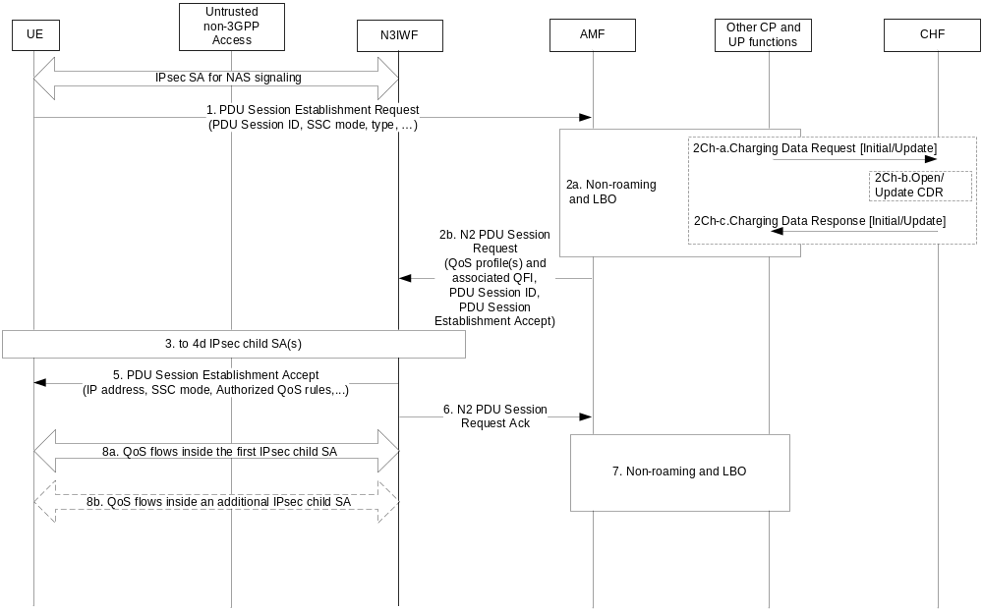Figure 5.2.2.13.2.1: PDU Session establishment via untrusted non-3GPP access
[2ch-a to 2ch-c]. Two cases:
- In case of "Initial request" the same steps as steps 7ch-a to 7ch-c in figure 5.2.2.2.1 apply, for initial SMF interaction with CHF, with Charging Data Request [Initial].
- In case of "Existing PDU Session" the "radio access type change" trigger may apply for SMF interaction with CHF, with Charging Data Request [Update].
5.2.2.13.2.2 PDU session establishment via Trusted Non-3GPP access network
After the UE registers to 5GC via trusted non-3GPP access network, the UE may request a PDU Session establishment by using the same procedure as the one specified in clause 5.2.2.13.2.1 for untrusted non-3GPP access, with the following modifications:
- The N3IWF in Figure 5.2.2.13.2.1 should be substituted with a TNGF and the Untrusted non-3GPP access should be substituted with a Trusted non-3GPP Access Point (TNAP).
- Charging Data Request [Initial/Update] contains RAT type and user location specifics to trusted non-3GPP.
- The TNGF may send a TNGF Identities parameter to AMF inside an N2 Uplink NAS Transport message. The TNGF Identities parameter contains a list of identifiers (i.e. FQDNs or IP addresses) of N3 terminations supported by the TNGF. If received by the AMF, it shall forward it to the SMF, which may use it as input to UPF selection.

5.2.2.13.3 PDU session modification
5.2.2.13.3.1 PDU session modification via an untrusted non-3GPP access network
The following figure 5.2.2.13.3.1 describes a PDU session charging modification via an untrusted non-3GPP access network scenario based on figure 4.12.16.1 in TS 23.502 [201] description:

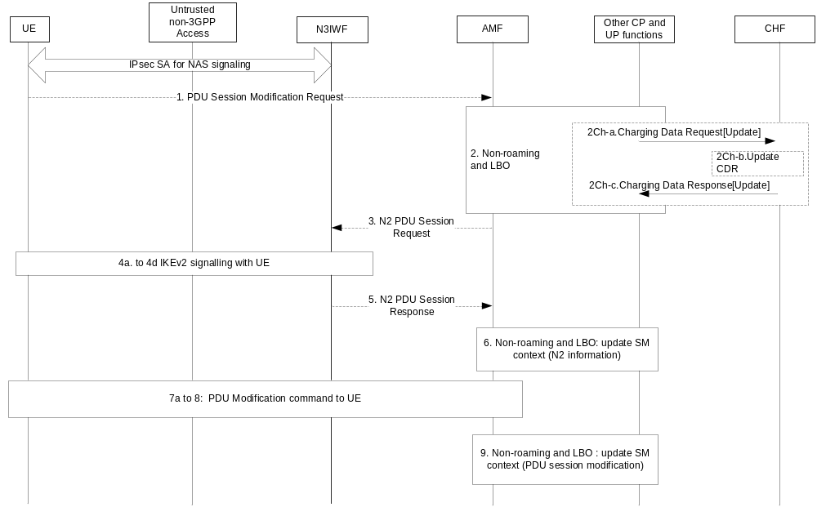
Figure 5.2.2.13.3.1: PDU Session modification via untrusted non-3GPP access

[2ch-a to 2ch-c]: Interaction between SMF and CHF triggered by the modification applied to the PDU session (e.g. QoS handling).
5.2.2.13.3.2 PDU session modification via Trusted Non-3GPP access network
The UE or network requested PDU Session Modification procedure via trusted non-3GPP access network is the same procedure as the one specified in clause 5.2.2.13.3.1 for untrusted non-3GPP access, with the following modifications:
- The N3IWF in Figure 5.2.2.13.3.1 should be substituted with a TNGF and the Untrusted non-3GPP access should be substituted with a Trusted non-3GPP Access Point (TNAP).
- Interaction between SMF and CHF triggered by the modification contains RAT type and user location specifics to trusted non-3GPP.

5.2.2.13.4 PDU session release
5.2.2.13.4.1 PDU session release via an untrusted non-3GPP access network
The following figure 5.2.2.13.4.1 describes a PDU session charging release via an untrusted non-3GPP access network scenario based on figure 4.12.17.1 in TS 23.502 [201] description:

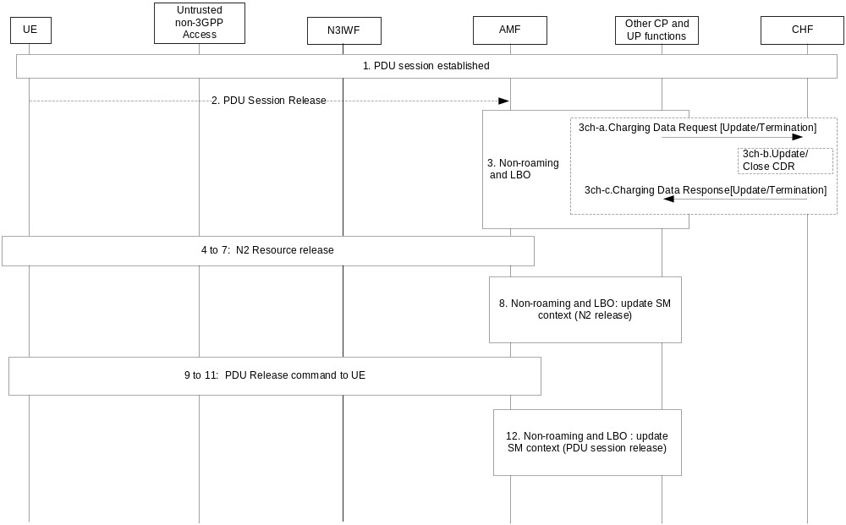Figure 5.2.2.13.4.1: PDU Session release via untrusted non-3GPP access
[3cha-3chb]. Two cases:
- In case the PDU session needs to be released, SMF interaction with CHF for release, with Charging Data Request [Termination].
- In case of handover from non-3GPP access to 3GPP access, SMF may interacts with CHF, with Charging Data Request [Update].
NOTE 1: the "radio access type change" trigger, if enabled, applied during the PDU session establishment over the 3GPP access which was performed prior to this PDU session release over non-3GPP access.
5.2.2.13.4.2 PDU session release via Trusted Non-3GPP access network
The UE or the network can release a PDU Session via a trusted non-3GPP access network as specified in clause 5.2.2.13.4.1 for the untrusted non-3GPP access with the following modifications:
- The untrusted non-3GPP access is substituted by a trusted non-3GPP access point (TNAP).
- The N3IWF is substituted by the TNGF.

5.2.2.14 PDU session served by I-SMF and SMF

5.2.2.14.1 General
When the I-SMF is inserted, re-allocated, or removed in a PDU Session as specified in TS 23.501 [200], the SMF may report the charging information to the CHF.
When the I-SMF with UL CL/BP is inserted based on information received from SMF, the I-SMF forwards traffic usage information to the SMF as specified in TS 23.501 [200].
When the V-SMF is changed for a Home Routed PDU Session as specified in TS 23.502 [201], the H-SMF may report the charging information to the H-CHF.

5.2.2.14.2 PDU session establishment with I-SMF insertion
The following figure 5.2.2.14.2.1 describes a PDU session establishment charging, for the case where the service area of the selected SMF does not include the location where the UE camps, based on TS 23.502 [201] figure 4.3.2.2.2, where the V-SMF and V-UPF are replaced by I-SMF and I-UPF, and H-SMF and H-UPF are replaced by SMF and UPF (PSA) respectively:

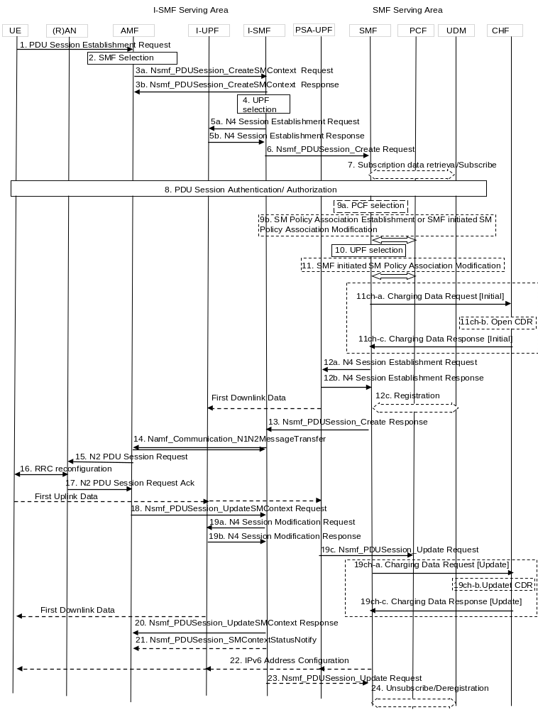
Figure 5.2.2.14.2.1: UE-requested PDU Session Establishment with I-SMF insertion
2. The AMF selects SMF and I-SMF upon SMF serving area cannot cover UE location.
5a. I-SMF selects one or more UPFs.
11. The SMF may perform a Session Management Policy Modification procedure to report some event to the PCF that has previously subscribed.
11ch-a. The SMF creates a Charging Id for the PDU session, and sends Charging Data Request [initial] including I-SMF information to CHF for authorization for the subscriber to start the PDU session which is triggered by start of PDU session charging event.
11ch-b. The CHF opens CDR for this PDU session.
11ch-c. The CHF acknowledges by sending Charging Data Response [Initial] to the SMF.
14. AMF to SMF: SM Request (N2 SM information).
[19a-b]. N4 session Modification.
19c, I-SMF notify SMF on N4 information with Traffic usage reporting.
19ch-a. This step may occur in case "start of service data flow" needs quota from CHF, for the SMF to request quota for both own and I-SMF usage.
19ch-b. The CHF updates CDR for this PDU session.
19ch-c. The CHF acknowledges by sending Charging Data Response [Update] to the SMF.
NOTE 1: The steps from 19ch-a to 19ch-c for quota request from CHF are not applicable for offline only charging.
20. SM Request with PDU session Update Response to AMF.
21. SMF sends SM Context Status Notify to AMF.
22. In case of PDU Type IPv6, IPv6 Address Configuration.
NOTE 2: I-SMF controlling both I-UPF and PSA2 UPF upon local traffic offload scenarios, can enforce usage report and/or quota management for PSA2 UPF.

5.2.2.14.3 PDU Session modification procedure with I-SMF involved
The following figure 5.2.2.14.3-1 describes a PDU Session modification charging message flow, for the case where the service area of the selected SMF does not include the location where the UE camps, with simplified I-SMF with UE and Serving Network message flows , based on TS 23.502 [201] figure 4.3.3.3-1, where the V-SMF and V-UPF are replaced by I-SMF and I-UPF, and H-SMF and H-UPF are replaced by SMF and UPF (PSA) respectively:
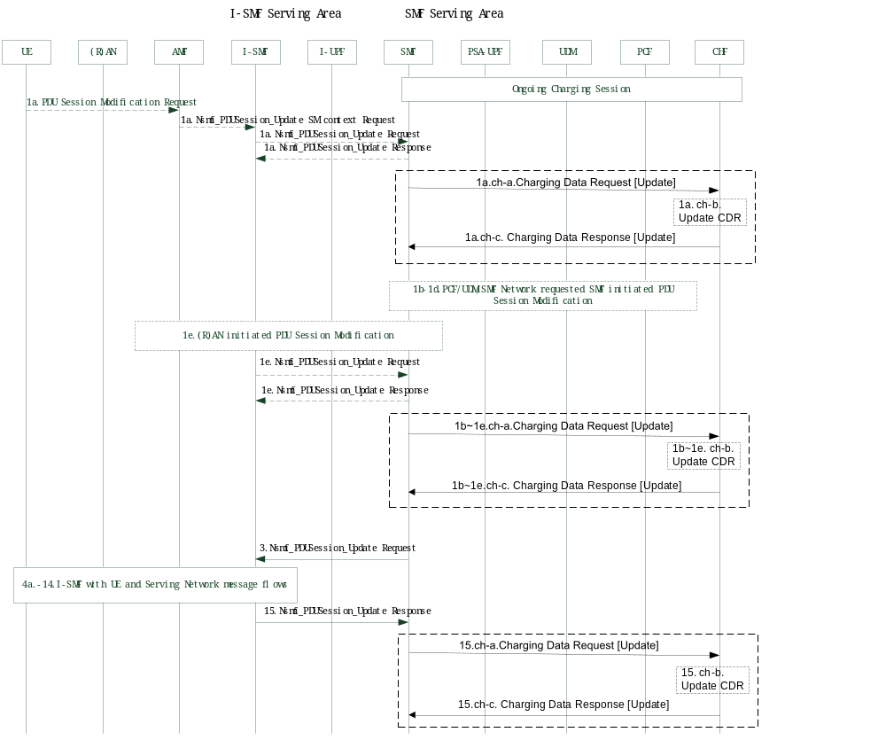
Figure 5.2.2.14.3-1: UE or network requested PDU Session Modification charging with I-SMF involved
PDU Session served by both I-SMF and SMF has been established, with the ongoing Charging session.
1a. UE or serving network AMF requested PDU Session Modification Request to I-SMF, I-SMF invokes a Nsmf_PDUSession_Update Request message to SMF, including User Location Information, QoS information and I-SMF information. SMF accept with Nsmf_PDUSession_Update_Response message to I-SMF.
1a.ch-a. All counts are closed in SMF and a Charging Data Request [Update] message with PDU Session related triggers including I-SMF information is sent to CHF, if required by immediate report category trigger. New counts and time stamps for all active service data flows are started in the SMF.
1a.ch-b. The CHF updates CDR for this PDU session.
1a.ch-c. The CHF acknowledges by sending Charging Data Response [Update] message to the SMF.
1b~1d. With PCF initiated SM Policy Association Modification or UDM updated the subscription data or SMF decided to modify PDU Session triggers, SMF starts SMF requested PDU Session Modification procedures.
1e. (R)AN initiated PDU Session Modification Request to I-SMF, I-SMF invokes a Nsmf_PDUSession_Update Request message to SMF, including User Location Information, QoS information with indication of QoS flow released and I-SMF information. SMF accept with Nsmf_PDUSession_Update_Response message to I-SMF.
1b~1e.ch-a. All counts are closed in SMF and a Charging Data Request [Update] message with PDU Session related triggers including I-SMF information is sent to CHF, if required by immediate report category trigger. New counts and time stamps for all active service data flows are started in the SMF.
1b~1e.ch-b. The CHF updates CDR for this PDU session.
1b~1e.ch-c. The CHF acknowledges by sending Charging Data Response [Update] message to the SMF.
3. With SMF initiated QoS flows modification procedure, SMF invokes a Nsmf_PDUSession_Update Request message to I-SMF.
4~14. I-SMF interacting with UE and Serving Network message flows, including the QoS rule(s) and QoS Flow level QoS parameters operations.
15. I-SMF invokes a Nsmf_PDUSession_Update Response message to SMF, including User Location Information, QoS flow information and I-SMF information.
15.ch-a. All counts are closed in SMF and a Charging Data Request [Update] message with PDU Session related triggers including I-SMF information is sent to CHF, if required by immediate report category trigger. New counts and time stamps for all active service data flows are started in the SMF.
15.ch-b. The CHF updates CDR for this PDU session.
15.ch-c. The CHF acknowledges by sending Charging Data Response [Update] message to the SMF.

5.2.2.14.4 PDU Session release procedure with I-SMF involved
The following figure 5.2.2.14.4-1 describes a PDU session release charging message flow, for the case where the service area of the selected SMF does not include the location where the UE camps, with simplified I-SMF with UE and Serving Network message flows , based on TS 23.502 [201] figure 4.3.4.3-1, where the V-SMF and V-UPF are replaced by I-SMF and I-UPF, and H-SMF and H-UPF are replaced by SMF and UPF (PSA) respectively.
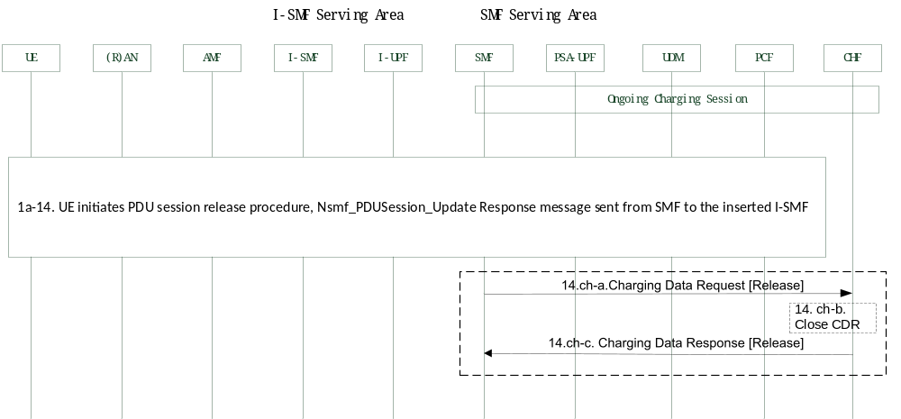
Figure 5.2.2.14.4-1: UE or network requested PDU Session release charging with I-SMF involved
PDU Session served by both I-SMF and SMF has been established, with the ongoing Charging session.
1a-14. UE initiates PDU session release procedure, finally with Nsmf_PDUSession_Update Response message sent from SMF to the inserted I-SMF.
14.ch-a. All counts are closed in SMF and a Charging Data Request [Release] message including I-SMF information is sent to CHF, with usage reporting.
14.ch-b. The CHF close CDR for this PDU session.
14.ch-c. The CHF acknowledges by sending Charging Data Response [Release] message to the SMF.

5.2.2.14.5 PDU Session procedures with I-SMF insertion/change/removal
PDU Session procedures with I-SMF insertion/change/removal, including below three figures described procedures covering Service Request, N2 based handover and Xn based handover.
The following figure 5.2.2.14.5-1 describes PDU session charging message flows, for the Service Request cases where
- the UE moves from SMF service area to new I-SMF service area, a new I-SMF is inserted (i.e. I-SMF insertion); or
- the UE moves from old I-SMF service area to new I-SMF service area, the I-SMF is changed (i.e. I-SMF change); or
- the UE moves from I-SMF service area back to SMF service area, the I-SMF is removed (i.e. I-SMF removal).
with simplified UE with 5GS message flows, based on TS 23.502 [201] figure 4.23.4.3-1, for I-SMF insertion, change, removal respectively, and specifies the corresponding charging message flow between SMF and CHF.
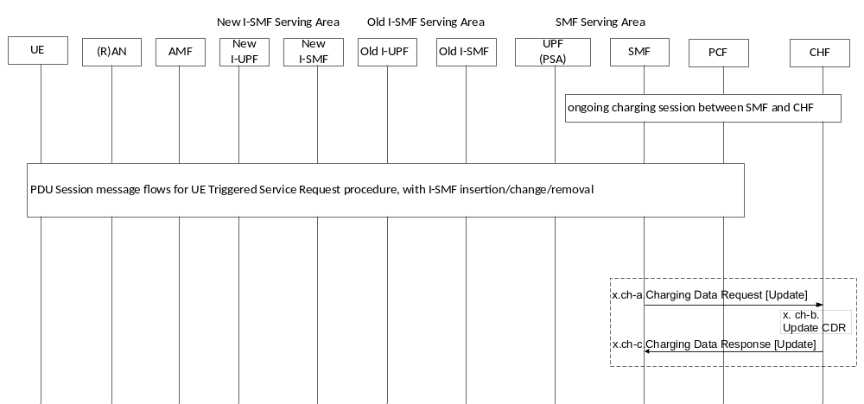Figure 5.2.2.14.5-1: PDU Session charging message flows for UE Triggered Service Request procedure with I-SMF insertion/change/removal
PDU Session served by both I-SMF and SMF has been established, with the ongoing Charging session.
PDU Session message flows for UE Triggered Service Request procedure, with I-SMF insertion/change/removal triggers charging message flows as below:
- I-SMF insertion message flows, upon UE moves from SMF service area to I-SMF service area, finally with Nsmf_PDUSession_Create Response message sent from SMF to the inserted I-SMF (Detail message flows refer to TS 23.502,4.23.4.3-1 step 3 to 8c), or finally with Nsmf_PDUSession_Update Response message sent from SMF to the inserted I-SMF (Detail message flows refer to TS 23.502 [201],4.23.4.3-1 step 18 to 20c).
- I-SMF change message flows, upon UE moves from old SMF service area to new I-SMF service area, finally with Nsmf_PDUSession_Update Response message sent from SMF to the inserted new I-SMF (Detail message flows refer to TS 23.502 [201],4.23.4.3-1 step 3 to 8c, or step 18 to 20c).
- I-SMF removal message flows, upon UE moves from I-SMF service area back to SMF service area, finally SMF send Nsmf_PDUSession_CreateSMContext Response message to AMF (Detail message flows refer to TS 23.502,4.23.4.3-1 step 10 to 16), or SMF send Nsmf_PDUSession_UpdateSMContext Response message to AMF (Detail message flows refer to TS 23.502 [201], 4.23.4.3-1 step 22 to 25)
x.ch-a. All counts are closed in SMF, and a Charging Data Request [Update] message including I-SMF information and “insertion/change/removal of I-SMF” trigger is sent to CHF, if required by immediate report category trigger. New counts and time stamps for all active service data flows are started in the SMF.
x.ch-b. The CHF updates CDR for this PDU session.
x.ch-c. The CHF acknowledges by sending Charging Data Response [Update] message to the SMF.
NOTE 1: x in figure 5.2.2.14.5-1, refer to the last step number in the detail message flows. For I-SMF insertion or I-SMF change, x refers to 8c or 20c. For I-SMF removal, x refers to 16 or 25.
The following figure 5.2.2.14.5-2 describes PDU session charging message flows, for N2 based handover, with I-SMF insertion, change, removal.
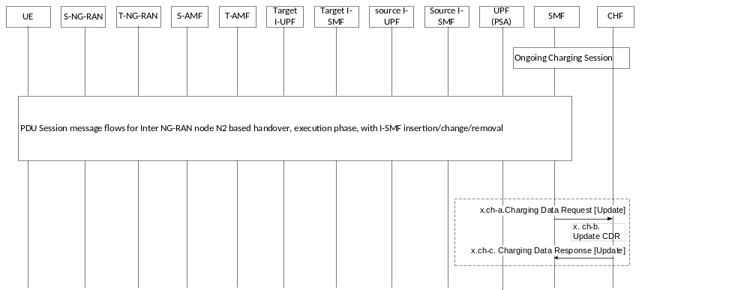
Figure 5.2.2.14.5-2: PDU Session charging message flows for Inter NG-RAN node N2 based handover, execution phase, with I-SMF insertion/change/removal
PDU Session served by both I-SMF and SMF has been established, with the ongoing Charging session between SMF and CHF.
PDU Session message flows for Inter NG-RAN node N2 based handover procedure, with I-SMF insertion/change/removal triggers charging message flows as below:
- I-SMF insertion message flows, for N2 based handover, refer to TS 23.502 [201], 4.23.7.3.3-1 step 2 to 8.
- I-SMF Change message flows, for N2 based handover, refer to TS 23.502 [201], 4.23.7.3.3-1 step 2 to 8,
- I-SMF Removal message flows, for N2 based handover, refer to TS 23.502 [201], 4.23.7.3.3-1 step 10 to 14.
x.ch-a. All counts are closed in SMF with the I-SMF, and a Charging Data Request [Update] message including I-SMF information and “insertion/change/removal of I-SMF” trigger is sent to CHF, if required by immediate report category trigger. New counts and time stamps for all active service data flows are started in the SMF.
x.ch-b. The CHF updates CDR for this PDU session.
x.ch-c. The CHF acknowledges by sending Charging Data Response [Update] message to the SMF.
NOTE 2: x in figure 5.2.2.14.5-2, refer to the last step number in the detail message flows. For I-SMF insertion or I-SMF change, x refers to 8. For I-SMF removal, x refers to 14.
The following figure 5.2.2.14.5-3 describes PDU session charging message flows, for Xn based handover, with I-SMF insertion, change, removal.
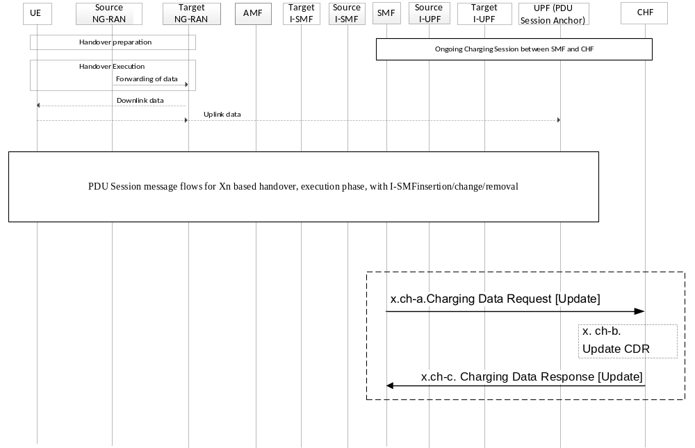
Figure 5.2.2.14.5-3: PDU Session charging message flows for Xn based handover, execution phase, with I-SMFinsertion/change/removal
PDU Session served by both I-SMF and SMF has been established, with the ongoing Charging session between SMF and CHF.
PDU Session message flows for X2 based handover procedure, with I-SMF insertion/change/removal triggers charging message flows as below:
- I-SMF insertion message flows, for Xn based handover, refer to TS 23.502 [201], 4.23.11.2-1 step 1 to 9.
- I-SMF Change message flows, for Xn based handover, refer to TS 23.502 [201], 4.23.11.3-1 step 1 to 9,
- I-SMF Removal message flows, for Xn based handover, refer to TS 23.502 [201], 4.23.11.4-1 step 1 to 8.
x.ch-a. All counts are closed in SMF with the I-SMF, and a Charging Data Request [Update] message including I-SMF information and “insertion/change/removal of I-SMF” trigger is sent to CHF, if required by immediate report category trigger. New counts and time stamps for all active service data flows are started in the SMF.
x.ch-b. The CHF updates CDR for this PDU session.
x.ch-c. The CHF acknowledges by sending Charging Data Response [Update] message to the SMF.
NOTE 3: x in figure 5.2.2.13.5-3, refer to the last step number in the detail message flows. For I-SMF insertion or I-SMF change, x refers to 9. For I-SMF removal, x refers to 8.

5.2.2.14.6 5GS to EPS handover using N26 interface with I-SMF removal
When 5GS to EPS handover using N26 interface in idle mode, procedure in TS 23.502 [201] clause 4.23.12.2 is applicable.
When 5GS to EPS handover using N26 interface in active mode, procedure in TS 23.502 [201] clause 4.23.12.6 is applicable.
Upon UE moves from I-SMF service area to EPS service area, with both RAT Type change and I-SMF removal triggered, PGW-C+SMF and CHF will conduct below charging procedures:
x.ch-a. All counts are closed in PGW-C+SMF with a Charging Data Request [Update] message including I-SMF information and both “RAT Type change” and “removal of I-SMF” triggers are sent to CHF, if required by immediate report category trigger. New counts and time stamps for all active service data flows are started in the PGW-C+SMF.
x.ch-b. The CHF updates CDR for this PDU session.
x.ch-c. The CHF acknowledges by sending Charging Data Response [Update] message to the PGW-C+SMF.
NOTE 1: x refers to the last message step number with I-SMF removal in the detail message flows in TS 23.502 [201] clause 4.23.12.2 or clause 4.23.12.6.

5.2.2.14.7 EPS to 5GS handover using N26 interface with I-SMF insertion
When EPS to 5GS handover using N26 interface in idle mode, procedure in TS 23.502 [201] clause 4.23.12.3 is applicable.
When EPS to 5GS handover using N26 interface in active mode, procedure in TS 23.502 [201] clause 4.23.12.7 is applicable.
Upon UE moves from EPS service area to I-SMF service area, with both RAT Type change and I-SMF insertion triggered, PGW-C+SMF and CHF conduct below charging procedures:
x.ch-a. All counts are closed in PGW-C+SMF with a Charging Data Request [Update] message including I-SMF information and both “RAT Type change” and “insertion of I-SMF” triggers are sent to CHF, if required by immediate report category trigger. New counts and time stamps for all active service data flows are started in the PGW-C+SMF.
x.ch-b. The CHF updates CDR for this PDU session.
x.ch-c. The CHF acknowledges by sending Charging Data Response [Update] message to the PGW-C+SMF.
NOTE 1: x refers to the last message step number with I-SMF insertion in the detail message flows in TS 23.502 [201] clause 4.23.12.3 or clause 4.23.12.7.

5.2.2.14.8 Addition/removal/change of PSA and UL CL or BP controlled by I-SMF
This clause is based on TS 23.502 clause 4.23.9.1, 4.23.9.2 and 4.23.9.3 procedures, describes simplified procedures of addition/removal/change of PSA and UL CL or BP controlled by I-SMF, adding with charging message flow:
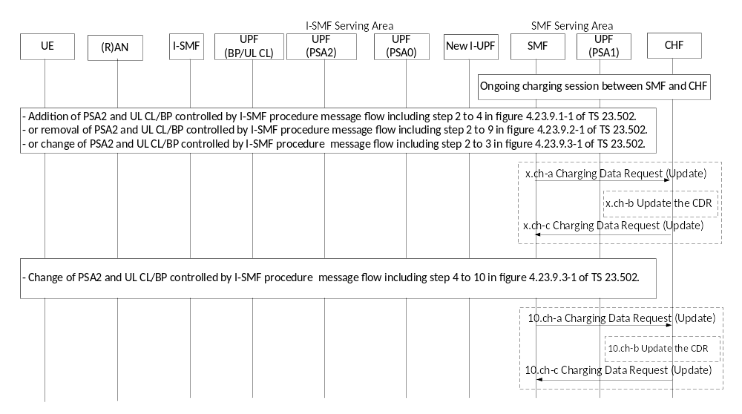
Figure 5.2.2.14.8-1: Addition/removal/change of PSA and UL CL or BP controlled by I-SMF
PDU Session served by both I-SMF and SMF has been established, with the ongoing Charging session.
PDU Session message flows with addition/removal/change of I-SMF controlled addition/removal/change of PSA and UL CL/BP with charging message flows as below:
- Addition of PDU Session Anchor (PSA2) for UL CL/BP controlled by I-SMF message flows, refer step 2 to step 4 described in figure 4.23.9.1-1 of TS 23.502[201].
- Removal of PDU Session Anchor (PSA2) for UL CL/BP controlled by I-SMF message flows, refer step 2 to step 9 described in figure 4.23.9.2-1 of TS 23.502[201].
- Change of PDU Session Anchor (PSA0 to PSA2) for UL CL/BP controlled by I-SMF message flows, refer step 2 to step 3 and step 4 to step 10 described in figure 4.23.9.3-1 of TS 23.502[201].
x.ch-a. All counts are closed in SMF for I-SMF controlled local PSA traffic, and a Charging Data Request [Update] message including I-SMF information and “addition/removal of UPF” trigger is sent to CHF, if required by immediate report category trigger. New counts and time stamps for all addition of PSA active service data flows are started in the SMF.
x.ch-b The CHF updates the CDR for this PDU Session.
x.ch-c. The CHF acknowledges by sending Charging Data Response [Update] to the SMF.
NOTE 1: x in figure 5.2.2.14.8-1, refer to the last step number in the detail message flows. For addition of PDU Session Anchor (PSA2), x refers to 4. For removal of PDU Session Anchor (PSA2), x refers to 9. For addition of PDU Session Anchor (PSA2) during change of PSA2, x refers to 3.
Removal of PDU Session Anchor (PSA0) for UL CL/BP controlled by I-SMF message flows, refer step 4 to step 10 described in figure 4.23.9.3-1 of TS 23.502[201].
10.ch-a. All counts are closed in SMF for I-SMF controlled the PSA0 traffic, and a Charging Data Request [Update] message including I-SMF information and “removal of UPF” trigger is sent to CHF, if required by immediate report category trigger.
10.ch-b The CHF updates the CDR for this PDU Session.
10.ch-c. The CHF acknowledges by sending Charging Data Response [Update] to the SMF.
NOTE 2: steps 10.ch-a to 10.ch-c are only applied in Change of PDU Session Anchor (PSA0 to PSA2) procedure.

5.2.2.14.9 Roaming Home routed PDU session - inter-PLMN V-SMF change
The following figure 5.2.2.14.9.1 describes the Home Routed PDU Session case in which the UE moves out of V-SMF service area in the serving PLMN to a new PLMN V-SMF service area, based on figure 4.23.4.3-1 of TS 23.502 [201], with I-SMF replaced by V-SMF in I-SMF change scenario:
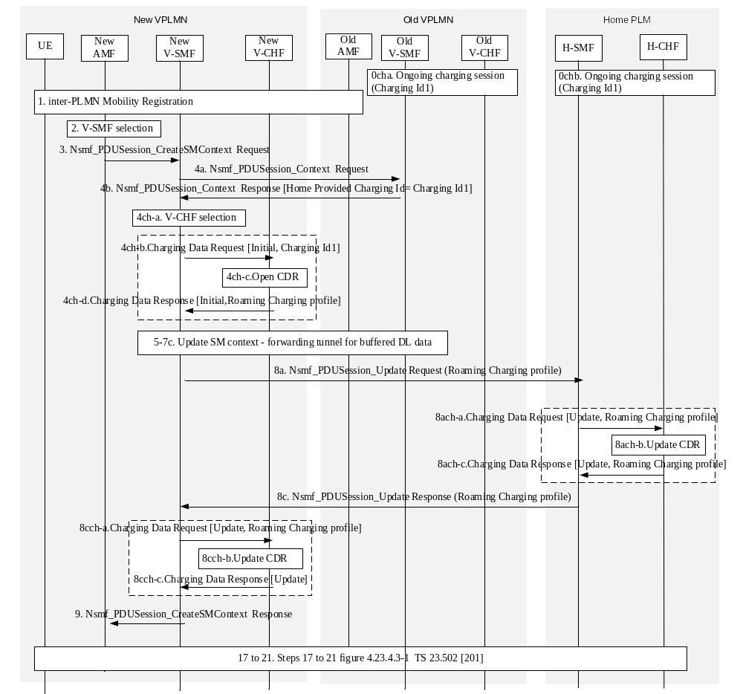
Figure 5.2.2.14.9.1: Roaming Home routed PDU session inter-PLMN V-SMF change
0cha: Ongoing charging session in old VPLMN for UE served by old V-SMF, using Charging Id1.
0chb: Ongoing charging session for HPLMN for UE served by old V-SMF, using Charging Id1.
1-2. UE moves into a different PLMN, and the new AMF determines the new V-SMF based on service area.
3- 4b. SM Context retrieval by new V-SMF from the old V-SMF. The Charging Id containing Charging Id1 value is conveyed to the new V-SMF.
4ch-a. The UE is identified as a roamer, the CHF is selected accordingly.
4ch-b. A Charging Data Request [Initial] is sent to V-CHF, indicating "in-bound roamer", with charging Id = Charging Id1 received on step 4b.
4ch-c. The V-CHF opens a CDR (indicating "in-bound roamer").
4ch-d. The V-CHF acknowledges by sending Charging Data Response [Initial] to the V-SMF and optionally supplies a "Roaming Charging Profile" to the V-SMF which overrides the default one.
5-7c. Refer steps 5 to 7c in Figure 4.23.4.3-1 of TS 23.502 [201].
8a. Nsmf_PDUSession_Update Request from new V-SMF towards the H-SMF with the "Roaming Charging Profile".
8ach-a. A Charging Data Request [Update] is sent to H-CHF in HPLMN, indicating the V-SMF change and "Roaming Charging Profile" received from the VPLMN.
8ach-b. The H-CHF in HPLMN updates the CDR.
8ach-c. The H-CHF in HPLMN acknowledges by sending Charging Data Response [Update] to the H-SMF and supplies the HPLMN selected "Roaming Charging Profile" for this VPLMN.
8c. Nsmf_PDUSession_Update Response from H-SMF to new V-SMF with the "Roaming Charging Profile".
8cch-a. A Charging Data Request [Update] is sent to V-CHF with charging information received from H-SMF, which includes the HPLMN selected "Roaming Charging Profile".
8cch-b. The V-CHF updates the CDR.
8cch-c. The V-CHF acknowledges by sending Charging Data Response [Update] to the V-SMF.
9, 17-21. Refer steps 9 and 17 to 21 in Figure 4.23.4.3-1 of TS 23.502 [201].

5.2.2.14.10 Roaming Home routed PDU session - intra-PLMN V-SMF change
The following figure 5.2.2.14.10.1 describes the Home Routed PDU Session case in which the UE moves out of V-SMF service area in the serving PLMN to a new V-SMF service area in the serving PLMN, based on figure 4.23.4.3-1 of TS 23.502 [201], with I-SMF replaced by V-SMF in I-SMF change scenario:
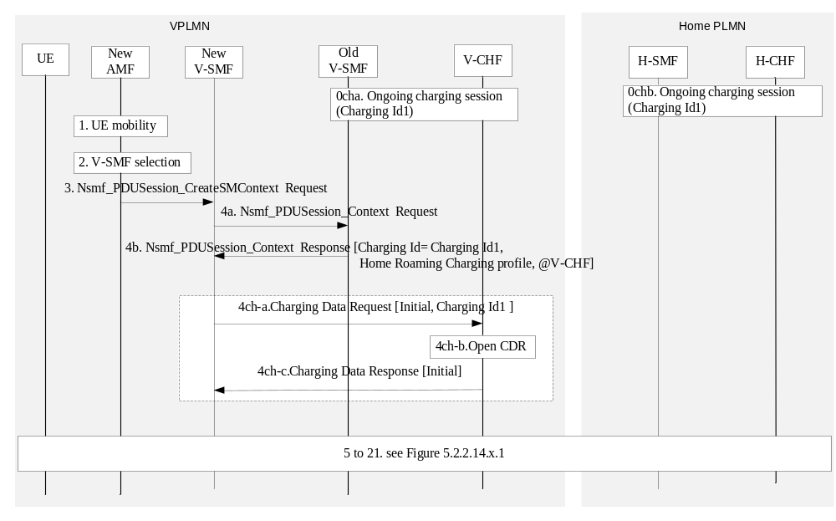
Figure 5.2.2.14.10.1: Roaming Home routed PDU session intra-PLMN V-SMF change
0cha and Ochb: same as in Figure 5.2.2.14.10.1
1-2. UE moves out of the old V-SMF service area, and the new AMF determines the new V-SMF service area in the same VPLMN.
3- 4b. SM Context retrieval by new V-SMF from the old V-SMF. The Charging Id containing Charging Id1 value, the "Home Roaming Charging Profile", and the V-CHF address, are conveyed to the new V-SMF.
4ch-a. A Charging Data Request [Initial] is sent to V-CHF, indicating "in-bound roamer", with charging Id (i.e. Charging Id1) received on step 4b.
NOTE: Since the same V-CHF is used, the Home Roaming Charging Profile to be used is already known by the V-CHF
4ch-b. The V-CHF opens a CDR (indicating "in-bound roamer").
4ch-c. The V-CHF acknowledges by sending Charging Data Response [Initial] to the V-SMF.
5-21. Same steps as in Figure 5.2.2.14.10.1, except the "Roaming Charging Profile" is not renegotiated, i.e.not contained in steps 8a, 8ach-a, 8ach-c, 8c and 8cch-a.

5.2.2.15 PDU session charging from SMF - ATSSS

5.2.2.15.1 General
This clause specifies PDU session charging for a MA PDU session as defined in TS 23.501 [200].
The flows are based on message flows specified in clause 4.22 TS 23.502 [201],

5.2.2.15.2 UE requested MA PDU session establishment
The following figure 5.2.2.15.2.1 describes charging procedure for MA PDU Session establishment requested by UE, based on figure 5.2.2.2.2.1 description with the following differences identified in clause 4.22.2.1 TS 23.502 [202]:
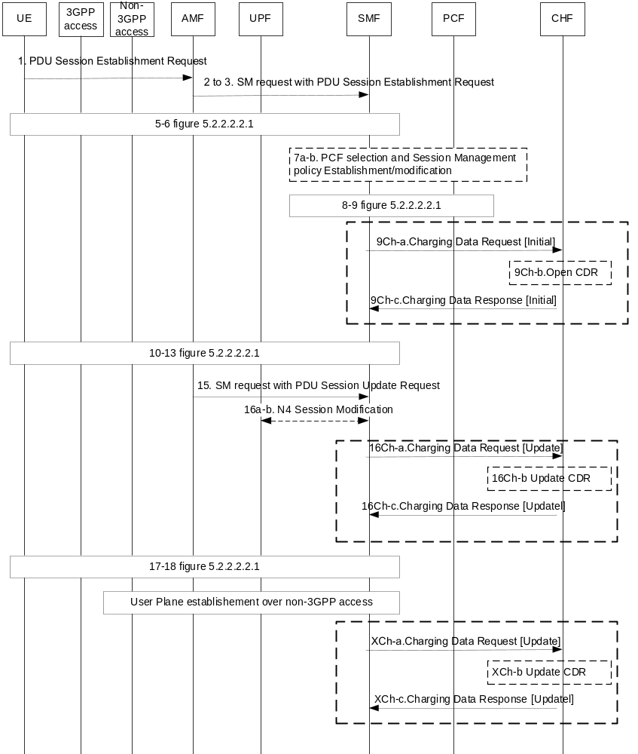
Figure 5.2.2.15.2.1: UE Requested MA PDU session establishment
- The UE is registered in both 3GPP access and non-3GPP access, and UE PDU Session Establishment Request message is sent over the 3GPP access.
1. PDU Session Establishment Request is indicated with "MA PDU Request" and ATSSS Capability (e.g. an "MPTCP Capability" and/or an "ATSSS-LL Capability").
2-3. The AMF informs the SMF that the request is for a MA PDU Session and indicates the UE is registered over both accesses.
7a-b. PCC Rules supplied by PCF contain ATSSS policy control information, optionally with a dedicated non-3GPP access rating group. From these PCC Rules, the SMF derives ATSSS rules for uplink and N4 rules for downlink for controlling the traffic steering, switching and splitting.
9ch-a. The SMF sends Charging Data Request [initial] indicating "MA PDU session requested by UE" to CHF for authorization for the subscriber to start the MA PDU session.
9ch-b. The CHF opens CDR for this MA PDU session.
9ch-c. The CHF acknowledges by sending Charging Data Response [Initial] to the SMF.
10-13. Procedure based on ATSSS policy and SMF derived both N4 Rules and ATSSS rules to UE.
16ch-a. This step may occur in case "start of service data flow" over 3GPP needs quota from CHF for appropriate rating group, the SMF sends Charging Data Request [Update] for requesting quota.
16ch-b. The CHF updates CDR for this MA PDU session.
16ch-c. The CHF acknowledges by sending Charging Data Response [Update] to the SMF.
After step 18 in figure 5.2.2.2.2.1, if the SMF was informed in step 2 that the UE is registered over both accesses, the SMF initiates the establishment of user-plane resources over non-3GPP access via AMF. After the user plane is established with the non-3GPP access:
Xch-a. The SMF sends Charging Data Request [Update]. This step may occur in case following chargeable events need quota from CHF for appropriate rating group, or if required by "immediate reporting" category:
- "start of SDF additional access" over non-3GPP.
- "start of service data flow" over non-3GPP or 3GPP.
Xch-b. The CHF updates CDR for this MA PDU session.
Xch-c. The CHF acknowledges by sending Charging Data Response [Update] to the SMF.
In the scenario where the PDU Session Establishment Request message for the MA PDU session is sent over the non-3GPP access, and the user plane over the non-3GPP access is established before the user plane over 3GPP:
16ch-a. This step may occur in case "start of service data flow" over non-3GPP needs quota from CHF for appropriate rating group, or if required by "immediate reporting" category
Xch-a. This step may occur in case following chargeable events need quota from CHF for appropriate rating group, or if required by "immediate reporting" category:
- "start of SDF additional access" over 3GPP.
- "start of service data flow" over non-3GPP or 3GPP.

5.2.2.15.3 UE requested PDU session establishment with Network Modification to MA PDU Session
The following flow describes the charging procedure for a single access PDU session establishment by ATSSS-capable UE and the 5GC network decides to convert to a Multi-Access PDU (MA PDU) Session, based on figure 5.2.2.2.2.1 description with the following differences identified in clause 4.22.3 TS 23.502 [202]:
- The UE is registered in both 3GPP access and non-3GPP access and sends a PDU Session Establishment Request message over the 3GPP access.
1. PDU Session Establishment Request may include "MA PDU Network-Upgrade Allowed" indication and its ATSSS Capability.7. The single-access PDU Session requested by the UE is converted into a MA PDU Session by SMF based on "MA PDU Network-Upgrade Allowed" indication, and PCC Rules are supplied by PCF containing ATSSS policy control information optionally with a dedicated non-3GPP access rating group.
9ch-a. The SMF sends Charging Data Request [initial] indicating "MA PDU session requested by Network modification" to CHF.
9ch-b. The CHF opens CDR for this MA PDU session.
9ch-c. The CHF acknowledges by sending Charging Data Response [Initial] to the SMF.
Steps after step 10 in clause 5.2.2.15.2 apply.

5.2.2.15.4 UE Requested PDU Session Establishment with Network Modification to MA PDU Session - roaming in Home routed scenario
The charging procedure for single access PDU session establishment requested by ATSSS-capable UE and converted to a Multi-Access PDU (MA PDU) Session by the 5GC network in roaming Home routed scenario, is based on figures in clause 5.2.2.15.X. and description in clause 4.22.3 TS 23.502 [202].

5.2.2.15.4.1 UE registered to the same VPLMN over 3GPP access and non-3GPP access
The charging procedure for UE registered to the same VPLMN over 3GPP access and non-3GPP access is based on figure 5.2.2.15.X.1.1 with differences identified in clause 4.22.3 TS 23.502 [202]:
- The UE is registered to the same VPLMN over 3GPP access and non-3GPP access, and UE PDU Session Establishment Request message is sent over the 3GPP access.
1-3a. UE PDU Session Establishment Request may include "MA PDU Network-Upgrade Allowed" indication and its ATSSS Capability. This indication may be conveyed by AMF to V-SMF.
6. The V-SMF provides the "MA PDU Network-Upgrade Allowed" indication to H-SMF, if received from AMF together with an indication whether the UE is registered over both accesses.
9a-b. The single-access PDU Session received by H-SMF with "MA PDU Network-Upgrade Allowed" indication is converted into a MA PDU Session. PCC Rules are supplied by PCF containing ATSSS policy control information optionally with a non-3GPP access dedicated rating group.
11ch-a to c. Same steps as in figure 5.2.2.12.2.1 with Charging Data Request [Initial] indicating "MA PDU session requested by the Network".

5.2.2.15.5 UE requested MA PDU session establishment - roaming in Home routed scenario

5.2.2.15.5.1 General
The charging procedure for MA PDU Session establishment requested by UE in roaming Home routed scenario is based on figure 5.2.2.12.2.1 and description in clause 4.22.2.2 TS 23.502 [202].

5.2.2.15.5.2 UE registered to the same VPLMN over 3GPP access and non-3GPP access
The following figure 5.2.2.15.5.2.1 describes charging procedure for MA PDU session charging establishment requested by UE in roaming Home routed scenario for UE registered to the same VPLMN over 3GPP access and non-3GPP access:

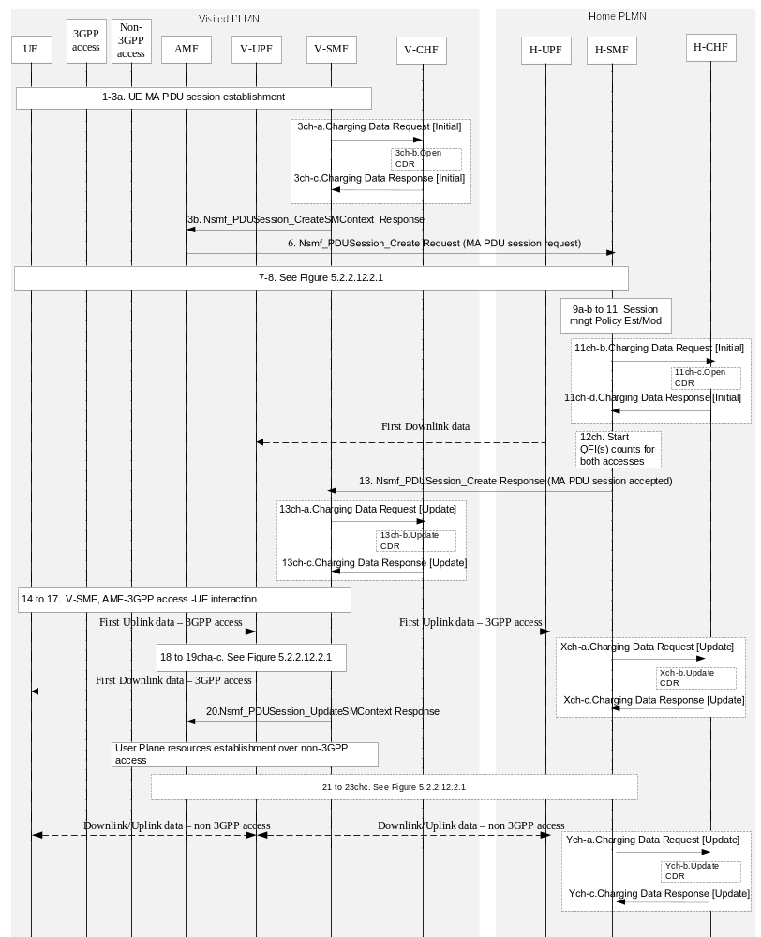
Figure 5.2.2.15.5.2.1: UE requested MA PDU session - Roaming Home Routed - same VPLMN
- The UE is registered to the same VPLMN over 3GPP access and non-3GPP access, and UE PDU Session Establishment Request message is sent over the 3GPP access.
1-3a. UE initiates a new PDU session indicated with "MA PDU Request" and ATSSS Capability. Selection by the AMF of V-SMF which supports MA PDU sessions. The AMF indicates to V-SMF that the UE is registered over both accesses
3ch-a to 3ch-d. Same steps as in figure 5.2.2.12.2.1.
6. The V-SMF informs the H-SMF that the request is for a MA PDU Session and the UE is registered over both accesses.
9a-b. PCC rules are supplied by H-PCF containing MA PDU session control information based on currently used list of Access Type(s) and RAT Type(s). The H-SMF initiates the establishment of user-plane resources over non-3GPP access and derives the ATSSS rules for the UE and the N4 rules for the H-UPF.
11ch-a to c. Same steps as in figure 5.2.2.12.2.1 with Charging Data Request [Initial] indicating "MA PDU session requested by UE".
12ch. Counts per QFI are started for both 3GPP and non-3GPP accesses.
13. Nsmf_PDUSession_Create Response from H-SMF to V-SMF with "MA PDU session Accepted" indication.
13ch-a to c. Same steps as in figure 5.2.2.12.2.1. Counts per QFI are started for both 3GPP and non-3GPP accesses.
14-19b. Procedure in the VPLMN for 3GPP access and based on H-SMF derived ATSSS rules to UE for the MA PDU session.
Xch-a. The H-SMF sends Charging Data Request [Update]. This step may occur in case "start of service data flow" chargeable event over 3GPP, when required by "immediate reporting" category.
Xch-b. The H-CHF updates CDR for this MA PDU session.
Xch-c. The H-CHF acknowledges by sending Charging Data Response [Update] to the V-SMF.
After the user plane resources are established over non-3GPP access in VPLMN, and traffic goes through between VPLMN and HPLMN over non-3GPP access:
Ych-a. The H-SMF sends Charging Data Request [Update] to H-CHF. This step may occur in case "start of service data flow " chargeable event over non-3GPP, when required by "immediate reporting" category.
Ych-b. The H-CHF updates CDR for this MA PDU session.
Ych-c. The H-CHF acknowledges by sending Charging Data Response [Update] to the V-SMF.

5.2.2.15.6 EPS interworking

5.2.2.15.6.1 5GS to EPS handover using N26 interface
The charging procedure for MA PDU Session 5GS to EPS handover using N26 interface scenario is based on figure 5.2.2.11.2.1 description with the differences identified in clause 4.22.6.2.1 TS 23.502 [202]:
0ch. A charging session between the PGW-C+SMF and CHF exists for the MA PDU Session with multiple QoS Flows over 3GPP access and non-3GPP access.
16ch-a. MA PDU session moved to EPS: All counts affected by the MA PDU session move to EPS are closed and a Charging Data Request [Update] is sent to CHF, if required by "RAT type change" trigger. New counts and time stamps for all active service data flows are started in the PGW-C+SMF.
MA PDU Session Release procedure over non-3GPP access triggered by PGW-C+SMF: All counts affected by the release of non-3GPP access are closed by "Termination of service data flow" trigger.

5.2.2.15.6.2 5GS to EPS mobility without N26 interface
The charging procedure for MA PDU Session 5GS to EPS mobility without using N26 interface scenario is based on figure 5.2.2.11.6.1 description with the differences identified in clause 4.22.6.2.5 TS 23.502 [202]:
0. UE is registered in 5GS and MA PDU Session is over both 3GPP and non-3GPP accesses.
10. E-UTRAN Initial attach procedure:
10ch-a. MA PDU Session is moved to EPS: All counts affected by the MA PDU session move to EPS are closed and a Charging Data Request [Update] is sent to CHF, if required by "Handover start" trigger. New counts and time stamps for all active service data flows are started in the PGW-C+SMF
10ch-b. The CHF updates CDR for this PDU session.
10ch-c. The CHF acknowledges by sending Charging Data Response [Update] to the PGW-C+SMF.
The PGW-C + SMF triggers the MA PDU Session Release procedure over non-3GPP access: All counts affected by the release of non-3GPP access are closed by "Termination of service data flow" trigger.
14. The PGW-C+SMF initiates release of the 5GS MA PDU Session(s) transferred to EPS.

5.2.2.15.7 Hybrid Access with Multi-Access PDU Session connectivity over NG-RAN and W-5GAN
The following flow describes the charging procedure for MA PDU Session establishment over NG-RAN and W-5GAN requested by 5G-RG, based on figure 5.2.2.15.2.1 description with the following differences identified in clause 4.12.2 TS 23.316 [203]:
- The UE is replaced by 5G-RG.
- Non-3GPP access(es) is specifically referred to wireline access.
When PDU Session Establishment Request message is sent over the 3GPP access (i.e. NG-RAN), or sent over the non-3GPP access (i.e. W-5GAN):
9ch-a. The SMF sends Charging Data Request [initial] to CHF for authorization for the 5G-RG to start the MA PDU session.
9ch-b. The CHF opens CDR for this MA PDU session.
9ch-c. The CHF acknowledges by sending Charging Data Response [Initial] to the SMF.

5.2.2.15.8 Hybrid Access with multi-access connectivity over E-UTRAN/EPC and W-5GAN
The following flow describes the charging procedure for MA PDU Session establishment over E-UTRAN/EPC and W-5GAN requested by 5G-RG using EPC interworking procedures, based on clause 4.12.3 TS 23.316 [203]:
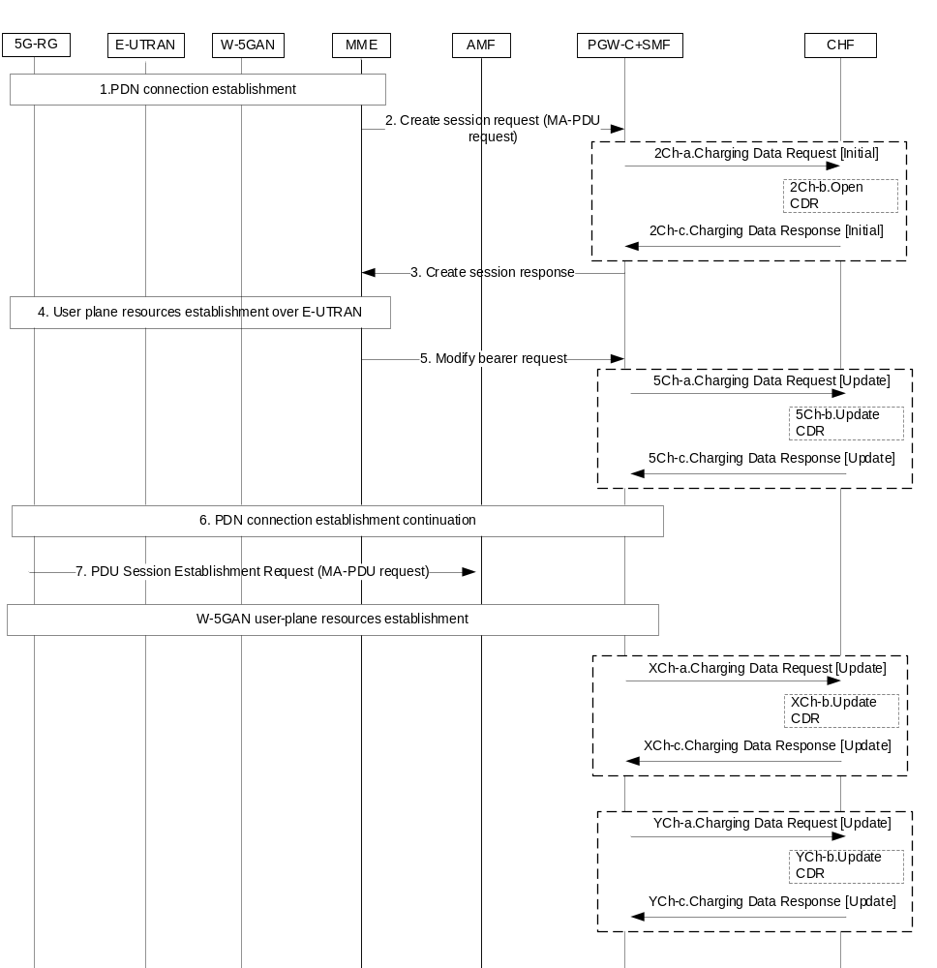
Figure 5.2.2.15.8.1: MA PDU session establishment requested by 5G-RG via EPC
- The 5G-RG is registered in EPC.
1. 5G-RG initiates PDN Connection establishment via E-UTRAN, indicating the PDN Connection is requested to be associated with a MA PDU Session and its "ATSSS-LL Capability".
2. Create session request in EPC to the selected PGW-C+SMF with the indication the PDN Connection is requested to be associated with a MA PDU Session.
2ch-a. The PGW-C+ SMF sends Charging Data Request [initial] indicating "MA PDU session requested" to CHF for authorization for the 5G-RG to use the PDN connection for a MA PDU session.
2ch-b. The CHF opens CDR for this PDN connection.
2ch-c. The CHF acknowledges by sending Charging Data Response [Initial] to the PGW-C+ SMF.
3. Create session response indicating the request for using the PDN Connection for MA-PDU Session is accepted.
4-5. User Plane resources establishment for E-UTRAN
5ch-a. This step may occur in case "start of service data flow" over 3GPP needs quota from CHF for appropriate rating group, the PGW-C+ SMF sends Charging Data Request [Update] for requesting quota.
5ch-b. The CHF updates CDR for this PDN connection.
5ch-c. The CHF acknowledges by sending Charging Data Response [Update] to the PGW-C+ SMF.
6. PDN connection establishment continuation
7. 5G-RG sends a PDU Session Establishment Request indicating "MA PDU Request" to establish W-5GAN user-plane resources.
When the user plane is established with W-5GAN (X corresponds to step 16a-b of figure 5.2.2.2.2.1 for the W-5GAN):
Xch-a. The PGW-C+ SMF sends Charging Data Request [Update]. This step may occur if required by "addition of access" trigger.
Xch-b. The CHF updates CDR for this MA PDU session.
Xch-c. The CHF acknowledges by sending Charging Data Response [Update] to the SMF.
After the user plane is established:
Ych-a. The PGW-C+ SMF sends Charging Data Request [Update]. This step may occur in case "start of service data flow" chargeable event needs quota from CHF for appropriate rating group, or if required by "immediate reporting" category.
Ych-b. The CHF updates CDR for this MA PDU session.
Ych-c. The CHF acknowledges by sending Charging Data Response [Update] to the PGW-C+ SMF.
In the scenario where the MA PDU Session is requested via 5GC/W-5GAN, the 5G-RG is registered to EPC and user-plane resources are added on 3GPP access over EPC, the following applies:
MA PDU session establishment via 5GC/W-5GAN per figure 5.2.2.15.2.1 until step 18 with PDU Session Establishment Request message for the MA PDU session sent over W-5GAN (i.e. non-3GPP access).
After step 18 of figure 5.2.2.2.2.1, the 5G-RG sends a PDN Connection Establishment Request via E-UTRAN, indicating "handover" and "MA PDU Request".
When the user plane is established with E-UTRAN over EPC:
Xch-a. The PGW-C+ SMF sends Charging Data Request [Update]. This step may occur if required by "addition of access" trigger.
After the user plane is established with E-UTRAN over EPC:
Ych-a. This step may occur in case "start of service data flow" chargeable event needs quota from CHF for appropriate rating group, or if required by "immediate reporting" category.

5.2.2.16 PDU session charging – wireline access

5.2.2.16.1 General
After registration management procedures to 5GC via wireline access network, a PDU session can be established via this wireline access, as specified in TS 23.316 [203] for different scenarios:
- 5G-RG connected via NR-RAN and W-5GAN;
- FN-RG connected via W-5GAN.

5.2.2.16.2 5G-RG Requested PDU Session Establishment via W-5GAN
The following figure 5.2.2.16.2.1 describes charging when 5G-RG requests a PDU session establishment via W-AGF.
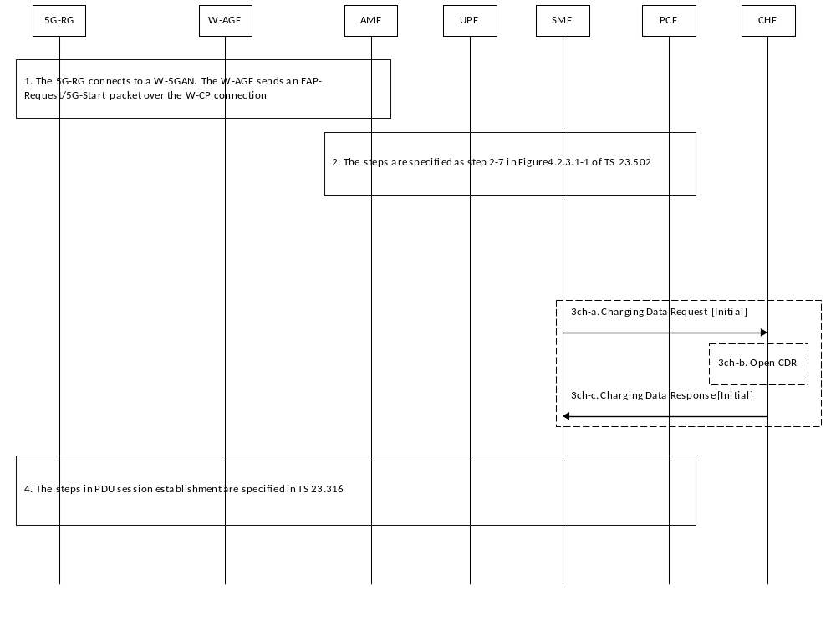1) The 5G-RG connects to a W-5GAN and the W-AGF sends an EAP-Request/5G-Start packet over the W-CP connection as described in clause 7.3.1.1 in TS 23.316 [203].
2) The steps are specified as step 2-7 in clause 4.3.2.1 of TS 23.502 [202].
3ch-a. The SMF creates a Charging Id for the PDU session, and sends Charging Data Request [Initial] to CHF for authorization for the subscriber information via wireline network to start the PDU session which is triggered by start of PDU session charging event.
3ch-b. The CHF opens CDR for this PDU session.
3ch-c. The CHF acknowledges by sending Charging Data Response [Initial] to the SMF.
4) The steps of PDU session establishment are specified in clause 7.3.1.1 of TS 23.316 [203].

5.2.2.16.3 FN-RG related PDU Session Establishment via W-5GAN
The following figure 5.2.2.16.3.1 describes charging when FN-RG requests a PDU session establishment via W-AGF. As described in clause 7.3.4 in TS 23.316 [203], after the registration procedure is completed, the W-AGF may establish PDU session(s) on behalf of the FN-RG.
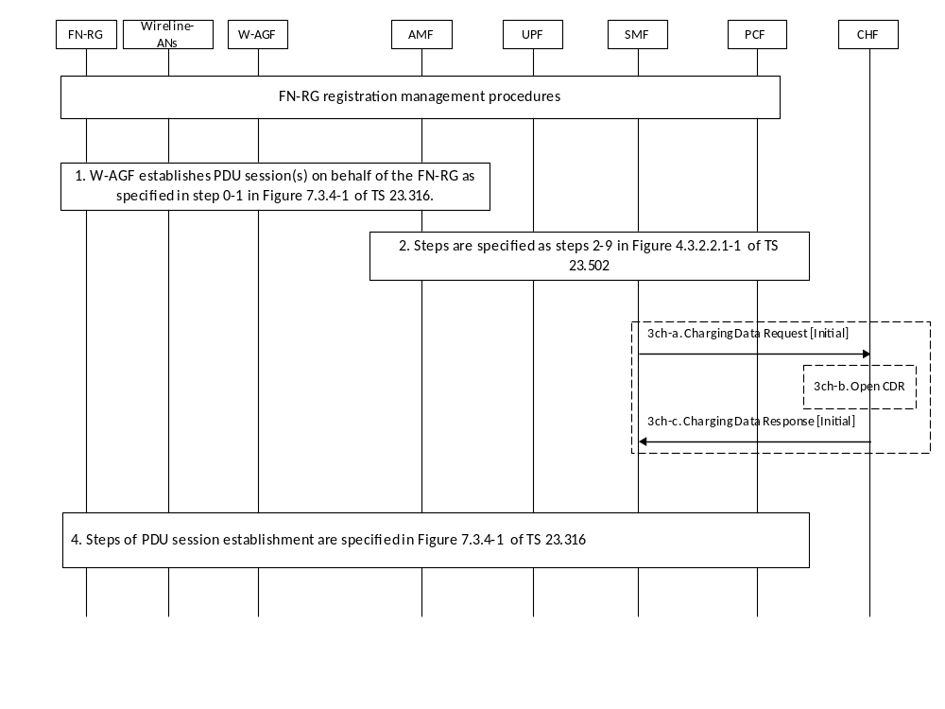
Figure 5.2.2.16.3.1: charging when FN-RG requests a PDU session establishment via W-AGF
1) After the registration procedure is completed, the W-AGF may establish PDU session(s) on behalf of the FN-RG as described in clause 7.3.4 in TS 23.316 [203].
2) The steps are specified as step 2-9 in clause 4.3.2.2.1 of TS 23.502 [202].
3ch-a. The SMF creates a Charging Id for the PDU session, and sends Charging Data Request [Initial] to CHF for authorization for the subscriber identified under wireline network to start the PDU session which is triggered by start of PDU session charging event.
3ch-b. The CHF opens CDR for this PDU session.
3ch-c. The CHF acknowledges by sending Charging Data Response [Initial] to the SMF.
4) The steps of PDU session establishment are specified in clause 7.3.4 of TS 23.316 [203].

5.2.2.16.4 Handover procedure

5.2.2.16.4.1 5G RG handover of a PDU Session procedure from W-5GAN access to 3GPP access
Following figure 5.2.2.16.4.1.1 describes charging when 5G-RG handover of a PDU Session procedure from W-5GAN access to 3GPP access.
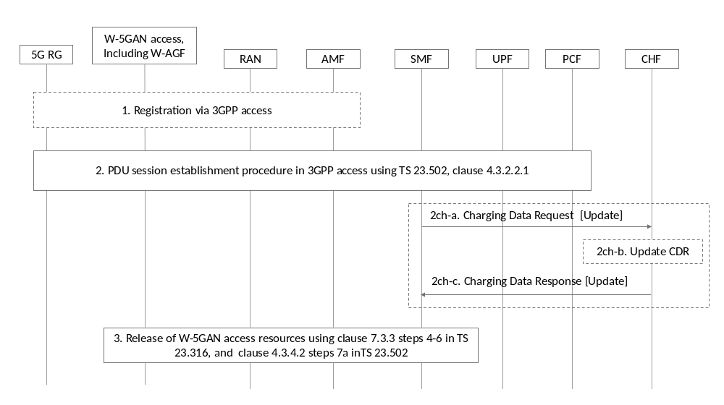
Figure 5.2.2.16.4.1.1: Handover of PDU session from W-5GAN access to 3GPP access
As described in clause 7.6.2.1 in TS 23.316 [203], the handover of a PDU session from W-5GAN access to 3GPP access is as following.
1-2) The steps are described in clause 7.6.2.1 in TS 23.316 [203], 5G-RG peforms registeration via 3GPP access and PDU session establishmeng procedure.
2ch-a-c. SMF may interact with CHF with Charging Data Request [Update].This step occurs in case "RAT type change" triggers, if required by "immediate reporting" category. The RAT type change trigger, if enabled, applied during the PDU session establishment via the 3GPP access network before SMF executes the release of W-5GAN access resource. Which RAT type used is described in clause 5.3.2.3 of TS 23.501 [200].
NOTE: Void
3. The step that the SMF executes the release of resources in W-5GAN access is same as step 3 as described in clause 7.6.3.1 of TS 23.316 [203].

5.2.2.16.4.2 5G RG handover of a PDU Session procedure from 3GPP to W-5GAN access
Following figure 5.2.2.16.4.2.1 describes charging when 5G-RG handover of a PDU Session procedure from 3GPP to W-5GAN access.
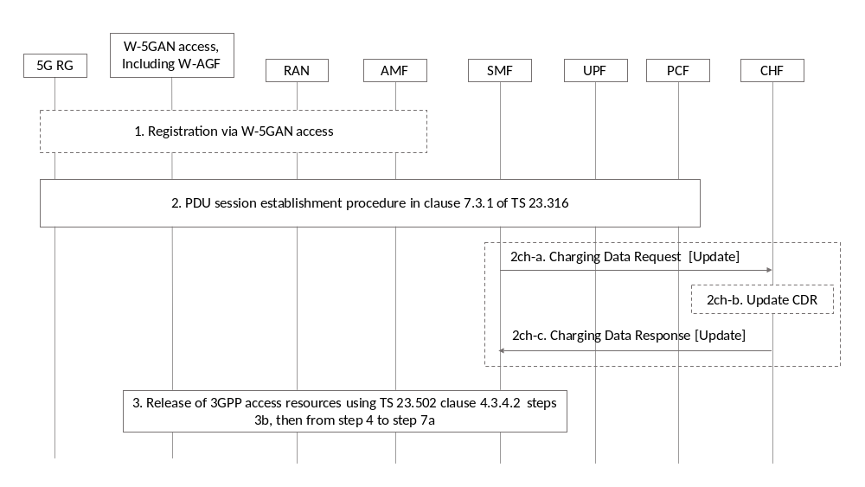
Figure 5.2.2.16.4.2.1: Handover of a PDU Session procedure from 3GPP to W-5GAN access
As described in clause 7.6.3.2 in TS 23.316 [203], the handover of a PDU session from 3GPP access to W-5GAN access is as following.
1) The 5G-RG initiates Reigistration procedure via W-5GAN as defined in clause 7.2.1.1 of TS 23.316 [203].
2) The 5G-RG performs PDU Session Establishment procedure via W-5GAN access as described in 7.6.3.2 of TS 23.316 [203].
2ch-a-c. SMF may interact with CHF with Charging Data Request [Update]. This step occurs in case "RAT type change" triggers, if required by "immediate reporting" category The RAT type change trigger, if enabled, applied during the PDU session establishment via the W-5GAN before SMF performs the release of 3GPP access resource. Which RAT type used is described in clause 5.3.2.3 of TS 23.501 [200].
NOTE: Void
3) The step that the SMF executes the release of resource via 3GPP access is same as step 3 as described in clause 7.6.3.2 of TS 23.316 [203].

5.2.2.17 Ultra Reliable Low Latency Communication (URLLC)

5.2.2.17.1 General
Support highly reliable URLLC services is specified in TS 23.501 [200] clause 5.33 procedures and TS 23.502 [201] message flows for different scenarios:
- Dual Connectivity based end to end Redundant User Plane Paths.
- Support of redundant transmission on N3/N9 interfaces.
- Support for redundant transmission at transport layer.

5.2.2.17.2 Void

5.2.2.17.3 Redundant transmission for high reliability communication

5.2.2.17.3.1 PDU Session establishment
- Dual Connectivity based end to end Redundant User Plane Paths
The charging message flow of PDU session establishment for supporting Dual Connectivity based end to end Redundant User Plane Paths, is based on Figure 5.2.2.2.2-1 description with the differences identified in clause 4.3.2.2.1.1 TS 23.502 [202].
In the Step 9ch-a, if the PDU Session requires redundancy, SMF sends the Charging Data Request [Initial] with the redundant transmission information.
If the PDU session establishment without redundancy handling based on local policy, SMF sends the Charging Data Request [Initial] as descriped in Figure 5.2.2.2.2-1. CHF considers the PDU session is used for the non-redundant transmission.
- Redundant transmission on N3/N9 interfaces
The charging message flow of PDU session establishment for supporting redundant transmission on N3/N9 interfaces, is based on Figure 5.2.2.2.2-1 description with the differences identified in clause 4.3.2.2.1.1 TS 23.502 [202].
As described in clause 5.33.1.2 of TS 23.501 [201], SMF decides to perform redundant transmission for one or more QoS Flows at the step 10.
In the Step 16ch-a，the SMF sends the Charging Data Request [Update] with the redundant transmission information.
- Redundant transmission at transport layer
The charging message flow of PDU session establishment for supporting redundant transmission at transport layer, is based on Figure 5.2.2.2.2-1 description with the differences identified in clause 4.3.2.2.1.1 TS 23.502 [202].
As per the clause 5.33.2.3 TS 23.501[201], the knowledge of supporting redundant transmission at transport layer can be configured in the SMF, or be configured in UPF and then obtained by the SMF via N4 capability negotiation during N4 Association setup procedure.
In the Step 16ch-a, SMF sends the Charging Data Request [Update] with the redundant transmission information.

5.2.2.17.3.2 PDU Session Modification
For redundant transmission on N3/N9 interfaces, the charging message flow of PDU session modification is based on Figure 5.2.2.2.3-1 description with the differences identified in clause 4.3.3.2 TS 23.502 [202].
2ch-a. If redundant transmission has not been activated to the PDU session and the SMF performs redundant transmission for the QoS Flow in step 2a, the SMF sends Charging Data Request [Update] to the CHF for the PDU session, with the trigger "Redundant transmission change".
If redundant transmission has been activated on the PDU Session, and the SMF stops redundant transmission in step 2a, the SMF sends Charging Data Request [Update] to the CHF for the PDU session, with the trigger "Redundant transmission change".
2ch-b. The CHF update the CDR for the URLLC.
2ch-c. The CHF acknowledges by sending Charging Data Response [Update] to the SMF.

5.2.2.17.3.3 PDU Session Release
For redundant transmission on N3/N9 interfaces, the charging message flow of PDU session release is based on Figure 5.2.2.2.4-1 description with the differences identified in clause 4.3.4.2 TS 23.502 [202].
2ch-a. The SMF sends Charging Data Request [Termination] to the CHF for terminating the charging associated with PDU session in each UPF, with the trigger "End of PDU session".
2ch-b. The CHF closes the CDR for the URLLC.
2ch-c. The CHF acknowledges by sending Charging Data Response [Termination] to the SMF.

5.2.3 CDR generation

5.2.3.1 Introduction
The CHF CDRs for PDU session charging and roaming QBC are generated by the CHF to collect charging information that they subsequently transfer to the Charging Gateway Function (CGF).
The following clauses describe in detail the conditions for opening, adding information to, and closing the CHF CDR.

5.2.3.2 Triggers for CHF CDR

5.2.3.2.1 General
A PDU session charging CHF CDR is used to collect charging information related to the PDU session data information for a UE in Flow Based Charging. Multiple service data flow containers per PDU session can be added in the CHF CDR by the CHF, upon receiving a Charging Data Request including new counts as defined in subclause 5.2.1.1.
A CHF CDR shall be opened when the CHF receives Charging Data Request[Initial].
As an alternative to the default CHF behaviour, the "Individual Partial record" mechanism can be used based on Operator's policy configured in the CHF. In this case a new CDR shall be opened for each Charging Data Request[Initial, Update, Termination], charging information shall be added and the CDR shall then be closed. The Sequence Number will be incremented for each Charging Data Request[Initial, Update, Termination] received by the CHF.

5.2.3.2.2 Triggers for CHF CDR charging information addition
When the CHF receives Charging Data Request[Update], with the change conditions identified in Table 5.2.3.2.2.1 the charging information shall be added in the PDU session charging CHF CDR, and the CDR shall remain open, as the default supported mechanism.
Table 5.2.3.2.2.1: Triggers for CHF CDR charging information addition
Trigger Conditions | Applicable for converged charging | Applicable for offline only charging
Change of Charging conditions
QoS change | Yes | Yes
User Location change | Yes | Yes
Serving Node change | Yes | Yes
Change of UE presence in Presence Reporting Area(s) | Yes | Yes
Change of 3GPP PS Data off Status | Yes | Yes
Handover cancel | Yes | Yes
Handover start | Yes | Yes
Limit per Rating Group
Expiry of data time limit per RG | Yes | Yes
Expiry of data volume limit per RG | Yes | Yes
Expiry of data event limit per RG | Yes | Yes
Quota management triggers
Time threshold reached | Yes | No
Volume threshold reached | Yes | No
Unit threshold reached | Yes | No
Time quota exhausted | Yes | No
Volume quota exhausted | Yes | No
Unit quota exhausted | Yes | No
Expiry of quota validity time | Yes | No
Re-authorization request by CHF | Yes | No

In case the "Individual Partial record" mechanism is enabled, the Table 5.2.3.2.2.1 is not applicable. The charging information consists of a set of containers, which are added as "List of Multiple Unit Usage" parameter of the CHF CDR. Each container identifies the configured counts (volume separated for uplink and downlink, elapsed time or number of events) per rating group or combination of the rating group and service id, associated with the changed charging conditions.

5.2.3.2.3 Triggers for CHF CDR partial record closure
When the CHF receives Charging Data Request [Update],with the change conditions identified in Table 5.2.3.2.3.1, the charging information shall be added in the PDU session charging CHF CDR, before the CDR is closed and a subsequent CHF CDR shall be opened with an incremented Sequence Number, as the default supported mechanism.
.
Table 5.2.3.2.3.1: Triggers for CHF CDR partial record closure
Trigger Conditions
Change of Charging conditions
UE time zone change
PLMN change
RAT type change
DNN-AMBR change
Removal of UPF
Insertion_of_ISMF
Change_of_ISMF
Removal_of_ISMF
Handover complete
Management intervention
Addition of access
Removal of access
Limit per PDU session
Expiry of data time limit per PDU session
Expiry of data volume limit per PDU session
Expiry of data event limit per PDU session
Expiry of limit of number of charging condition changes

In case the "Individual Partial record" mechanism is enabled, the Table 5.2.3.2.3.1 is not applicable.

5.2.3.2.4 Triggers for CHF CDR closure
When the CHF receives Charging Data Request[Termination], the charging information shall be added in the PDU session charging CHF CDR and the CDR shall be closed.

5.2.3.3 Triggers for CHF CDR for roaming QBC

5.2.3.3.1 General
A Roaming QBC CHF CDR is used to collect charging information related to Roaming QBC in V-SMF, and the PDU session charging CHF CDR is used to collect charging information related to Roaming QBC in H-SMF. QoS flow containers per PDU session can be added in the CHF CDRs by the CHF, upon receiving a Charging Data Request.
The charging information received from the CHF consists of a set of containers, which are added as "List Multiple QFI container" parameter of the CHF CDRs. Each container identifies the configured counts (volume separated for uplink and downlink, elapsed time) per QoS Flow, associated with the changed charging conditions.
A roaming CHF CDR shall be opened when the CHF receives Charging Data Request[Initial] indicating "in-bound roamer".

5.2.3.3.2 Triggers for CHF CDR charging information addition for roaming QBC
When the CHF receives Charging Data Request[Update], with the change conditions identified in Table 5.2.3.3.2.1 the charging information shall be added in the CHFCDR, and the CDR shall remain open, as the default supported mechanism.
Table 5.2.3.3.2.1: Triggers for CHF CDR charging information addition for roaming QBC
Trigger Conditions
Change of Charging conditions
QoS change
User Location change
Serving Node change
Change of UE presence in Presence Reporting Area(s)
Change of 3GPP PS Data off Status
Limit per QoS Flow
Expiry of data time limit per QoS Flow
Expiry of data volume limit per QoS Flow
Others
End of QoS Flow

In case the "Individual partial record" mechanism is enabled, this sub-clause is not applicable.

5.2.3.3.3 Triggers for CHF CDR partial record closure for roaming QBC
When the CHF receives Charging Data Request[Update] with the change conditions identified in Table 5.2.3.3.3.1, the charging information shall be added in the CHF CDR, before the CDR is closed and a subsequent CHF CDR shall be opened with an incremented Sequence Number, as the default supported mechanism.
Table 5.2.3.3.3.1: Triggers for CHF CDR partial record closure for roaming QBC
Trigger Conditions
Change of Charging conditions
UE time zone change
PLMN change
RAT type change
DNN-AMBR change
Removal of UPF
Management intervention
Limit per PDU session
Expiry of data time limit per PDU session
Expiry of data volume limit per PDU session
Expiry of data event limit per PDU session
Expiry of limit of number of charging condition changes

In case the "Individual partial record" mechanism is enabled, the Table 5.2.3.3.3.1 is not relevant: instead, the charging information shall be added in the CHF CDR, before the CDR is closed and a subsequent CHF CDR shall be opened with an incremented Sequence Number for each Charging Data Request[Update] received by the CHF.

5.2.3.3.4 Triggers for roaming QBC CHF CDR closure
When the CHF receives Charging Data Request[Termination], the charging information shall be added in the roaming QBC CHF CDR and the CDR shall be closed.

5.2.4 Ga record transfer flows
In 5G, both fully qualified partial CDRs (FQPC) and reduced partial CDRs (RPC), as specified in TS 32.240 [1] may be supported on the Ga interface. In line with TS 32.240 [13], the support of FQPCs is mandatory, the support of RPCs is optional. For further details on the Ga protocol application refer to TS 32.295 [54].

5.2.5 Bd CDR file transfer
In 5G, both fully qualified partial CDRs (FQPC) and reduced partial CDRs (RPC), as specified in TS 32.240 [1] may be supported on the Bd interface. In line with TS 32.240 [13], the support of FQPCs is mandatory, the support of RPCs is optional. For further details on the Bd protocol application refer to TS 32.297 [52].

6. Definition of charging information

6.1 Data description for 5G data connectivity charging

6.1.1 Message contents

6.1.1.1 General
The Charging Data Request and Charging Data Response are specified in TS 32.290 [57] and include charging information. The Charging Data Request can be of type [Initial, Update, Termination].
Table 6.1.1.1.1 describes the use of these messages for converged charging.
Table 6.1.1.1.1: Converged charging messages reference table
Message | Source | Destination
Charging Data Request | SMF | CHF
Charging Data Response | CHF | SMF

The following clauses describe the different fields used in the Charging Data messages and the category in the tables is used according to the charging data configuration defined in clause 5.4 of TS 32.240 [1].

6.1.1.2 Charging Data Request message
Table 6.1.1.2.1 illustrates the basic structure of a Charging Data Request message from the SMF as used for 5G data connectivity converged charging.
Table 6.1.1.2.1: Charging Data Request message contents
Information Element | Category for converged charging | Category for offline only charging | Description
Session Identifier | O_{C} | O_{C} | Described in TS 32.290 [57]
Subscriber Identifier | O_{M} | M | Described in TS 32.290 [57]  In case SUPI is not present (for emergency service), the User Equipment Info in table 6.2.1.2.1. shall be present for identifying the user.
NF Consumer Identification | M | M | Described in TS 32.290 [57]
NF Functionality | M | O_{C} | Described in TS 32.290 [57]
NF Name | O_{C} | O_{C} | Described in TS 32.290 [57]
NF Address | O_{C} | O_{C} | Described in TS 32.290 [57]
NF PLMN ID | O_{C} | O_{C} | Described in TS 32.290 [57]
Invocation Timestamp | M | M | Described in TS 32.290 [57]
Invocation Sequence Number | M | M | Described in TS 32.290 [57]
Retransmission Indicator | O_{C} | O_{C} | Described in TS 32.290 [57]
Notify URI | O_{C} | O_{C} | Described in TS 32.290 [57]
Service Specification Information | O_{C} | O_{C} | Described in TS 32.290 [57]
Supported Features | O_{C} | - | This field indicates the features supported by the NF consumer.
Triggers | O_{C} | O_{C} | This field is described in TS 32.290 [57] and holds the 5G data connectivity specific triggers described in clause 5.2.1.
Multiple Unit Usage | O_{C} | O_{C} | Described in TS 32.290 [57]  This field is not applicable to QBC.
Rating Group | M | M | Described in TS 32.290 [57]
Requested Unit | O_{C} | - | Described in TS 32.290 [57]
Used Unit Container | O_{C} | O_{C} | Described in TS 32.290 [57]
Triggers | O_{C} | O_{C} | This field is described in TS 32.290 [57] and holds the 5G data connectivity specific triggers described in clause 5.2.1.
PDU Container Information | O_{C} | O_{C} | This field holds the 5G data connectivity PDU session container specific information described in clause 6.2.
UPF ID | O_{C} | O_{C} | This field holds the UPF identifier used to identify the UPF.  These fields shall only be included when either quota is requested per UPF, or used units are reported per UPF
multi-homed PDU address | Oc | Oc | This field holds the IPv6 prefix used by UPF. It may only be used for IPv6 multi-homed PDU sessions and then only for reporting used units.
PDU Session Charging Information | O_{M} | O_{M} | This field holds the 5G data connectivity specific information described in clause 6.2.
Roaming QBC information | O_{M} | O_{M} | This field holds the roaming QBC specific information defined in clause 6.2.1.4  This field is not applicable to FBC.

6.1.1.3 Charging data response message
Table 6.1.1.3.1 illustrates the basic structure of a Charging Data Response message from the CHF as used for 5G data connectivity converged charging.
Table 6.1.1.3.1: Charging Data Response message contents
Information Element | Category for converged charging | Category for offline only charging | Description
Session Identifier | O_{C} | O_{C} | Described in TS 32.290 [57]
Invocation Timestamp | M | M | Described in TS 32.290 [57]
Invocation Result | O_{C} | M | Described in TS 32.290 [57]
Invoation Result Code | O_{C} | M | Described in TS 32.290 [57]
Failed Parameter | O_{C} | O_{C} | Described in TS 32.290 [57]
Failure Handling | O_{C} | O_{C} | Described in TS 32.290 [57]
Invocation Sequence Number | M | M | Described in TS 32.290 [57]
Session Failover | O_{C} | O_{C} | Described in TS 32.290 [57]
Supported Features | O_{C} | - | This field indicates the features supported by the NF consumer.
Multiple Unit Information | O_{C} | O_{C} | Described in TS 32.290 [57]  This field is not applicable to QBC.
Result Code | O_{C} | O_{C} | Described in TS 32.290 [57]
Rating Group | M | M | Described in TS 32.290 [57]
UPF ID | O_{C} | O_{C} | This field holds the UPF identifier used for quota granted per UPF by CHF
Granted Unit | O_{C} | - | Described in TS 32.290 [57]
Validity Time | O_{C} | - | Described in TS 32.290 [57]
Final Unit Indication | O_{C} | - | Described in TS 32.290 [57]
Time Quota Threshold | OC | - | Described in TS 32.290 [57]
Volume Quota Threshold | OC | - | Described in TS 32.290 [57]
Unit Quota Threshold | OC | - | Described in TS 32.290 [57]
Quota Holding Time | O_{C} | - | Described in TS 32.290 [57]
Triggers | O_{C} | O_{C} | This field is described in TS 32.290 [57] and holds the 5G data connectivity specific triggers described in clause 5.2.1.
Triggers | O_{C} | O_{C} | This field is described in TS 32.290 [57] and holds the 5G data connectivity specific triggers described in clause 5.2.1.
PDU Session Charging Information | O_{M} | O_{M} | This field holds the 5G data connectivity specific information described in clause 6.2.
Roaming QBC Information | O_{M} | O_{M} | This field holds the roaming QBC specific information defined in clause 6.2.1.4  This field is not applicable to FBC.

6.1.2 Ga message contents

6.1.3 CDR description on the B_{d} interface

6.1.3.1 General
This clause describes the CDR content and format generated for 5G data connectivity - PDU session charging.
The following tables provide a brief description of each CDR parameter. The category in the tables is used according to the charging data configuration defined in clause 5.4 of TS 32.240 [1]. Full definitions of the CDR parameters, sorted by the name in alphabetical order, are provided in TS 32.298 [51].

6.1.3.2 PDU session charging CHF CDR data
If enabled, CHF CDRs for PDU session charging shall be produced for each PDU session. In roaming Home routed scenario, the PDU session charging CHF CDR shall cover both Flow based Charging and Qos flow Based Charging (QBC) from H-SMF.
The fields of PDU session charging CHF CDR are specified in table 6.1.3.2.1.
Table 6.1.3.2.1: PDU session charging CHF record data
Field | Category | Description
Record Type | M | CHF record.
Recording Network Function ID | O_{M} | This field holds the name of the recording entity, i.e. the CHF id.
Subscriber Identifier | O_{M} | This field holds the Subscription Permanent Identifier (SUPI) of the served party. This fields should be present except for emergency session. The detail of SUPI is specified in clause 5.9.2 of TS 23.501 [200]
NF Consumer Information | M | This field holds the information of the SMF that used the charging service.
NF Functionality | M | This field contains the function of the node (i.e. SMF)
NF Name | O_{C} | This field holds the name of the SMF used.
NF Address | O_{C} | This fields holds the IP Address of the SMF used.
NF PLMN ID | O_{C} | This field holds the PLMN identifier (MCC MNC) of the SMF.
List of Multiple Unit Usage | O_{M} | This field holds a list of changes in charging conditions for all service data flows within this PDU session.This list is categorized per rating group or per combination of rating group and service id or per combination of rating group, sponsor identity and application service provider identity. In addition, usage is differentiated between with and without quota management. Each change is time stamped. Charging conditions are used to categorize traffic volumes, elapsed time and number of events, such as per tariff period.
Rating Group | O_{M} | This filed holds the rating group.
Used Unit Container | O_{C} | This field holds the used units and information connected to the reported units.
Service Identifier | O_{C} | This field holds the Service Identifier.
Quota management Indicator | O_{M} | This field holds an indicator on whether the used units are with or without quota management.
Triggers | O_{C} | This field holds the reason for closing the used unit container.
Trigger Timestamp | O_{C} | This field holds the timestamp of the trigger.
Time | O_{C} | This field holds the amount of used time.
Total Volume | O_{C} | This field holds the amount of used volume in both uplink and downlink directions.
Uplink Volume | O_{C} | This field holds the amount of used volume in uplink direction.
Downlink Volume | O_{C} | This field holds the amount of used volume in downlink direction.
Service Specific Unit | O_{C} | This field holds the amount of used service specific units.
Event Time Stamps | O_{C} | This field holds the timestamps of the event reported in the Service Specific Units, if the reported units are event based.
Rating Indicator | O_{C} | This field indicates if the units have been rated or not.
Local Sequence Number | M | This field holds the container sequence number.
PDU Container Information | O_{C} | This field holds the 5G data connectivity specific information defined in clause 6.2.1.3.
UPF ID | OC | This field holds the UPF identifier used to identify the UPF when reporting the usage for the UPF.
Multi-homed PDU address | Oc | This field holds the Multi-homed IPv6 prefix used by UPF, identified by the UPF ID. It may only be used for reporting used units.
Record Opening Time | M | Time stamp when the PDU session is activated in the SMF or record opening time on subsequent partial records.
Duration | M | This field holds the duration of this record.
Record Sequence Number | C | Partial record sequence number, only present in case of partial records.
Cause for Record Closing | M | The reason for the release of the record.
Diagnostics | OM | This field holds a more detailed reason for the release of the PDU session, when a single cause is applicable.
Local Record Sequence Number | OM | Consecutive record number created by the CDF. The number is allocated sequentially including all CDR types.
Record Extensions | OC | A set of network operator/manufacturer specific extensions to the record. Conditioned upon the existence of an extension.
PDU Session Charging Information | O_{M} | This field holds the 5G data connectivity specific information defined in clause 6.2.1.2.
Roaming QBC information | OC | This field holds the roaming QBC specific information defined in clause 6.2.1.4, when applicable.

6.1.3.3 Roaming QBC CHF CDR data
If enabled, CHF CDRs for Roaming QBC shall be produced in VPLMN for each PDU session established for an in-bound roamer. The fields of Roaming QBC CHF CDR are specified in table 6.1.3.3.1.
Table 6.1.3.3.1: Roaming QBC CHF record data
Field | Category | Description
Record Type | M | CHF record.
Recording Network Function ID | O_{M} | This field holds the name of the recording entity, i.e. the CHF id.
Subscriber Identifier | M | This field holds the 5G Subscription Permanent Identifier (SUPI) of the served party, if available.
NF Information | O_{C} | This field holds the information of the V-SMF that used the charging service.
NF Functionality | M | This field contains the function of the node.
NF Name | O_{C} | This field holds the name of the V-SMF used.
NF Address | O_{C} | This fields holds the IP Address of the V-SMF used.
NF PLMN ID | Oc | This field holds the PLMN identifier (MCC MNC) of the V-SMF.
Record Opening Time | M | Time stamp when the PDU session is activated in the SMF or record opening time on subsequent partial records.
Duration | M | This field holds the duration of this record.
Record Sequence Number | C | Partial record sequence number, only present in case of partial records.
Cause for Record Closing | M | The reason for the release of the record.
Diagnostics | O_{M} | This field holds a more detailed reason for the release of the PDU session, when a single cause is applicable.
Local Record Sequence Number | O_{M} | Consecutive record number created by the CHF. The number is allocated sequentially including all CDR types.
Record Extensions | O_{C} | A set of network operator/manufacturer specific extensions to the record. Conditioned upon the existence of an extension.
PDU Session Charging Information | O_{M} | This field holds the 5G data connectivity specific information defined in clause 6.2.1.2.
Roaming QBC Information | O_{M} | This field holds the 5G data connectivity Roaming QBC specific information defined in clause 6.2.1.4

6.2 5G data connectivity charging specific parameters

6.2.1 Definition of 5G data connectivity charging information

6.2.1.1 General
The Charging Information parameter used for 5G data connectivity charging is provided in the following sub-clauses.

6.2.1.2 Definition of PDU session charging information
PDU session specific charging information used for 5G data connectivity charging is provided within the PDU session charging Information.
The detailed structure of the PDU Session Charging Information can be found in table 6.2.1.2.1.
Table 6.2.1.2.1: Structure of PDU Session Charging Information
Information Element | Category | Description
Charging Id | O_{M} | This field holds the Charging Id for PDU session.
Home Provided Charging Id | O_{C} | This field holds the Charging Id generated by H-SMF.This field is only applicable in V-SMF in the home routed roaming scenario for EPS to 5GS interworking.
User Information | O_{M} | Group of user information.
User Identifier | O_{C} | This field contains the identification of the user (i.e. GPSI).
User Equipment Info | O_{C} | This field holds the identification of the terminal (i.e. PEI, MAC Address)  It is used for identifying the user in case SUPI is not present during emergency service. The detail identification of the wireline access is specified in clause 4.7.7 of TS 23.316 [203].
unauthenticatedFlag | O_{C} | This field indicates the served SUPI is not authenticated.
Roamer In Out | O_{C} | This field holds an indication if the roamer is in-bound or out-bound. This field is present only if UE is identified as a roamer.
User Location Info | O_{C} | This field indicates details of where the UE is currently located (access-specific user location information).  For MA PDU session, this field holds the user location associated to the 3GPP access
MA PDU Non 3GPP User Location info | O_{C} | This field holds the user location associated to the non 3GPP access for MA PDU session.
User Location Time | O_{C} | The NTP time at which the UE was last known to be in the location.  For MA PDU session, this field holds the user location time associated to the 3GPP access.
MA PDU Non 3GPP User Location Time | O_{C} | This field holds the user location time associated to the non 3GPP access for MA PDU session.
UE Time Zone | O_{C} | This field holds the Time Zone of where the UE is located, if available where the UE currently resides.
Presence Reporting Area Information | O_{C} | This field contains part of the Presence Reporting Area Information of UE as defined in TS 23.501[200], comprising the Presence Reporting Area identifier(s) and an indication on whether the UE is inside or outside the Presence Reporting Area, if available.
PDU Session Information | O_{C} | Group of PDU session information.
PDU Session ID | M | This field holds identifier of PDU session.
Network Slice Instance Identifier | O_{M} | This field holds network slice information the PDU session belongs to.
PDU Type | O_{M} | This field holds the type of PDU session.
PDU Address | O_{C} | Group of UE IP address.
PDU Ipv4 Address | O_{C} | This field holds the IP Address of the served SUPI allocated for PDU session, i.e. IPv4 address.
PDU IPv6 Address with Prefix | O_{C} | This field holds the IP Address of the served SUPI allocated for PDU session, i.e. IPv6 prefix.
PDU Address prefix length | O_{C} | PDP/PDN Address prefix length of an IPv6 typed Served PDU Address. The field needs not available for prefix length of 64 bits.
IPv4 Dynamic Address Flag | O_{C} | This field indicates whether served PDP/PDN address for IPv4 is dynamically allocated. This field is missing if address is static.
IPv6 Dynamic Address Flag | O_{C} | This field indicates whether served PDP/PDN address for IPv6 is dynamically allocated. This field is missing if address is static.
Additional PDU IPv6 prefixes | O_{C} | This field holds a list of additional IPv6 prefix allocated for the PDU session, when applicable.
SSC Mode | O_{C} | This field holds SSC mode of PDU session.
MA PDU session information | O_{C} | This field holds information associated to the MA PDU session.
MA PDU session indicator | O_{C} | This field indicates the PDU session is a MA PDU session requested by the UE or requested by Network modification based ATSSS capabilities provided by the UE and the Network.
ATSSS capability | O_{C} | This field holds the ATSSS capability supported by the MA PDU session
SUPI PLMN ID | O_{C} | This field holds PLMN ID of the SUPI.
Serving Network Function ID | O_{C} | This field holds the identity of the serving network function  - AMF identity for the PDU sessions being served by SMF in non-roaming  - V-SMF identity for the home routed roaming  - I-SMF identity for PDU session being served by SMF + I-SMF  - ePDG identity for handover between EPC/ePDG and 5GS  - SGW identity for the EPC/E-UTRAN interworking  In all other cases the identity is implementation specific.
Serving Network Function Functionality | M | This field holds the functionality of the serving network function:  - AMF for the PDU sessions being served by SMF in non-roaming  - SMF for the home routed roaming  - I-SMF for the PDU session being served by SMF + I-SMF  - ePDG for handover between EPC/ePDG and 5GS  - SGW for EPC/E-UTRAN interworking  .
Serving Network Function Name | O_{C} | This field holds the unique identifier of the serving network function instance.
Serving Network Function Addresses | O_{C} | This field holds the IP addresses of the serving network function.
Serving Network Function FQDN | O_{C} | This field holds the FQDN the serving network function.  When the serving network function is an AMF, this FQDN is the AMF name as defined in clause 5.9.5 of 3GPP TS 23.501 [200].
Serving Network Function PLMN ID | O_{C} | This field holds the PLMN ID of the network the Serving Network Function belongs to.
AMF Identifier | O_{C} | This field holds the AMF identifier.
Serving CN PLMN ID | O_{C} | This field holds the serving Core Network Operator PLMN ID selected by the UE if different from SMF PLMN ID.
RAT Type | O_{C} | This field holds the Radio Access Technology (RAT) currently serving the UE.  For MA PDU session, this field holds the Radio Access Technology (RAT) associated to the 3GPP access
MA PDU Non 3GPP RAT Type | O_{C} | This field holds the Radio Access Technology (RAT) serving the UE in non 3GPP access for MA PDU session.
Data Network Name Identifier | M | This field contains the identifier of the DNN the user is connected to.
DNN Selection Mode | O_{C} | This field indicates whether the requested DNN corresponds to an explicitly subscribed DNN or to the usage of a wildcard subscription.
Authorized QoS Information | O_{C} | This field holds the authorized QoS applied to PDU session.
Subscribed QoS Information | O_{C} | This field holds the subscribed default QoS for the PDU session.
Authorized Session-AMBR | O_{C} | This field holds the authorized Session-AMBR for the PDU session.
Subscribed Session-AMBR | O_{C} | This field holds the subscribed Session-AMBR for the PDU session.
PDU session start Time | O_{C} | This field holds the timestamp when PDU session starts.
PDU session stop Time | O_{C} | This field holds the timestamp when PDU session terminates.
Diagnostics | O_{C} | This field holds a detailed reason for the release of the PDU session and complements the "Change Condition" information.
Enhanced Diagnostics | O_{C} | This field holds a more detailed reason for the release of the PDU session, when a set of causes are applicable.
Charging Characteristics | O_{C} | This field holds the Charging Characteristics for this PDU session.
Charging Characteristics  Selection Mode | O_{C} | This field holds information about how the "Charging Characteristics" was selected.
3GPP PS Data Off Status | O_{C} | This field holds the 3GPP Data off Status when UE's 3GPP Data Off status is Activated or Deactivated.
Session Stop Indicator | O_{C} | This field indicates to the CHF that the PDU session has been terminated.
Redundant Transmission  Type | O_{C} | This field holds the redundant transmission Type.
PDU Session Pair ID | O_{C} | This field holds an identifier that may be used to link two redundant PDU Sessions for dual connectivity based end to end redundant user plane paths type.
Unit Count Inactivity Timer | O_{C} | This field holds the threshold for the time period when no units has been counted by the SMF. It holds either the value configured in SMF, if it is supported, or the value to be used as received from the CHF. A value of zero indicates that this mechanism shall not be used.  This field is not applicable to QBC.
RAN Secondary RAT Usage Report | O_{C} | This field holds the secondary RAT usage reported from NG-RAN.
NG RAN Secondary RAT Type | O_{C} | This field holds the value of Secondary RAT Type, as provided by the NG-RAN.
Qos Flows Usage Reports | O_{C} | This field holds a list of containers per QFI with volumes reported, each container is time stamped.
QoS Flow Id | O_{M} | This field holds the QoS flow Identifier (QFI)
Start Timestamp | O_{C} | This field holds the start timestamp of the collected usage.
End Timestamp | O_{C} | This field holds the end timestamp of the collected usage.
Downlink Volume | O_{C} | This field holds the amount of used volume in downlink direction.
Uplink Volume | O_{C} | This field holds the amount of used volume in uplink direction.

6.2.1.3 Definition of PDU Container information
Used Unit Container, described in table 6.1.1.2.1, specific charging information used for 5G data connectivity charging is provided within the PDU Container Information described in table 6.2.1.3.1.
Table 6.2.1.3.1: Structure of PDU Container Information
Information Element | Category | Description
Time of First Usage | O_{C} | This field holds the Timestamp when the first transmitted IP packet of the service data flow matching the current used unit container
Time of Last Usage | O_{C} | This field holds the Timestamp when the last transmitted IP packet of the service data flow matching the current used unit container
QoS Information | O_{C} | This field holds the QoS applied during the service data container interval
QoS Characteristics | O_{C} | This field holds the QoS characteristics applied for QoS information. It is only be used when the non-standardized 5QI is present in QoS information.
AF Charging Identifier | O_{C} | An identifier, provided from the AF, may be used to correlate the measurement for the Charging key/Service identifier values in this PCC rule with application level reports.
AF Charging Id String | O_{C} | A string that, may be provided from the AF instead of AF Charging Identifier, depending on support.
User Location Information | O_{C} | This field holds the user location during the used unit container interval
UE Time Zone | O_{C} | This field holds the Time Zone of where the UE is located, during the used unit container interval.
Presence Reporting Area Information | O_{C} | This field holds the Presence Reporting Area Information of UE during the used unit container interval.
Serving Network Function ID | O_{C} | Serving Network Function identifier.
RAT Type | O_{C} | This field holds the RAT type during the used unit container interval.  For MA PDU session, this field holds the RAT type associated to the access which activated the rating group.
Sponsor Identity | O_{C} | This field holds the identifier of the sponsor when sponsored data connectivity is used
Application Service Provider Identity | O_{C} | This field holds the identifier of the application service provider that is delivering a service to the end user.
Charging Rule Base Name | O_{C} | This field holds the reference to group of PCC rules predefined at the SMF
3GPP PS Data Off Status | O_{C} | This field holds the 3GPP Data off Status during the used unit container interval
MA PDU Steering functionality | O_{C} | This field holds the Steering functionality used during the used unit container interval when MA PDU session
MA PDU Steering mode | O_{C} | This field holds the Steering mode used during the used unit container interval when MA PDU session.
Redundant Transmission Indication | O_{C} | This field holds the indication to indicate whether the reported usage is redundant transmission.

6.2.1.4 Definition of roaming QBC information
Roaming QBC specific charging information used for 5G data connectivity charging is provided within the Roaming QBC Information.
The detailed structure of the Roaming QBC Information can be found in table 6.2.1.4.1.
Table 6.2.1.4.1: Structure of Roaming QBC Information
Information Element | Category | Description
Multiple QFI container | OC | This field holds a list of QFI containers. It may have multiple occurrences
Triggers | OC | This field holds the reason for closing the QFI unit container.
Trigger Timestamp | OC | This field holds the timestamp of the trigger.
Time | OC | This field holds the amount of used time.
Total Volume | OC | This field holds the amount of used volume in both uplink and downlink directions.
Uplink Volume | OC | This field holds the amount of used volume in uplink direction.
Downlink Volume | OC | This field holds the amount of used volume in downlink direction.
Local Sequence Number | M | This field holds a QFI data container sequence number
QFI Container information | OC | This field holds the QFI data container information defined in clause 6.2.1.5
UPF ID | OC | This field holds the UPF identifier used to identify the UPF when reporting the usage for the UPF.
Roaming Charging Profile | OC | This field holds the Roaming Charging Profile associated to the PDU session for roaming QBC.
Trigger | OC | This field holds the trigger applicable to QBC.  This field has multiple occurrences
Trigger type | OC | This field holds the chargeable event defined in table 5.2.1.6.1.
Trigger category | OC | This field holds the trigger category (i.e. immediate or deferred reporting)
Time Limit | OC | This field holds the limit value in seconds when the trigger type is "Expiry of data time limit"
Volume Limit | OC | This field holds the limit value in octets when the trigger type is "Expiry of data volume limit"
Max Number of charging condition changes | OC | This field holds the limit value when the trigger type is "Expiry of limit of number of charging condition changes"
Partial record method | OC | This field holds the method uses by the CHF for partial record closure: default or Individual.

6.2.1.5 Definition of QFI Container information
QFI Container information, defined in table 6.2.1.4.1, specific charging information used for 5G data connectivity QBC charging is provided within the QFI Container Information described in table 6.2.1.5.1.
Table 6.2.1.5.1: Structure of QFI Container Information
Information Element | Category | Description
QoS Flow Id | M | This field holds the QoS flow Identifier (QFI)
Time of First Usage | O_{C} | This field holds the Timestamp when the first transmitted IP packet of the service data flow matching the current QFI data container
Time of Last Usage | O_{C} | This field holds the Timestamp when the last transmitted IP packet of the service data flow matching the current QFI data container
QoS Information | O_{C} | This field holds the QoS applied during the QFI data container interval
QoS Characteristics | O_{C} | This field holds the QoS characteristics applied for QoS information. It is only be used when the non-standardized 5QI is present in QoS information.
User Location Information | O_{C} | This field holds the user location during the QFI data container interval
UE Time Zone | O_{C} | This field holds the Time Zone of where the UE is located, during the QFI data container interval
Presence Reporting Area Information | O_{C} | This field holds the Presence Reporting Area Information of UE during the QFI data container interval.
RAT Type | O_{C} | This field holds the RAT type during the QFI data container interval
Report Time | M | This field holds the Timestamp when the QFI data container was closed
Serving Network Function ID | O_{C} | Group of serving Network Function identifier.
3GPP PS Data Off Status | O_{C} | This field holds the 3GPP Data off Status during the QFI data container interval
Redundant Transmission Indication | O_{C} | This field holds the indication to indicate whether the reported usage is redundant transmission.

6.2.2 Detailed message format for converged charging
The following clause specifies per Operation Type the charging data that are sent by SMF for 5G data connectivity converged charging or offline only charging.
The Operation Types are listed in the following order: I (Initial)/U (Update)/T (Termination)/E (Event). Therefore, when all Operation Types are possible it is marked as IUTE. If only some Operation Types are allowed for a node, only the appropriate letters are used (i.e. IUT or E) as indicated in the table heading. The omission of an Operation Type for a particular field is marked with "-" (i.e. IU-E). Also, when an entire field is not allowed in a node the entire cell is marked as "-".
Table 6.2.2.1 defines the basic structure of the supported fields in the Charging Data Request message for 5G data connectivity converged charging or offline only charging.
Table 6.2.2.1: Supported fields in Charging Data Request message
Information Element | Functionality of SMF |  | FBC |  | QBC | FBC |  |  | QBC
Information Element | Charging Service |  | Converged Charging |  | Converged Charging | Offline Only Charging |  |  | Offline Only Charging
Information Element | Supported Operation Types |  | I/U/T/E |  | I/U/T/E | I/U/T/E |  |  | I/U/T/E
Session Identifier |  |  | -UT- |  | -UT- | -UT- |  |  | -UT-
Subscriber Identifier |  |  | IUT- |  | IUT- | IUT- |  |  | IUT-
NF Consumer Identification |  |  | IUT- |  | IUT- | IUT- |  |  | IUT-
Invocation Timestamp |  |  | IUT- |  | IUT- | IUT- |  |  | IUT-
Invocation Sequence Number |  |  | IUT- |  | IUT- | IUT- |  |  | IUT-
Retransmission Indicator |  |  | IUT- |  | IUT- | IUT- |  |  | IUT-
Notify URI |  |  | IU- |  | IU- | IU- |  |  | IU-
Supported Features |  |  | IU- |  | IU- | - |  |  | -
Service Specification Information |  |  | IUT- |  | IUT- | IUT- |  |  | IUT-
Triggers |  |  | -UT- |  | -UT- | -UT- |  |  | -UT-
Multiple Unit Usage |  |  | IUT- |  | - | IUT- |  |  | -
Rating Group |  |  | IUT- |  | - | IUT- |  |  | -
Requested Unit |  |  | IU-- |  | - | - |  |  | -
Used Unit Container |  |  | -UT- |  | - | -UT- |  |  | -
Triggers |  |  | -UT- |  | - | -UT- |  |  | -
PDU Container Information |  |  | -UT- |  | - | -UT- |  |  | -
UPF ID |  |  | IUT- |  | IUT- | IUT- |  |  | IUT-
PDU Session Charging Information |  |  | IUT- |  | IUT- | IUT- |  |  | IUT-
Charging Id |  |  | IUT- |  | IUT- | IUT- |  |  | IUT-
Home Provided Charging Id |  |  | -UT- |  | -UT- | -UT- |  |  | -UT-
User Information |  |  | IUT- |  | IUT- | IUT- |  |  | IUT-
User Location Info |  |  | IUT- |  | IUT- | IUT- |  |  | IUT-
MA PDU Non 3GPP User Location Info |  |  | IUT- |  | IUT- | IUT- |  |  | IUT-
User Location Time |  |  | IUT- |  | IUT- | IUT- |  |  | IUT-
MA PDU Non 3GPP User Location Time |  |  | IUT- |  | IUT- | IUT- |  |  | IUT-
UE Time Zone |  |  | IUT- |  | IUT- | IUT- |  |  | IUT-
Presence Reporting Area Information |  |  | -UT- |  | -UT- | -UT- |  |  | -UT-
PDU Session Information |  |  | IUT- |  | IUT- | IUT- |  |  | IUT-
PDU Session ID |  |  | IUT- |  | IUT- | IUT- |  |  | IUT-
Network Slice Instance Identifier |  |  | IUT- |  | IUT- | IUT- |  |  | IUT-
PDU Type |  |  | IUT- |  | IUT- | IUT- |  |  | IUT-
PDU Address |  |  | IUT- |  | IUT- | IUT- |  |  | IUT-
SSC Mode |  |  | IUT- |  | IUT- | IUT- |  |  | IUT-
MA PDU session information |  |  | IUT- |  | IUT- | IUT- |  |  | IUT-
SUPI PLMN ID |  |  | IUT- |  | IUT- | IUT- |  |  | IUT-
Serving Network Function ID |  |  | IUT- |  | IUT- | IUT- |  |  | IUT-
Serving CN PLMN ID |  |  | IUT- |  | IUT- | IUT- |  |  | IUT-
RAT Type |  |  | IUT- |  | IUT- | IUT- |  |  | IUT-
MA PDU Non 3GPP RAT Type |  |  | IUT- |  | IUT- | IUT- |  |  | IUT-
Data Network Name Identifier |  |  | IUT- |  | IUT- | IUT- |  |  | IUT-
DNN Selection Mode |  |  | IUT- |  | IUT- | IUT- |  |  | IUT-
Authorized QoS Information |  |  | IUT- |  | IUT- | IUT- |  |  | IUT-
Subscribed QoS Information |  |  | IUT- |  | IUT- | IUT- |  |  | IUT-
Authorized Session-AMBR |  |  | IUT- |  | IUT- | IUT- |  |  | IUT-
Subscribed Session-AMBR |  |  | IUT- |  | IUT- | IUT- |  |  | IUT-
PDU session start Time |  |  | I--- |  | I--- | I--- |  |  | I---
PDU session stop Time |  |  | --T- |  | --T- | --T- |  |  | --T-
Diagnostics |  |  | --T- |  | --T- | --T- |  |  | --T-
Enhanced Diagnostics |  |  | --T- |  | --T- | --T- |  |  | --T-
Charging Characteristics |  |  | IUT- |  | IUT- | IUT- |  |  | IUT-
Charging Characteristics Selection Mode |  |  | IUT- |  | IUT- | IUT- |  |  | IUT-
3GPP PS Data Off Status |  |  | IUT- |  | IUT- | IUT- |  |  | IUT-
Session Stop Indicator |  |  | --T- |  | --T- | --T- |  |  | --T-
Redundant Transmission Type |  |  | IUT- |  | IUT- | IUT- |  |  | IUT-
PDU Session Pair ID |  |  | IUT- |  | IUT- | IUT- |  |  | IUT-
Unit Count Inactivity Timer |  |  | IU-- |  | - | IU-- |  |  | -
RAN Secondary RAT Usage Report |  | -UT- |  | -UT- |  |  | -UT- | -UT-
Roaming QBC information |  |  | - |  | IUT- | - |  |  | IUT-
Multiple QFI container |  |  | - |  | IUT- | - |  |  | IUT-
UPF ID |  |  | - |  | IUT- | - |  |  | IUT-
Roaming Charging Profile |  |  | - |  | IU-- | - |  |  | IU--

Table 6.2.2.2 defines the basic structure of the supported fields in the Charging Data Response message for 5G data connectivity converged charging or offline only charging.
Table 6.2.2.2: Supported fields in Charging Data Response message
Information Element | Functionality of SMF | FBC | QBC | FBC |  | QBC
Information Element | Charging Service | Converged Charging | Converged Charging | Offline Only Charging |  | Offline Only Charging
Information Element | Supported Operation Types | I/U/T/E | I/U/T/E | I/U/T/E |  | I/U/T/E
Session Identifier |  | I--- | I--- | I--- |  | I---
Invocation Timestamp |  | IUT- | IUT- | IUT- |  | IUT-
Invocation Result |  | IUT- | IUT- | IUT- |  | IUT-
Invocation Sequence Number |  | IUT- | IUT- | IUT- |  | IUT-
Session Failover |  | IU-- | IUT- | IU-- |  | IUT-
Supported Features |  | IU-- | IU-- |  | - |  | -
Triggers |  | IU-- | IU-- | IU-- |  | IU--
Multiple Unit information |  | IU-- | - | IU-- |  | -
Result Code |  | IU-- | - | IU-- |  | -
Rating Group |  | IU-- | - | IU-- |  | -
UPF ID |  | IU-- | - | IU-- |  | -
Granted Unit |  | IU-- | - | - |  | -
Validity Time |  | IU-- | - | - |  | -
Final Unit Indication |  | IU-- | - | - |  | -
Time Quota Threshold |  | IU-- | - | - |  | -
Volume Quota Threshold |  | IU-- | - | - |  | -
Unit Quota Threshold |  | IU-- | - | - |  | -
Quota Holding Time |  | IU-- | - | - |  | -
Triggers |  | IU-- | - | IU-- |  | -
PDU Session Charging Information |  | IU-- | IU-- | IU-- |  | IU--
Charging Id |  | - | - | - |  | -
Home Provided Charging Id |  | - | - | - |  | -
User Information |  | - | - | - |  | -
User Location Info |  | - | - | - |  | -
MA PDU Non 3GPP User Location info |  | - | - | - |  | -
User Location Time |  | - | - | - |  | -
MA PDU Non 3GPP User Location Time |  | - | - | - |  | -
UE Time Zone |  | - | - | - |  | -
Presence Reporting Area Information |  | IU-- | IU-- | IU-- |  | IU--
PDU Session Information |  | - | - | - |  | -
PDU Session ID |  | - | - | - |  | -
Network Slice Instance Identifier |  | - | - | - |  | -
PDU Type |  | - | - | - |  | -
PDU Address |  | - | - | - |  | -
SSC Mode |  | - | - | - |  | -
MA PDU session information |  | - | - | - |  | -
SUPI PLMN ID |  | - | - | - |  | -
Serving Network Function ID |  | - | - | - |  | -
Serving CN PLMN ID |  | - | - | - |  | -
RAT Type |  | - | - | - |  | -
MA PDU Non 3GPP RAT Type |  | - | - | - |  | -
Data Network Name Identifier |  | - | - | - |  | -
DNN Selection Mode |  | - | - | - |  | -
Authorized QoS Information |  | - | - | - |  | -
Subscribed QoS Information |  | - | - | - |  | -
Authorized Session-AMBR |  | - | - | - |  | -
Subscribed Session-AMBR |  | - | - | - |  | -
PDU session start Time |  | - | - | - |  | -
PDU session stop Time |  | - | - | - |  | -
Diagnostics |  | - | - | - |  | -
Enhanced Diagnostics |  | - | - | - |  | -
Charging Characteristics |  | - | - | - |  | -
Charging Characteristics Selection Mode |  | - | - | - |  | -
Charging Rule Base Name |  | - | - | - |  | -
3GPP PS Data Off Status |  | - | - | - |  | -
Session Stop Indicator |  | - | - | - |  | -
Redundant Transmission Type |  | - | - | - |  | -
PDU Session Pair ID |  | - | - | - |  | -
Unit Count Inactivity Timer |  | IU-- | - | - |  | -
RAN Secondary RAT Usage Report |  | - | - | - |  | -
Roaming QBC information |  | - | IU-- | - |  | IU--
Multiple QFI container |  | - | - | - |  | -
UPF ID |  | - | - | - |  | -
Roaming Charging Profile |  | - | IU-- | - |  | IU--

6.2.3 Formal 5G data connectivity charging parameter description

6.2.3.1 5G data connectivity CHF CDR parameters
The detailed definitions, abstract syntax and encoding of the PDU session charging and Roaming QBC CHF CDRs parameters are specified in TS 32.298 [51].

6.2.3.2 5G data connectivity resources attributes
The detailed definitions of resources attributes used for 5G data connectivity charging are specified in TS 32.291 [58].

Annex A (normative):
Charging Characteristics

A.1 General
A subscriber may have Charging Characteristics assigned to his subscription and/or his subscribed DNNs. Default Charging Characteristics may also be pre-provisioned on the SMF.
During UE PDU session establishment, when the SMF retrieves subscription data from the UDM, if a subscribed Charging Characteristics for the requested DNN is identified, it may override the SMF pre-provisioned Charging Characteristics.
The Charging Characteristics parameter consists of a string of 16 bits designated as Behaviours (B), freely defined by Operators, as shown in TS 32.298 [51]. Each bit corresponds to a specific charging behaviour which is configured on a per operator basis, and pointed when bit is set to "1" value.
A charging behaviour is defined as an association to a specific usage design:
One usage may consist of a set of trigger profiles associated to the PDU session in converged charging as described in the Table A.1 example:
Table A.1: Example of Charging Characteristics behaviours for SMF

 |  |  |  |  | PDU session charging
Behaviour index | Default charging method | PDU session charging method |  | Charging service |  | Primary and Secondary CHF  addresses | Active | Time  Limit  Per PDU session | Vol  Limit  Per PDU session | Change  Cond.  Per PDU session | Tariff times | …
0 | Online | - |  | Converged charging |  | URI 1  URI 2 | Yes | 10 min | 1Mb | 2 | 0-7,  7-12 | ...
1 | Offline | - |  | Converged charging |  | URI 1  URI 2 | Yes | 15  min | 5Mb | 3 | 0-24 | …
2 | Online | - |  | Converged charging |  | URI 1  URI 2 | Yes | 30  min | 2Mb | 2 | 0-7,  7-12 | ...
3 |  | Offline only |  | Offline only charging |  | URI 1  URI 2 | Yes | 15  min | 1MB | -1 | -0-24 | ...
4 | - | Offline  only |  | Converged charging |  | URI 1  URI 2 | No | 15  min | 1MB | 1 | 0-24 | …
… | … |  |  |  |  | … | … | … | … | … | … | …

Associated to the behaviour, the following may also be configured:
- the CHF addresses to be used by the SMF, optionaly with associated CHF instance ID(s) and/or CHF set ID(s);
- the "Default charging method" (online or offline) to be used as the default one for every PCC rules of the PDU Session;
- the PDU session charging method indicating whether the charging method for the PDU session is "offline only".
- charging service.
The "Default charging method",PDU session charging method and CHF addresses with possible associated CHF instance ID(s) and/or CHF set ID(s) configured in the applicable Charging Characteristics behaviour, are superseded by "Default charging method", PDU session charging method and CHF addresses with possible associated CHF instance ID(s) and/or CHF set ID(s) supplied by the PCF if any, during SMF interaction with the PCF at PDU session establishment, as described in TS 23.503 [202].

Annex B (normative):
Interworking

B.1 General
This clause specifies the EPS and 5GS interworking.

B.2 Definition of charging information for interworking

B.2.1 Data description for interworking with EPC

B.2.1.1 Message contents
The Charging message as described in clause 6.1.1 shall apply to the PGW-C+SMF for interworking with EPC scenario.
When UE is connected to PGW-C+SMF via EPC and interworking with 5GS is supported, the information and mechanism included in clause 6.1.1 and TS 32.290[57] is supported.
Editor’s Note: The full Annex is still FFS.

B.2.1.2 Ga message contents

B.2.1.3 CDR description on the Bd interface
The CDR description defined in clause 6.1.3.2 with Roaming QBC information per clause B.2.2.1.1 is used for interworking with EPC scenario.

B.2.2 Interworking charging specific parameters

B.2.2.1 Definition of Interworking charging information

B.2.2.1.1 Message content
The charging information defined in clause 6.2.1 is used for interworking with EPC scenario.
The specific information used for PS charging when UE is connected to P-GW+SMF via EPC is provided within the Charging Data Request message, as defined in clause 6.1.1.2, with the following difference:
Table B.2.2.1.1-1: Charging Data Request message contents
Information Element | Category | Description
Roaming QBC information | O_{C} | This field holds the QBC information specific to 5GC interworking with EPC as defined in clause B.2.2.1.2.  This field is applicable in both non-roaming and roaming Home Routed scenario.

B.2.2.1.2 Roaming QBC information
Roaming QBC information specific to 5GC interworking with EPC when UE is connected to P-GW+SMF via EPC is defined in table B.2.2.1.2-1:

Table B.2.2.1.2-1: Roaming QBC information
Information Element | Category | Description
MultipleQFIcontainer | O_{C} | This field holds the containers associated to a charging condition change on an IP-CAN bearer. This is included when triggers conditions are met (Qos change, tariff time change ...).  It may have multiple occurences.  This field is applicable for both non-roaming and roaming Home Routed scenario
Triggers | O_{C} | Described in table 6.2.1.4.1
Trigger Timestamp | O_{C} | Described in table 6.2.1.4.1
Uplink Volume | O_{C} | Described in table 6.2.1.4.1
Downlink Volume | O_{C} | Described in table 6.2.1.4.1
Local Sequence Number | O_{C} | Described in table 6.2.1.4.1
QFI Container information | O_{C} | This field holds the data container information defined in clause B.2.2.1.3

B.2.2.1.3 QFI Container Information
QFI Container Information specific to 5GC interworking with EPC when UE is connected to P-GW+SMF via EPC is defined in table B.2.2.1.3-1:
Table B.2.2.1.3-1: QFI Container Information
Information Element | Category | Description
QoS Information | O_{C} | Described in table 6.2.1.5.1
QoS Characteristics | O_{C} | Described in table 6.2.1.5.1
User Location Information | O_{C} | Described in table 6.2.1.5.1
Presence Reporting Area Information | O_{C} | Described in table 6.2.1.5.1
RAT Type | O_{C} | Described in table 6.2.1.5.1
Report Time | M | Described in table 6.2.1.5.1
3GPP PS Data Off Status | O_{C} | Described in table 6.2.1.5.1
EPS bearer Charging Id | O_{M} | This field holds the Charging Id associated to the bearer the QoS flow is mapped to.
Diagnostics | O_{M} | This field holds a more detailed reason for the release of the IP-CAN bearer, when a single cause is applicable.
Enhanced Diagnostics | O_{C} | This field holds a more detailed reason for the release of the IP-CAN bearer, when a set of causes is applicable.

B.2.2.2 Detailed message format for Interworking charging
The message format defined in clause 6.2.2 is used for interworking with EPC scenario.
The supported fields in table 6.2.2.1 for the converged charging message shall apply to the P-GW+SMF for the applicable fields, with the difference that SMF is replaced by P-GW+SMF.
The table B.2.2.2-1 describes the mapping between the Multiple QFI Container Information Elements defined for interworking and Traffic data volumes CDR parameters defined in 32.298 [51] for EPC.
Table B.2.2.2-1: MultipleQFI Container for Interworking mapping to EPC Traffic data volumes
Information Element for 5G Data connectivity | Information Element for Interworking | Corresponding to 32.298 [51]
Multiple QFI Container | Yes | Traffic data volumes
Triggers | Yes | Change condition
Trigger Timestamp | Yes | Change Time
Time | No | -
Total Volume | No | -
Uplink Volume | Yes | Data Volume Uplink
Downlink Volume | Yes | Data Volume Downlink
Local Sequence Number | yes | -
QFI Container Information | Yes | -
QFI | No | -
Time of First Usage | No | -
Time of Last Usage | No | -
QoS Information | Yes | EPC QoS Information
User Location Information | Yes | User Location Information
UE Time Zone | No | -
Presence Reporting Area Information | Yes | Presence Reporting Area Status
RAT Type | Yes | RAT Type
Serving Network Function ID | No | -
3GPP PS Data Off Status | yes | 3GPP PS Data Off Status
- | 3GPP Charging Id | Charging Id
- | Enhanced Diagnostics | Enhanced Diagnostics
- | Diagnostics | Diagnostics
- | No | UWAN User Location Information
- | No | User CSG information
- | No | Access Availability Change Reason
- | No | Related Change of Charging Condition
- | No | CP CIoT EPS optimisation indicator
- | No | Serving PLMN Rate Control

B.2.2.3 Formal Interworking charging parameter description
The CHF CDR parameters and resources attributes defined in clause 6.2.3 is used for interworking with EPC scenario.

Annex C (normative):
Support of GERAN/UTRAN access

C.1 General
This Annex specifies Nchf from SMF+PGW-C enhanced to support UE accessing the network via GERAN/UTRAN.

C.2 5G data connectivity charging principles and scenarios

C.2.1 5G data connectivity charging principles
The 5G data connectivity charging principles as described in clause 5.1 shall apply with the differences that SMF is replaced by SMF+PGW-C supporting GERAN/UTRAN access, and only following clauses are applicable:
- Clauses 5.1.1 to 5.1.9 except 5.1.6 and 5.1.5.3;
- Clauses 5.1.11 to 5.1.12.
For GERAN/UTRAN access, the Charging Identifier of the PDU session will be generated by SMF+PGW-C for the PDP Context.

C.2.2 5G data connectivity converged online and offline charging scenarios
The 5G data connectivity converged online and offline charging scenarios as described in clause 5.2 shall apply with the differences that SMF is replaced by SMF+PGW-C supporting GERAN/UTRAN access, and only following clauses are applicable:
- Clauses 5.2.1.1 to 5.2.1.9 except 5.2.1.5;
- Clauses 5.2.2.1 to 5.2.2.2.
In Table 5.2.1.4.1 and Table 5.2.1.6.1, only trigger conditions related to GERAN/UTRAN access scenarios are applicable.

C.2.3 CDR generation and transfer
Clause 5.2.3 shall apply, with the difference in trigger tables where only triggers related to GERAN/UTRAN access scenarios are applicable.
Clauses 5.2.4 and 5.2.5 are applicable.

C.3 Data description for 5G data connectivity charging

C.3.1 Data description for support of GERAN/UTRAN access

C.3.1.1 Message contents
The charging message as described in clause 6.1.1 shall apply to the SMF+PGW-C to support GERAN/UTRAN access. The differences of charging message in clause 6.1.1 used for the SMF+PGW-C to support GERAN/UTRAN access are described as following.
- UPF ID is not applicable;
- Multi-homed PDU address is not applicable;
- PDU Session Charging Information is described in C.3.2.

C.3.1.2 Ga message contents
The Ga message transfer as described in clause 5.2.4 shall apply to the SMF+PGW-C to support GERAN/UTRAN access.

C.3.1.3 CDR description on the B_{d} interface
The CDR description defined in clause 6.1.3 shall apply with the differences that SMF is replaced by SMF+PGW-C supporting GERAN/UTRAN access, and the following fields in table 6.1.3.2.1 are not applicable:
- UPF ID;
- Multi-homed PDU address.

C.3.2 5G data connectivity charging specific parameters

C.3.2.1 Definition of 5G data connectivity charging information
The charging information defined in clause 6.2.1 is used for the SMF+PGW-C to support GERAN/UTRAN access.
The specific PDU session charging information when UE is connected to SMF+P-GW-C via GERAN/UTRAN is provided as defined in table 6.2.1.2.1, with the differences that PDU session is replaced by PDP context in fields description and other differences described under following table C.3.2.1-1:
Table C.3.2.1-1: Structure of PDU Session Charging Information
Information Element | Category | Description
Charging Id | O_{M} | Described in table 6.2.1.2.
Home Provided Charging Id | - | This field is not applicable.
User Information | O_{M} | Described in table 6.2.1.2.
User Identifier | O_{C} | Described in table 6.2.1.2.
User Equipment Info | O_{C} | Described in table 6.2.1.2.
unauthenticatedFlag | O_{C} | Described in table 6.2.1.2.
Roamer In Out | O_{C} | Described in table 6.2.1.2.
User Location Info | O_{C} | Described in table 6.2.1.2.  The "User Location Information" (ULI) IE indicating CGI/SAI/RAI shall apply as described in clause 7.7.51 of TS 29.060 [x].
MA PDU Non 3GPP User Location info | - | This field is not applicable.
User Location Time | O_{C} | Described in table 6.2.1.2.
MA PDU Non 3GPP User Location Time | - | This field is not applicable.
UE Time Zone | O_{C} | Described in table 6.2.1.2.
Presence Reporting Area Information | O_{C} | This field is not applicable..
PDU Session Information | O_{C} | Described in table 6.2.1.2.
PDU Session ID | M | Described in table 6.2.1.2.
Network Slice Instance Identifier | - | This field is not applicable.
PDU Type | O_{M} | Described in table 6.2.1.2.
PDU Address | O_{C} | Described in table 6.2.1.2.
PDU Ipv4 Address | O_{C} | Described in table 6.2.1.2.
PDU IPv6 Address with Prefix | O_{C} | Described in table 6.2.1.2.
PDU Address prefix length | O_{C} | Described in table 6.2.1.2.
IPv4 Dynamic Address Flag | O_{C} | Described in table 6.2.1.2.
IPv6 Dynamic Address Flag | O_{C} | Described in table 6.2.1.2.
SSC Mode | - | This field is not applicable.
MA PDU session information | - | This field is not applicable.
MA PDU session indicator | - | This field is not applicable.
ATSSS capability | - | This field is not applicable.
SUPI PLMN ID | O_{C}- | Described in table 6.2.1.2.
Serving Network Function ID | O_{C} | Described in table 6.2.1.2.
Serving Network Function Functionality | M | Described in table 6.2.1.2.  This field holds “SGSN” when SMF+PGW-C serves GERAN/UTRAN access.
Serving Network Function Name | - | Described in table 6.2.1.2.
Serving Network Function Addresses | O_{C} | Described in table 6.2.1.2.
Serving Network Function FQDN | O_{C} | Described in table 6.2.1.2.
Serving Network Function PLMN ID | O_{C} | Described in table 6.2.1.2.
AMF Identifier | - | This field is not applicable.
Serving CN PLMN ID | O_{C} | Described in table 6.2.1.2.
RAT Type | O_{C} | Described in table 6.2.1.2.
MA PDU Non 3GPP RAT Type | - | This field is not applicable.
Data Network Name Identifier | M | Described in table 6.2.1.2, with DNN replaced by APN.
DNN Selection Mode | - | This field is not applicable.
Authorized QoS Information | O_{C} | Described in table 6.2.1.2  QoS information mapped according interaction with PCC as specified in clause 4.11.0a.2 of TS 23.502 [201]
Subscribed QoS Information | O_{C} | Described in table 6.2.1.2  QoS information mapped according interaction with PCC as specified in clause 4.11.0a.2 of TS 23.502 [201].
Authorized Session-AMBR | O_{C} | Described in table 6.2.1.2.
Subscribed Session-AMBR | O_{C} | Described in table 6.2.1.2.
PDU session start Time | O_{C} | Described in table 6.2.1.2.
PDU session stop Time | O_{C} | Described in table 6.2.1.2.
Diagnostics | O_{C} | Described in table 6.2.1.2.
Enhanced Diagnostics | O_{C} | Described in table 6.2.1.2.
Charging Characteristics | O_{C} | Described in table 6.2.1.2.
Charging Characteristics  Selection Mode | O_{C} | Described in table 6.2.1.2.
3GPP PS Data Off Status | O_{C} | Described in table 6.2.1.2.
Session Stop Indicator | - | This field is not applicable.
Redundant Transmission  Type | - | This field is not applicable.
PDU Session pair ID | - | This field is not applicable.
Unit Count Inactivity Timer | - | This field is not applicable.
RAN Secondary RAT Usage Report | - | This field is not applicable.

The specific PDU Container Information when UE is connected to SMF+P-GW-C via GERAN/UTRAN is provided as defined in table 6.2.1.3.1, with the differences described under following table C.3.2.1-2:
Table C.3.2.1-2: Structure of PDU Container Information
Information Element | Category | Description
Time of First Usage | O_{C} | Described in table 6.2.1.3.1.
Time of Last Usage | O_{C} | Described in table 6.2.1.3.1.
QoS Information | O_{C} | Described in table 6.2.1.3.1.
QoS Characteristics | O_{C} | Described in table 6.2.1.3.1.
AF Charging Identifier | O_{C} | Described in table 6.2.1.3.1.
AF Charging Id String | O_{C} | Described in table 6.2.1.3.1.
User Location Information | O_{C} | Described in table 6.2.1.3.1.
UE Time Zone | O_{C} | Described in table 6.2.1.3.1.
Presence Reporting Area Information | O_{C} | Described in table 6.2.1.3.1.
Serving Network Function ID | O_{C} | Described in table 6.2.1.3.1.
RAT Type | O_{C} | Described in table 6.2.1.3.1.
Sponsor Identity | O_{C} | Described in table 6.2.1.3.1.
Application Service Provider Identity | O_{C} | Described in table 6.2.1.3.1.
Charging Rule Base Name | O_{C} | Described in table 6.2.1.3.1.
3GPP PS Data Off Status | O_{C} | Described in table 6.2.1.3.1.
MA PDU Steering functionality | - | This field is not applicable.
MA PDU Steering mode | - | This field is not applicable.
The specific Roaming QBC information is described in table B.2.2.1.2-1 and QFI Container Information is described in table B.2.2.1.3-1 for when UE is connected to SMF+P-GW via GERAN/UTRAN, with the differences that PDU session is replaced by PDP context in fields description.

C.3.2.2 Detailed message format for converged charging
The basic structure of supported fields in Charging Data Request/Response message defined in clause 6.2.2 shall apply for fields applicable when SMF+PGW-C supports GERAN/UTRAN access.

C.3.2.3 Formal 5G data connectivity charging parameter description
TheCHF CDR parameters and resources attributes defined in clause 6.2.3 shall apply for fields applicable when SMF+PGW-C supports GERAN/UTRAN access.

Annex D (informative):
Change history
Change history
Date | Meeting | TDoc | CR | Rev | Cat | Subject/Comment | New version
2018-09 | SA#81 |  |  |  |  | Upgrade to change control version | 15.0.0
2018-12 | SA#82 | SP-181057 | 0001 | 1 | F | Correction on the User Information | 15.1.0
2018-12 | SA#82 | SP-181057 | 0002 | 1 | F | Clarification of Charging Characteristics in roaming | 15.1.0
2018-12 | SA#82 | SP-181057 | 0003 | 1 | F | Clarification of CHF selection | 15.1.0
2018-12 | SA#82 | SP-181057 | 0004 | 1 | F | Clarification of Charging Identifier | 15.1.0
2018-12 | SA#82 | SP-181057 | 0029 | - | F | Correction on flows for alignment with TS 23.502 | 15.1.0
2018-12 | SA#82 | SP-181057 | 0007 | 1 | F | Allow updating of Notify URI | 15.1.0
2018-12 | SA#82 | SP-181057 | 0008 | 1 | F | Correction of Invocation result at http ok | 15.1.0
2018-12 | SA#82 | SP-181057 | 0009 | 1 | F | Correction of Online non-blocking handling | 15.1.0
2018-12 | SA#82 | SP-181057 | 0010 | 1 | F | Correction of UPF Id definition | 15.1.0
2018-12 | SA#82 | SP-181057 | 0011 | 1 | F | Correction of Serving Network Function ID definition | 15.1.0
2018-12 | SA#82 | SP-181057 | 0012 | 1 | F | Correction of Unused Quota Timer naming | 15.1.0
2018-12 | SA#82 | SP-181057 | 0013 | 1 | B | Introduction Data Volume Reporting for Option 4&7 | 15.1.0
2018-12 | SA#82 | SP-181057 | 0014 | 1 | F | Complete flows alignment with TS 23.502 | 15.1.0
2018-12 | SA#82 | SP-181057 | 0015 | 1 | F | PRA Charging Clarification | 15.1.0
2018-12 | SA#82 | SP-181057 | 0016 | 1 | F | Add missing clause on formal description | 15.1.0
2019-03 | SA#83 | SP-190115 | 0030 | - | F | Correction of category for subscriber identifier | 15.2.0
2019-03 | SA#83 | SP-190116 | 0035 | 1 | F | Correction of NF Consumer Information | 15.2.0
2019-03 | SA#83 | SP-190116 | 0044 | 1 | F | Correct definition of Individual Partial record mechanism | 15.2.0
2019-03 | SA#83 | SP-190115 | 0046 | 1 | F | Correction of QoS Information | 15.2.0
2019-03 | SA#83 | SP-190115 | 0047 | 1 | F | Correction of user information | 15.2.0
2019-03 | SA#83 | SP-190115 | 0048 | 1 | F | Correction of serving network function | 15.2.0
2019-03 | SA#83 | SP-190115 | 0049 | 1 | F | Correction of Trigger Conditions for FBC | 15.2.0
2019-03 | SA#83 | SP-190115 | 0050 | 1 | F | Remove Quota Consumption Time | 15.2.0
2019-03 | SA#83 | SP-190112 | 0033 | 1 | B | Addition of the Triggers for Interworking | 16.0.0
2019-03 | SA#83 | SP-190112 | 0034 | 1 | B | Addition of the Message flow for Interworking | 16.0.0
2019-03 | SA#83 | SP-190127 | 0035 | 1 | B | Add offline only charging | 16.0.0
2019-03 | SA#83 | SP-190127 | 0036 | 1 | B | Add offline only charging for SMF | 16.0.0
2019-03 | SA#83 | SP-190127 | 0038 | 1 | B | Add offline only charging CDR generation | 16.0.0
2019-03 | SA#83 | SP-190127 | 0039 | 1 | B | Add description of charging information for offline only charging | 16.0.0
2019-03 | SA#83 | SP-190127 | 0040 | 1 | B | Add offline only charging for flow based charging | 16.0.0
2019-03 | SA#83 | SP-190127 | 0041 | 1 | B | Add offline only charging for QoS flow based charging | 16.0.0
2019-03 | SA#83 | SP-190127 | 0043 | 2 | B | Add offline only charging triggers for SSC modes | 16.0.0
2019-03 | SA#83 | SP-190127 | 0045 | 1 | B | Add Offline charging service procedures. | 16.0.0
2019-03 | SA#83 | SP-190127 | 0051 | 1 | B | Add offline only charging for CHF selection | 16.0.0
2019-06 | SA#84 | SP-190381 | 0057 | 1 | B | Clarify the charging session for interworking | 16.1.0
2019-06 | SA#84 | SP-190381 | 0058 | 1 | B | Add the quota management for Interworking | 16.1.0
2019-06 | SA#84 | SP-190381 | 0059 | 1 | B | Definition of charging information for interworking with EPC | 16.1.0
2019-06 | SA#84 | SP-190382 | 0060 | 1 | B | Add detailed message format for offline charging | 16.1.0
2019-06 | SA#84 | SP-190382 | 0062 | 1 | B | CHF selection in offline only | 16.1.0
2019-06 | SA#84 | SP-190382 | 0065 | 1 | D | Correction of missing SDF abbreviation | 16.1.0
2019-06 | SA#84 | SP-190383 | 0066 | - | A | Correction of Start of a QoS Flow trigger | 16.1.0
2019-09 | SA#85 | SP-190757 | 0067 | 1 | B | Clarification for EPC interworking triggers | 16.2.0
2019-09 | SA#85 | SP-190757 | 0068 | - | B | EPC interworking call flow correction | 16.2.0
2019-09 | SA#85 | SP-190757 | 0070 | 1 | B | Modify the Charging id | 16.2.0
2019-09 | SA#85 | SP-190757 | 0071 | 1 | B | Message flow for 5GS and EPC interworking in Home routed scenario | 16.2.0
2019-09 | SA#85 | SP-190757 | 0072 | 1 | B | Definition of charging information for interworking with EPC | 16.2.0
2019-09 | SA#85 | SP-190758 | 0073 | 1 | B | Introduce offline only determination by SMF | 16.2.0
2019-09 | SA#85 | SP-190759 | 0074 | 1 | A | Correction of Serving Node change | 16.2.0
2019-09 | SA#85 | SP-190759 | 0076 | 1 | F | Correction of Termination action | 16.2.0
2019-09 | SA#85 | SP-190757 | 0082 | 1 | B | Clarification on RAT Type change | 16.2.0
2019-09 | SA#85 | SP-190759 | 0083 | 1 | A | Add the selection model in PDU session information | 16.2.0
2019-09 | SA#85 | SP-190759 | 0086 | 1 | A | Coordination of information element category | 16.2.0
2019-09 | SA#85 | SP-190759 | 0087 | - | A | Correction of PDU session charging information definition | 16.2.0
2019-09 | SA#85 | SP-190759 | 0090 | 1 | F | Correction of AF Charging Identifier naming | 16.2.0
2019-12 | SA#86 | SP-191155 | 0107 | - | A | Add the Service specification Information | 16.3.0
2019-12 | SA#86 | SP-191159 | 0108 | 1 | F | Add the Qos Characteristics | 16.3.0
2019-12 | SA#86 | SP-191155 | 0109 | 1 | A | Add the QNC support | 16.3.0
2019-12 | SA#86 | SP-191155 | 0110 | 1 | A | Correction of PCC rules description | 16.3.0
2019-12 | SA#86 | SP-191155 | 0111 | - | A | Correction of UPF ID in CHF CDR data | 16.3.0
2019-12 | SA#86 | SP-191155 | 0113 | 1 | A | Clarification of sponsored data connectivity charging | 16.3.0
2019-12 | SA#86 | SP-191155 | 0114 | 1 | A | Correction of Unit Count Inactivity Timer | 16.3.0
2019-12 | SA#86 | SP-191167 | 0115 | 1 | B | Add charging requirement for I-SMF | 16.3.0
2019-12 | SA#86 | SP-191167 | 0116 | 1 | B | Add charging principle for I-SMF | 16.3.0
2019-12 | SA#86 | SP-191167 | 0117 | 1 | B | Add charging trigger conditions for I-SMF | 16.3.0
2019-12 | SA#86 | SP-191167 | 0118 | 1 | B | Add I-SMF PDU session charging information | 16.3.0
2019-12 | SA#86 | SP-191151 | 0121 | 1 | F | Correction of Interworking flow | 16.3.0
2019-12 | SA#86 | SP-191155 | 0122 | - | F | Correction of Container definition | 16.3.0
2019-12 | SA#86 | SP-191159 | 0123 | 1 | F | Correction of QoS Based Charging description | 16.3.0
2019-12 | SA#86 | SP-191159 | 0124 | 1 | F | Definition of Emergency Session handling | 16.3.0
2019-12 | SA#86 | SP-191177 | 0126 | 1 | F | Missing default trigger for Offline only | 16.3.0
2019-12 | SA#86 | SP-191167 | 0127 | 1 | B | Adding ETSUN architecture with I-SMF insertion | 16.3.0
2019-12 | SA#86 | SP-191167 | 0129 | 1 | B | Adding I-SMF in 5G data connectivity charging information | 16.3.0
2019-12 | SA#86 | SP-191167 | 0132 | 1 | B | Adding I-SMF in PDU Session Charging message flow | 16.3.0
2019-12 | SA#86 | SP-191167 | 0133 | 1 | B | PDU Session modification procedure with I-SMF involved | 16.3.0
2019-12 | SA#86 | SP-191167 | 0134 | 1 | B | PDU session release procedure with I-SMF involved | 16.3.0
2019-12 | SA#86 | SP-191167 | 0135 | 1 | B | PDU Session procedures with I-SMF insertion/change/removal | 16.3.0
2019-12 | SA#86 | SP-191151 | 0139 | 1 | F | Correction of handover triggers | 16.3.0
2019-12 | SA#86 | SP-191167 | 0142 | 1 | B | Adding I-SMF triggers related actions in SMF | 16.3.0
2019-12 | SA#86 | SP-191167 | 0144 | 1 | B | Add CDR trigger condition for change of I-SMF | 16.3.0
2019-12 | SA#86 | SP-191167 | 0145 | 1 | B | Add charging ID assigned by SMF with I-SMF | 16.3.0
2019-12 | SA#86 | SP-191156 | 0153 | 1 | A | Correction of Unit Count Inactivity Timer | 16.3.0
2019-12 | SA#86 | SP-191156 | 0154 | 1 | A | Alignment of Rating Indicator | 16.3.0
2019-12 | SA#86 | SP-191156 | 0155 | 1 | A | Clarify on limit for multiple UPFs | 16.3.0
2019-12 | SA#86 | SP-191156 | 0156 | 1 | A | Clarify on the triggers for time and volume | 16.3.0
2019-12 | SA#86 | SP-191167 | 0160 | 1 | B | Adding I-SMF controlled UPF triggers per RG level | 16.3.0
2019-12 | SA#86 | SP-191156 | 0162 | 1 | A | Correction of charging rule base name | 16.3.0
2020-03 | SA#87E | SP-200170 | 0140 | 2 | B | 5GS to EPS handover using N26 interface with I-SMF | 16.4.0
2020-03 | SA#87E | SP-200170 | 0141 | 2 | B | EPS to 5GS handover using N26 interface with I-SMF | 16.4.0
2020-03 | SA#87E | SP-200170 | 0167 | 1 | B | Introduction of V-SMF change in Roaming HR - principles | 16.4.0
2020-03 | SA#87E | SP-200179 | 0168 | 1 | B | Introduction of ATSSS architecture reference and charging requirements | 16.4.0
2020-03 | SA#87E | SP-200179 | 0169 | 1 | B | Introduction of MA PDU session and PCC Rules | 16.4.0
2020-03 | SA#87E | SP-200179 | 0170 | 1 | B | Introduction of ATSSS flows | 16.4.0
2020-03 | SA#87E | SP-200179 | 0172 | 1 | B | Introduction of V-SMF change in Roaming HR - flows | 16.4.0
2020-03 | SA#87E | SP-200179 | 0182 | 2 | B | Add the branching point or UL CL controlled by I-SMF | 16.4.0
2020-03 | SA#87E | SP-200164 | 0185 | 1 | B | Add 5WWC charging requirements | 16.4.0
2020-03 | SA#87E | SP-200164 | 0186 | 1 | B | Add 5WWC charging requirements | 16.4.0
2020-03 | SA#87E | SP-200164 | 0188 | 1 | B | Add procedure for 5G-RG scenario | 16.4.0
2020-03 | SA#87E | SP-200164 | 0189 | 2 | B | Add procedure for FN-RG scenario | 16.4.0
2020-03 | SA#87E | SP-200164 | 0190 | 2 | B | Add description on identifier in a PDU session for 5G RG and FN RG | 16.4.0
2020-03 | SA#87E | SP-200170 | 0200 | 2 | B | Addition/removal/change of PSA2 and UL CL or BP controlled by I-SMF | 16.4.0
2020-03 | SA#87E | SP-200170 | 0203 | 1 | B | Remove Editor's note of PDU Session establishment with I-SMF insertion | 16.4.0
2020-03 | SA#87E | SP-200182 | 0204 | 3 | B | Introduce CHF-Controlled Quota Management | 16.4.0
2020-07 | SA#88E | SP-200484 | 0212 | 1 | F | Add the Retransmission Indicator | 16.5.0
2020-07 | SA#88E | SP-200505 | 0214 | 1 | B | Add description on charging information | 16.5.0
2020-07 | SA#88E | SP-200505 | 0215 | 1 | B | Add procedure for 5G-RG handover | 16.5.0
2020-07 | SA#88E | SP-200506 | 0217 | 1 | F | Correction of Charging Identifier definition | 16.5.0
2020-07 | SA#88E | SP-200495 | 0218 | 2 | B | Introduction of MA PDU session information | 16.5.0
2020-07 | SA#88E | SP-200495 | 0219 | 1 | B | Clarify ATSSS when same rating group for 3GPP and non-3GPP | 16.5.0
2020-07 | SA#88E | SP-200495 | 0220 | - | B | Introduction of ATSSS Roaming Home Routed Network requested | 16.5.0
2020-07 | SA#88E | SP-200495 | 0221 | 1 | B | Introduction of ATSSS Roaming Home Routed UE requested | 16.5.0
2020-07 | SA#88E | SP-200495 | 0222 | - | B | Introduction of ATSSS EPS interworking | 16.5.0
2020-07 | SA#88E | SP-200507 | 0223 | 1 | F | Correction of Serving Network Function Functionality for I-SMF | 16.5.0
2020-07 | SA#88E | SP-200495 | 0224 | - | B | Introduction of architecture reference for ATSSS Hybrid access | 16.5.0
2020-07 | SA#88E | SP-200495 | 0225 | - | B | Introduction of flows for ATSSS Hybrid access NG-RAN and W-5GAN | 16.5.0
2020-07 | SA#88E | SP-200495 | 0226 | - | B | Introduction of flows for ATSSS Hybrid access EPC and W-5GAN | 16.5.0
2020-07 | SA#88E | SP-200495 | 0227 | 1 | B | Introduction of non-3GPP access information for MA PDU session | 16.5.0
2020-07 | SA#88E | SP-200495 | 0228 | - | B | Introduction of ATSSS triggers and CDR handling | 16.5.0
2020-07 | SA#88E | SP-200495 | 0229 | 1 | B | Introduction of MA PDU information in detailed messages | 16.5.0
2020-07 | SA#88E | SP-200485 | 0230 | 1 | F | Correct the PDU address | 16.5.0
2020-07 | SA#88E | SP-200505 | 0232 | 1 | B | Add Trusted non-3GPP access related charging requirements | 16.5.0
2020-07 | SA#88E | SP-200508 | 0233 | 1 | B | Settings of Supported Features for CHFCQM | 16.5.0
2020-07 | SA#88E | SP-200485 | 0234 | 1 | F | Correcting of PDU session information in charging data response | 16.5.0
2020-09 | SA#89e | SP-200740 | 0236 | 1 | F | Charging Id Handling 5GC interworking with EPC | 16.6.0
2020-09 | SA#89e | SP-200740 | 0237 | 1 | F | Clarify Charging information 5GC interworking with EPC | 16.6.0
2020-09 | SA#89e | SP-200733 | 0238 | - | B | Completion of ATSSS triggers | 16.6.0
2020-09 | SA#89e | SP-200813 | 0239 | 1 | F | Correction of missing AF Charging Id in string format | 16.6.0
2020-09 | SA#89e | SP-200740 | 0242 | 1 | F | Add EPC/ePDG interworking procedures | 16.6.0
2020-09 | SA#89e | SP-200740 | 0243 | 1 | F | Add ePDG as serving node | 16.6.0
2020-09 | SA#89e | SP-200816 | 0245 | 1 | F | Align 5WWC RAT types | 16.6.0
2020-09 | SA#89e | SP-200813 | 0246 | 1 | F | Correct architecture figures and description about CHF selection. | 16.6.0
2020-09 | SA#89e | SP-200813 | 0247 | 1 | F | Add PDU Address in for IPv6 multi-homing | 16.6.0
2020-09 | SA#89e |  |  |  |  | Editorial corrections after CR implementation | 16.6.1
2020-12 | SA#90e | SP-201076 | 0248 | - | F | Correction of Charing Id in roaming HR scenario upon V-SMF change | 16.7.0
2020-12 | SA#90e | SP-201051 | 0249 | 1 | F | Add Multi-homed PDU Address in CHF-CDR for IPv6 multi-homing | 16.7.0
2020-12 | SA#90e | SP-201051 | 0250 | 1 | F | Add the QNC subscription | 16.7.0
2020-12 | SA#90e | SP-201051 | 0252 | 1 | F | Add the enhanced Diagnostics for 5G Charging | 16.7.0
2020-12 | SA#90e | SP-201051 | 0256 | 1 | F | Correcting UPF addition trigger | 16.7.0
2020-12 | SA#90e | SP-201088 | 0259 | 1 | F | Correction on the QoS information in PDU Container | 16.7.0
2020-12 | SA#90e | SP-201088 | 0265 | 1 | F | Correction on the Quota Management Mode | 16.7.0
2020-12 | SA#90e | SP-201088 | 0266 | 1 | F | Correction of PDU session modification flow | 16.7.0
2020-12 | SA#90e | SP-201067 | 0254 | 1 | B | Add URLLC Charging Requirement | 17.0.0
2020-12 | SA#90e | SP-201067 | 0255 | 1 | B | Add Highly reliable URLLC services Charging | 17.0.0
2020-12 | SA#90e | SP-201067 | 0260 | 1 | B | Add Triggers for URLLC services | 17.0.0
2020-12 | SA#90e | SP-201067 | 0261 | 1 | B | Add Message Flow for URLLC services | 17.0.0
2020-12 | SA#90e | SP-201067 | 0263 | 1 | B | Add Charging Principle for Usage Reporting | 17.0.0
2021-03 | SA#91e | SP-210160 | 0271 | 1 | A | Correct steps in V-SMF change procedure | 17.1.0
2021-03 | SA#91e | SP-210161 | 0274 | 1 | B | Add the PDU Modification and Release Message flow | 17.1.0
2021-03 | SA#91e | SP-210161 | 0275 | 1 | B | Add PDU Modification and Release Message flow for URLLC Charging | 17.1.0
2021-03 | SA#91e | SP-210161 | 0276 | 1 | B | Add the Quota Management for URLLC Charging | 17.1.0
2021-03 | SA#91e | SP-210161 | 0277 | 1 | B | Add the Usage Reporting for URLLC Charging | 17.1.0
2021-03 | SA#91e | SP-210161 | 0278 | 1 | B | Add Charging Information for URLLC Charging | 17.1.0
2021-03 | SA#91e | SP-210160 | 0280 | - | A | Correction of V-SMF Change in Roaming HR - flows | 17.1.0
2021-03 | SA#91e | SP-210149 | 0282 | 1 | A | Correction of PDU Session Information | 17.1.0
2021-03 | SA#91e | SP-210162 | 0285 | - | A | Correcting missing handover cancel in table | 17.1.0
2021-03 | SA#91e | SP-210149 | 0287 | 1 | A | Charging id clarification | 17.1.0
2021-03 | SA#91e | SP-210147 | 0289 | 1 | A | Trigger Override clarification | 17.1.0
2021-03 | SA#91e | SP-210147 | 0291 | - | A | Add the description for the trigger Conditions | 17.1.0
2021-03 | SA#91e | SP-210147 | 0293 | 1 | A | Correct the description for the Multiple UPFs | 17.1.0
2021-03 | SA#91e | SP-210147 | 0295 | 1 | A | Correction of Termination action | 17.1.0
2021-03 | SA#91e | SP-210147 | 0297 | 1 | A | Correction of Charging Id assigned by the V-SMF | 17.1.0
2021-03 | SA#91e |  |  |  |  | Correction of error in CR implementation | 17.1.1
2021-06 | SA#92e | SP-210466 | 0301 | 1 | B | Support of GERAN/UTRAN access by SMF+PGW-C | 17.2.0
2021-06 | SA#92e | SP-210418 | 0303 | 1 | A | Correct the handover description | 17.2.0
2021-06 | SA#92e | SP-210418 | 0305 | 1 | A | Correct the PAR reporting information | 17.2.0
2021-06 | SA#92e | SP-210396 | 0306 | 1 | B | Correct the message flow for URLLC Charging | 17.2.0
2021-06 | SA#92e | SP-210396 | 0307 | 1 | B | Add the definition for non-redandunt transmission | 17.2.0
2021-06 | SA#92e | SP-210396 | 0309 | 1 | B | Add RSN for URLLC Charging | 17.2.0
2021-06 | SA#92e | SP-210407 | 0310 | 1 | C | Correction on Reference Points for 5GS | 17.2.0
2021-06 | SA#92e | SP-210418 | 0312 | - | A | Correction on support of CHF set | 17.2.0
2021-06 | SA#92e | SP-210400 | 0314 | 1 | A | Correction on PDU address using DHCPv6 for connected RG to 5GC | 17.2.0
2021-09 | SA#93e | SP-210863 | 0319 | 1 | B | Addition of the PDU Session Pair ID | 17.3.0
2021-09 | SA#93e | SP-210863 | 0321 | 1 | B | Correction on usage reporting for URLLC charging | 17.3.0
2021-09 | SA#93e | SP-210888 | 0322 | 1 | B | Update description for charging message in Annex C.2 | 17.3.0
2021-09 | SA#93e | SP-210886 | 0324 | - | A | Addition of supported fields for the Offline Only Charging | 17.3.0
2021-09 | SA#93e | SP-210886 | 0326 | - | A | Correction on Charging Data Request Message | 17.3.0
2021-09 | SA#93e | SP-210886 | 0328 | - | A | Alignment of the charging data request and response | 17.3.0
2021-09 | SA#93e | SP-210886 | 0330 | 1 | A | Correcting serving network function usage | 17.3.0

