3GPP TSG-SA5 Meeting #137e S5-213385

e-meeting, 10 - 19 May 2021
CR-Form-v11.4
CHANGE REQUEST
 | 28.541 | CR | 0505 | rev | - | Current version: | 17.2.0
For HELP on using this form: comprehensive instructions can be found at
http://www.3gpp.org/Change-Requests.

Proposed change affects: | UICC apps |  | ME |  | Radio Access Network | X | Core Network | X

Title: | fix cardinality on the NetworkSlice to NetworkSliceSubnet relationship
Source to WG: | Nokia, Nokia Shanghai Bell, HPE
Source to TSG: | S5
Work item code: | TEI16 |  |  |  |  |  | Date: |  |  | 2021-04-29
Category: | A |  |  |  |  |  | Release: |  |  | Rel-17
 | Use one of the following categories:  F (correction)  A (mirror corresponding to a change in an earlier release)  B (addition of feature),  C (functional modification of feature)  D (editorial modification)  Detailed explanations of the above categories can  be found in 3GPP TR 21.900. |  |  |  |  |  |  |  | Use one of the following releases:  Rel-8 (Release 8)  Rel-9 (Release 9)  Rel-10 (Release 10)  Rel-11 (Release 11)  Rel-12 (Release 12)  Rel-13 (Release 13)  Rel-14 (Release 14)  Rel-15 (Release 15)  Rel-16 (Release 16)
Reason for change: |  | According to network slice subnet concept described in TS 28.530, A network slice subnet may be shared by two or more network slices, this is called a shared constituent of network slice. This sharing may be direct or indirect. The direct sharing implies that the network slice subnet is offered as network slice multiple times. The 1:1 relationship between NetworkSlice and NetworkSliceSubnet cannot support the case that one network slice subnet is offered as network slice multiple times.
Summary of change: |  | Change cardinality on the NetworkSlice to NetworkSliceSubnet from 1:1 to *:1
Consequences if not approved: |  | The deployment/implementation options would be limited
Clauses affected: |  | 6.2.1
 |  | Y | N
Other specs |  |  | X | Other core specifications |  |  |  | TS/TR ... CR ...
affected: |  |  | X | Test specifications |  |  |  | TS/TR ... CR ...
(show related CRs) |  |  | X | O&M Specifications |  |  |  | TS/TR ... CR ...
Other comments: |  | no stage 3 impacted

Start of 1st modification

6.2.1 Relationships

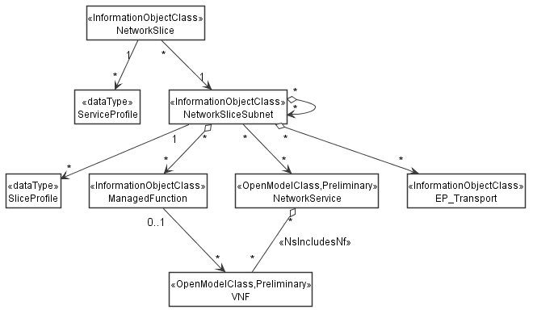

Figure 6.2.1-1: Network slice NRM fragment relationship
NOTE 1: The <<OpenModelClass>> NetworkService and <<OpenModelClass>> VNF are defined in [40].
NOTE 2: The target Network Service (NS) instance represents a group of VNFs and PNFs that are supporting the source network slice subnet instance.
NOTE 3: The instance tree of this NRM fragment would not contain the instances of NetworkService and VNF. However, the NetworkSliceSubNet instances would have an attribute holding the identifiers of NetworkService instances and the ManagedFunction instance would have an attribute holding identifiers of VNF instances.
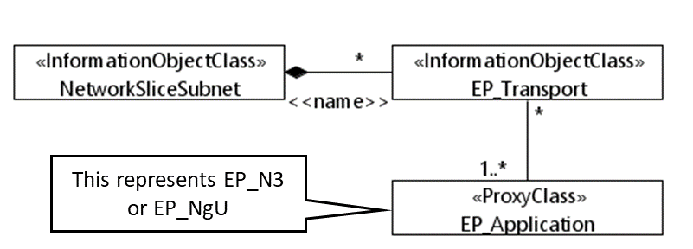
Figure 6.2.1-2: Transport EP NRM fragment relationship

End of modification

Start of 2nd modification

End of modification

