3GPP TSG-SA5 Meeting #137e S5-213380

e-meeting, 10 - 19 May 2021
CR-Form-v11.4
CHANGE REQUEST
 | 28.541 | CR | 0500 | rev | - | Current version: | 16.8.0
For HELP on using this form: comprehensive instructions can be found at
http://www.3gpp.org/Change-Requests.

Proposed change affects: | UICC apps |  | ME |  | Radio Access Network | X | Core Network | X

Title: | Fix editorial issue of network slice NRM
Source to WG: | Nokia, Nokia Shanghai Bell, Hewlett Packard Enterprise
Source to TSG: | S5
Work item code: | TEI16 |  |  |  |  |  | Date: |  |  | 2021-04-29
Category: | F |  |  |  |  |  | Release: |  |  | Rel-16
 | Use one of the following categories:  F (correction)  A (mirror corresponding to a change in an earlier release)  B (addition of feature),  C (functional modification of feature)  D (editorial modification)  Detailed explanations of the above categories can  be found in 3GPP TR 21.900. |  |  |  |  |  |  |  | Use one of the following releases:  Rel-8 (Release 8)  Rel-9 (Release 9)  Rel-10 (Release 10)  Rel-11 (Release 11)  Rel-12 (Release 12)  Rel-13 (Release 13)  Rel-14 (Release 14)  Rel-15 (Release 15)  Rel-16 (Release 16)
Reason for change: |  | The change on Transport EP NRM fragment relationship was missed when implemented the approved CR0444 (S5-212315).
Summary of change: |  | Change containing IOC of EP_Transport to SubNetwork based on approved CR0444. In addition, move all containment relationship to a dedicated diagram to be clearer and avoid mistake in the future
Consequences if not approved: |  | Incorrect naming containment relationship will cause error implemenation
Clauses affected: |  | 6.2.1
 |  | Y | N
Other specs |  |  | X | Other core specifications |  |  |  | TS/TR ... CR ...
affected: |  |  | X | Test specifications |  |  |  | TS/TR ... CR ...
(show related CRs) |  |  | X | O&M Specifications |  |  |  | TS/TR ... CR ...
Other comments: |  | Stage 3 code was correctly implemented, so no change on stage 3 in this CR

Start of 1st modification

6.2.1 Relationships
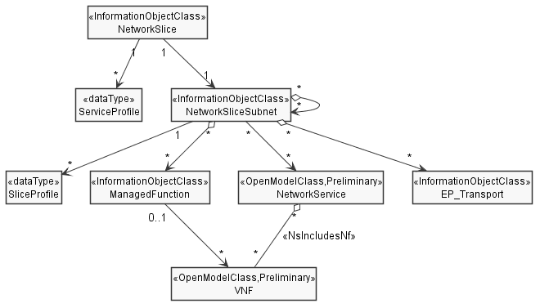

Figure 6.2.1-1: Network slice NRM fragment relationship
NOTE 1: The <<OpenModelClass>> NetworkService and <<OpenModelClass>> VNF are defined in [40].
NOTE 2: The target Network Service (NS) instance represents a group of VNFs and PNFs that are supporting the source network slice subnet instance.
NOTE 3: The instance tree of this NRM fragment would not contain the instances of NetworkService and VNF. However, the NetworkSliceSubNet instances would have an attribute holding the identifiers of NetworkService instances and the ManagedFunction instance would have an attribute holding identifiers of VNF instances.

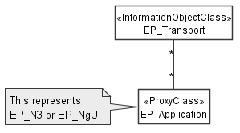
Figure 6.2.1-2: Transport EP NRM fragment relationship
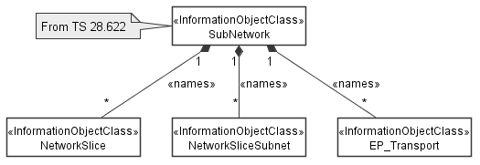
Figure 6.2.1-3: containment relationship for network slice fragment

End of modification

