3GPP TSG-SA5 Meeting #137-e S5-213227

Online, , 10th May 2021 - 19th May 2021
CR-Form-v12.1
CHANGE REQUEST
 | 28.313 | CR | Draft CR | rev | - | Current version: | 17.0.0
For HELP on using this form: comprehensive instructions can be found at
http://www.3gpp.org/Change-Requests.

Proposed change affects: | UICC apps |  | ME |  | Radio Access Network | x | Core Network

Title: | Rel-17 Input to DraftCR 28.313 MLB procedure
Source to WG: | Huawei
Source to TSG: | S5
Work item code: | eSON_5G |  |  |  |  |  | Date: |  |  | 2021-04-30
Category: | B |  |  |  |  |  | Release: |  |  | Rel-17
 | Use one of the following categories:  F (correction)  A (mirror corresponding to a change in an earlier release)  B (addition of feature),  C (functional modification of feature)  D (editorial modification)  Detailed explanations of the above categories can  be found in 3GPP TR 21.900. |  |  |  |  |  |  |  | Use one of the following releases:  Rel-8 (Release 8)  Rel-9 (Release 9)  Rel-10 (Release 10)  Rel-11 (Release 11)  …  Rel-15 (Release 15)  Rel-16 (Release 16)  Rel-17 (Release 17)  Rel-18 (Release 18)
Reason for change: |  | This contribution proposes to add the load balancing optimization procedure for to DraftCR 28.313.
Summary of change: |  | Add the load balancing optimization procedure.
Consequences if not approved: |  | The load balancing optimization function would not be clear.
Clauses affected: |  | 8.2.X
 |  | Y | N
Other specs |  |  | x | Other core specifications |  |  |  | TS/TR ... CR ...
affected: |  |  | x | Test specifications |  |  |  | TS/TR ... CR ...
(show related CRs) |  |  | x | O&M Specifications |  |  |  | TS/TR ... CR ...
Other comments: |  | Input to DraftCR to 28.313 for capturing Rel-17 MLB procedure
This CR's revision history:

1st modified section

8 SON procedures

8.2 Distributed SON management

8.2.x MLB Optimization (Mobility load balancing)
Figure 8.2.x-1 depicts a procedure that describes how D-SON management function can manage the MLB optimization function.
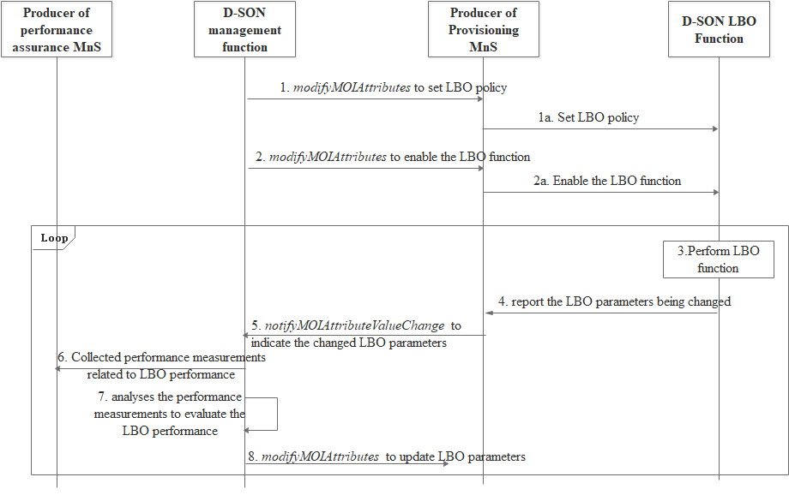
Figure 8.2.x-1: The management of distributed LBO procedure
1. The D-SON management function consumes the Producer of provisioning MnS with modifyMOIAttributes operation to configure the LBO policy for NR cell(s).
1.a The MnS of provisioning sets the LBO policy at the D-LBO LBO function (NOTE)
2. The D-SON management function consumes the Producer of provisioning MnS with modifyMOIAttributes operation to enable the D-LBO function for NR cell(s).
2.a The MnS of provisioning enables the D-LBO LBO function (NOTE).
3. The D-LBO function determines it is necessary to optimize the load distribution by executing the LBO actions.
4. The D-LBO function reports the LBO parameters (e.g. the handover and/or cell reselection parameters and/or isLBallowed parameters) changes to Producer of provisioning MnS.
5. The Producer of provisioning MnS sends a notification notifyMOIAttributeValueChange to D-SON management function to indicate the LBO parameters have been changed.
6. The D-SON management function collects LBO related performance measurements.
7. The D-SON management function analyzes the measurements to evaluate the LBO performance.
8. The D-SON management function consumes the MnS of NF provisioning with modifyMOIAttributes operation to update the LBO parameters (e.g. the handover and/or cell reselection parameters and/or isLBallowed parameters) of the NR cell or its neighbors if the LBO performance does not meet the target. The MnS of provisioning update the LBO parameters at the D-LBO function (NOTE).
NOTE: The interface between MnS of provisioning and D-LBO function is not subject to standardization.
End of modified section

