3GPP TSG-SA5 Meeting #135e S5-211348

e-meeting, 25 January – 3 February 2021

Source: Nokia, Nokia Shanghai Bell

Title: TD forge process proposal for yaml code in 135e meeting

Document for: Discussion and Endorsement
Agenda Item: 6.3

1 Decision/action requested
Please discuss and endorse

2 References
[1] 3GPP TS 28.541: "Management and orchestration; 5G Network Resource Model (NRM); Stage 2 and Stage 3".

3 Rationale
More than 100 compilation errors of OpenAPI code found in latest Rel16 and Rel17 TSs, many of them were editorial issues, e.g. implement/merge CRs incorrectly or missed some changes as too much lines scattered in a large yaml file, format error such as different indent, copy paste error, inconsistent between yaml files from different TSs, etc. Most of the errors cannot be addressed with existing forge process.
As we agreed in process before, only compilation error free code, then related stage 2 and 3 CRs, can be agreed in group. With the code in current TS and existing process, it’s very difficult to CR author to validate the code correctly, then the NRM CRs cannot be agreed without proof of succesfully code validation.
Note: You could check if there’s compilation error in forge validation report. If the code was compiled successfully, you will either not receive “[3GPP Forge] Validation failed: sa5-data-models-any-commit” email from 3GPP Forge, or from the link in the email, you will see the file you changed is valid. E.g. if you changed sliceNrm.yaml, and there’s no compilation error introduced by your change, after you commit the change in Forge, you will either see the commit is successful, or you may receive an email from 3GPP Forge with the validation report link, from the report you should see “---- Validating ./sliceNrm.yaml: /specs/sliceNrm.yaml is valid”.
Observation 1: As dependency between codes in multiple TSs and “editorial” error introduced during implementation of TS, we could always get compilation error for code in published TSs, then in published forge release branch. For Rel16 TSs after SA#90 as an example, the Rel16-SA90-agreed branch is just reflected the published TSs agreed in SA#90, compilation errors are still existed on the branch. We have to create another branch, e.g. Rel16-SA90-agreed-fix-compilation-error branch to fix compilation errors for Rel16, and create CRs based on this branch to fix TSs, but can be only approved in next SA meeting. In addition, referring the code in forge to update TSs line by line by comparing Rel16-SA90-agreed and Rel16-SA90-agreed-fix-compilation-error branches is doable, but it’s really complicated and also time consumable and error prone.
Observation 2: As CR author create their CR branch from release branch, e.g. Rel16 branch, the baseline itself is not error free, this cause challenges for the CR authors to validate their change. They have to rebased their change on error free branch, e.g. Rel16-SA90-agreed-fix-compilation-error with git tool and operations proposed by Michele, this can be a little challenges to many CR authors.
Note from Forge expert: rebasing is strongly recommended in order to prevent merge conflicts. Unfortunately Gitlab support for rebase is partial, therefore some rebase operations should be done locally and uploaded to the Forge via usage of Git or a Git Client. For information on rebasing, please refer to https://git-scm.com/book/en/v2/Git-Branching-Rebasing .
What CR authors should do, is to rebase their own branch onto Rel16-SA90-agreed-fix-compilation-error (or similar for Rel17). To do this operation, independently from the tooling, please do:
- Make sure your local clone of the repository is up to date (git-fetch operation)
- Make a local copy of the -agreed-fix-compilation-error branch
- Checkout your working branch containing your CR
- Execute the rebase onto the -fix-compilation-error branch, (from the command line use -i option, or use a Graphical Tool)

Note: For Rel17, as no Rel17 version of TS 28.623 and TS 28.532, the latest verion of Rel16 branch in Forge (I supposed it’s release 16 frozen verion) instead of code from latest Rel16 TSs was used as baseline of branch Rel17-SA90-agreed.

Please see the current status of Rel 16 OpenAPI code in forge in below picture.
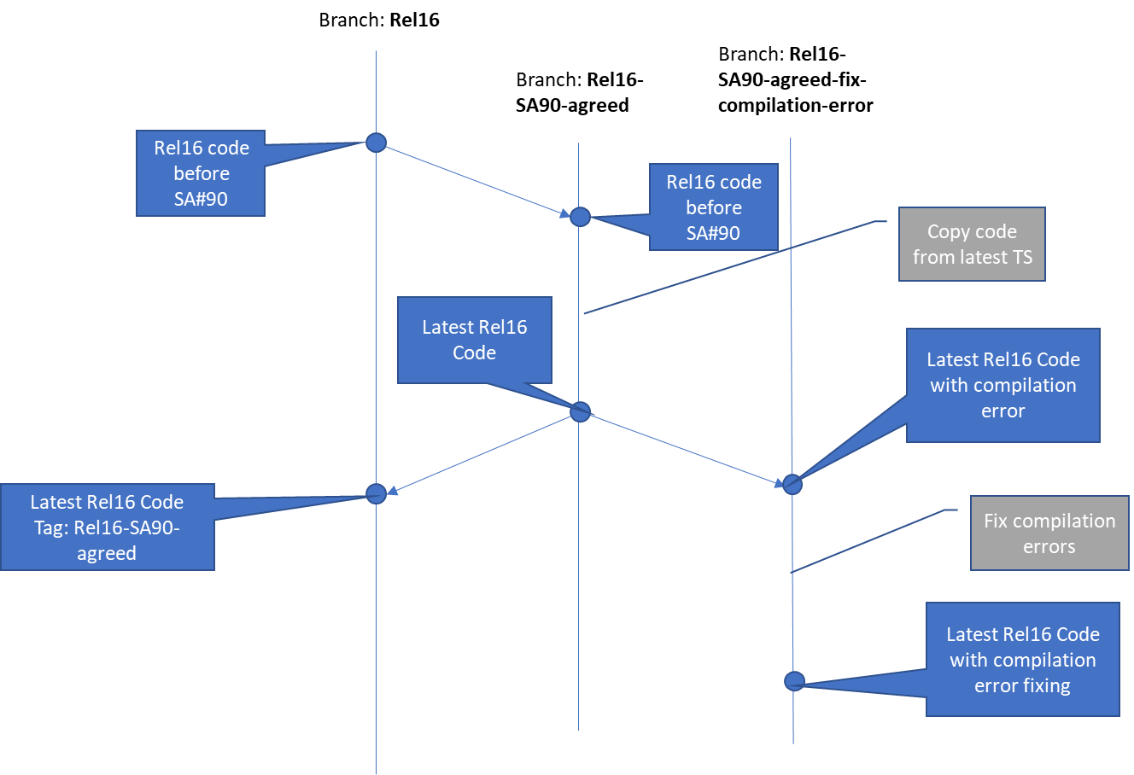

Three options are proposed in clause 4 to implement and validate code in both TS and Forge in this meeting.

4 Detailed proposal

4.1 Option 1: create CR branch based on latest codes of TSs
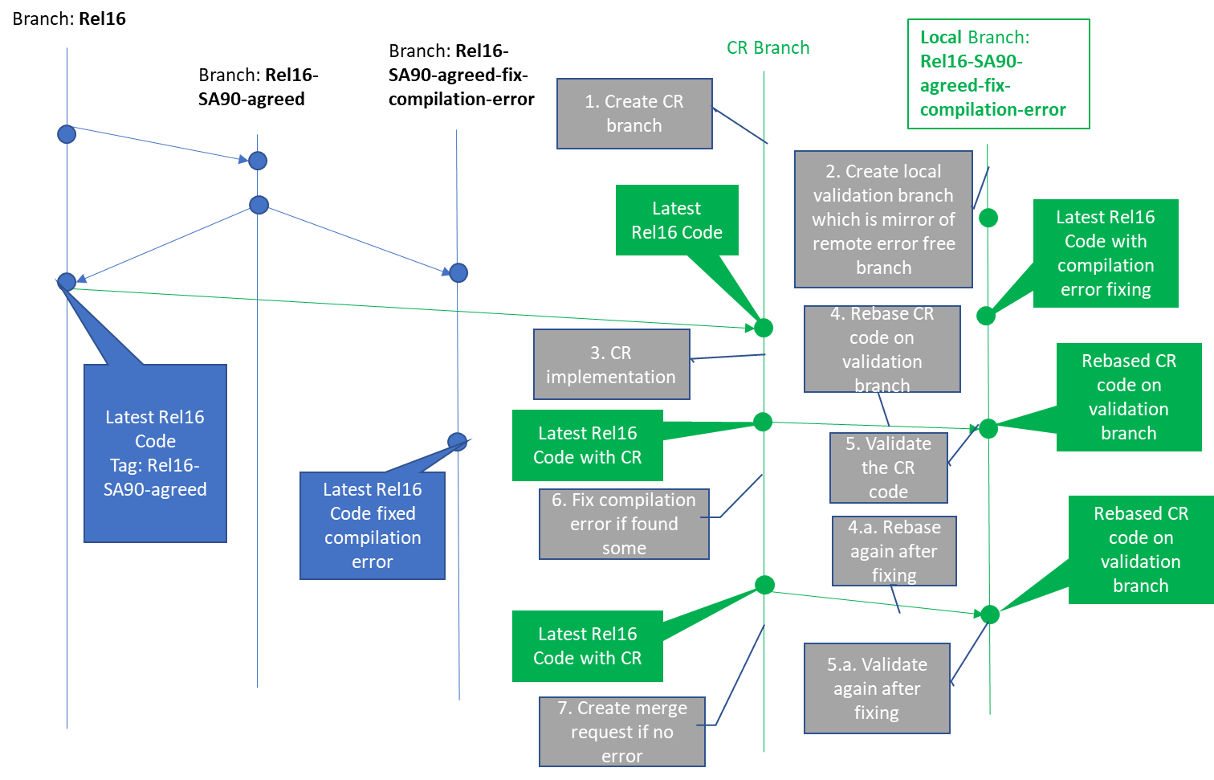
Precondition:
- update TS for the CR, copy updated TS code to Forge file in step 3
Post condition:
- update TS accordingly if compilation error found and fixed in forge.
- CRs will be merged by MCC one by one after being approval in SA meeting.
Note: CRs to fix compilation errors of latest TSs will be proceeded as normal CR
Pros:
- Strictly follow SA/CT process
Cons:
- referring the code in forge to update TSs line by line, or change the code in TS directly line by line is complicated, time consumable and error prone for the author.
- implement hundreds line change of code is complicated, time consumable and error prone for MCC
- change of code in different TSs which the current TS depends on can’t be detected
- the procedure to validate the code is challenge to CR authors

4.2 Option 2: create CR branch based on latest codes with compilation error fixing
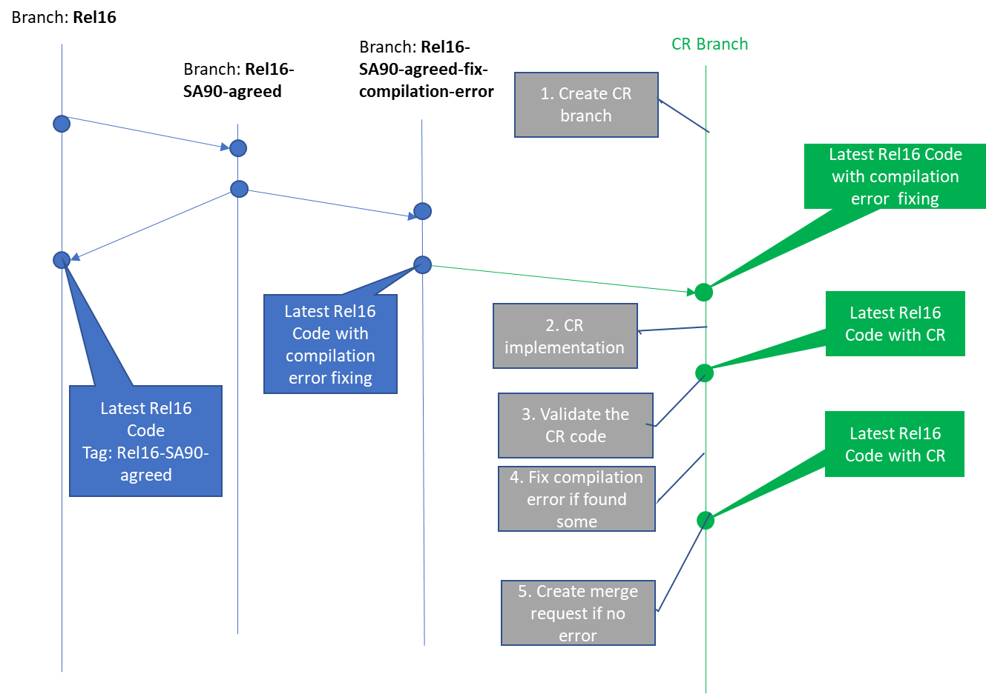
Precondition:
- Code moderator create baseline branch, extracts codes in latest TSs in forge files, and correct compiling erros on the baseline branch
- Code moderator Create CRs (call baseline CRs) to replace code in latest TS with error free forge file (code on Rel16-SA90-agreed-fix-compilation-error), and create baseline of the TS for this meeting
- CR (call normal CR) author update TS for the CR based on the new TS baseline created by Code moderator in last step
- CR author copies updated TS code to Forge file in step 2
Note: alternatively, CR author can implement code change in forge based on error free Forge baseline, and copy-paste the changed code one by one to TS, that means the change mark of each CR need to be reflected in MS word of the CR as only putting forge link tDoc is not allowed in 3GPP SA at present.
Post condition:
- update TS accordingly if compilation error found and fixed in forge.
- All stage 3 CRs, including cleanup CRs and normal technical CRs will be sent to SA for approval
- when implement CRs after SA meeting, MCC merges other normal CRs one by one to the error free Forge baseline branch. After merged all CRs, MCC copied the merged code from Forge baseline branch to Annexes of TSs without update the TS line by line for each CR.
Note: one more step before SA meeting is needed for integration/cross check of all CRs of all TSs. Then conflict could be fixed before SA. Otherwise the conflict can only be sovled after SA and fixed in next SA
Note: baseline CRs will be handled differently than other normal CRs. Relevant comments should be put for both baseline and normal CRs on CR cover page. E.g. For baseline CR, put comments such as “this CR is baseline CR, and need to be merged first” . For other CRs, put comments such as “the CR is dependent on baseline CR xxxx, and merged based on that CR ”
Pros:
- Simplify the validation procedure for normal CR author
- Comply with SA/CT process in some extent
- Simplify MCC’s work to build baseline and merge code
Cons:
- the CR author still need to change the code line by line in TS
- conflict may not be detected before SA
- normal technical CR has risk to be rejected as wrong baseline (of TS, as the new error free TS baseline was not published) or has change on change issue (normal technical CR changes based on the change of the cleanup CR)

4.3 Option 3: create CR branch based on latest codes with compilation error fixing and copy merged code to TS

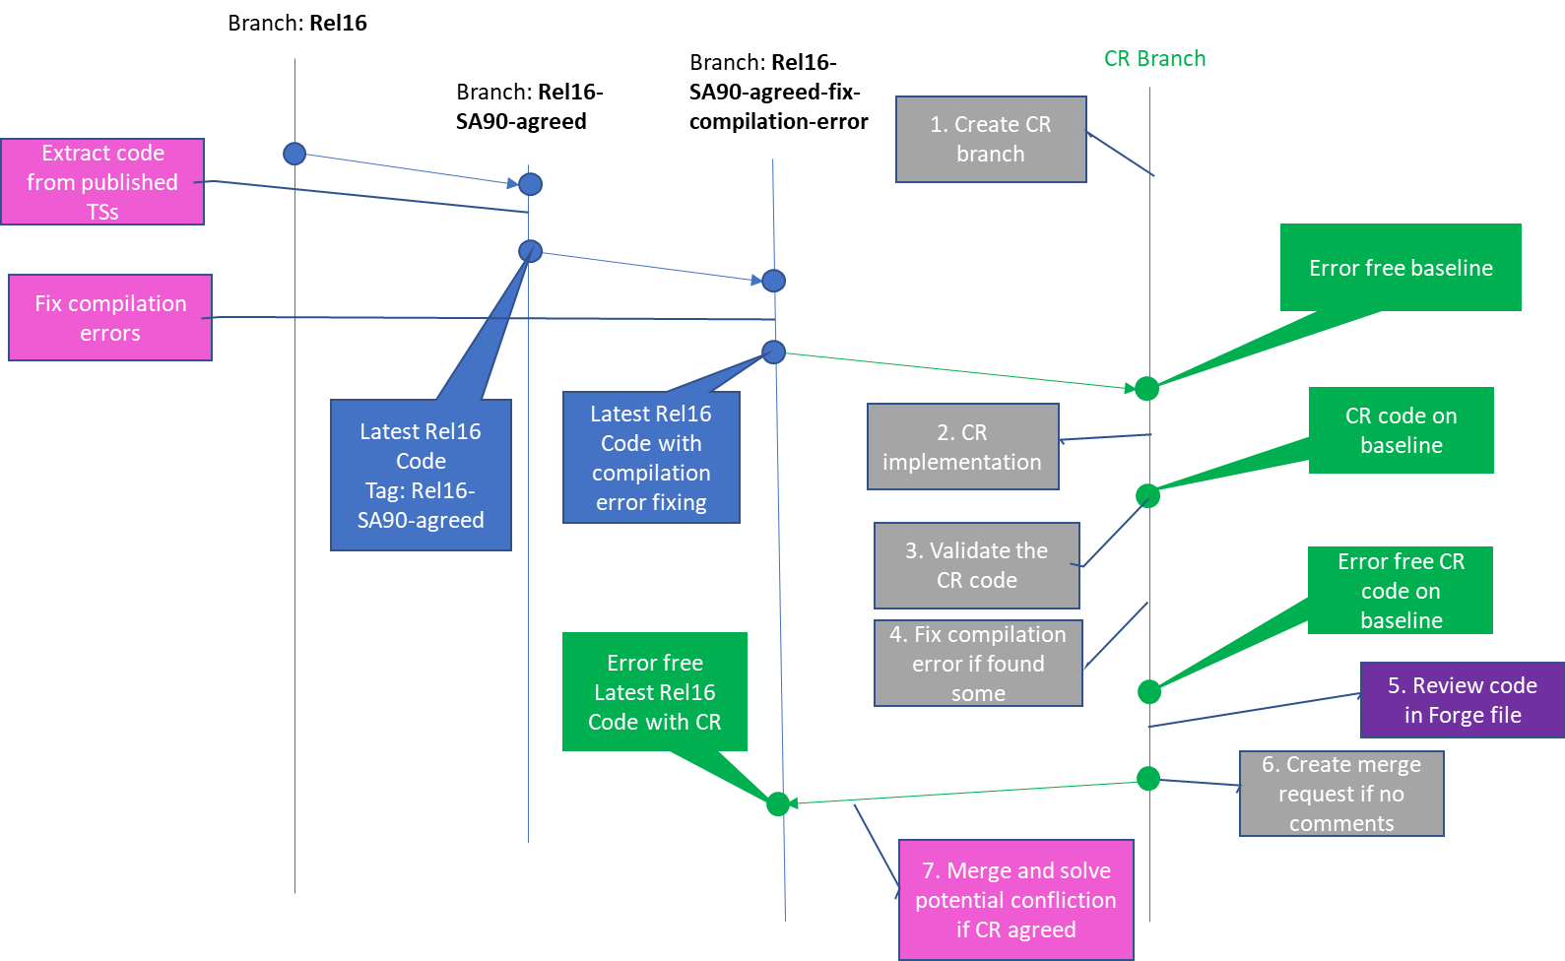
Legend:
Assumption:
- All normal technical CR authors don’t need to touch TS but just work on Forge
- No stage 3 code change reflected in individual technical CR
Precondition:

- Code moderater extracted latest code from published TSs to Forge files, fixed the compiling errors and generated error free Forge baseline. e.g. branch Rel16-SA90-agreed-fix-compilation-error shown in above figure (in SA5#135e)
Procedures:
Before SA5#136e meeting:
1. CR author created CR branch from the error free Forge baseline branch
2. CR author implements the code change in Forge, or alternatively writes the code with other edit tool and copy the changed file to Forge.
3. CR author commit the code to Forge and check the report of the commit.
4. If commit report shows failure, CR author need to fix the compiling error and validate again until get successfully commit report.
5. Once all errors are fixed, with comparation function of Forge, CR author generates a compaeration result in Forge, and sends out the link for email review
Note: CR author could put the link of forge code (or comparation result) and validation report (see commit result) in either cover page of tDoc or in the email thread for review.
During SA5#136e meeting:
6. Other delegates review the stage 3 code (through link of the Forge) together with stage 2 change (in MS word file)
During or after SA5#136e meeting but before SA#91:
7. Once the CR agreed (no review issue, no validation error), CR author submit merge request for the CR branch in Forge

Post condition:
Alternative 1 (two steps):
Before SA#91 (in SA5#135 or 136):
- Code moderator creates CRs (call baseline CRs) to fix compiling errors in latest TS. One CR will be created for each type of stage 3 code of each TS of each Release. E.g. 6 CRs will be created to fix compiling errors of openAPI codes. Two for rel16 and rel17 28.541, two for rel16 and rel17 28.536, one for rel16 28.532, and one for rel16 28.623
- Only these cleanup CRs will be submitted to SA#91 for approval
After SA#91:
- MCC implements those cleanup CRs in TSs to build correct TS baseline
- MCC merges the baseline branch to release branch
- Stage 3 codes of
- normal technical CRs will be postponed to the SA5 meeting after SA#91. That means all NRM CR with stage 3 change can only be conditionally agreed in SA5#135 and SA5#136, then the related CR author creates stage 3 code based on correct baseline after SA#91, and resubmit the NRM CR to SA5#137. (option 2 may be adopted in this stage)
Alternative 2 (one step with mega CRs):
After SA5#136 and before SA#91:
- MCC merges all nomral technical CRs to the error free baseline branch. Code morderator would assist for solve potential conflict between CRs
Note: MCC and code moderate need to ensure no compilation error in the Forge baseline branch after all agreed CR branches merged.

- Code moderator creates several mega CRs to cover all cleanup and tehnical changes in SA5#135 and 136. One CR will be created for each type of stage 3 code of each TS of each Release. E.g. 6 CRs will be created to fix compiling errors of openAPI codes. Two for rel16 and rel17 28.541, two for rel16 and rel17 28.536, one for rel16 28.532, and one for rel16 28.623
- The mega CRs will be sent to SA#91 for approval
After SA#91:

- MCC implements those CRs in TSs.
- MCC merges the baseline branch to release branch

Pros:
- Simplify the code implementation and validation procedure for all stackholders
- dependency between different TSs could be solved
- still follow SA/CT process

Cons:

- if some SA5 agreed technical CRs could not be finally approved in SA meeting, the whole mega CR would be impacted
- low risk to be rejected as use the corect baseline which follow SA process
Either adopted alternative 1 or 2 of option 3 will be decided in SA#136e

Please endorse option 3 as it looks more balanced.

