3GPP TSG SA WG5 Meeting 135-e TDoc S5-211333

electronic meeting, online, 25 January - 3 February 2021
CR-Form-v12.1
CHANGE REQUEST
 | 28.535 | CR | 0029 | rev | - | Current version: | 16.2.0
For HELP on using this form: comprehensive instructions can be found at
http://www.3gpp.org/Change-Requests.

Proposed change affects: | UICC apps |  | ME |  | Radio Access Network | X | Core Network | X

Title: | Clarify intelligence in clause 4
Source to WG: | S5
Source to TSG: | Ericsson, Deutsche Telekom
Work item code: | COSLA |  |  |  |  |  | Date: |  |  | 2021-01-07
Category: | F |  |  |  |  |  | Release: |  |  | Rel-16
 | Use one of the following categories:  F (correction)  A (mirror corresponding to a change in an earlier release)  B (addition of feature),  C (functional modification of feature)  D (editorial modification)  Detailed explanations of the above categories can  be found in 3GPP TR 21.900. |  |  |  |  |  |  |  | Use one of the following releases:  Rel-8 (Release 8)  Rel-9 (Release 9)  Rel-10 (Release 10)  Rel-11 (Release 11)  …  Rel-15 (Release 15)  Rel-16 (Release 16)  Rel-17 (Release 17)  Rel-18 (Release 18)
Reason for change: |  | In clause 4 Concepts and background a closed control loop is depicted in Figure 4.3.1. In the decide step in the figure the word “Intelligence” is used without further explanation in the descriptive text. The more concrete term that should be used is Decide, i.e. the decision support services are provided by a decide management function.
Summary of change: |  | Update Figure 4.3.1 to replace Intelligence with Decide
Consequences if not approved: |  | The reader could be under the impression that all “intelligence” is in the decide step and misunderstand the concept leading to incompatible implementations
Clauses affected: |  | 4.3
 |  | Y | N
Other specs |  |  | X | Other core specifications |  |  |  | TS/TR ... CR ...
affected: |  |  | X | Test specifications |  |  |  | TS/TR ... CR ...
(show related CRs) |  |  | X | O&M Specifications |  |  |  | TS/TR ... CR ...
Other comments:
This CR's revision history:

First change

4.3 Communication service assurance service
Communication service assurance relies on a set of management services that together provide the CSP with the capability to assure the communication service as per agreement (for example an SLS) with a CSC (e.g. enterprise). The overall solution and information flows between management services and the closed control loop steps [5] are shown in Figure 4.3.1.
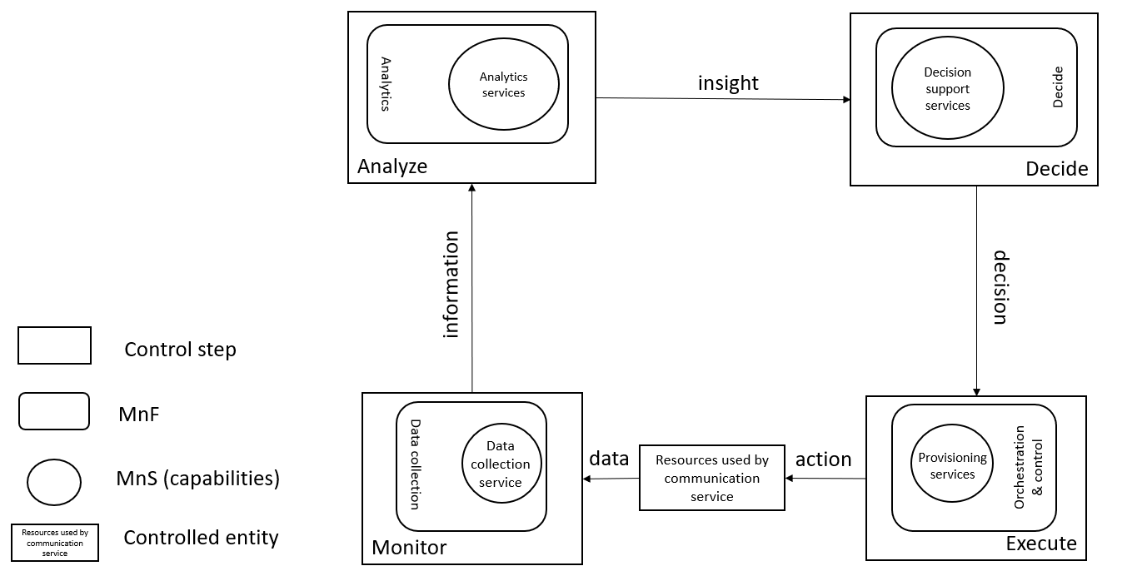

Figure 4.3.1: Overview of closed control loop information flows
In Figure 4.3.1 the controlled entity represents the resources used by a communication service and the assurance of this communication service is provided by the closed control loop between the different management services provided by the management system.
The input to the closed control loop is the data concerning the resources used by the communication service and corrresponding service KPIs which is monitored by the closed control loop and step "Monitor", analyzed by the closed control loop step “Analyze”, a decision on potential solution by the closed control loop step "Decide" which may be a possible action for the closed control loop step "Execute", The role of the decision support services is to provide variable degrees of automated decision making and human oversight support. The following two examples demonstrate how a closed control loop can be used:
- when a service experience degradation is detected (for example due to resource shortage or faults in the network), the resources used by a communication service may be adjusted automatically to improve the service experience
- the data associated with the communication service is monitored by the management services for data collection, this management service provides information to an assurance root cause analysis management service (example of an analytics service) and based on that information the assurance root cause analysis takes place, followed by proposing activities, mitigation or suggestions to solve the problem. The proposed activities, for example mitigation or problem-solving suggestion(s) are executed through provisioning services to bring the behaviour of the communication service within the requested boundaries of the metrics (SLS goals) that are controlled by the closed control loop.
The management services available for the closed control loop steps for "Monitor", "Analyze" and "Decide" are based on file transfer described in TS 28.550 [3], or data streaming described in TS 28.550 [3] and notifications described in TS 28.545 [6].
The information provided from the "Monitor" step to the "Analyze" step includes performance measurements (see TS 28.552 [7]), KPI’s (see TS 28.554 [8]), performance threshold monitoring events and fault supervision events (see TS 28.532 [9]).
The insights provided from the "Analyze" step to the "Decide" step includes analytics outcomes that are not specified in the present document.
The decision support services provided from the "Decide" step to the "Execute" step are not specified in the present document.
End of change

