3GPP TSG-SA5 Meeting #135 S5-211249

Online, , 25 Jan- 03 Feb 2021

Source: Samsung, Telefonica

Title: InputToDraftCR for WI eMA5SLA Configuration Parameters

Document for: Approval

Agenda Item: 6.4.2

1 Decision/action requested
The group is asked to discuss and agree on the proposal.

2 References
[1] 3GPP TR 23.700-40 Study on enhancement of network slicing; Phase 2

3 Rationale
SA2 has concluded on KI related to Maximum number of UEs, Maximum number of PDU sessions, Downlink maximum throughput per UE and Uplink maximum throughput per UE. And they are expecting related configuration to come from OAM. This document is trying to say that OAM CAN provide those configurations. However, further work is needed as follows
- We need to get SA2’s opinion on the exact name of “Configuration Parameters”. Hence, is the LS (S5-211122) proposed to SA2.
- 5GC NRM need to be extended with the appropriate “Configuration Parameters” and the 5GS function. That information also we will get from SA2. Hence the Editor’s Note
Indicate which of the ServiceProfile attributes can be translated into SliceProfile (S5-205278 tell us that today) and then further which of the SliceProfile attributes can be translated into configuration parameters for 5GS (CN/RAN). This is again based on “CNSliceSubnetProfile” and “RANSliceSubnetProfile” in S5-205278
Regarding the exact name for configurable parameters, it is proposed to send an LS to SA2 for information and possible suggestions.
The changes proposed are marked with the signature “DG #135e” and “DG #135e 27Jan”.
4. Detailed proposal

1st Modified Section

Annex L (normative):
Relation of GSMA GST, ServiceProfile and SliceProfile

L.1 General
This annex describes the relation between GSMA GST [50] and information model ServiceProfile and SliceProfile.

L.2 GSMA GST, ServiceProfile and SliceProfile
The GSMA GST is used as the SLA information for the communication between the vertical industry and the communication service provider. The SLA requirements can be fulfilled from management aspect and control aspect in a coordinated way. The SLS includes ServiceProfile information model.
As shown in figure L.2.1, the GST [50] is translated and used as input to NRM ServiceProfile, the ServiceProfile can be translated to corresponding requirements for dedicated domains. For example, 5GC SliceProfile is used to carry 5GC domain requirements, NG-RAN SliceProfile is used to carry NG-RAN domain requirements, and TN requirements are translated and provided to TN domain.
Some of the information (as shown in Table L.2.1) in 5GC SliceProfile and NG-RAN SliceProfile is translated to configurable parameters related to network function behaviour for the control plane SLA support purpose. While other information (e.g delay tolerance, determistic communication support) in 5GC SliceProfile and NG-RAN SliceProfile are kept at OAM domain and is used to determine the overall behaviour of the network slice.

The following table show the translation of GST attributes.
GST Attributes | ServiceProfile Parameter | SliceProfile Parameter | Configurable Parameter
Maximum number of UEs | maxNumberofUEs | maxNumberofUE | TBD
Maximum number of PDU sessions | maxNumberofConns | maxNumberofPDUSessions | TBD
Downlink maximum throughput per UE | dLThptPerUE | dLThptPerUEPerSubnet | TBD
Uplink maximum throughput per UE | uLThptPerUE | uLThptPerUEPerSubnet | TBD

Table L.2.1: GST translation
Editors note: The list of exact configurable parameters is to be revisted depending on the requirements from SA2 and RAN WGs.

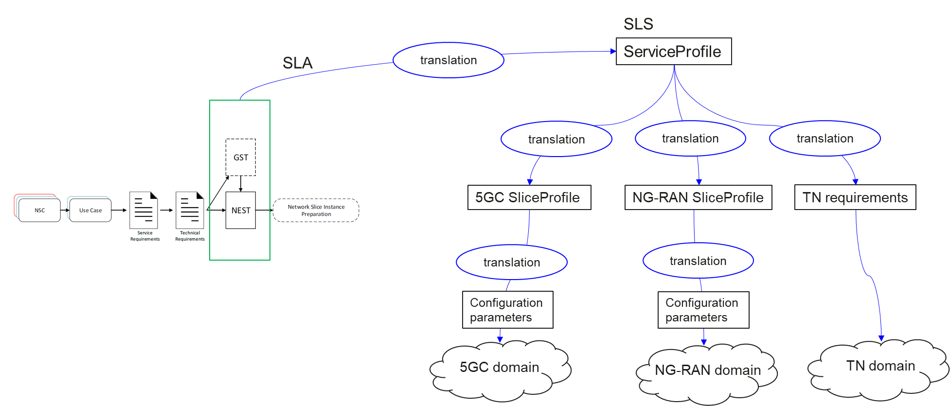
Figure L.2.1 Relation between GSMA GST, ServiceProfile and SliceProfile
End of modified section

