**3GPP TSG-SA5 Meeting #135 S5-211249**

**Online, , 25 Jan- 03 Feb 2021**

**Source: Samsung, Telefonica**

**Title: InputToDraftCR for WI eMA5SLA Configuration Parameters**

**Document for: Approval**

**Agenda Item: 6.4.2**

# 1 Decision/action requested

***The group is asked to discuss and agree on the proposal.***

# 2 References

[1] 3GPP TR 23.700-40 Study on enhancement of network slicing; Phase 2

# 3 Rationale

As per the conclusion in [1] the maximum number of UE and the maximum number of connection per slice will be handeled in CN. The conclusion in section 8.1 of [1] requires O&M configurable for the same in 5GC. Hence, this contribution proposes to identify the related attributes of Service Profile and Slice Profile that can be translated into configurable parameters for CN.

In the same line, as per the interim conclusion for data rate per network slice in UL and DL per UE, this contribution proposes to identify the related attributes of Service Profile and Slice Profile that can be translated into configurable parameters for CN.

Regarding the exact name for configurable parameters, it is proposed to send an LS to SA2 for information and possible suggestions.

The changes proposed are marked with the signature “DG #135e” and “DG #135e 27Jan”.

4. Detailed proposal

|  |
| --- |
| **1st Modified Section** |

Annex L (normative):   
Relation of GSMA GST, ServiceProfile and SliceProfile

# L.1 General

This annex describes the relation between GSMA GST [50] and information model ServiceProfile and SliceProfile.

# L.2 GSMA GST, ServiceProfile and SliceProfile

The GSMA GST is used as the SLA information for the communication between the vertical industry and the communication service provider. The SLA requirements can be fulfilled from management aspect and control aspect in a coordinated way. The SLS includes ServiceProfile information model.

As shown in figure L.2.1, the GST [50] is translated and used as input to NRM ServiceProfile, the ServiceProfile can be translated to corresponding requirements for dedicated domains. For example, 5GC SliceProfile is used to carry 5GC domain requirements, NG-RAN SliceProfile is used to carry NG-RAN domain requirements, and TN requirements are translated and provided to TN domain.

Some of the information (e.g maximum number of connection per slice, downlink throughput per slice) in 5GC SliceProfile and NG-RAN SliceProfile is translated to configurable parameters related to network function behaviour for the control plane SLA support purpose. While other information (e.g delay tolerance, determistic communication support) in 5GC SliceProfile and NG-RAN SliceProfile are kept at OAM domain and is used to determine the overall behaviour of the network slice.

The following table show the list of GST attributes translated into attributes of ServiceProfile and SliceProfile. It also shows the corresponding Configurable Parameters.

|  |  |  |  |
| --- | --- | --- | --- |
| GST Attributes | ServiceProfile Attribute | SliceProfile Attribute | Configurable Parameter |
| Maximum number of UEs | maxNumberofUEs | maxNumberofUE | maxNumberofUE |
| Maximum number of PDU sessions | maxNumberofConns | maxNumberofPDUSessions | maxNumofPDUSessionPerSlice |
| Downlink maximum throughput per UE | dLThptPerUE | dLThptPerUEPerSubnet | Slice-MBR (maximum bit rate per UE per slice in downlink) |
| Uplink maximum throughput per UE | uLThptPerUE | uLThptPerUEPerSubnet | Slice-MBR (maximum bit rate per UE per slice in uplink) |

Table L.2.1: List of configurable parameter

Editors note: The list of exact configurable parameters is to be revisted depending on the requirements from SA2 and RAN WGs.

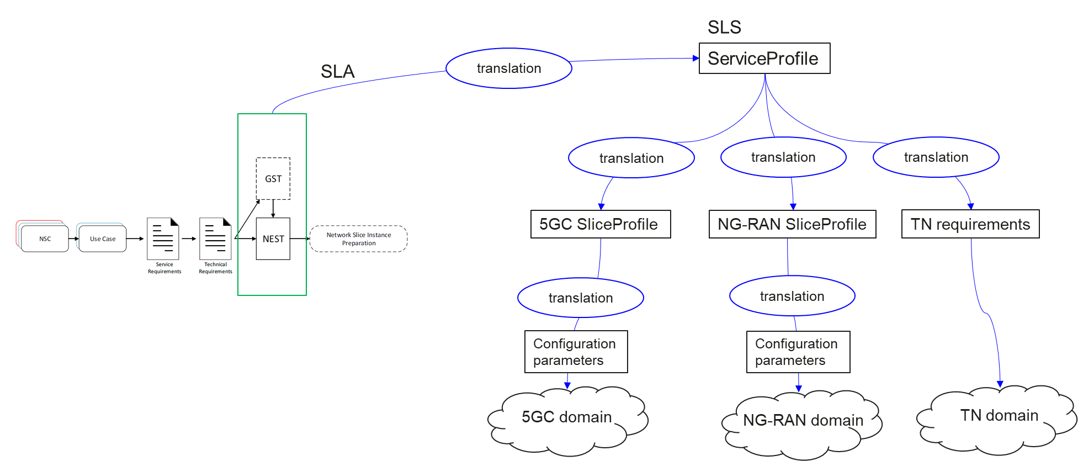

Figure L.2.1 Relation between GSMA GST, ServiceProfile and SliceProfile

|  |
| --- |
| **End of modified section** |