3GPP TSG SA WG5 Meeting 135-e S5-211225

electronic meeting, online, 25 January - 3 February 2021

Source: Huawei, China Mobile

Title: Add procedure for intent lifecycle management

Document for: Approval
Agenda Item: 6.4.10

1 Decision/action requested
The group is asked to discuss and approval.

2 References
[1] 3GPP draft TS 28.312: “Management and orchestration; Intent driven management services for mobile networks v0.1.0”.

3 Rationale
This contribution proposes to add procedures for intent lifecycle management.

4 Detailed proposal
It proposes to make the following changes to TS 28.312[1].
1st Change

6 Stage 2 definition for Intent Driven Management
Editor's note: this clause will specify the stage2 definition for Intent driven management which may include the management operations, management entities and management information

6.3 Procedures for intent lifecycle management

6.3.1 Introduction
This clauses describes the procedures for intent lifecycle management, which support all concrete intent defined in clause 6.2 Information model definition for intent. The concrete intent means the realization of GenericIntent_ IOC, e.g. NetworkOptimizationIntent, RadioNetworkDeploymentIntent.
Editor’s Note: the intent feasible check capability and intent fulfilment feedback information needs to be considered, which may need to enhance the following procedure or add new procedures.

6.3.2 Create an intent
The Figure 6.3.2-1 illustrates the procedure for create a new intent.
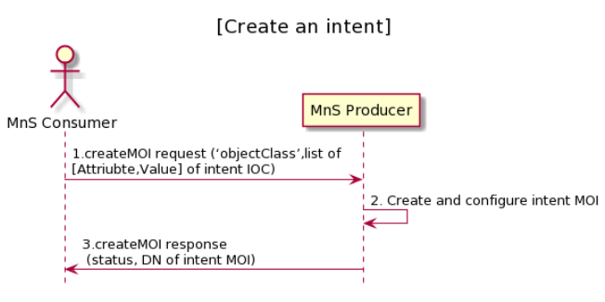
Figure 6.3.2-1 Procedure for create an intent
- MnS Consumer sends createMOI request to MnS Producer with ‘objectClass’ and list of [Attribute,Vlaue] for the new intent to be created. The detailed [Attribute,Value] see the concrete intent IOC defined in clause 6.2. ‘objectCalss’ is the name for the concrete intent IOC.
- Based on the request, MnS Producer creates the concrete intent MOI (i.e. instance of intent IOC) with value for attribute ‘objectInstance’ allocated, and configure the new created intent MOI with the received list of [Attribute, Value]. ‘objectInstance’ is the identifier (DN) for the concrete intent MOI.
- MnS Producer sends a createMOI response to the MnS consumer with status (OperationSucceeded or OperationFailed) and ‘objectInstance’ of the created intent MOI.

6.3.3 Activate an intent
The Figure 6.3.3-1 illustrates the procedure for activate an intent.

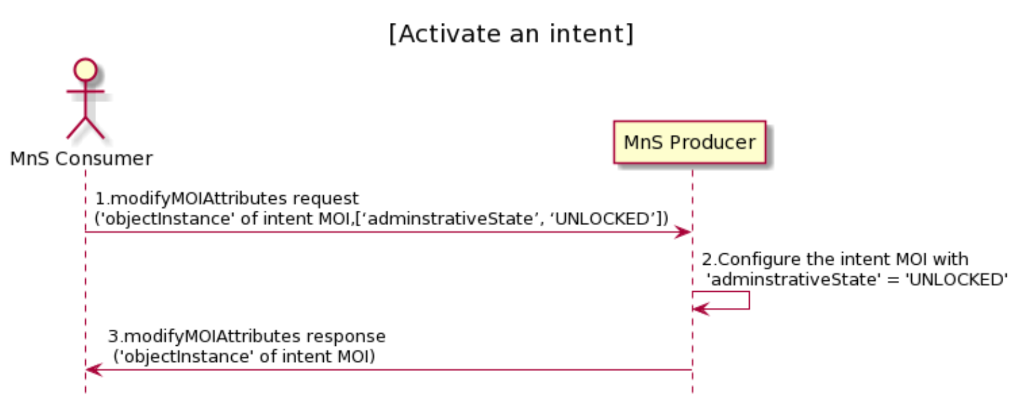
Figure 6.3.3-1 Procedure for activate an intent
- MnS Consumer sends modifyMOIAttributes request to MnS Producer with ‘objectInstance’ of the intent MOI and [‘AdminstrativeState’, ‘UNLOCKED’].
- Based on the request, MnS Producer configure the intent MOI with ‘AdminstrativeState’ = ’UNLOCKED’.
- MnS Producer sends a modifyMOIAttributes reponse to the MnS consumer with status (OperationSucceeded or OperationFailed) and ‘objectInstance’ of the modified intent MOI.

6.3.4 De-activate an intent
The Figure 6.3.4-1 illustrates the procedure for de-activate an intent.

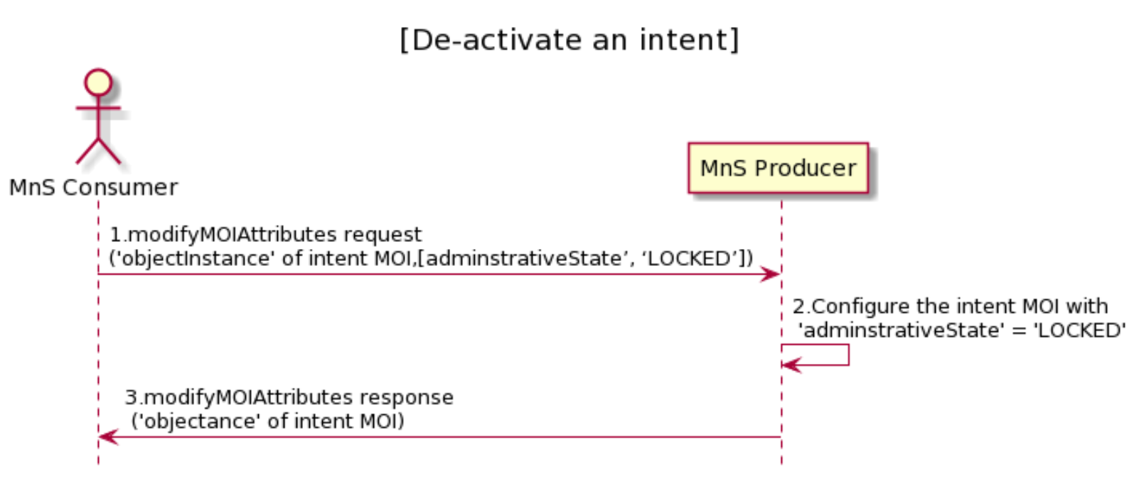
Figure 6.3.4-1 Procedure for de-activate an intent
- MnS Consumer sends modifyMOIAttributes request to MnS Producer with ‘objectInstance’ of the intent MOI and [‘adminstrativeState’, ‘LOCKED’].
- Based on the request, MnS Producer configure the intent MOI with ‘adminstateiveState’ = ’UNLOCKED’.
- MnS Producer sends a modifyMOIAttributes reponse to the MnS consumer with status (OperationSucceeded or OperationFailed) and ‘objectInstance’ of the modified intent MOI.

6.3.5 Modify an intent
The Figure 6.3.5-1 illustrates the procedure for modify an existing intent.
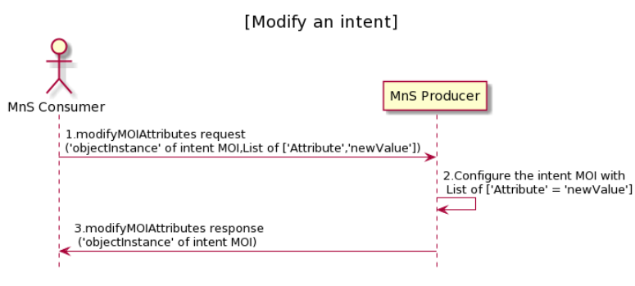
Figure 6.3.5-1 Procedure for modify an intent
- MnS Consumer sends modifyMOIAttributes request to MnS Producer with ‘objectInstance’ of the intent MOI and List of [‘Attrribute’, ‘newValue’] to be modified. The detailed [Attribute,Value] see the concrete intent IOC defined in clause 6.2.
- Based on the request, MnS Producer configure the intent MOI with list of ‘Attribute’ = ’newValue’ which is required to be modified.
- MnS Producer sends a modifyMOIAttributes response to the MnS consumer with status (OperationSucceeded or OperationFailed), ‘objectInstance’ of the modified intent MOI and, and list of [‘Attrribute’, ‘newValue’] which is modified.

6.3.6 Delete an intent
The Figure 6.3.6-1 illustrates the procedure for modify an existing intent.

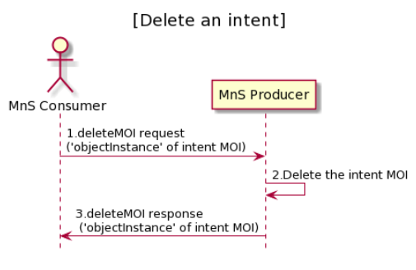
Figure 6.3.6-1 Procedure for delete an intent
- MnS Consumer sends deleteMOIAttributes request to MnS Producer with ‘objectInstance’ of the intent MOI.
- Based on the request, MnS Producer delete the intent MOI.
- MnS Producer sends a deleteMOIAttributes response to the MnS consumer with status (OperationSucceeded or OperationFailed), ‘objectInstance’ of the deleted intent MOI.

6.3.7 Query an intent
The Figure 6.3.7-1 illustrates the procedure for query an existing intent.

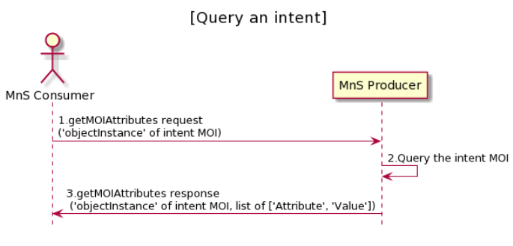
Figure 6.3.7-1 Procedure for query an intent
- MnS Consumer sends getMOIAttributes request to MnS Producer with ‘objectInstance’ of the intent MOI.
- Based on the request, MnS Producer obtain the list of [attribute, value] of the intent MOI.
- MnS Producer sends a getMOIAttributes response to the MnS consumer with status (OperationSucceeded or OperationFailed), ‘objectInstance’ of the deleted intent MOI, the list of [attribute, value] of the intent MOI. The detailed [Attribute,Value] see the concrete intent IOC defined in clause 6.2.

2nd Change

Annex A (informative):
PlantUML source code

A.1 Procedures for intent lifecycle management

A.1.1 Create an intent

@startuml
title "[Create an intent]"
actor "MnS Consumer" as MnS_Consumer
participant "MnS Producer" as MnS_Producer
MnS_Consumer -> MnS_Producer: 1.createMOI request (‘objectClass’,list of \n[Attriubte,Value] of intent IOC)
MnS_Producer -> MnS_Producer: 2. Create and configure intent MOI
MnS_Producer -> MnS_Consumer: 3.createMOI response\n (status, DN of intent MOI)
hide footbox
@enduml
A.1.2 Activate an intent
@startuml
title "[Activate an intent]"
actor "MnS Consumer" as MnS_Consumer
participant "MnS Producer" as MnS_Producer
MnS_Consumer -> MnS_Producer: 1.modifyMOIAttributes request \n('objectInstance' of intent MOI,[‘adminstrativeState’, ‘UNLOCKED’])
MnS_Producer -> MnS_Producer: 2.Configure the intent MOI with \n 'adminstrativeState' = 'UNLOCKED'
MnS_Producer -> MnS_Consumer: 3.modifyMOIAttributes response\n ('objectInstance' of intent MOI)
hide footbox
@enduml

A.1.3 De-activate an intent
@startuml
title "[De-activate an intent]"
actor "MnS Consumer" as MnS_Consumer
participant "MnS Producer" as MnS_Producer
MnS_Consumer -> MnS_Producer: 1.modifyMOIAttributes request \n('objectInstance' of intent MOI,[adminstrativeState’, ‘LOCKED’])
MnS_Producer -> MnS_Producer: 2.Configure the intent MOI with \n 'adminstrativeState' = 'LOCKED'
MnS_Producer -> MnS_Consumer: 3.modifyMOIAttributes response\n ('objectance' of intent MOI)
hide footbox
@enduml

A.1.4 Modify an intent
@startuml
title "[Modify an intent]"
actor "MnS Consumer" as MnS_Consumer
participant "MnS Producer" as MnS_Producer
MnS_Consumer -> MnS_Producer: 1.modifyMOIAttributes request \n('objectInstance' of intent MOI,List of ['Attribute','newValue'])
MnS_Producer -> MnS_Producer: 2.Configure the intent MOI with \n List of ['Attribute' = 'newValue']
MnS_Producer -> MnS_Consumer: 3.modifyMOIAttributes response\n ('objectInstance' of intent MOI)
hide footbox
@enduml

A.1.5 Delete an intent
@startuml
title "[Delete an intent]"
actor "MnS Consumer" as MnS_Consumer
participant "MnS Producer" as MnS_Producer
MnS_Consumer -> MnS_Producer: 1.deleteMOI request \n('objectInstance' of intent MOI)
MnS_Producer -> MnS_Producer: 2.Delete the intent MOI
MnS_Producer -> MnS_Consumer: 3.deleteMOI response\n ('objectInstance' of intent MOI)
hide footbox
@enduml

cA.1.6 Query an intent
@startuml
title "[Query an intent]"
actor "MnS Consumer" as MnS_Consumer
participant "MnS Producer" as MnS_Producer
MnS_Consumer -> MnS_Producer: 1.getMOIAttributes request \n('objectInstance' of intent MOI)
MnS_Producer -> MnS_Producer: 2.Query the intent MOI
MnS_Producer -> MnS_Consumer: 3.getMOIAttributes response\n ('objectInstance' of intent MOI, list of ['Attribute', 'Value'])
hide footbox
@enduml
End of changes

