3GPP TSG-SA5 Meeting #135-e S5-211209rev1

electronic meeting, online, 25 January - 3 February 2021

Source: CATT

Title: pCR Add possilbe solution for ProSe Direct Discovery

Document for: Approval

Agenda Item: 7.5.3

1 Decision/action requested
The group is asked to discuss and agree on the proposal.

2 References
[1] 3GPP TR 32.846: “Study on charging aspects of Proximity-based Services in 5GS”.

3 Rationale
SA2 study has concluded some apects for 5G ProSe Direct Discovery.
This contribution adds possible solutions for ProSe Direct Discovery.

4 Detailed proposal
1st Modified Section

2 References
The following documents contain provisions which, through reference in this text, constitute provisions of the present document.
- References are either specific (identified by date of publication, edition number, version number, etc.) or non-specific.
- For a specific reference, subsequent revisions do not apply.
- For a non-specific reference, the latest version applies. In the case of a reference to a 3GPP document (including a GSM document), a non-specific reference implicitly refers to the latest version of that document in the same Release as the present document.
[1] 3GPP TR 21.905: "Vocabulary for 3GPP Specifications".
[2] 3GPP TS 23.287: "Architecture enhancements for 5G System (5GS) to support Vehicle-to-Everything (V2X) services".
[3] 3GPP TR 23.752: “Study on system enhancement for Proximity based Services (ProSe) in the 5G System (5GS)”.
[4] 3GPP TS 32.277: "Proximity-based Services (ProSe) charging".
[5] 3GPP TS 32.240: "Telecommunication management; Charging management; Charging architecture and principles ".
[6] 3GPP TS 32.290: "Telecommunication management; Charging management; 5G system; Services, operations and procedures of charging using Service Based Interface (SBI)"
[7] 3GPP TS 23.501: "System Architecture for the 5G System; Stage 2".
[8] 3GPP TS 23.303: "Proximity-based services (ProSe); Stage 2".
[9] 3GPP TS 22.115: "Service aspects; Charging and billing".
[x] 3GPP TS 28.201: "Charging management; Network slice performance and analytics charging in the 5G System (5GS); Stage 2".
[y] 3GPP TS 23.304: "Proximity based Services (ProSe) in the 5G System (5GS)".

Next Modified Section

6.1.4.1 Solution #1.1: ProSe Direct Discovery charging for Announce Request charging for Key issues #1.1

6.1.4.1.1 Consideration for ProSe Direct Discovery charging for Announce Request
5G DDNMF is defined to manage the dynamic ProSe Direct Discovery. Functionalities of the 5G DDNMF and the interactions with the UEs are similar to that of the DDNMF defined in TS 23.303 [8].
The Charging Enablement Function (CEF) is defined in TS 28.201 [x], for ProSe converged charging the CEF is a consumer of NF service provider for ProSe (e.g.,5G DDNMF) and charging (Nchf) service provider.
ProSe Direct Discovery Announce Request allows a 5G ProSe-enabled UE to request a set of ProSe App Code from the 5G DDNMF, with associated validity timer and security materials, to announce over the air. Charging Data Request[Event] is triggered for Announcing UE after DDNMF responds to the Discovery Request or to the Announce Authorization message.
The 5GS should collect the following charging information:
- identity of the mobile subscriber using the ProSe functionality, e.g. IMSI;
- identity of the PLMN where the ProSe functionality is used;
- specific ProSe functionality used, e.g. Announcing, Monitoring, or Match Report;
- role of the UE in the ProSe, e.g. Announcing UE, Monitoring UE, Discoveree UE, Discoverer UE;
- model of the Direct Discovery used by the UE, e.g. Model A, or Model B;
- the validity period associated with ProSe Application Code allocated to an Announcing UE;
- the PLMN ID extracted from the set of Filters provided for a Monitoring UE in a Monitor Request and the maximum validity period associated with the set of Filters;
- the PLMN ID extracted from the ProSe Application Code and the monitored PLMN ID with the timestamp reported by a Monitoring UE in the Match Report message, which is triggered by the Monitoring UE when the ProSe Application Code that matches the Discovery Filters does not have ProSe Application ID already locally stored that correspond to this ProSe Application Code;
- ProSe Application ID used in the ProSe Direct Discovery;
- Application ID related to the ProSe Direct Discovery.
- NR PC5 radio technology used for ProSe Direct Discovery.

6.1.4.1.2 Architecture Description
A set of trigger conditions are defined for the 5G DDNMF (CTF) or CEF to invoke a Charging Data Request [Event] towards the CHF.
The converged charging architecture is proposed for the event based charging for 5GS ProSe under the alternatives：
- Charging Trigger Function (CTF) based, as depicted in figure 6.1.4.1.2-1.
- Charging Enablement Function (CEF) based, depicted in figure 6.1.4.1.2-2.

Figure 6.1.4.1.2-1: The Converged Charging System (CTF)
Figure 6.1.4.1.2-2: The Converged Charging System (CEF)

6.1.4.1.3 Flow Description
6.1.4.1.3.1 Message flows with CTF
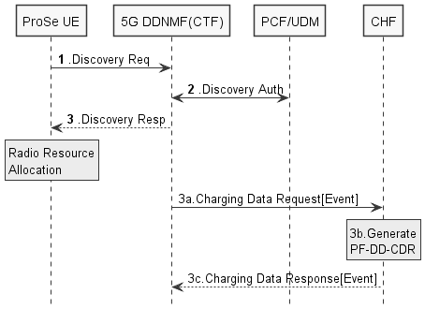
Figure 6.1.4.1.3.1: Message flow for ProSe Direct Discovery Announce Request - CTF (non-roaming)
The detailed description for the message flow will be defined in TS 23.304[y].
1-2. These steps are the same as the ProSe Direct Discovery will be defined in TS 23. 304 [y].
3. The 5G DDNMF responds with a Discovery Response with:
- (ProSe Application Code, validity timer, PC5_tech) for open discovery.
- (ProSe Application Code, ProSe Restricted Code/ ProSe Restricted Code Prefix[ProSe Restricted Code Suffix pool], validity timer, Discovery Entry ID, Announcing Enabled indicator, PC5_tech) for restricted discovery.
3a. The 5G DDNMF triggers Charging Data Request[Event] to CHF in HPLMN where event represents Announce. The PF-DD-CDR is generated by CHF for Announcing UE.
3b. The CHF creates a CDR for this Announcing UE.
3c. The CHF returns Charging Data Response corresponding to the received Charging Data Request[Event].

6.1.4.1.3.2 Message flows with CEF
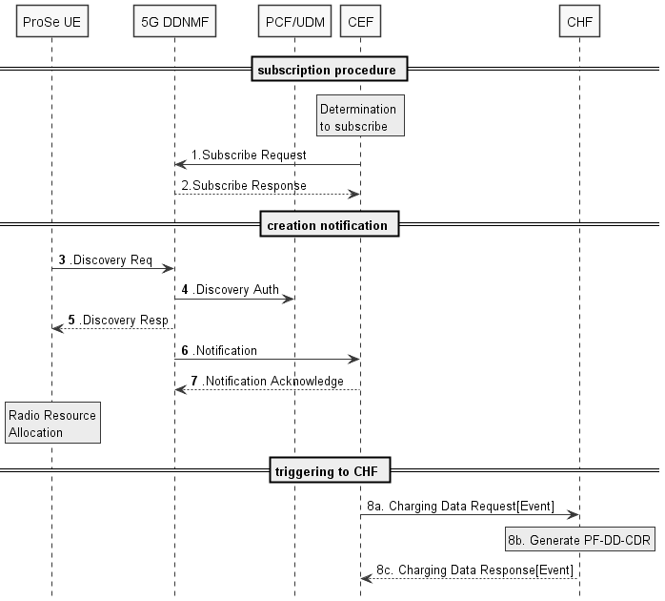
Figure 6.1.4.1.3.2: CEF-Message flow for ProSe Direct Discovery Announce Request (non-roaming)
1. Determination by CEF to subscribe to ProSe Direct Discovery Service.
2. Subscribe Request: the CEF subscribes to 5G DDNMF.
3-5. These steps are the same as the ProSe Direct Discovery will be defined in TS 23.304[y].
6. Notification: DDNMF notifies the CEF that ProSe Direct Discovery message has been processed.
7. Notification Acknowledge sent by the CEF.
8-a. The CEF sends Charging Data Request [Event] to CHF associated to the event represents Announce.
8-b. The CHF creates a CDR for this Announcing UE.
8-c. The CHF acknowledges by sending Charging Data Response to the CEF.
Editor’s Note: It is FFS for how 5G DDNMF works as ProSe Direct Discovery Service Provider.

6.1.4.1.4 Solution evaluation
TBD

Next Modified Section

End of Modified Sections

