3GPP TSG SA WG5 Meeting 135-e TDoc S5-211194

electronic meeting, online, 25 January - 3 February 2021
CR-Form-v12.1
CHANGE REQUEST
 | 28.130 | CR | 0005 | rev | 1 | Current version: | 16.0.0
For HELP on using this form: comprehensive instructions can be found at
http://www.3gpp.org/Change-Requests.

Proposed change affects: | UICC apps |  | ME |  | Radio Access Network | X | Core Network | X

Title: | Update the concept to support 5G network sharing
Source to WG: | ZTE Corporation
Source to TSG: | SA5
Work item code: | MANS |  |  |  |  |  | Date: |  |  | 2021-01-06
Category: | B |  |  |  |  |  | Release: |  |  | Rel-17
 | Use one of the following categories:  F (correction)  A (mirror corresponding to a change in an earlier release)  B (addition of feature),  C (functional modification of feature)  D (editorial modification)  Detailed explanations of the above categories can  be found in 3GPP TR 21.900. |  |  |  |  |  |  |  | Use one of the following releases:  Rel-8 (Release 8)  Rel-9 (Release 9)  Rel-10 (Release 10)  Rel-11 (Release 11)  …  Rel-15 (Release 15)  Rel-16 (Release 16)  Rel-17 (Release 17)  Rel-18 (Release 18)
Reason for change: |  | NG-RAN sharing is not included in the description of RAN sharing concept.  The definition of MOCN is not clear and does not align with the definition of GWCN.
Summary of change: |  | The description of RAN sharing concept is updated to include NG-RAN sharing.  The definition of MOCN is updated.
Consequences if not approved: |  | The description of RAN sharing concept will be incomplete and the definiton of MOCN will be unclear.
Clauses affected: |  | 3.1, 4.1
 |  | Y | N
Other specs |  |  | X | Other core specifications |  |  |  | TS/TR ... CR ...
affected: |  |  | X | Test specifications |  |  |  | TS/TR ... CR ...
(show related CRs) |  |  | X | O&M Specifications |  |  |  | TS/TR ... CR ...
Other comments:
This CR's revision history:

1st of Changes

3.1 Definitions
For the purposes of the present document, the terms and definitions given in TS 32.101 [2], TS 32.102 [3] and TR 21.905 [1] and the following apply. A term defined in the present document takes precedence over the definition of the same term, if any, in TS 32.101 [2], TS 32.102 [3] and TR 21.905 [1], in that order.

Organizational roles:
Master Operator (MOP): In Radio Access Network (RAN) and/or Core Network (CN) sharing scenarios, deployment and daily operation of shared network elements are entrusted to a single Actor, called the Master Operator. The Master Operator provides network and OAM&P services to other Operators, called Participating Operators (POPs). The Master Operator is the only one to have a direct OAM&P connection from its Domain Manager (DM) to the shared network elements.
Participating Operator (POP): Participating Operators are service providers who share, alongside other Participating Operators, the network (RAN and/or CN) facilities provided by the Master Operator. According to TS 36.300 [4] up to 6 operators can share a RAN.
Note: In a RAN/CN sharing scenario where Company A and Company B are POPs, MOP represents a role which can be played by either:
- Company A or Company B: in that case, Company A or Company B plays both roles, i.e. is the MOP and one of the POPs simultaneously, or
- A joint-venture between Company A and Company B, or
- A third-party entity: in this context, third party is referring to a wholesale mobile connectivity provider.
In the two latter cases, companies A and B rely on another company to play the role of MOP. This company cannot play the role of POP.

Management systems:
Master Operator Network Manager (MOP-NM): Network Manager enabling the Master Operator to manage the shared RAN and/or shared CN.
Master Operator Shared CN dm (MOP–SC-DM): Domain Manager enabling the Master Operator to manage the Shared CN.
Master Operator Shared RAN dm (MOP–SR-DM): Domain Manager enabling the MOP to manage the Shared RAN.
Participating Operator CN DM (POP-CORE-DM): Domain Manager enabling a Participating Operator to manage its own (not shared) Core Network.
Participating Operator Network Manager (POP-NM): Network Manager enabling a Participating Operator to manage its own (not shared) network and its portion of the shared network.
Participating Operator RAN DM (POP-RAN-DM): Domain Manager enabling a Participating Operator to manage its own (not shared) RAN.

Managed resources in a shared Radio Access Network (RAN) environment:
Shared RAN (S-RAN): A set of Radio Access Network elements (physical or virtualized) shared among Participating Operators.

Managed resources in a shared Core Network (CN) environment:
Shared CN (S-CORE): A set of Core Network elements shared among Participating Operators. It may or may not include all core network elements. For example, the Participating Operators may share only the MMEs while having independent S/P GWs.

Next change

4 Concepts and background

4.1 RAN sharing scenarios
Various network sharing scenarios exist, amongst which one category is RAN sharing which can be divided into the following (non exhaustive) list of sub-categories:
- Passive RAN sharing, also known as infrastructure sharing (including site sharing).
- Active RAN sharing, where active network elements of the RAN are shared:
- RAN-only sharing (MOCN; see TS 23.251 [5] and TS 23.501[x]), i.e. BTSs / BSCs (respectively NodeBs / RNCs and eNodeBs) in a 2G Radio Access Network (respectively a 3G Radio Access Network and an E-UTRA network), and gNBs in a 5G NR network;
- Gateway Core Network (GWCN; see TS 23.251 [5]), (there is no passive core network sharing).
In MOCN, POPs have a common S-RAN, have their individual Core Network and their own PLMN code(s).
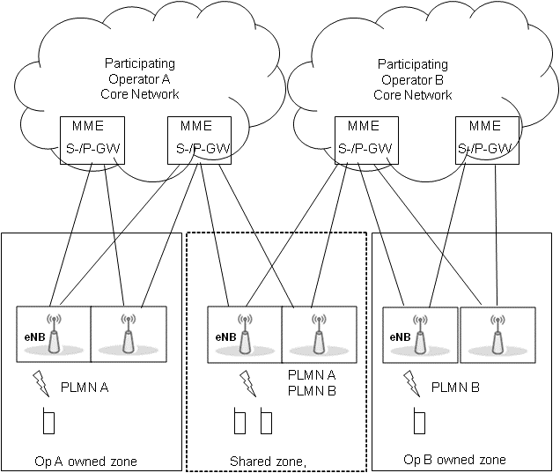
Figure 4.1-1: Multiple Operator Core Network (MOCN)
In GWCN, besides sharing Radio Access Network nodes, the POPs also share Core Network nodes (see TS 23.251 [5] – clause 4.1).
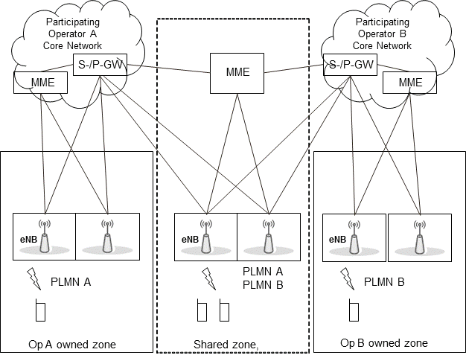
Figure 4.1-2: GateWay Core Network (GWCN)

End of Change

