3GPP TSG-SA5 Meeting #135-e S5-211090rev1

Online, , 25th Jan 2021 - 3rd Feb 2021
CR-Form-v12.1
CHANGE REQUEST
 | 28.531 | CR | 0061 | rev | - | Current version: | 16.8.0
For HELP on using this form: comprehensive instructions can be found at
http://www.3gpp.org/Change-Requests.

Proposed change affects: | UICC apps |  | ME |  | Radio Access Network | X | Core Network | X

Title: | Rel-16 CR 28.531 Correction of NSI and NSSI Operations
Source to WG: | Ericsson LM
Source to TSG: | S5
Work item code: | TEI16 |  |  |  |  |  | Date: |  |  | 2021-01-14
Category: | F |  |  |  |  |  | Release: |  |  | Rel-16
 | Use one of the following categories:  F (correction)  A (mirror corresponding to a change in an earlier release)  B (addition of feature),  C (functional modification of feature)  D (editorial modification)  Detailed explanations of the above categories can  be found in 3GPP TR 21.900. |  |  |  |  |  |  |  | Use one of the following releases:  Rel-8 (Release 8)  Rel-9 (Release 9)  Rel-10 (Release 10)  Rel-11 (Release 11)  …  Rel-15 (Release 15)  Rel-16 (Release 16)  Rel-17 (Release 17)  Rel-18 (Release 18)
Reason for change: |  | The Operations defined for allocateNsi/allocateNssi as well as deallocateNsi/deallocateNssi needs to be corrected to be aligned with the procedure descriptions. Specific clarifications are needed when it comes to what the ServiceProfile and the SliceProfile represents.
Summary of change: |  | - The allocateNsi operation is updated to reflect that a ServiceProfile represents the input service requirements to a NetworkSlice instance and that a new network slice instance is always created if networkSliceSharingIndicator is equal to “non-shared”.  - The allocateNssi operation is updated to reflect that a SliceProfile represents the input service requirements to the NetworkSliceSubnet instance.  - The deallocateNsi operation is updated to include serviceProfileId as input parameter.  - The deallocateNssi operation is updated to include sliceProfileId as input parameter.  - The deallocateNsi and the deallocateNssi text aligned.  - Implementation error in SP-201050 corrected (in 7.2)
Consequences if not approved: |  | The network slice (and network slice subnet) operations will be faulty, and could lead to interoperability problem.
Clauses affected: |  | 6.5.1.1, 6.5.2.1, 6.5.3.1, 6.5.3.2, 6.5.4.1, 6.5.4.2, 7.2
 |  | Y | N
Other specs |  |  | x | Other core specifications |  |  |  | TS/TR ... CR ...
affected: |  |  | x | Test specifications |  |  |  | TS/TR ... CR ...
(show related CRs) |  | x |  | O&M Specifications |  |  |  | TS 28.541 CR 0429
Other comments: |  | Proposal was Endorsed in S5-206329. Relates to CR 0429 when it comes to the introduction of networkSliceSharingIndicator attribute.
This CR's revision history:

First change

6.5.1 AllocateNsi operation

6.5.1.1 Description
This operation is invoked by allocateNsi operation service consumer to request the provider to allocate a network slice instance to satisfy network slice related requirements. The provider may create a new NSI or using existing NSI to satisfy the request. The requirements in the request are compared/matched against the actual capabilitites of all candidate NSIs by the provider. If an existing NSI can be found e.g. with the right coverage and with good enough latency, it is eligible for allocation. In case not, or if networkSliceSharingIndicator is equal to “non-shared”, a new NSI is created with capabilities to host the service, provided that required NSSIs can be created.

6.5.1.2 Input parameters
Parameter Name | Support Qualifier | Information Type / Legal Values | Comment
attributeListIn | M | LIST OF SEQUENCE< attribute name, attribute value> | This parameter specifies the network slice related requirements defined in ServiceProfile in Clause 6.3.3 in TS 28.541 [6].

6.5.1.3 Output parameters
Parameter name | Support Qualifier | Matching Information / Legal Values | Comment
attributeListOut | M | LIST OF SEQUENCE< attribute name, attribute value> | This list of name/value pairs contains the attributes of the NSI which has been allocated and the actual value assigned to each.
status | M | ENUM (OperationSucceeded, OperationFailed) | An operation may fail because of a specified or unspecified reason.
nSId | M | An attribute uniquely identifies the network slice instance. | It specifies the unifique identifier of the NSI which has been allocated.

Next change

6.5.2 AllocateNssi operation

6.5.2.1 Description
This operation is invoked by allocateNssi operation service consumer to request the provider to allocate a network slice subnet instance to satisfy the network slice subnet related requirements. The provider may create a new NSSI or using existing NSSI to satisfy the request. The requirements in the request are compared/matched against the actual capabilitites of all candidate NSSIs by the provider. If an existing NSSI can be found e.g. with the right coverage and with good enough latency, it is eligible for allocation. In case not, a new NSSI is created with capabilities to host the service, if enough resoures are available.

6.5.2.2 Input parameters
Parameter Name | Support Qualifier | Information Type / Legal Values | Comment
attributeListIn | M | LIST OF SEQUENCE< attribute name, attribute value> | This parameter specifies the network slice subnet related requirements defined in SliceProfile in Clause 6.3.4 in TS 28.541 [6].

6.5.2.3 Output parameters
Parameter name | Support Qualifier | Matching Information / Legal Values | Comment
attributeListOut | M | LIST OF SEQUENCE< attribute name, attribute value> | This list of name/value pairs contains the attributes of the NSSI which has been allocated and the actual value assigned to each.
status | M | ENUM (OperationSucceeded, OperationFailed) | An operation may fail because of a specified or unspecified reason.
nSSId | M | An attribute uniquely identifies the network slice subnet instance. | It specifies the unifique identifier of the NSSI which has been allocated.

Next change

6.5.3 DeallocateNsi operation

6.5.3.1 Description
This operation is invoked by deallocateNsi operation service consumer to request the provider to deallocate a service profile in an NSI. The provider may terminate the requested NSI or modify the requested NSI without termination to satisfy the request.

6.5.3.2 Input parameters
Parameter Name | Support Qualifier | Information Type / Legal Values | Comment
nSId | O | An attribute uniquely identifies the network slice instance. | It specifies the unifique identifier of the NSI.
serviceProfileId | M | An attribute that globally uniquely identifies the service profile in an NSI. | It specifies the global unifique identifier of the service profile in the NSI which is to be deallocated.

6.5.3.3 Output parameters
Parameter name | Support Qualifier | Matching Information / Legal Values | Comment
status | M | ENUM (OperationSucceeded, OperationFailed) | An operation may fail because of a specified or unspecified reason.

Next change

6.5.4 DeallocateNssi operation

6.5.4.1 Description
This operation is invoked by deallocateNssi operation service consumer to request the provider to deallocate a slice profile in an NSSI. The provider may terminate the requested NSSI or modify the requested NSSI without termination to satisfy the request.

6.5.4.2 Input parameters
Parameter Name | Support Qualifier | Information Type / Legal Values | Comment
nSSId | O | An attribute uniquely identifies the network slice subnet instance. | It specifies the unifique identifier of the NSSI.
sliceProfileId | M | An attribute uniquely identifies the slice profile in an NSSI. | It specifies the unifique identifier of the slice profile in the NSSI which is to be deallocated.

6.5.4.3 Output parameters
Parameter name | Support Qualifier | Matching Information / Legal Values | Comment
status | M | ENUM (OperationSucceeded, OperationFailed) | An operation may fail because of a specified or unspecified reason.

Next change

7.2 Procedure of Network Slice Instance Allocation
The Figure 7.2-1 illustrates the procedure of creating a new NSI or using an existing NSI to satisfy the required network slice related requirements.
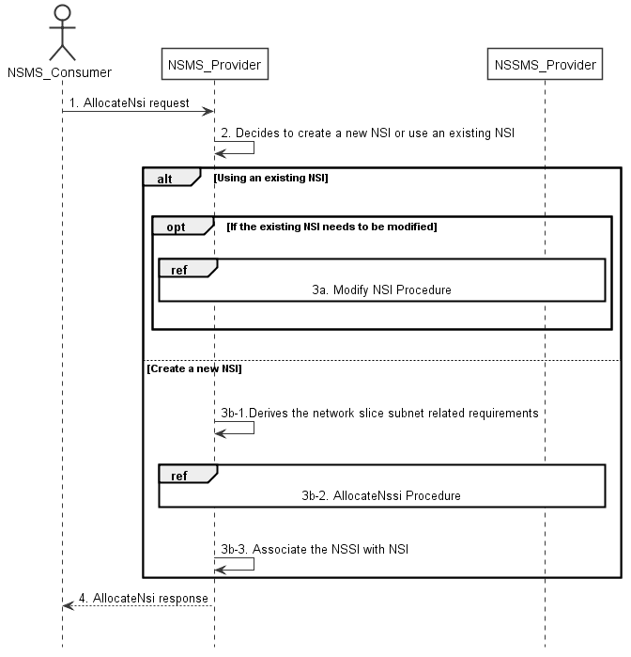
Figure 7.2-1: Network Slice Instance Allocation Request procedure
1) Network Slice Management Service Provider (NSMS_Provider) receives an AllocateNsi request (see AllocateNsi operation defined in clause 6.5.1) from Network Slice Management Service Consumer (NSMS_Consumer) with network slice related requirements (the network slice related requirements are defined as the attributes in the ServiceProfile see clause 6.3.3 in TS 28.541 [6]).
2) Based on the network slice related requiremen and the knowledge of the capabilities of existing deployed network slices, the NSMS_Provider compare/match the provided requirements against all the candidate NetworkSlice instances, and then decides whether to use an existing NSI or create a new NSI. If the network slice related requirements allow the requested NSI to be shared and if an existing suitable NSI can be reused, the NSMS_Provider may decide to use the existing NSI.

End of change

