3GPP TSG-SA5 Meeting #134e S5-206205

e-meeting 16th - 25th November 2020
CR-Form-v12.0
CHANGE REQUEST
 | 28.535 | CR | draftCR | rev | - | Current version: | 16.1.0
For HELP on using this form: comprehensive instructions can be found at
http://www.3gpp.org/Change-Requests.

Proposed change affects: | UICC apps |  | ME |  | Radio Access Network | x | Core Network | x

Title: | Coordination between control loops
Source to WG: | Huawei
Source to TSG: | S5
Work item code: | eCOSLA |  |  |  |  |  | Date: |  |  | 2020-11-2
Category: | B |  |  |  |  |  | Release: |  |  | Rel-17
 | Use one of the following categories:  F (correction)  A (mirror corresponding to a change in an earlier release)  B (addition of feature),  C (functional modification of feature)  D (editorial modification)  Detailed explanations of the above categories can  be found in 3GPP TR 21.900. |  |  |  |  |  |  |  | Use one of the following releases:  Rel-8 (Release 8)  Rel-9 (Release 9)  Rel-10 (Release 10)  Rel-11 (Release 11)  Rel-12 (Release 12)  Rel-13 (Release 13)  Rel-14 (Release 14)  Rel-15 (Release 15)  Rel-16 (Release 16)
Reason for change: |  | There may be multiple control loops ongoing in the autonomous network. The control loops reside in different domains, including 3GPP Cross Management Domain, 5GC Management Domain, NG-RAN Management Domain, 5GC Domain and NG-RAN Domain etc. Different domains may be deployed for the same or different coverage areas. Control loops in different domains may need to interact for the overall network automation, e.g. 3GPP Cross Management Domain interact with 5GC Management Domain, NG-RAN Management Domain for assurance goals or assurance goal status .
Summary of change: |  | Add description and requirements for coordination between control loops.
Consequences if not approved: |  | It is not clear whether multiple parallel control loops are correlated.
Clauses affected: |  | 4.2.x(new)
 |  | Y | N
Other specs |  |  | x | Other core specifications |  |  |  | TS/TR ... CR ...
affected: |  |  | x | Test specifications |  |  |  | TS/TR ... CR ...
(show related CRs) |  |  | x | O&M Specifications |  |  |  | TS/TR ... CR ...
Other comments: |  | This is input to the Rel-17 28.535 DraftCR.
This CR's revision history:

1st of changes

4.2.x Coordination between control loops
Different control loops reside in management domains or network function to support the overall autonomous networks. Different domains may be deployed for the same or different coverage areas. The purposes and results of different control loops may have impacts on one another. Coordination between control loops are needed in the management, 5GC and NG-RAN domains, to improve the performance in order to achieve the goal(s) of the control loops or conflict resolution, as shown in the figure 4.2.x-1.
A control loop may coordinate with other control loops in the same domain or in a different domain. Control loops in domain management are responsible for local optimization. Control loops in cross domain management may need to coordinate with control loops in multiple domains for the end to end optimizations.
The relationships between control loops can be hierarchical and peer-to peer. Coordination in management domains include the following categories:
- Coordination between Cross Management Domain and the 5GC Management Domain
- Coordination between Cross Management Domain and the NG-RAN Management Domain
- Coordination between 5GC Management Domain and the NG-RAN Management Domain
- Coordination within Cross Management Domain, 5GC Management Domain or NG-RAN Management Domain

Coordination in management domains provides the SLS assurance from the overall management perspective. It also provides governace and objective to the 5GC NFs and gNBs..

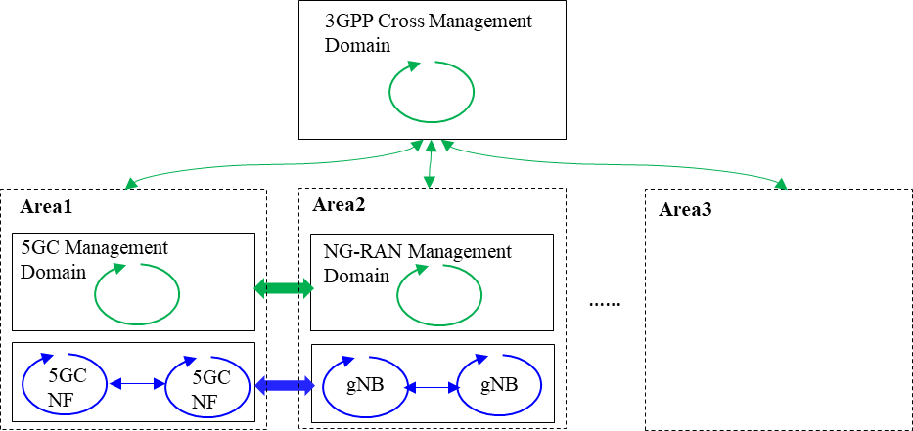
Figure 4.2.x-1: Coordination between control loops
2nd of changes

6.2 Requirements
REQ-CSA-CON-01 The 3GPP management system shall have the capability to take actions for a set of communication services serving certain group of UEs based on the target SLS.
REQ-CSA-CON-02 The 3GPP management system shall have the capability to collect service experience information.
REQ-CSA-CON-03 The 3GPP management system shall have the capability to analyse the performance information related to the set of communication services serving certain group of UEs.
REQ-CSA-CON-04 The 3GPP management system shall have the capability to modify the configuration parameters related to the set of communication services serving certain group of UEs.
REQ-CSA-CON-05 The 3GPP management system shall have the capability to collect NSI related data from one or more 5GC NF(s).
NOTE 1: An example for NSI related data may be QoE data.
REQ-CSA-CON-06 The 3GPP management system shall have the capability to derive which communication service is associated to the QoE data from the collected NSI related QoE data.
REQ-CSA-CON-07 The 3GPP management system shall have the capability to ascertain SLS breach.
REQ-CSA-CON-08 The 3GPP management system shall have the capability to perform the root cause analysis (e.g., identifying the underlying reason) for an SLS breach.
REQ-CSA-CON-09 The 3GPP management system shall have the capability to take corrective actions against the root cause identified.
REQ-CSA-CON-10 The 3GPP management system shall have the capability to translate communicate service requirements to cross domain SLS goal and single domain SLS goal.
REQ-CSA-CON-11 The 3GPP management system shall have the capability to collect single domain SLS analysis as input to cross domain SLS analysis.
REQ-CSA-CON-12 The 3GPP management system shall have the capability to allow its authorized consumer to control the SLS assurance (e.g. specify the SLS to be assured, enable/disable, specify the assurance time and update the SLS assurance requirements).
REQ-CSA-CON-13 The 3GPP management system shall have the capability to allow its authorized consumer to obtain the SLS assurance progress information and fulfil information.
NOTE 2: The management system refers to the producer of management service for SLS assurance.
REQ-CSA-CON-xx1 The 3GPP management system shall have the capability to allow coordinations between different control loops in different management domains or within a management domain for SLS assurance.
REQ-CSA-CON-xx2 The 3GPP management system shall have the capability to allow Cross Management Domain to configure SLS assurance goals for 5GC Management Domain and NG-RAN Management Domain.

REQ-CSA-CON-xx3 The 3GPP management system shall have the capability to allow control loops in Cross Management Domain to collect SLS assurance goal status of control loops in 5GC Management Domain and NG-RAN Management Domain .

End of changes

