3GPP TSG-SA5 Meeting #134e S5-206183

e-meeting 16th - 25th November 2020
CR-Form-v12.0
CHANGE REQUEST
 | 28.536 | CR | 0014 | rev | - | Current version: | 16.1.0
For HELP on using this form: comprehensive instructions can be found at
http://www.3gpp.org/Change-Requests.

Proposed change affects: | UICC apps |  | ME |  | Radio Access Network | x | Core Network | x

Title: | Update SLS Assurance Procedure
Source to WG: | Huawei
Source to TSG: | S5
Work item code: | COSLA |  |  |  |  |  | Date: |  |  | 2020-11-2
Category: | F |  |  |  |  |  | Release: |  |  | Rel-16
 | Use one of the following categories:  F (correction)  A (mirror corresponding to a change in an earlier release)  B (addition of feature),  C (functional modification of feature)  D (editorial modification)  Detailed explanations of the above categories can  be found in 3GPP TR 21.900. |  |  |  |  |  |  |  | Use one of the following releases:  Rel-8 (Release 8)  Rel-9 (Release 9)  Rel-10 (Release 10)  Rel-11 (Release 11)  Rel-12 (Release 12)  Rel-13 (Release 13)  Rel-14 (Release 14)  Rel-15 (Release 15)  Rel-16 (Release 16)
Reason for change: |  | The AssuranceControlLoop_consumer may use assurance fulfilment (including QoE fulfilment) information to modify ServiceProfile or SliceProflie to update the AssuranceControlLoopGoal if its QoE fulfilment is not satisfied.
Summary of change: |  | AsuranceControlLoop_consumer may update the ServiceProfile or SliceProflie if its QoE fulfilment is not satisfied.
Consequences if not approved: |  | The scenario of “QoE fulfilment is not satisfied” could not be covered by the procudure
Clauses affected: |  | 4.1.3.1
 |  | Y | N
Other specs |  |  | x | Other core specifications |  |  |  | TS/TR ... CR ...
affected: |  |  | x | Test specifications |  |  |  | TS/TR ... CR ...
(show related CRs) |  |  | x | O&M Specifications |  |  |  | TS/TR ... CR ...
Other comments:
This CR's revision history:

1st of changes

4.1.3.1 SLS Assurance Procedure

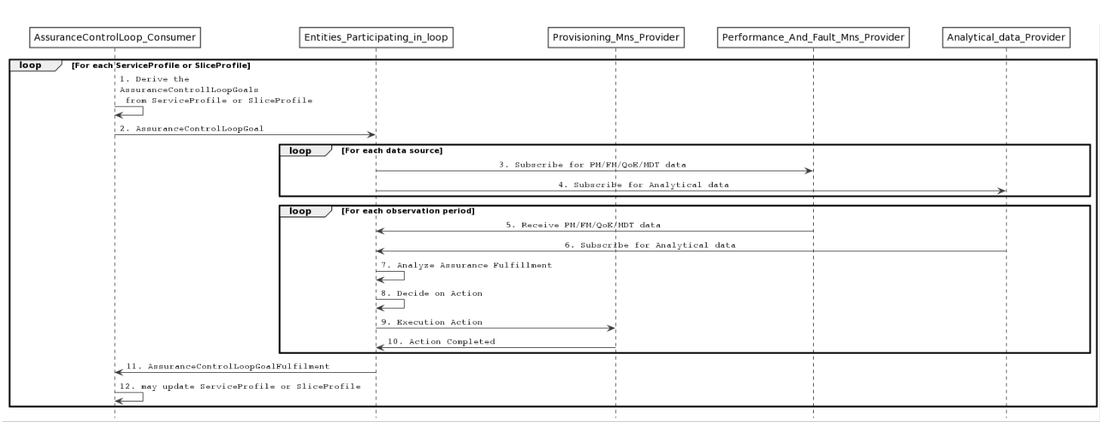
Figure 4.1.3.1.1 SLS assurance procedure
1. AssuranceControlLoop_consumer derives AssuranceControlLoopGoal from the ServiceProfile or SliceProfile.
2. AssuranceControlLoop_consumer provides the AssuranceControlLoopGoal to Entities_Participating_in_loop by utilizing the provision management services defined in as defined in clause 11.1.1.3 of TS 28.532 [7].
NOTE 1: In case the Entities_Participating_in_loop represents CrossDomain_Entities_Participating_in_loop, the AssuranceControlLoopGoal is the attribute(s) of the ServiceProfile. In case the Entities_Participating_in_loop represents Domain_Entities_Participating_in_loop, the AssuranceControlLoopGoal is the attribute(s) of the SliceProfile.
3. Entities_Participating_in_loop subscribes the related performance data (e.g., the packet delay related measurements), fault data, QoE data (e.g., buffer level) and MDT data from respective sources by utilizing the Operation establishStreamingConnection as defined in clause 6.2.1 of TS 28.550 [3].
4. Entities_Participating_in_loop, optionally, subscribes the related analytical data from MDAS or network functions, e.g., NWDAF. In case of NWDAF as a provider, Nnwdaf_EventsSubscription Service as defined in clause 4.2 is used.
5. Entities_Participating_in_loop collects the related performance, fault, QoE and MDT data (e.g., the packet delay related measurements), fault data, QoE data (e.g., buffer level) and MDT data from respective sources by utilizing the Operation establishStreamingConnection as defined in clause 6.2.1 of TS 28.550 [3].
6. Entities_Participating_in_loop, optionally, collects the related analytical data from MDAS or network functions, e.g., NWDAF. In case of NWDAF as a provider, Nnwdaf_EventsSubscription Service as defined in clause 4.2 of TS 29.520 [11] is used.
7. Entities_Participating_in_loop assesses if the AssuranceControlLoopGoal has been fulfilled.
8. Entities_Participating_in_loop assesses if and which action to take in case the AssuranceControlLoopGoal has not been fulfilled.
9. As per the mitigation action (e.g., scale out) resources are changed, the generic provisioning management service as defined in clause 11.1 of TS 28.532 [7] is utilized for the same.
10. Action completed.
NOTE 2: The Entities_Participating_in_loop continues to monitor and analyse the performance and perform the adjustment until the attribute(s) of SliceProfile is assured.
11. AssuranceControlLoop_consumer receives the confirmation of assurance fulfilment from Entities_Participating_in_loop by utilizing the provision management services defined in clause 11.1.1.3 of TS 28.532 [7].
12. According to AssuranceControlLoopGoalFulfilment report and/or resource availability etc, AssuranceControlLoop_consumer may negotiate with CSC and update ServiceProfile or SliceProflie.

end of changes

