3GPP TSG-SA5 Meeting #133-e S5-205350

Online, 12th Oct 2020 - 21st Oct 2020
CR-Form-v12.1
CHANGE REQUEST
 | 28.530 | CR | 0035 | rev | - | Current version: | 16.3.0
For HELP on using this form: comprehensive instructions can be found at
http://www.3gpp.org/Change-Requests.

Proposed change affects: | UICC apps |  | ME |  | Radio Access Network | X | Core Network | X

Title: | Correction of missing Figure 4.1.7.1 Examples of network slice as NOP internals
Source to WG: | Ericsson
Source to TSG: | SA5
Work item code: | TEI16 |  |  |  |  |  | Date: |  |  | 2020-10-13
Category: | F |  |  |  |  |  | Release: |  |  | Rel-16
 | Use one of the following categories:  F (correction)  A (mirror corresponding to a change in an earlier release)  B (addition of feature),  C (functional modification of feature)  D (editorial modification)  Detailed explanations of the above categories can  be found in 3GPP TR 21.900. |  |  |  |  |  |  |  | Use one of the following releases:  Rel-8 (Release 8)  Rel-9 (Release 9)  Rel-10 (Release 10)  Rel-11 (Release 11)  …  Rel-15 (Release 15)  Rel-16 (Release 16)  Rel-17 (Release 17)  Rel-18 (Release 18)
Reason for change: |  | Only in the current version of this specification “Figure 4.1.7.1: Examples of network slice as NOP internals” is missing.
Summary of change: |  | Added the missing Figure 4.1.7.1.
Consequences if not approved: |  | Clause 4.1.7 is incomplete as the Figure is not there.
Clauses affected: |  | 4.1.7
 |  | Y | N
Other specs |  |  | X | Other core specifications |  |  |  | TS/TR ... CR ...
affected: |  |  | X | Test specifications |  |  |  | TS/TR ... CR ...
(show related CRs) |  |  | X | O&M Specifications |  |  |  | TS/TR ... CR ...
Other comments: |  | Correction of CR implementation error
This CR's revision history:

First change

4.1.7 Network slices as NOP internals
In the "network slices as NOP internals" model, network slices are not part of the CSP service offering and hence are not visible to CSCs. However, the NOP, to provide support to communication services, may decide to deploy network slices, e.g. for internal network optimization purposes. This model allows CSC to use the network as the end user or optionally allows CSC to monitor the service status (assurance of the SLA associated with the internally offered network slice).
The CSP should be able to provide the service status information (e.g. service performance, fault information, traffic data, etc) to CSC via the management exposure interface.
Figure 4.1.7.1 illustrates an example on how network slices can be utilized to deliver communication services:
a) A network slice is used as NOP internal, and CSP delivers communication services to end customers (CSC).
b) The CSC should be able to monitor the network and service status information (e.g. service performance, fault information, traffic data, etc.) provided by CSP.

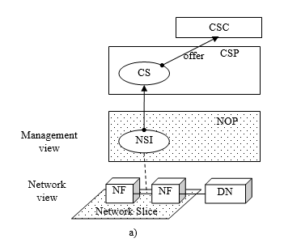
Figure 4.1.7.1: Examples of network slice as NOP internals
NOTE: In Figure 4.1.7.1, NS represents network slice, CS represents communication service.

End of changes

