3GPP TSG-SA5 Meeting #133-e S5-205265rev4

Online, , 12th Oct 2020 - 21st Oct 2020
CR-Form-v12.1
CHANGE REQUEST
 | 28.531 | CR | 0059 | rev | - | Current version: | 16.7.0
For HELP on using this form: comprehensive instructions can be found at
http://www.3gpp.org/Change-Requests.

Proposed change affects: | UICC apps |  | ME |  | Radio Access Network | x | Core Network | x

Title: | Correction of allocateNsi operations and procedures
Source to WG: | Ericsson LM, Samsung
Source to TSG: | S5
Work item code: | TEI16 |  |  |  |  |  | Date: |  |  | 2020-10-02
Category: | F |  |  |  |  |  | Release: |  |  | Rel-16
 | Use one of the following categories:  F (correction)  A (mirror corresponding to a change in an earlier release)  B (addition of feature),  C (functional modification of feature)  D (editorial modification)  Detailed explanations of the above categories can  be found in 3GPP TR 21.900. |  |  |  |  |  |  |  | Use one of the following releases:  Rel-8 (Release 8)  Rel-9 (Release 9)  Rel-10 (Release 10)  Rel-11 (Release 11)  …  Rel-15 (Release 15)  Rel-16 (Release 16)  Rel-17 (Release 17)  Rel-18 (Release 18)
Reason for change: |  | The “Procedure of Network Slice Instance Allocation” of clause 7.2 is unclear when it comes to how a request is compared/matched against existing NetworkSlice instances.
Summary of change: |  | The “Procedure of Network Slice Instance Allocation” of clause 7.2 are updated to reflect that the input requirements to an allocation must be compared/matched against the actual capabilities from possible network slices.
Consequences if not approved: |  | It will be unclear how to allocatean service to a network slice instance.
Clauses affected: |  | 7.2
 |  | Y | N
Other specs |  |  | x | Other core specifications |  |  |  | TS/TR ... CR ...
affected: |  |  | x | Test specifications |  |  |  | TS/TR ... CR ...
(show related CRs) |  |  | x | O&M Specifications |  |  |  | TS/TR ... CR ...
Other comments: |  | Proposal discussed in S5-205268, S5-205261 have TS 28.541 updates.
This CR's revision history:

First change

7.2 Procedure of Network Slice Instance Allocation
The Figure 7.2-1 illustrates the procedure of creating a new NSI or using an existing NSI to satisfy the required network slice related requirements.
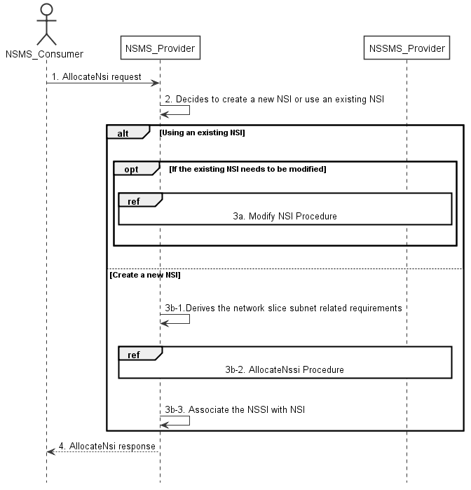
Figure 7.2-1: Network Slice Instance Allocation Request procedure
1) Network Slice Management Service Provider (NSMS_Provider) receives an AllocateNsi request (see AllocateNsi operation defined in clause 6.5.1) from Network Slice Management Service Consumer (NSMS_Consumer) with network slice related requirements (the network slice related requirements are defined as the attributes in the ServiceProfile see clause 6.3.3 in TS 28.541 [6]
2) Based on the network slice related requirements and the knowledge of the capabilities of existing deployed network slices the NSMS_Provider compare/match the provided requirements against all the candidate NetworkSlice instances, and then decides whether to use an existing NSI or create a new NSI. If the network slice related requirements allow the requested NSI to be shared and if an existing suitable NSI can be reused, the NSMS_Provider may decide to use the existing NSI.
3a) If using an existing NSI and the existing NSI needs to be modified to satisfy the network slice related requirements, the NSMS_Provider invokes the procedure to modify the existing NSI as described in clause 7.6.
3b-1) If creating a new NSI, the NSMS_Provider derives the network slice subnet related requirements from the received network slice related requirements. Before NSMS_Provider derives the network slice subnet related requirements, NSMS_Provider may invoke corresponding network slice subnet capability information querying procedure as described in clause 7.8.
3b-2) The NSMS_Provider invokes the NSSI allocation procedure as described in clause 7.3.
3b-3) The NSMS_Provider creates the MOI for NSI and configures the MOI with the DN of MOI for the NSSI, other configuration information may be configured for the created MOI.
Note: The detailed configuration information is described in network slice NRM (see NetworkSlice IOC defined in clause 6.3.1 in TS 28.541 [6]).
4) The NSMS_Provider sends NSI allocation result (see AllocateNsi operation defined in clause 6.5.1) to the NSMS_Consumer. If an existing NSI is modified or a new NSI is created successfully to satisfy the network slice related requirements, the result includes the relevant network slice instance information (see NetworkSlice IOC defined in clause 6.3.1 in TS 28.541 [6]):
- DN of the MOI for NSI.
Otherwise the result may include the reason of failure, for example, the required latency or user number cannot be satisfied, or the physical resource is not enough.

End of change

