3GPP TSG-SA5 Meeting #133-e S5-205238

Online, , 12th Oct 2020 - 21st Oct 2020
CR-Form-v12.1
CHANGE REQUEST
 | 28.536 | CR | 0010 | rev | - | Current version: | 16.1.0
For HELP on using this form: comprehensive instructions can be found at
http://www.3gpp.org/Change-Requests.

Proposed change affects: | UICC apps |  | ME |  | Radio Access Network | X | Core Network | X

Title: | Move and update content of clause 4.1.1 Overview to Annex
Source to WG: | Ericsson LM, Deutsche Telekom, NEC
Source to TSG: | SA5
Work item code: | COSLA |  |  |  |  |  | Date: |  |  | 2020-10-02
Category: | F |  |  |  |  |  | Release: |  |  | Rel-16
 | Use one of the following categories:  F (correction)  A (mirror corresponding to a change in an earlier release)  B (addition of feature),  C (functional modification of feature)  D (editorial modification)  Detailed explanations of the above categories can  be found in 3GPP TR 21.900. |  |  |  |  |  |  |  | Use one of the following releases:  Rel-8 (Release 8)  Rel-9 (Release 9)  Rel-10 (Release 10)  Rel-11 (Release 11)  …  Rel-15 (Release 15)  Rel-16 (Release 16)  Rel-17 (Release 17)  Rel-18 (Release 18)
Reason for change: |  | - According the the 32.160 the text describing the different steps in a closed control loop is not describing class definitions, operations and other types of information that would be expected in a stage 2 description.  - The control step “Analyze and Decide” shows a very specific set of analytics service and intelligence service. For communication service assurance there can be other analytics services and intelligence services to support the use cases described in 28.535, therefore the diagram needs to be updated to reflect this.  - Clarify threshold monitoring as it is specifically mentioned.  - Missing references
Summary of change: |  | - A new Annex has been added  - The text of clause 4.1.1 is moved to the new Annex and clause 4.1.1 is made Void.  - The reference list in clause 2 has been updated to include missing references  - The text in new Annex has been updated to clarify and add reference for Threshold monitoring  - The old figure in clause 4.1.1 has been update in the new Annex
Consequences if not approved: |  | The reader of the specification may get confused about the purpose of the description and misunderstand the context of following clauses.
Clauses affected: |  | 2, 4.1.1, Annex C (new)
 |  | Y | N
Other specs |  |  | X | Other core specifications |  |  |  | TS/TR ... CR ...
affected: |  |  | X | Test specifications |  |  |  | TS/TR ... CR ...
(show related CRs) |  |  | X | O&M Specifications |  |  |  | TS/TR ... CR ...
Other comments:
This CR's revision history:

First change

2 References
The following documents contain provisions which, through reference in this text, constitute provisions of the present document.
- References are either specific (identified by date of publication, edition number, version number, etc.) or non-specific.
- For a specific reference, subsequent revisions do not apply.
- For a non-specific reference, the latest version applies. In the case of a reference to a 3GPP document (including a GSM document), a non-specific reference implicitly refers to the latest version of that document in the same Release as the present document.
[1] 3GPP TR 21.905: "Vocabulary for 3GPP Specifications".
[2] ETSI GS ZSM 002 (V1.1.1) (2019-08): "Zero-touch network and Service Management (ZSM); Reference Architecture".
[3] 3GPP TS 28.550: "Management and orchestration; Performance assurance".
[4] 3GPP TS 28.545: "Management and orchestration; Fault Supervision (FS)".
[5] 3GPP TS 28.622: "Telecommunication management; Generic Network Resource Model (NRM) Integration Reference Point (IRP); Information Service (IS)".
[6] 3GPP TS 28.541: "Management and orchestration; 5G Network Resource Model (NRM); Stage 2 and stage 3".
[7] 3GPP TS 28.532: "Management and orchestration; Generic management services".
[8] 3GPP TS 32.302: "Telecommunication management; Configuration Management (CM); Notification Integration Reference Point (IRP); Information Service (IS)".
[9] 3GPP TS 28.531: "Management and orchestration; Provisioning".
[10] 3GPP TS 32.160: "Management and orchestration; Management service template".
[x] 3GPP TS 28.552: "Management and orchestration; 5G performance measurements"
[y] 3GPP TS 28.554: "Management and orchestration; 5G end to end Key Performance Indicators (KPI)"

Second change

4.1.1 Void

Second change

Annex C (informative):
Communication service assurance service
Communication service assurance relies on a set of management services that together provide the CSP with the capability to assure the communication service as per agreement with a CSC (e.g. enterprise). The overall solution and information flows between management services and the closed control loop steps [2] are shown in Figure C.1.

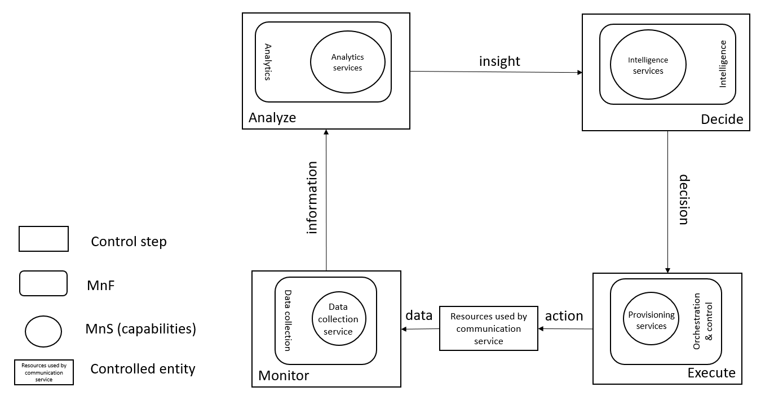
Figure C.1: Overview of closed control loop information flows
In Figure C.1 the controlled entity represents the resources used by a communication service and the assurance of this communication service is provided by the closed control loop between the different management services provided by the management system.
The input to the closed control loop is the data concerning the resources used by the communication service which is monitored by the closed control loop step "Monitor", analysed by the closed control loop step “Analyze”, decision on potential solution by the closed control loop step "Decide" which may be a possible action for the closed control loop step "Execute", for example when the service experience degrades, the resources used by a communication service have to be adjusted. The role of the intelligence services is to provide variable degrees of automated decision making and human oversight support. For example the data associated with the communication service is monitored by the management services for data collection, this management service provides information to the analytics management service and based on that information the assurance analysis takes place followed by proposing activities, mitigation or suggestion to solve the problem. The proposed activities, for example mitigation or problem-solving suggestion are executed through provisioning service to bring the behaviour of the communication service within the requested boundaries of the metrics (SLS goals) that are controlled by the closed control loop.
The management services available for the closed control loop steps for "Monitor", "Analyse" and "Decide" are based on file transfer described in TS 28.550 [3], or data streaming described in TS 28.550 [3] and notifications described in TS 28.545 [4].
The information provided from the "Monitor" step to the "Analyse" step includes performance measurements (see TS 28.552 [12]), KPI’s (see TS 28.554 [13]), performance threshold monitoring events and fault supervision events (see TS 28.532 [7]).
The insights provided from the "Analyse" step to the "Intelligence" step includes analytics outcomes that are not specified in the current release of present document.
The decision provided from the "Intelligence" step to the "Execute" step includes policy configuration see TS 28.541 [6] and intent configuration management which is not specified in the current release of present document

End of changes

