**3GPP TSG- Meeting # *rev1***

**, , -**

|  |  |  |  |  |  |  |  |  |
| --- | --- | --- | --- | --- | --- | --- | --- | --- |
| *CR-Form-v12.1* | | | | | | | | |
| **CHANGE REQUEST** | | | | | | | | |
|  | | | | | | | | |
|  |  | **CR** |  | **rev** |  | **Current version:** |  |  |
|  | | | | | | | | |
| *For* [***HE******LP***](http://www.3gpp.org/3G_Specs/CRs.htm#_blank)*on using this form: comprehensive instructions can be found at* [*http://www.3gpp.org/Change-Requests*](http://www.3gpp.org/Change-Requests)*.* | | | | | | | | |
|  | | | | | | | | |

|  |  |  |  |  |  |  |  |  |
| --- | --- | --- | --- | --- | --- | --- | --- | --- |
| ***Proposed change affects:*** | UICC apps |  | ME |  | Radio Access Network | **x** | Core Network | **x** |

|  |  |  |  |  |  |  |  |  |  |  |
| --- | --- | --- | --- | --- | --- | --- | --- | --- | --- | --- |
|  | | | | | | | | | | |
| ***Title:*** | Cleanup based on refined slice definition | | | | | | | | | |
|  |  | | | | | | | | | |
| ***Source to WG:*** |  | | | | | | | | | |
| ***Source to TSG:*** |  | | | | | | | | | |
|  |  | | | | | | | | | |
| ***Work item code:*** |  | | | | |  | ***Date:*** | | |  |
|  |  | | | |  | |  | | |  |
| ***Category:*** |  |  | | | | | ***Release:*** | | |  |
|  | *Use one of the following categories:* ***F*** *(correction)* ***A*** *(mirror corresponding to a change in an earlier release)* ***B*** *(addition of feature),* ***C*** *(functional modification of feature)* ***D*** *(editorial modification)*  Detailed explanations of the above categories can be found in 3GPP [TR 21.900](http://www.3gpp.org/ftp/Specs/html-info/21900.htm). | | | | | | | | *Use one of the following releases: Rel-8 (Release 8) Rel-9 (Release 9) Rel-10 (Release 10) Rel-11 (Release 11) … Rel-15 (Release 15) Rel-16 (Release 16) Rel-17 (Release 17) Rel-18 (Release 18)* | |
|  |  | | | | | | | | | |
| ***Reason for change:*** | | The slice/slicesubnet definitions has recently been updated in TS 28.530 to clarify the slicing terms used in SA2 and those used in SA5.  TS 28.533 uses today a number of terms that needs to be updated. Examples are use of NSI, NSSI, NS, NSS, and network slice instance, and network slice subnet instance. | | | | | | | | |
|  | |  | | | | | | | | |
| ***Summary of change:*** | | TS 28.533 has been updated to reflect the refined slice definition in the same way as previous done for TS 28.530/552/544:  1. Replaced NSI (or network slice instance)” with “network slice” if the NSI is used to represent network slice and with “NetworkSlice instance” if specific the instance is considered.  2. Replaced NSSI (or network slice subnet instance)” with “network slice subnet” if the NSI is used to represent network slice subnet and with “NetworkSliceSubnet instance” if specific the instance is considered.  3. Replaced abbreviation NS with “Network Service” and NSS with “network slice subnet”. | | | | | | | | |
|  | |  | | | | | | | | |
| ***Consequences if not approved:*** | | Misusing network slice instance caused conceptual issues inside and outside 3GPP and let existing specification not implementable. | | | | | | | | |
|  | |  | | | | | | | | |
| ***Clauses affected:*** | | 4.3, 4.6, 5.2, A4, A5, A6, A7, A8 | | | | | | | | |
|  | |  | | | | | | | | |
|  | | **Y** | **N** |  | | | |  | | |
| ***Other specs*** | |  | **x** | Other core specifications | | | | TS/TR ... CR ... | | |
| ***affected:*** | |  | **x** | Test specifications | | | | TS/TR ... CR ... | | |
| ***(show related CRs)*** | |  | **x** | O&M Specifications | | | | TS/TR ... CR ... | | |
|  | |  | | | | | | | | |
| ***Other comments:*** | | Similar cleanups has previous been done for: 28.530 (S5-203411), 28.552 (S5-203336), 28.554 (S5-203337) | | | | | | | | |
|  | |  | | | | | | | | |
| ***This CR's revision history:*** | |  | | | | | | | | |

|  |
| --- |
| First change |

## 

## 4.3 Combination of MnS components

A MnS is composed by a MnS component type A and

- a MnS component type B, or

- a MnS component type B and a MnS component type C.

The instances of management services carry information about specified management service components in the metadata attributes. Figure 4.3.1 illustrates examples of management service instances with various management service components of type A, type B and type C:

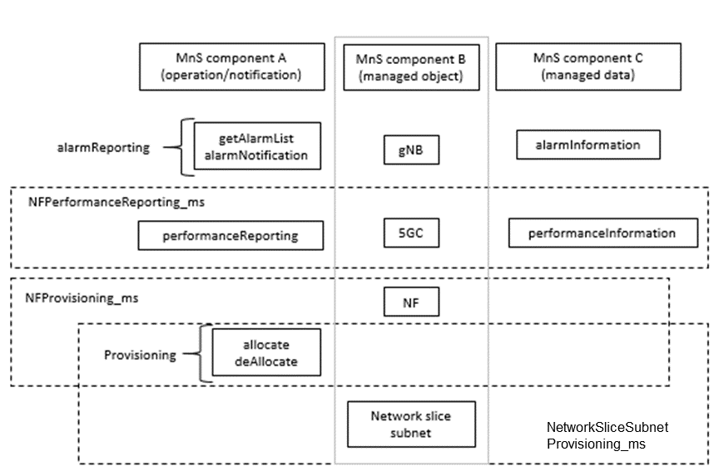

Figure 4.3.1: Example of Management Service and component type A, B and C

|  |
| --- |
| Next change |

## 4.6 Management data analytics capability

Mobile networks have the capability to support a wide variety of services and requirements. This, along with increasing flexibility of the network may present management and operational challenges and complexities. The management system can therefore benefit from management data analytics services for improving networks performance and efficiency to accommodate and support the diversity of services and requirements. The management data analytics utilize the network management data collected from the network (including e.g. service, slicing and/or network functions related data) and make the corresponding analytics based on the collected information. For example, the information provided by PM data analytics services can be used to optimize network performance, and the information provided by FM data analytics services can be used to predict and prevent failures of the network. MDAS can be deployed at different levels, for example, at a domain level (e.g. RAN, CN, network slice subnet) and/or in a centralized manner (e.g. at a PLMN level).

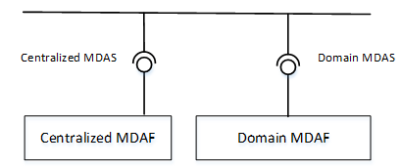

Figure: 4.6.1: Service based architecture for management data analytics

|  |
| --- |
| Next change |

## 5.2 Management interactions with NFV MANO

3GPP management system shall be capable to consume NFV MANO interface (e.g. Os-Ma-nfvo, Ve-Vnfm-em and Ve-Vnfm-vnf reference points).

Producer of management services can consume management interfaces provided by NFV MANO for following purposes:

- Network Service LCM.

- VNF LCM, PM, FM, CM on resources supporting VNF.

|  |
| --- |
| Next change |

# A.4 Utilization of interface to NFV-MANO by the producer of management services

In this deployment scenario the providers of the network slice subnet related management services and NF related management services are also consuming the management interfaces provided by the NFV-MANO:

- VNF PM, FM and LCM

- Network Service PM, FM and LCM

These interfaces are provided via the Os-Ma-nfvo and the Ve-Vnfm-em reference points as specified in the following specifications:

- Configuration Management (CM): TS 28.510 [11], TS 28.511 [12], TS 28.512 [13], TS 28.513 [14],

- Fault Management (FM): TS 28.515 [15], TS 28.516 [16], TS 28.517 [17], TS 28.518 [18],

- Performance Management (PM): TS 28.520[19], TS 28.521 [21], TS 28.522 [22], TS 28.523 [23],

- Life Cycle Management (LCM): TS 28.525[24], TS 28.526 [25], TS 28.527 [26], TS 28.528 [27].

In this deployment scenario:

- the entity denoted as NSSMF (network slice subnet Management Function), is capable of consuming the VNF LCM and LCM related services provided by the NFV-MANO (NFVO). Same entity is also a provider of the network slice subnet related management services.

- the entity denoted as NFMF (NF Management Function), is capable of application level management of VNFs and PNFs and is a producer of the NF Provisioning service that includes Configuration Management (CM), Fault Management (FM) and Performance Management. Same entity is consumer of the NF Provisioning service produced by VNFs and PNFs.



Figure A.4.1 The deployment scenario for network slice subnet management with interface to NFV-MANO

The use case Network slice subnet instance creation in the clause 5.1.2 of the TS 28.531 [8] shows example of interaction between:

- the consumer of the network slice subnet related management services (e.g. network slice subnet provisioning service) and the NSSMF as the provider of the network slice subnet related management services.

- the NSSMF and the NFMF.

and also, the interaction between:

- the NSSMF and the NFV-MANO,

- the NFMF and the NFV-MANO.

NOTE: Figure A.4.1 shows an example of a deployment scenario, not all scenarios are captured by this figure.

|  |
| --- |
| Next change |

# A.5 Management Data Analytics Service (MDAS)

A management data analytics service (MDAS) provides data analytics of different network related parameters including for example load level and/or resource utilisation. For example, the MDAS for a network function (NF) can collect the NF's load related performance data, e.g. resource usage status of the NF. The analysis of the collected data may provide forecast of resource usage information in a predefined future time. This analysis may also recommend appropriate actions e.g. scaling of resources, admission control, load balancing of traffic, etc.

A MDAS for a NetworkSliceSubnet instance provides network slice subnet related data analytics. The service may consume the corresponding MDAS of its constituent NFs'. The MDAS for a network slice subnet may further classify or shape the data in different useful categories and analyse them for different network slice subnet management needs (e.g. scaling, admission control of the constituent NFs etc.). If an network slice subnet is composed of multiple other network slice subnets, the MDAS for a network slice subnet acts as a consumer of MDAS of the constituent network slice subnets for further analysis e.g. resource usage prediction, failure prediction for an network slice subnet, etc.

A MDAS for a NetworkSlice instance provides network slice related data analytics. The service may consume the corresponding MDAS of its constituent network slice subnet(s). The network slice MDAS may further classify or shape the data in different useful categories according to different customer needs, e.g. slice load, constituent network slice subnet load, communication service loads. This data can be used for further analysis e.g. resource usage prediction, failure prediction for an network slice, etc.

|  |
| --- |
| Next change |

# A.6 Utilization of management services in functional management architecture

The management services for a mobile network including network slicing may be produced by a set of functional blocks. This annex shows an example of such deployment scenario where functional blocks (such as NSMF, NSSMF, NFMF and CSMF) are producing and consuming various management services.

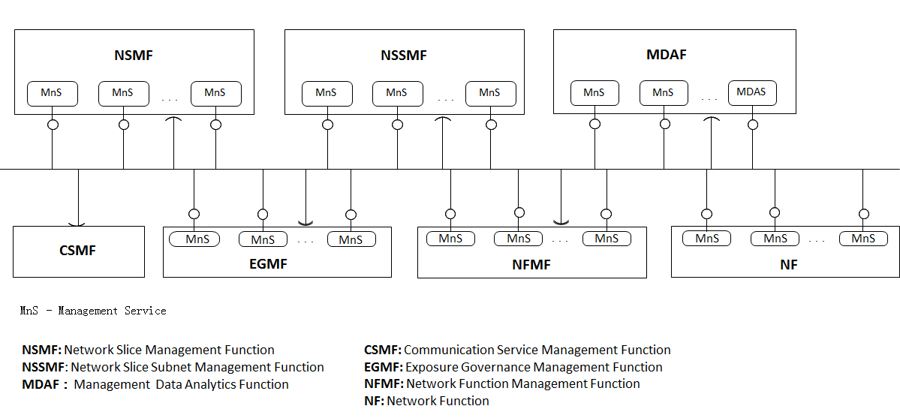

Figure A.6.1: Example of functional management architecture

In this deployment example:

- NFMF (Network Function Management Function) provides the management services for managing one or more NF(s) and may consume some management services produced by other functional blocks.

- The NF provides some management services, for example the NF performance management services, NF configuration management services and NF fault supervision services.

- NSSMF provides the management services for one or more network slice subnets and may consume some management services produced by other functional blocks.

- NSMF provides the management services for one or more network slices and may consume some management services produced by other functional blocks.

- MDAF provides the Management Data Analytics Service for one or more NF, network slice subnet and/or network slice, and may consume some management services produced by other functional blocks.

- CSMF consumes the management service(s) provided by the other functional blocks. This deployment example does not illustrate what management services the CSMF consumes.

- EGMF provides management service(s) with applied exspoure governance and a management service with management capability exposure governance to one or more management service consumers and may consume some management services produced by other functional blocks.

- One functional block may consume the management service(s) provided by another functional block, depending on the management scope of the functional block(s). The scope may be expressed in the terms of Management Service Components (see clause 4.3).

|  |
| --- |
| Next change |

# A.7 Utilization of management data analytics services

A management data analytics service (MDAS) provides data analytics for the network. MDAS can be deployed at different levels, for example, at domain level (e.g. RAN, CN, network slice subnet) or in a centralized manner (e.g. in a PLMN level). A domain-level MDAS provides domain specific analytics, e.g. resource usage prediction in a CN or failure prediction in a network slice subnet, etc. A centralized MDAS can provide end-to-end or cross-domain analytics service, e.g. resource usage or failure prediction in an network slice, optimal CN node placement for ensuring lowest latency in the connected RAN, etc. Figure A.7.1 illustrates an example of deployment model of the MDAS:

- Domain MDAF produces Domain MDAS

- Domain MDAS is consumed by the Centralized MDAF and the other authorized MDAS Consumers (for example, infrastructure manager, network manager, network slice manager, network slice subnet manger, other 3rd party OSS, etc.)

- Centralized MDAF produces Centralized MDAS

- Centralized MDAS is consumed by different authorized MDAS Consumers

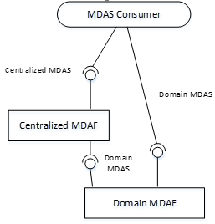

Figure A.7.1: MDAS provided at different levels

|  |
| --- |
| Next change |

# A.8 An example of deployment scenario for network and network slice

This annex shows an example of deployment scenario for management of a mobile network including network slicing.

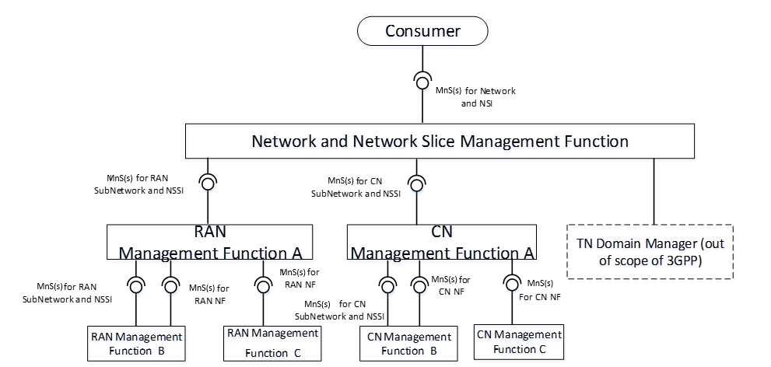

Figure A.8.1: An example of deployment scenario for management of a mobile network including network slicing

In this deployment scenario:

- Network and Network Slice Management Function provides the management services for network or network slicewhich includes RAN part, CN part and TN part to the Consumer. Network and Network Slice Management Function consumes management services for RAN SubNetwork or network slice subnet produced by RAN Management Function, management services for CN SubNetwork or network slice subnet produced by CN Management Function and interface produced by TN Manager.

- RAN Management Function provides the management services for a RAN SubNetwork or network slice subnet and/or management services for RAN NF(s). RAN Management Function may consume management service for RAN SubNetwork or network slice subnet and management services for RAN NF. In this scenario, the following RAN Management Function(s) are described:

- RAN Management Function A provides the management services for RAN SubNetwork or network slice subnet to Network and Network Slice Management Function. RAN Management Function A consumes the management services for RAN network slice subnet(s) and management services for RAN NF produced by RAN Management Function B, and management services for RAN NF produced by RAN Management Function C.

- RAN Management Function B provides the management services for RAN network slice subnet and management services for RAN NF to RAN Management Function A.

- RAN Management Function C provides the management services for RAN NF to RAN Management Function A.

- CN Management Function provides the management services for a CN network slice subnet and/or management services for CN NF. CN Management Function may consume management service for CN network slice subnetand management services for CN NF. In this scenario, the following CN Management Function(s) are described:

- CN Management Function A provides the management services for CN network slice subnetto Network and Network Slicing Management Function. CN A consumes the management services for CN network slice subnet and management services for CN NF produced by CN Management Function B and management services for CN NFs produced by CN Management Function C.

- CN Management Function B provides the management services for CN network slice subnet and management services for CN NF to RAN Management Function A.

- CN Management Function C provides the management services for CN NF to CN Management Function A.

|  |
| --- |
| End of changes |