3GPP TS 28.536 V16.1.0 (2020-09)
Technical Specification

3rd Generation Partnership Project;
Technical Specification Group Services and System Aspects;
Management and orchestration;
Management services for communication service assurance; Stage 2 and stage 3
(Release 16)
The present document has been developed within the 3rd Generation Partnership Project (3GPP TM) and may be further elaborated for the purposes of 3GPP.
The present document has not been subject to any approval process by the 3GPP Organizational Partners and shall not be implemented.
This Specification is provided for future development work within 3GPP only. The Organizational Partners accept no liability for any use of this Specification.
Specifications and Reports for implementation of the 3GPP TM system should be obtained via the 3GPP Organizational Partners' Publications Offices.

3GPP
Postal address

3GPP support office address
650 Route des Lucioles - Sophia Antipolis
Valbonne - FRANCE
Tel.: +33 4 92 94 42 00 Fax: +33 4 93 65 47 16
Internet
http://www.3gpp.org

Copyright Notification
No part may be reproduced except as authorized by written permission.
The copyright and the foregoing restriction extend to reproduction in all media.

© 2020, 3GPP Organizational Partners (ARIB, ATIS, CCSA, ETSI, TSDSI, TTA, TTC).
All rights reserved.

UMTS™ is a Trade Mark of ETSI registered for the benefit of its members
3GPP™ is a Trade Mark of ETSI registered for the benefit of its Members and of the 3GPP Organizational Partners
LTE™ is a Trade Mark of ETSI registered for the benefit of its Members and of the 3GPP Organizational Partners
GSM® and the GSM logo are registered and owned by the GSM Association

Contents
Foreword 4
Introduction 5
1 Scope 6
2 References 6
3 Definitions of terms, symbols and abbreviations 6
3.1 Terms 6
3.2 Symbols 7
3.3 Abbreviations 7
4 Communication service assurance service 7
4.1 Stage 2 7
4.1.1 Overview 7
4.1.2 Model 8
4.1.2.1 Imported and associated information entities 8
4.1.2.1.1 Imported information entities and local labels 8
4.1.2.2 Class diagram 9
4.1.2.2.1 Relationships 9
4.1.2.2.2 Inheritance 9
4.1.2.3 Class definitions 9
4.1.2.3.1 AssuranceControlLoop 9
4.1.2.3.2 AssuranceGoalStatus 10
4.1.2.3.3 AssuranceControlLoopGoal <<ProxyClass>> 10
4.1.2.3.4 ObservationTimePeriod <<dataType>> 11
4.1.2.4 Attribute definitions 11
4.1.2.4.1 Attribute properties 11
4.1.2.4.2 Constraints 12
4.1.2.4.3 Notifications 12
4.1.2.5 Common notifications 13
4.1.2.5.1 Alarm notifications 13
4.1.2.5.2 Configuration notifications 13
4.1.3 Procedures 13
4.1.3.1 SLS Assurance Procedure 13
4.2 Stage 3 14
4.2.1 Solution Set (SS) for JSON/YAML 14
Annex A (informative): Control loop deployed in different layers 15
A.1 Introduction 15
A.2 Control loop in communication service layer 15
A.3 Control loop in network slice layer 15
A.4 Control loop in network slice subnet layer 16
A.5 Control loop in NF layer 16
Annex B (normative): OpenAPI definition of the COSLA NRM 17
B.1 General 17
B.2 Solution Set (SS) definitions 17
B.2.1 OpenAPI document "coslaNrm.yml" 17
Annex C (informative): Change history 20

.

Foreword
This Technical Specification has been produced by the 3rd Generation Partnership Project (3GPP).
The contents of the present document are subject to continuing work within the TSG and may change following formal TSG approval. Should the TSG modify the contents of the present document, it will be re-released by the TSG with an identifying change of release date and an increase in version number as follows:
Version x.y.z
where:
x the first digit:
1 presented to TSG for information;
2 presented to TSG for approval;
3 or greater indicates TSG approved document under change control.
y the second digit is incremented for all changes of substance, i.e. technical enhancements, corrections, updates, etc.
z the third digit is incremented when editorial only changes have been incorporated in the document.
In the present document, modal verbs have the following meanings:
shall indicates a mandatory requirement to do something
shall not indicates an interdiction (prohibition) to do something
The constructions "shall" and "shall not" are confined to the context of normative provisions, and do not appear in Technical Reports.
The constructions "must" and "must not" are not used as substitutes for "shall" and "shall not". Their use is avoided insofar as possible, and they are not used in a normative context except in a direct citation from an external, referenced, non-3GPP document, or so as to maintain continuity of style when extending or modifying the provisions of such a referenced document.
should indicates a recommendation to do something
should not indicates a recommendation not to do something
may indicates permission to do something
need not indicates permission not to do something
The construction "may not" is ambiguous and is not used in normative elements. The unambiguous constructions "might not" or "shall not" are used instead, depending upon the meaning intended.
can indicates that something is possible
cannot indicates that something is impossible
The constructions "can" and "cannot" are not substitutes for "may" and "need not".
will indicates that something is certain or expected to happen as a result of action taken by an agency the behaviour of which is outside the scope of the present document
will not indicates that something is certain or expected not to happen as a result of action taken by an agency the behaviour of which is outside the scope of the present document
might indicates a likelihood that something will happen as a result of action taken by some agency the behaviour of which is outside the scope of the present document
might not indicates a likelihood that something will not happen as a result of action taken by some agency the behaviour of which is outside the scope of the present document
In addition:
is (or any other verb in the indicative mood) indicates a statement of fact
is not (or any other negative verb in the indicative mood) indicates a statement of fact
The constructions "is" and "is not" do not indicate requirements.

Introduction
The present document describes closed loop assurance solution enabling a service provider or an operator to continuously deliver the requested level of communication service quality to the customer and is part of a TS-family covering the 3rd Generation Partnership Project Technical Specification Group Services and System Aspects Management and orchestration of networks, as identified below:
TS 28.535: Management Services for Communication Service Assurance; Requirements
TS 28.536: Management Services for Communication Service Assurance; Stage 2 and stage 3
The solution described builds upon the management services specifications as identified below:
TS 28.530: Management and orchestration; Concepts, use cases and requirements
TS 28.533: Management and orchestration; Architecture framework
TS 28.532: Management and orchestration; Generic management services.
TS 28.540: Management and orchestration; 5G Network Resource Model (NRM); Stage 1
TS 28.541: Management and orchestration; 5G Network Resource Model (NRM); Stage 2 and stage 3
TS 28.531: Management and orchestration; Provisioning
TS 28.545: Management and orchestration; Fault Supervision (FS)
TS 28.550: Management and orchestration; Performance assurance
TS 28.552: Management and orchestration; 5G performance measurements
TS 28.554: Management and orchestration; 5G End to end Key Performance Indicators (KPI)

1 Scope
The present document describes the management services for communication service assurance and specifies stage 2 and stage 3 for closed loop communication service assurance solution that adjusts and optimizes the services provided by NG-RAN and 5GC.

2 References
The following documents contain provisions which, through reference in this text, constitute provisions of the present document.
- References are either specific (identified by date of publication, edition number, version number, etc.) or non-specific.
- For a specific reference, subsequent revisions do not apply.
- For a non-specific reference, the latest version applies. In the case of a reference to a 3GPP document (including a GSM document), a non-specific reference implicitly refers to the latest version of that document in the same Release as the present document.
[1] 3GPP TR 21.905: "Vocabulary for 3GPP Specifications".
[2] ETSI GS ZSM 002 (V1.1.1) (2019-08): "Zero-touch network and Service Management (ZSM); Reference Architecture".
[3] 3GPP TS 28.550: "Management and orchestration; Performance assurance".
[4] 3GPP TS 28.545: "Management and orchestration; Fault Supervision (FS)".
[5] 3GPP TS 28.622: "Telecommunication management; Generic Network Resource Model (NRM) Integration Reference Point (IRP); Information Service (IS)".
[6] 3GPP TS 28.541: "Management and orchestration; 5G Network Resource Model (NRM); Stage 2 and stage 3".
[7] 3GPP TS 28.532: "Management and orchestration; Generic management services".
[8] 3GPP TS 32.302: "Telecommunication management; Configuration Management (CM); Notification Integration Reference Point (IRP); Information Service (IS)".
[9] 3GPP TS 28.531: "Management and orchestration; Provisioning".
[10] 3GPP TS 32.160: "Management and orchestration; Management service template".
[11] 3GPP TS 29.520: "5G System; Network Data Analytics Services; Stage 3".
[12] 3GPP TS 28.552: "Management and orchestration; 5G performance measurements".
[13] 3GPP TS 28.554: "Management and orchestration; 5G end to end Key Performance Indicators (KPI)".

3 Definitions of terms, symbols and abbreviations

3.1 Terms
For the purposes of the present document, the terms given in TR 21.905 [1] and the following apply. A term defined in the present document takes precedence over the definition of the same term, if any, in TR 21.905 [1].

3.2 Symbols
Void.

3.3 Abbreviations
For the purposes of the present document, the abbreviations given in TR 21.905 [1] and the following apply. An abbreviation defined in the present document takes precedence over the definition of the same abbreviation, if any, in TR 21.905 [1].
COSLA Closed loop SLS Assurance
CSC Communication Service Customer
CSP Communication Service Provider
IOC Information Object Class
IS Information Service
JSON JavaScript Object Notation
YAML YAML Ain't Markup Language
MDAS Management Data Analytics Service
MDT Minimization of Drive Tests
MnS Management Service
NF Network Function
NRM Network Resource Model
NSSI NetworkSlice Subnet Instance
NWDAF NetWork Data Analytics Function
QoE Quality of Experience
SLA Service Level agreement
SLS Service Level Specification

4 Communication service assurance service

4.1 Stage 2

4.1.1 Overview
Communication service assurance relies on a set of management services that together provide the CSP with the capability to assure the communication service as per agreement with a CSC (e.g. enterprise). The overall solution and information flows between management services and control steps [2] are shown in Figure 4.1.1.1.
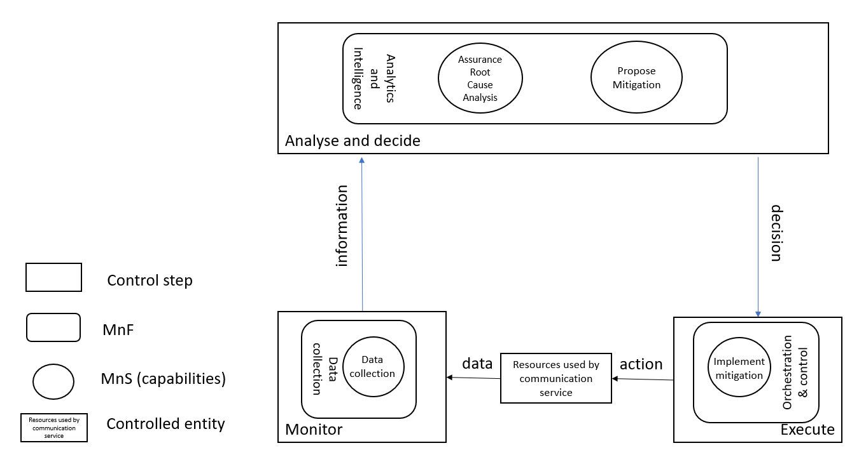
Figure 4.1.1.1: Overview of information flows
In Figure 4.1.1.1 the controlled entity represents the resources used by a communication service and the assurance of this communication service is provided by the loop between the different management services provided by the management system. The input to the loop is the data concerning the resources used by the communication service which is monitored by the control step Monitor and the output of the step " Analysis and Decide" may be a possible action from the control step "Execute", when for example the service experience degrades, the resources used by a communication service have to be adjusted. The data associated with the communication service is monitored by the management services for data collection, the management service provides information to the assurance root cause analysis management service and based on that information the assurance root cause analysis takes place followed by propose mitigation or suggestion to solve the problem. The mitigation or problem-solving suggestion is executed to bring the behaviour of the communication service within the requested boundaries of the metrics (SLS goals) that are controlled by the loop.
NOTE: The interface for interaction between the capabilities in the Analyse and decide step is not addressed in this document.
The management services available for the control steps for "Monitor" and "Analyse" as well as "Decide" are based on file transfer described in TS 28.550 [3], or data streaming described in TS 28.550 [3] and notifications described in TS 28.545 [4].
The information provided from the "Monitor" step to the "Analyse and Decide" step includes performance measurements (see TS 28.552 [12]), KPI’s (see TS 28.554 [13]), performance threshold monitoring events and fault supervision events (see TS 28.532 [7]).

4.1.2 Model

4.1.2.1 Imported and associated information entities

4.1.2.1.1 Imported information entities and local labels
Label reference | Local label
TS 28.622 [5], IOC, Top | Top
TS 28.622 [5], IOC, SubNetwork | SubNetwork
TS 28.622 [6], ProxyClass, ManagedEntity | ManagedEntity
TS 28.541 [6], dataType, ServiceProfile | ServiceProfile
TS 28.541 [6], dataType, SliceProfile | SliceProfile

4.1.2.2 Class diagram

4.1.2.2.1 Relationships
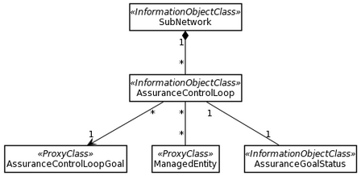
Figure 4.1.2.2.1.1: Assurance management NRM fragment

4.1.2.2.2 Inheritance
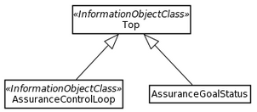
Figure 4.1.2.2.2.1: Assurance management inheritance relationships

4.1.2.3 Class definitions

4.1.2.3.1 AssuranceControlLoop
4.1.2.3.1.1 Definition
This IOC represents the capabilities of a control loop, these include:
- to automatically adjust a ManagedEntity (for example a network slice) to meet the objective described in AssuranceControlLoopGoal
- to report the effectiveness of an AssuranceControlLoop
- state management of an AssuranceControlLoop
- to keep track of the lifecycle of an AssuranceControlLoop
4.1.2.3.1.2 Attributes
Attribute name | Support Qualifier | isReadable | isWritable | isInvariant | isNotifyable
operationalState | M | T | F | F | T
administrativeState | M | T | T | F | T
controlLoopLifeCyclePhase | M | T | T | F | T
observationTimePeriod | M | T | T | F | T
assuranceGoalStatus | M | T | F | F | T

4.1.2.3.1.3 Constraints
No constraints have been defined for this document.
4.1.2.3.1.4 Notifications
The common notifications defined in clause 4.1.2.5 are valid for this IOC, without exceptions or additions.

4.1.2.3.2 AssuranceGoalStatus
4.1.2.3.2.1 Definition
This class represents the status of the controlLoopGoal at the end of an observationPeriod. The status can be reported as actual status and predicted status. Data that is monitored by an assuranceControlLoop and includes measurements [x] and KPI's [y] and predictions that are applicable to the assuranceControlLoopGoals.
An assuranceGoalStatus holds the value of the observation and where applicable the value of a prediction. Depending on the AssuranceGoal the type of the AssuranceGoalStatusObserved and AssuranceGoalStatusPredicted can be different for different AssuranceGoalStatus MOIs.
4.1.2.3.2.2 Attributes
Attribute name | Support Qualifier | isReadable | isWritable | isInvariant | isNotifyable
AssuranceGoalStatusObserved | M | T | T | F | T
AssuranceGoalStatusPredicted | O | T | T | F | T
.
4.1.2.3.2.3 Attribute constraints
No constraints have been defined for this document.
4.1.2.2.3.4 Notifications
The common notifications defined in subclause 4.1.2.5 are valid for this IOC, without exceptions or additions.

4.1.2.3.3 AssuranceControlLoopGoal <<ProxyClass>>
4.1.2.3.3.1 Definition
This IOC represents the <<dataType>> ServiceProfile and <<dataType>> SliceProfile, defined in network slice NRM in [6].
4.1.2.3.3.2 Attributes
The attributes are defined in network slice NRM in [6].
4.1.2.3.3.3 Attribute constraints
The attribute constraints are defined in network slice NRM in [6].
4.1.2.3.3.4 Notifications
The notifications of IOCs using the <<dataType>> ServiceProfile or <<dataType>> SliceProfile are defined in network slice NRM in [6].

4.1.2.3.4 ObservationTimePeriod <<dataType>>
4.1.2.3.4.1 Definition
This datatype represents the time that a goal is observed which can be specified in seconds, minutes, hours or days depending on the goal that is being observed.
4.1.2.3.4.2 Attributes
Attribute name | Support Qualifier | isReadable | isWritable | isInvariant | isNotifyable
observationTime | M | T | T | F | T
timeUnit | M | T | T | F | T

4.1.2.3.3.3 Attribute constraints
No constraints have been defined for this document.
4.1.2.3.3.4 Notifications
The common notifications defined in subclause 4.1.2.5 are valid for this IOC, without exceptions or additions.

4.1.2.4 Attribute definitions

4.1.2.4.1 Attribute properties
The following table defines the properties of attributes that are specified in the present document.
Table 4.1.2.4.1.1
Attribute Name | Documentation and Allowed Values | Properties
controlLoopLifeCyclePhase | It indicates the lifecycle phase of the ControlLoop.  AllowedValues: Preparation, Commissioning, Operation and Decommissioning. | type: Enum  multiplicity: 1  isOrdered: N/A  isUnique: N/A  defaultValue: None  isNullable: False
observationTimePeriod | It indicates the time duration over which a controlLoopGoal is observed. During the observation period various observation data is collected to assess if the controlLoopGoal has been met  The observation time is expressed in timeUnits. | type: Integer  multiplicity: 1  isOrdered: N/A  isUnique: N/A  defaultValue: None  isNullable: False
timeUnit | It indicates the unit of time used to express the observationTime  AllowedValues: second, minute, hour, day | type: Enum  multiplicity: 1  isOrdered: N/A  isUnique: N/A  defaultValue: None  isNullable: False
observationTime | It indicates the observation time expressed in number of timeUnit. | type: Integer  multiplicity: 1  isOrdered: N/A  isUnique: N/A  defaultValue: None  isNullable: False
assuranceGoalStatus | It reports the status of the controlLoopGoal at the end of an observationPeriod. The status can be reported as actual status or predicted status. | type: <<dataType>>  multiplicity: 1  isOrdered: N/A  isUnique: N/A  defaultValue: None  isNullable: False
assuranceGoalStatusObserved | It indicates the actual value of the controlLoopGoal at the end of an observation period | type: AssuranceGoalStatusObserved  multiplicity: 1  isOrdered: N/A  isUnique: N/A  defaultValue: None  isNullable: False
assuranceGoalStatusPredicted | It indicates the predicted value of the controlLoopGoal at the end of an observation period see note 1, or of a future observation period, see note 2. | type: AssuranceGoalStatusPredicted  multiplicity: 1  isOrdered: N/A  isUnique: N/A  defaultValue: None  isNullable: False
NOTE 1: The predictive capability is provided by using a different population for assessment than the population for which measurements are available.
NOTE 2: The predictive capability is provided by using a method for predicting the most likely status in the future.

4.1.2.4.2 Constraints
No constraints have been identified for this document.

4.1.2.4.3 Notifications
This subclause presents a list of notifications, defined in [7], that provisioning management service consumer can receive. The notification parameter objectClass/objectInstance, defined in [10], would capture the DN of an instance of an IOC defined in the present document.

4.1.2.5 Common notifications

4.1.2.5.1 Alarm notifications
This clause presents a list of notifications, defined in TS 28.532 [7], that an MnS consumer may receive. The notification header attribute objectClass/objectInstance, defined in TS 32.302 [8], shall capture the DN of an instance of a class defined in the present document.

4.1.2.5.2 Configuration notifications
This clause presents a list of notifications, defined in TS 28.532 [7], that an MnS consumer may receive. The notification header attribute objectClass/objectInstance, defined in TS 32.302 [8], shall capture the DN of an instance of a class defined in the present document.

4.1.3 Procedures

4.1.3.1 SLS Assurance Procedure
Figure 4.1.3.1.1 SLS assurance procedure
1. AssuranceControlLoop_consumer derives AssuranceControlLoopGoal from the ServiceProfile or SliceProfile.
2. AssuranceControlLoop_consumer provides the AssuranceControlLoopGoal to Entities_Participating_in_loop by utilizing the provision management services defined in as defined in clause 11.1.1.3 of TS 28.532 [7].
NOTE 1: In case the Entities_Participating_in_loop represents CrossDomain_Entities_Participating_in_loop, the AssuranceControlLoopGoal is the attribute(s) of the ServiceProfile. In case the Entities_Participating_in_loop represents Domain_Entities_Participating_in_loop, the AssuranceControlLoopGoal is the attribute(s) of the SliceProfile.
3. Entities_Participating_in_loop subscribes the related performance data (e.g., the packet delay related measurements), fault data, QoE data (e.g., buffer level) and MDT data from respective sources by utilizing the Operation establishStreamingConnection as defined in clause 6.2.1 of TS 28.550 [3].
4. Entities_Participating_in_loop, optionally, subscribes the related analytical data from MDAS or network functions, e.g., NWDAF. In case of NWDAF as a provider, Nnwdaf_EventsSubscription Service as defined in clause 4.2 is used.
5. Entities_Participating_in_loop collects the related performance, fault, QoE and MDT data (e.g., the packet delay related measurements), fault data, QoE data (e.g., buffer level) and MDT data from respective sources by utilizing the Operation establishStreamingConnection as defined in clause 6.2.1 of TS 28.550 [3].
6. Entities_Participating_in_loop, optionally, collects the related analytical data from MDAS or network functions, e.g., NWDAF. In case of NWDAF as a provider, Nnwdaf_EventsSubscription Service as defined in clause 4.2 of TS 29.520 [11] is used.
7. Entities_Participating_in_loop assesses if the AssuranceControlLoopGoal has been fulfilled.
8. Entities_Participating_in_loop assesses if and which action to take in case the AssuranceControlLoopGoal has not been fulfilled.
9. As per the mitigation action (e.g., scale out) resources are changed, the generic provisioning management service as defined in clause 11.1 of TS 28.532 [7] is utilized for the same.
10. Action completed.
NOTE 2: The Entities_Participating_in_loop continues to monitor and analyse the performance and perform the adjustment until the attribute(s) of SliceProfile is assured.
11. AssuranceControlLoop_consumer receives the confirmation of assurance fulfilment from Entities_Participating_in_loop by utilizing the provision management services defined in clause 11.1.1.3 of TS 28.532 [7].

4.2 Stage 3

4.2.1 Solution Set (SS) for JSON/YAML
The JSON/YAML solution set is documented in clause B.2.

Annex A (informative):
Control loop deployed in different layers

A.1 Introduction
This example gives a high-level view of control loops deployed in different layers, which consists of control loop in communication service layer, control loop in network slice layer, control loop in network slice subnet layer and control loop in NF layer, as described as Figure A.1.1, where the analytic could be leverage MDAS, and different control loops can provide input (interact with) to other control loops (in the same layer or different layers) and obtain the output from other control loops (in the same layer or different layers).
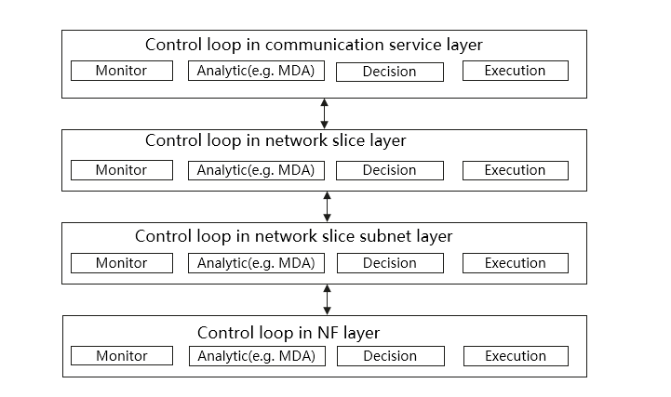
Figure A.1.1: Control loop in different layers

A.2 Control loop in communication service layer
SLA/SLS requirements provided from CSC are translated into serviceProfile, which represents the requirements for communication service assurance to the CSP. Coordination between control loop in communication service layer and control loop in network slice layer is needed to calculate the communication service resource requirements and to assure the communication service SLA/SLS requirements.
When the communication service is active, network slice performance is monitored and analysed for the communication service according to end user service experiences.
If service degradation occurs or it is predicted, the 3GPP management system could take actions, i.e. the allocated resources are scaled up or the SLS is adjusted based on pre-agreement/interaction between CSP and CSC.

A.3 Control loop in network slice layer
After receiving SLA/SLS requirements from service profile and completing the network slice provisioning, the network slice performance (e.g. KPI, QoE) are monitored and reported. Compared to the SLA/SLS requirements from service profile, when network slice performance is not met, the 3GPP management system identifies the root cause and may reconfigure the resources according to analytical report from MDAS producer. The network slice resources are also modified accordantly in case the network slice performance requirement needs to be changed based on communication service requirement adjustment.

A.4 Control loop in network slice subnet layer
After decomposing service profile to slice profile, the performance requirements for each network slice subnet are obtained. The 3GPP management system could have the capability of service observation (e.g., the supervision to the NSSI) based on MDAS. Based on such observation and comparison with initial subnet performance requirements, management actions on the NSSI might be performed if NSSI performance requirements fulfillment indicates a problem. Another possible scenario is that, when the NSSI performance requirement is changed because of the network slice modification management action, the NSSI resources might be also reconfigured.

A.5 Control loop in NF layer

NOTE: The control loop in NF layer is not addressed in the present document.

Annex B (normative):
OpenAPI definition of the COSLA NRM

B.1 General
This annex contains the OpenAPI definition of the COSLA NRM in YAML format.
The Information Service (IS) of the COSLA NRM is defined in clause 3.
Mapping rules to produce the OpenAPI definition based on the IS are defined in TS 32.160 [10].

B.2 Solution Set (SS) definitions

B.2.1 OpenAPI document "coslaNrm.yml"

openapi: 3.0.3

info:
title: coslaNrm
version: 16.4.0
description:
OAS 3.0.1 specification of the Cosla NRM
© 2020, 3GPP Organizational Partners (ARIB, ATIS, CCSA, ETSI, TSDSI, TTA, TTC).
All rights reserved.

externalDocs:
description: 3GPP TS 28.536 V16.4.0; 5G NRM, Slice NRM
url: http://www.3gpp.org/ftp/Specs/archive/28_series/28.536/

paths: {}

components:

schemas:

#------------ Type definitions ---------------------------------------------------

ControlLoopLifeCyclePhase:
anyOf:
- type: string
enum:
- PREPARATION
- COMMISSIONING
- OPERATION
- DECOMMISSIONING
- type: string

TimeUnit:
anyOf:
- type: string
enum:
- SECOND
- MINUTE
- HOUR
- DAY
- type: string

OperationalState:
anyOf:
- type: string
enum:
- ENABLED
- DISABLED
- type: string

AdministrativeState:
anyOf:
- type: string
enum:
- LOCKED
- SHUTTING_DOWN
- UNLOCKED
- type: string

ObservationTime:
type: integer

ObservationTimePeriod:
type: object

AssuranceControlLoopGoal:
type: object

AssuranceGoalStatus:
type: object

AssuranceGoalStatusObserved:
type: object

AssuranceGoalStatusPredicted:
type: object

#-------- Definition of concrete IOCs --------------------------------------------

AssuranceControlLoop-Single:
allOf:
- $ref: 'genericNrm.yaml#/components/schemas/SubNetwork-Attr'
- type: object
properties:
operationalState:
$ref: '#/components/schemas/OperationalState'
administrativeState:
$ref: '#/components/schemas/AdministrativeState'
controlLoopLifeCyclePhase:
$ref: '#/components/schemas/ControlLoopLifeCyclePhase'
observationTimePeriod:
allOf:
- $ref: '#/components/schemas/ObservationTimePeriod'
- type: object
properties:
observationTime:
$ref: '#/components/schemas/ObservationTime'
timeUnit:
$ref: '#/components/schemas/TimeUnit'
AssuranceGoalStatus:
allOf:
- $ref: '#/components/schemas/AssuranceGoalStatus'
- type: object
properties:
assuranceGoalStatusObserved:
$ref: '#/components/schemas/AssuranceGoalStatusObserved'
assuranceGoalStatusPredicted:
$ref: '#/components/schemas/AssuranceGoalStatusPredicted'
managedEntity-Multiple:
$ref: '#/components/schemas/ManagedEntity-Multiple'
assuranceControlLoopGoal:
$ref: '#/components/schemas/AssuranceControlLoopGoal'

ManagedEntity-Single:
oneOf:
- $ref: 'sliceNrm.yaml#/components/schemas/NetworkSlice'
- $ref: 'sliceNrm.yaml#/components/schemas/NetworkSliceSubnet'
- $ref: 'genericNrm.yaml#/components/schemas/ManagedFunction-Attr'
- $ref: 'genericNrm.yaml#/components/schemas/ManagedElement-Attr'

#-------- Definition of JSON arrays for name-contained IOCs ----------------------

AssuranceControlLoop-Multiple:
type: array
items:
$ref: '#/components/schemas/AssuranceControlLoop-Single'

ManagedEntity-Multiple:
type: array
items:
$ref: '#/components/schemas/ManagedEntity-Single'

Annex C (informative):
Change history

Change history
Date | Meeting | TDoc | CR | Rev | Cat | Subject/Comment | New version
2020-07 | SA#88e |  |  |  |  | Upgrade to change control version | 16.0.0
2020-09 | SA#89e | SP-200749 | 0001 | - | F | Update control loop deployed in different layers with SLA decomposition | 16.1.0
2020-09 | SA#89e | SP-200750 | 0004 | - | F | Add references to clause 4.1.2.3 | 16.1.0
2020-09 | SA#89e | SP-200750 | 0005 | - | F | Correct title and add references in clause 4.1.1 | 16.1.0
2020-09 | SA#89e | SP-200750 | 0006 | - | F | Remove Editor's Note in clause 4.1.1 | 16.1.0
2020-09 | SA#89e | SP-200750 | 0007 | - | F | Replace Editors Note in clause Annex A.5 with a Note | 16.1.0
2020-09 | SA#89e |  | 0030 | - | F | Add abbreviations to clause 3.3 | 16.1.0

