3GPP TSG-SA5 Meeting #132e S5-204393

e-meeting 17th 28th August 2020
CR-Form-v12.0
CHANGE REQUEST
 | 28.536 | CR | <CR#> | rev | - | Current version: | 16.0.0
For HELP on using this form: comprehensive instructions can be found at
http://www.3gpp.org/Change-Requests.

Proposed change affects: | UICC apps |  | ME |  | Radio Access Network | X | Core Network | X

Title: | Update text and figure in clause 4.1.1
Source to WG: | Ericsson, Deutsche Telekom
Source to TSG: | S5
Work item code: | COSLA |  |  |  |  |  | Date: |  |  | 2020-08-07
Category: | B |  |  |  |  |  | Release: |  |  | Rel-17
 | Use one of the following categories:  F (correction)  A (mirror corresponding to a change in an earlier release)  B (addition of feature),  C (functional modification of feature)  D (editorial modification)  Detailed explanations of the above categories can  be found in 3GPP TR 21.900. |  |  |  |  |  |  |  | Use one of the following releases:  Rel-8 (Release 8)  Rel-9 (Release 9)  Rel-10 (Release 10)  Rel-11 (Release 11)  Rel-12 (Release 12)  Rel-13 (Release 13)  Rel-14 (Release 14)  Rel-15 (Release 15)  Rel-16 (Release 16)
Reason for change: |  | The control step “Analyze and Decide” shows a very specific set of analytics service and intelligence service. For communication service assurance there can be other analytics services and intelligence services to support the use cases described in 28.535, therefore the diagram needs to be updated to reflect this.  Clarify threshold monitoring as it is specifically mentioned.  The title of the clause 4.1.1 is also proposed to be updated to reflect the content better.
Summary of change: |  | The reference list in clause 2 has been updated  Title of clause 4.1.1 has been updated  Threshold monitoring has been clarified and referenced  Figure 4.1.1.1 has been updated  The text in clause 4.1.1 has been updated
Consequences if not approved:
Clauses affected: |  | 2, 4.1.1
 |  | Y | N
Other specs |  |  | X | Other core specifications |  |  |  | TS/TR ... CR ...
affected: |  |  | X | Test specifications |  |  |  | TS/TR ... CR ...
(show related CRs) |  |  | X | O&M Specifications |  |  |  | TS/TR ... CR ...
Other comments:
This CR's revision history:

First change

2 References
The following documents contain provisions which, through reference in this text, constitute provisions of the present document.
- References are either specific (identified by date of publication, edition number, version number, etc.) or non-specific.
- For a specific reference, subsequent revisions do not apply.
- For a non-specific reference, the latest version applies. In the case of a reference to a 3GPP document (including a GSM document), a non-specific reference implicitly refers to the latest version of that document in the same Release as the present document.
[1] 3GPP TR 21.905: "Vocabulary for 3GPP Specifications".
[2] ETSI GS ZSM 002 (V1.1.1) (2019-08): "Zero-touch network and Service Management (ZSM); Reference Architecture".
[3] 3GPP TS 28.550: "Management and orchestration; Performance assurance".
[4] 3GPP TS 28.545: "Management and orchestration; Fault Supervision (FS)".
[5] 3GPP TS 28.622: "Telecommunication management; Generic Network Resource Model (NRM) Integration Reference Point (IRP); Information Service (IS)".
[6] 3GPP TS 28.541: "Management and orchestration; 5G Network Resource Model (NRM); Stage 2 and stage 3".
[7] 3GPP TS 28.532: "Management and orchestration; Generic management services".
[8] 3GPP TS 32.302: "Telecommunication management; Configuration Management (CM); Notification Integration Reference Point (IRP); Information Service (IS)".
[9] 3GPP TS 28.531: "Management and orchestration; Provisioning".
[10] 3GPP TS 32.160: "Management and orchestration; Management service template".
[x] 3GPP TS 28.552: "Management and orchestration; 5G performance measurements"
[y] 3GPP TS 28.554: "Management and orchestration; 5G end to end Key Performance Indicators (KPI)"

Second change

4 Communication service assurance service

4.1 Stage 2

4.1.1 Overview
Communication service assurance relies on a set of management services that together provide the CSP with the capability to assure the communication service as per agreement with a CSC (e.g. enterprise). The overall solution and information flows between management services and control steps [2] are shown in Figure 4.1.1.1.

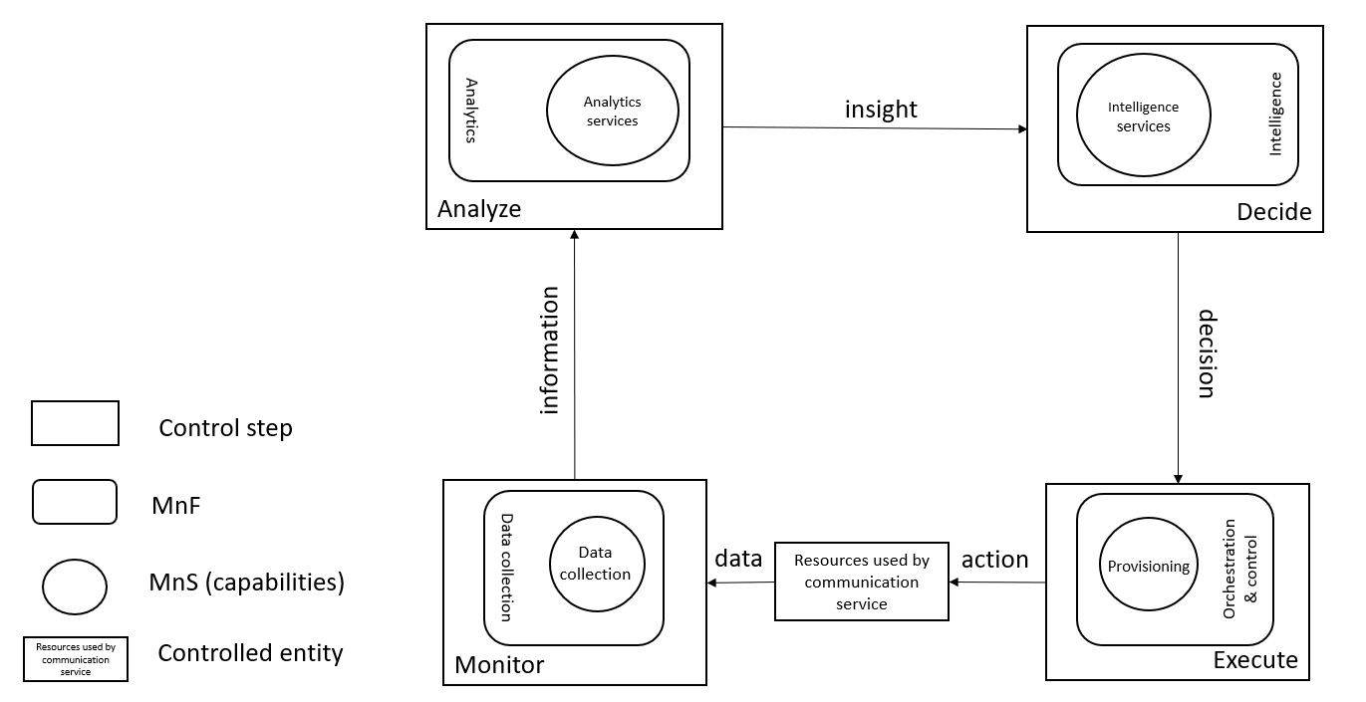
Figure 4.1.1.1: Overview of information flows
In Figure 4.1.1.1 the controlled entity represents the resources used by a communication service and the assurance of this communication service is provided by the loop between the different management services provided by the management system. The input to the loop is the data concerning the resources used by the communication service which is monitored by the control step Monitor and the output of the step "Decide" should be a decision for the control step "Execute" to make an action, when for example the service experience degrades, the resources used by a communication service have to be adjusted. The data associated with the communication service is monitored by the management services for data collection, the management service provides information to the analytics services (an example of an analytics service is an assurance root cause analysis management service) which produces specific information, i.e. insight, for an intelligence service to propose a mitigation or suggestion to solve the problem. The mitigation or problem-solving suggestion is executed to bring the behaviour of the communication service within the requested boundaries of the metrics (SLS goals) that are controlled by the loop.

The management services available for the control steps for "Monitor", "Analyse" "Decide" and Execute are based on file transfer described in TS 28.550 [3], or data streaming described in TS 28.550 [3] and notifications described in TS 28.545 [4].
The information provided from the "Monitor" step to the "Analyse" step includes performance measurements (see TS 28.552 [x]), KPI’s (see TS 28.554 [y]), and fault supervision events (see TS 28.532 [7]). Threshold detection events created in the "Analyse" step are specified TS 28.532 [7].

The insight from the "Analyse" step to the "Decide" step is can be provided as an analytics report, which are not specified in the current release of the present document.
The decision provided from the "Decide" step to the "Execute" step includes resource configuration (see TS 28.541 [6]), which is not specified in the current release of the present document. An example of resource configuration is adjustment of RRM policy in the RAN.

Editor's Note: Further details including the relationship between the content of the figure "Overview of information flows", Trace as well as MDT are FFS

End of changes

