3GPP TSG-SA5 Meeting #132-e S5-204379

Online, , 17th Aug 2020 - 28th Aug 2020
CR-Form-v12.0
CHANGE REQUEST
 | 28.541 | CR | 0358 | rev | - | Current version: | 16.5.0
For HELP on using this form: comprehensive instructions can be found at
http://www.3gpp.org/Change-Requests.

Proposed change affects: | UICC apps |  | ME |  | Radio Access Network |  | Core Network | ■

Title: | Rel-17 CR GST Translation and Configuration
Source to WG: | Samsung Electronics Benelux BV
Source to TSG: | S5
Work item code: | EMA5SLA |  |  |  |  |  | Date: |  |  | 2020-08-07
Category: | C |  |  |  |  |  | Release: |  |  | Rel-17
 | Use one of the following categories:  F (correction)  A (mirror corresponding to a change in an earlier release)  B (addition of feature),  C (functional modification of feature)  D (editorial modification)  Detailed explanations of the above categories can  be found in 3GPP TR 21.900. |  |  |  |  |  |  |  | Use one of the following releases:  Rel-8 (Release 8)  Rel-9 (Release 9)  Rel-10 (Release 10)  Rel-11 (Release 11)  Rel-12 (Release 12)  Rel-13 (Release 13)  Rel-14 (Release 14)  Rel-15 (Release 15)  Rel-16 (Release 16)
Reason for change: |  | Section L.2 says: Some of the information in 5GC SliceProfile and NG-RAN SliceProfile is translated to configurable parameters of network function for the control plane SLA support purpose. This need to be further extended with respect to:  - Identifying GST attributes that will be translated into configurable parameter  - Identifying ServiceProfile attributes that will be translated into SliceProfile attributes  - How to manage the GST attributes which does not get translated into configurable parameters  Please see S5-204347 for details.
Summary of change: |  | Existing ANNEX is extended to include crucial aspect of GST management.
Consequences if not approved: |  | In-complete GST management solution.
Clauses affected: |  | L
 |  | Y | N
Other specs |  |  | ■ | Other core specifications |  |  |  | TS/TR ... CR ...
affected: |  |  | ■ | Test specifications |  |  |  | TS/TR ... CR ...
(show related CRs) |  |  | ■ | O&M Specifications |  |  |  | TS/TR ... CR ...
Other comments:
This CR's revision history:

------------------------------------------------------------Change 1 Start-----------------------------------------------------------

Annex L (normative):
Relation of GSMA GST, ServiceProfile and SliceProfile

L.1 General
This annex describes the relation between GSMA GST [50] and information model ServiceProfile and SliceProfile.

L.2 GSMA GST, ServiceProfile and SliceProfile
The GSMA GST is used as the SLA information for the communication between the vertical industry and the communication service provider. The SLA requirements can be fulfilled from management aspect and control aspect in a coordinated way. The SLS includes ServiceProfile information model.
As shown in figure L.2.1, the GST [50] is translated and used as input to NRM ServiceProfile, the ServiceProfile can be translated to corresponding requirements for dedicated domains. For example, 5GC SliceProfile is used to carry 5GC domain requirements, NG-RAN SliceProfile is used to carry NG-RAN domain requirements, and TN requirements are translated and provided to TN domain. Some of the information in 5GC SliceProfile and NG-RAN SliceProfile is translated to configurable parameters of network function for the control plane SLA support purpose.
NOTE: how to do the translation is out of the scope of this document.

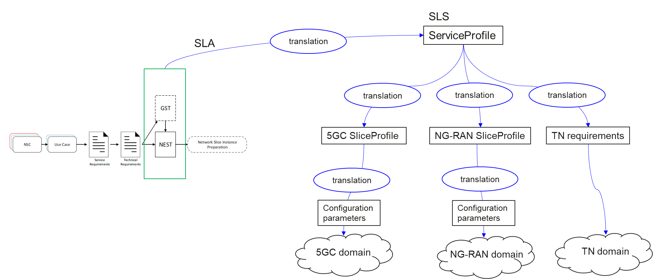
Figure L.2.1 Relation between GSMA GST, ServiceProfile and SliceProfile

L.3 GST configuration and enforcement
The attributes in GST can be categorized into two categories; Configurable Attributes and Non-configurable Attributes. The Configurable Attributes are those attributes which will get translated into configuration parameters for network functions. Non-Configurable Attributes: The Non-Configurable Attributes are those attributes which will not get translated into configuration parameters for network functions. The Non-Configuration attribute will be enforced during slice provisioning.
Note: The configuration parameters are enforced by the individual network functions at run-time, as appropriate.
Editors note: The list of configuration parameters is FFS.

------------------------------------------------------------Change 1 End-----------------------------------------------------------

